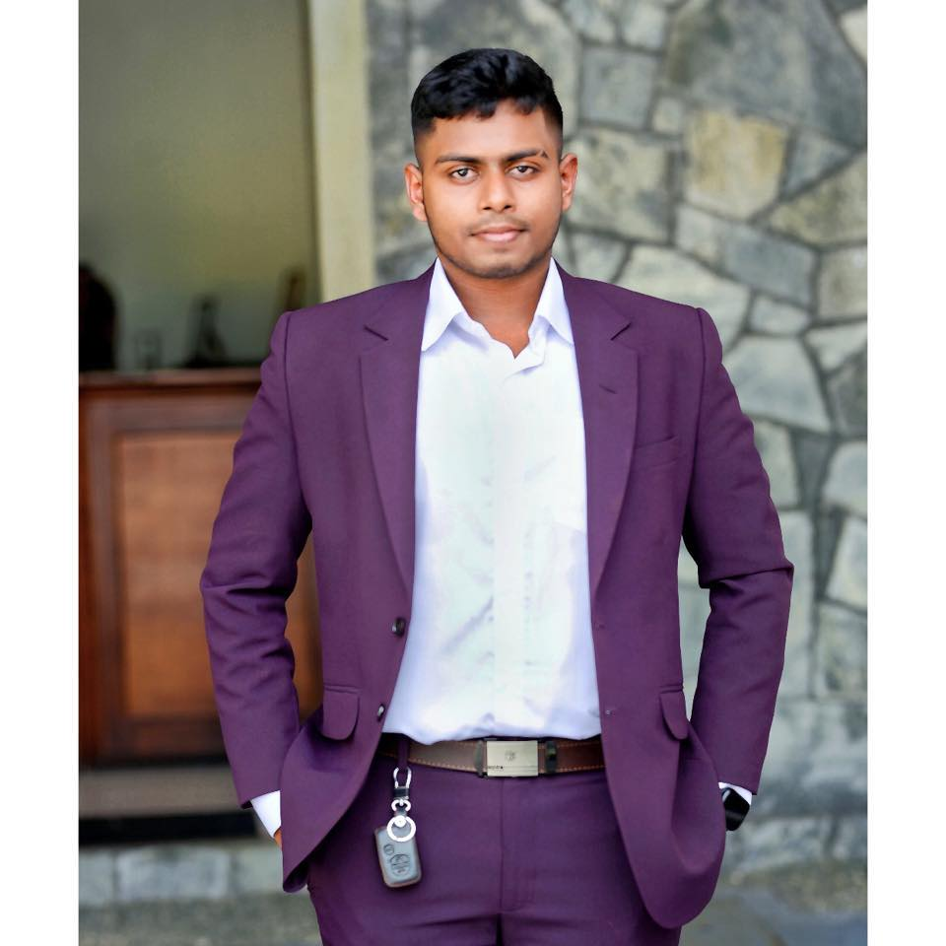
- Sinhala
- English
- Tamil

G.C.E O/L EXAMINATION 2021, G/P.DE.S.Kularathna College Ambalangoda

Subject | Grade
Information & Communication Technology | A
Mathematics | A
Sinhala | B
English | B
History | C
Buddhism | C
Science | C
Music (ORI) | C
Tamil | C
G.C.E A/L EXAMINATION (Mathematics) 2021, G/P.DE.S.Kularathna College Ambalangoda

Subject | Grade
Information & Communication Technology | C

HND IN SOFTWARE ENGINEERING , Institute Of Software Engineering Panadura

- I have involved in swimming since 2010.
- I became a member of the Sri Lanka Life Saving Association in 2016.
- I have involved Sri Lanka Saukyadana Movement in 2019

EXTRA CURICULAR ACTIVITIES
EDUCATIONAL QUALIFICATION
PERSONAL DETAILS
Address:
Galle, SriLanka.
Email :
chamodvishmina@gmail.com
Phone :
+94702201571

Full NAME : GEEGANAGE CHAMOD VISHMINA KULARATHNA
GENDER : MALE
NATIONALITY: SRILANKAN
AGE : 21
CIVIL STATUS : SINGLE
NIC No : 200522500647

Chamod Vishmina
Software Engineer

- Swimming
- Play Cricket
Hobbies
Languages
- Figma
- CSS
- Java
- HTML
- Database
- JavaScript
- VS Code

Skills
Contact \\\\\\

