Student Performance Analysis Dashboard
Report based on Student_Performance_Data.pbix

1. Project Overview
This report documents the Power BI project “Student Performance Analysis Dashboard”. The dashboard analyses the marks, attendance and pass/fail results of ten students across three subjects (Mathematics, ICT and English) so that a teacher or administrator can quickly see how the class is performing and which students need support.
The project follows the standard Power BI workflow: data imported from Excel and cleaned in Power Query, a small data model with calculated measures written in DAX, and a single-page interactive report with KPI cards, charts and slicers.
Item | Detail
Report title | STUDENT PERFORMANCE ANALYSIS DASHBOARD
Data source | Excel workbook Student_Performance_Data.xlsx (sheet “StudentData”)
Data model | One table (StudentData): 30 rows, 7 columns, no relationships
Report pages | 1 page (1920 × 1080, fit to page)
Visuals | 10 visuals: 1 title box, 4 KPI cards, 3 charts, 2 slicers
Look and feel | Dark blue background (#1C3C64), Fluent 2 base theme, blue/pink accent colours

2. Data Source and Data Model

2.1 Source data
Data is loaded from Excel using Power Query. The query promotes the first row to headers and sets data types (text for IDs, names, gender and subject; whole number for Marks and Attendance). Each student appears once per subject, so every student has three rows. Attendance is recorded once per student and repeated on each of their rows.
Column | Type | Description
StudentID | Text | Unique student code (S001 to S010)
StudentName | Text | Student’s first name
Gender | Text | Male or Female (5 students each)
Subject | Text | Mathematics, ICT or English
Marks | Whole number | Subject mark out of 100
Attendance | Whole number | Student’s attendance percentage
Result | Text (calculated) | Pass or Fail, created in DAX

2.2 Calculated column and measures
One calculated column and five DAX measures drive the whole dashboard. The pass mark is 50.
Name | DAX expression
Result (column) | IF(StudentData[Marks] >= 50, "Pass", "Fail")
Total Students | DISTINCTCOUNT(StudentData[StudentID])
Average Marks | AVERAGE(StudentData[Marks])
Pass Count | CALCULATE(COUNTROWS(StudentData), StudentData[Marks] >= 50)
Pass Rate | DIVIDE([Pass Count], COUNTROWS(StudentData), 0)
Average Attendance | AVERAGE(StudentData[Attendance])

3. Dashboard Design
The report page has a centred title banner across the top, two dropdown slicers on the left, four KPI cards in the middle and right, and three charts along the bottom.
Visual | Type | Fields and purpose
Title | Text box | “STUDENT PERFORMANCE ANALYSIS DASHBOARD”, 60 pt bold, centred
Subject filter | Slicer (dropdown) | Subject – filters every visual by subject
Gender filter | Slicer (dropdown) | Gender – filters every visual by gender
Total Students | Card | Distinct count of students
Pass Rate | Card | Share of results at or above 50
Average Attendance | Card | Mean attendance percentage
Average Marks | Card | Mean marks across the selected rows
Average Marks by Subject | Clustered column chart | Subject vs average Marks
Pass / Fail split | Donut chart | Result vs count of StudentID
Average Marks by Student | Clustered bar chart | StudentName vs average Marks, sorted high to low

Saved slicer state. The file was saved with the Subject slicer set to Mathematics and the Gender slicer set to Male, so opening it shows a filtered view (5 male students, Mathematics only). To see the whole class, clear both slicers. The analysis in Section 4 uses the full dataset; the filtered view is summarised in Section 4.1.

4. Key Findings

4.1 Headline KPIs
10  Total students | 67.3  Average marks | 76.7%  Pass rate | 84.5%  Average attendance
Full dataset (30 subject results, all subjects, both genders)
Across the class, the average mark is 67.3 and 76.7% of subject results are passes (23 of 30). Average attendance is 84.5%.
In the view the file was saved with (Mathematics, Male), the cards show 5 students, an average mark of 51.2, a pass rate of 40% and average attendance of 75.8%. This is well below the whole-class figures and already hints at the gender and attendance patterns below.

4.2 Performance by subject and overall results
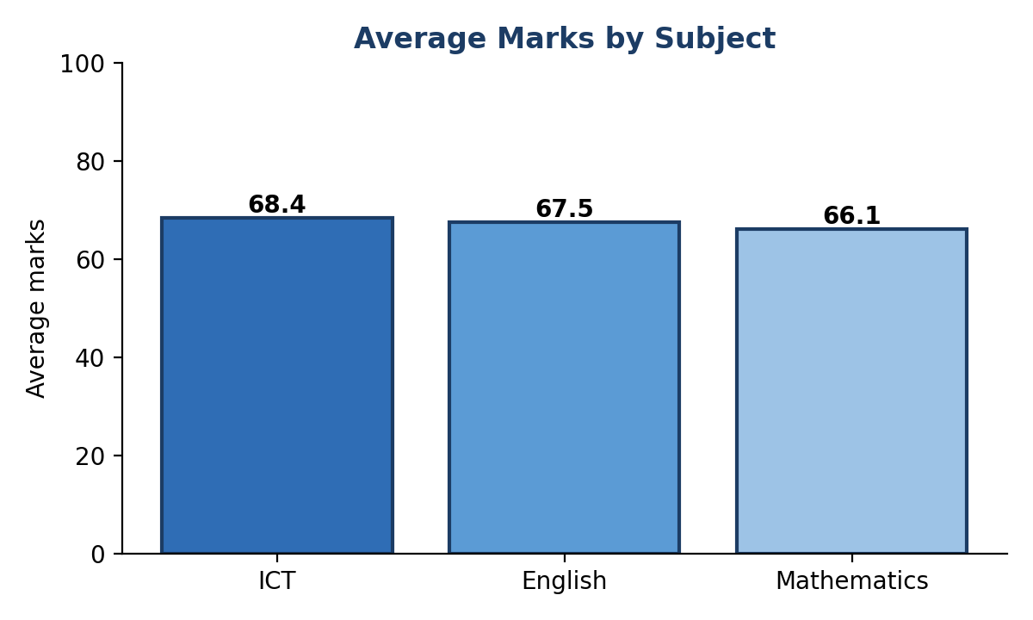 | 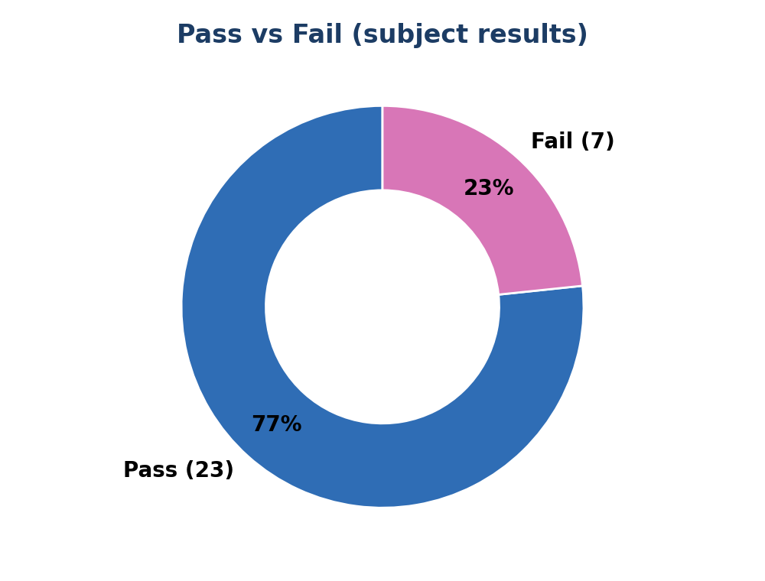
Figure 1: Average marks by subject (left) and pass/fail split (right)
Subject | Average marks | Pass rate | Fail count
ICT | 68.4 | 80% | 2
English | 67.5 | 80% | 2
Mathematics | 66.1 | 70% | 3

- Subjects are close. ICT has the highest average (68.4) and Mathematics the lowest (66.1), but the spread between subjects is small (about 2 marks).
- Mathematics is the weakest subject for passing. Mathematics has the most failures (3 of 10) and the lowest pass rate (70%); ICT and English each have 80%.

4.3 Performance by student
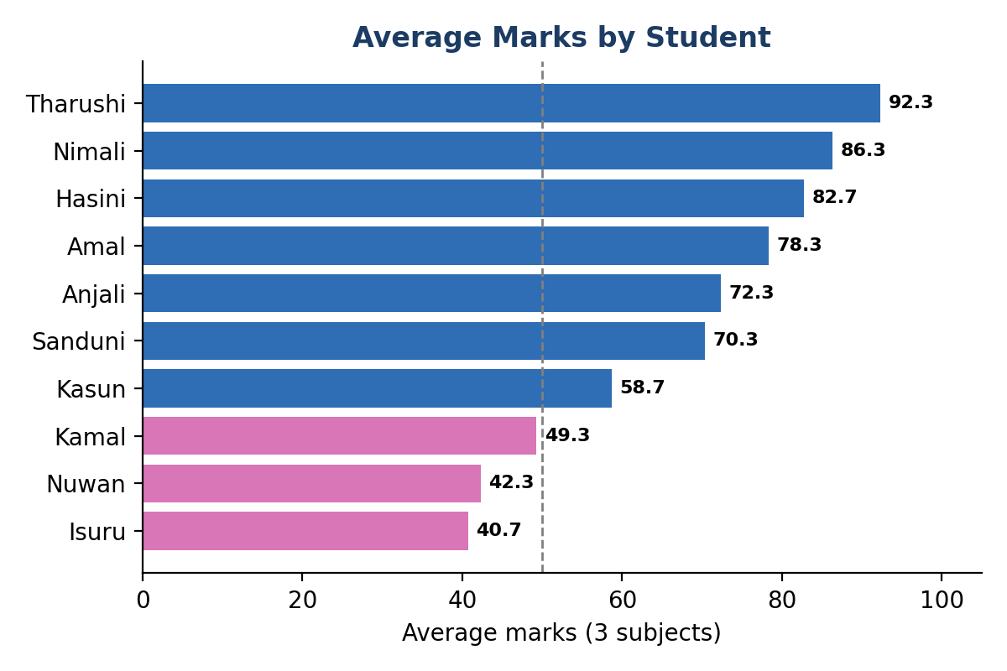
Figure 2: Average marks per student (pink = below the pass mark of 50)
ID | Name | Gender | Maths | ICT | English | Average | Attend.
S006 | Tharushi | Female | 95 | 89 | 93 | 92.3 | 98%
S002 | Nimali | Female | 88 | 91 | 80 | 86.3 | 96%
S010 | Hasini | Female | 83 | 79 | 86 | 82.7 | 94%
S001 | Amal | Male | 78 | 85 | 72 | 78.3 | 92%
S008 | Anjali | Female | 72 | 68 | 77 | 72.3 | 90%
S004 | Sanduni | Female | 67 | 74 | 70 | 70.3 | 88%
S007 | Kasun | Male | 58 | 63 | 55 | 58.7 | 80%
S003 | Kamal | Male | 45 | 55 | 48 | 49.3 | 75%
S005 | Nuwan | Male | 35 | 42 | 50 | 42.3 | 62%
S009 | Isuru | Male | 40 | 38 | 44 | 40.7 | 70%
Table 1: Marks by student and subject, ranked by average. Shaded rows average below 50.
- Top performers. Tharushi (92.3), Nimali (86.3) and Hasini (82.7) lead the class, each passing all three subjects with attendance of 94% or more.
- Students at risk. Isuru (40.7), Nuwan (42.3) and Kamal (49.3) average below 50. Isuru fails all three subjects, while Nuwan and Kamal each fail two.
- Failures are concentrated. Seven of the ten students pass every subject; the three at-risk students account for all seven failed results.

4.4 Gender comparison
Gender | Students | Average marks | Pass rate | Avg. attendance
Female | 5 | 80.8 | 100% | 93.2%
Male | 5 | 53.9 | 53.3% | 75.8%

Female students average about 27 marks higher than male students (80.8 vs 53.9) and pass every subject. The gap appears in all three subjects (Mathematics 81.0 vs 51.2, ICT 80.2 vs 56.6, English 81.2 vs 53.8). It is not uniform, however: Amal, a male student, ranks fourth overall with an average of 78.3, and all three at-risk students are male.

5. Recommendations
- Targeted support. Arrange extra support for Isuru, Nuwan and Kamal, starting with Mathematics where all three fail.
- Monitor attendance. Because low attendance accompanies low marks, set an attendance alert (for example below 80%) so teachers can follow up early.
- Strengthen Mathematics. Review how Mathematics is taught and assessed, since it has the lowest average and pass rate.
- Peer learning. Pair high performers with struggling students for peer study groups.
- Investigate the gender gap. Look into why male students as a group trail female students, for example study habits, engagement or support needs, before drawing conclusions.

6. Dashboard Improvements
- Add a student-level pass measure. The Pass Rate card counts subject results, not students. Adding a student-level measure (students passing all subjects) would give a clearer picture.
- Add drill-down. Adding a table visual and an attendance slicer would let users drill from the KPIs down to individual students.
- Use conditional formatting. Highlighting marks below 50 in red or pink would make at-risk results visible at a glance.
- Reset the slicers. Setting both slicers to “All” before saving means the dashboard opens showing the whole class.

7. Limitations
- Ten students and 30 results is too small to treat the gender and attendance patterns as statistically reliable. They describe this class only.
- The correlation between attendance and marks does not show that attendance causes higher marks.
- Attendance is stored once per student, so the Average Attendance card is a mean over subject rows, which equals the student mean here because every student has three rows.
- The data source path points to a local OneDrive folder, so the report refreshes only on a computer that has the Excel file at that location.

8. Conclusion
The Student Performance Analysis Dashboard gives a clear, interactive view of class performance. The class passes 76.7% of subject results with an average mark of 67.3, but results are uneven: three students, all with the lowest attendance, account for every failure, and Mathematics is the weakest subject. With the small improvements suggested above, the dashboard can serve as a practical early-warning tool for identifying students who need help.

