Sri Lanka Institute of Information Technology

Data warehousing and Business Intelligence
Assignment 2



KUMARAGE C D – IT23572560
Year 03 Semester 01 - WE 01.02

Table of Contents
Step 1: Data Source 4
1.1 Overview of the Data Source 4
1.2 Data Warehouse Details 4
1.3 Tables Used 4
1.3.1 Fact Table 4
1.3.2 Dimension Tables 4
1.4 ER Diagram 5
1.5 Data Preparation Verification 6
Step 2: SSAS Cube Implementation 6
2.1 Creating the SSAS Project 6
2.2 Creating the Data Source 6
2.3 Creating the Data Source View (DSV) 7
2.4 Creating Dimensions 8
2.4.1 DimDate Dimension 8
2.4.2 DimProduct Dimension 10
2.4.3 DimCustomer Dimension 11
2.4.4 DimStore Dimension 12
2.4.5 DimPaymentMethod Dimension 13
2.5 Creating the Cube 13
2.6 Configuring Dimension Usage 14
2.7 Measures in the Fact Table 15
2.9 Processing the Cube 16
Step 3: Demonstration of OLAP Operations 16
3.1 Connecting Excel to the SSAS Cube 16
3.2 OLAP Operations Demonstrated 17
3.2.1 Roll-Up 17
3.2.2 Drill-Down 18
3.2.3 Slice 19
3.2.4 Dice 20
3.2.5 Pivot 21
Step 4: Power BI Reports 22
4.1 Connecting Power BI Desktop to RetailDW 22
4.2 Data Modeling in Power BI 23
4.3 Report 1: Matrix Visual Report 23
4.3.1.Steps Followed 23
4.4 Report 2: Slicers with Cascading Filters and Multiple Visuals 25
4.4.1.Data Preparation 25
4.4.2. Steps Followed 25
4.5 Report 3: Drill-Down Hierarchical Report 27
4.5.1 Steps Followed 27
4.5.2 Navigation 27
4.6 Report 4: Drill-Through Report 29
4.6.1 Steps Followed 29
4.6.2 DAX Measures 29
4.8 Publishing to Power BI Service 30

Step 1: Data Source

1.1 Overview of the Data Source
For Assignment 2, the data source used is the Retail Data Warehouse (RetailDW) that was designed,implemented, and populated with data in Assignment 1.The data warehouse was build using SQL Server Integration Services (SSIS) and Microsoft SQL Server Management Studio (SSMS) with SQL Server as the target database platform.

1.2 Data Warehouse Details
Database Name | RetailDW
Platform | SQL Server
ETL Tool | SQL Server Integration Services (SSIS)
Development Tool | SQL Server Management Studio (SSMS)
Data Sources | CSV files (customers, reviews, support tickets), Excel files (campaigns, interactions), SQL Server table (transactions)
Schema Type | Star Schema
Data Range | 2020 – 2025

1.3 Tables Used

1.3.1 Fact Table
•FactSales – contain transactional sales data including measures such as quantity, price, discount_applied, and txn_process_time_hours

1.3.2 Dimension Tables
•DimDate – contain date-related attributes for time analysis.
•DimCustomer – contain customer demographic and geographic details
•DimProduct – contain product and product category information
•DimStore – contains store location and sales channel information.
•DimPaymentMethod – contain payments method classifications

1.4 ER Diagram
The following ER diagram represent the RetailDW data warehouse. It illustrates the relationships between the central fact table and the surrounding dimension tables.how the relationships works in RetailDW.

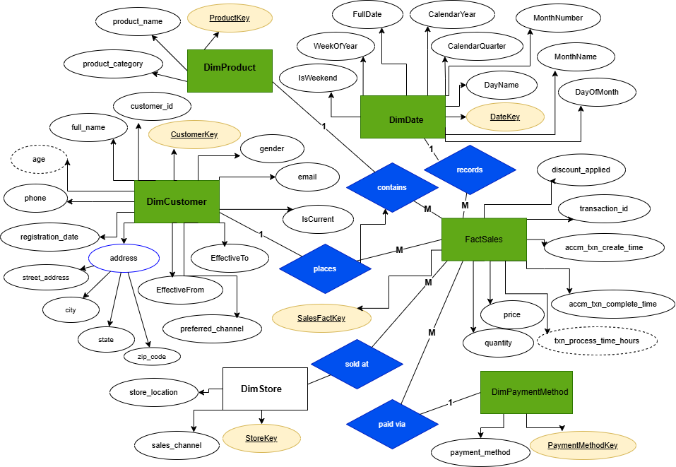
(view ER diagram)

1.5 Data Preparation Verification
Before using the data warehouse as source for Assignment 2,the following verifications and fixes were applied to ensure data integrity:
•Verified all dimension and fact tables are properly loaded
•Confirmed all foreign key relationships are intact
•Ensured no NULL keys exist in the fact table

Step 2: SSAS Cube Implementation

2.1 Creating the SSAS Project
SSAS Multidimensional Cube Project is created using SQL Server Data Tools within Visual Studio.The following steps are followed:
1.Open Visual Studio and create new Analysis Services Multidimensional Project
2.Set the project name as RetailCubeProject and Click Create to initialize the project.

2.2 Creating the Data Source
Data source connection was established to link the SSAS project to the RetailDW data warehouse:
1. Create New Data Source to launch the wizard and Select SQL Server as the connection type
2.set Server to: CHAMODI and Set Database to: RetailDW
3.Selects Windows Authentication (chamodi\msi) as the authentication method and Complete the wizard and save the data source
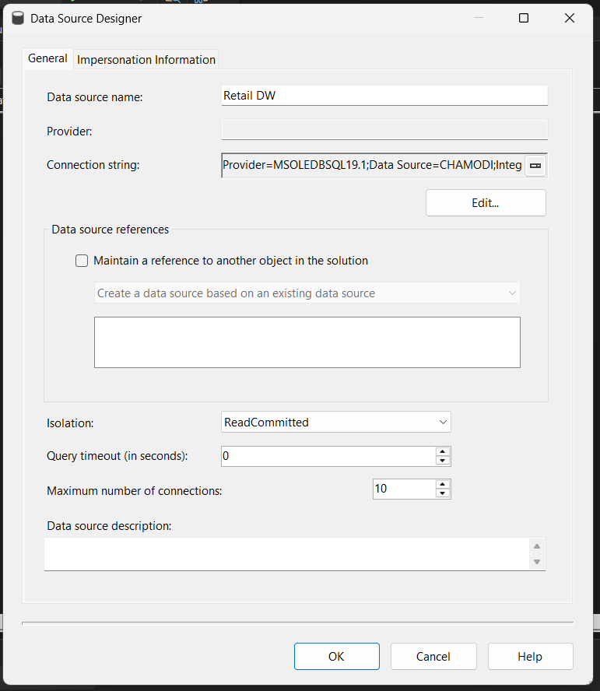

2.3 Creating the Data Source View (DSV)
Data Source View was created to define the logical schema used by the cube:
1.Create New Data Source View and Select the RetailDW data source
2.Add the following tables to the DSV:
◦FactSales
◦DimDate
◦DimCustomer
◦DimProduct
◦DimStore
◦DimPaymentMethod
5.Complete the wizard to generate the DSV
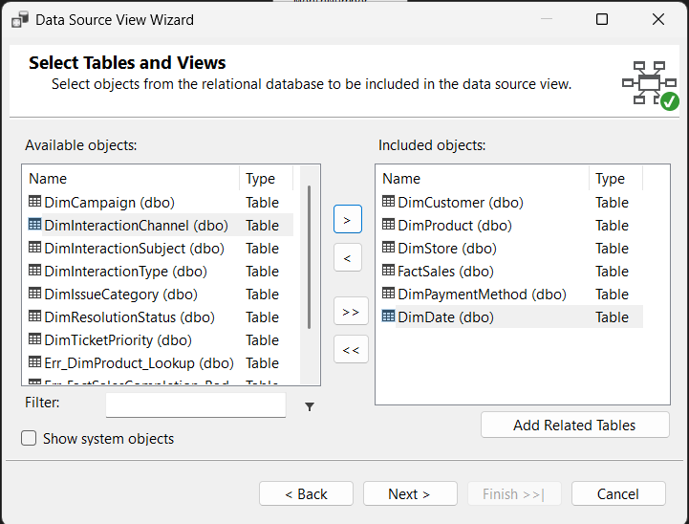

2.4 Creating Dimensions
Individual dimensions were created for each dimension table in the DSV. The following dimensions were configured:

2.4.1 DimDate Dimension
Attributes used:
•DateKey (Key Attribute)
•FullDate
•CalendarYear
•CalendarQuarter
•MonthNumber
•MonthName
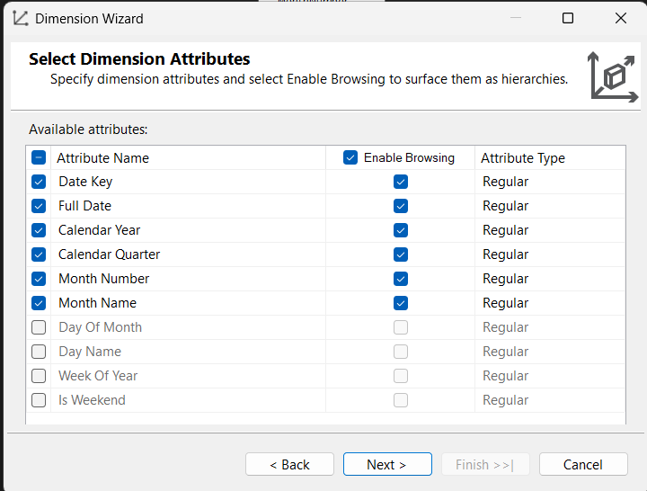
Attribute property settings:
Attribute | KeyColumns | NameColumn
Full Date | DateKey | FullDate
Calendar Year | CalendarYear | CalendarYear
Calendar Quarter | CalendarYear + CalendarQuarter | CalendarQuarter
Month Name | CalendarYear + MonthNumber | MonthName

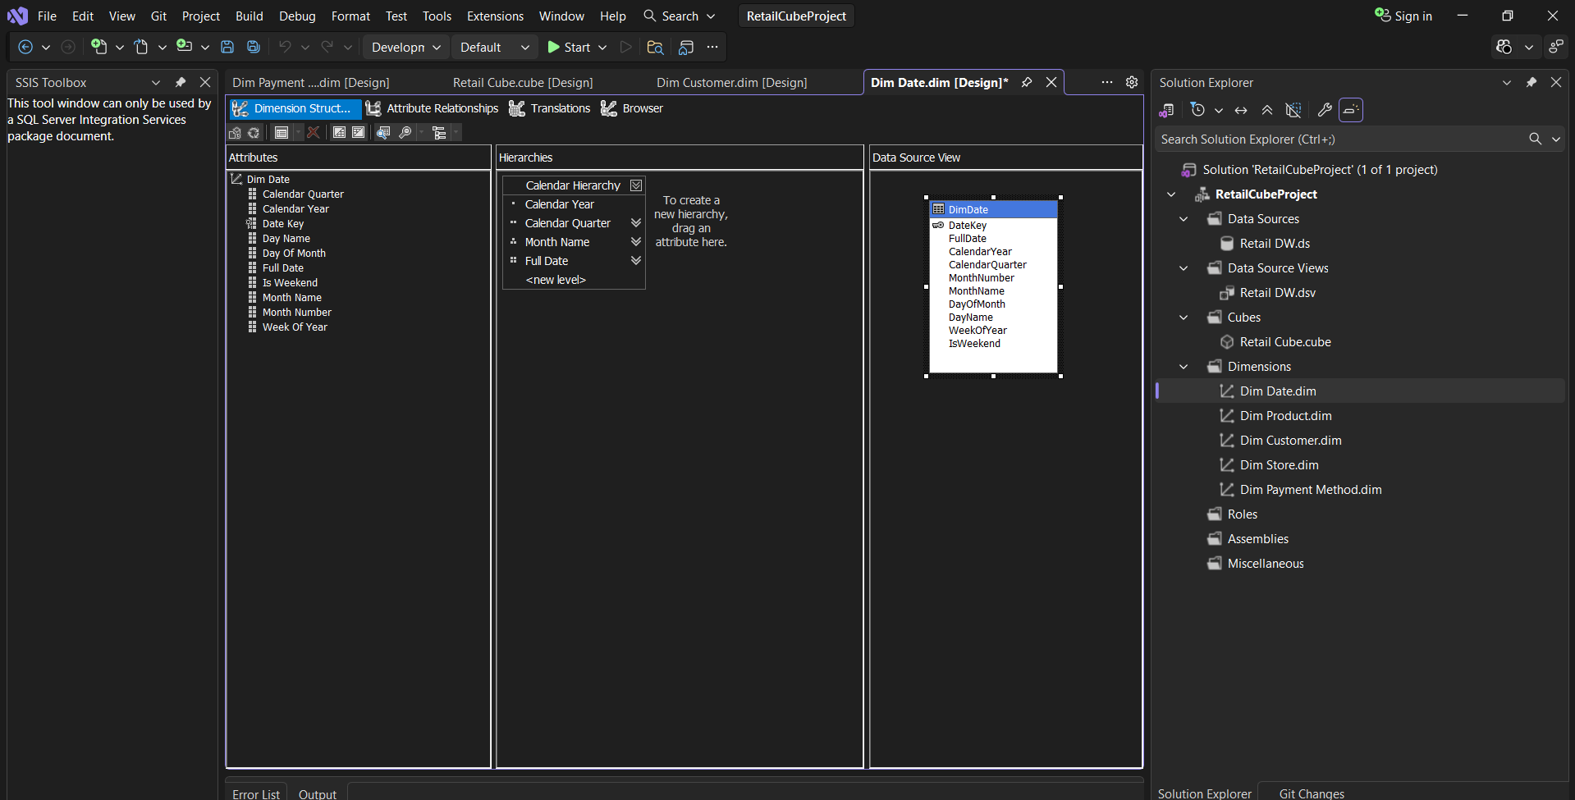

2.4.1.1 Date Hierarchy
Hierarchy Name: Calendar Hierarchy
•Level 1: Calendar Year
•Level 2: Calendar Quarter
•Level 3: Month Name
•Level 4: Full Date
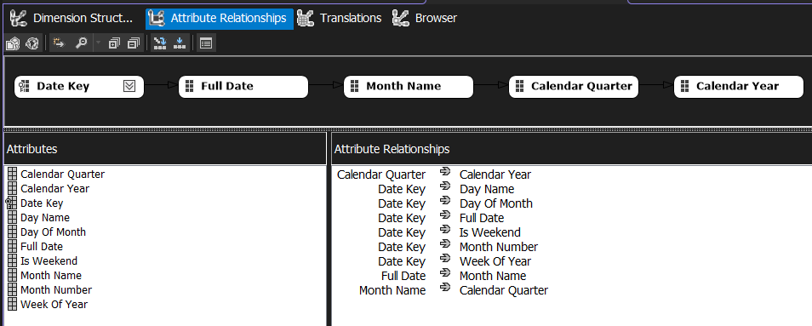

2.4.2 DimProduct Dimension
Attributes used:
•ProductKey (Key Attribute)
•product_name
•product_category

Attribute | KeyColumns | NameColumn
Product Name | ProductKey | product_name
Product Category | product_category | product_category

2.4.2.1 Product Hierarchy
Hierarchy Name: Product Hierarchy
•Level 1: Product Category
•Level 2: Product Name

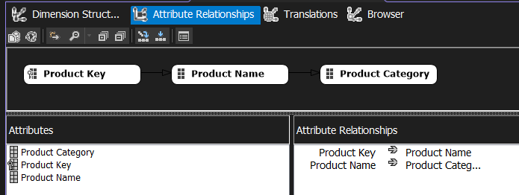

2.4.3 DimCustomer Dimension
No hierarchyies are created for DimCustomer.
Attributes used:
•CustomerKey (Key Attribute)
•full_name
•city
•state

Attribute | KeyColumns | NameColumn
Full Name | CustomerKey | full_name
City | CustomerKey | city
State | CustomerKey | state
Attributes Relationships used in DimCustomer :
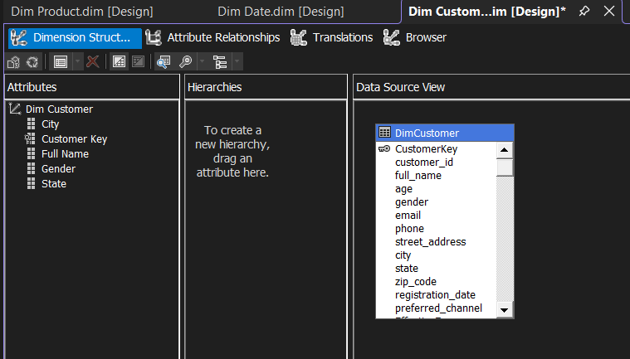

2.4.4 DimStore Dimension
No hierarchyies are created for DimStore and DimPaymentMethod as these dimensions do not have a natural hierarchical structure
Attributes used:
•StoreKey (Key Attribute)
•store_location
•sales_channel
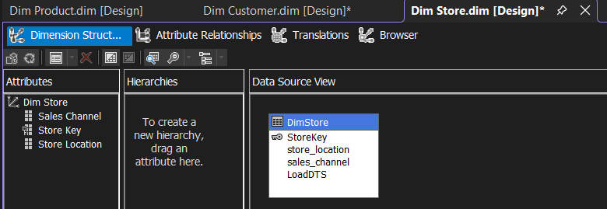

2.4.5 DimPaymentMethod Dimension
Attributes used:
•PaymentMethodKey (Key Attribute)
•payment_method
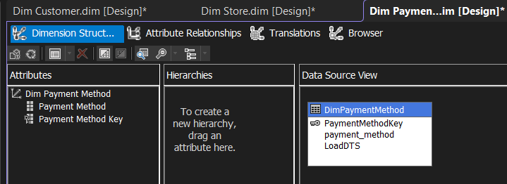

2.5 Creating the Cube
The cube was created using the Cube Wizard in SSDT
1.Right-click on Cubes in Solution Explorer Click New Cube
2.Select Use existing tables as the build method
3.Select FactSales as the measure group table
4.Add the following dimensions to the cube:
◦Date (DimDate)
◦Customer (DimCustomer)
◦Product (DimProduct)
◦Store (DimStore)
◦Payment Method (DimPaymentMethod)
5.Complete the wizard
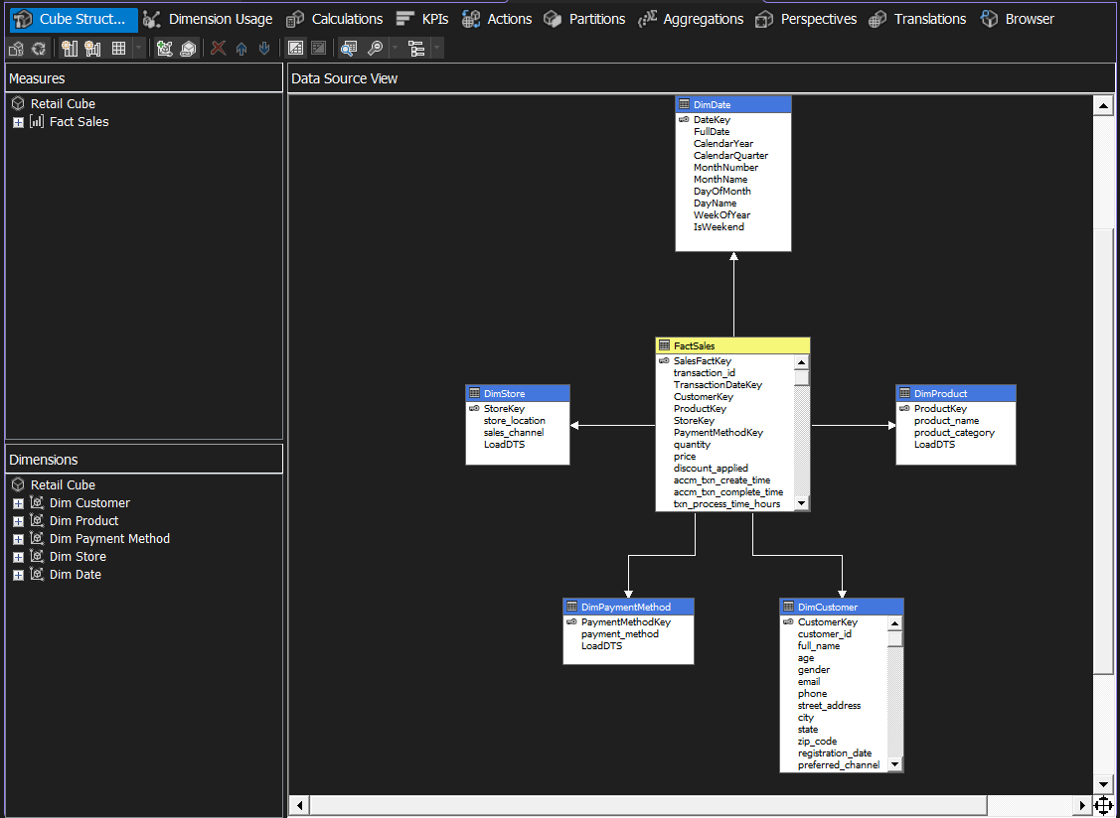

2.6 Configuring Dimension Usage
Dimension relationships were configur in the Dimension Usage tab to link each dimension to the fact table via the appropriate foreign key
Dimension | Relationship Type | Foreign Key in FactSales
Date (DimDate) | Regular | TransactionDateKey
Customer (DimCustomer) | Regular | CustomerKey
Product (DimProduct) | Regular | ProductKey
Store (DimStore) | Regular | StoreKey
Payment Method (DimPaymentMethod) | Regular | PaymentMethodKey

2.7 Measures in the Fact Table
The following measures were included from the FactSales fact table:
Measure | Aggregation Function | Description
quantity | SUM | Total units sold
price | SUM | Total sales revenue
discount_applied | SUM | Total discount given
txn_process_time_hours | SUM | Transaction processing duration
fac_sales_count | COUNT | Count of rows

2.9 Processing the Cube
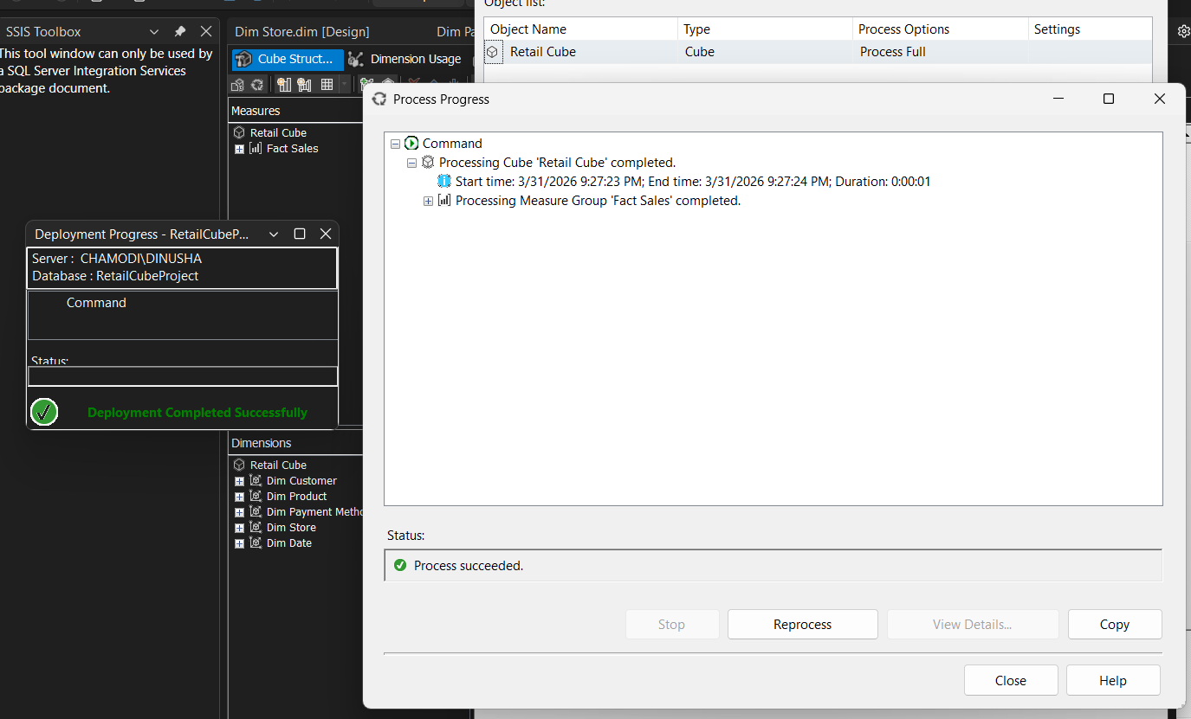

Step 3: Demonstration of OLAP Operations

3.1 Connecting Excel to the SSAS Cube
Microsoft Excel was connected to the SSAS cube to perform OLAP operations using Pivot Tables and Pivot Charts. The connection was established via the Data tab:
1.Open Microsoft Excel and Go to the Data tab on the ribbon to Get and Data From Database and From Analysis Services
2.In the Data Connection Wizard, enter the server name: CHAMODI\DINUSHA and Select the RetailCubeProject database
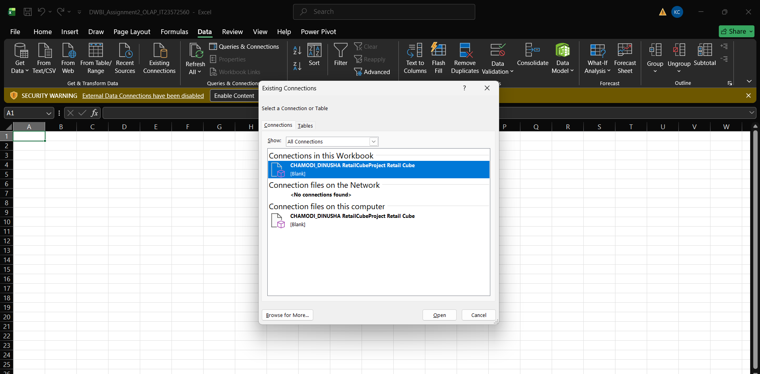
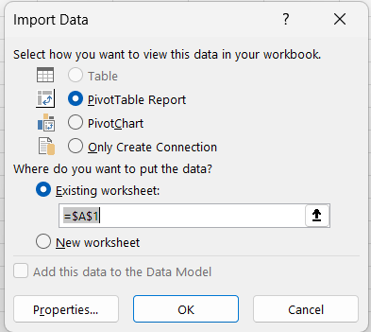

3.2 OLAP Operations Demonstrated
The following five OLAP operations were demonstrate using Pivot Tables and Pivot Charts connected to the SSAS cube:

3.2.1 Roll-Up
Roll-up aggregates data from lower level of the hierarchy to a higher level, reducing detail and increasing summarization.

Steps performed:
1.Placed the Calendar Hierarchy in the Rows area of the Pivot Table
2.Added the SUM of Price measure to the Values area
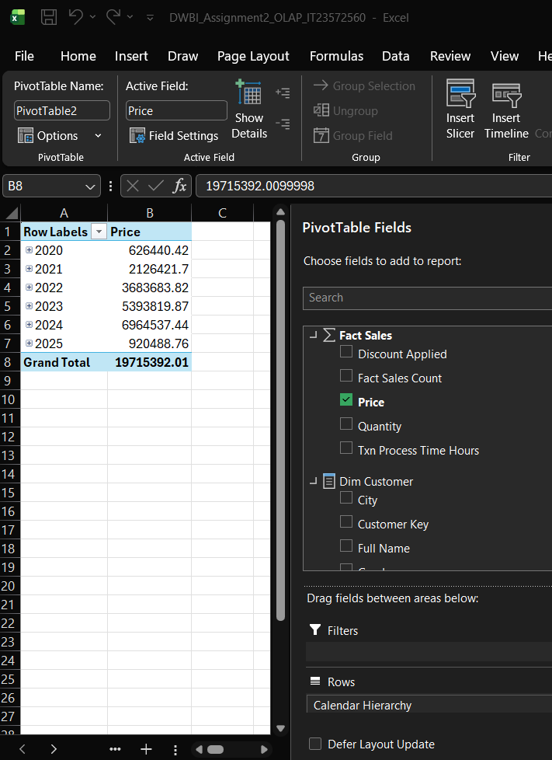

3.2.2 Drill-Down
It navigates from a summarized level to a more detailed level within the hierarchy.
Year → Quarter → Month → Date.
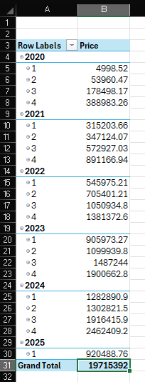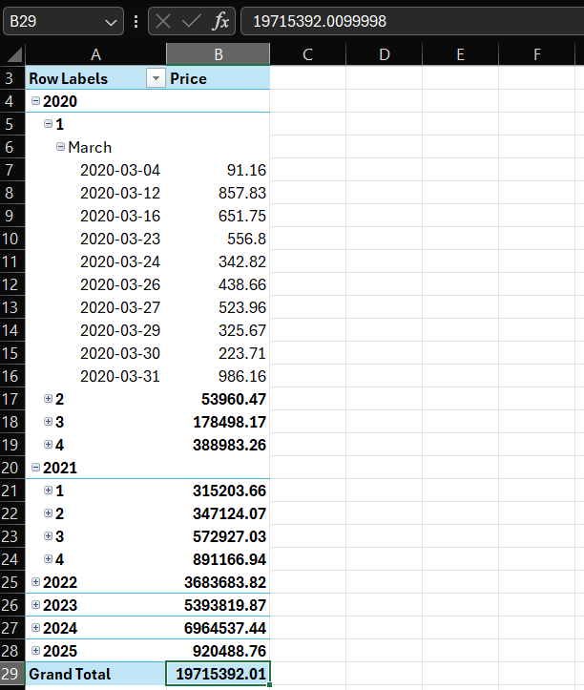

3.2.3 Slice
This select single dimension member to filter the dataset along one dimension, creating a subset view.

Steps performed
1.dragged the Payment Method dimension to the Filters area
2.Selected a specific payment method from the filter dropdown
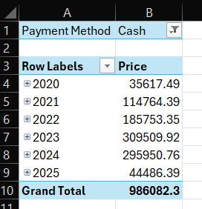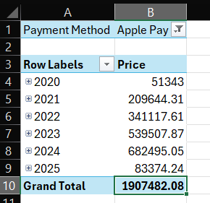
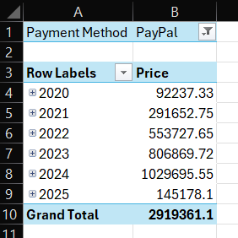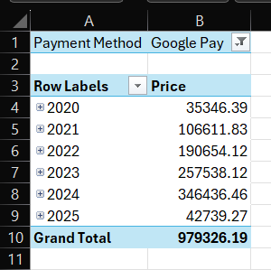

3.2.4 Dice
Dice select sub-cube by applying filters on multiple dimensions simultaneously.

Steps performed
1.Applied multiple filters simultaneously
ex-
◦Product dimension: Smart Phones
◦Date dimension:2022 to 2024
◦Payment Method: Pay pal
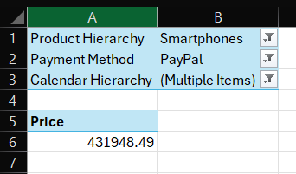

ex-
◦Product dimension: TVs
◦Date dimension: 2025.01.04
◦Payment Method:Debit Card
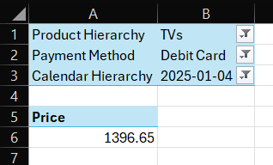

3.2.5 Pivot
Pivot rotat the data view by rearrangging the rows and columns,changing the analysis perspective without altering the underllying data.

Steps performed
- Initially placed Product Category in Rows and Calendar Year in Columns, with SUM of Price in Values
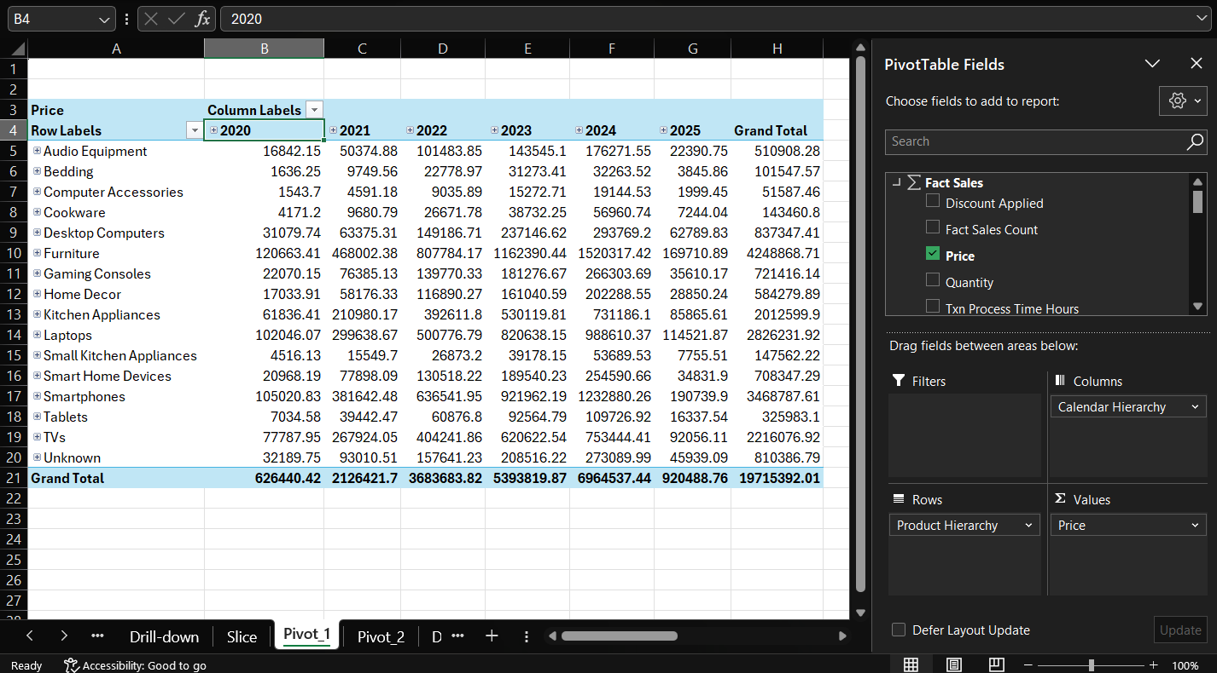
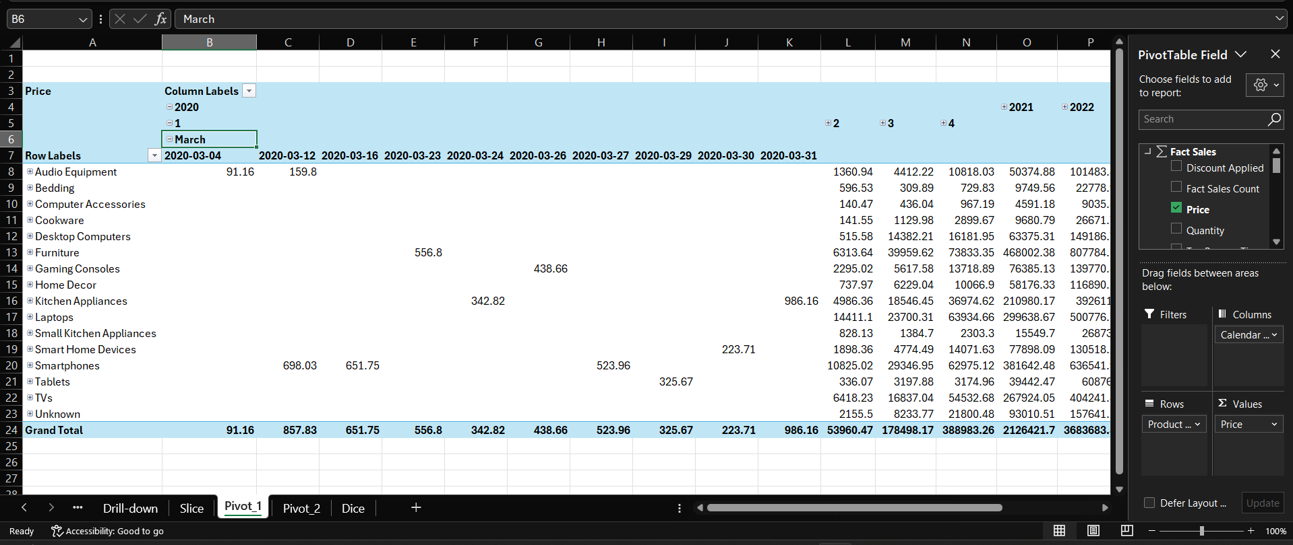
- Dragged Calendar Year from Columns to Rows, Dragged Product Category from Rows to Columns
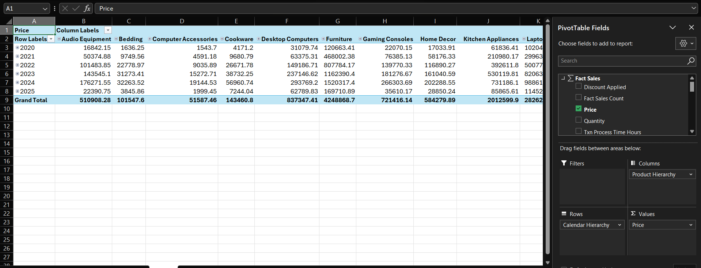
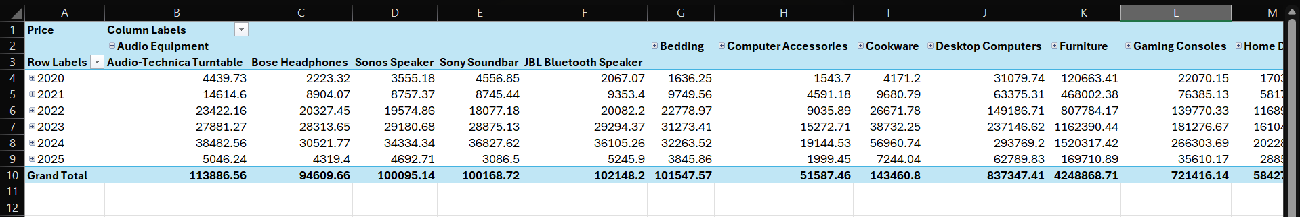

Step 4: Power BI Reports

4.1 Connecting Power BI Desktop to RetailDW
Power BI Desktop was connected to the RetailDW SQL Server data warehouse to import the required tables for reporting:
1.Open Power BI Desktop and connect
◦Server: CHAMODI
◦Database: RetailDW
2.Select Import as the data connectivity mode and Authenticate using Windows credentials: chamodi\msi
3.In the Navigator, select the following tables:
◦FactSales
◦DimDate
◦DimCustomer
◦DimProduct
◦DimStore
◦DimPaymentMethod
5.Click Load to import all selected tables into Power BI

4.2 Data Modeling in Power BI
After loading the tables, the relationships were verified in the Model View:

Dimension Table | Fact Table | Join Key
DimDate | FactSales | DateKey → TransactionDateKey
DimCustomer | FactSales | CustomerKey
DimProduct | FactSales | ProductKey
DimStore | FactSales | StoreKey
DimPaymentMethod | FactSales | PaymentMethodKey

4.3 Report 1: Matrix Visual Report
Create a report with a Matrix visual to display detailed tabular data with row and column groupings.

4.3.1.Steps Followed
1.In Power BI Desktop, created a new report page and named it Report 1 – Matrix Visual
2.From the Visualizations pane, selected the Matrix visual
3.Configured the Matrix fields as follows:
◦Rows: product_category (from DimProduct) → product_name (creating a row hierarchy)
◦Columns: CalendarYear (from DimDate)
◦Values: SUM of price (from FactSales)
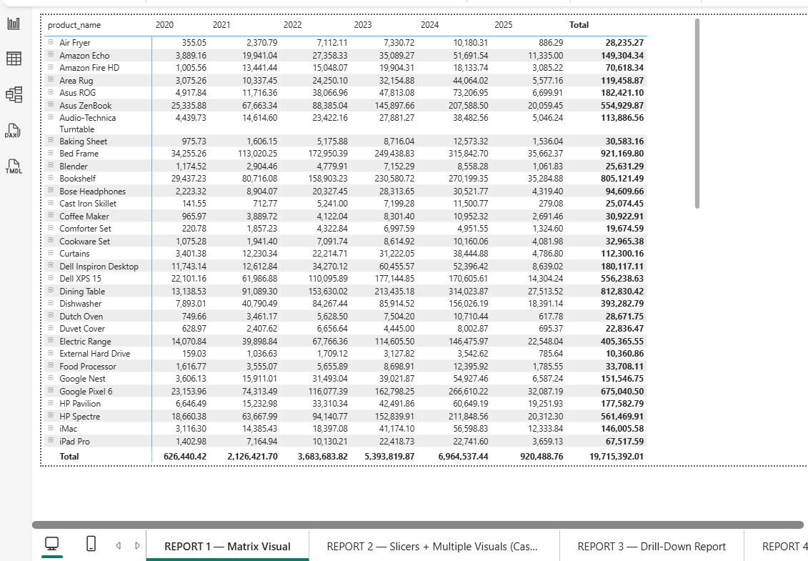
The Matrix visual display total sales (price) broke down by product category and product name in rows, and by calendar year in columns. This provide comprehensive cross tabular view of how each product performed across each year, with row subtotals per category and a grand total column.

4.4 Report 2: Slicers with Cascading Filters and Multiple Visuals

4.4.1.Data Preparation
To implement cascading filters between the Product Category slicer and the Product Name slicer, the relationship between DimProduct.product_category and DimProduct.product_name was leveraged.since a both fields exist in the same DimProduct table, when the Category slicer fillters the table, the name slicer automaticallly update to show only products within the selected category.

4.4.2. Steps Followed
1.Added Slicer 1 – Product Category:
◦Visual: Slicer
◦Field: product_category from DimProduct
◦Style: List (vertical dropdown)
2.Added Slicer 2 – Product Name:
◦Visual: Slicer
◦Field: product_name from DimProduct
◦Style: List
Visual Type | Fields Used | Insight Shown
Line Chart | CalendarYear (X-axis) vs SUM of price (Y-axis) | Yearly sales trend over 2020–2025
Pie Chart | payment_method (Legend) vs SUM of price (Values) | Sales distribution by payment method
Stacked Column Chart | CalendarYear (X-axis), product_category (Legend), SUM of price (Y-axis) | Category-wise sales by year
Card (KPI) | SUM of price | Total Sales KPI – single number summary

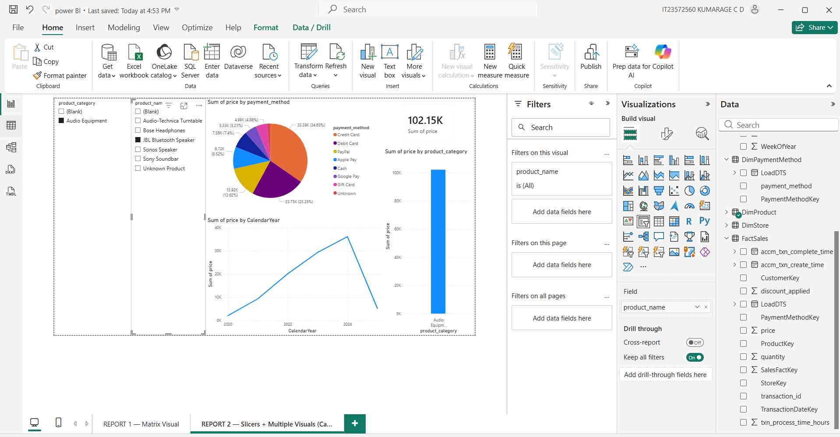
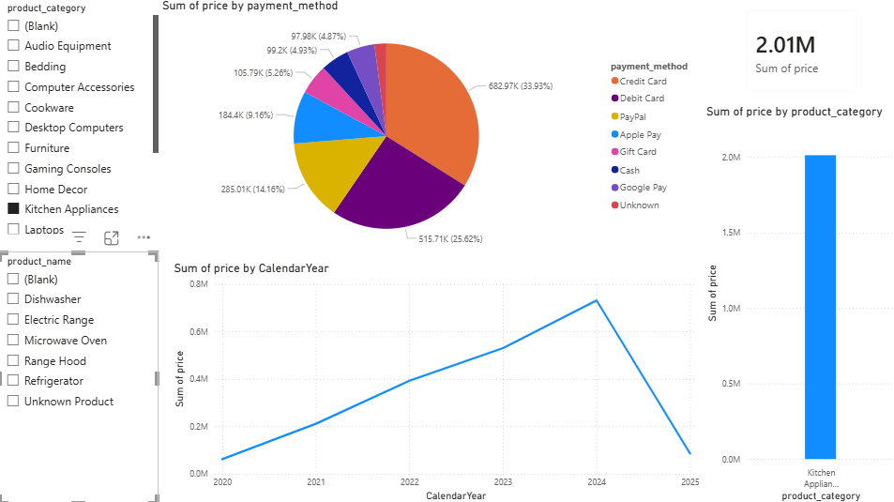

4.5 Report 3: Drill-Down Hierarchical Report

4.5.1 Steps Followed
- Created report page and add clustered column chart with date hierarchy in x axis using year, quarter and month, and set y axis as sum of price
- Enabled drill down and also add line chart with same hierarchy and sum of quantity for compare sales and volume.

4.5.2 Navigation
- Use drill down arrow for enable drill mode, then click year for go to quarter and quarter go to month level.
- Use drill up button for go back and also use next level option for drill all data together

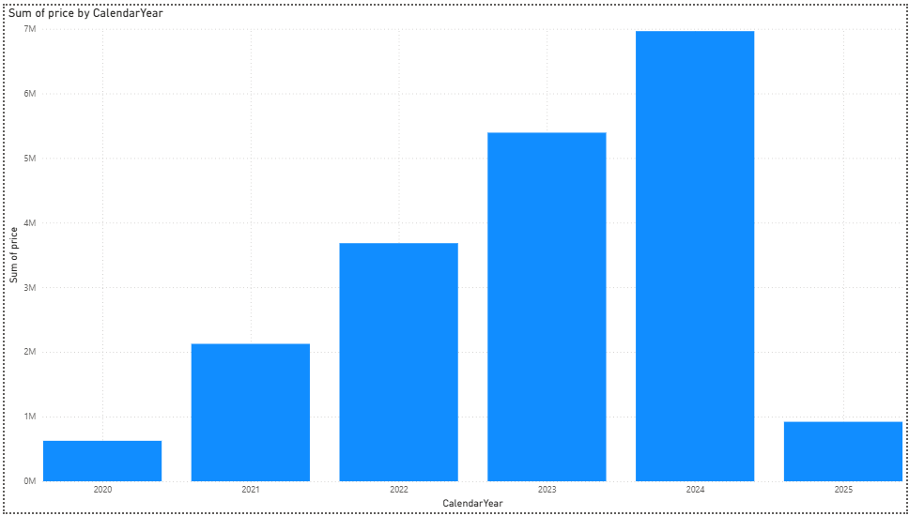
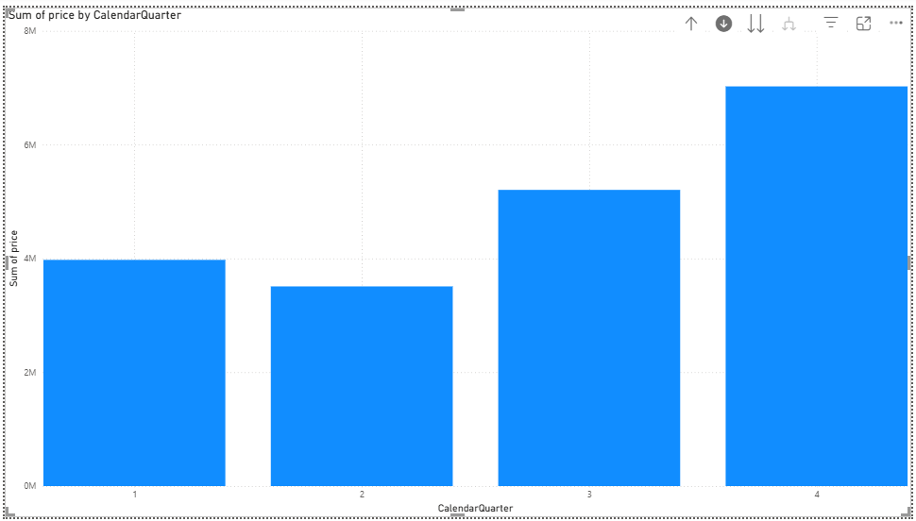

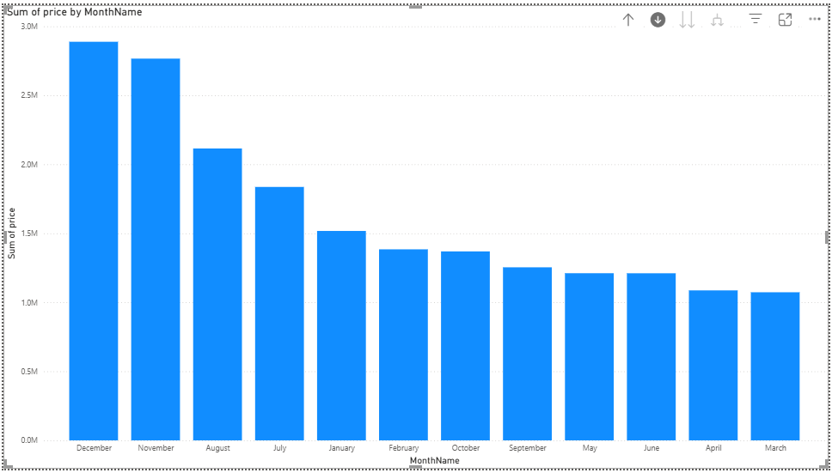

4.6 Report 4: Drill-Through Report

4.6.1 Steps Followed
- Created summary page with bar chart showing sum of price by product category and created drill through detail page
- Set drill through using product category and added table, card and monthly chart for show detailed view
- Drill through done by right click on category and navigate to detail page with filtered data
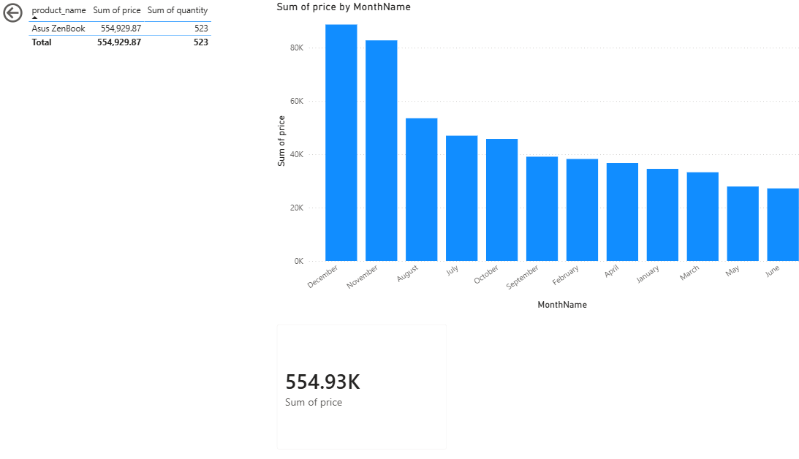

4.6.2 DAX Measures
No additional DAX measures were explicitly required since standard aggregations (SUM) were sufficient. All calculations are handled using Power BI's implicit measures.

4.8 Publishing to Power BI Service
4.8.1.Steps Followed
- Click publish in power bi desktop and sign in, then select workspace and upload report
- Open power bi service and check all reports working correct and showing proper data online.
