**PUSL3190 Computing Individual Project**

**Project Initiation Document**

Material-related Size Recommendations

Supervisor: Ms.Hirushi Dilpriya

Name: Gunathilaka M Chamodi

Plymouth Index Number: 10819486

Degree Program: BSc (Hons) Software Engineering

**Table of Contents**

Chapter 01 3

**Introduction** 3

Chapter 02 5

**Business Case** 5

2.1 Business Need 5

2.2 Business Objectives 5

Chapter 03 6

**Project Objectives** 6

Main objectives 6

Specific objectives 6

Chapter 04 7

**Literature Review** 7

Chapter 05 9

**Method of Approach** 9

Mathematical Model 9

Database and Integration 10

High level architecture 10

Chapter 06 11

**Initial Project Plan** 11

Chapter 07 12

**Risk Analysis** 12

Technical risks 12

Operational risks 12

Business risks 12

Chapter 08 13

**Mobile Application User Interfaces.** 13

**References** 15

# Chapter 01

## **Introduction**

According to a survey conducted by Coresight Research, within US apparel brands and retailers, discovered that the average return rate of the online apparel sales in US is about 24.4% (Coresight & Zheng, 2023). The reasons for high return rates in online clothing are people having different body shapes and compared to the user body measurements the clothing brand’s size chart measurements with clothing item specifications being different. Besides the material of the clothing item should also be considered when considering the sizes.

In a study that collected data from the in-person interviews were asked about online apparel shopping and its feedback. Both ‘product quality’ and ‘return and exchanges’ topics were mentioned 18 times each. Which mentioned more often than the other topics (Yin & Xu, 2021).

Since the quality of the product matters, this system provides the user with a feature to select the preferred materials of the clothing according to their likings. Which gives a certainty about the product quality.

According to Statista, comparing to other retail product categories such as shoes, bags and accessories, the highest returned rate which is 26% is for the clothing items among all the categories. (Dopson, 2023). Since not all the customers are happy with the online clothing purchasing, developing a system that can recommend the best fitting size before buying the actual product would be a better solution.

This proposed system called ‘Material-related size recommendations’, can recommend the perfectly fitting size for the user by getting one user specific measurement such as user’s chest size. Then that measurement would be compared with the specific clothing brand’s size chart, considering the material of the clothing item as well. This gives the user a material-related size recommendation.

Data from several surveys found that men have more trust in online shopping (purchases) than women who reported have lesser trust (Kumar & Singh, 2014). Therefore, this system would be mainly focused on women and in age range of 20-55. Women found difficulties with the materials related sizes mostly. A survey would be conducted to collect the data about this.

Through the survey, data such as user’s chest size and their preferred size according to the type of the material would be checked. And the data about brand’s past purchases made by the user are gathered through a web application given to the users. And a mobile application provides a good user experience with user-friendly user interfaces (UIs) for the user to get the recommended fitting size of the clothing item. In addition to that some more features are available in the mobile application.

Both mobile application and a web application are used in this ‘Material-related size recommendations’ system. Mobile application is for the user to enter the one user-specific body measurement which is the chest size. Then that data would be sent to the related database.

The brand’s size charts with its measurements, such as small (S) , medium (M) , large (L) , extra-large (XL), etc.. are stored in another database.

The web application is used to collect data from users about the past purchases made from each brand (feedback). From these data, can improve the reliability of the mathematical model and the system.

# Chapter 02

## **Business Case**

### 2.1 Business Need

* A customer can easily find the clothing that fits and to check the availability.
* Thus, after checking the availability the clothing, can make the payment for it as well.
* Increases the brand engagements.
* Increases the sales revenue.
* Better user experience.
* User-friendly UIs for both web and mobile applications

### 2.2 Business Objectives

* Ables to boost the sales revenue of clothing brands.
* According to an analysis, found that once people are satisfied with the (online) shopping experience, the customer would be loyal to the brand in a behavioral way or an attitudinal way (Al-dweeri, et al., 2017). Therefore, it enhances customer satisfaction and can boost the brand’s revenue by increasing the sales.
* Reducing the return rates of the apparel industry.
* Enhances user engagement.
* Using customer feedback, it improves the reliability of the model and the user engagement in this system.
* Able to improve the in-person shopping /physical shopping experience.
* Shopping malls which have different clothing brands, this system can be introduced as a new feature development to their already existing mobile or web application(s), which enhances the user experience and expand the
* Secured data.
* Data is authenticated ensuring the privacy of the data.

# Chapter 03

## **Project Objectives**

### Main objectives

1. Recommend the best fitting clothing size for the user according to the body measurement, and the material attributes.
2. Ability to select a clothing item according to the preferred clothing material.
3. Shows the sizes of the items that available in the current stocks.
4. Able to purchase and make the payment.
5. Provides a user feedback system.
6. Improves online shopping experience.

### Specific objectives

1. A mathematical model would compare both the user specific measurement (chest size) and the clothing material with the clothing brand’s size chart, then find the best fitting clothing size (S, M, L, XL, etc.) for the user.
2. A feature for the customer to first select a material such as cotton, linen, silk, etc. Then the user could select/ search for a suitable clothing item from the preferred material.

This value-added feature benefits the users to find the exact same material that searching for. When the ordered or selected clothing item is delivered, can find whether it has the exact same material attributes. This minimizes low quality and wrong order delivering. Thus, increases brand loyalty.

1. Payment using PayPal sandbox feature, the user is able to make the payment through the mobile application.
2. Users can make feedback about their previous purchases.
3. High apparel return rates mostly in blouses and shirts as mentioned in the page number 3, this system assists the users to find the best fitting clothing item while reducing the return rates.

# Chapter 04

## **Literature Review**

Using ‘FashionFit’ system, user can virtually try on any unbranded clothing item from any retailers using AI. The 3D pose maps the user’s body and Neural body fit model creates 3D models of the body according to the body shapes. Then able to virtually try on the clothing using GANs framework in machine learning (Hashmi, et al., 2020). In that system it uses 3D body pose to map the user’s body based on an image. Even though the accuracy of mapping can be lesser, the user can get a better virtual experience with this technology for any retail clothing items. However, this proposed system is more relied on the data of buying history of the users and material-related size questionnaire survey data to mathematically see the accuracy of the fit on.

A system where gathers the data about user’s previous purchases, and with the specific clothing item’s details it predicts the suitable size of for user using the GBM classifier (Abdulla, et al., 2019). In this ‘material-related size recommendations’ system, a mathematical model would be trained to perform this task.

Research about ‘Avatar manager system’, developed a system where the user can try on the clothing item, he/she likes on an avatar when do online shopping. Men and women can select a suitable body type which matched for each user from the given options. Then after should select the preferred body size such as small or large or extra-large, etc. In the end of this process user can adjust the avatar’s body measurements compared to the user’s body measurements. Then it would display how the selected clothing item would fit on according to the user’s body measurements (Polke & Kumari, 2018).

By analyzing a collection of data, system would be able to tell the size of clothing that is recommended for the user and without fully need of the visualization. Thus, the reliability of this can be further improved with the customer feedback/review. So that the visualization is not essential in this proposed system.

THE FIT (Korea) implemented an AI-based system in online shopping malls, that recommends the suitable shoe size for the customer. This application collects the data about customer’s order history and compares that data with the customer’s actual foot size and recommends a shoe size from currently available shoe products (Yuan, et al., 2021). In both the systems, a similarity feature can be seen. Thus, this ‘material-related size recommendations’ system, uses both survey data and customer/ user feedback data to get accurate size recommendations.

According to a system that implemented using a Hierarchical Bayesian model. It can recommend a size while checking the highest probability about customer keeping the product without returning it and according to their preference through using a survey conducted about millions of purchase data (Romain Guigourès, 2018).

# Chapter 05

## **Method of Approach**

### Mathematical Model

The model is trained using a questionnaire survey that conducted about the martial-related sizes in clothing items and to make the model more reliable it gathers the data about the customer’s order history through the web application. This feature comes as user feedback as the first scratch of the prototype shows bellow,

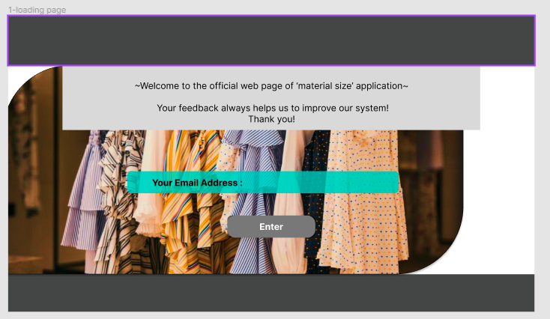

Figure 1. UI of customer entering the email address page.

Figure 2. UI of customer entering the material and size of their previous purchase page.

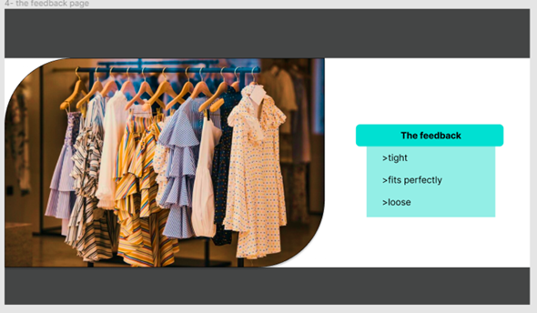

Figure 3. UI of customer feedback page

### Database and Integration

The web application is connected is first connected to the MongoDB atlas database with ASP.NET Core. Then the data would be retried from the database for to send it to the mobile application using java.

### High level architecture

Figure 4. high-level architecture

# Chapter 06

## **Initial Project Plan**

Table 1. Gantt Chart for the proposed system.

As it shown in the table 1, according to the Gantt chart of this proposed system, the background research, data collection and analysis, as well as creating the user interfaces for both web and mobile applications are done and completed. Starting from the 3rd week of December the frontend development stage would begin.

# Chapter 07

## **Risk Analysis**

### Technical risks

* Security risks about user authentication and code securing.
* Can use sessions and validations.
* Sending the mobile application and web application data to the database.
* Displaying the availability of the stocks correctly.
* Navigating to the respective pages of the applications.
* The scalability of the system.

### Operational risks

* Data backups
* Using a cloud-based version control tool such as git and GitHub.

Business risks

* Accuracy of the size recommendations.
* This decides whether the user would stay and interacts with the system in future as well, while gaining the customer loyalty.
* Customer feedback.
* Feedback about the entire system as well as the user experience.

# Chapter 08

## **Mobile Application User Interfaces.**

The mobile application UIs are designed as this for now.

Figure 5. UIs of user login page and the entering user chest size page.

Figure 6. UIs of clothing item list page, selecting a material of clothing page, select clothing according to the preferred material attributes page, respectively.

Figure 7. UIs of size recommendations and availability page and payment page.

# **References**

Administration, I. T., 2021. *eCommerce Sales & Size Forecast.* [Online]   
Available at: https://www.trade.gov/ecommerce-sales-size-forecast  
[Accessed 10 November 2023].

Coresight & Zheng, S., 2023. *The True Cost of Apparel Returns: Alarming Return Rates Require Loss-Minimization Solutions.* [Online]   
Available at: https://coresight.com/research/the-true-cost-of-apparel-returns-alarming-return-rates-require-loss-minimization-solutions/  
[Accessed 13 November 2023].

Yin, W. & Xu, B., 2021. *Effect of online shopping experience on customer loyalty in apparel business-to-consumer ecommerce,* s.l.: Sage Journals.

Dopson, E., 2023. *Ecommerce Returns: Expert Guide to Best Practices (2024).* [Online]   
Available at: https://www.shopify.com/enterprise/ecommerce-returns  
[Accessed 12 November 2023].

Al-dweeri, R. M. et al., 2017. *The Impact of E-Service Quality and E-Loyalty on Online Shopping: Moderating Effect of E-Satisfaction and E-Trust,* s.l.: ResearchGate.

Kumar, D. V. & Singh, R., 2014. *Women Online Shopping: A Critical Review of Literature,* s.l.: SSRN.

Hashmi, M. F. et al., 2020. *FashionFit: Analysis of Mapping 3D Pose and Neural Body Fit for Custom Virtual Try-On,* s.l.: IEEE.

Abdulla, G. M., Singh, S. & Borar, S., 2019. *Shop your Right Size: A System for Recommending Sizes for Fashion products,* s.l.: ACM Digital Library.

Polke, N. & Kumari, S., 2018. *Avatar Manager System for Online Fashion Clothing APP,* India: IEEE.

Yuan, Y., Park, M.-J. & Huh, J.-H., 2021. *A Proposal for Clothing Size Recommendation System Using Chinese Online Shopping Malls: The New Era of Data,* s.l.: MDPI.

Romain Guigourès, Y. K. H. K.-S. S. B. S., 2018. *A hierarchical bayesian model for size recommendation in fashion.* s.l., ResearchGate.