**PUSL3190 Computing Individual Project**

**Interim**

Mobile Application for Material-related Size Recommendations with React-js

Supervisor: Ms. Hirushi Dilpriya

Name: Gunathilaka M Chamodi

Plymouth Index Number: 10819486

Degree Program: BSc (Hons) Software Engineering

Table of Contents

Chapter 01 Introduction 4

**1.1** **Introduction** 4

**1.2** **Problem Definition** 6

**1.3** **Project Objectives** 7

Chapter 02 System Analysis 9

**2.1 Facts Gathering Techniques** 9

**2.2 Existing System** 14

**2.3 Use case diagram** 15

**2.4 Drawbacks of the existing system** 17

Chapter 03 Requirements Specification 18

**3.1 Functional Requirements** 18

**3.2 Non-Functional Requirements** 18

**3.3 Hardware / Software Requirements** 19

**3.4 Networking Requirements (Optional)** 19

Chapter 04 Feasibility Study 20

**4.1 Operational Feasibility** 20

**4.2 Technical Feasibility** 20

**4.3 Outline Budget** 20

Chapter 05 System Architecture 21

**5.1 Class Diagram of Proposed System** 21

**5.2 ER Diagram** 22

**5.3 High-level Architectural Diagram** 23

Chapter 06 Development Tools and Technologies 24

**6.1 Development Methodology** 24

**6.2 Programming Languages and Tools** 24

**6.3 Third Party Components and Libraries** 27

**6.4 Algorithms** 28

Chapter 07 Discussion 30

**Overview** 30

**Summary** 30

**Challenges Faced** 30

**Upcoming Work** 31

**Appendix** 32

**References** 36

**Table of Figures**

Figure 1: Pie chart showing the importance of clothing materials 4

Figure 2: Bar chart of online sales in 2019 (Administration, 2021) 6

Figure 3: The Questionnaire about the best fitting size recommendation system 9

Figure 4: Pie chart showing respondents’ gender 10

Figure 5: Pie chart showing respondents’ Age 10

Figure 6: Pie chart showing the importance of materials 11

Figure 7: Pie chart showing respondents’ confidence about getting correct size 11

Figure 8: Pie chart showing respondents’ experience with the online size recommendation systems 12

Figure 9: Pie chart showing respondents’ preference about a size recommending application 12

Figure 10: Questionnaire about asking correct UK sizes for the specific materials 13

Figure 11: Use Case diagram 15

Figure 12: Code set of user authentication 18

Figure 13: Class Diagram 21

Figure 14: ER Diagram 22

Figure 15: High-level Diagram 23

Figure 16: Gantt Chart 24

Figure 17: Postman API request body showing the test HTTP requests 25

Figure 18: MySQL database table of showing how the test post requests are being updated 25

Figure 19: Postman API’s response to the testing request. 26

Figure 20: Frontend UI of the user feedback page 28

# Chapter 01 Introduction

## **Introduction**

According to a survey conducted by Coresight Research, within US apparel brands and retailers, discovered that the average return rate of the online apparel sales in US is about 24.4% (Coresight & Zheng, 2023). The reasons for high return rates in online clothing are people having different body shapes and compared to the user body measurements the clothing brand’s size chart measurements with clothing item specifications being different. Materials can be stretchable or non-stretchable and should be highly considered when buying the product.

According to the questionnaire survey that conducted for this project, 62.5% of respondents stated that the material is important when purchasing a clothing item or an apparel as shown in figure 1 below. Thus, 31.3% of respondents stated that it is very important. None of the respondents say that the material consideration is not important.

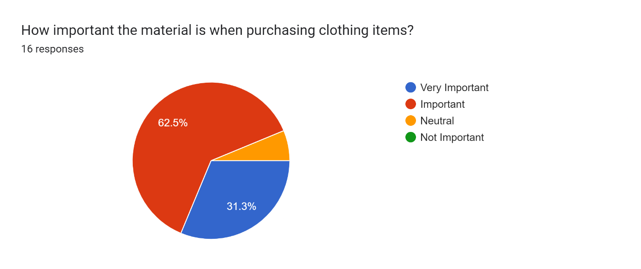

Figure 1: Pie chart showing the importance of clothing materials

Cotton, Polyester, Linen, etc., materials can be considered as non-stretchable and usually require a bigger size of the product. While stretchable materials like Spandex blend fabrics such as Polyester/ Spandex blend or elastane need a smaller size in comparison to non-stretchable fabrics.

In a study that collected data from the in-person interviews were asked about online apparel shopping and its feedback. Both ‘product quality’ and ‘return and exchanges’ topics were mentioned 18 times each. Which mentioned more often than the other topics (Yin & Xu, 2021).

Since the quality of the product matters, the developing system provides the user with a feature to select the preferred materials of the clothing according to their likings. Which gives a certainty about the product quality. It can be fully 100% cotton/ polyester/ linen or else it can be a spandex blend material.

According to Statista, comparing to other retail product categories such as shoes, bags and accessories, the highest returned rate which is 26% is for the clothing items among all the categories (Dopson, 2023). Since not all the customers are happy with the online clothing purchasing, developing a system that can recommend the best fitting size before buying the actual product would be a better solution.

The developing system is called ‘Material-related size recommendations’, can recommend the perfectly fitting size for the user by getting one user specific body measurement such as user’s chest size. Then that measurement would be compared with the specific clothing brand’s size chart, while considering the material aspects of that clothing item as well. In addition to that, the material-wise size recommendation data would be gathered from previous customer purchases made from a specific brand. (In here it only focuses about a specific brand and can use this exact solution to expand this system while collaborating with several other brands.)

This system collects the data about customer’s order history through a page where user can enter their chest width, material of the clothing they bought, and the fitted size when do both physical and online shopping. Using all these data, system can give the user a material-related size recommendation.

Data from several surveys found that men have more trust in online shopping (purchases) than women who reported have lesser trust (Kumar & Singh, 2014). Therefore, the developing system would be mainly focused on women and the age range of 20-54. Since women found difficulties with the materials related sizes mostly.

The developing system uses a mobile application which provides user-friendly user interfaces (UIs) for the user to get the recommended fitting size of the clothing item. In addition to that some more features are available in this application such as user feedback which could improve the reliability of the system.

Through the react native mobile application, the user can enter the user-specific body measurement which is the chest size, and that data would be sent to the related databases to give the best fitting size. And technologies as react native for the mobile application frontend, MySQL database with java spring boot for the backend would be use as a full- stack.

## **Problem Definition**

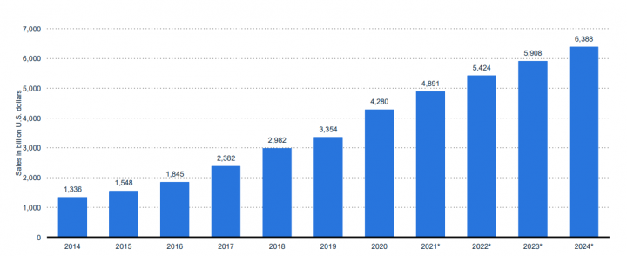

Figure 2: Bar chart of online sales in 2019 (Administration, 2021)

After the covid19 pandemic in 2019, the worldwide online shopping sales has rapidly increased as shown in the above figure 2. Furthermore, 8 percent of increment in online shopping sales can be seen within the next couple of years in comparison to past few years, for all sectors including fashion clothing (Administration, 2021).

According to a study, it reported that according to Bloomberg, even after the COVID 19 ended 41% of American people claimed to like online shopping (apparel and other items) more than visiting the shop and purchase items physically. Furthermore, it stated in a survey that conducted in 2022, online sales are booming in the China as ¾ of are related to clothing and fashion categories (Vaghasiya & Sitapara, 2023). These reported data display how much online shopping in apparel or clothing sectors has boosted up.

Although apparel and clothing sales has shown a major growth in the online shopping, the return rates of those sectors also have been highly increased as stating 40% to 50% (Cullinane, et al., 2017). As the following research paper and other data shows, the high return rates globally have become a big issue in online appeal shopping. To overcome this problem, creating a system that recommends a best fitting clothing size for the customers would be great. Thus, creating a mobile application where user enters his/her chest size and gather the user feedback of past purchases made from that specific brand and feed to the model to give excellent size recommendations would be the best solution.

## **Project Objectives**

Main objectives

1. Recommend the best fitting clothing size for the user according to the body measurement, and the material attributes with compared to the brand size chart measurements.
2. Target users are women who’s in between age rage of 20-54 for this system.
3. Ability to select a clothing item according to the preferred clothing material.
4. Displays the current stock availability of an item.
5. Able to purchase and make the payment through PayPal sandbox.
6. Provides a user feedback system that can improve the model.
7. Improves online shopping experience.

Specific objectives

1. A mathematical model would compare both the user-specific body measurement (chest size) and the clothing material with the clothing brand’s size chart, then find the best fitting clothing size such as UK size 8/ 10/ 12/ 14/ 16 for the user.
2. Analyzing using only one body measurement which is the user chest size (width), because it is convenient for the users to measure and put only one body measurement rather than taking a lot of time to give all other his/ her body measurements.
3. A feature for the user to first select a material such as cotton, linen, polyester, or spandex blend fabrics such as polyester, elastane. After selecting the preferred material could select a clothing item from the list of cloths according to the user-selected material.

This value-added feature benefits the users to find the exact same material that searching for. When the selected clothing item is delivered, can find whether it has the exact same material attributes. This minimizes low quality and wrong order delivery. Thus, increases brand loyalty.

1. Payment using PayPal sandbox feature, the user can make the payment after getting the size recommendation and the availability of that selected product.
2. Users can leave feedback about their previous purchases, so that it would improve the reliability of system, can keep make much better recommendations with time goes on.
3. As for high return rates in apparel such as for blouses and tops, the developing system could assist the user to find the best fitting clothing item while reducing the return rates.

# Chapter 02 System Analysis

## **2.1 Facts Gathering Techniques**

Facts gathering techniques can be listed in 2 parts, such a primary and secondary data gathering techniques. As for the primary data gathering, have conducted a survey questionnaire to gather data about different perfectives for the developing system.

Figure 3: The Questionnaire about the best fitting size recommendation system

In the figure 3 shows, the questionnaire which is about asking the participants to enter their gender, age, and how important the material is when buying an clothing item, the confidence about getting the expected matching size when buying the item online, and if the participants has ever used/experienced an online size recommendation system or an app, moreover, if the participants like to have/ use an online size recommending system application in their day to day life. Thus, the full questionnaire can be viewed under the appendix section.

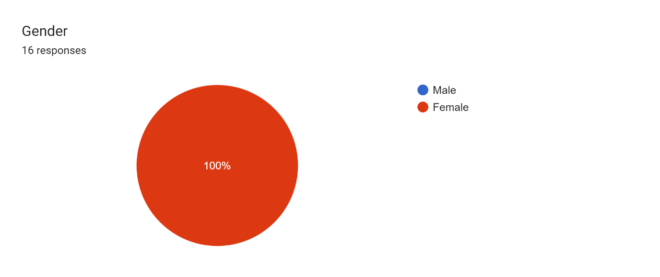

Figure 4: Pie chart showing respondents’ gender

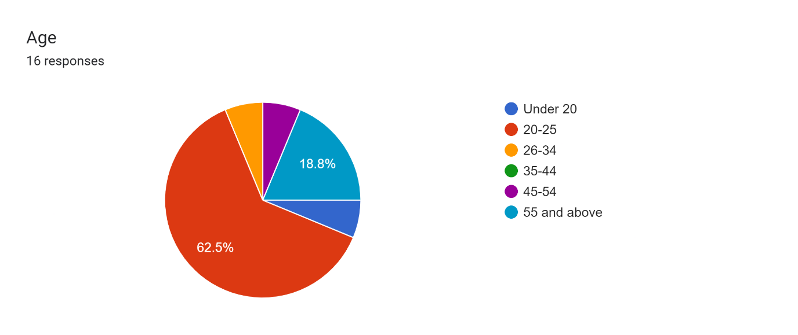

Figure 5: Pie chart showing respondents’ Age

Since the developing application’s target audience is females between 20 to around 54 aged people, from that criterion the data would be collected. As in the figure 4, and 5 above, it shows the responses or the results of this questionnaire. While all the respondents are female and with all combined 93.9% of respondents are in between the age of 20-54. (Considering that under 20 aged females would not be used for collecting the data since the developing application mainly targets ages between 20-54 women.

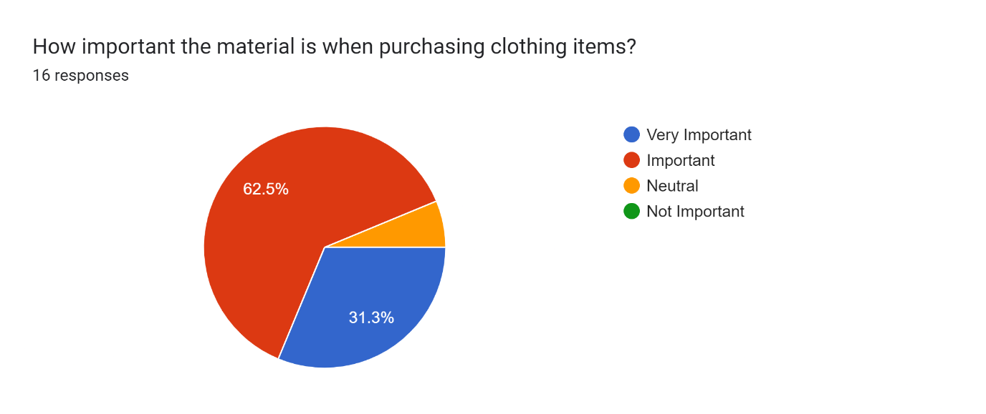

Figure 6: Pie chart showing the importance of materials

Forms response chart. Question title: How confident are you in choosing the correct size when do online shopping?
. Number of responses: 16 responses.

Figure 7: Pie chart showing respondents’ confidence about getting correct size

Figure 6 and 7 describes about the importance of the material and how accurate the sizes are when buying the product online. While in figure 8 and 9 below describes, whether if the user has already experienced online size recommendation systems and if she/he would like to experience such an application.

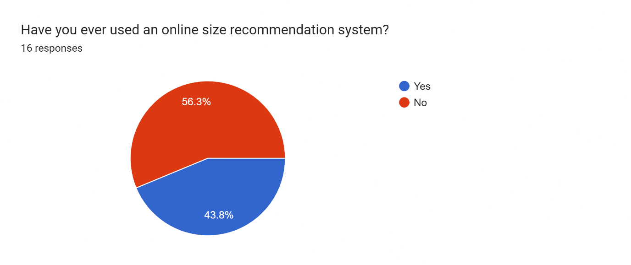

Figure 8: Pie chart showing respondents’ experience with the online size recommendation systems

Forms response chart. Question title: Would you like an app that provides size recommendations for you based on your body measurement relates to clothing item&apos;s material ?
. Number of responses: 16 responses.

Figure 9: Pie chart showing respondents’ preference about a size recommending application

As the mathematical model’s training dataset expected to use the survey data which includes questions such as the preferred UK size for different materials such as cotton, polyester, linen and spandex-blend fabrics or materials as it shows in the figure 10 below for the cotton material. However, this technique of using the survey data did not succeed because having low number of responses. If were to use this method, must have at least 200 responses.

Figure 10: Questionnaire about asking correct UK sizes for the specific materials

As for the secondary data gathering, have gathered data from existing systems which would be described in the following topic about 2.2 Existing System.

## **2.2 Existing System**

Using ‘FashionFit’ system, user can virtually try on any unbranded clothing item from any retailers using AI. The 3D pose maps the user’s body and Neural body fit model creates 3D models of the body according to the body shapes. Then able to virtually try on the clothing using GANs framework in machine learning (Hashmi, et al., 2020). In that system it uses 3D body pose to map the user’s body based on an image.

A system where gathers the data about user’s previous purchases, and with the specific clothing item’s details, predicts the suitable size of for user using the GBM classifier as reduces the return rates (Abdulla, et al., 2019). By analyzing a collection of data, system would be able to tell the size of clothing that is recommended for the user and without fully need of the visualization.

Research about ‘Avatar manager system’, developed a system where the user can try on the clothing item, he/she likes on an avatar when do online shopping. Men and women can select a suitable body type which matched for each user from the given options. Then after should select the preferred body size such as small or large or extra-large, etc. In the end of this process user can adjust the avatar’s body measurements compared to the user’s body measurements. Then it would display how the selected clothing item would fit on according to the user’s body measurements (Polke & Kumari, 2018).

THE FIT (Korea) implemented an AI-based system in online shopping malls, that recommends the suitable shoe size for the customer. This application collects the data about customer’s order history and compares that data with the customer’s actual foot size and recommends a shoe size from currently available shoe products (Yuan, et al., 2021).

According to a system that implemented using a Hierarchical Bayesian model. It can recommend a size for the product by checking the highest probability about customer keeping the product without returning it and according to their preference through using a survey conducted about millions of purchase data (Romain Guigourès, 2018).

## **2.3 Use case diagram**

Figure 11: Use Case diagram

The system name is ‘Size Recommendation system’ and actors are external objects that can be listed as primary actors, secondary actors. The primary actor in the developing system is the user/ customer which displays on the left side of the container/ system in the figure 11 shows above. These people can use the system to get the size recommendations.

In the other hand the secondary actor in here is the clothing brand shown in the right side of the figure 9. It reacts when the user/ customer selects an item and checks the stock availability and also when making the payment.

As for the use cases it has base and included use case. As an example, the login ‘base use case’ needs ‘included use case’ to verify and authenticate the user. Furthermore, this system has ‘extended use case’ which the relationship with the ‘base use case’ does not happen every time, such as when login to the system the login error message would not occur every time.

## **2.4 Drawbacks of the existing system**

According to the Fashion fit system (Hashmi, et al., 2020) mentioned above, this existing system uses augmented reality where the customer can virtually try on clothing items. Although it gives the user a better virtual experience, the accuracy of mapping the body coordinates could be rather low. However, the developing system is more relied on the data of buying history of each user and would train a model to provide accurate size recommendations.

Also, in Avatar manager system (Polke & Kumari, 2018) it creates an avatar to check whether the clothing item fits, where the user must select their body shape such as small/ large or extra-larger first. This could be a better easy approach for the user in terms of not needing to physically try on the product. But since it is asking the user to select the shape of his/her body shape, the accuracy of choose the correct size of the avatar and adjusting user body measurements to it could be somewhat would not give accurate results.

# Chapter 03 Requirements Specification

## **3.1 Functional Requirements**

* Displaying the best fitting UK size for the user selected clothing item.
* Could select the clothing item according to the preferred material.
* Ability to give user feedback about previous purchases made.
* Feature to see the stock availability.
* Able to make payments using PayPal.
* Able to login to the system once a user has registered.

## **3.2 Non-Functional Requirements**

* Security:

According to the figure 12 below, only if the user exists in the system the user can login. In a register table users can register so the new record with the user details would be added. Then after when the user logs in, data would be retrieved and would be checked.

Figure 12: Code set of user authentication

* Accessibility

The application can run on both iOS and Android improving the accessibility of the system to the user being a cross-platform application.

* Maintainability

And have also used getters and setters in java encapsulation as a security measurement. Which helps to improve maintainability of the code structure and the security.

* UI and UX

Provides better user experience and user-friendly UI while securing the data.

## **3.3 Hardware / Software Requirements**

Hardware

A Mobile phone (Android/ iOS) and a computer that has accessed to Wi-Fi and has enough RAM (ex: 8GB and 8GB< would be preferred) and CPU.

Software

Node js should be installed prior to installing this application. Thus, Visual studio code IDE is used to run the react-native application. And IntelliJ IDEA is used for the java spring boot backend with MySQL workbench application to run the database.

## **3.4 Networking Requirements (Optional)**

To run this application the development machine and the user’s mobile phone needs to be in the same (Wi-Fi) network, so the development machine’s IP address can be accessed by the mobile phone. Since the development machine would be the remote server and have to use its IPv4 address in the react-native’s frontend for axios request URL, to interact with the java spring boot with MySQL backend.

# Chapter 04 Feasibility Study

## **4.1 Operational Feasibility**

When first starting this application, it needs to run the ‘npx react-native run-android’ command on the terminal or command prompt inside the folder where the project is located. Furthermore, needs to be in the same Wi-Fi network connection while running both the java spring backend and the react native metro builder. Thus, needs to put the related IPv4 inside the axios request URL.

## **4.2 Technical Feasibility**

The developing application is running on react-native. And react-native is a cross-platform. By running ‘npm start’ on the command prompt or the terminal, can select the platform that should be running this application. Can run this system on Android, IOS or Web (reactnative.dev, n.d.).

When it comes to running and connecting to the server, cannot use localhost to make requests to the server through development machine, since it is using a remote server. Only using the development machine’s local IP address (ex: IPv4 - Internet Protocol version 4) we can access this server. Mobile application can also access this IP address since it is also connected to the same network as the development machine.

## **4.3 Outline Budget**

For this developing system have not used any additional paid software licenses or libraries. Thus, this system’s outline budget would be none, since as for MySQL database is also not hosted on a cloud service in this project.

# Chapter 05 System Architecture

## **5.1 Class Diagram of Proposed System**

The visibility of the methods and attributes are shown using the + or – symbol public and private access specifiers accordingly as shown in the figure 13 below. User can give feedback as well as can enter his/her chest size. After entering the user size, user could select a clothing item from the list, then from that would give user the best fitting size recommendation and the stock availability.

Figure 13: Class Diagram

## **5.2 ER Diagram**

Figure 14: ER Diagram

The entities of this system are user, feedback, and clothing items. As shown in the figure 14, user can send feedback, also assume that one user sends only one feedback while feedback is sent by a user. Furthermore, while clothing items has user feedback, the user can also buy the selected clothing item.

## **5.3 High-level Architectural Diagram**

As for the high-level diagram such changes were developed when compared to the previous high-level diagram. As according to the new high-level diagram in the figure 15 below, from react-native application (frontend), would send the http request to the java spring server. Then after processing the requests and it performs the specific tasks while connecting and interacting with MySQL database as necessary.

Figure 15: High-level Diagram

# Chapter 06 Development Tools and Technologies

## **6.1 Development Methodology**

Figure 16: Gantt Chart

This developing system can be considered as using a hybrid approach methodology, where it is a combination of waterfall and agile methodologies. As the Gantt chart shows above in the figure 16, first created few user interfaces as login, register, and enter size pages from week 10 to 13. Which can be considered as waterfall methodology to work on a one task before going to the backend development. Then after the entire project has done using agile methodology.

After the week 13 have continuously developed both frontend and the backend together to develop and deliver a working product such as an entire feature. For that used an iterative approach which includes sprints. The testing has also started while doing the backend development to overcome big issues that can occur later, and this can be considered as characteristics of the agile methodology as do testing throughout the development process.

## **6.2 Programming Languages and Tools**

Programming Languages

React-native framework is used to develop the frontend of this mobile application, while for the backend it uses Java Spring Boot framework with MySQL database. This can be considered as a great stack for developing a mobile app. MySQL is hosted on a remote server using port 3306 which use to communicate to a network, while for java spring boot it is using the tomcat server with port 8080 to run that its server and the React’s metro is running on the port 8081.

Tools

* Testing

Uses postman as a tool, to test the HTTP requests and its responds. Under collections have created a new collection called ‘Sizerecom’. There a new POST request is send to the ‘http:// 192.168.186.125:8080/user’ endpoint (IPv4 address) and that request would be sent in a JSON format as shows in the figure 17 below,

Figure 17: Postman API request body showing the test HTTP requests

When the request is sent, it would update the MySQL database tables as in the figure 18 below. So, then it could test the APIs in this application as it uses ‘PostMapping’ annotation in java spring boot to handle and send the POST requests.

Figure 18: MySQL database table of showing how the test post requests are being updated

A new GET request is made to get (retrieve) the data and view all users in endpoint of ‘/allusers’. As can see in the figure 19, the ID is auto incrementing by one using the ‘@GeneratedValue’ annotation with ‘@Id’ annotation. The Id then used as the primary key.

Figure 19: Postman API’s response to the testing request.

* Version Control

For every project it is important to use good amount of version control, to keep backups and for code maintainability. As for this developing application, the data is committed/ saved on two different branches as ‘testdev’ and main. First each feature’s backend part and frontend part would be committed to the testdev subbranch, then after if both frontend and backend of that feature is working fine, it would be committed to the main branch from the ‘testdev’ branch.

## **6.3 Third Party Components and Libraries**

For the mobile application have used third party components and libraries to add more additional functionalities to the system while creating the application well organized by enhancing the user experience also.

1. @react-navigation/native

* This can navigate the user from one screen to another screen using the navigate (‘’) method.

1. @react-navigation/stack

* This creates a stack, so if put ‘A’ screen on top and ‘B’ screen under that, this library can stack them and would go to the screen ‘A’ first the navigates to the screen ‘B’.

1. npx react-native link react-native-gesture-handler react-native-screens react-native-svg

* Since the ‘Button’ component in react-native does not include many options when it comes to editing or styling the component, in here it uses a component called ‘TouchableOpacity’ which can easily be styled and act as a button.

1. react-native-screens library

* uses to create a stack where navigate between the screens.

1. @react-navigation/native @react-navigation/bottom-tabs

* to create the bottom navigation bar in most of the pages

1. @react-native-picker/picker

* To create the dropdown list in the ‘Material.jsx’ page

1. Axios library

* uses this library to make http requests from the react-native app to the server.

## **6.4 Algorithms**

This project uses a mathematical model to give size recommendations to the users and focuses on a one specific brand. This application provides the user a user feedback page. Since each brand has their own size charts with its measurements, this system asks the user to select his/her chest size from various size ranges as shown in the figure 20 below. And behind every chest size selection label it has the brand’s UK size for that specific size range (for the developer purposes). This code structure is planning to be used in the mathematical model.

Figure 20: Frontend UI of the user feedback page

Furthermore, for this mathematical model user must enter the material of the clothing he/she bought, together with the chest size, because in here are analyzing how the sizes are being vary with the material of the clothing. And though it is not developing in this system, as a future development can also use the same technics for the clothing item designs also, as how the sizes are varying with the design of the clothing (Cami Tops, Cross-Over Tops, Kaftan Tops, Flared Tops). Thus, this can be considered as an additional future development, and would not be developed in the current application.

# Chapter 07 Discussion

## **Overview**

As an overview of this report, the introduction is where the problem definition and the project objectives are also included. Furthermore, the project objectives can be divided into main and specific objectives. Fact gathering technics like questionnaires and data about existing systems with its drawbacks are included in the system analysis section of the project.

In the requirement specifications section, functional, non-functional with hardware/software and network requirements are included. Operational and technical feasibility were discussed and for system architecture different diagrams that are required were mentioned. A hybrid method of approach was used for the methodology. Thus, third-party libraries were installed, to have different functionalities to the system.

## **Summary**

When a person does online shopping, finding the best fitting correct size for she/he is somewhat difficult. Furthermore, for online shopping women have low trust in buying the apparel (Kumar & Singh, 2014). So, developing a system that only focuses on women, providing online size recommendations would be the best. This developing system would give the size recommendations based on the material attributes, since the size can be varied with the clothing item’s material. More ever, this system would use the brand’s size chart with its measurements to give the best recommendations.

## **Challenges Faced**

For this system, to develop the mathematical model it was planned to use the questionnaire result data. However, since the responses from the questionnaire was not enough, the accuracy of training the model using those data would not be reliable. So currently it is planned to use dummy data for the user feedback page as entering the data about user’s previous purchases (fitted size and material details). Using the dummy data would not be an issue since in the real-life application, the same method could be used to train the model using real users. In addition, with the time being the reliability of this system would be increased.

## **Upcoming Work**

It is not clearly decided what/ how the mathematical model would be created. But it has yet to be created and designed taking the user feedback and gathering data. This application uses dummy data as user feedback. And from that data could create the model after analyzing the data. After this step is done, needs to display the recommended size for each user from the selected product or clothing item with the stock availability.

# **Appendix**

The questionnaire about the developing/ proposed system can be seen below respectively.

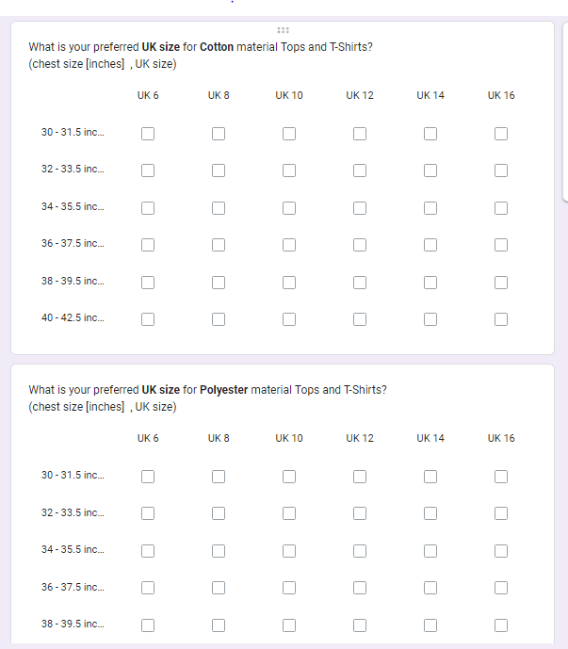

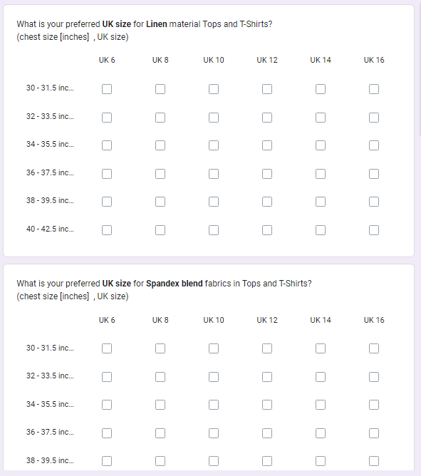



# **References**

1. Coresight & Zheng, S., 2023. The True Cost of Apparel Returns: Alarming Return Rates Require Loss-Minimization Solutions. [Online]   
   Available at: https://coresight.com/research/the-true-cost-of-apparel-returns-alarming-return-rates-require-loss-minimization-solutions/  
   [Accessed 13 November 2023].
2. Yin, W. & Xu, B., 2021. Effect of online shopping experience on customer loyalty in apparel business-to-consumer ecommerce, s.l.: Sage Journals.
3. Dopson, E., 2023. Ecommerce Returns: Expert Guide to Best Practices (2024). [Online]   
   Available at: https://www.shopify.com/enterprise/ecommerce-returns  
   [Accessed 12 November 2023].
4. Kumar, D. V. & Singh, R., 2014. Women Online Shopping: A Critical Review of Literature, s.l.: SSRN.
5. Administration, I. T., 2021. eCommerce Sales & Size Forecast. [Online]   
   Available at: https://www.trade.gov/ecommerce-sales-size-forecast  
   [Accessed 10 November 2023].
6. Vaghasiya, C. & Sitapara, J., 2023. A STUDY ON RETURNS RATES IN THE FASHION INDUSTRY WITH REFERENCE TO AN E-COMMERCE BUSINESS, s.l.: JETIR.
7. Cullinane, S., Karlsson, E., browne, m. & Wang, Y., 2017. Retail clothing returns: A review of key issues, s.l.: ResearchGate.
8. ReactNative, n.d. Introduction. [Online]   
   Available at: https://reactnative.dev/docs/getting-started  
   [Accessed 28 February 2023].
9. Hashmi, M. F. et al., 2020. FashionFit: Analysis of Mapping 3D Pose and Neural Body Fit for Custom Virtual Try-On, s.l.: IEEE.
10. Abdulla, G. M., Singh, S. & Borar, S., 2019. Shop your Right Size: A System for Recommending Sizes for Fashion products, s.l.: ACM Digital Library.
11. Polke, N. & Kumari, S., 2018. Avatar Manager System for Online Fashion Clothing APP, India: IEEE.
12. Yuan, Y., Park, M.-J. & Huh, J.-H., 2021. A Proposal for Clothing Size Recommendation System Using Chinese Online Shopping Malls: The New Era of Data, s.l.: MDPI.
13. Romain Guigourès, Y. K. H. K.-S. S. B. S., 2018. A hierarchical bayesian model for size recommendation in fashion. s.l., ResearchGate.

‌