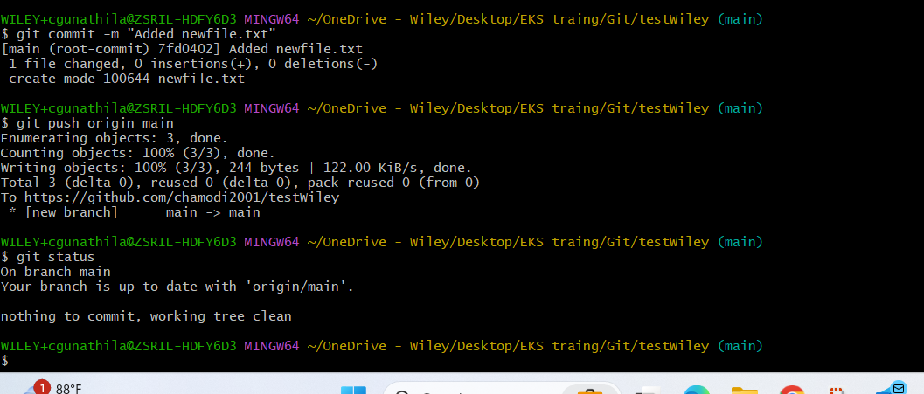  
  
.//made changes in the local dir, now gonna add them in github web

git commit -m "Added newfile.txt"

git push origin main

git status

//fetching the data- I created a new branch usinh github

git fetch origin

//goto the QA branch that I created.

git checkout QA

// i want my word doc created in my local pc to puch to my QA named branch

Git add word.  
git commit -m "Added word doc to QA branch”  
git push origin QA