# **Brownian Motion - Pearson Worksheet Name ______________**

Chapter 6 Change

extra worksheet 2:Brownian motion

Science understanding Verbal/Linguistic, Visual/Spatial

Brownian Motion and the Particle Theory of Matter

In 1827 Scottish botanist, Robert Brown, used a microscope to examine pollen grains floating on water. He noticed that the pollen grains did not sit still but were constantly moving in random directions, as shown in Figure 6.2.1. This random motion was later called Brownian motion. It describes the motion of many things in nature including the diffusion of gas particles.

At the time, Brown’s observations provided the most direct evidence for the Particle Theory of Matter as his findings showed that the water particles were interacting with the grains of pollen to cause the observed random movement.

The Particle Theory of Matter states that:

• all matter is made up of particles

• the particles are constantly moving

• the particles cannot be split or compressed

• the particles are attracted to each other.

**a 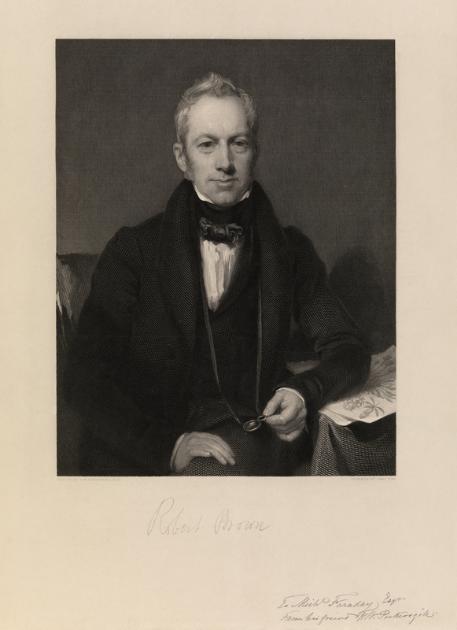 b** 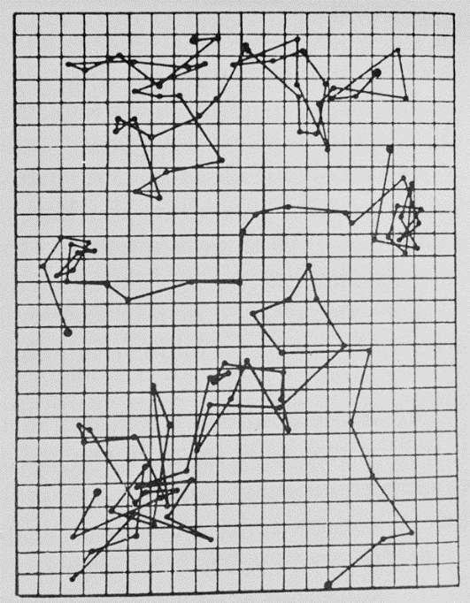

**Figure 6.2.1**

a) Portrait of Robert Brown b) Robert Brown’s notes tracking the position of pollen particles over time.

Questions

1 a Assess which two statements of the Particle Theory of Matter are shown most directly by Brown’s observations.

**b Justify** your answer.

2 Construct a model of the Brownian motion of a pollen grain. Start from the centre of the grid, roll a die and move according to the following rules.

1 move one square right

2 move one square left

3 move one square up

4 move one square down

5 move back the way you came

6 remain stationary

Track each move with a coloured pen.

|  |  |  |  |  |  |  |  |  |  |
| --- | --- | --- | --- | --- | --- | --- | --- | --- | --- |
|  |  |  |  |  |  |  |  |  |  |
|  |  |  |  |  |  |  |  |  |  |
|  |  |  |  |  |  |  |  |  |  |
|  |  |  |  |  |  |  |  |  |  |
|  |  |  |  |  |  |  |  |  |  |
|  |  |  |  |  |  |  |  |  |  |
|  |  |  |  |  |  |  |  |  |  |
|  |  |  |  |  |  |  |  |  |  |
|  |  |  |  |  |  |  |  |  |  |
|  |  |  |  |  |  |  |  |  |  |

Describe your path from the centre to the edge.

3 Assess which aspects of Brownian motion the model describes accurately.

4 Assess which aspects of Brownian motion are missing from the model or are not realistic.