# **Particle Theory Worksheet Name ____________**

**Read the following text and answer the questions at the bottom**

## **The particle theory model**

For scientists to understand how the atoms and other particles are arranged in materials they have developed a model known as the particle model. This model does not rely on us actually having to see the atoms and other particles. Scientists have built up this model by performing investigations and making observations of the behaviour of different types of matter. You will be making similar observations in your practical work about the types of matter. In the particle model, matter is described as being made of very small particles that are constantly moving. These particles are arranged differently in solids, liquids and gases. The following three sections present some of the evidence for the particle model.

## **Brownian Motion**

Robert Brown first investigated pollen grains in water in 1827. Pollen was selected because it is very light. He observed that the pollen grains were constantly moving around in a random manner. The particle theory model explains these observations in terms of the particles that make up water bumping into the pollen grain. This type of movement was named Brownian Motion.

Machine generated alternative text:
pollen grain 
We cannot see the individual atoms which make 
up water particles. We can seg the ettect ot these 
panicles on the pollen grain which shows a 
series ot random movements dug to being hit by 
the water panicles.

## **Smells**

Your nose is very sensitive to particles. Your ability to smell can be explained in terms of small particles moving into your nose and dissolving into a layer of mucous in your nasal membrane. The smell of a cooking roast in your house and the smell of someone's perfume from a distance are examples of particles moving through the air into your nose. The movement of these small particles through a substance such as air is known as diffusion.

Your teacher may also demonstrate the movement of substances such as ammonia. If a small amount of this liquid is placed at the front of a still and sealed room, the particles (which have a very noticeable smell) will soon spread (diffuse) throughout the whole room, providing further evidence that matter is made of small particles.

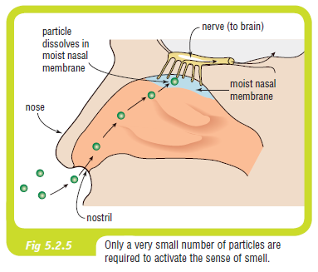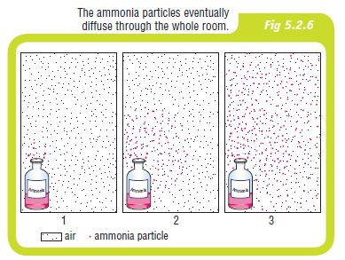

## **Dissolving**

In a similar way to diffusion, substances such as sugar can dissolve when placed in water. Dissolving can be explained in terms of small particles moving through the water particles. You would have noticed that this movement can be sped up by stirring, which forces the particles to move (dissolve) in the water faster.

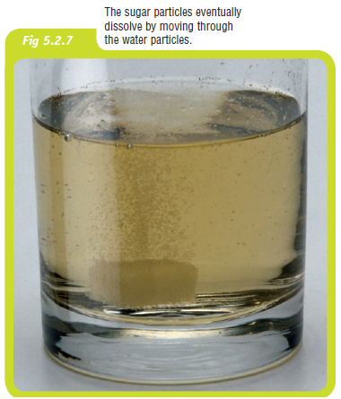

**Questions**

1. How does Brownian motion show us that particles exist?
2. Why did Robert Brown use pollen grains in his experiment?
3. Some strong perfume is placed at the front of your classroom. Eventually you can smell this perfume at the back of the classroom. What is this movement called?
4. Describe what happens when particles dissolve.
5. What happens to the particles in a solid as it is heated?
6. Is the force of attraction larger or smaller between particles of a solid when compared to the particles in a gas?
7. Use particle theory to explain why air can be compressed, but wood cannot.