

**VARTIKA** Scheme **-** A ***SERB*** initiative

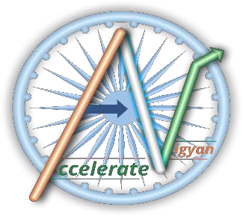

**Training and Skill Internship for PG Students**

**on**

**Modelling of High-Speed VLSI Interconnects**

**Duration**: 15th June – 15th July 2022

**Organized by:**

**ABV- Indian Institute of Information Technology & Management Gwalior, India**

**Undertaking from the Student Applicant**

1. I hereby provide my consent to participate in the Training and Skill Internship on **“Modelling of High-Speed VLSI Interconnects**” Organized by ABV-IIITM Gwalior upon selection.
2. I will attend the internship, sincerely with utmost dedication and will submit the report in the end of the internship program.
3. I shall also be responsible and attentive to involve myself during the discussion/interaction session.
4. I am aware that it is mandatory to attend all the sessions and compulsorily qualify for the course assessment in order to successfully avail of the certification.
5. I understand that the videos and lecture material supplied during this workshop are only for educational/academic purposes.
6. Uploading/hosting/sharing on any platform shall be unlawful on the grounds of Intellectual Property Rights.
7. Any Proxy participation in the sessions/exam shall invite immediate cancellation of his/her candidature and the same shall be reported to the parent institution.
8. It is highly advisable to use a desktop or laptop PC and avoid the use of a smartphone since the internship involves tutorials & Hands-on-sessions.
9. I agree to abide by any other terms and conditions of Organizing Institute and DST-SERB.

Name of the Applicant : Gender & Age : Programme (M.Tech/M.S./Msc.) : Institution/University : Date : Place : Signature of the Applicant :