CAR RENTAL MANAGEMENT SYSTEM

###### **TABLE OF CONTENTS**

**Sr. No. Contents Page No.**

**1. INTRODUCTION 01**

1.1 Abstract overview of project

1.2 Background and motivation

**2. SCOPE OF PROJECT 02**

**3. SYSTEM REQUIREMENTS 03**

3.1 Hardware requirements

3.2 Software requirements

**4. OPERATIVE REQUIREMENTS 04**

4.1 Functional requirements

4.2 Non-functional requirements

**5. EXISTING SYSTEM 06**

5.1 Advantages of existing system

5.2 Disadvantages/Limitations of existing system

**6. UML DIAGRAM 07**

**7. USER MODULE 08**

7.1 Output screens

**8. CONCLUSION 11**

**1. INTRODUCTION**

* 1. **Abstract overview of project**

The most advanced travel agents offering cab rental and hiring services in India, take due advantage of Information Technology tools to improve the level of our efficiency. However, this is only one aspect of services. And this project continually strives to offer the best of services - both in terms of man and machine, to our dual-ended clients.  
  
Further, this project’s utmost priority is to offer quality services to our worthy users. To achieve this, the project admin regularly monitors the inflow of cars and sanctions only the trusted ones to make it hireable.

* 1. **Background and motivation**

The application aims to provide a service to the car owners who wish to rent their cars at their desired cost and henceforth, earn a side income.

The renting customers can avail the hiring facility provided by the owners on a time-constraint basis, with the flexibility to select their desired cars from the available wide range, uploaded by their counterparts.

The prime motive is to bridge the gap between the dual-headed client requirements, by ascertaining authentication by the Admin.

**01**

**2. Scope of project**

This project traverses a lot of areas ranging from business concept to computing field, including:

* Car rental industry:

This includes study on how the car rental business is being done, process involved and opportunity that exist for improvement.

* HTML tools used for the development of the application.
* General customers as well as the company’s staff will be able to use the system effectively.
* Web-platform means that the system will be available for access 24/7

except when there is a temporary server issue which is expected to be

minimal.

Currently, the system has been developed to function on the local host server for the sole purpose of mini-project.

However, with further modifications, and in accordance with copyright and non-infringement issues, the web application can be published over the Internet, to be accessible by the masses.

**02**

**3. SYSTEM REQUIREMENTS**

**3.1 Hardware requirements**

* Hard disk: Minimum 500 GB
* RAM: Minimum 4 GB
* Processor: Any processor above Pentium IV
  1. **Software requirements**
* Operating system: Windows/Linux based
* User interface: HTML/CSS
* Programming language: Java
* IDE/Software used: Eclipse, Xampp
* Web technology: Java servlet
* Database: MySQL
* Database connectivity: JDBC
* Web server: Tomcat 7.0

**03**

**4. OPERATIVE REQUIREMENTS**

**4.1 Functional requirements**

Requirement analysis is a software engineering technique that is composed of the various tasks that determine the needs or conditions that are to be met for a new or altered product, taking into consideration the possible conflicting requirements of the various users.

Functional requirements are those requirements that are used to illustrate the internal working nature of the system, the description of the system, and explanation of each subsystem. It consists of what task the system should perform, the processes involved, which data should the system hold and the interfaces of the user.

The functional requirements identified are:

* Customer’s registration:

The system should allow new users to register and login to the account.

* Online reservation of cars:

Customers should be able to use the system to make booking and online reservation.

* Automatic update to database once reservation is made or new customer registered:

Whenever there’s new reservation or new registration, the system should be able update the database without any additional efforts from the admin.

**4.2 Non-functional requirements**

It describes aspects of the system that are concerned with how the system provides the functional requirements.

**04**

They are:

* Security**:**

The subsystem should provide a high level of security and integrity of the data held by the system, only authorized personnel of the company can gain access to the company’s secured page on the system and only users with valid password and username can login to users’ page.

* Performance and Response time:

The system should have high performance rate when executing user’s input and should be able to provide feedback or response within a short time span usually 50 seconds for highly complicated task and 20 to 25

seconds for less complicated task.

* Error handling:

Error should be considerably minimized and an appropriate error message that guides the user to recover from an error should be provided.

* Availability:

This system should always be available for access at 24 hours, 7 days a week.

* Ease of use:

Considered the level of knowledge possessed by the users of this system, a simple but quality user interface should be developed to make it easy to understand and which will require less training.

**05**

**5. EXISTING system**

**5.1 Advantages of existing system**

* This online car rental solution is fully functional and flexible.
* It is very easy to use.
* It helps in office administration by streamlining and standardising the procedures.
* It saves a lot of time, money and labour.
* Eco-friendly: The monitoring of the vehicle activity and the overall business becomes easy and includes the least of paper work.
* The software acts for an office that is open 24/7.
* It increases the efficiency of the management at offering quality services to the customers.
* It provides custom features development and support with the software.

**5.2 Disadvantages/limitations of existing system**

* To access the cars’ database, user must login to the system.
* User must manually filter his car preferences.
* Access to the WWW is mandatory, for larger implementation of the project as a web application.

**06**

**6. UML diagram**

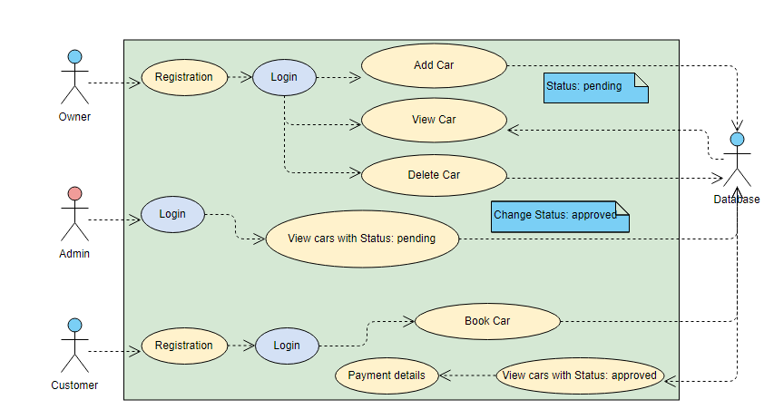

**07**

**7. user module 08**

**7.1 Output screens**

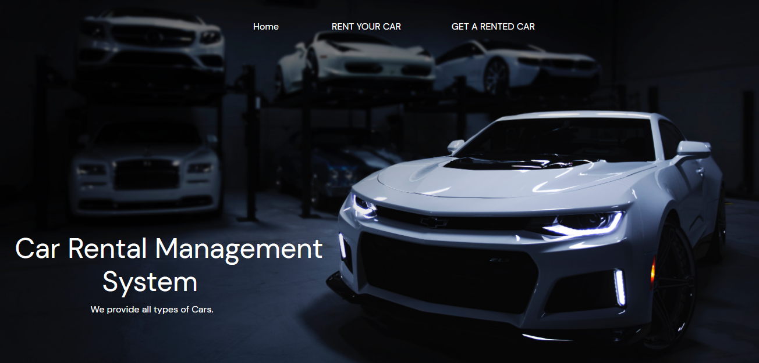

1. Home page

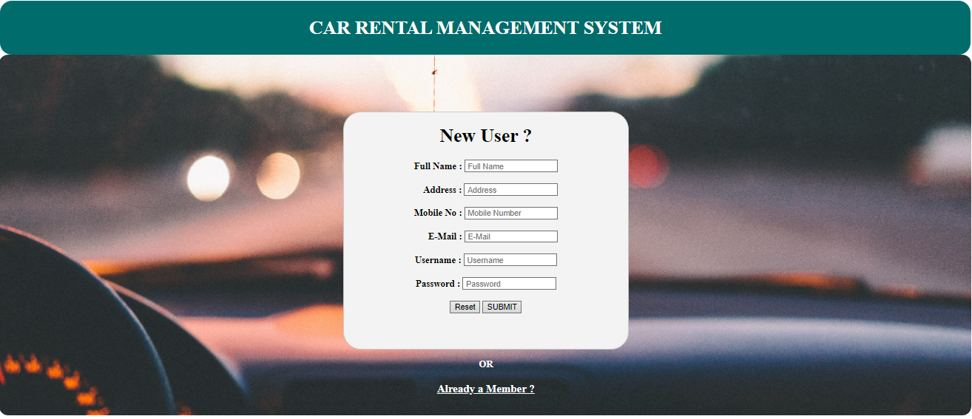

1. Registration page

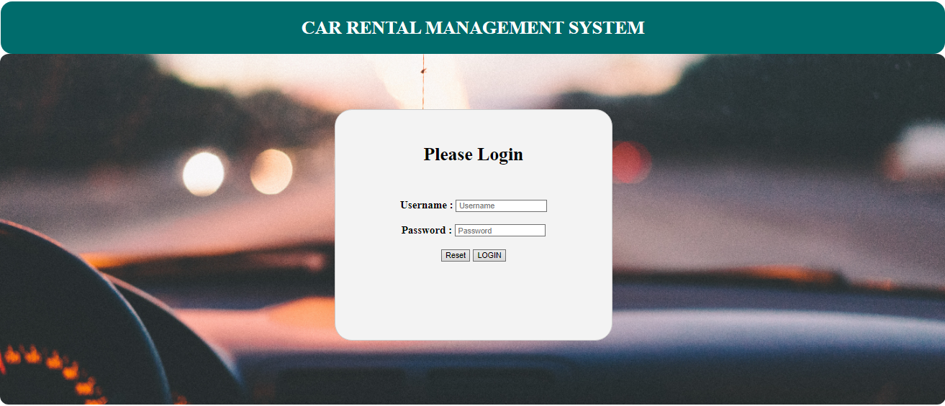

1. Login page

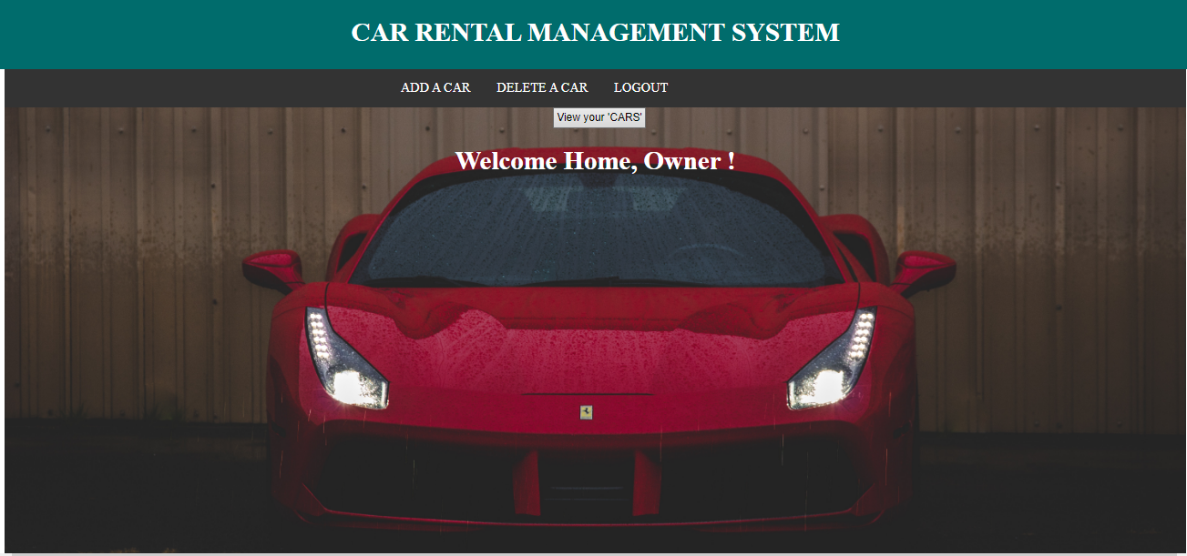

1. Owner home page

**09**

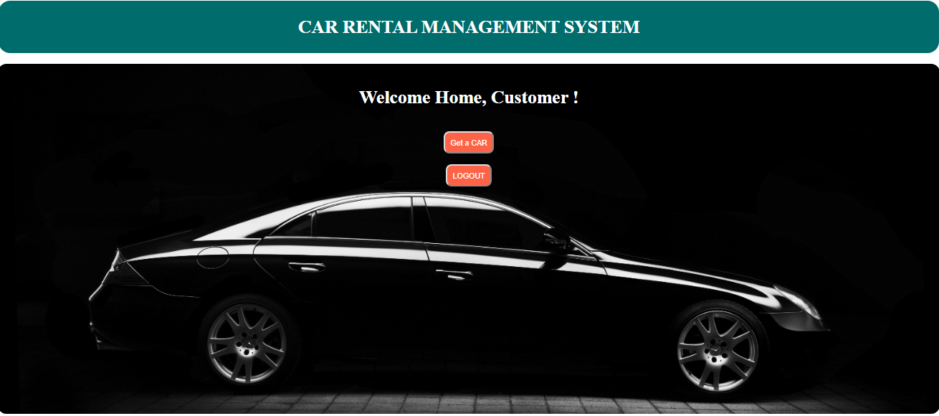

1. Customer home page

**10**

**8. Conclusion**

While implementing the project, we learnt a great deal about the following steps of software development:

* Requirement Gathering and Analysis.
* Design.
* Actual implementation.
* testing.
* efficient deployment.

Besides, the concepts of Java servlets, JDBC, MySQL, HTML, etc. were the foundational pioneers in designing and developing the software.

**11**