AI Bug Analyzer
Design Document
By
Animesh Singh
Introduction & Purpose
The AI Bug Analyzer is an event-driven, retrieval-augmented system that ingests raw error text, crash logs, or structured alerts (e.g. JIRA webhooks), converts them into a standardized schema, and — once the full pipeline is complete — will retrieve semantically similar historical defects to help developers understand root cause and resolution paths faster.
System Architecture
The system follows a decoupled three-tier architecture: an Ingestion & Preprocessing layer, a Storage & Retrieval layer (RAG), and an Orchestration & LLM layer. Each tier can scale and fail independently.
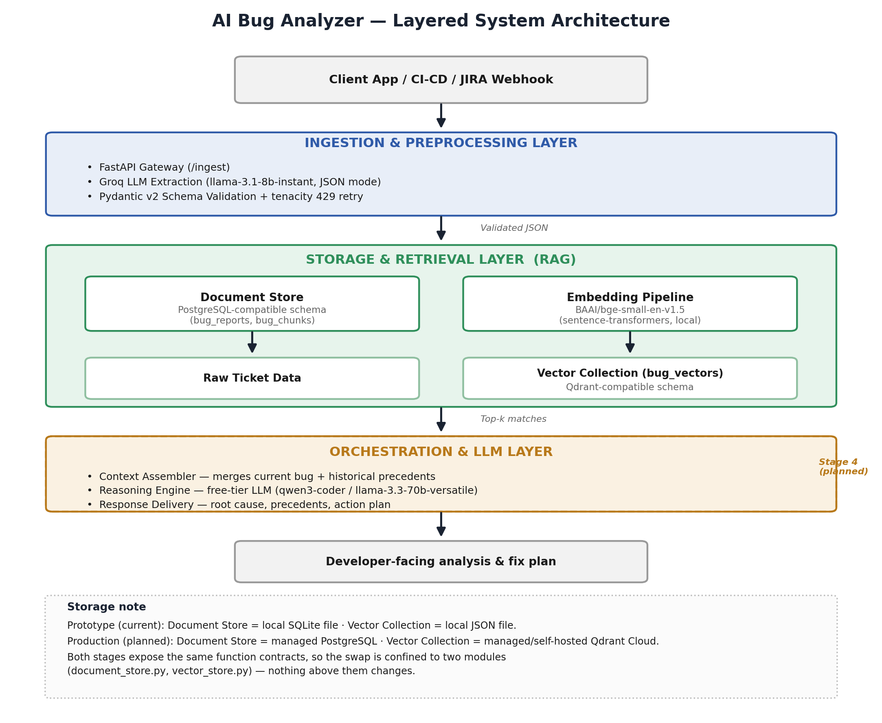

Ingestion: Parse raw text into strict schema using Groq llama-3.1-8b-instant (JSON mode), Pydantic v2, tenacity retry.
Local Chunking: Split structured report into contextual chunks using langchain-text-splitters (RecursiveCharacterTextSplitter)
Local Embedding: Convert chunks into vectors using sentence-transformers, BAAI/bge-small-en-v1.5 (384-d)
Context Assembly & Reasoning: Retrieve similar past bugs, generate fix plan using Vector similarity search + openrouter free reasoning LLM

Prototype Progress

The bug ingestion pipeline has been implemented as a local prototype that simulates the intended production architecture. For the prototyping phase, a lightweight frontend built with HTML, CSS, and JavaScript allows users to submit raw bug reports and crash logs.
The backend runs locally on http://localhost:8000, while the frontend is served on http://localhost:5500.
When a user submits a bug report, the raw input is sent to the backend, where it is processed through the ingestion pipeline. The first stage uses Groq's free API to extract key information from the raw log and convert it into a strictly validated JSON structure.
The structured bug report is then stored in a local SQLite database, which serves as a stand-in for the PostgreSQL database planned for the final system.
Next, the structured report is flattened and split into smaller chunks. These chunks are passed through the embedding pipeline, where they are converted into vector embeddings using a local embedding model.
Finally, the generated embeddings are stored in a local JSON file that simulates a vector database during the prototyping phase. This design closely mirrors the planned production architecture while keeping all storage and processing entirely local, making it easy to replace the SQLite database and JSON-based vector store with PostgreSQL and Qdrant in future development.

