Creating an AWS account

1. Visit the following url: https://aws.amazon.com/ which will bring you to this page
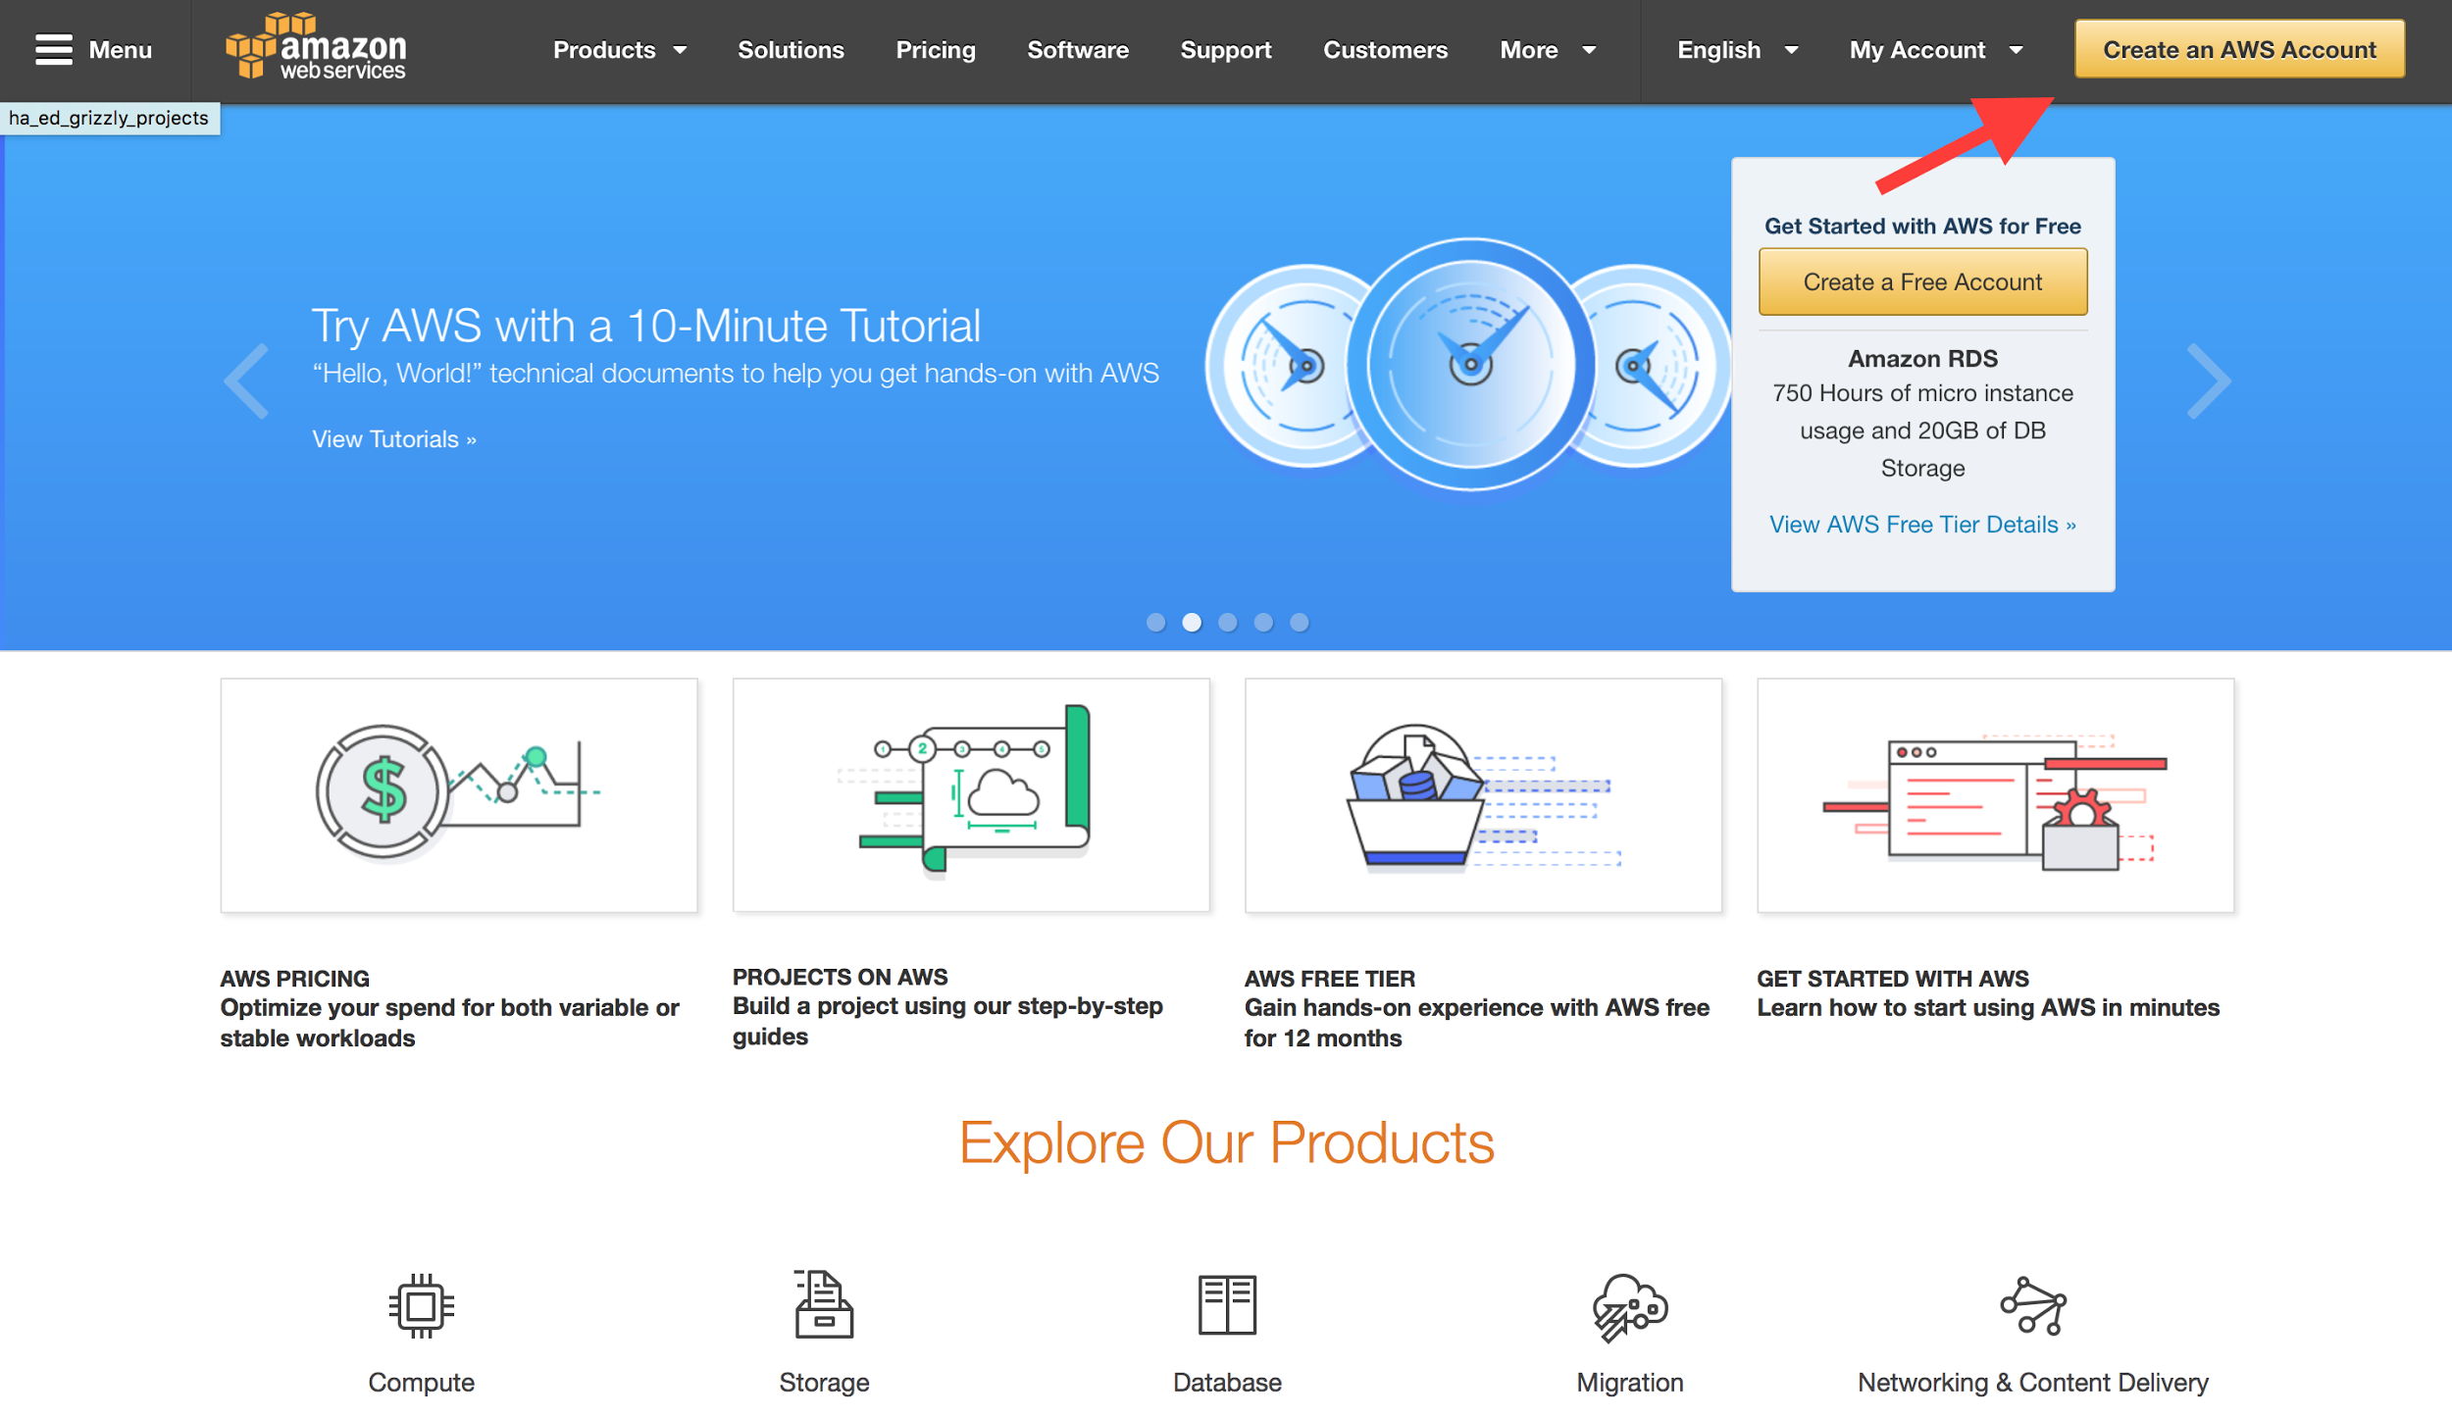
3. You will need to click the button ‘Create an AWS Account’ to begin actual account creation.
4. To setup an account for Georgia’s select ‘Company Account’ and continue following the sign up instructions from there.

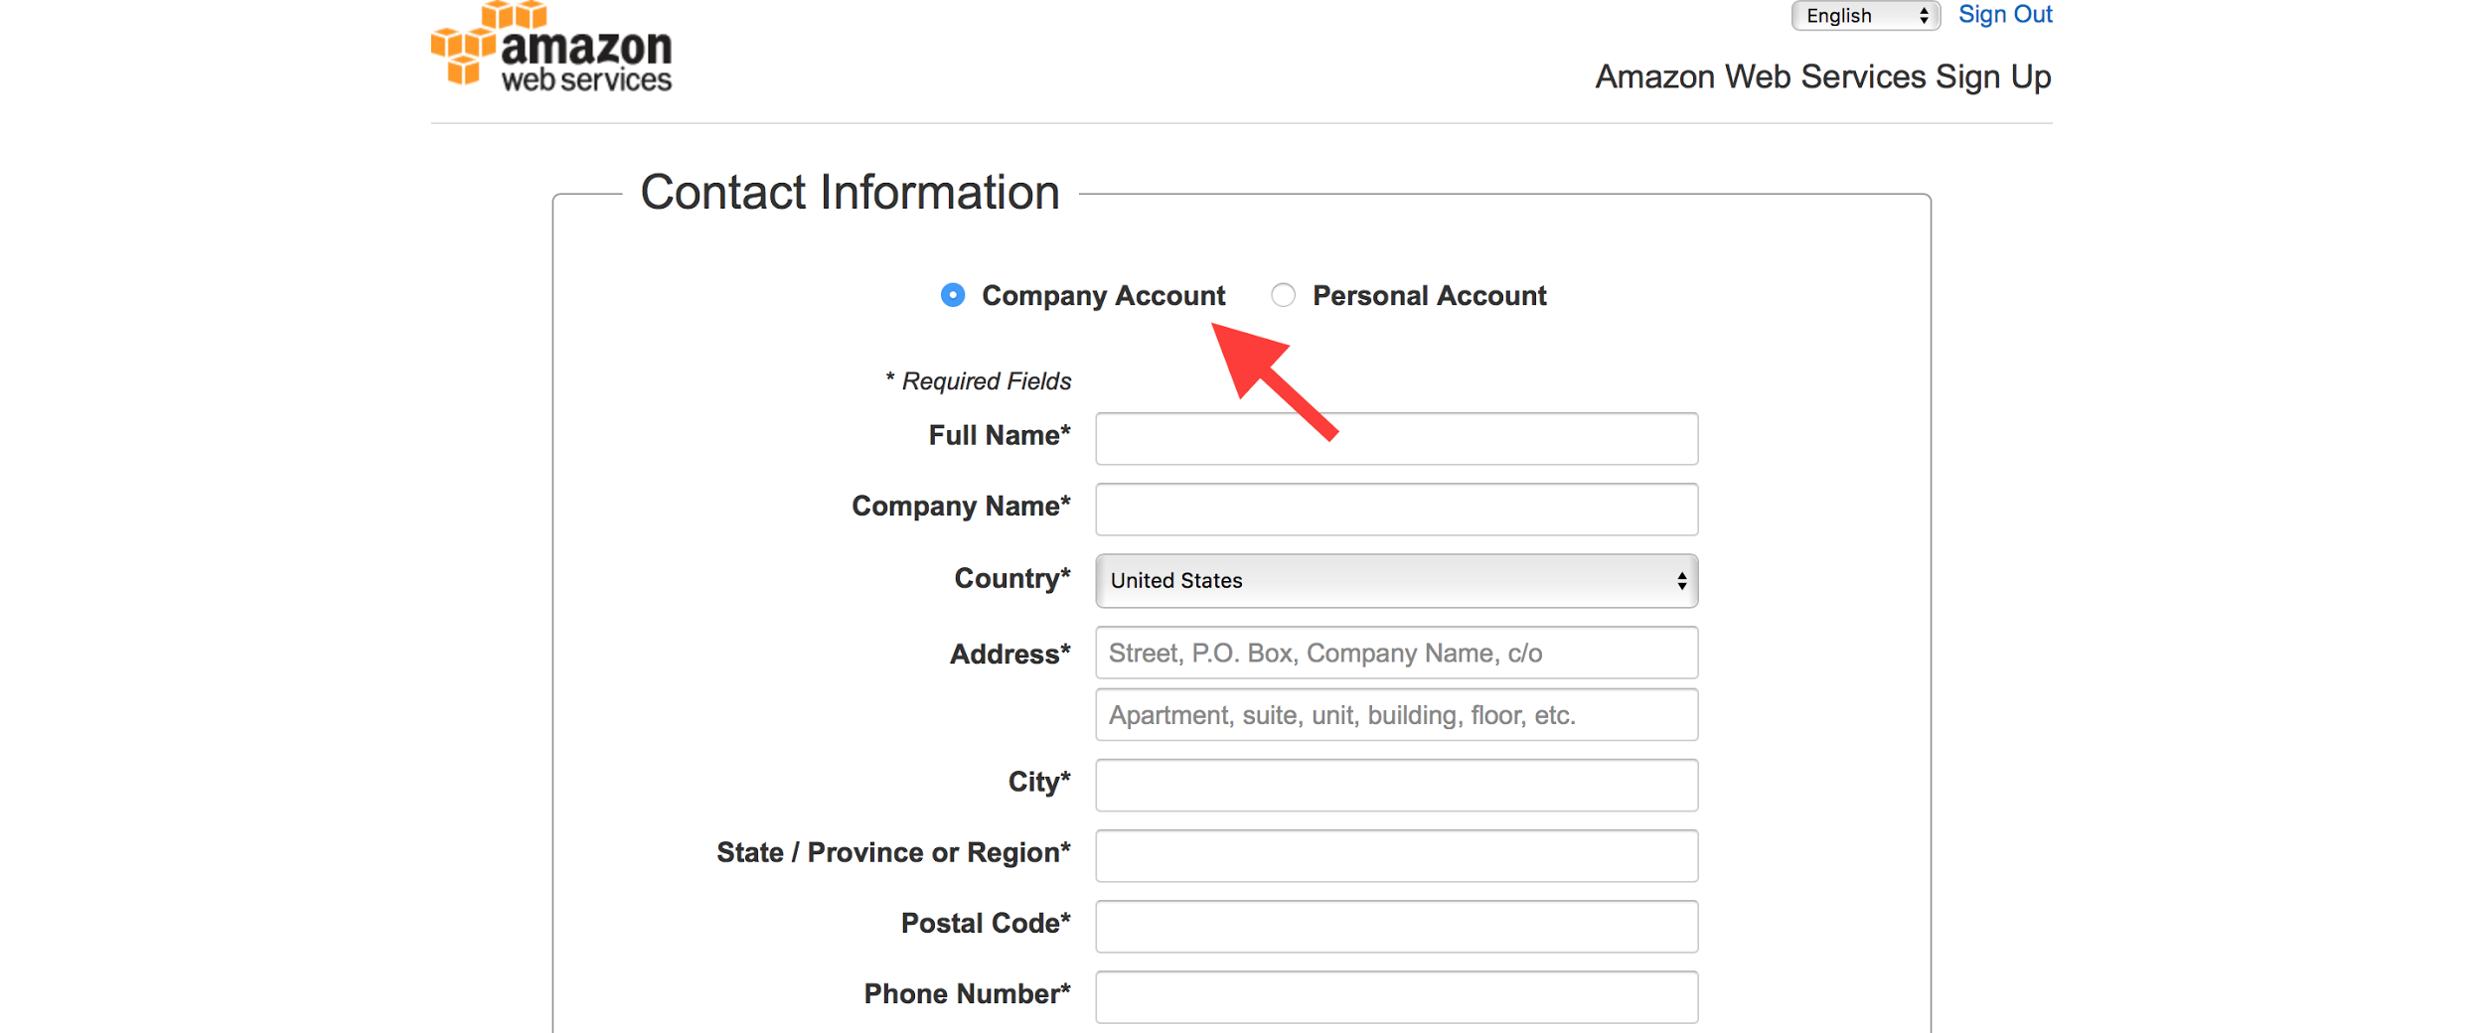

5. Once you have completed the sign up process you should end up at this page. Hover over the ‘My Account’ tab and click ‘AWS Management Console’ to continue with the system installation
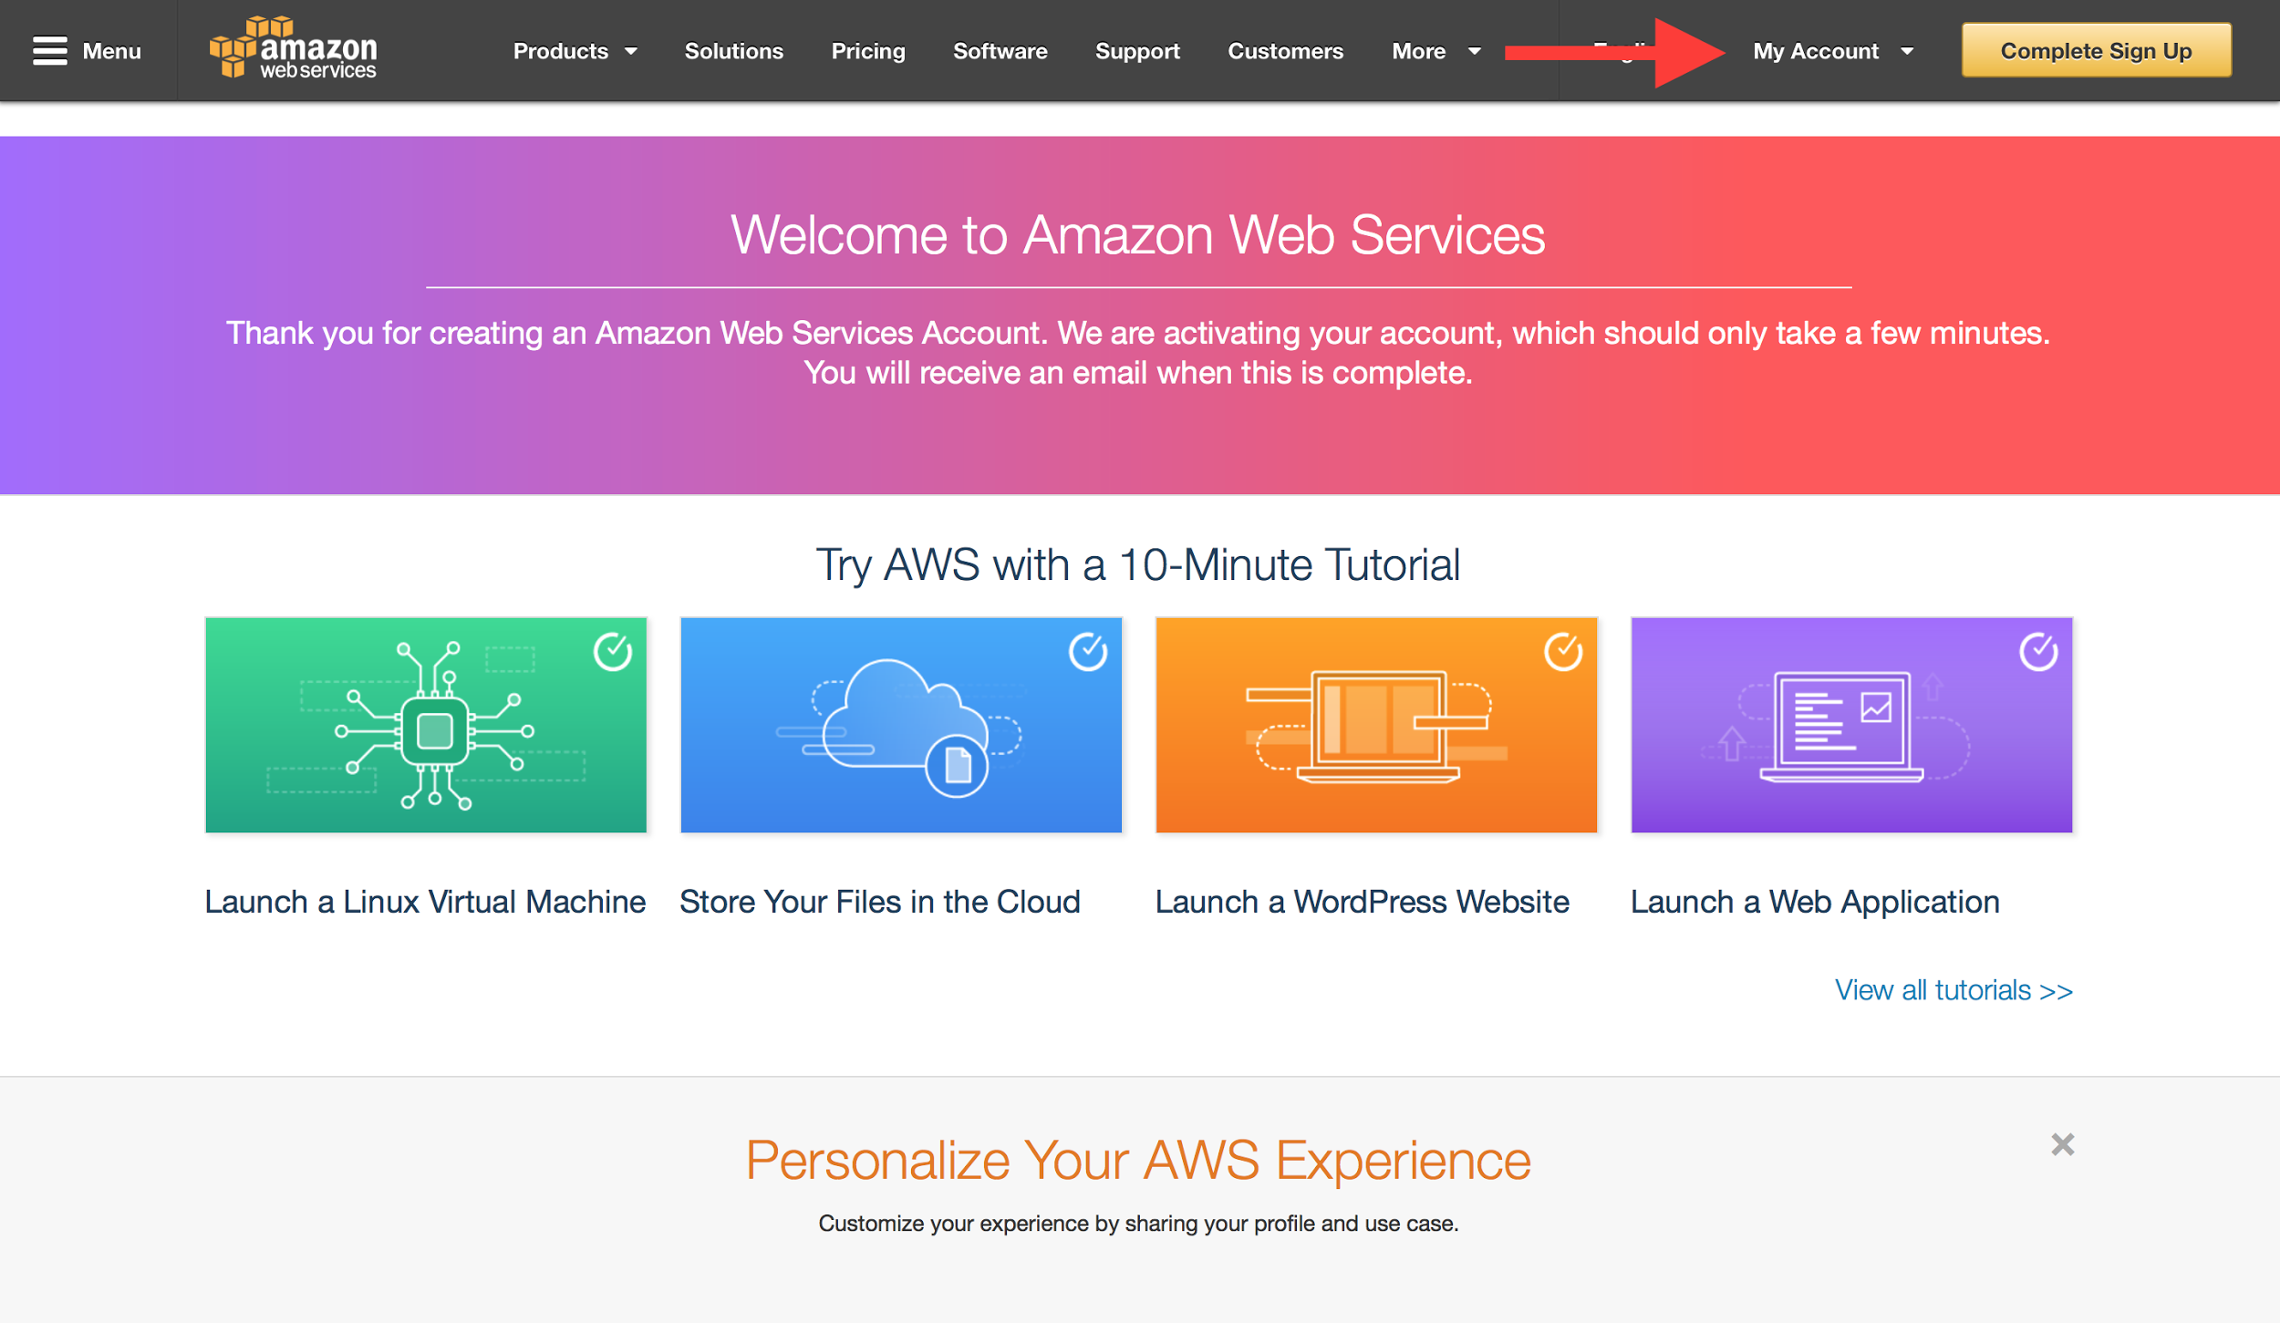

6. You will be redirected to the following page
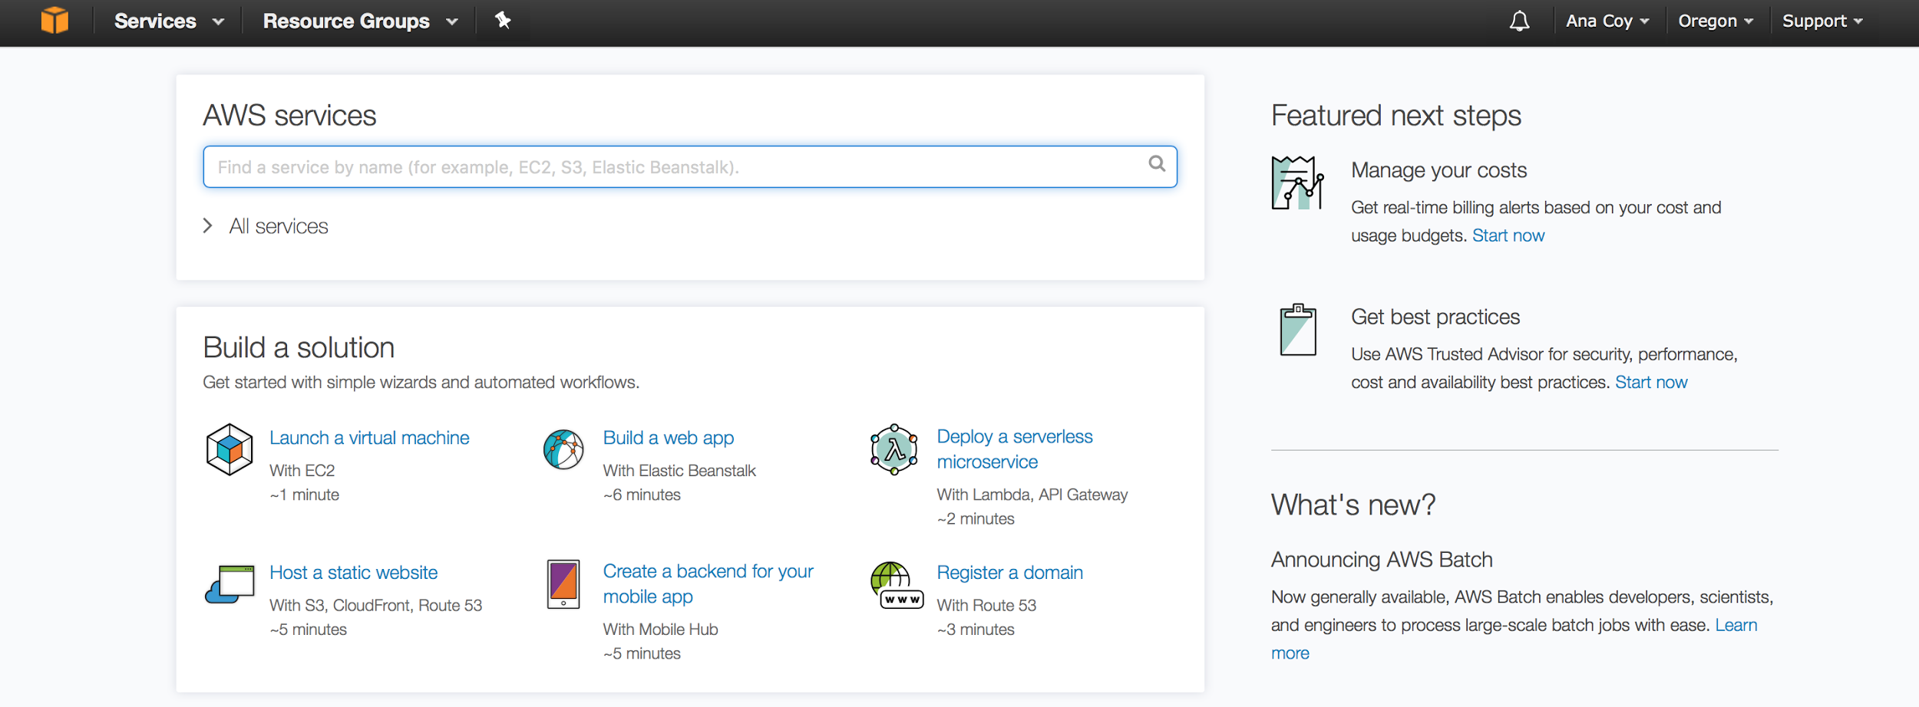

Create a GitHub Account
- Go to https://github.com/pricing
- Click on “Join Github for free”
- Under “Create you personal account,” type your username, email address, and password, then click “Create an Account”
- Select the Free account type.
- Click Finish sign up.

Setting Up an AWS EC2 instance:
- Create a Key Pair
  - Navigate to AWS Console, then click on EC2
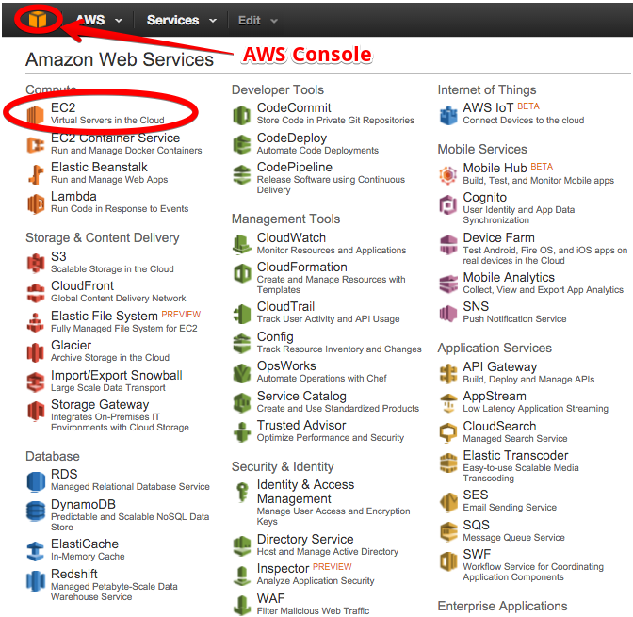

  - On the left pane, click on Key Pairs, then click on Key Pair.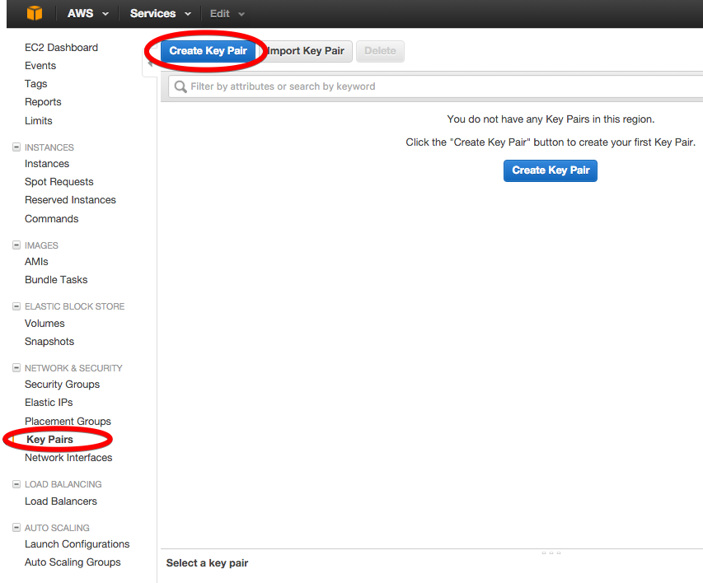
  - Enter a name for your key, then click Create. The Key Pair will be automatically downloaded.
    - Move this key to a permanent location.
    - You will need to change the permissions of this key to read only:
      - Enter the following command: chmod 400 [key-name].pem

- Create a Secure Group
  - Navigate to the left pane of your EC2, and clock on Security Groups, then click Create Security Group.
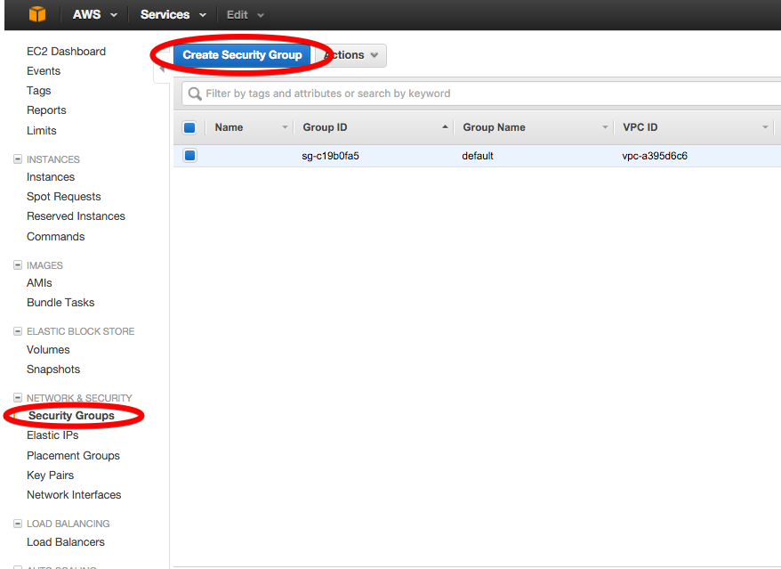
  - Fill out the Security Group Name and give it a Description
    - One the Inbound tab, click Add Rules create the following 3 rules
      - Select HTTP under Type.
        - Make sure Source is set to Anywhere.
      - Select HTTPS under Type.
        - Make sure Source is set to Anywhere.
      - Select SSH under Type.
        - Make sure Source is set to My IP.
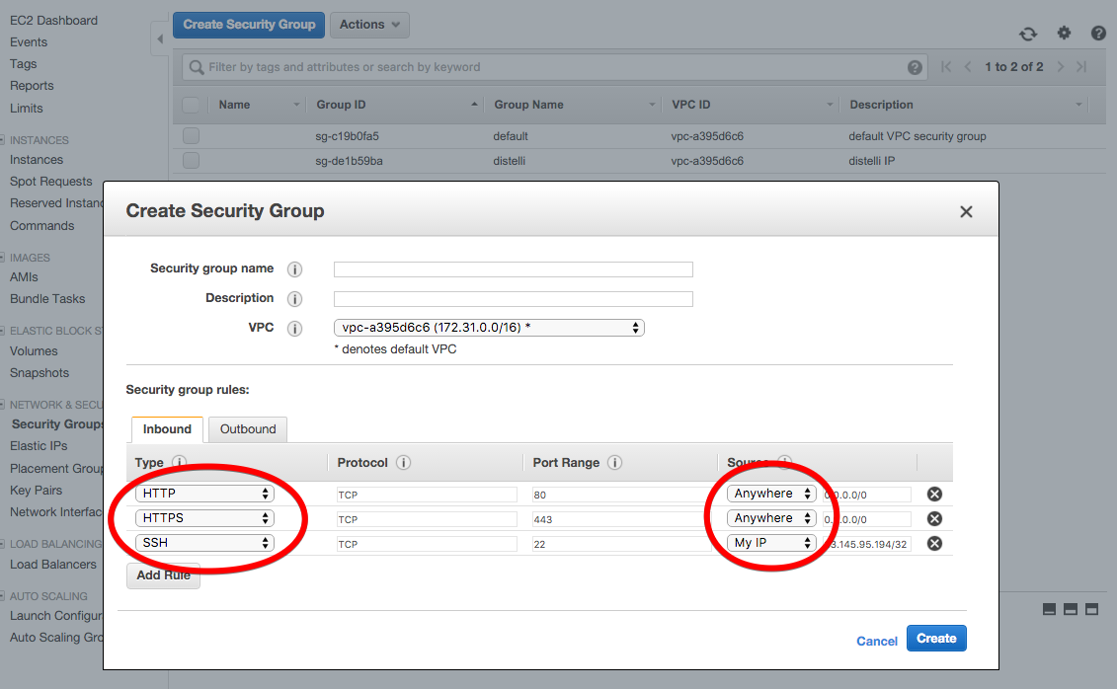

- Launch EC2 Instance
  - One the left pane, click on EC2 Dashboard, then click on Launch Instance
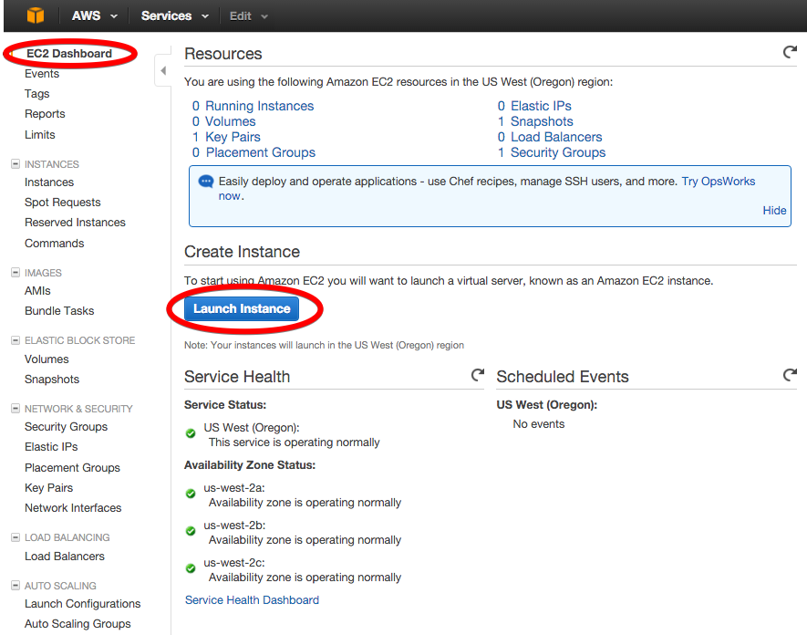

  - Choose your server OS and proceed.
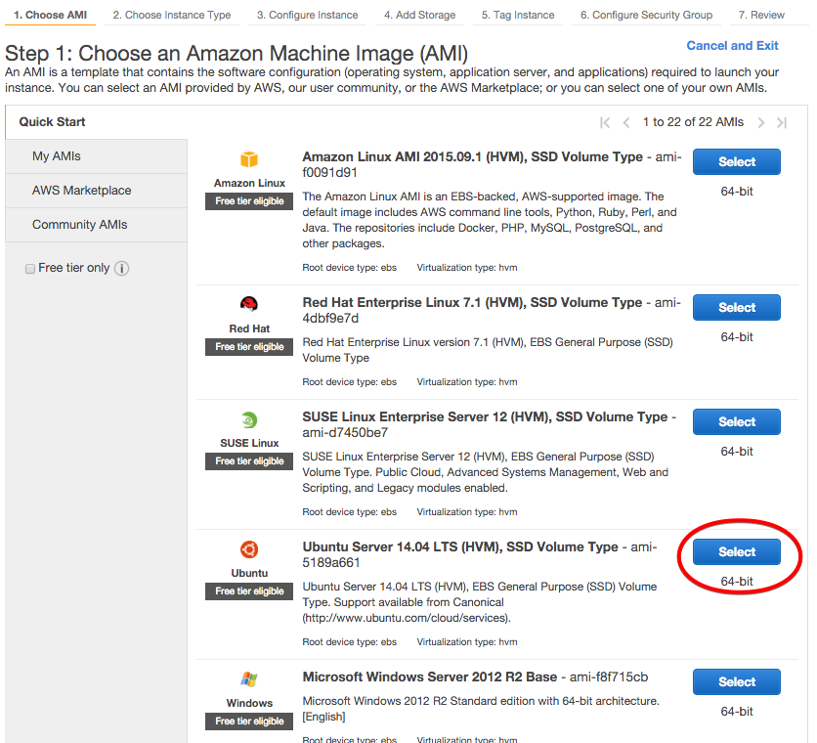
  - Select Configure Security Group on top of the page.
  - Check the option Select an existing security group, then select the name of your group.
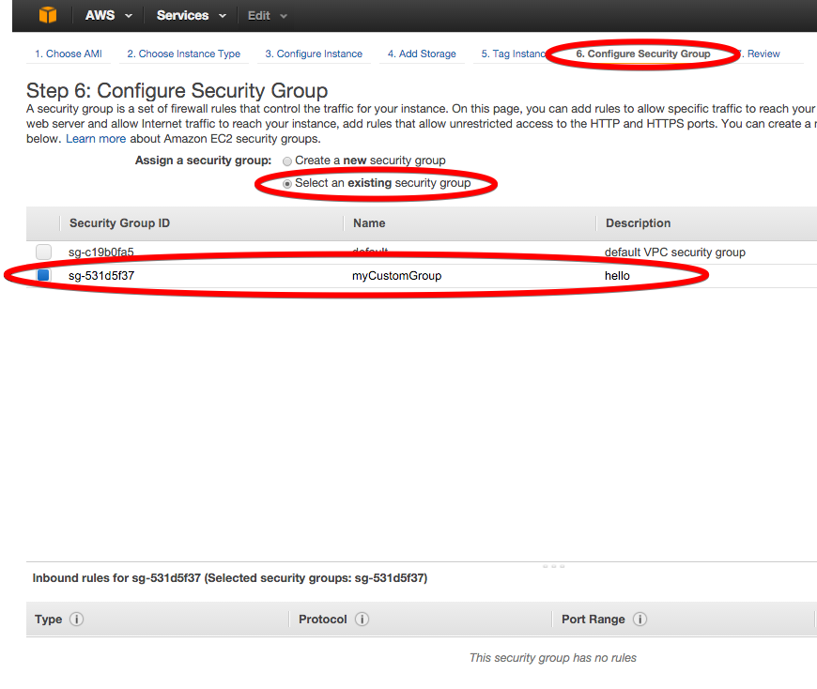
  - Click Review and Launch.
  - Click Launch.
    - Select the key pair you created, then select Launch instances.
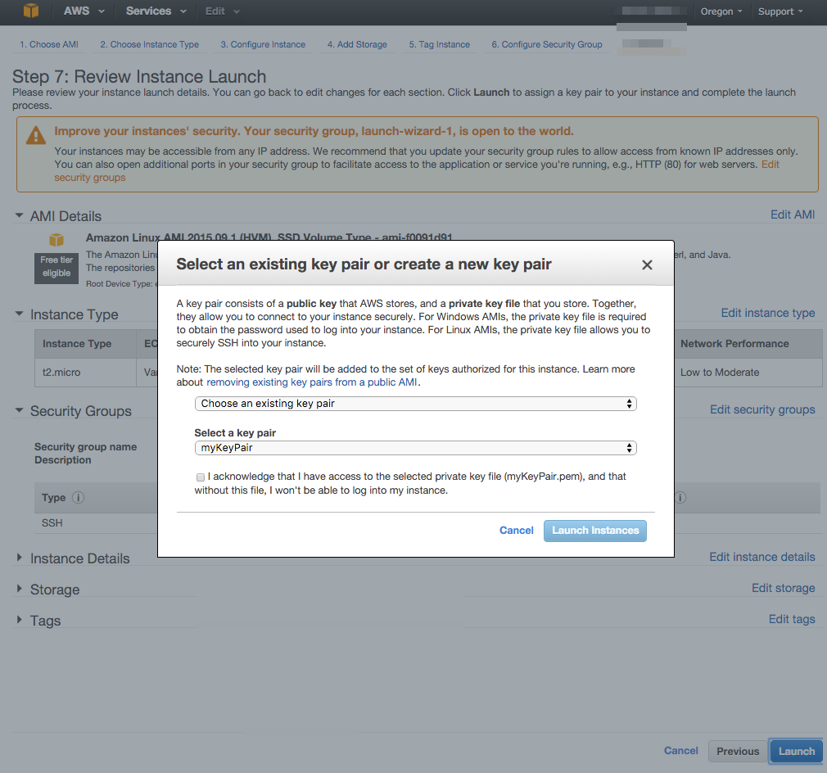
  - Navigate to the left pane of the EC2, and click on Instances.
    - Check out the Instance State, and make sure it is running
    - You will need your instance IP address to connect your instance
    - Your instance IP address can be found in the instance’s details
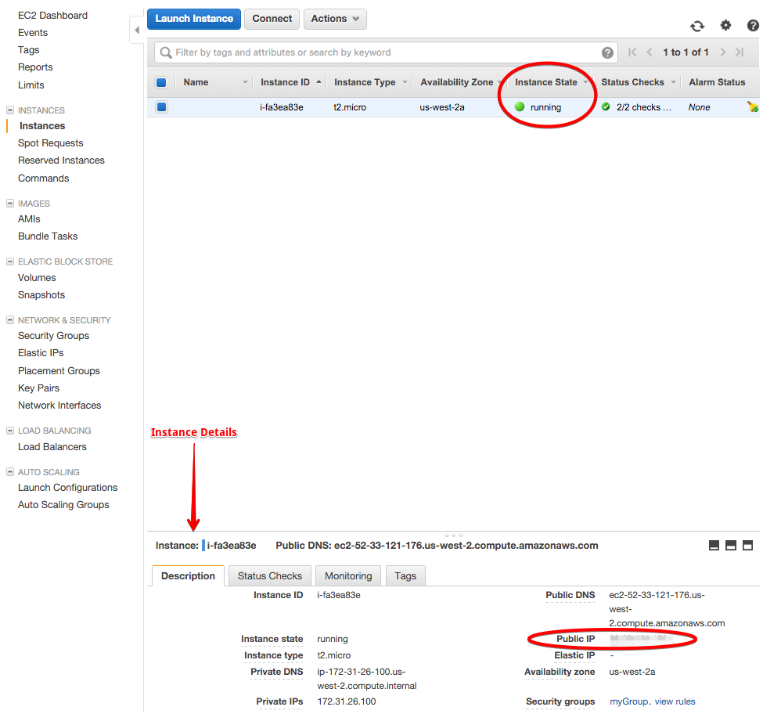

- Connect to Instance
  - Open your terminal.
    - Navigate to the directory where your Key Pair is saved
    - Enter the following commands:
      - chmod 700 [your key name pair].pem
      - ssh -i “[your key name pair].pem” ubuntu@[instance IP address]
  - Enter the following command to update your instance:
    - sudo apt-get update
    - sudo apt-get install apache2 libapache2-mod-wsgi python-pip python-dev
    - sudo pip install django
    - sudo apt-get install mysql-server python-mysqldb
    - sudo apt-get install git
  - Set up database - open your terminal
    - Enter ‘mysql’
    - You should see ‘mysql>’ on the left hand side
    - Enter the following commands:
      - create database georgias;
      - grant all on georgias.* to ‘georgias’ identified by ‘georgiaspassword’;
      - exit;
    - Enter ‘mysql -u georgias -pgeorgiaspassword georgias < georgias.sql’
    - Enter ‘mysql’
    - Enter ‘INSERT INTO auth_users VALUES (‘admin_user’, ‘email@email.com’, ‘password’);’
    - Close the terminal
  - Pull your code files
    - If from github, enter ‘git clone https://github.com/uva-slp/georgias.git’
    - Otherwise, through scp terminal commands
  - Migrate database
    - Enter ‘cd georgias’
    - ‘python manage.py makemigrations’
    - ‘python manage.py migrate’
  - Configure apache2
    - ‘cd /etc/apache2/sites-enabled’
    - ‘vi georgias.conf’
    - Paste or type this:
      - WSGIScriptAlias / /home/ubuntu/georgias/georgias/wsgi.py
WSGIPythonPath /home/ubuntu/georgias/
<Directory /home/ubuntu/georgias/georgias>
<Files wsgi.py>
Require all granted
</Files>
</Directory>

Alias /media/ /home/ubuntu/georgias/media/
Alias /static/ /home/ubuntu/georgias/static/

<Directory /home/ubuntu/georgias/static/>
Require all granted
</Directory>

<Directory /home/ubuntu/georgias/media/>
Require all granted
</Directory>
    - Enter ‘:wq’
    - Enter ‘sudo service apache2 restart
  - Navigate to the public IP address and the application should be usable

