Georgia’s Healing House Resident Management System
User Manual

Sumeet Babu, Ana Coy, Ashley Huynh,
Michael Liao, Jason Valenzuela

User Manual

Table of Contents

INTRODUCTION………………………………………………………………………………………………………………………… 2
About the system………………………………………………………………………………………………… 2
About this document………………………………………………………………………………………… 2
SYSTEM OVERVIEW………………………………………………………………………………………………………………… 3
Background………………………………………………………………………………………………………………… 3
How does it work?……………………………………………………………………………………………… 3-4
FUNCTIONALITIES………………………………………………………………………………………………………………… 5
User creation……………………………………………………………………………………………………… 5
User login……………………………………………………………………………………………………………… 6
User profile edit…………………………………………………………………………………………… 7
Application form submission……………………………………………………………… 8
Accept/deny Applicant……………………………………………………………………………… 9-10
Interview form submission…………………………………………………………………… 11
Accept/deny Interviewee………………………………………………………………………… 12-13
Individual Resident Report Submission………………………………… 14
View Individual Resident Reports……………………………………………… 15
Donation submission…………………………………………………………………………………… 16
Email Donors………………………………………………………………………………………………………… 17
Critical Incident Report submission……………………………………… 18-19
View Resident Activity Summary……………………………………………………… 20-24
Filter Resident Activity Summary………………………………………………… 25
GLOSSARY…………………………………………………………………………………………………………………………………… 26

Introduction |

About the system
The resident management system is a tool for creating, editing, and managing data on residents of Georgia’s Healing House (GHH), an organization focused on providing a structured living environment for women recovering from substance abuse. The system is intended to be used by staff members who will enter various data points about the residents into the system. Eventually, these data points can be aggregated into reports which summarize resident activity and recovery within the house.

About this document
This document is the GHH resident management system User Manual. It describes how to use the application through its web browser interface. It assumes your system administrators have already been set up prior to the use of the system.

The bulk of the manual is divided up into sections under the ‘Functionalities’ chapter. Each of these sections deals with a different aspect of the application and is accompanied with screenshots of the system.

System Overview |
Background
Georgia’s Healing House opened in September 2015 with the vision of providing a healing house for women to have a supportive living environment as they maintain sobriety and build a new life after incarceration or treatment. After operating successfully for several years, the organization found more opportunities to receive better funding for the house through large foundations. However, in order to secure this funding, GHH needed to provide hard evidence to prove the success of the house in its daily operations.

The resident management system provides GHH with a solution to its problem by providing a method by which they can aggregate the resident activity and recovery within the house. Prior to the development of the application, GHH relied on a paper-based system which was inefficient and prone to inconsistencies in data. With our software, will no longer have to sift through pages and pages of forms to try and summarize the activities within the house. Our system automate aggregation with the click of a button, thus allowing staff members to spend less time filling out forms and more time providing residents with the supportive environment they need for recovery.

How Does it Work?
The resident management system has the following major components

Applicants
Prior to be admitted to the house, a woman must submit a resident application. This requires filling out a form containing very basic information about her identity, current living situation, and history with drugs and/or alcohol.

Interviewees
If a woman application is indicates she might be a good fit for the residence, she continues on to the interview phase. Her she fills out another form containing more detailed information about that woman’s drug usage and history in other substance abuse programs.

Residents
If a woman is approved through the application and interview phase, she may be admitted as a resident into GHH. Once a woman is a resident, there are certain rules she is expected to follow such as, regularly attending therapy, searching for employment, etc.

Donations
A minor aspect of the system involves tracking financial information from donations to GHH.

Reports
Reports record resident activity within the house. Within our system, each report falls into a category: court dates, therapy visits, interviews, critical incidents, etc.

Functionalities |

User creation
- Select the “Staff” tab in the navigation bar

- Fill out the appropriate information for the new user using the “Create New Staff Member” form
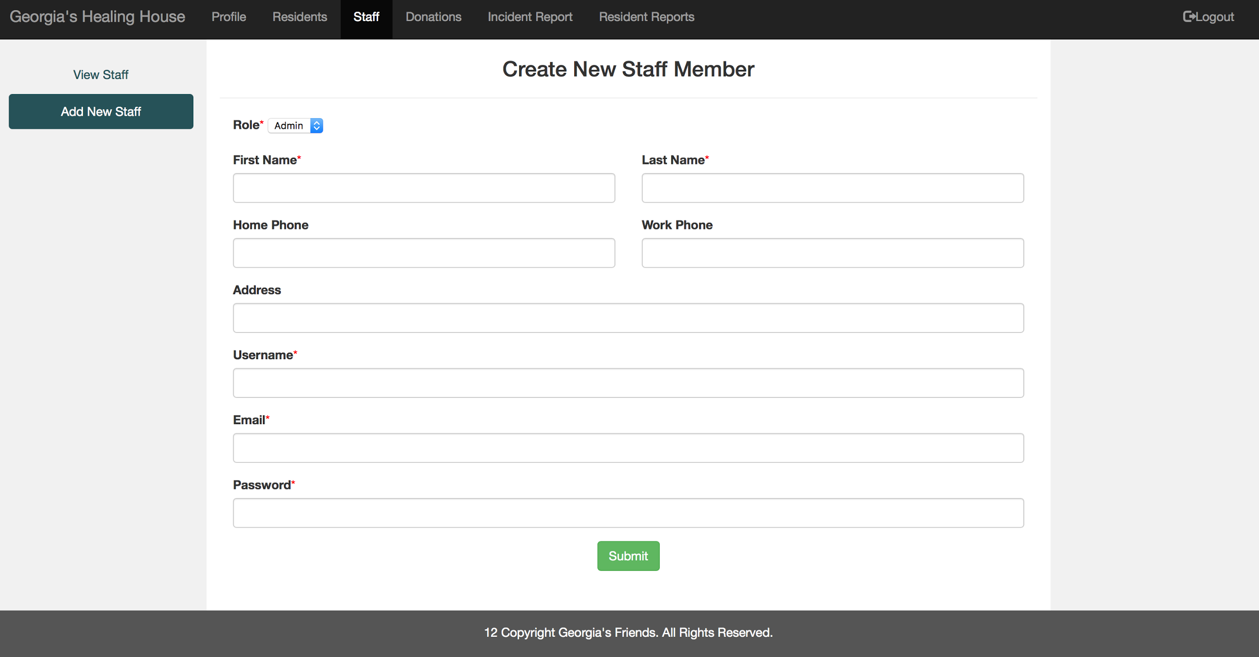
- Upon the successful creation of a user, the green message picture below will appear.
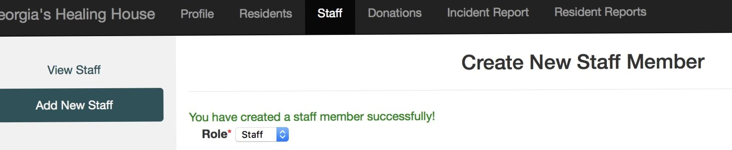

User login
- Locate the login button in the upper right corner of the general site page.
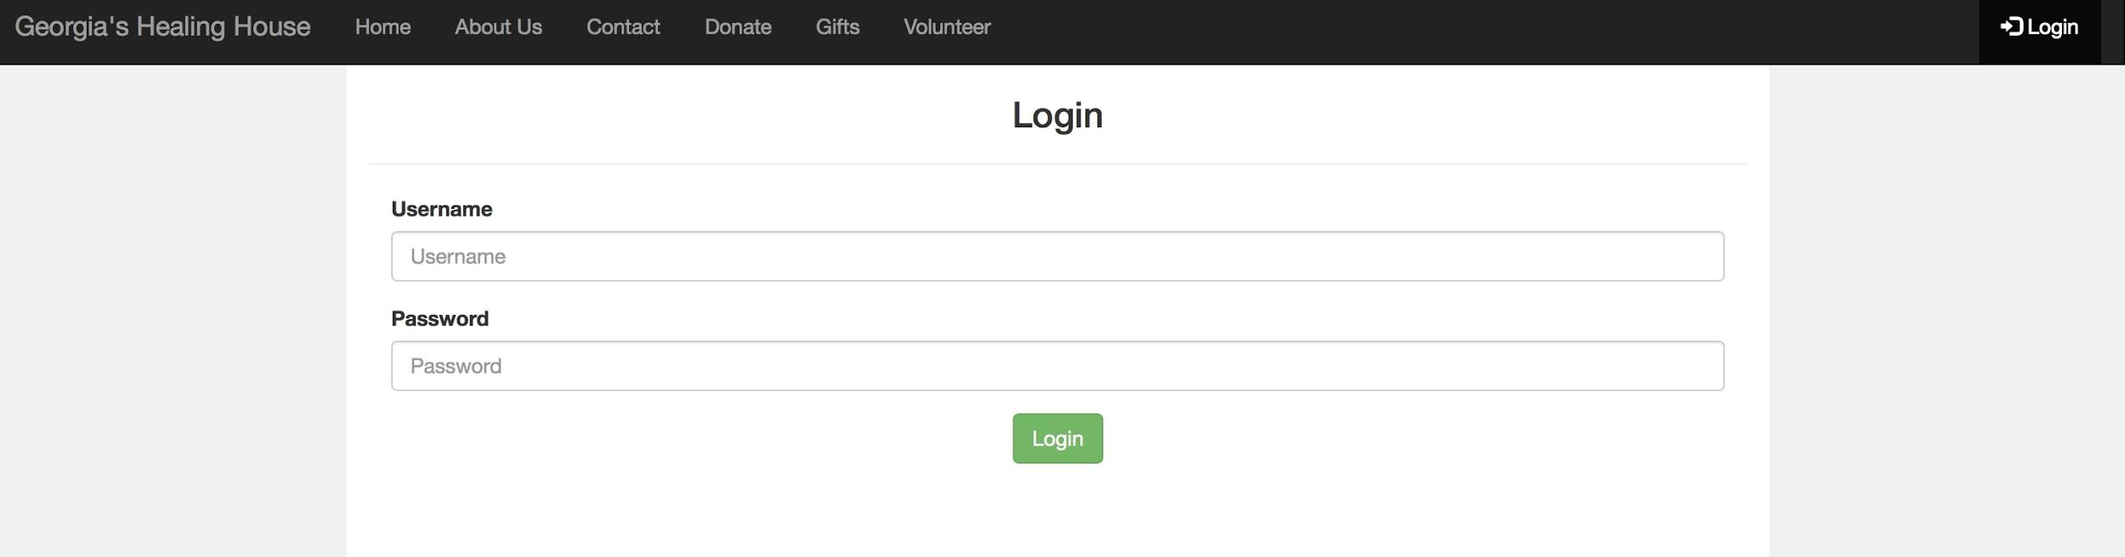
- Selecting “Login” will redirect you to a form in which you can enter your user information
- Upon successful login, you will be redirected to your personal user profile page

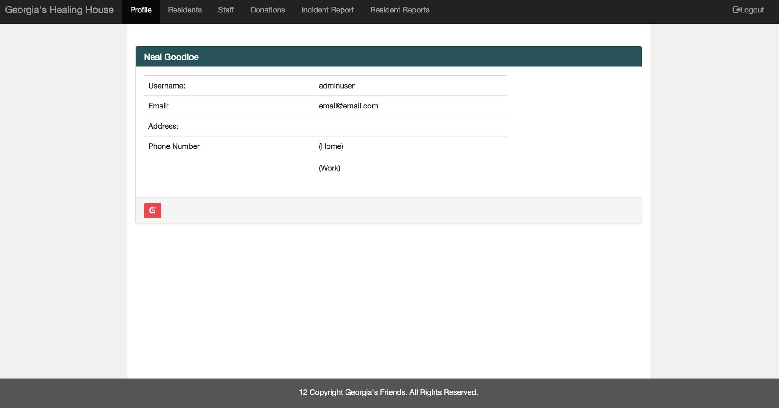

User profile edit
- Select the red edit button in the lower left hand corner of your user profile
- You will be redirected to an “Edit Profile” form in which you can alter any of you user profile information with the exception of username and password. Upon completion, select “Submit” and you will be redirected to the user profile page.

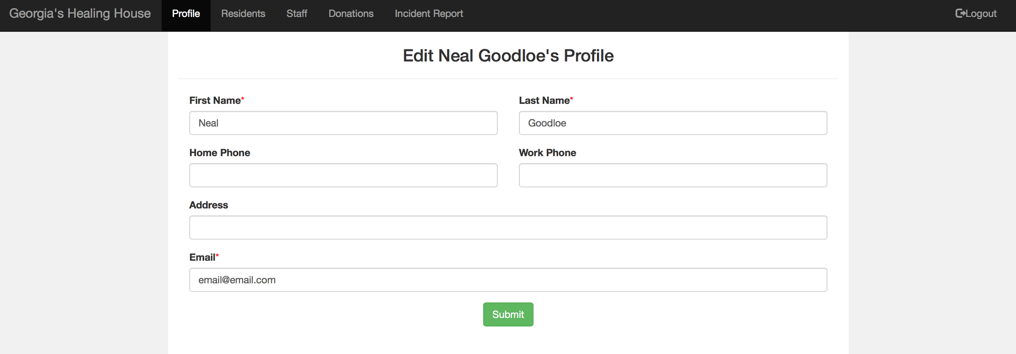

Application form submission
- Select the “Residents” tab in the navigation bar

- Select “Submit Application” located in the side navigation bar on the left hand side.

- Here, you will see a “Resident Application” form in which you can fill out an applicant’s information in the appropriate fields.

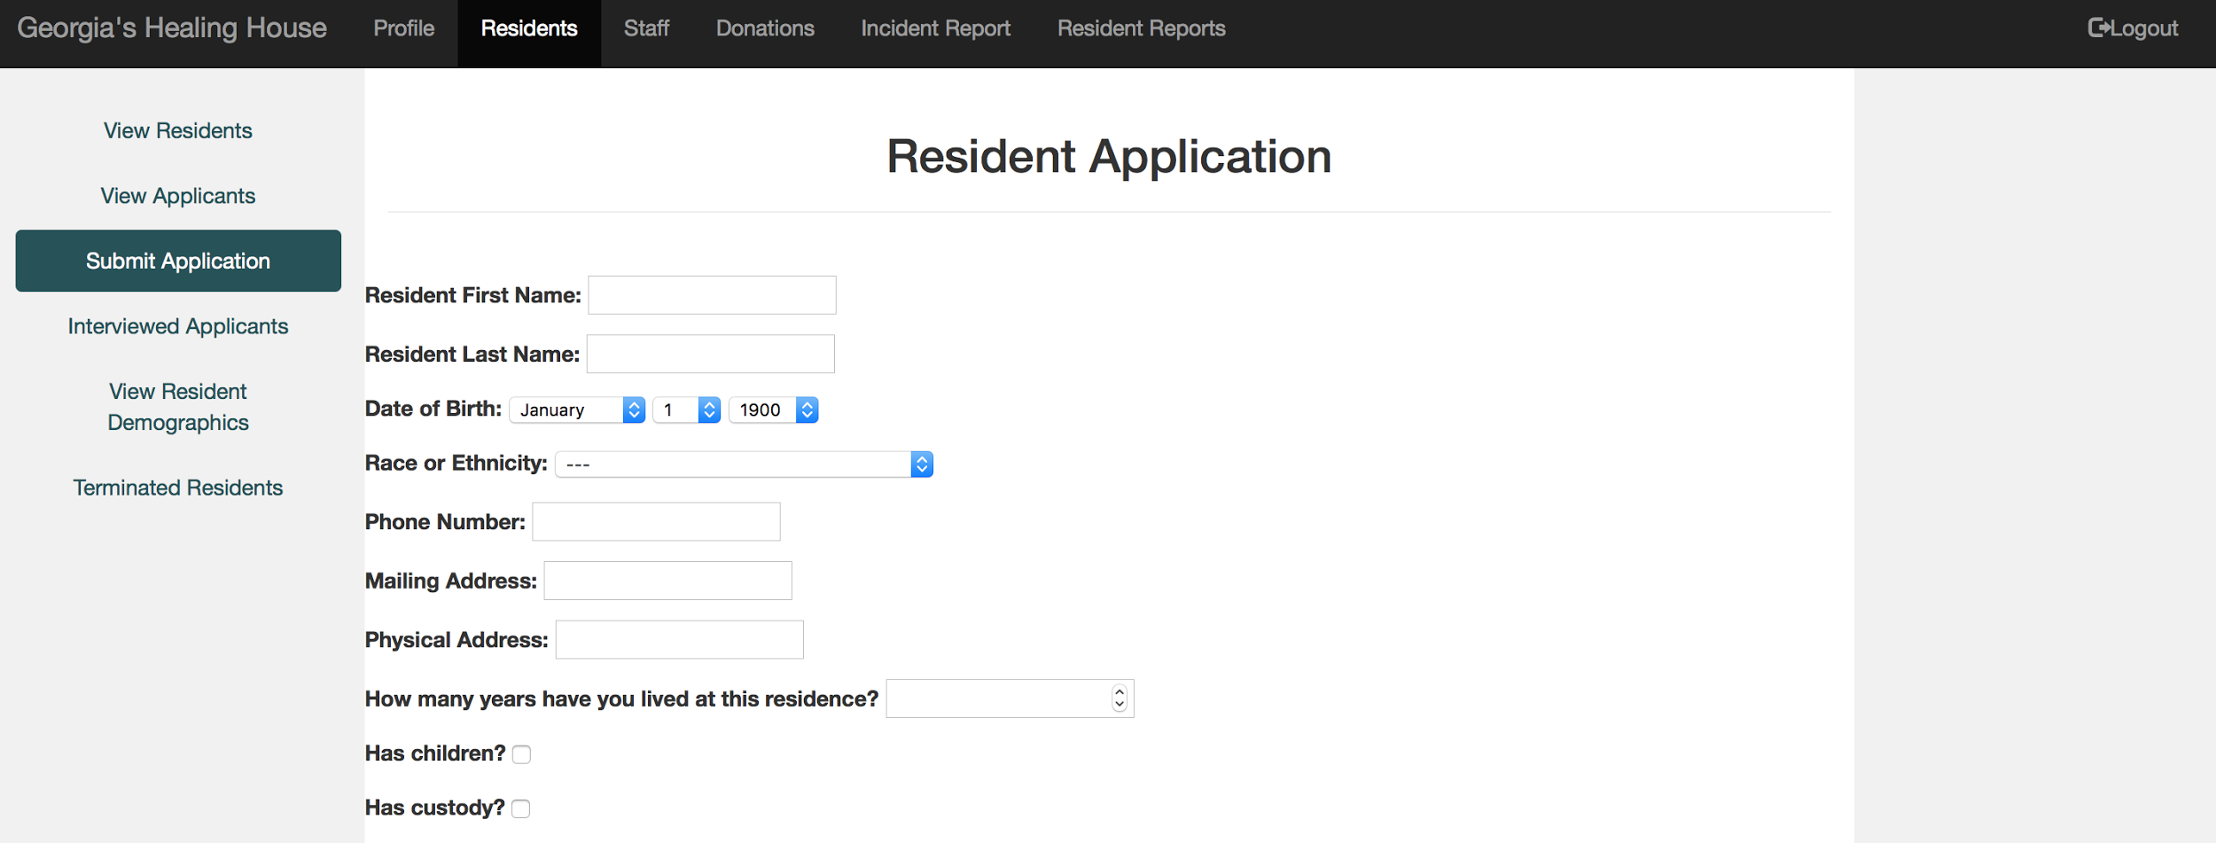
- Once you have reached the end of the application form, select “Submit”
- Upon successful submission of an applicant form, you will be redirected to “View Applicants” where the new applicant should be listed in the table

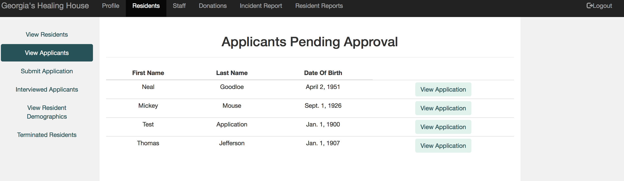
Accept/deny Applicant
- Select the “Residents” tab in the navigation bar

- Select “View Applicants” located in the side navigation bar on the left hand side
- Select “View Application” for the applicant who you wish to accept/deny.

- You will be redirected to a summary of that applicant’s application information

- Scroll to the bottom of the summary where you will find two options: “Approve for Interview” and “Terminate”


- Upon selecting “Approve for Interview”, you will be redirected to the first page of the interview form
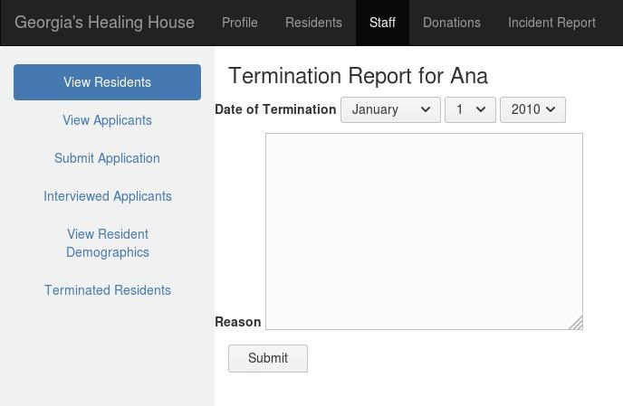
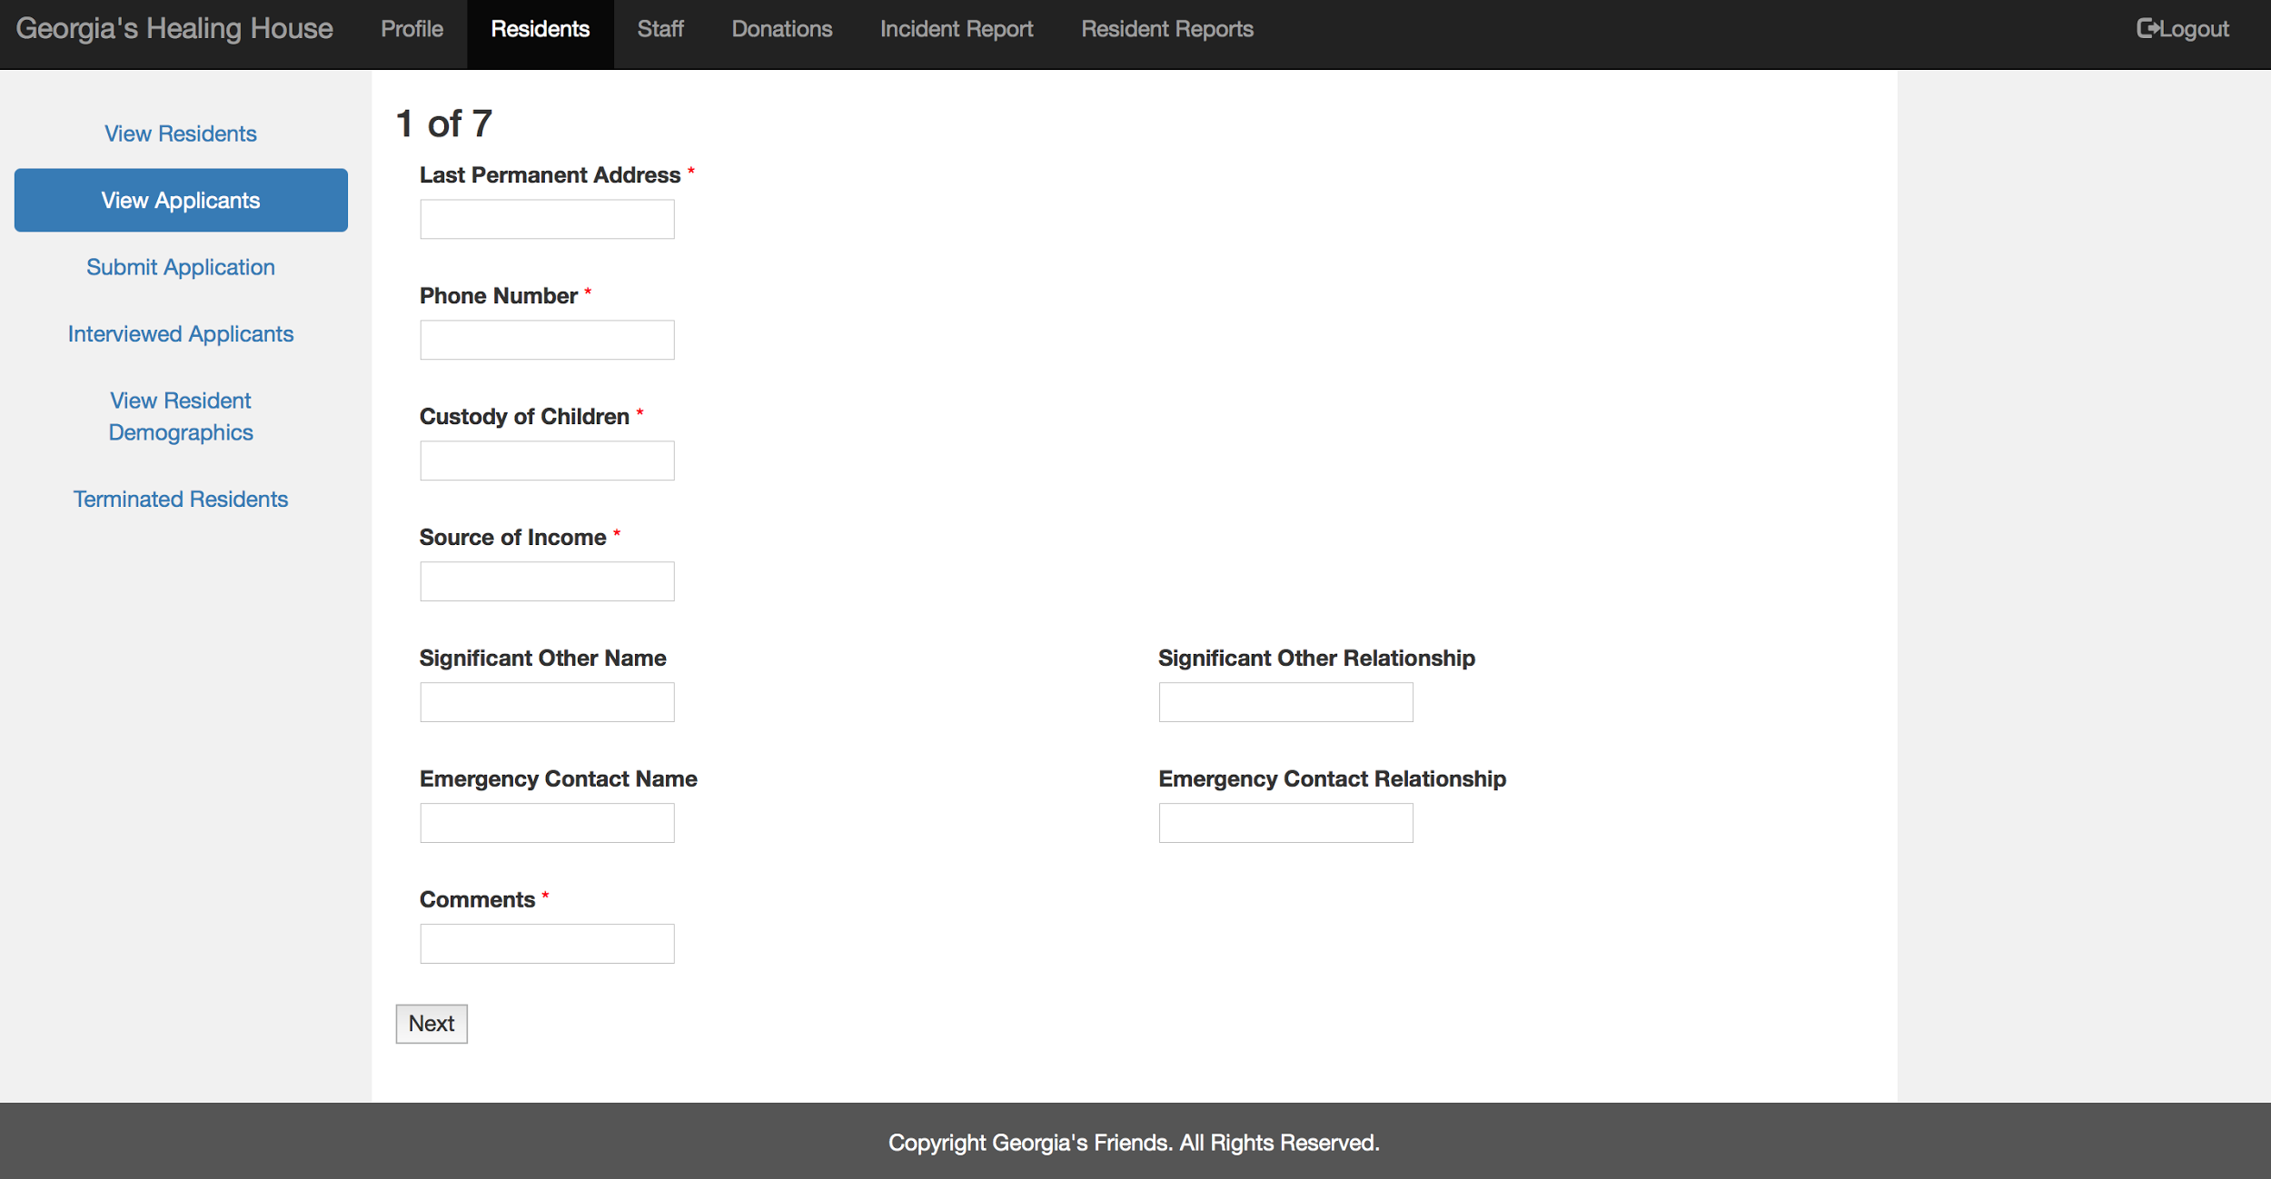
- Upon selecting “Terminate” you will be redirected to a termination form
Interview form submission
- After approving an applicant for an interview, you will be redirected to the first page of the interview form

- Fill out all the required information for each page (required fields are marked by a red star) for all 7 pages

- At the end of the interview form, select “Submit” and you will be redirected to the “Interview Applicants” tab where you will see the interviewee listed in the table

Accept/deny Interviewee
- Select the “Residents” tab in the navigation bar

- Select “Interviewed Applicants” located in the side navigation bar on the left hand side.

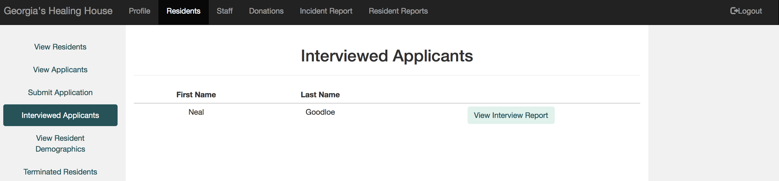
- Select “View Interview Report” for the interviewee who you wish to accept/deny
- You will be redirected to a summary of that interviewees interview form

- Scroll to the bottom of the summary where you will see two options: “Approve” and “Terminate”
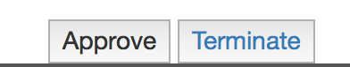

- If you select “Approve”, you will be redirected to “Current Residents” where you should see the approved interviewee listed as a resident in the table
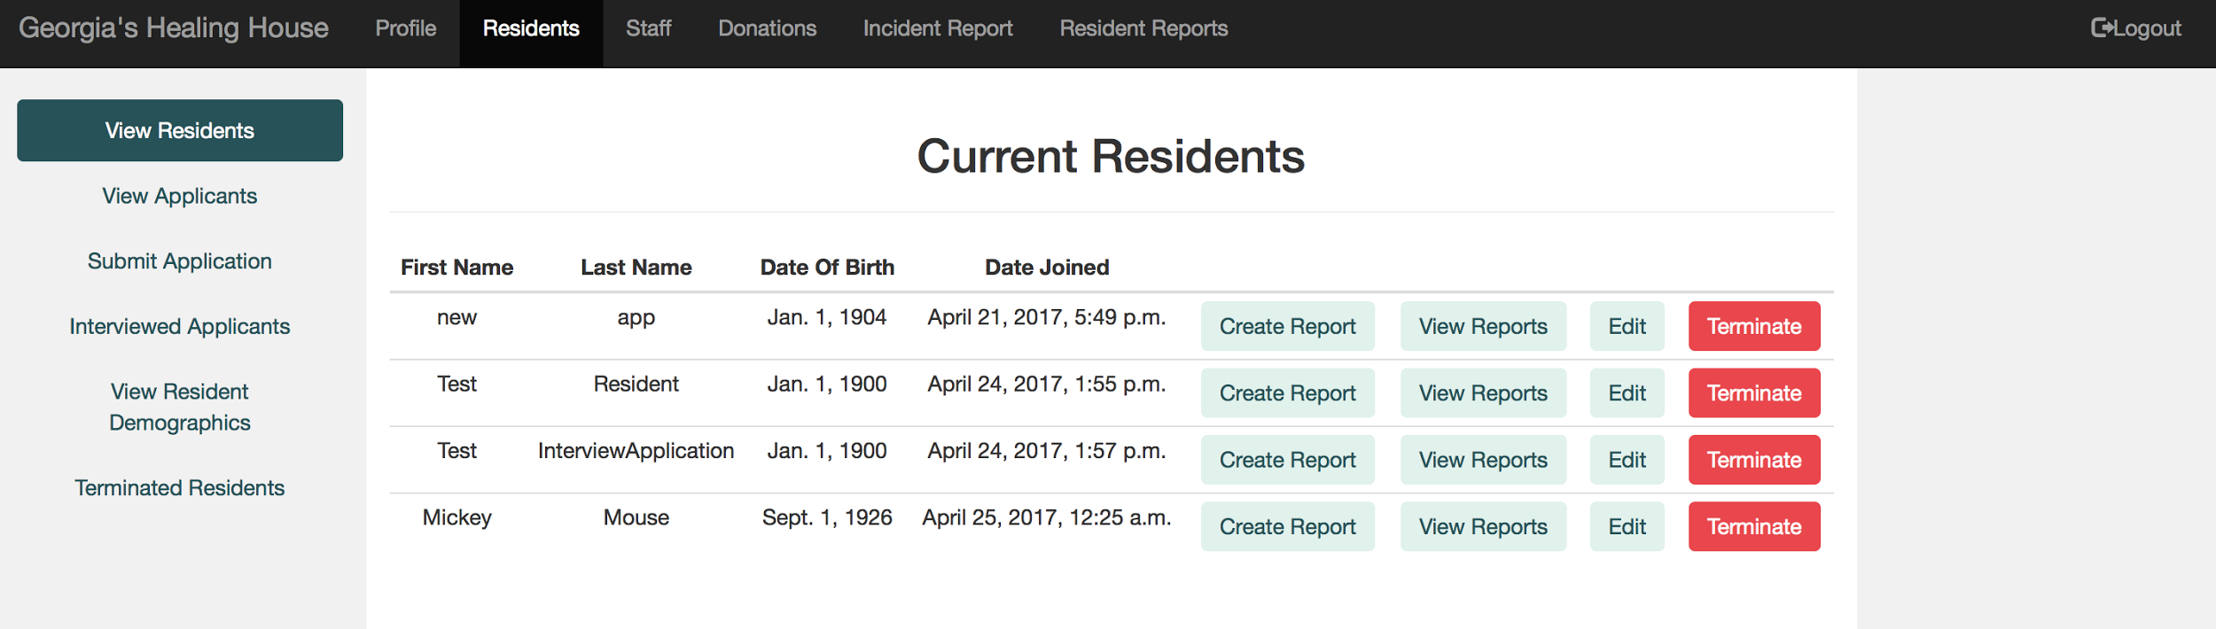
- Is you select “Terminate”, you will be redirected to a termination form

Individual Resident Report Submission
- Select the “Residents” tab in the navigation bar

- Select “View Residents” located in the side navigation bar on the left hand side

- Select “Create Report” for the Resident who you wish to submit an individual report for
- You will be redirected to a “Add new report” form for the resident you selected.

- Fill out the report information in the form and select “Submit” when finished. You will be redirected back to the list of current residents.

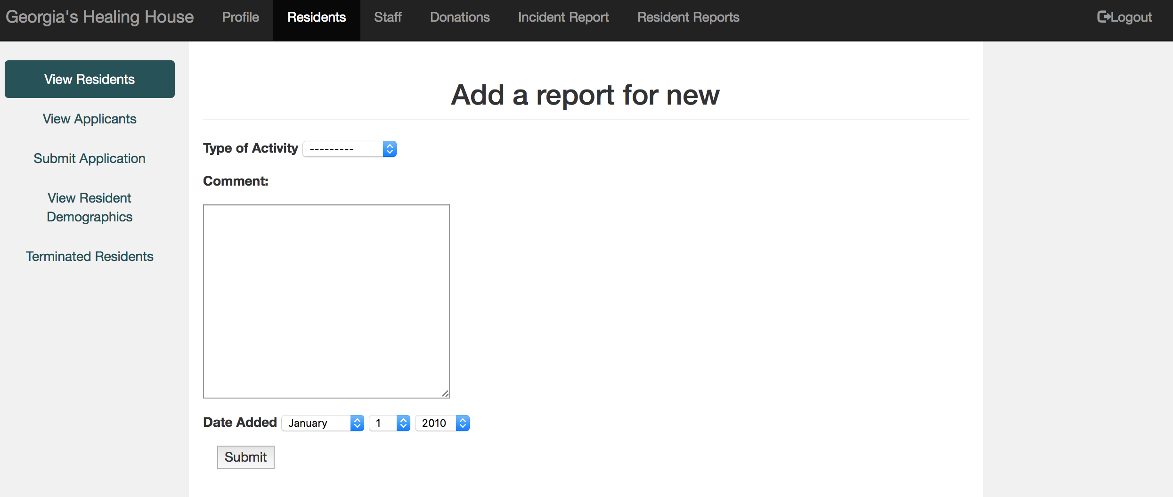

View Individual Resident Reports
- Select the “Residents” tab in the navigation bar

- Select “View Residents” located in the side navigation bar on the left hand side

- Select “View Reports” for the Resident whose reports you wish to see

- You will be redirected to a list of reports for the Resident who you have selected
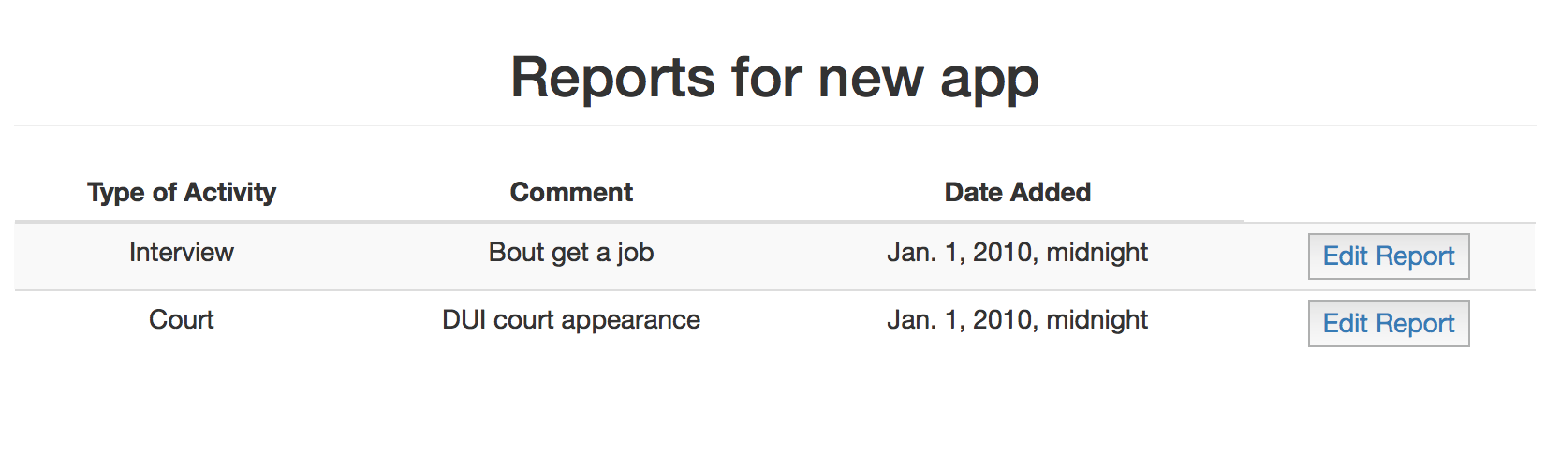

Donation submission
- Select the “Donations” tab in the navigation bar

- Select “List Donors” located in the side navigation bar on the left hand side

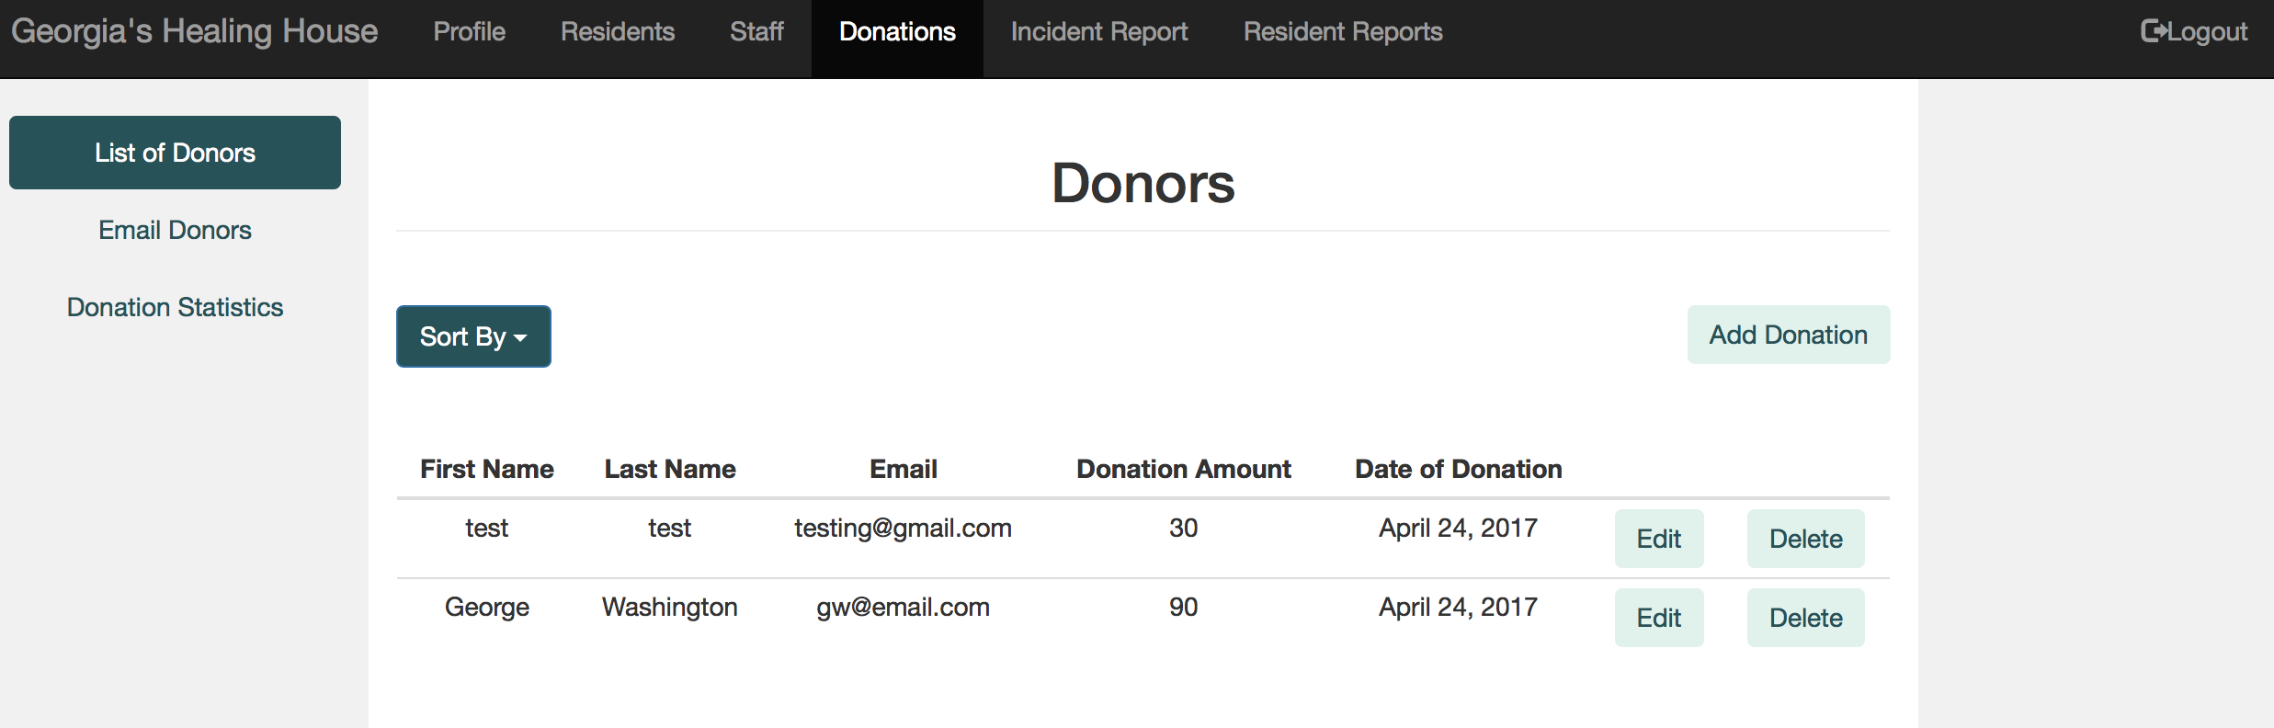
- Select “Add Donation” near the right hand side of the screen
- You will be redirected to a simple “Donation Information” form

- Select “Submit” when you have completed the form and you will be redirected to the list of donors.

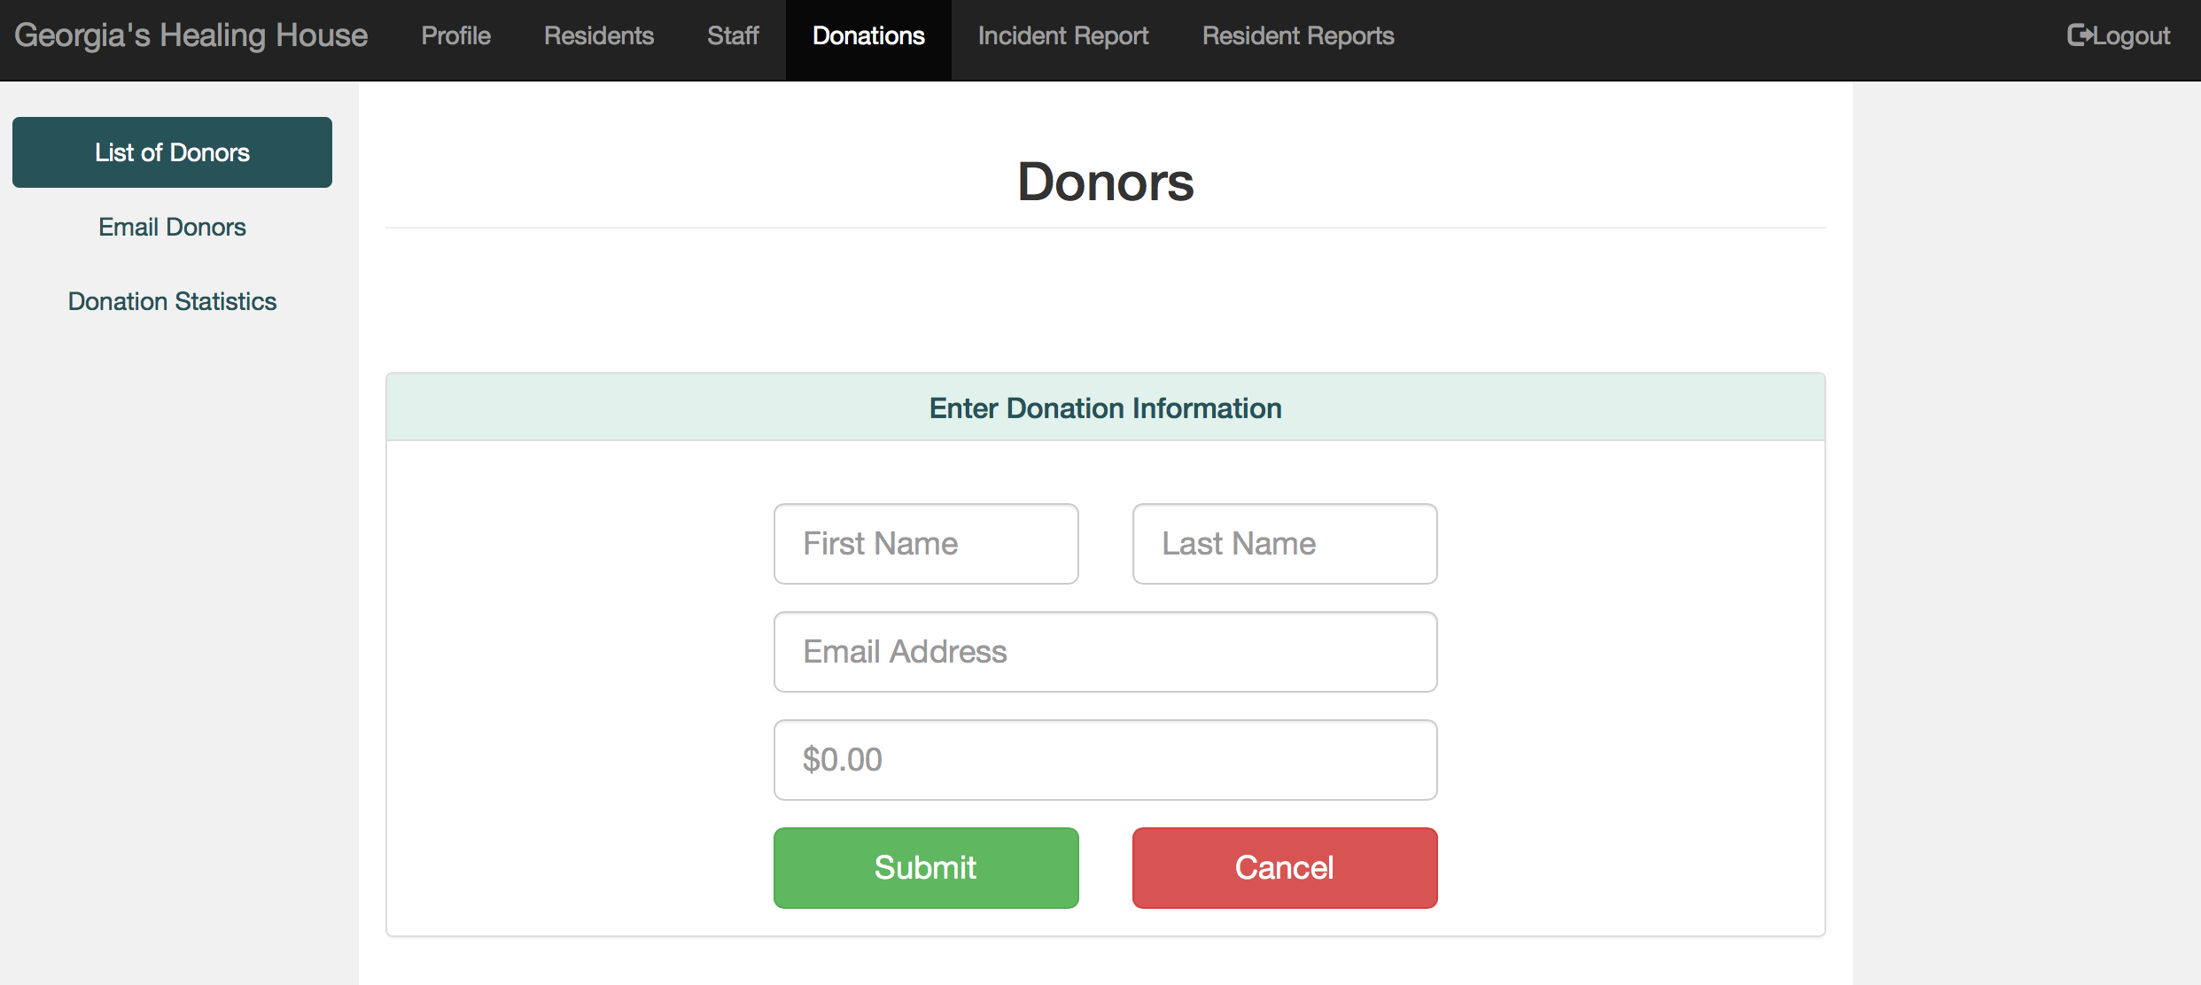

Email Donors
- Select the “Donations” tab in the navigation bar

- Select “Email Donors” located in the side navigation bar on the left hand side

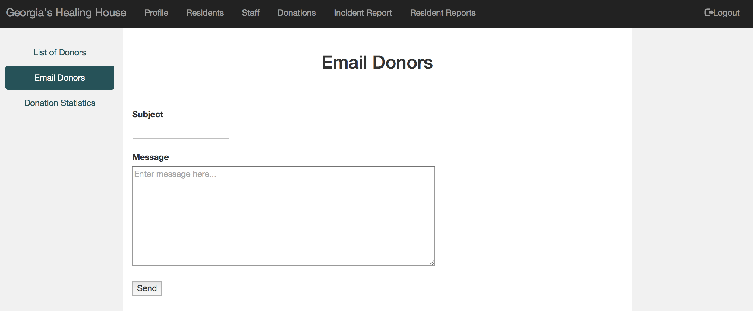
- You will be redirected to a form with a line labeled “Subject” and textbox labeled “Message”. The subject will be the subject of the email donors will see when you send out the mass email. The message will compose the contents of the mass email.

- When you select “Send”, a mass email will be sent out to all donors in the system.

Critical Incident Report submission
- Select the “Incident Report” tab in the navigation bar

- Select “Incident Reports” located in the side navigation bar on the left hand side

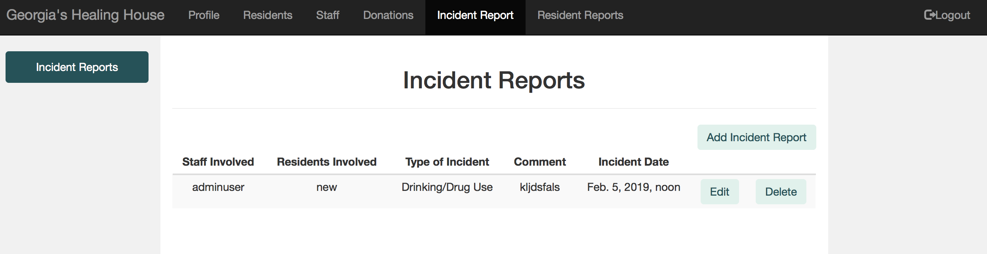
- Select “Add Incident Report” near the right hand side of the screen

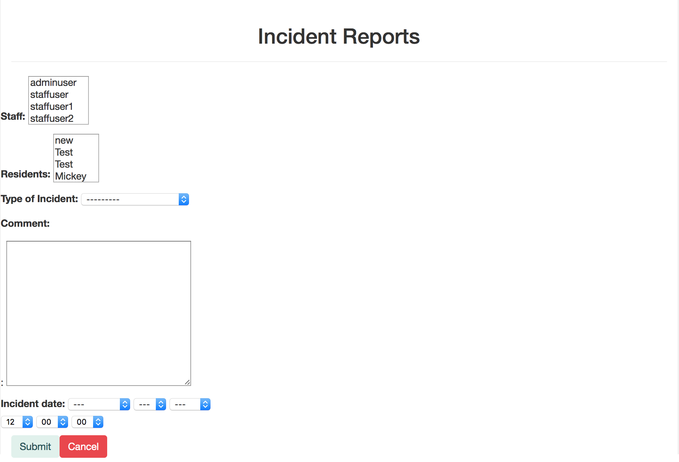
- You will be redirected to a “Incident Report” form

- Upon completion, select “Submit” and you will be redirected back to the list of incident reports

View Resident Activity Summary
- Select the “Resident Reports” tab in the navigation bar

- Select “Resident Reports” located in the side navigation bar on the left hand side

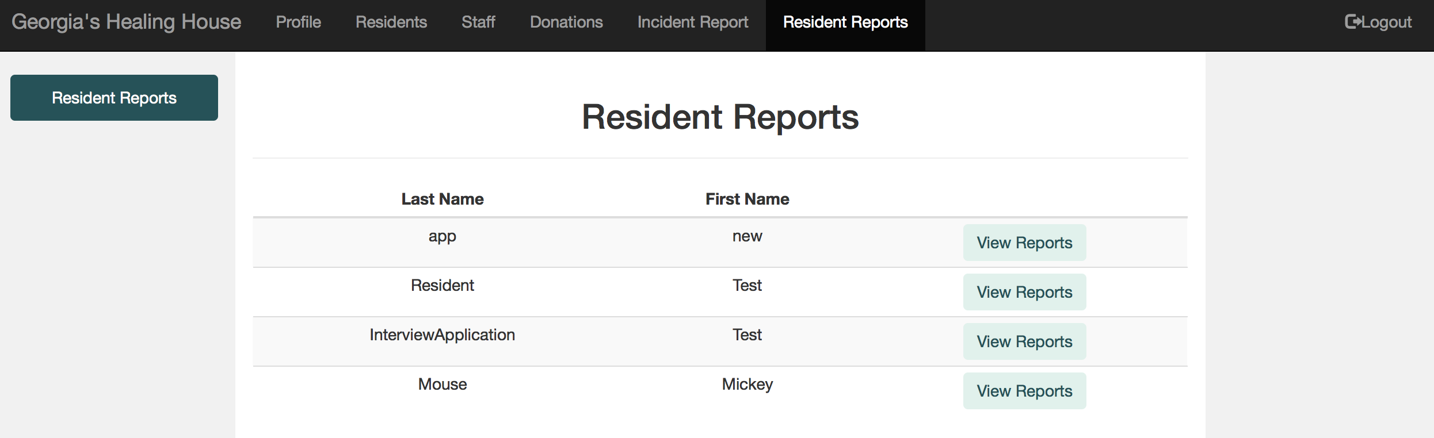
- Select “View Reports” for the Resident whose reports summary you wish to see
- You will be redirected to a view with 4 bars

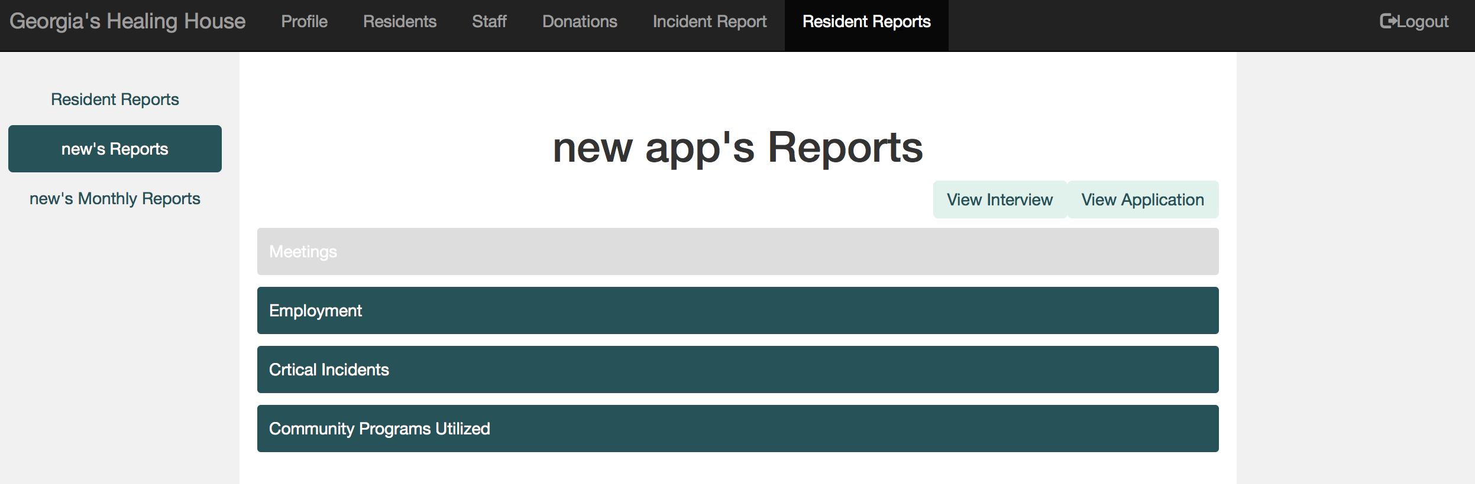

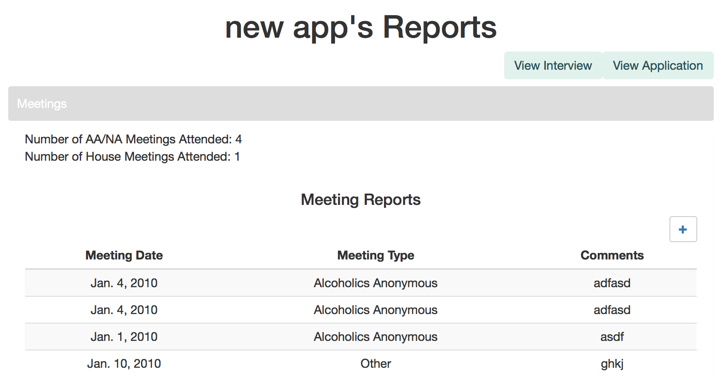
- Selecting the “Meetings” bar will show a summary of that Resident’s attendance at AA/NA meetings or house meetings.
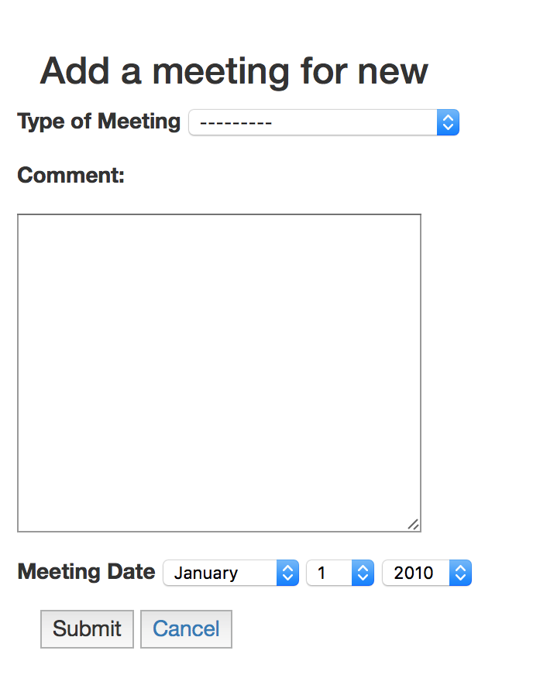
- The add button allows you to add a new meeting

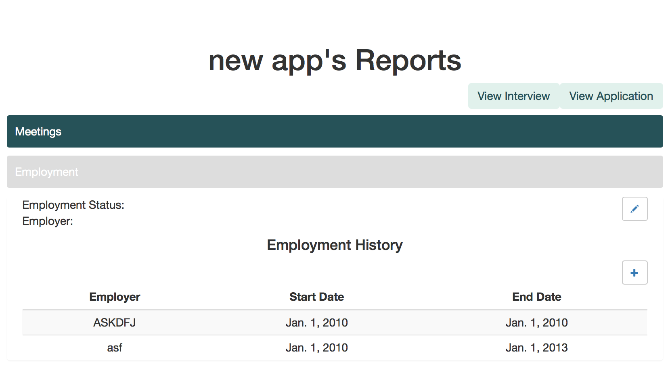
7. Selecting the “Employment” bar will show a summary of that Resident’s employment history while in the house.
8. The add button allows you to add a new place of employment
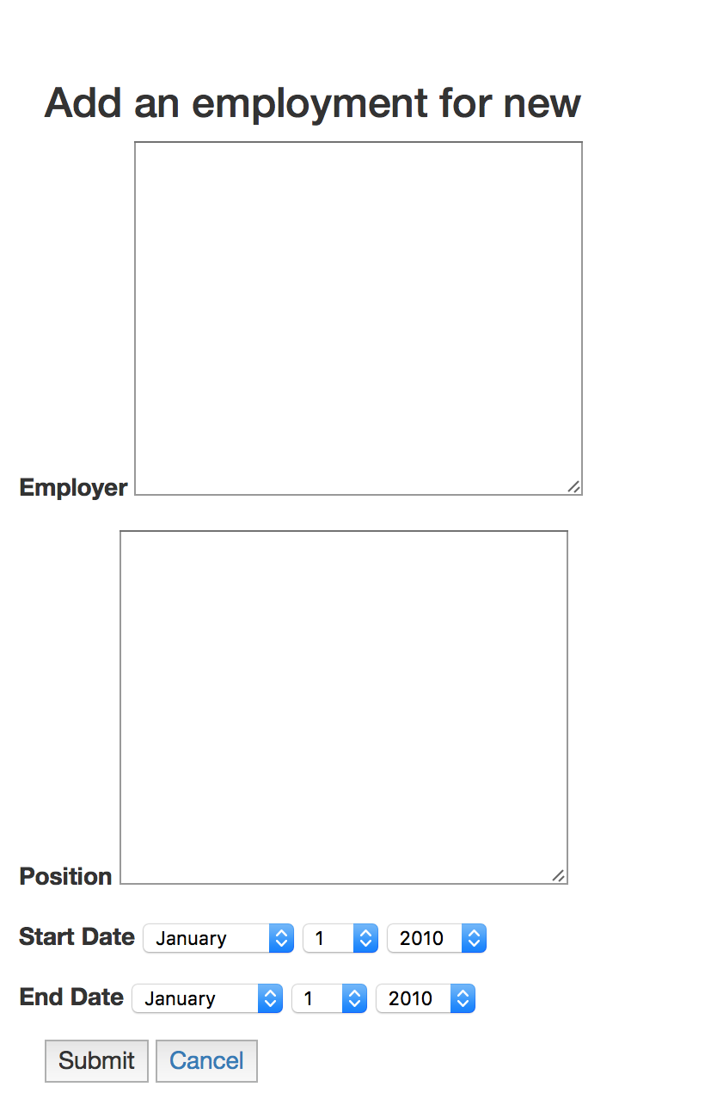
9. Selecting the “Critical Incidents” bar will show a summary of that Resident’s critical incidents while in the house.
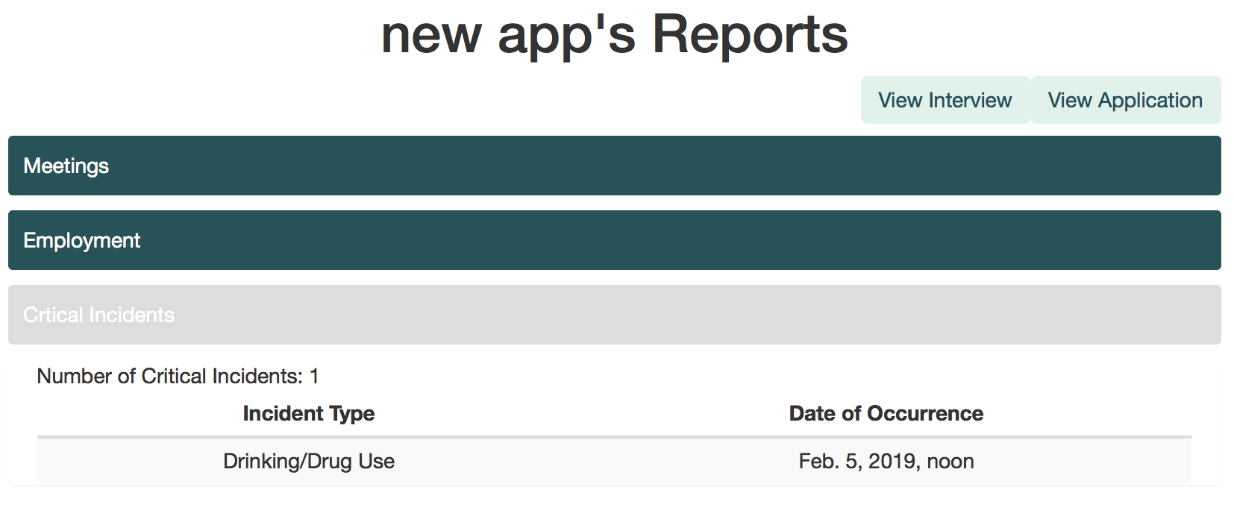
10. Selecting the “Community Programs Utilized” bar will show a summary of that Resident’s community program/service attendance while in the house.
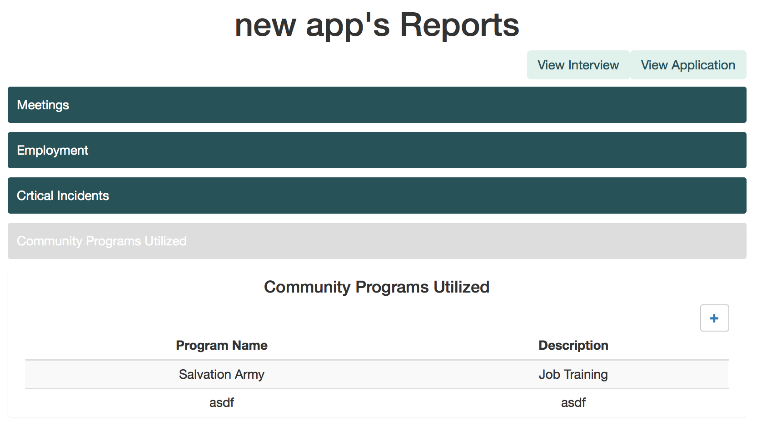

11. The add button allows you to add a new community program/service
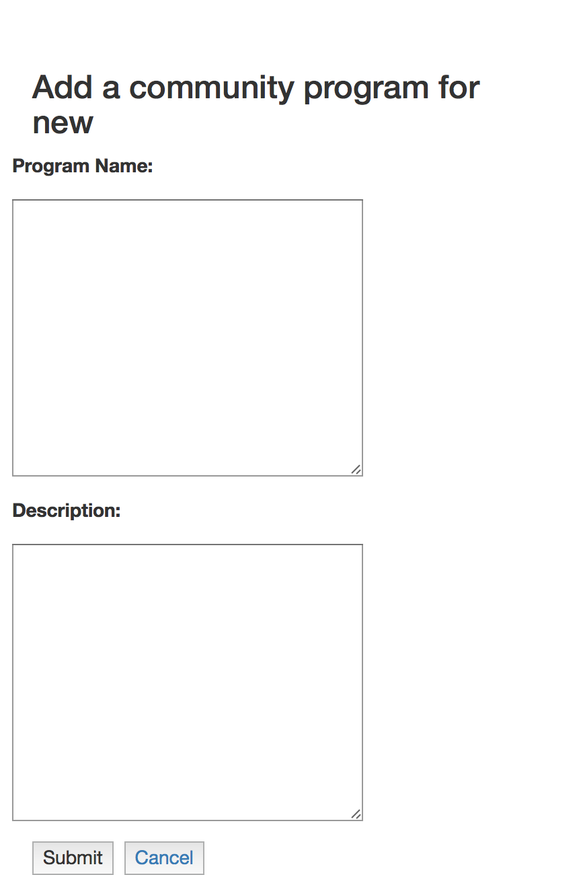

Filter Resident Activity Summary
- Select the “Resident Reports” tab in the navigation bar

- Select the “Monthly Reports” tab located in the side navigation bar on the left hand side
- You will be redirected to a view similar to that which was seen for the Resident Activity Summary

- Use the Filter option to select a date.

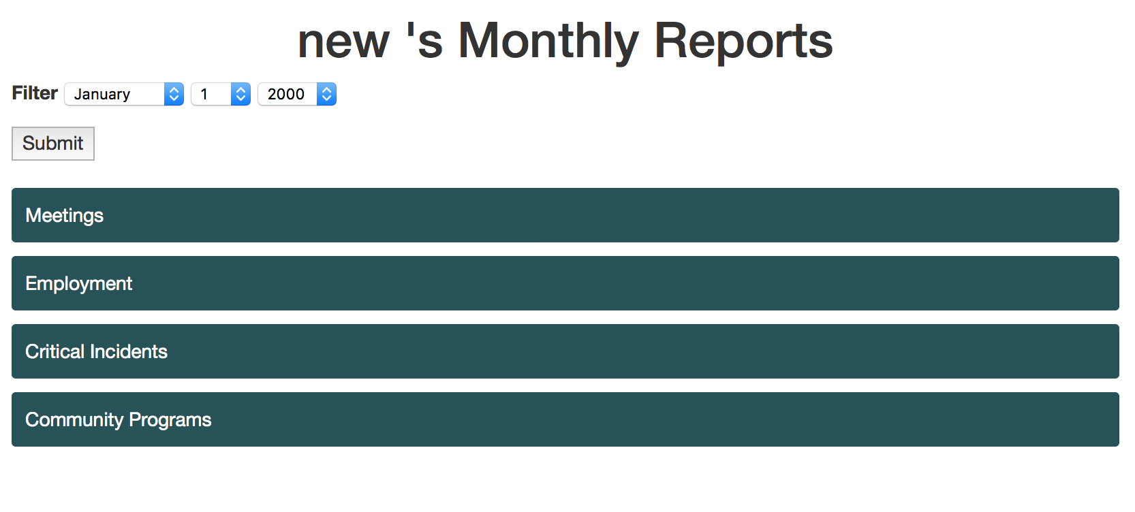
- This will filter out only the reports which correspond to those dates

Glossary |
Administrator - User level that has possesses all system privileges, including deleting and editing information and creating other administrators

Applicant - An individual who has completed the application process and is waiting to be interviewed

Approval - Admission of an Applicant/Interviewee to the next phase

Critical Incident - any event committed by a Resident that may have violated house rules or caused harm to another resident.

Disable User - make a Staff user inactive in the system (unable to login)

Donation - charity given to the house in monetary form

Enable User - make a Staff user active in the system (able to login)

Interviewee - Applicants that have been interviewed and whose interviews are being reviewed to be accepted or terminated.

Phase - one of the three steps a woman must go through to become a resident: Application, Interview, Admittance

Report - A summary of a Resident activity while in the house (includes court dates, therapy visits, interviews, employment, AA/NA meetings, community service, and critical incidents)

Resident - An individual who resides at the Georgia’s Healing House and passed the application and interview process.

Staff - User level that possesses all input privileges and some edit privileges

Termination - Remove a Resident from the system

