ICP2021 Lab XX report

Name: Christian Paul Domingo
Username: eeuc1c
Date prepared: 14 February 2012

Top left
clear all
clc
close all

%Assignment
x = rand(1,200);
y = (x.*10) - 5;
x = y;

plot(x);
axis([0 200 -5 5]);
title('Signal');

Top right
clear all
clc
close all

%Assignment
x = rand(1,200);
y = x; %diagonal line

z = rand(1,200);
i = 1;
while(size(z)~=200)

z = z(i);
if (z > y)
%print red stars
plot(x,z,'*',...
'markersize', 10,...
'markeredgecolor','r');
else
%print blue triangles
plot(x,'^',...
'markersize', 10,...
'markeredgecolor','b');
end
i = i+1;
z = z+1;
end

axis([0 1 0 1]);
title('Scatterplot');

---- Paste the code here ----

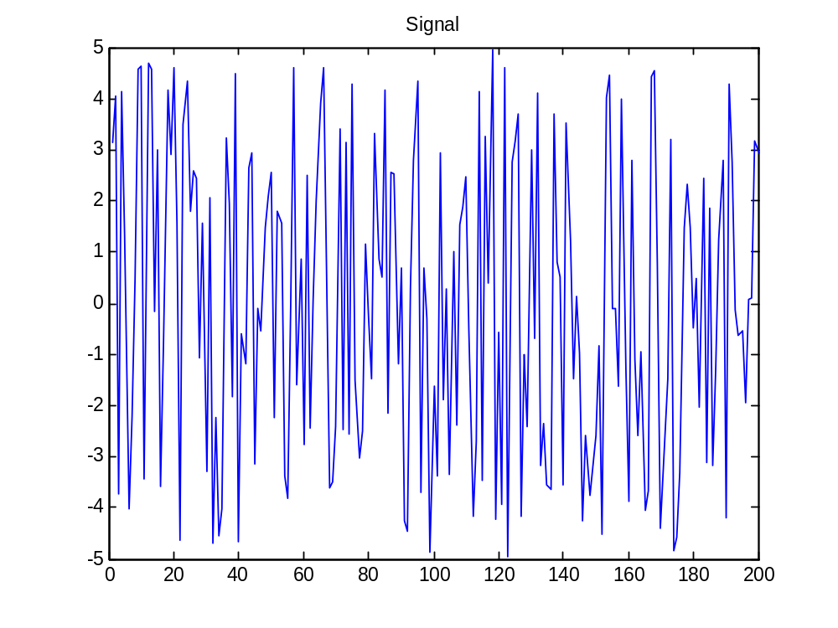

---- Paste Matlab output / figures here ----

---- Put additional comments here ----

