ICP2021 Lab XX report

Name: Christian Paul Domingo
Username: eeuc1c
Date prepared: 24 January 2012

clear all
clc
close all

% First attemp on MATLAB
a = eye(4);
b_a = [1 2 3 4; 5 6 7 8; 9 10 11 12; 13 14 15 16];
b_b = b_a + 3.5
c = a + b_b;
imagesc(c)

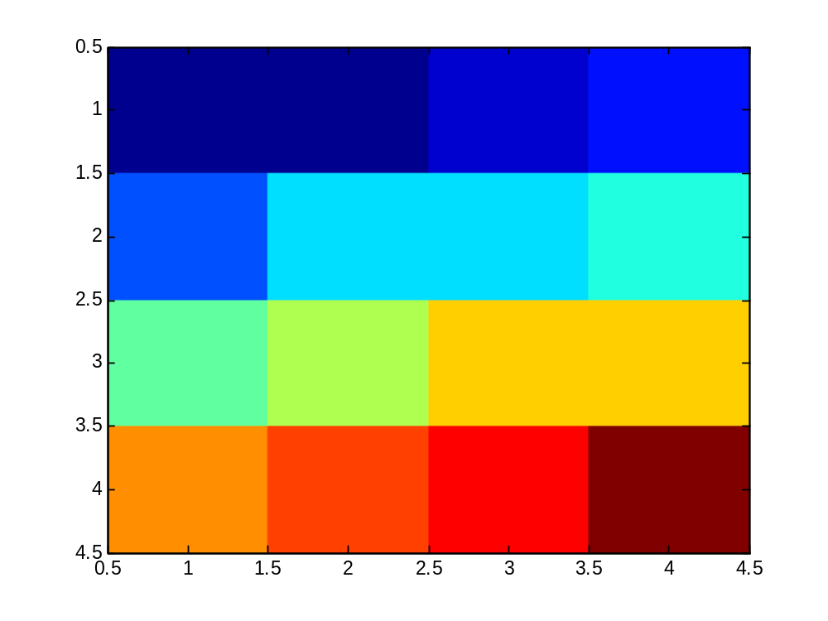

This is my first attempt on MATLAB

