ICP2021 Lab XX report

Name: Name: Christian Paul Domingo
Username: eeuc1c
Date prepared: 07 February 2012

clear all
clc
close all

%fig 1
x = 0:0.5:3;
subplot(1,2,1)
hold on
plot(x,x.^2,'k.-')
plot(x,sqrt(x),'r^-')
plot(x,log(x),'b*-')
axis tight
grid on
legend('x^2','sqrt(x)','log(x)',...
'location','NorthWest')
title('Function of x');
xlabel('x')

%continuation
x = 3:0.5:6;0
subplot(1,2,2)
hold on
plot(x,sqrt(x),'r^-')
plot(x,log(x),'b*-')
axis tight
grid on
axis([3 6 -1 9])
title('- continuation');
xlabel('x')

clear all
clc
close all

%(i) array of quantifiers
%(ii) nouns of expression
%(III) verbs
%(iv) another array one with nouns or expressions

i = {'all', 'few', 'many', 'several', 'some', 'every', 'each', 'one', 'none', 'no one'};
ii = {'Government', 'you', 'I', 'Thomas', 'Europe', 'animals', 'University', 'politicians'};
iii = {'eat', 'drink', 'grow', 'walk', 'run', 'jump', 'sing', 'hugs', 'adore', 'look', 'headbutted', 'hates'};
iv = {'the world', 'ACTA' , 'hogwarts!', 'like a G6', 'and goes mental','like an owl','to music','is alone','arguement is invalid','Lord of the Rings','the Hulk!'};

theString = i(ceil(rand*10)) ii(ceil(rand*10)) iii(ceil(rand*10)) iv(ceil(rand*10))
disp(theString)

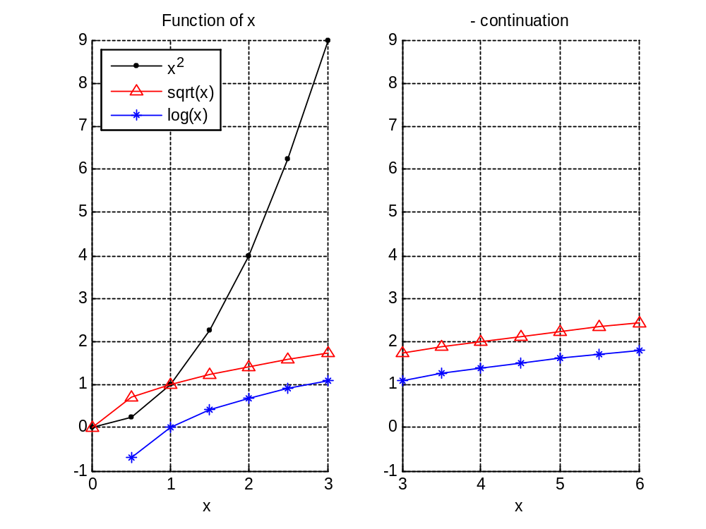

---- Put additional comments here ----

