Week 3 Day 1 Assignment

Topic: Implement playwright/typescript with vibe coding

Prompt used:

Analyze my entire code base for selenium java (Feature file, page class, Feature+page class).

Go step by step. Once on my approval proceed with next step

-- Also analyze what combination of automation frameworks is currently available and not available.
- -Analyze what is currently working and not working.
-- Give the files in which implementation is done
-- Proceed with Playwright Typescript implementation

Start in Ask mode
Model: Claude Haiku 4.5

Analysis of the codebase structure to provide comprehensive analysis report.

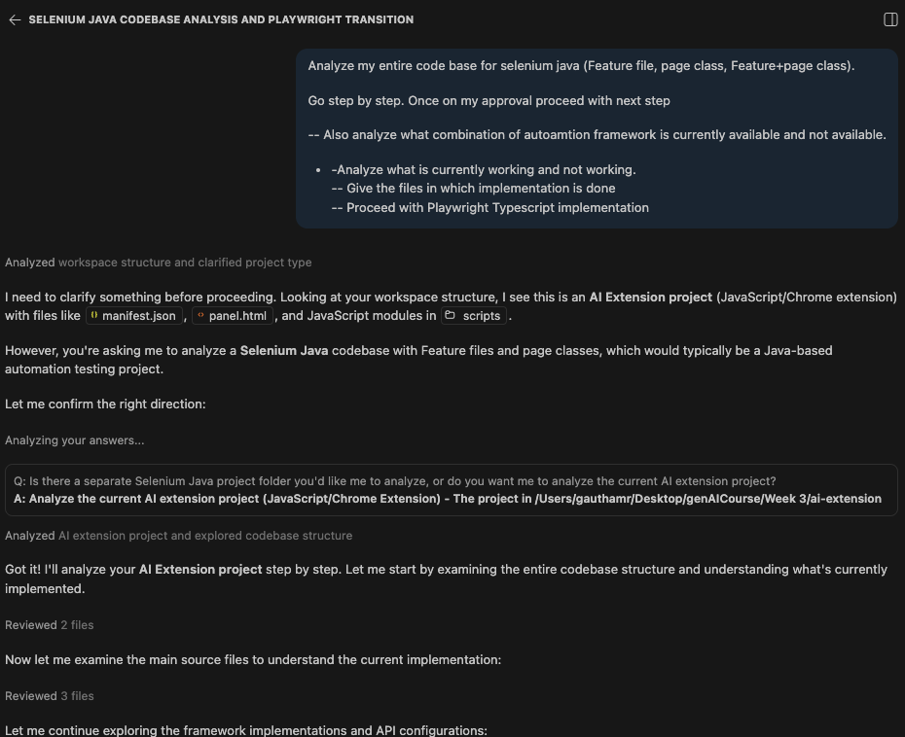

STEP 1: CODEBASE ANALYSIS COMPLETE

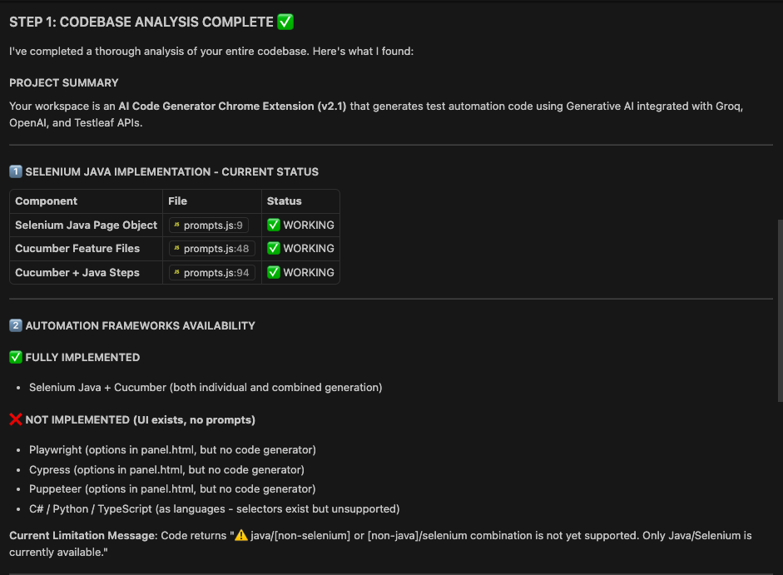

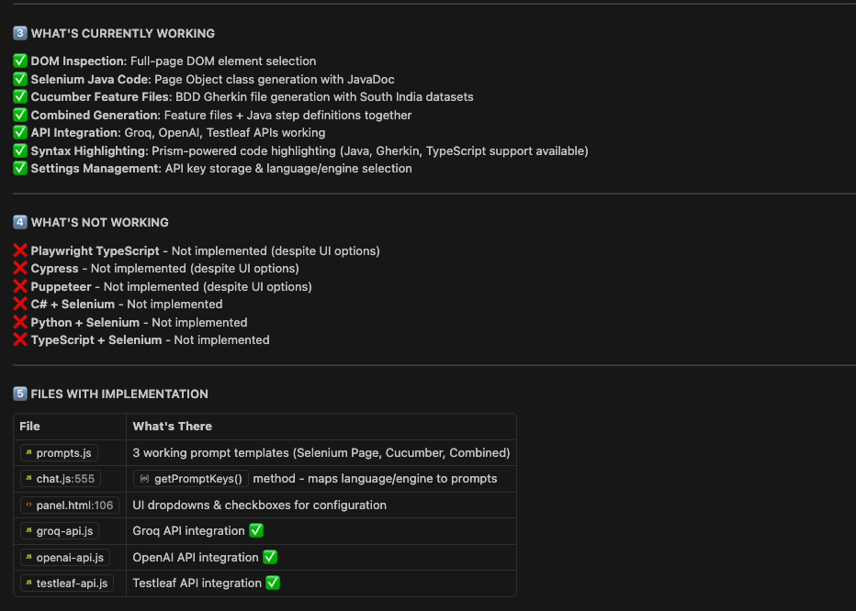

STEP 2: AUTOMATION FRAMEWORK IMPLEMENTAION

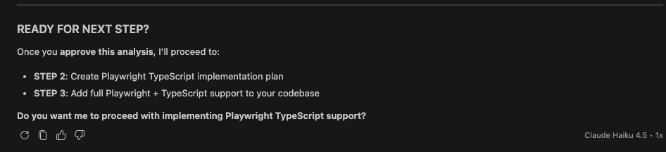

Switching to Agent mode for implementation.

“Proceed with implementing Playwright TypeScript support”

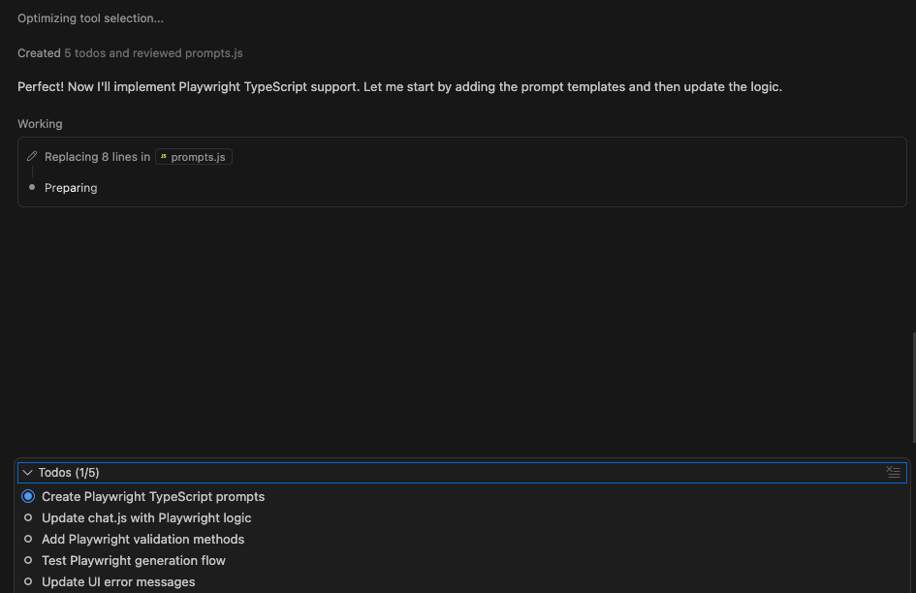

POST COMPLETION
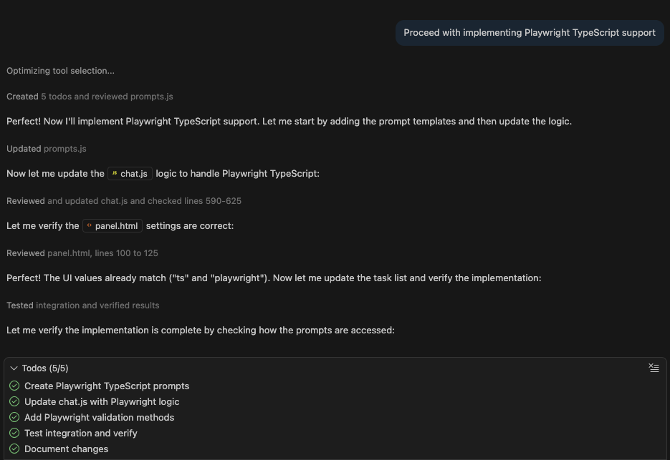

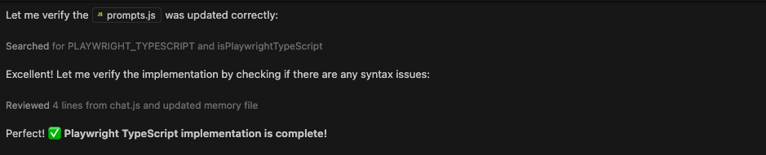

STEP 2: PLAYWRIGHT TYPESCRIPT IMPLEMENTED

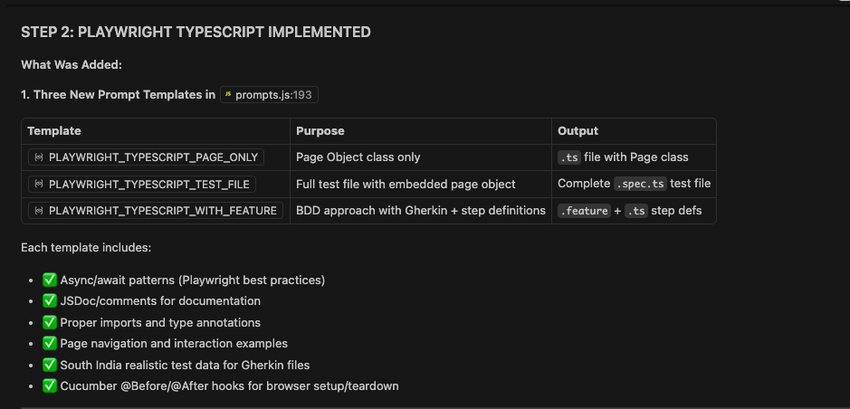

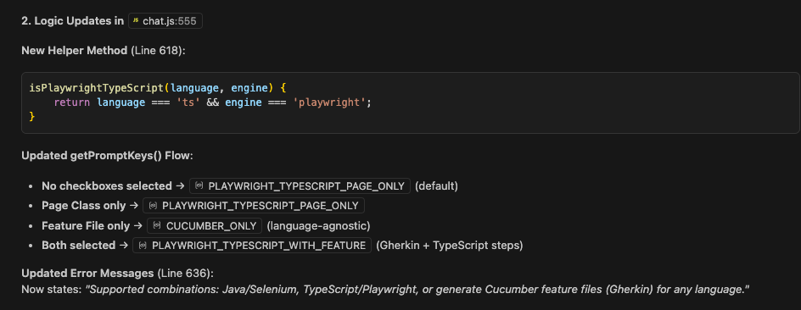

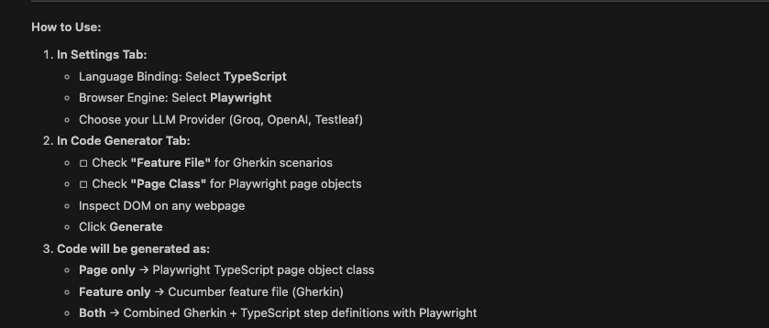

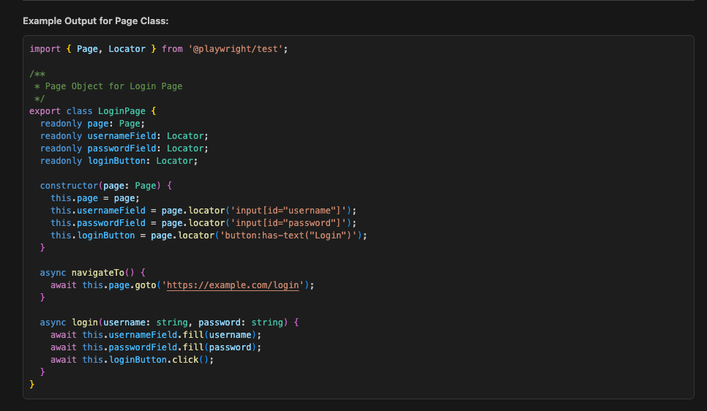

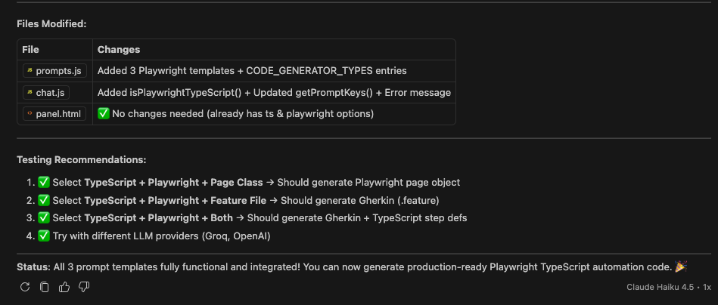

Verifying in the extension

Generation of Feature file

Feature: Hero section CTA navigation on Ibotta homepage

As a South Indian user exploring cash‑back offers,
I want to verify that the hero call‑to‑action buttons
navigate to the correct destination pages.

Background:
Given I open the Ibotta homepage

Scenario Outline: Verify "<ctaLabel>" button redirects correctly for users from <city>
Given I am a user from "<city>"
When I should see the hero heading "Make Every Purchase Rewarding"
And I click the "<ctaLabel>" button
Then I should be navigated to "<expectedUrl>"

Examples:
| city | ctaLabel | expectedUrl |
| Chennai | Get cash back | https://home.ibotta.com |
| Bengaluru | Explore solutions| https://ipn.ibotta.com/brand-solutions |
| Hyderabad | Get cash back | https://home.ibotta.com |

Generation of Playwright TypeScript page object class

import { Before, After, Given, When, Then } from '@cucumber/cucumber';
import { chromium, Browser, Page, expect, Locator } from '@playwright/test';

// ---------- Global test objects ----------
let browser: Browser;
let page: Page;

// ---------- Page Object Model ----------
class HeroSection {
readonly page: Page;
readonly heading: Locator;
readonly getCashBackBtn: Locator;
readonly exploreSolutionsBtn: Locator;

constructor(page: Page) {
this.page = page;
this.heading = page.locator('h1.HeroTextCTAs_heading__Aa15y');
this.getCashBackBtn = page.locator('a:has-text("Get cash back")');
this.exploreSolutionsBtn = page.locator('a:has-text("Explore solutions")');
}

async clickButton(label: string) {
if (label === 'Get cash back') {
await this.getCashBackBtn.click();
} else if (label === 'Explore solutions') {
await this.exploreSolutionsBtn.click();
} else {
throw new Error(`Unsupported CTA label: ${label}`);
}
}
}

// ---------- Hooks ----------
Before(async () => {
// Explicitly use Chromium
browser = await chromium.launch({ headless: true });
const context = await browser.newContext();
page = await context.newPage();
});

After(async () => {
if (page) await page.close();
if (browser) await browser.close();
});

// ---------- Step Definitions ----------
Given('I open the Ibotta homepage', async () => {
await page.goto('https://ibotta.com/');
});

Given('I am a user from {string}', async (city: string) => {
// In a real test we might set a location cookie or mock geolocation.
// Here we simply log the city for traceability.
console.log(`Simulating user location: ${city}`);
});

When('I should see the hero heading {string}', async (expectedHeading: string) => {
const hero = new HeroSection(page);
await expect(hero.heading).toHaveText(expectedHeading);
});

When('I click the {string} button', async (ctaLabel: string) => {
const hero = new HeroSection(page);
await hero.clickButton(ctaLabel);
});

Then('I should be navigated to {string}', async (expectedUrl: string) => {
// Wait for navigation to complete and verify the URL.
await page.waitForLoadState('load');
await expect(page).toHaveURL(expectedUrl);
});

