Week 3 Day 2 Assignment

Home Assignment

With vibe coding implement the below

1)Connect to jira via api
2)Fetch the user storie from jira to generate testcases

Prompt Used:

Analzye my existing code base and Implement Jira integration
GO STEP BY STEP up on my approval proceed with next step
--[Mandatory] Backend first then proceed with Frontend

Instruction
[MANDATORY] Implement Jira connectivity email,api key should be configurable
[CRITICAL] Fetch the Projects from Jira (Projects should be autopopulated as dropdown)
[CRITICAL] Fetch User stories for the project (user stories should be autpopulated
as dropdown)

REFER MY POSTMAN COLLECTION

--There was some jira fetch issue Debugged and Implemented successfully
--Prompt response not added as multiple debugging requires to be carried and implementation by changing the next high end model in the Agent

Back end Ran Successfully:
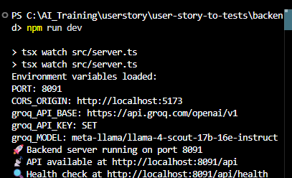

Front end Ran Successfully:

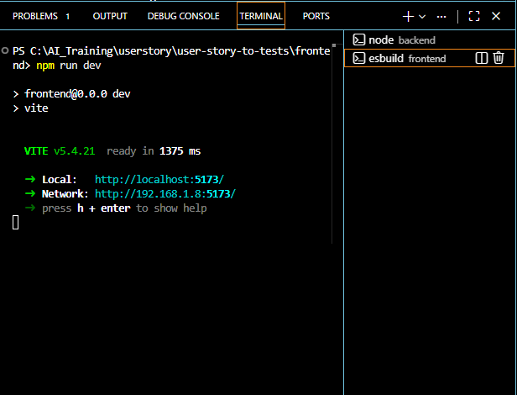

Tool:

