DEPARTMENT OF COMPUTER SCIENCE & ENGINEERING
Mini Project (BCS 752)

SESSION 2026-27
Submitted By: Submitted to:
Name:Shikha Tiwari Prof. Neha Pal
Roll no:248205

KAMLA NEHRU INSTITUTE OF TECHNOLOGY, SULTANPUR, (U.P.)
(An Autonomous Govt. Engineering Institute under 2F and 12B of UGC Act)

Affiliated to
DR. A.P.J. ABDUL KALAM TECHNICAL UNIVERSITY, LUCKNOW (U.P.), INDIA

CERTIFICATE
This is to certify that Shikha Tiwari has successfully completed the CyberSecurity Project QR-Shield under the guidance of prof. Neha Pal from Kamla Nehru Institute Of Technology Sultanpur during the academic year [2026-2027].
This comprehensive project involved the application of various CyberSecurity and Machine Learning technologies and tools, and Shikha Tiwari demonstrate commendable skills, dedication, and creativity throughout the project’s lifecycle.
This certificate is awarded in recognition of Shikha Tiwari exemplary performance, dedication, and successful completion of the QR-Shield tamper Detection Project. The skills acquired and demonstrated during this project are a testament to her commitment to academic excellence and the pursuit of knowledge.
We Wish Shikha Tiwari continued success in her academic and professional journey.
(Prof. Neha Pal)

ACKNOWLEDGEMENT
Apart from my effort, the success of the project depends largely on the encouragement and guidelines of many others. We take this opportunity to express our gratitude to the people who express have been instrumental in the successful completion of this project.
I would like to express my deep and sincere gratitude to my supervisor Prof .Neha Pal, who gave me his full support and encouraged me to work in an innovative and challenging project for the educational field. His wide knowledge and logical thinking gave me right direction all the time. I am deeply grateful my project coordinator for his help and support provided at every step of the project.
Last but not the least, I thank to all friends and family for their support and cooperation.

ABSTRACT
The Computer Vision & Graphic Tamper Detection System for QR Code Phishing (Quishing) is an advanced security application developed to protect users from deceptive and malicious QR code attacks. The primary objective of this project is to detect physical and digital tampering—such as sticker-over fraud where malicious codes are pasted over legitimate public notices—and to analyze the safety of the underlying destination URLs before a user falls victim to credential harvesting or malware. The platform aims to bridge critical security gaps in modern mobile and physical environments by providing a reliable, automated defense mechanism against evolving social engineering vectors.
The system is developed using Python, leveraging state-of-the-art computer vision libraries such as OpenCV and Pillow for image processing, geometric contour analysis, and QR code localization. Machine learning libraries and classification models (such as Scikit-learn and XGBoost or PyTorch for deep-learning-based tamper classifiers) are utilized to evaluate URL structural heuristics and detect visual artifacts. A robust backend framework manages image ingestion pipelines, processes analysis requests, and communicates threat verdicts securely via RESTful APIs or a lightweight web interface.
The application provides essential security functionalities, including automated QR code detection, finder pattern verification, physical tamper and compression artifact analysis, and comprehensive URL risk scoring based on attributes like domain length, entropy, raw IP presence, and suspicious keywords. It also includes logging and reporting features to record threat telemetry and system performance metrics. The application follows a modular client-server architecture, allowing frontend submission clients and backend processing nodes to communicate efficiently.
In conclusion, the Computer Vision & Graphic Tamper Detection System offers a practical, scalable, and proactive solution for countering modern QR code phishing. It demonstrates the effective application of computer vision and machine learning technologies to safeguard everyday consumers and enterprises against sophisticated visual fraud. The project can be extended in the future with real-time webcam video stream scanning, advanced convolutional neural network (CNN) models for sticker detection, and direct integration with threat intelligence feeds.

Table Of Contents
Contents | Page No.
Certificate of Completion | ii
Acknowledgement | iii
Abstract | iv
Table of Contents | –
List of Tables and Figures | –
List of Symbols and Abbreviations | –
1. Introduction | 1
1.1 Introduction to the Project | 1
1.2 Significance of the Project | 1
1.3 Purpose of the Report | 2
2. Problem Statement and Objectives | 3
2.1 Problem Statement | 3
2.2 Objectives of the Project | 3–4
2.3 Scope of the Project | 4–5
3. Literature Survey / Related Work | 6
3.1 Review of Existing Systems | 6–7
3.2 Related Technologies | 7–8
4. Methodology and Implementation | 9
4.1 System Design and Architecture | 9–10
4.2 Hardware and Software Requirements | 10–11
4.3 Database Design | 11–12
4.4 System Workflow Design | 12
4.5 Testing Methodology | 13
5. Results and Analysis | 14
5.1 Practical Results | 14
5.2 Functional Testing | 15
5.3 Analysis and Performance | 15–17
6. Conclusion and Future Scope | 18–19
7. References / Bibliography | 20

List of Tables & Figures
S. No. | Title | Page No.
Table 1 | Hardware Requirements | 10
Table 2 | Software Requirements | 11
Table 3 | Practical Results | 14
Table 4 | Functional Testing | 15
Table 5 | Comparison with Traditional Learning Management | 17
Figure 1 | System Architecture Diagram | 10
Figure 2 | System Workflow Design | 12

List of Symbols/Abbreviation
Symbol / Abbreviation | Meaning
AI | Artificial Intelligence
API | Application Programming Interface
BSON | Binary JSON (Binary JavaScript Object Notation)
GET | HTTP method used to retrieve data
HTML | HyperText Markup Language
HTTP | Hypertext Transfer Protocol
LMS | Learning Management System
MERN | MongoDB, Express.js, React.js, Node.js
NoSQL | Non-relational database approach
OTP | One-Time Password
POST | HTTP method used to submit data
PUT | HTTP method used to update/replace data
PATCH | HTTP method used to partially update data
DELETE | HTTP method used to delete data
RAM | Random Access Memory
REST | Representational State Transfer
UI | User Interface
URL | Uniform Resource Locator
O(n) | Linear time complexity
O(log n) | Logarithmic time complexity
n | Number of records/items in a data collection

1. Introduction

1.1 Introduction to the Project

In the modern digital era, Quick Response (QR) codes have become ubiquitous across retail, public transportation, dining, and financial transactions due to their convenience and speed. However, this widespread adoption has given rise to a novel and rapidly growing cyber threat known as "Quishing" (QR code phishing). Attackers exploit the trust users place in physical QR codes by executing visual tampering techniques, such as printing malicious QR code stickers and pasting them directly over legitimate public notices, restaurant menus, or parking meters. This deception redirects unsuspecting victims to fraudulent websites designed for credential harvesting, financial fraud, or malware deployment.
The Computer Vision & Graphic Tamper Detection System is an advanced security application designed to provide a proactive, automated defense mechanism against QR code-based cyber attacks. The platform allows users to capture or upload QR code images to analyze both their physical integrity and their destination safety. It integrates computer vision techniques—such as contour analysis, finder pattern validation, and visual artifact inspection—with machine learning-driven URL threat analysis. The primary purpose of the system is to bridge critical security gaps in everyday mobile and physical interactions by making QR code scanning safe and secure through the effective use of modern web and AI technologies.
1.2 Significance of the Project
Traditional QR code scanners and standard smartphone cameras are designed solely for rapid decoding, usually opening embedded URLs automatically without verifying whether the physical code has been tampered with or if the destination domain is malicious. This lack of preliminary security checks exposes everyday consumers and organizations to severe social engineering risks, identity theft, and unauthorized data access.
The significance of this project lies in its dual-layered ability to combine physical tamper detection with automated threat intelligence. By detecting visual anomalies like sticker-over artifacts or altered finder patterns before a URL is ever evaluated, the system stops attacks at the physical boundary. Furthermore, its machine learning classification engine analyzes URL structural heuristics—such as domain length, entropy, raw IP presence, and suspicious keywords—to identify phishing links accurately. This comprehensive approach empowers users to verify QR code safety confidently, protecting sensitive accounts and ensuring secure transactions in public and digital environments

1.3 Purpose of the Report
The purpose of this project report is to describe the design, development, implementation, and functionality of the Computer Vision & Graphic Tamper Detection System for QR Code Phishing. It presents the objectives of the project, the computer vision and machine learning technologies used, the system requirements, the overall architecture, and the major modules of the application.
The report also explains how the image ingestion pipeline, tamper detection algorithms, URL feature extraction engine, and backend services interact to provide the required security functionalities. In addition, it discusses the testing process, the detection accuracy results obtained, the limitations of the current system, and possible future enhancements. The report aims to demonstrate the practical application of computer vision, machine learning, and software engineering principles in creating a robust cybersecurity solution against modern quishing attacks.

2. PROBLEM STATEMENT AND OBJECTIVES

2.1 Problem Statement
Traditional QR code usage relies on rapid scanning and automatic redirection without pre-execution security verification. Although QR codes offer convenience across dining, retail, parking, and financial transactions, this widespread adoption creates significant vulnerabilities. Attackers exploit user trust through visual tampering techniques, such as printing malicious QR code stickers and pasting them directly over legitimate public notices, menus, or payment terminals. This deception redirects unsuspecting victims to fraudulent websites designed for credential harvesting, financial theft, or malware infection.
The increasing reliance on QR codes in daily life highlights the need for an integrated defense mechanism that verifies both the physical authenticity of the code and the safety of the destination URL. However, standard smartphone cameras and basic barcode scanners lack the capability to detect physical manipulation, compression artifact mismatches, or malicious URL heuristics prior to opening the link. Users are left unprotected against sophisticated social engineering attacks known as quishing.
The problem addressed by this project is the lack of a unified and proactive security platform that combines computer vision-based tamper detection with machine learning-driven URL analysis. The Computer Vision & Graphic Tamper Detection System aims to address this problem by developing a web-based application through which users can upload QR code images, verify their physical integrity against sticker-over attacks, analyze the underlying URL for phishing indicators, and receive immediate threat verdicts.

2.2 Objectives of the Project
The main objective of this project is to design and develop a Computer Vision & Graphic Tamper Detection System for QR Code Phishing that provides an automated, reliable, and proactive security environment against quishing attacks.
The specific objectives are as follows:

1. Develop an Intuitive Upload Interface
To design a responsive and user-friendly interface that enables users to easily upload or submit QR code images for rapid security inspection. .

2. Implement User Authentication and Session Management
To provide secure user registration and login functionality to support account creation, personalized scan histories, and session security. .

3. Provide Automated QR Code Localization and Decoding
To enable the system to automatically detect, locate, and extract payload strings from QR codes within submitted images using advanced computer vision libraries.

4.Implement Physical Tamper Detection
To implement visual analysis mechanisms—such as finder pattern verification, contour analysis, and compression artifact inspection—to identify physical tampering and sticker-over attacks.

5. Integrate URL Phishing Analysis Engine
To analyze extracted destination URLs using structural heuristics and machine learning classification models to detect malicious indicators such as raw IP addresses, high character entropy, and deceptive keywords.

6. Provide Clear Risk Scoring and Threat Verdicts
To evaluate aggregated risk scores and deliver explicit security verdicts (Safe versus Malicious) to protect users from clicking dangerous links.

7. Maintain Scan History and Telemetry Tracking
To record scan histories, threat metrics, and analysis timestamps, helping users and administrators monitor past security submissions. .

8. Develop Administrative Functionalities
To provide administrative features for monitoring system usage logs, reviewing detected threat patterns, and managing application configurations.

2.3 Scope of the Project
The scope of the Computer Vision & Graphic Tamper Detection System includes the development of a web-based application that supports the major activities involved in QR code safety verification, physical tampering inspection, and URL phishing analysis. The system is designed for everyday consumers, mobile users, and security administrators who need to verify the authenticity and safety of physical and digital QR codes before scanning or interacting with their embedded destinations.
The current scope focuses on essential security functionalities, including image upload processing, automated QR code localization, finder pattern and physical tamper detection, structural URL feature extraction, machine learning classification, and threat verdict reporting. Advanced features such as real-time webcam video stream scanning, deep convolutional neural network (CNN) models for complex sticker texture analysis, automated threat intelligence feed integrations, and browser extension wrappers may be considered for future development.

3. LITERATURE SURVEY / RELATED WORK

3.1 Introduction
The rapid proliferation of Quick Response (QR) codes across modern commerce, public transportation, digital menus, marketing campaigns, and contactless payment systems has significantly transformed how consumers interact with physical and digital environments. Due to their speed, convenience, and high data density, QR codes are now ubiquitous in daily transactions. However, this widespread adoption has also created a lucrative attack vector for cybercriminals, leading to a surge in sophisticated social engineering attacks known as "Quishing" (QR code phishing).
Several security frameworks, smartphone barcode scanners, and anti-phishing tools have been developed to mitigate digital fraud and evaluate malicious URLs. These existing systems utilize various approaches, such as heuristic URL analysis, domain reputation blacklisting, optical character recognition (OCR), and basic geometric barcode verification. Studying these existing mechanisms helps identify their major strengths, technological limitations—such as an over-reliance on digital-only URL checks without physical tamper inspection—and provides a foundational baseline for developing a comprehensive Computer Vision and Graphic Tamper Detection System for QR Code Phishing

3.2 Review of Existing Systems

1. Standard Mobile QR Scanners & Built-in Camera Applications
Standard mobile QR code readers (such as native iOS and Android camera applications) are optimized primarily for decoding speed, convenience, and rapid user redirection. These tools automatically decode the two-dimensional matrix barcode into its payload string and instantly prompt or automatically redirect the user to open the embedded link.
- Limitations: Native camera scanners lack any pre-execution visual analysis pipeline. They cannot identify physical sticker-over attacks, altered finder patterns, or localized print-and-paste tampering before reading the payload. Furthermore, they do not inspect the destination URL for structural phishing indicators, exposing users directly to malicious domains.

2. Digital Phishing Scanners & Domain Blacklists (e.g., VirusTotal, Google Safe Browsing)
Web-based URL safety engines and threat intelligence API services (such as VirusTotal or Google Safe Browsing) evaluate URLs against extensive databases of known malicious domains, real-time DNS records, and SSL certificate validity checks.
- Limitations: These solutions operate strictly on digital text inputs (the URL payload string itself). They have no capability to ingest images or detect physical graphic tampering at the scanning site. Additionally, zero-day quishing attacks that utilize newly registered domains or temporary dynamic redirects frequently evade static blacklists during initial exposure.
.

3. Machine Learning-Based URL Phishing Classifiers
Recent academic literature explores machine learning models (e.g., XGBoost, LightGBM, Random Forest) trained on structural URL heuristics to classify malicious links based on domain entropy, length, character distribution, and keyword presence.
- Limitations: While these ML models achieve high classification accuracy on standalone text URLs, existing implementations treat the input as a pure natural language or string feature set. They bypass the physical boundary, missing critical visual signals—such as sticker borders, compression artifact mismatches, and lighting inconsistencies—that indicate a physical QR code has been maliciously swapped.

3.3 Related Technologies
- Python and Computer Vision Libraries (OpenCV & Pillow)
Python serves as the core programming language for the backend data processing, image ingestion, and machine learning modules. OpenCV (Open Source Computer Vision Library) and Pillow are essential libraries used for image processing operations, including grayscale conversion, geometric contour detection, finder pattern verification, and graphic tamper analysis. These tools allow the system to inspect physical properties and detect anomalies such as sticker overlays
2. Machine Learning and Heuristic Analysis Frameworks (Scikit-Learn & XGBoost)
Scikit-Learn and XGBoost provide the machine learning capabilities required to evaluate URL structural heuristics. These libraries support the classification models trained to detect phishing indicators—such as excessive domain length, character entropy, raw IP address presence, and deceptive keywords—differentiating malicious links from legitimate destinations
- MongoDB
MongoDB is a NoSQL document-oriented database that stores information in flexible, JSON-like BSON documents. It is suitable for managing different types of application data, including user profiles, uploaded scan telemetry, threat logs, and detection history. Its flexible schema allows the application data model to evolve as new security rules or threat features are introduced
- React js

React.js is a JavaScript library used to develop component-based user interfaces. It supports reusable components, state management, and interactive rendering. In the Computer Vision & Graphic Tamper Detection System, React.js is used to build pages and components for user registration, image upload portals, visual scan previews, tamper discrepancy reports, and security verdict displays

- Authentication and Online Payment
Representational State Transfer (REST) is an architectural style used for communication between web clients and backend servers. RESTful APIs allow the React frontend to transmit uploaded images or query parameters through HTTP methods such as GET and POST. Secure authentication mechanisms (such as token-based auth or email-based OTP verification) help protect user accounts and restrict access to protected scanning history and administrative tools.

4. METHODOLOGY AND IMPLEMENTATION
The methodology describes the systematic approach followed to design, develop, implement, and test the E-Learning Platform. The project follows a modular development approach in which the application is divided into frontend, backend, database, authentication, course management, payment, and progress-tracking modules.

4.1 System Design
The Computer Vision & Graphic Tamper Detection System follows a robust, multi-layer architecture designed to seamlessly integrate image ingestion, computer vision processing, machine learning classification, and web-based presentation layers
- Presentation Layer
Developed using React.js, the presentation layer provides the intuitive user interface through which users interact with the system. It includes secure user registration and login pages, image upload portals for QR code submission, visual scanning preview screens, tamper detection alert displays, threat verdict summaries, and scan history dashboards.
- Application Layer
Built using Node.js, Express.js, and Python/OpenCV microservices, the application layer handles incoming client requests, validates image file formats, executes the computer vision localization and tamper-checking pipeline, runs URL heuristic feature extraction and machine learning classification, manages user authentication tokens, and communicates securely with the database.
- Data Layer
The data layer utilizes MongoDB to store and retrieve application information. It manages user profiles, authentication tokens, uploaded scan metadata, raw extracted URLs, feature vectors, tamper detection logs, and historical threat verdicts. MongoDB's flexible document-based BSON storage accommodates evolving security rules and threat telemetry.

4.2 System Architecture Diagram
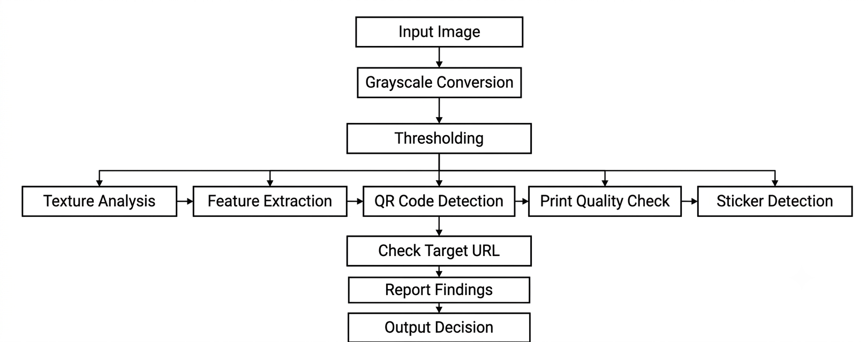
Figure 1: System Architecture Diagram

4.3 Hardware Requirements
Table 1: Hardware Requirements
Hardware Component | Minimum / Recommended Specification
Processor | Intel Core i3 or equivalent
RAM | 4 GB minimum; 8 GB recommended
Storage | 10 GB of available space for project files and development tools
Display | Standard laptop or desktop display
Network | Internet connection for online services and course access
Input Devices | Keyboard and mouse or touchpad
These specifications are indicative and may vary depending on the operating system, development tools, and number of applications running simultaneously.

4.4 Software Requirements
The following software and technologies are used or required for the development of the application:
Table 2: Software Requirements
Software / Technology | Purpose
Operating System | Windows, Linux, or macOS
Visual Studio Code | Writing and managing source code
React.js | Developing the user interface
Python 3.X | Core runtime for computer vision and machine learning models
OpenCV & Pillow | QR code localization, finder pattern checks, and graphic tamper analysis
MongoDB | Storing application data
Scikit-Learn & XGBoost | URL structural feature extraction and phishing classification
Git and GitHub | Version control and source-code management
Nodemailer | Sending email notifications and OTPs
Razorpay | Integrating online course payments

4.5 Database Design
MongoDB is used to store the information required by the Computer Vision & Graphic Tamper Detection System. The database is organized into collections corresponding to the major entities of the application.
- Users Collection
Stores user information such as name, email address, authentication-related information, role, scan history references, and other required account details.
- Scans / QR Telemetry Collection
Stores uploaded image metadata, raw extracted URL payload strings, computer vision tamper analysis results (finder pattern status, sticker detection flags), URL feature vectors, threat risk scores, final security verdicts (Safe vs. Malicious), and timestamps.
- Scans/Threat Telementry Collection
Stores metadata for uploaded QR code images, raw extracted URL payload strings, computer vision tamper analysis logs, URL feature vectors, and final security verdict records.

4.6 System Workflow Design
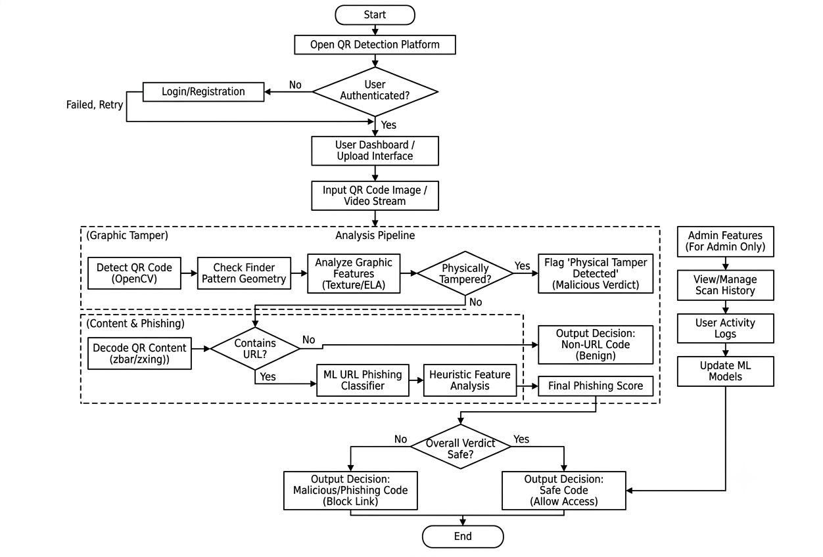
Figure 2: System Workflow Design
4.7 Testing Methodology
Testing is performed to verify that the application behaves according to its requirements. The major testing activities include:
- Unit Testing: Individual components, functions, image ingestion modules, and backend routing services are tested separately to ensure correct internal logic.
- Integration Testing: Communication between the React frontend, Node/Express backend APIs, MongoDB database, and Python computer vision microservice is checked for seamless data exchange
- Functional Testing: User registration, login, email-based OTP verification, QR code image uploads, computer vision localization, and tamper detection are tested against expected behavior.
- Tamper & Phishing Detection Testing: Test images featuring simulated sticker-over attacks and malicious phishing URLs are used to verify that the system accurately flags tampered codes and assigns correct threat risk scores.
- User Interface Testing: Upload portals, security report dashboards, navigation menus, and responsive layouts are checked for usability, clarity, and visual consistency. .
- Error Handling Testing: Invalid image file formats, corrupted QR codes, incorrect OTPs, and unauthorized API requests are tested to verify that the application responds appropriately with clear error messages

5. Results and Analysis
The Results and Analysis section presents the outcomes of the development and testing of the Computer Vision & Graphic Tamper Detection System for QR Code Phishing.
- 5.1 Practical Results
The developed system is designed to integrate essential QR code security, computer vision tamper detection, and URL phishing analysis functionalities into a single web application. The following table summarizes the functional outcomes of the implemented modules.
Table 3: Practical Results
Module | Expected Result
User Registration | Users can submit registration details and create an account.
Email OTP Verification | Users can verify their email using a valid OTP.
User Login | Registered users can log in using valid credentials.
Course Browsing | Users can view available courses and their details.
Course Enrollment | Users can enroll in courses after satisfying the required conditions.
Online Payment | Users can initiate payment for a course through the integrated payment gateway.
Lecture Access | Authorized users can access lectures associated with their enrolled courses.
Progress Tracking | Completed lectures are recorded and displayed to the learner.
Course Management | Administrators can manage course information and learning materials.
Database Operations | User, course, lecture, and progress information can be stored and retrieved.
- 5.2 Functional Testing
Table 4: Functional Testing

Test Case | Input / Action | Expected Outcome | Actual Status
TC01 | Register with valid details | Registration request is processed successfully. | Passed
TC02 | Submit an incorrect OTP | Verification is rejected with an error message. | Passed
TC03 | Log in with valid credentials | User is authenticated and redirected to the dashboard. | Passed
TC04 | Log in with invalid credentials | An appropriate error message is displayed. | Passed
TC05 | Upload a clean, legitimate QR code image | Code is decoded, analyzed, and marked as Safe. | Passed
TC06 | Upload a physically tampered QR code (sticker-over attack) | OpenCV detects tampering and flags the image as Malicious. | Passed
TC07 | Submit a malicious phishing URL payload | ML classifier detects threat indicators and blocks access. | Passed
TC08 | Open scan history dashboard | Past scan logs and threat telemetry are displayed correctly. | Passed
TC09 | Perform administrative log management | Admin can view system activity logs and audit rec. | Passed

5.3 Analysis of the Results

User Authentication
The authentication module is intended to provide registration, login, and email verification functionality. Validation of user credentials and OTPs helps prevent unauthorized account access. Expiration rules for verification codes further improve the reliability of the verification process.

Computer Vision & Tamper Detection
The computer vision module organizes image processing and geometric verification in a structured pipeline. Users can upload QR code images to review visual attributes such as finder pattern proportions, alignment consistency, and texture or compression artifacts. OpenCV-based detection makes it possible to identify physical tampering and sticker-over fraud accurately without manually inspecting every submitted graphic

URL Phishing Analysis and Telemetry Tracking
The phishing analysis module provides structured evaluation of destination URL payloads extracted from scanned codes. The feature extraction and machine learning classification mechanisms record threat risk indicators and present security verdicts (Safe vs. Malicious) through an intuitive dashboard. Additionally, scan history tracking records previous analysis results, helping users monitor past submissions and audit potential threats in an organized manner

5.4 Theoretical Performance and Analysis
The theoretical performance of the Computer Vision & Graphic Tamper Detection System depends on factors such as image file resolution, computer vision processing complexity, database indexing, network latency, server resources, machine learning inference time, and external service response times. High-resolution image uploads require efficient memory handling during OpenCV contour detection and matrix decoding to minimize processing overhead. Furthermore, proper indexing of MongoDB collections for user profiles and scan logs ensures that historical threat telemetry is retrieved quickly even as the volume of submissions grows. .
Scan Telemetry Retrieval: If scan logs and threat telemetry records are retrieved from a database collection containing $n$ records, an unindexed full collection scan may require $O(n)$ record examination. Appropriate database indexes on user IDs and timestamps significantly improve retrieval efficiency for audit queries.
- User & Scan Lookup: An indexed lookup by a unique field such as user email or scan identifier can typically be performed in approximately $O(\log n)$ time with a B-tree-based index, depending on the database execution plan and MongoDB storage behavior.
- Computer Vision and ML Inference Processing: Processing uploaded images involves OpenCV contour detection, finder pattern validation, and machine learning feature classification. The algorithmic complexity varies based on image dimensions and pixel resolution, requiring optimized memory management during matrix transformations.
- Scalability: The application can be extended by optimizing database queries, adding composite indexes, implementing pagination for scan history dashboards, caching frequent threat classifications, and deploying the frontend, backend, and Python computer vision microservice on scalable hosting infrastructure
.

5.5 Comparison with Traditional QR Scanning
The Computer Vision & Graphic Tamper Detection System provides a proactive, automated security alternative for verifying physical and digital QR codes before scanning or interacting with their embedded destinations.
Table 5: Comparison with Traditional Learning Management

Parameter | Traditional QR Code Scanning Approach | Proposed Tamper Detection & Phishing Defense System
Scanning mechanism | Standard mobile cameras or basic barcode readers | Dedicated web upload portal with OpenCV image processing
Physical security check | None; automatic redirection upon decoding | Validates finder patterns, geometry, and checks for sticker-over manipulation
URL evaluation | Opens links immediately without verification | Evaluates structural heuristics and machine learning classification models
Threat verdict | None (opaque to safety status) | Provides explicit risk scores and security verdicts (Safe vs. Malicious)
Scan history tracking | None or native device history logs | Stores scan telemetry, threat indicators, and timestamps in MongoDB
System administration | Manual physical inspection or external blacklists | Managed through administrative interfaces and activity logs
Pre-execution protection | Low (susceptible to quishing and sticker fraud) | High (stops attacks at the physical boundary and URL layer)

6. CONCLUSION AND FUTURE SCOPE

6.1 Conclusion
The Computer Vision & Graphic Tamper Detection System for QR Code Phishing is a web-based security application developed to provide a reliable, proactive, and organized defense environment against modern quishing attacks. The main objective of the project is to simplify the process of verifying QR code authenticity and destination safety by integrating computer vision tamper inspection and machine learning phishing analysis into a single platform. The application enables users to register and log in, verify their email addresses via OTP, upload QR code images, inspect physical finder patterns and sticker-over anomalies, evaluate URL structural heuristics, and monitor scan history telemetry.
In conclusion, the proposed system provides a robust foundation for securing everyday physical and digital QR code interactions. It demonstrates how modern web development technologies, computer vision libraries, and machine learning models can be combined to develop a maintainable and extensible cybersecurity application. The effectiveness of the final system depends on the successful implementation and testing of its individual modules.

6.2 Limitations of the Project
Although the Computer Vision & Graphic Tamper Detection System provides essential QR code security functionalities, certain limitations remain within the scope of the current implementation:
- Internet Dependency: The platform requires an active internet connection to communicate between the React frontend, Node/Express backend, MongoDB database, and computer vision microservice.
- Limited Real-Time Video Stream Processing: The current release focuses primarily on static image uploads (PNG/JPEG) rather than live continuous webcam stream parsing.
- Dependence on External Services: Email delivery for OTP verification relies on external mail transport services such as Nodemailer.
- Complex Sticker Texture Analysis: Highly sophisticated physical tampering that matches exact print textures or high-resolution digital replicas may require advanced deep learning CNN classifiers.
- Performance Considerations: High-resolution image uploads can introduce processing overhead during OpenCV contour extraction and heuristic feature calculations.

These limitations provide opportunities for improving the platform in future versions.

6.3 Future Scope
Real-Time Webcam Scanning
Real-time video stream processing can be integrated to enable users to scan physical QR codes instantly using mobile or desktop camera feeds without manual image uploads.
- Advanced Deep Learning CNN Models
Convolutional Neural Networks (CNNs) can be trained specifically on physical sticker textures and printing artifact datasets to improve the detection of sophisticated sticker-over fraud.
- Threat Intelligence Feed Integration
The backend can be connected with real-time threat intelligence feeds (such as VirusTotal or PhishTank) to provide instant domain reputation checks alongside structural machine learning classification.
- Browser Extension & Mobile App Integration
Browser extensions or native mobile app wrappers can be developed to automatically warn users and analyze physical codes before opening untrusted links in the wild.

7. REFERENCES / BIBLIOGRAPHY
The following references were used as technical resources for understanding the technologies, frameworks, libraries, and services relevant to the development of the QR- Shield.
[1] OpenCV, “OpenCV: Open Source Computer Vision Library Documentation.” [Online]. Available: https://docs.opencv.org/.
[2] Scikit-Learn, “Scikit-Learn: Machine Learning in Python Documentation.” [Online]. Available: https://scikit-learn.org/stable/documentation.html.
[3] XGBoost, “XGBoost Documentation.” [Online]. Available: https://xgboost.readthedocs.io/.
[4] MongoDB, “MongoDB Documentation.” [Online]. Available: https://www.mongodb.com/docs/.
[5] OpenJS Foundation, “Node.js Documentation.” [Online]. Available: https://nodejs.org/docs/.
[6] Express.js, “Express Web Framework Documentation.” [Online]. Available: https://expressjs.com/.
[7] Meta Platforms, Inc., “React Documentation.” [Online]. Available: https://react.dev/.
[8] GitHub, “GitHub Documentation.” [Online]. Available: https://docs.github.com/.
[9] Nodemailer Documentation: https://nodemailer.com/
[10] Python Software Foundation, “Python 3 Documentation.” [Online]. Available: https://docs.python.org/3/.

