Contents

**1. Build a Resume Site.** 2

**2. push the project on github** 6

**3. deploy your project on heroku.** 7

# **1. Build a Resume Site.**

Hello, guys!

Let’s start deploying your own resume site on Heroku.

First, you need to choose & download a resume template. I chose ‘vue-modern-resume’ template as a resume template. If you want to use other project, please skip this step.

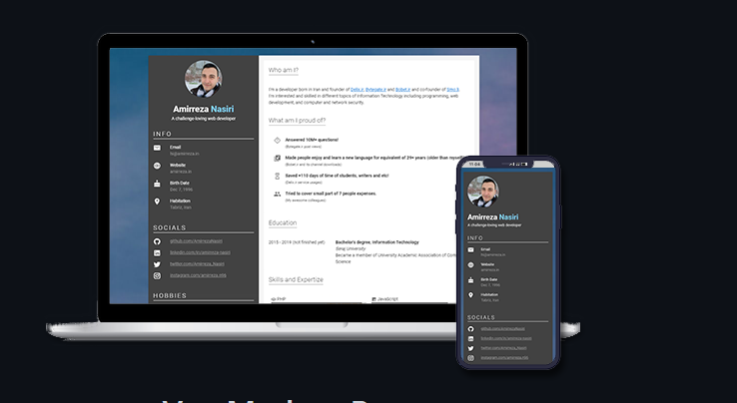As you can see, it’s a vue.js project.

Ok. Let’s start now.

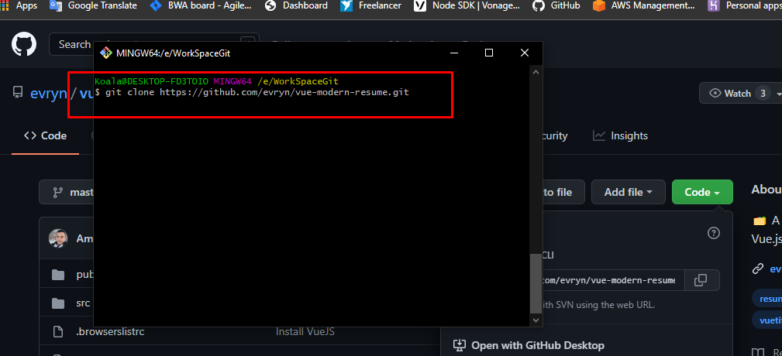We need to download the project.

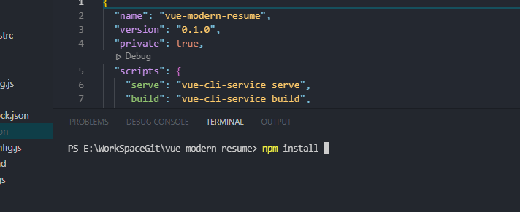

After download it, let’s install dependencies of the project by above instruction.

After install dependencies, follow these steps.

Please create a file named server.js & write some code lines as below screenshot.

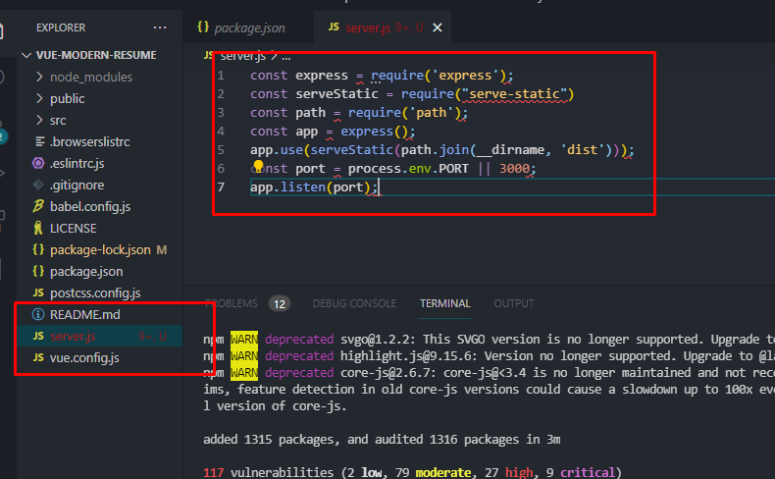

And please install express module as below.

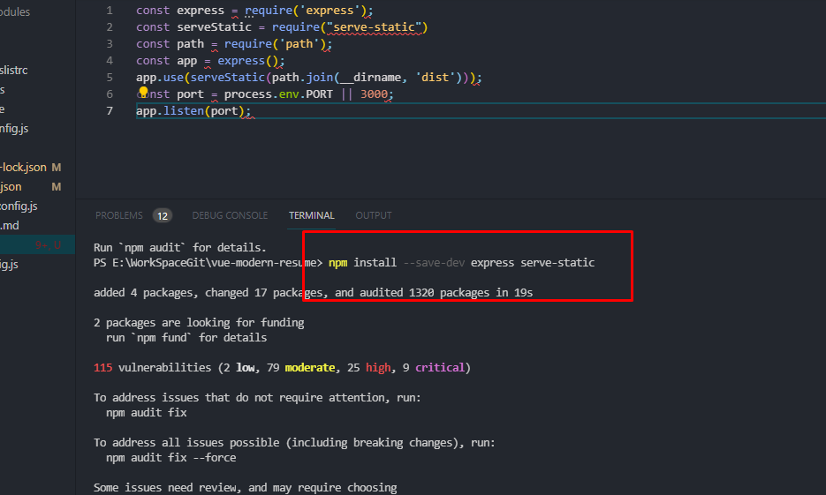

And as shown in the screenshot below, please insert 2 script line in pakage.json in the project.

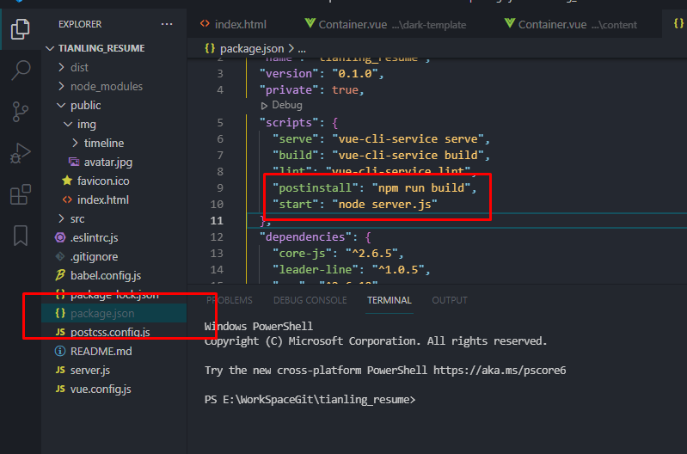

Are you done? Okay.

We need to build the project now. As I mentioned above, it’s a vue.js project.

So you need to install vue.js project dev env(install vue-cli).

You’ll be able to install vue dev env on your computer by yourself. I’ll skip this step here.

As a result of building, a directory named ‘./dist’ is generated in your project.

Please see the screenshot below.

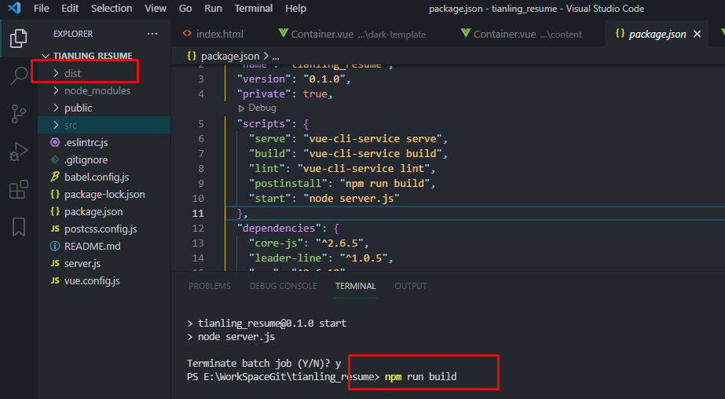

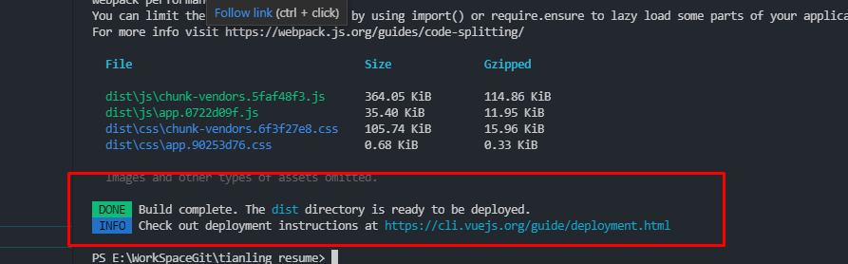

Done? Okay. We can test it locally.

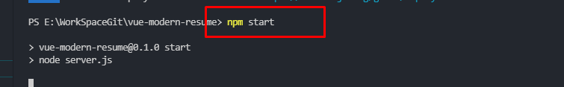

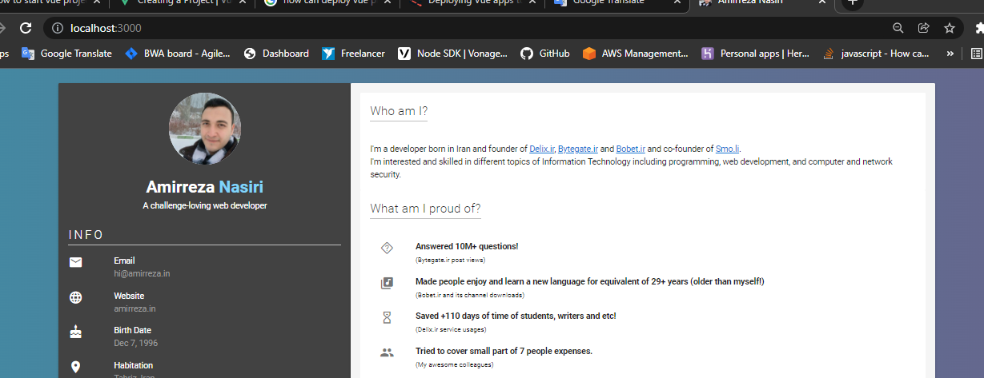

how is it? Well done!!! You are awesome. 😊

Now let's move on to step 2.

# **2. push the project on github**

Please create a repository and push your project on github.

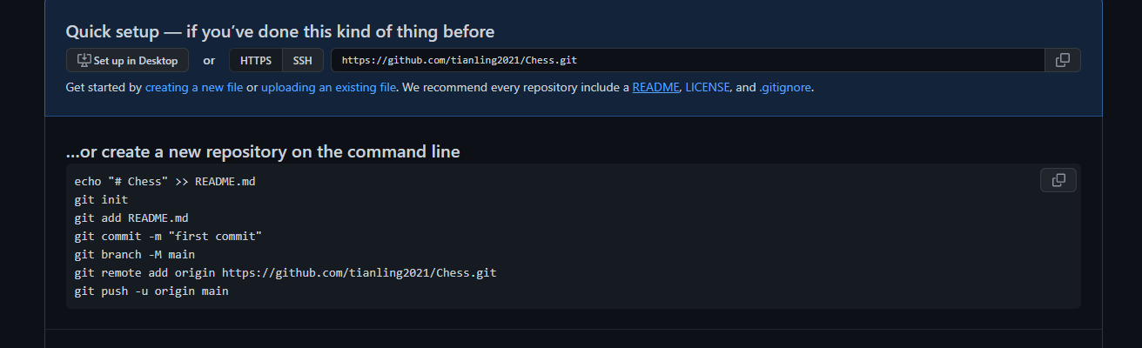

You can reference a doc from IJH for this step.

After that, let’s deploy the project on heroku.

# **3. deploy your project on heroku.**

You need to signup to heroku first. I won’t say more about it.

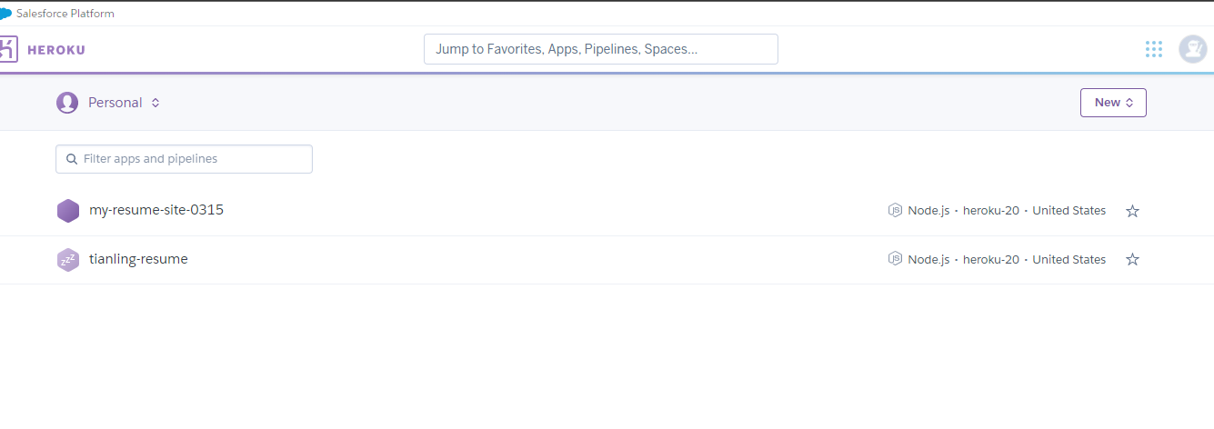

It’s a dashboard of the heroku account.

Let’s create new app for your resume project. 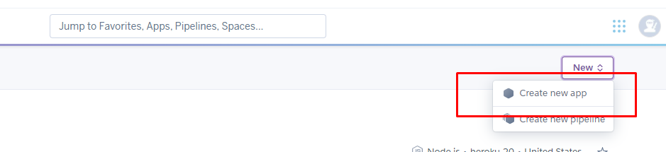

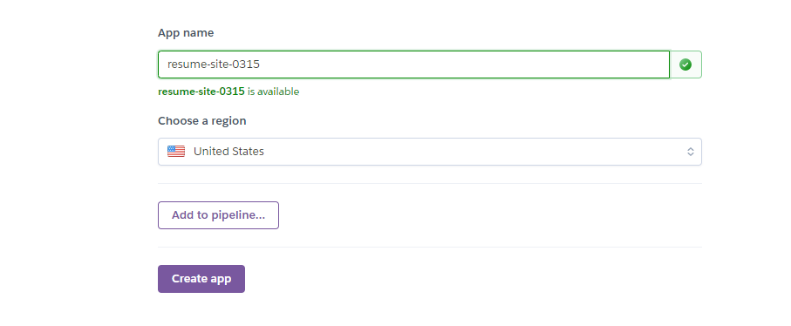

Okay. Now you can deploy your project on heroku.

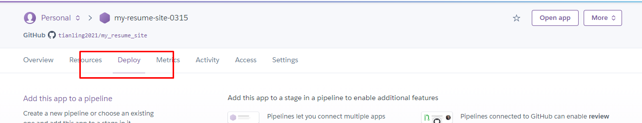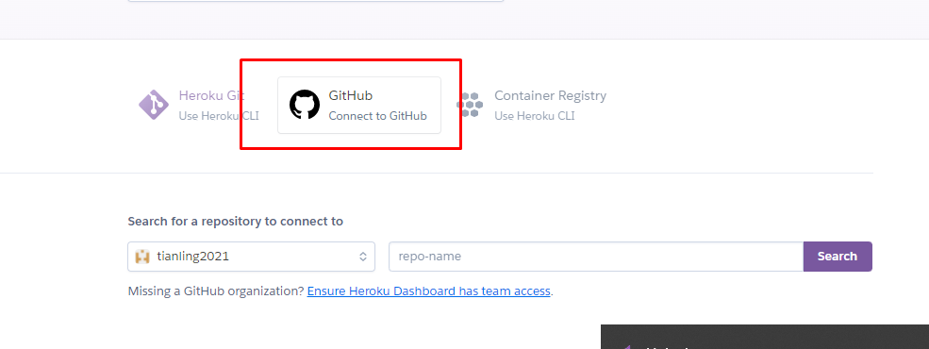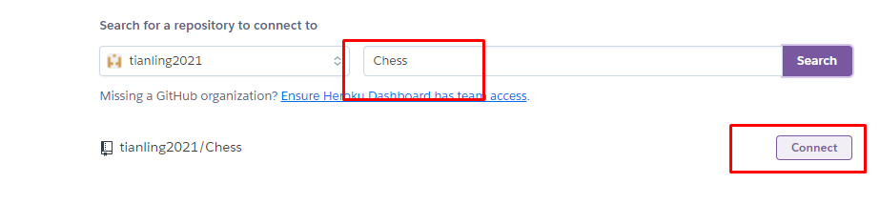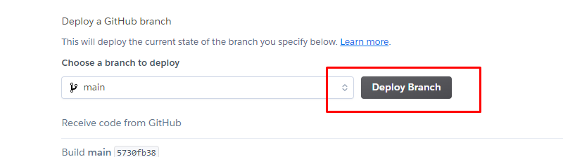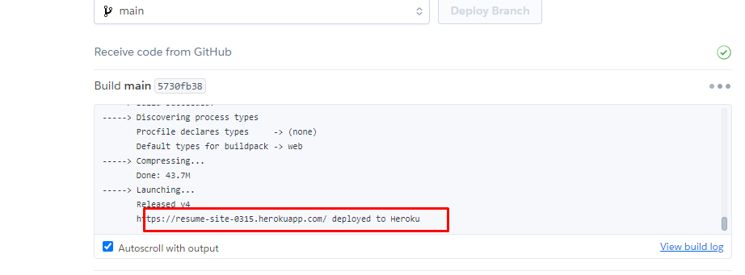

How is it going? You can open the app with above url.

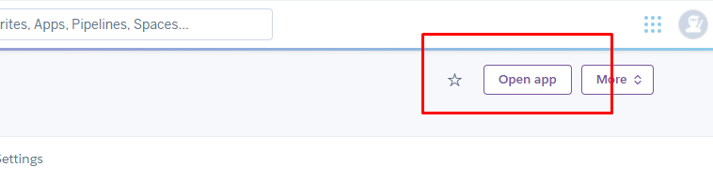

Voila~~!!!!

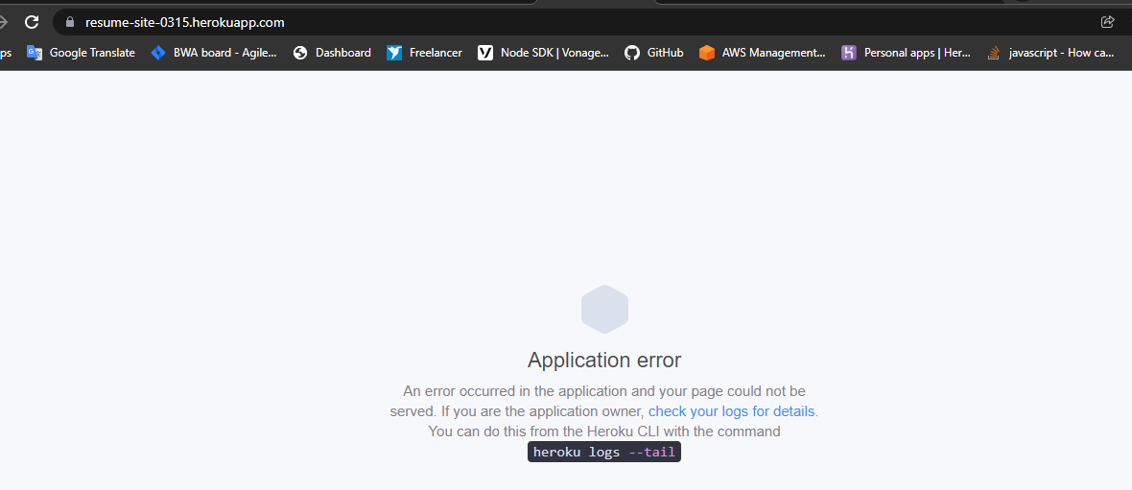

Please don't be disappointed. It is still okay.

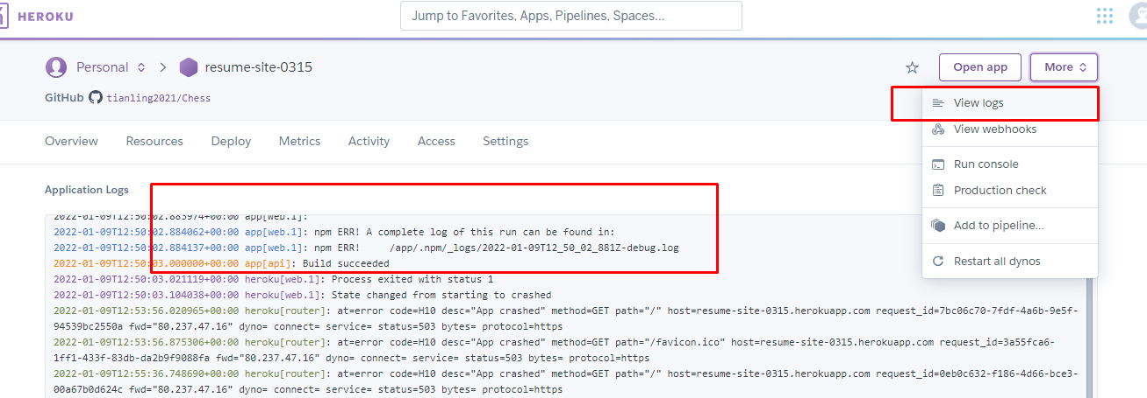

To fix issue, you can install heroku cli.

Please install heroku cli on your computer.

<https://devcenter.heroku.com/articles/heroku-cli#download-and-install>

After that, please follow me!!! 😊

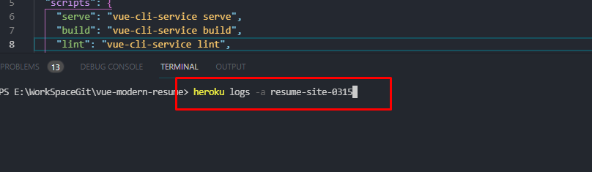

You need to change app name with your app name in the above command.

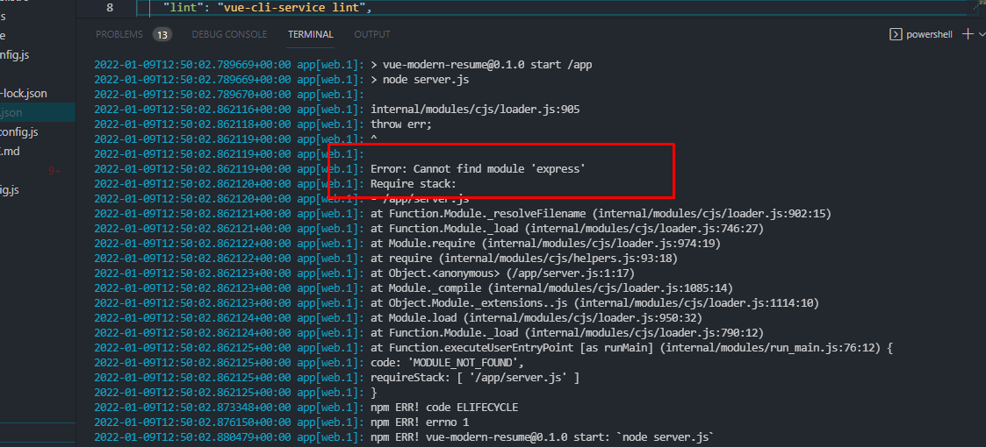

This is a course of the issue. Can you fix it on your side? Okay. Let’s do it together.

Please try to run below command.

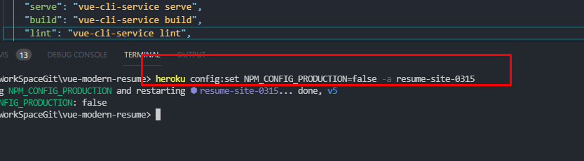

Okay. After that, let’s run heroku app again.

It’s working well? You are a genius. Me too? Thank you very much… 😊