<https://runrun.it/>

This provides task management platform with a timer-focused function.

You will improve your task management skills, and at the same time, log time spent on every task you work.

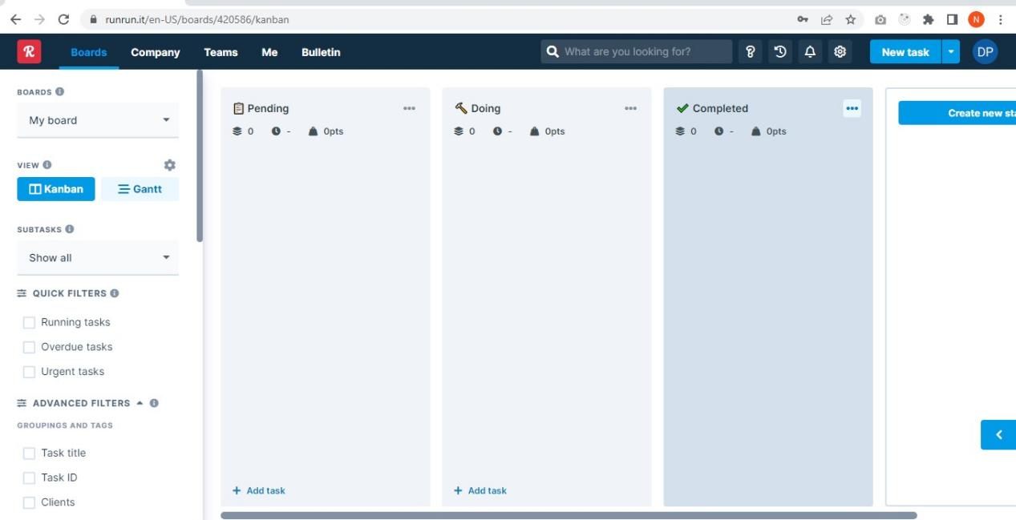

~What to do~

From May 3, you need to log all your working hours.

Create task cards on runrun.it for things you do including studying, coding, etc and then log hours on those task cards while you work on relevant tasks.

~How to~

1. Create task

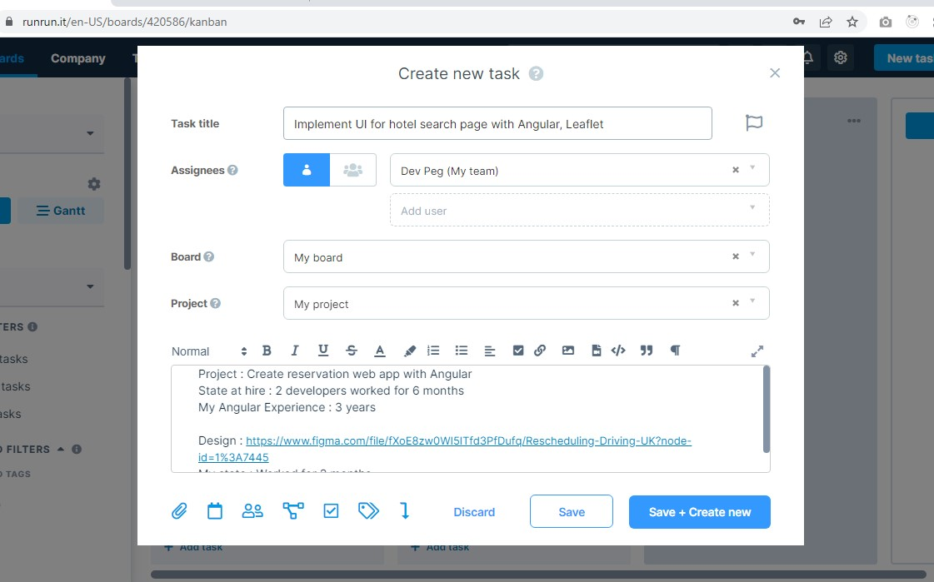

Click on “New task” button on the top right area.

Fill the form and save it.

Rule

- Title should begin with verb, mention work section and tech stack

Example : Implement UI for hotel search page with Angular, Leaflet

- Description should have simple project(not task) description, state at hire(how much work progressed at the time of hiring), experience in stack(how many years), my state(how long you worked so far), and additional information like design url

Example :

Project : Create reservation web app with Angular

State at hire : 2 developers worked for 6 months

My Angular Experience : 3 years

Design : https://www.figma.com/file/fXoE8zw0WI5lTfd3PfDufq/Rescheduling-Driving-UK?node-id=1%3A7445

My state : Worked for 2 months

1. Add more information on details popup

When you click on the card, it shows details popup.

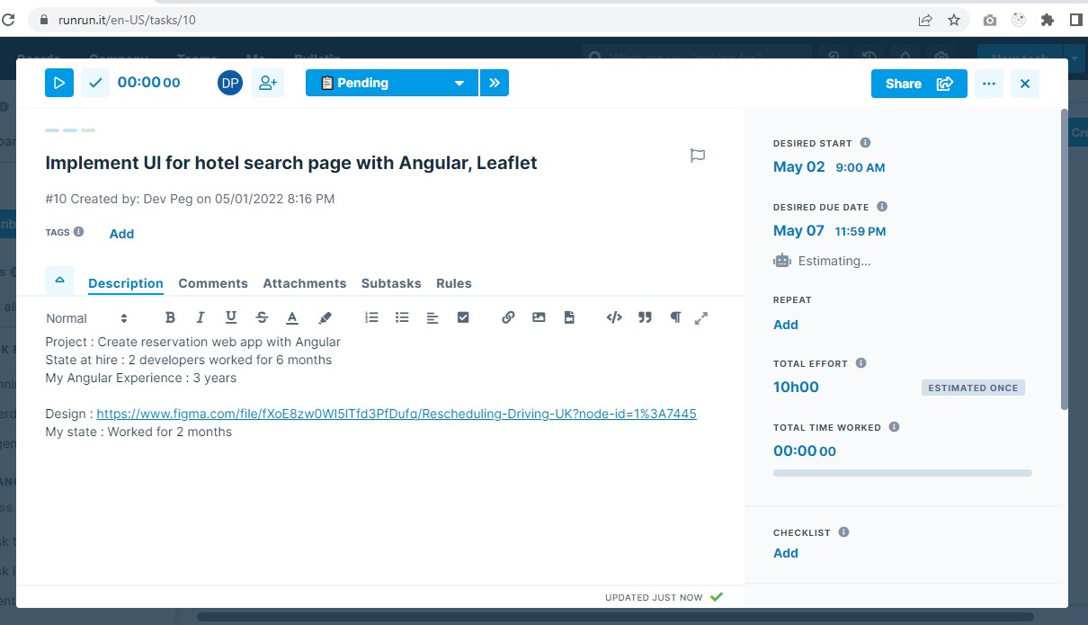

Add desired start date, desired due date, total efforts needed, attachments(if there is any), and so on.

1. Begin the task and log time spent for the task

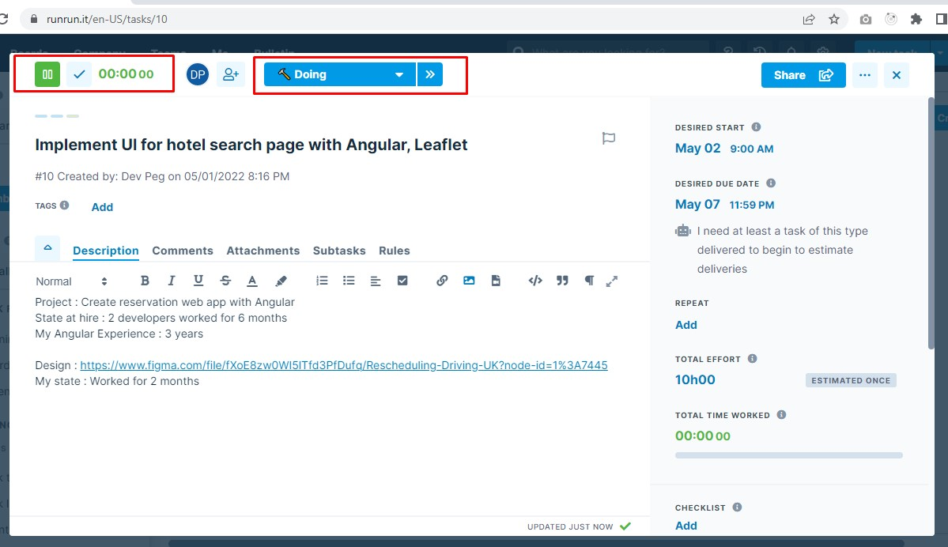

Change the state of card to “Doing” and click on play icon on the top left area.

You can also play and pause on main screen.

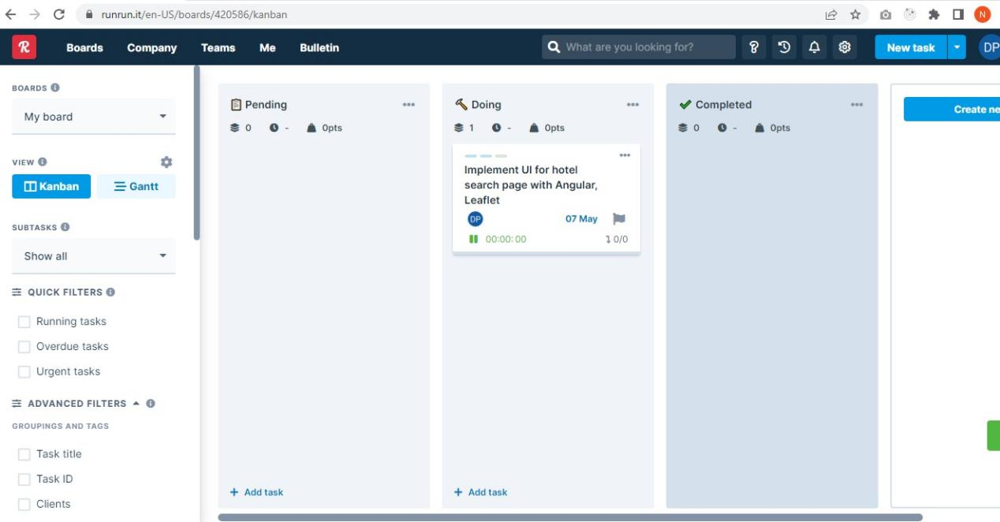

If the task takes time more or less than expected, add comments explaining why.