# Exercise 1: Candles Of Birthday Cake

**Problem**

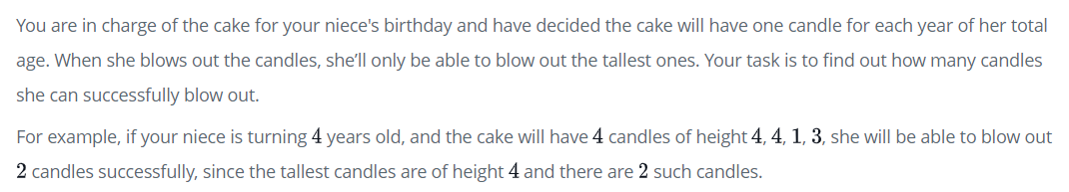

**Function Description**

Complete the function. It must return an integer representing the number of candles she can blow out.

**Test Input**

|  |
| --- |
| fun main() {      val input = arrayOf(3, 2, 1 ,3)      println(birthDayCake(input))  } |

**Expect Output**

|  |
| --- |
| 2 |

# Exercise 2: Difference Of Diagonal

**Problem**

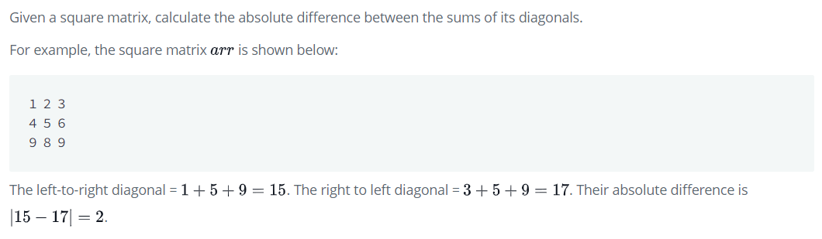

**Function Description**

Complete the function. It must return an integer representing the absolute diagonal difference.

**Test Input**

|  |
| --- |
| fun main() {      val row1 = intArrayOf(11, 2, 4)      val row2 = intArrayOf(4, 5, 6)      val row3 = intArrayOf(10, 8, -12)      val matrix = arrayOf(row1, row2, row3)      println(diagonalDifference(matrix))  }  fun diagonalDifference(arr: Array<IntArray>): Int {      // to do      return 0  } |

Expect Output

|  |
| --- |
| 15 |

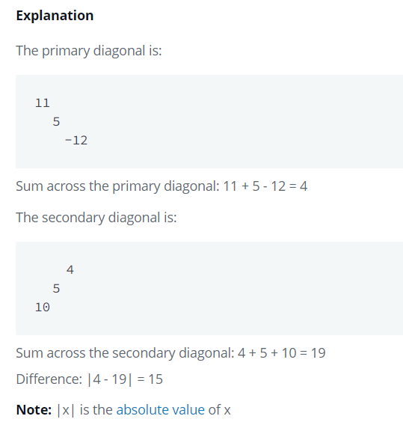

# Exercise 3: Sock Store

**Problem**

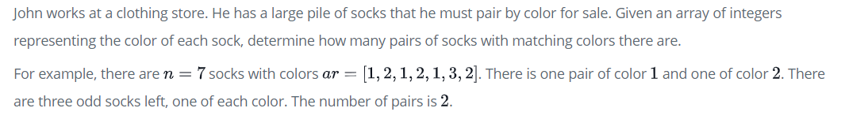

**Function Description**

Complete the function. It must return an integer representing the number of matching pairs of socks that are available.

**Test Input**

|  |
| --- |
| fun main() {  val socks = arrayOf(10, 20, 20, 10, 10, 30, 50, 10, 20)      println(sockMerchant(input))  } |

**Expect Output**

|  |
| --- |
| 3 |

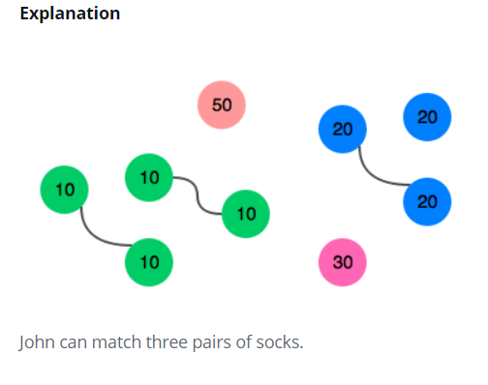s

# Exercise 4: My Leaderboard

**Problem**

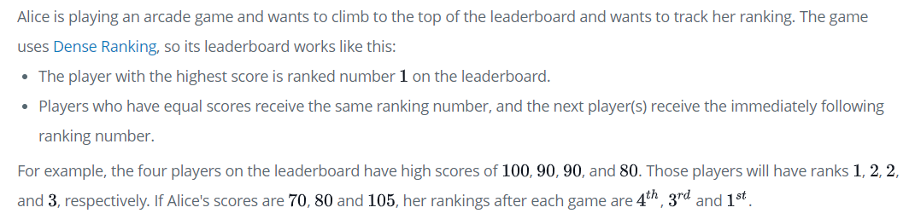

**Function Description**

Complete the function for show Alice rank.

**Test Input**

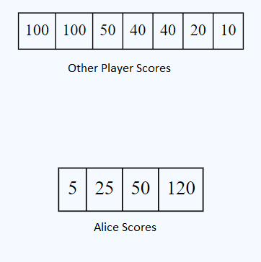

|  |
| --- |
| fun main() {  val otherPlayerScores = arrayOf(100, 100, 50, 40, 40, 20, 10)      val aliceScoreEachRound = arrayOf(5, 25, 50, 120)  }  fun climbingLeaderboard(scores: Array<Int>, alices: Array<Int>)  {      println("HI")  } |

**Expect Output**

|  |
| --- |
| 6  4  2  1 |

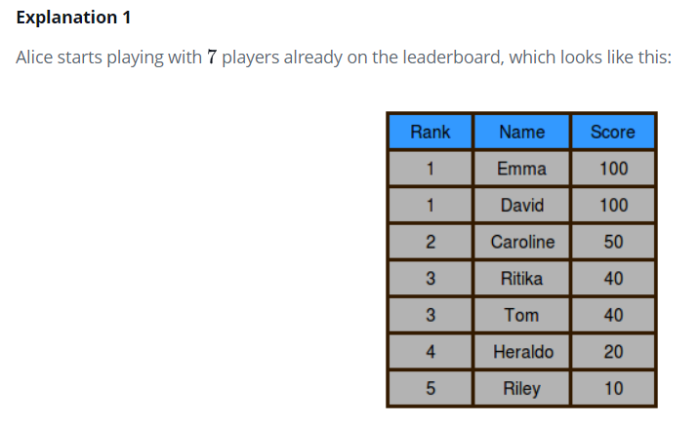

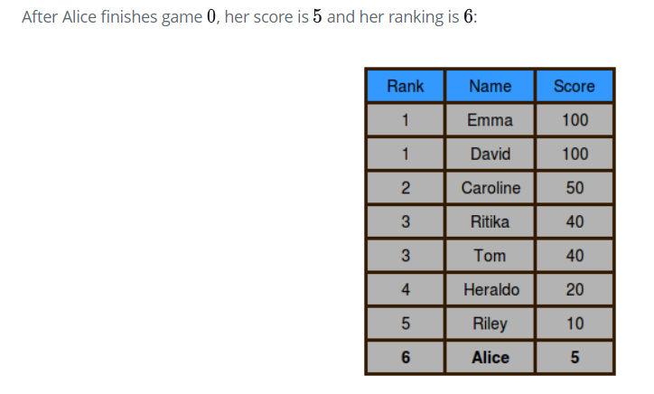

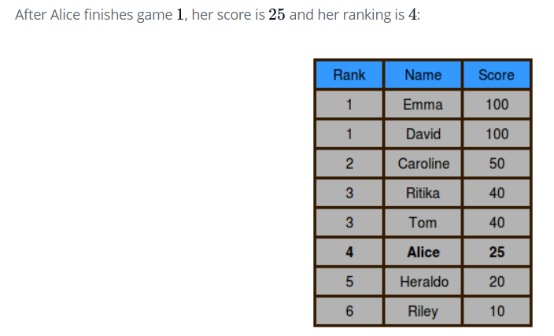

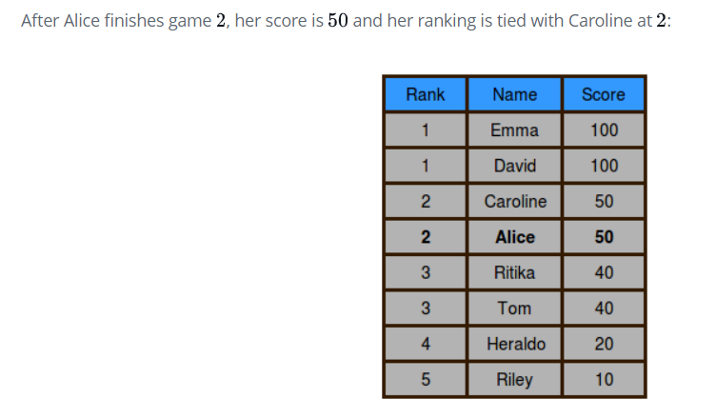

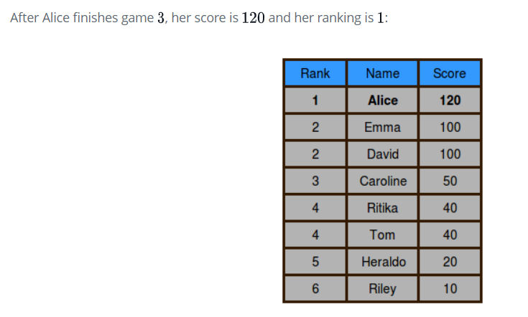

# Exercise 5: Staircase

**Problem**

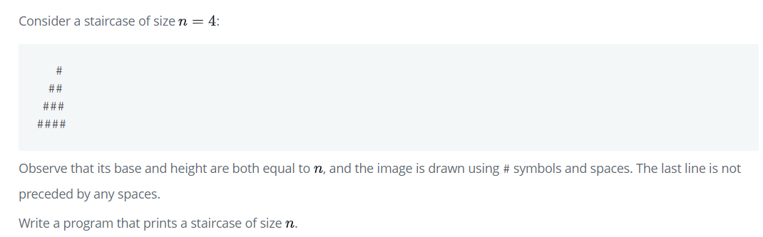

**Function Description**

Complete the function. It should print a staircase as described above.

**Test Input**

|  |
| --- |
| fun main() {      val floor = 6  } |

**Expect Output**

|  |
| --- |
|  |

# Exercise 6: Min and Max Sum

**Problem**

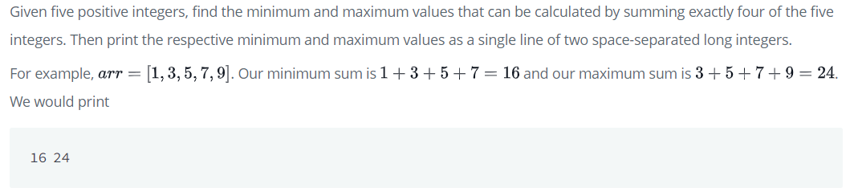

**Function Description**

Complete the function. It should print two space-separated integers on one line: the minimum sum and the maximum sum of 4 of 5 elements.

**Test Input**

|  |
| --- |
| fun main() {      val arr = arrayOf(1,2,3,4,5)  } |

**Expect Output**

|  |
| --- |
| 10 14 |