# New Project

1. Start new project with “Empty Activity”

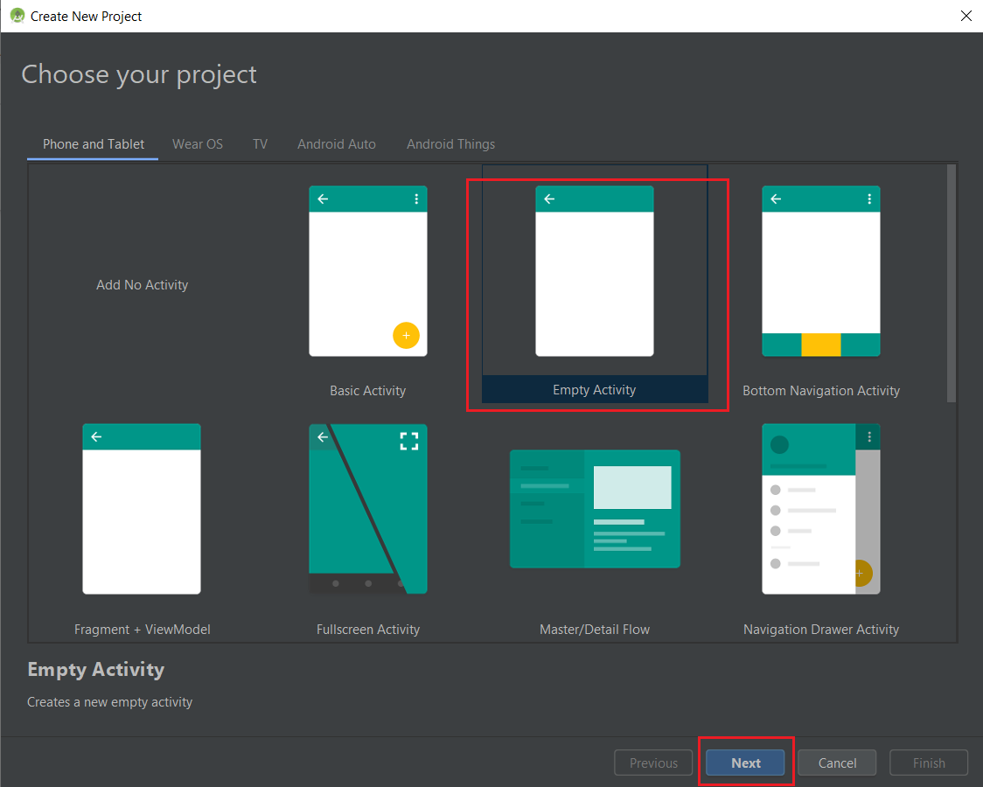

1. Setup project name and be sure to select “Kotlin” Language and Minimum API for “API 19”

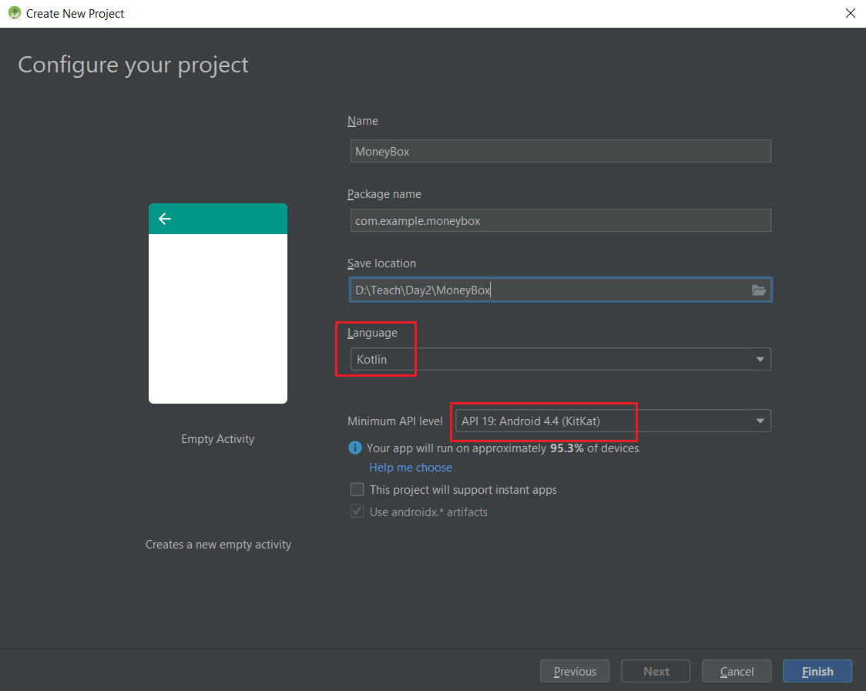

1. Setup dependencies in “build.gradle (Module.app)” as below and press “Sync Now”



|  |
| --- |
| dependencies {  def nav_version = "2.3.0-alpha02"  implementation "androidx.navigation:navigation-fragment-ktx:$nav_version"  implementation "androidx.navigation:navigation-ui-ktx:$nav_version"  implementation "androidx.navigation:navigation-dynamic-features-fragment:$nav_version"  androidTestImplementation "androidx.navigation:navigation-testing:$nav_version"  } |

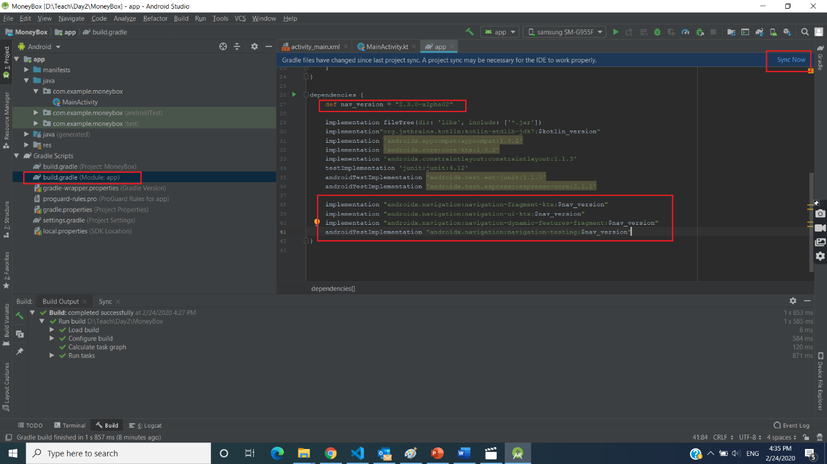

1. Create “nav_graph.xml” File

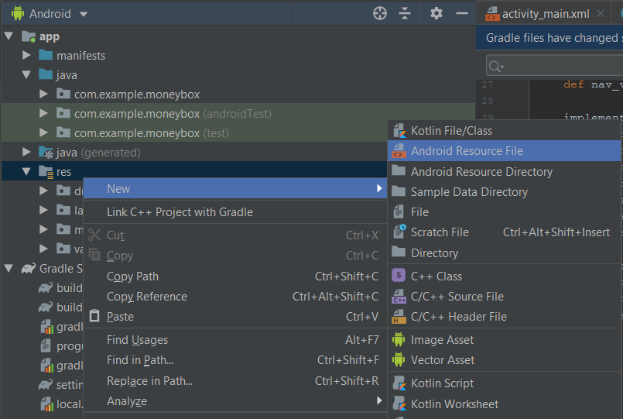

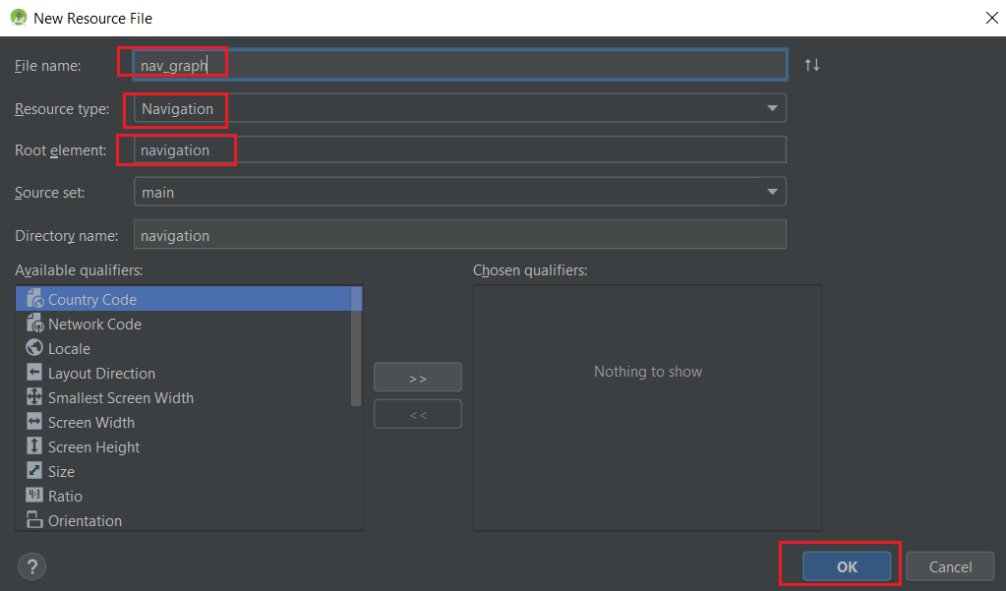

1. Create “Splash Screen” Fragment

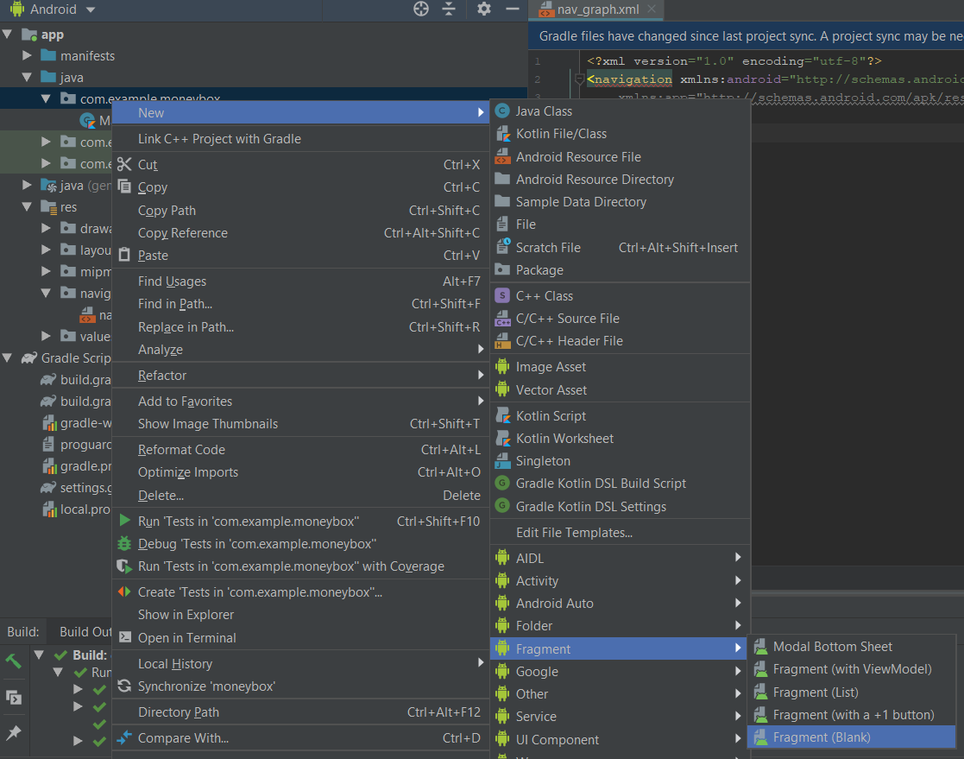

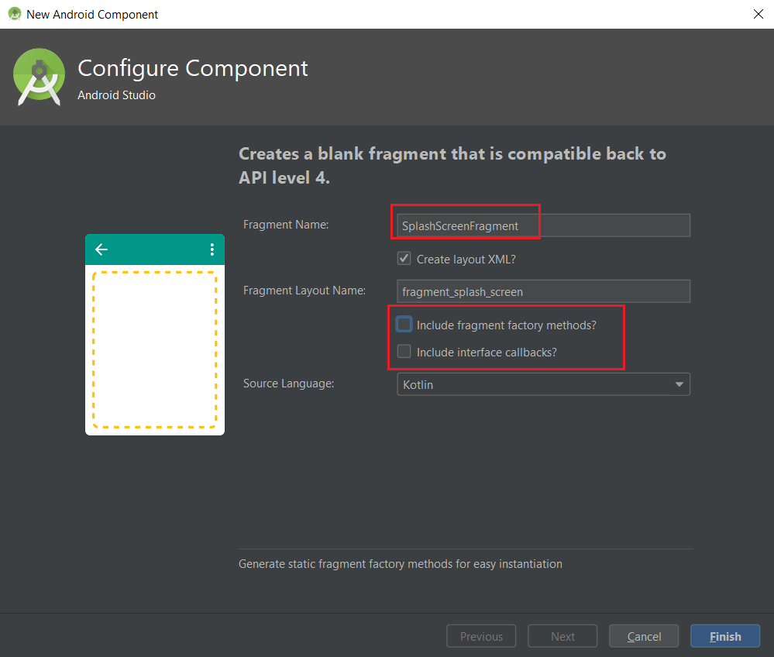

1. **Task 1.** Create another fragment

* RegisterFragment
* OverviewFragment
* DetailFragment

1. Add a **NavHost** to an activity



Ref: <https://developer.android.com/guide/navigation/navigation-getting-started#add-navhost>

|  |
| --- |
| <?xml version="1.0" encoding="utf-8"?>  <androidx.constraintlayout.widget.ConstraintLayout xmlns:android="http://schemas.android.com/apk/res/android"  xmlns:app="http://schemas.android.com/apk/res-auto"  xmlns:tools="http://schemas.android.com/tools"  android:layout_width="match_parent"  android:layout_height="match_parent"  tools:context=".MainActivity">  <fragment  android:id="@+id/nav_host_fragment"  android:name="androidx.navigation.fragment.NavHostFragment"  android:layout_width="0dp"  android:layout_height="0dp"  app:defaultNavHost="true"  app:layout_constraintBottom_toBottomOf="parent"  app:layout_constraintEnd_toEndOf="parent"  app:layout_constraintStart_toStartOf="parent"  app:layout_constraintTop_toTopOf="parent"  app:navGraph="@navigation/nav_graph" />    </androidx.constraintlayout.widget.ConstraintLayout> |

1. Go to res/navigation/nav_graph.xml and create first destination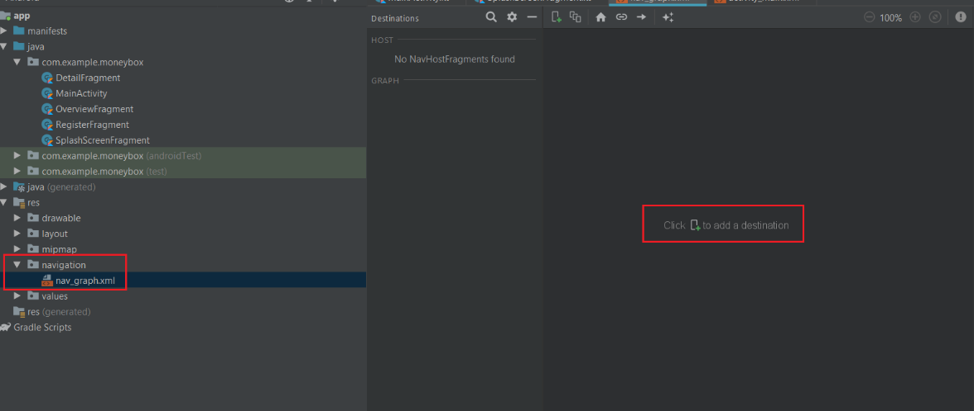

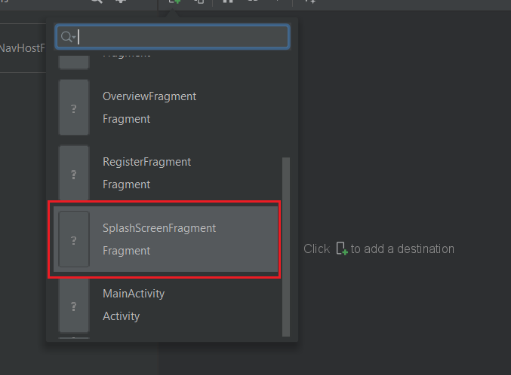

1. **Task 2:** Create New Destination for another fragment

* RegisterFragment
* OverviewFragment
* DetailFragment

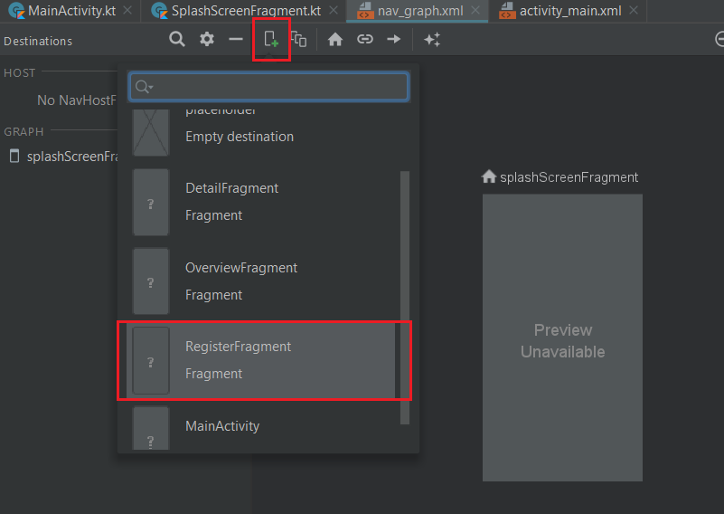

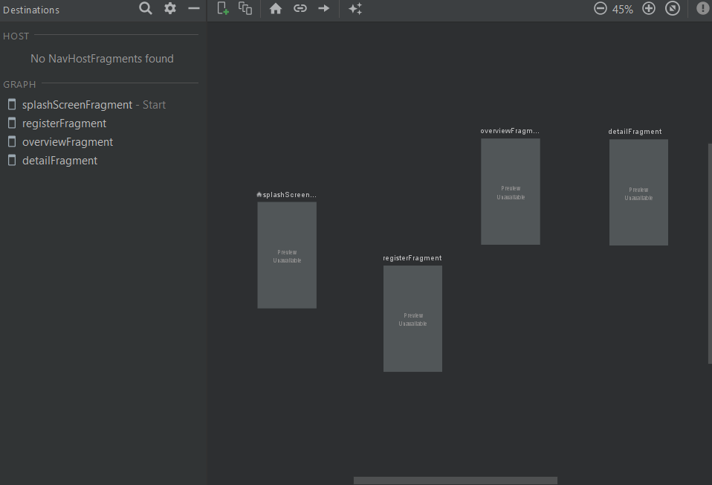

1. Prepare Animation folder

Ref: <https://developer.android.com/guide/topics/resources/animation-resource>

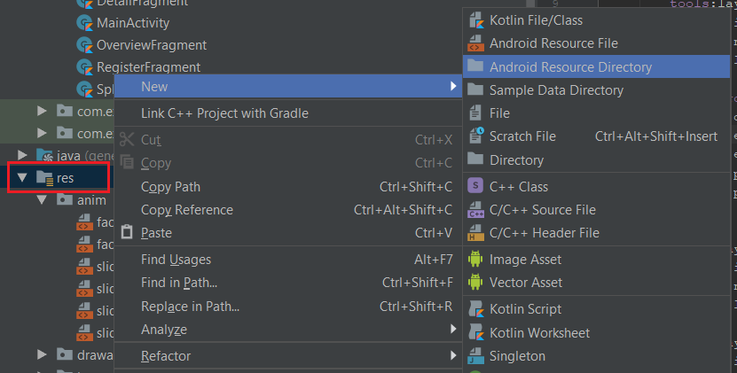

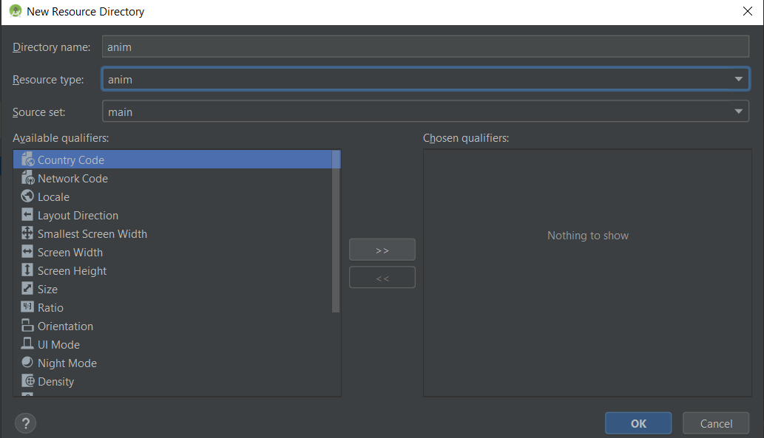

Copy all xml from folder “.../AssetsFile/anim” and paste to “anim” folder

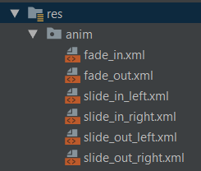

1. Setup Action Between Destination.

Right click on SplashScreenFragment then add Action -> to Destination

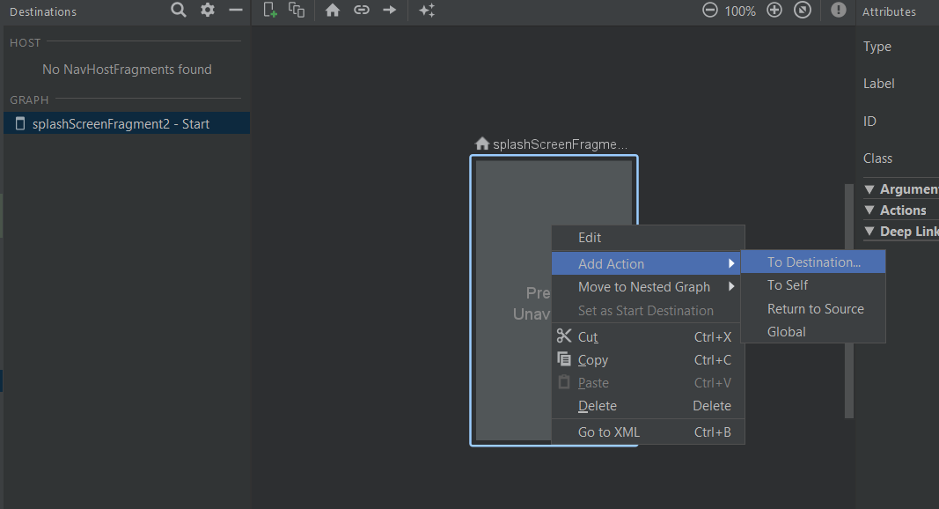

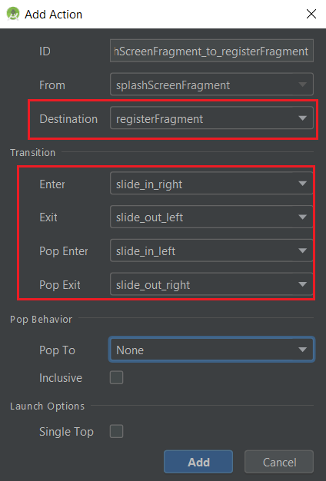

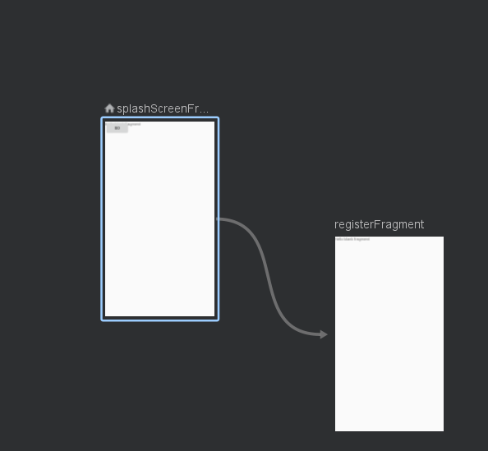

1. **Task 3:** Complete another Actions

* SplashScreenFragment -> OverviewFragment
* RegisterFragment -> OverviewFragment
* OverviewFragment -> DetailFragment

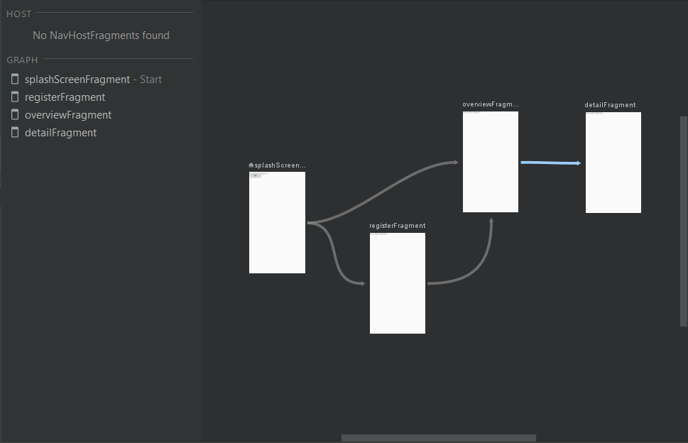

1. Test Navigation

* Remove TextView and **Add button** to “res\layout\fragment_splash_screen.xml”

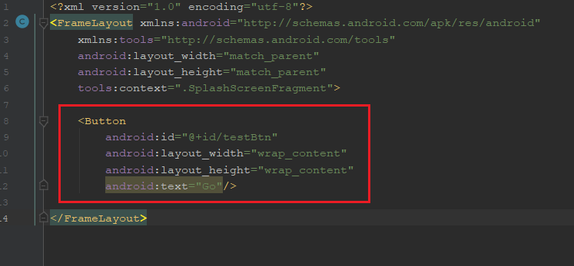

* Set OnClick Function to button in “SplashScreenFragment” file

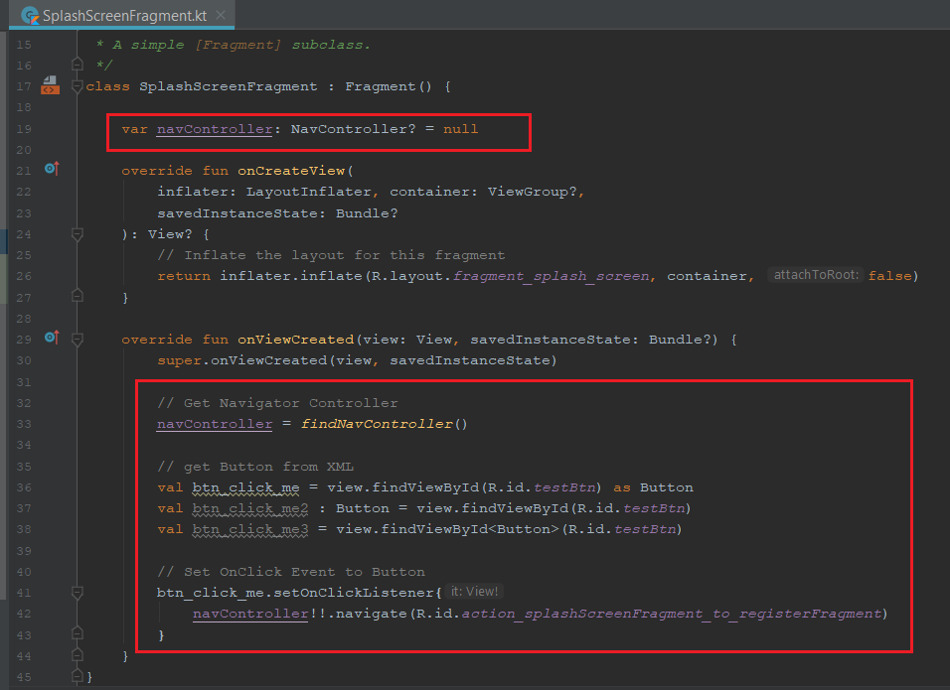

* Run test on Emulator

# Splash Screen

### **Library for Animation**

Ref: <https://github.com/airbnb/lottie-android>

1. Adding Library to “build.gradle : Module App” and press “Sync Now”

|  |
| --- |
| dependencies {  implementation 'com.airbnb.android:lottie:3.4.0'  } |

1. **Download** Animation file from <https://lottiefiles.com/16320-piggy-bank-coins-in>

And **Re-name to “pig_coin.json”**

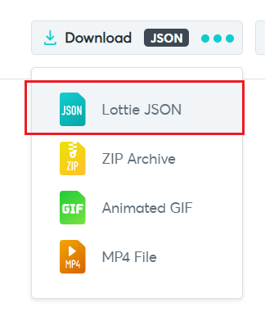

1. Put download file in raw folder

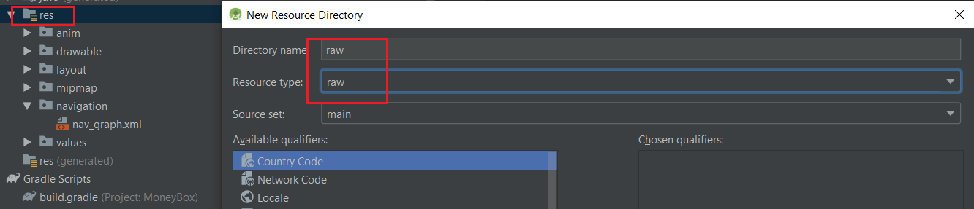

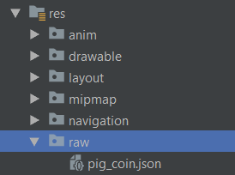

1. Open “res\layout\fragment_splash_screen.xml”

* Change root layout from “FrameLayout” To “androidx.constraintlayout.widget.ConstraintLayout”
* Add “LottieAnimationView”

|  |
| --- |
| <com.airbnb.lottie.LottieAnimationView  android:id="@+id/animation_view"  android:layout_width="175dp"  android:layout_height="237.5dp"  android:scaleType="centerCrop"  app:layout_constraintBottom_toBottomOf="parent"  app:layout_constraintEnd_toEndOf="parent"  app:layout_constraintStart_toStartOf="parent"  app:layout_constraintTop_toTopOf="parent"  app:layout_constraintVertical_bias="0.313"  app:lottie_autoPlay="true"  app:lottie_loop="true"  app:lottie_rawRes="@raw/pig_coin" /> |

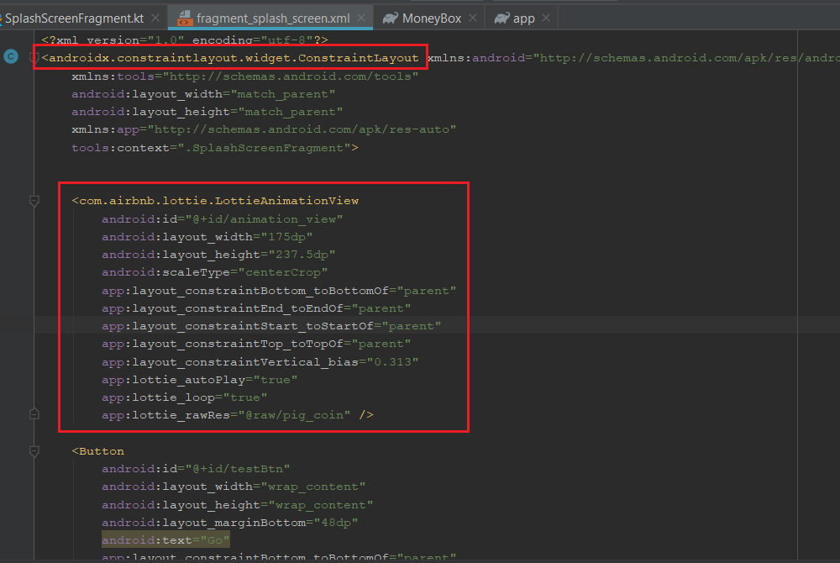

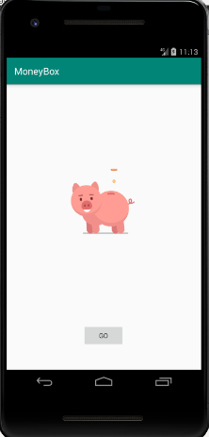

### Remove Action Bar

Change Theme Style to “NoActionBar” in “res/values/styles.xml”

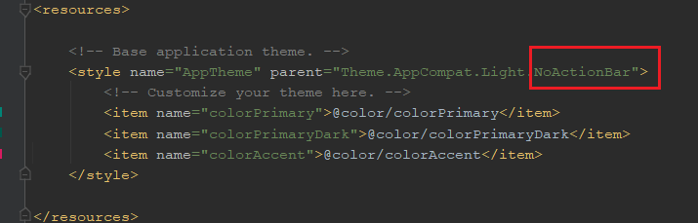

Add Background Color in “res\layout\fragment_splash_screen.xml”

|  |
| --- |
| android:background="#FFEADE" |

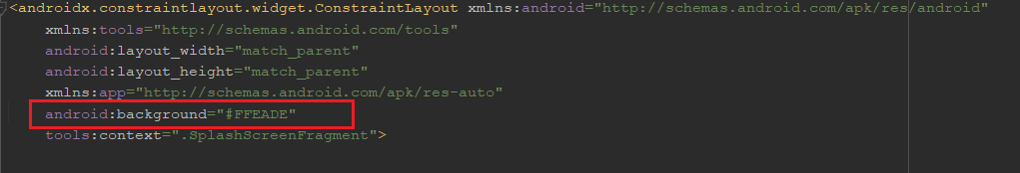

Re-Run for Test

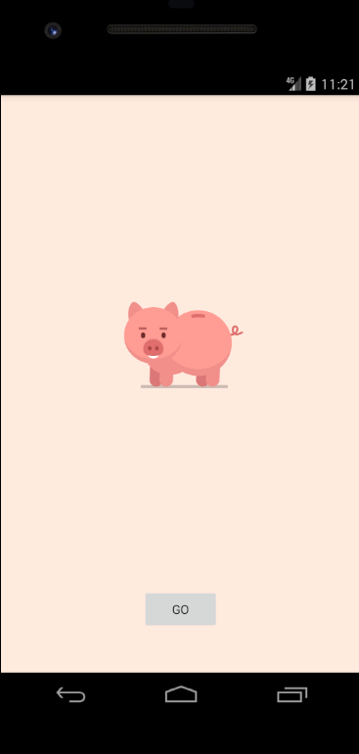

### Custom Fonts

Ref: <https://developer.android.com/guide/topics/ui/look-and-feel/fonts-in-xml>

Resource: <https://fonts.google.com/>

Create fonts folder

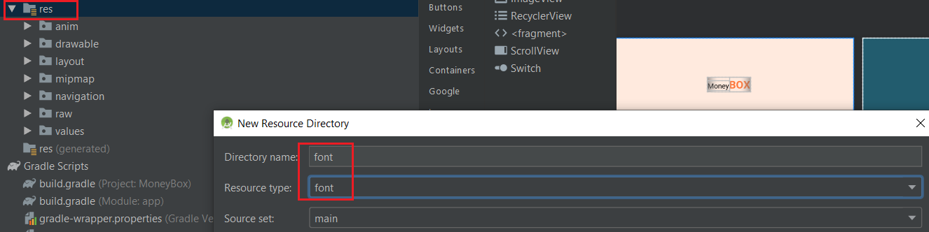

Copy all file in “…/AssetsFile/Font/xxx” to “res/font/”

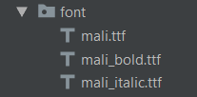

Create File “mali_family.xml” to reference all font together.

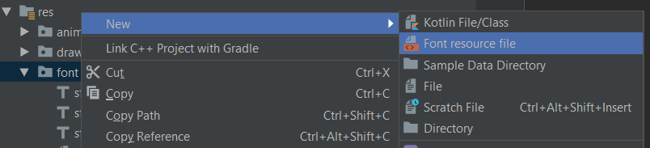

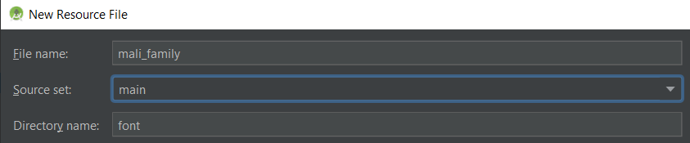

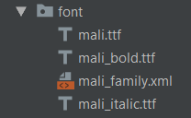

Edit “sf_pro_family.xml” as Below

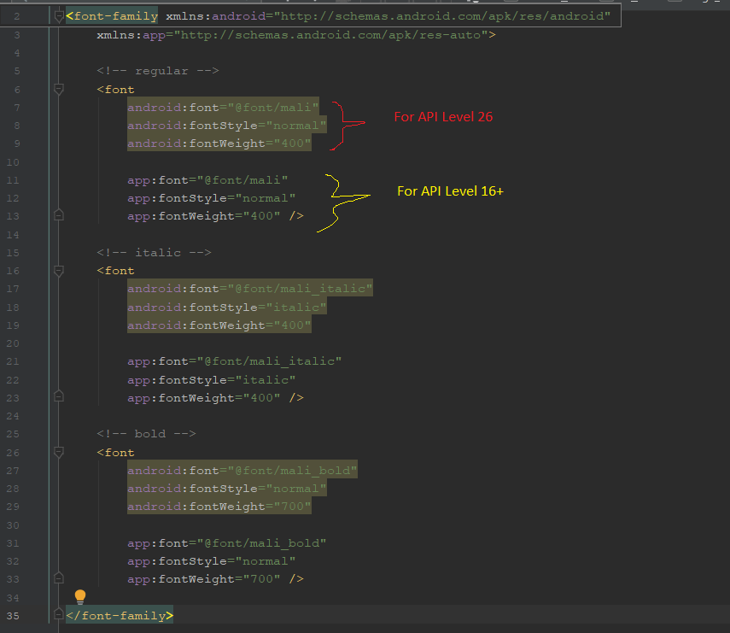

|  |
| --- |
| <?xml version="1.0" encoding="utf-8"?>  <font-family xmlns:android="http://schemas.android.com/apk/res/android"  xmlns:app="http://schemas.android.com/apk/res-auto">  <!-- regular -->  <font  android:font="@font/mali"  android:fontStyle="normal"  android:fontWeight="400"  app:font="@font/mali"  app:fontStyle="normal"  app:fontWeight="400" />  <!-- italic -->  <font  android:font="@font/mali_italic"  android:fontStyle="italic"  android:fontWeight="400"  app:font="@font/mali_italic"  app:fontStyle="italic"  app:fontWeight="400" />  <!-- bold -->  <font  android:font="@font/mali_bold"  android:fontStyle="normal"  android:fontWeight="700"  app:font="@font/mali_bold"  app:fontStyle="normal"  app:fontWeight="700" />  </font-family> |

Add TextView in “res\layout\fragment_splash_screen.xml”

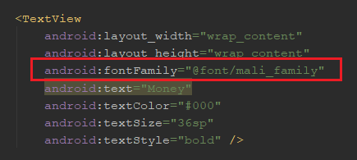



### Set Material Theme

Add Library to “build.gradle : Module App”

|  |
| --- |
| implementation 'com.google.android.material:material:1.1.0-rc02' |

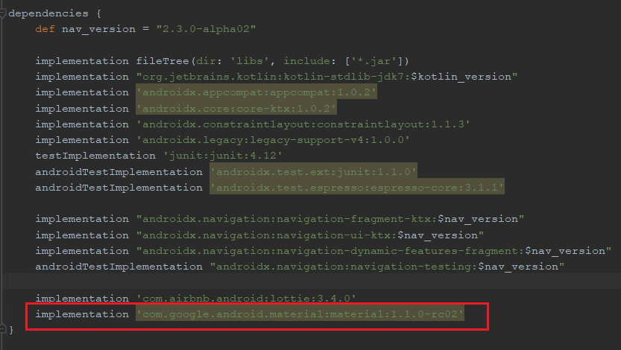

Adjust App Theme to “Material” in “Res/Values/Styles.xml”

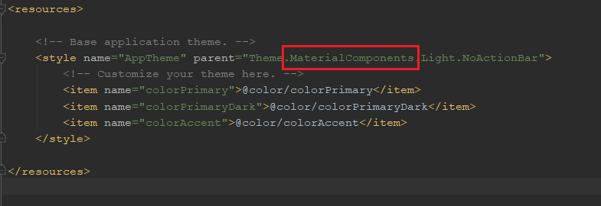

|  |
| --- |
| <resources>  <!-- Base application theme. -->  <style name="AppTheme" parent="Theme.MaterialComponents.Light.NoActionBar">  <!-- Customize your theme here. -->  <item name="colorPrimary">@color/colorPrimary</item>  <item name="colorPrimaryDark">@color/colorPrimaryDark</item>  <item name="colorAccent">@color/colorAccent</item>  </style>  </resources> |

Adjust Primary Color “Res/Values/Colors.xml”

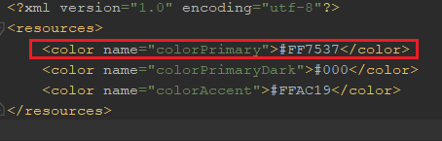

|  |
| --- |
| <resources>  <!-- Base application theme. -->  <style name="AppTheme" parent="Theme.MaterialComponents.Light.NoActionBar">  <!-- Customize your theme here. -->  <item name="colorPrimary">@color/colorPrimary</item>  <item name="colorPrimaryDark">@color/colorPrimaryDark</item>  <item name="colorAccent">@color/colorAccent</item>  </style>  </resources> |

Adjust Button Type in “res\layout\fragment_splash_screen.xml”

|  |
| --- |
| <com.google.android.material.button.MaterialButton  android:id="@+id/testBtn"  android:layout_width="200dp"  android:layout_height="wrap_content"  android:layout_marginBottom="28dp"  android:text="Start"  app:cornerRadius="18dp"  /> |



### Assignment

Complete UI as below

