# Extra

Create Login screen as below

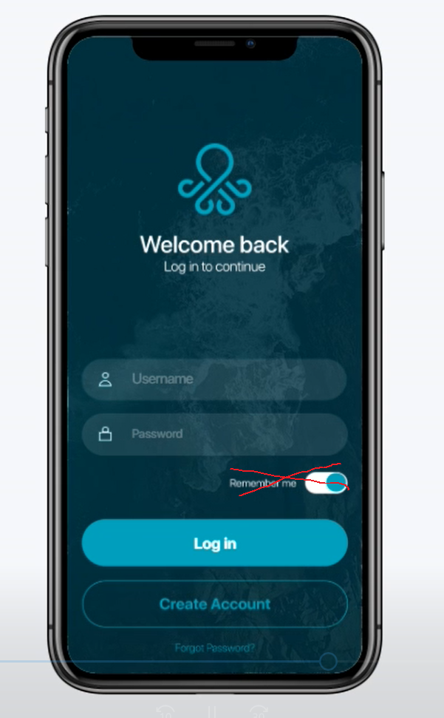

* Remember me is bad UX in Mobile.
* Resource file in AssetsExtra Folder

## Guideline

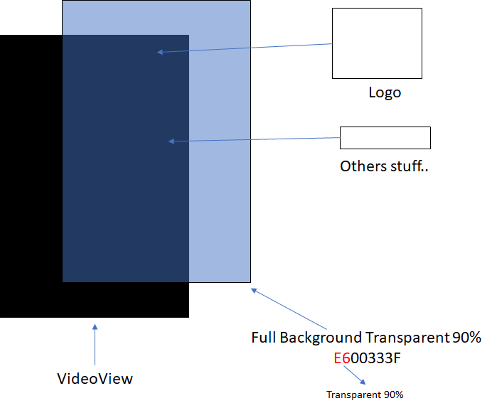

**VideoView**

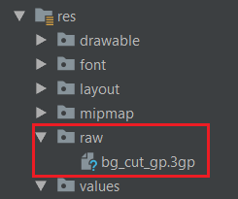

Media version support read more**:** <https://developer.android.com/guide/topics/media/media-formats>

* XML

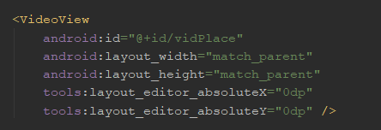

* Code

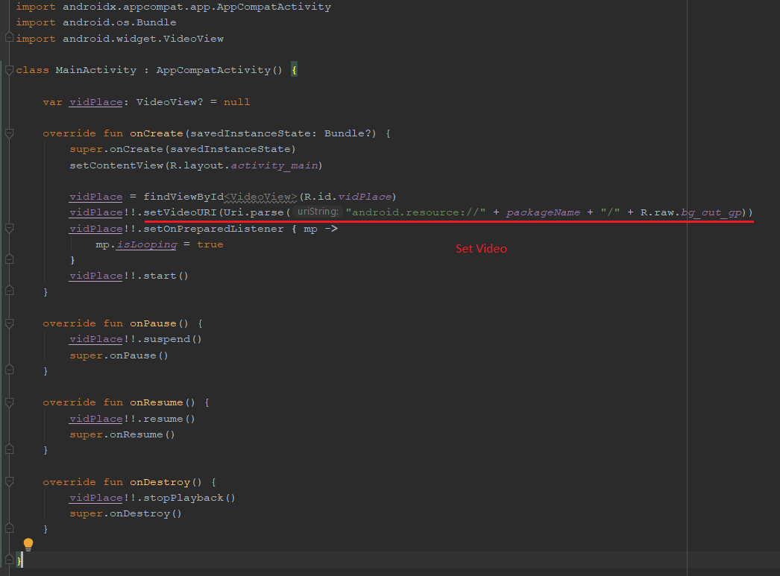

**Logo**

**Path:** "…\AssetsFileExtra\drawable\logo.webp"



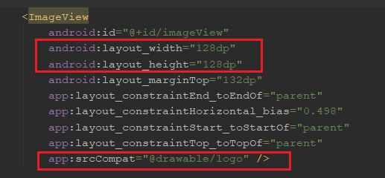

**Text Input**

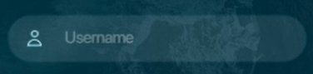

Drop all drawable asset in drawable folder

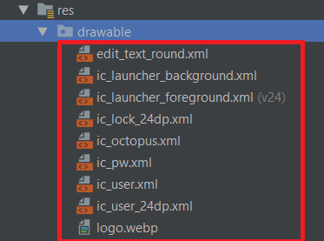

Follow below step to setup project for support Vector Drawable File

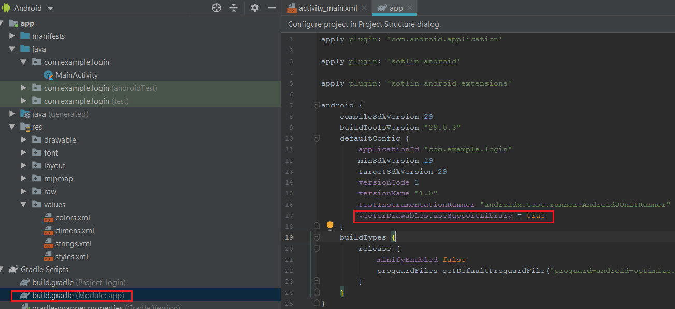

|  |
| --- |
| **vectorDrawables.useSupportLibrary = true** |

Set Style as below

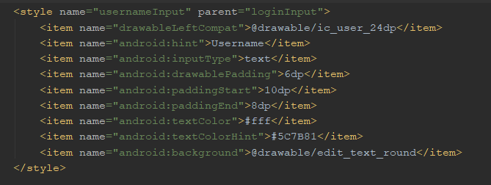

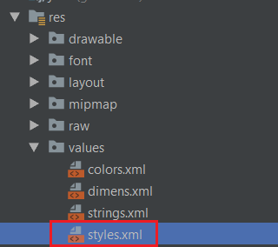

Using style

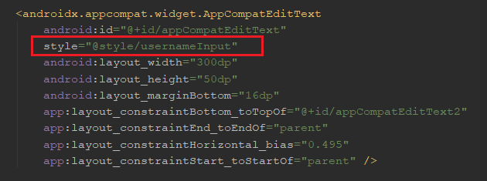

Button

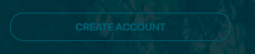

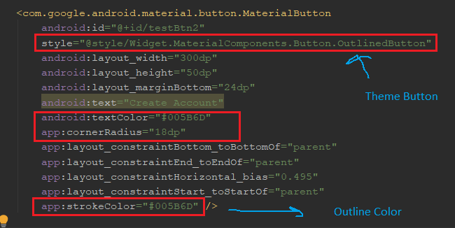

Read more about theme here: <https://material.io/develop/android/components/buttons/>



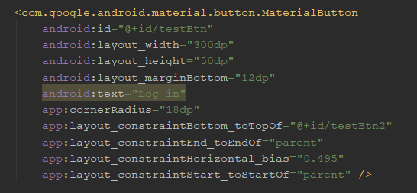

Don’t forget to set Primary Color theme

