

Assignment 1
Subject 308-471 Data Warehousing and Data Mining
Topic Introduction to R
(Expression, Logical Values, Variables, Functions, Help, Vectors, Plots)

ชื่อ – นามสกุล (Name and surname) | รหัสนักศึกษา (Student ID)

- วัตถุประสงค์ของปฏิบัติการ
  - เพื่อให้นักศึกษา เข้าใจโปรแกรม R เบื้องต้น
Objective: To study the fundamental of R programming.

- คำสั่งสำหรับปฏิบัติการ
- ให้นักศึกษาปฏิบัติการ ตามหัวข้อปฏิบัติการเป็น รายบุคคล
Lab instruction: Please read the exercise carefully and do it by yourself. ☺

- คำสั่งสำหรับจัดทำรายงานหรือเอกสาร (Submitting report instruction)
  - Please send electronic document by write your name, surname, and student ID in the document and submit to LMS2 of 308-471.
  - Please rename filename to 308-471_A1_ and then following by your student ID. For example, 308-471_A1_5XXXXXXXX.
  - Only accept the Microsoft Word file.
  - The deadline for this exercise is on Mar 28, 2018, 23:59.

Note: This assignment is adapted from http://tryr.codeschool.com, https://www.r-project.org/, and https://support.rstudio.com. You can study more detailed information from these links.
Chapter 1: Installation R and R-studio
- Download and install R for precompiled binary distributions of the base system and contributed packages.
  - Go to https://cran.r-project.org/ and then select R by your OS. Windows and Mac users most likely want one of these versions of R. About Linux, please check with your Linux package management system in addition to select folder those links of https://cran.r-project.org/bin/linux.
Or
For Windows: download the binary setup file for R from the following link.( R for Windows ) and open the downloaded .exe file and Install R.
For Mac: download the appropriate version of .pkg file form the following link. ( R for Mac ) and open the downloaded .pkg file and Install R
For Linux: for complete R System installation in Linux/Ubuntu, follow the instructions on the following link (Link), put ‘sudo apt-get install r-base’ in terminal.

- Download and install R Studio
On the following link Download R Studio by choosing the appropriate installer file for your operating system, download it and then run it to install R-studio from https://www .rstudio.com/products/rstudio/download/.
After installing R and RStudio, start using R/R studio by launching RStudio from your computer.
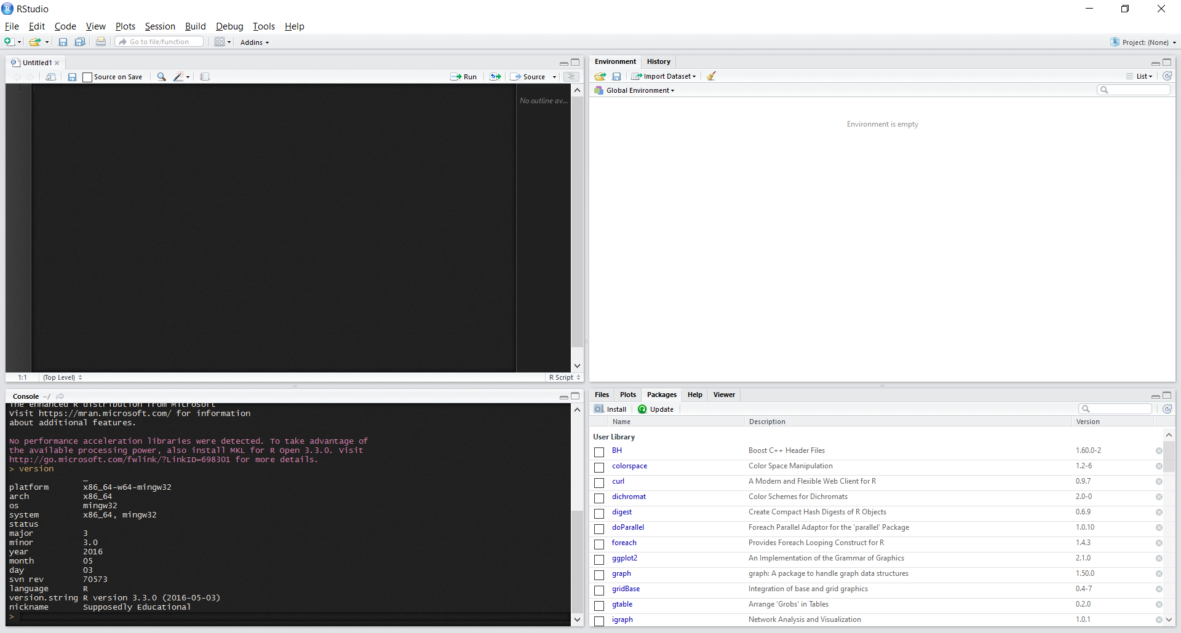
1.Code Editor
2. Work Space and History
3. R Console
4. Plots, Packages, and Files
Figure 1 R Studio screen

RStudio is a four-pane workspace for 1) creating file containing R script, 2) typing R commands, 3) viewing command histories, 4) viewing packages, files, plots and more.

Top-left panel #1, code editor allowing you to create and open a file containing R script. The R script is where you keep a record of your work. R script can be created as follow: File –> New –> R Script.
Top-right panel #2, there are 2 tabs. First, workspace tab shows the list of R objects you created during your R session and second, history tab shows the history of all previous commands
Bottom-left panel #3, R console for typing R commands.
Bottom-right panel#4, Files tab shows files in your working directory. Plots tab shows the history of plots you created. From this tab, you can export a plot to a PDF or an image files. Packages tab shows external R packages available on your system. If checked, the package is loaded in R.

Please answer the following questions.

Question1: What is your platform? (Hint: Type ‘version’ and then Enter in R console)
Answer 1:

Question 2: What is your version of R? (Hint: Type ‘version’ and then Enter in R console)
Answer 2:

Question 3: What is your version of R Studio? (Hint: Try Help > About RStudio)
Answer 3:

Chapter 2. Using R
Instruction: Please type the expression at the black background to R console, press enter, and then put the results from R console in the following box.

2.1 Expression
At R Console, try math expression.

> 308 – 1
[1]

> 308 * 1 - 1
[1]

Type the string expression “Data Warehouse and Data Mining”. (Don't forget the quotes!)

> “Data Warehouse and Data Mining”
[1]

2.2 Logical Values
The logical expressions return a "logical value": TRUE or FALSE. T and F are shorthand for TRUE and FALSE. Try this:

> 308 < 1
[1]

> 308 == 1
[1]

2.3 Variables
Storing values into a variable to access it later. Type x <- 308 means to store 308 in x.

Store your name in x.

>

Then browse x.
> x
[1]

Store 308 in x.

>

Try dividing x by 2 (/ is the division operator).
> x/2
[1]

Assign the TRUE logical value to x.

>

2.4 Functions
You call a function by typing its name, followed by one or more arguments to that function in parenthesis. For example, type sum(1, 3, 5), then the result is 9.

Let's try using the sum function, to add up a few numbers. Enter:
> sum(1, 2, 3, 4)
[1]

Repeating a value n time using rep.
> rep(“Data Warehouse”, times = 3)
[1]

2.5 Help
Try using help(functionname), it brings up help for the given function.

> help(rep)
[1]

Try using example(functionname) brings up examples of usage for the given function. Try displaying examples for the min function:

> example(sum)
[1]

2.6 Files
Short scripts Tip. R commands can also be written in plain text files (with a ".R" extension, by convention) for executing later. You can run them directly from the command line, or from within a running R instance.

Set your working directory

While you are working with Files, please set your working directory. The working directory is a folder where R reads and saves files.

Using command line, try this command
> s setwd("~/path/to/R/folder") )

Using RStudio, go to Session> Set Working Directory > Choose Directory… as Fig.2, then select your working folder, and click ‘Select folder’ button.

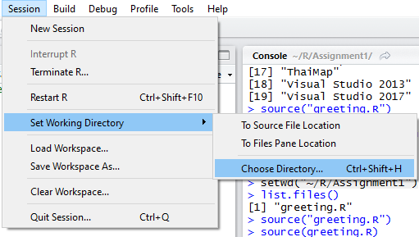

Figure 2 Set or change your working directory through RStudio

You can list the files in the current directory from within R, by calling the list.files function. Try it now:
> list.files()

What is this directory? (For example: C:\Users\Yourname\Documnets\R\Assignment1\.)

Please download all of files in Assignment1 folder of LMS2 to your workspace directory.
Now, to run a script, pass a string with its name to the source function. Try running the “greeting.R” script:

> source('~/R/Assignment1/greeting.R', echo=TRUE)

Chapter 3. Vectors
A vector is simply a list of values. R relies on vectors for many of its operations.

The vector's values can be numbers, strings, logical values, or any other type, as long as they're all the same type.

Try creating a vector of numbers, like this:

> c(1, 2, 3, 4)
[1]

This c(1, 2, 3, 4) expression means a vector ‘c’ combining a list of numbers.

Now try creating a vector with strings:
> c('a', 'b', 'c', ‘d’)
[1]

Note, vectors cannot hold values with different modes (types). Try mixing modes; number, logic, string, and see what happens:

> c( 1, TRUE, 'three')
[1]

Sequence Vectors

You can create a vector with a sequence of numbers with start:end notation. Let's make a vector with values from 11 - 19:

> 11:19
[1]

Let's do the same thing with seq function:

> seq(11, 19)
[1]

Vector Access
Try getting the third value of ‘sentence’ variable:

> sentence <- c('I', 'want', 'a', ‘key’)
> sentence[4]
[1]

You can assign new values within an existing vector. Try changing the fourth word to "bag":
> sentence[4] <- “bag”

You can use a vector within the square brackets to access multiple values. Try getting the second and fourth words:
> sentence[c(2, 4)]
[1]

Vector Names
Make a 3-item vector, and store it in the ranks variable. You can assign names to a vector's elements by passing a second vector filled with names to the names assignment function, like this:

> ranks <- 1:3
> names(ranks) <- c("first", "second", "third")
> ranks

> ranks["first"]

Plotting One Vector
The barplot function draws a bar chart with a vector's values. We'll make a new vector for you, and store it in the vesselsSunk variable. Now try passing the vector to the barplot function:

> vesselsSunk <- c(4, 5, 1, 8)
> barplot(vesselsSunk)

Assign names to the vector's values, R will use those names as labels on the bar plot. Let's use the names assignment function again:

> names(vesselsSunk) <- c("England", "France", "Norway", “Thailand”)

Please type the following commands barplot() and capture the results putting in the big box.

> barplot(vesselsSunk)

Now, try calling barplot on a vector of integers ranging from 1 through 100:
> barplot(1:100)

Scatter Plots
The plot function takes two vectors, one for X values and one for Y values, and draws a graph of them. Let's draw a graph showing the relationship of numbers and their sines.

First, we'll need some sample data. We'll create a vector for you with some fractional values between 0 and 20, and store it in the x variable.
Now, try creating a second vector with the sines of those values:

> x <- seq(1, 30, 0.2)
> y <- sin(x)
> plot(x, y)

Please put plot(x, y) to R console and then go to Plots Tab. Capture the diagram and paste to the following box.

Notice on the graph that values from the first argument (x) are used for the horizontal axis, and values from the second (y) for the vertical.

