Table of Contents
Introduction 4
Key Factors Impacting Passenger ‘Satisfaction’ 4
Methodology 5
Extract, Transform, and Load (ETL) Phase 5
EDA Findings 6
Selected Analytical Models: Decision Tree and Random Forest 13
Evaluation of Implemented Models 14
Recommendations 18
Next Steps 18
References 19
Appendix 20

Table of Figures
Figure 1: Data Preparation Outcome 6
Figure 2: Bar Plot for Passenger Satisfaction 7
Figure 3: Histogram for Distribution of Age Variable 8
Figure 4: Inflight Wi-Fi Service Rating by Passengers 9
Figure 5: Departure and Arrival Delays 10
Figure 6: Distribution of Satisfaction by Gender 11
Figure 7: Class based Distribution of Satisfaction Counts 12
Figure 8: Correlation Heatmap of Attributes 13
Figure 9: Classification Report of Decision Tree Model 15
Figure 10: Classification Report of Random Forest 15
Figure 11: ROC Curve for Both the Models 16
Figure 12: Feature Importance Score for Variables 17

Introduction
In a very competitive airlines sector of nowadays, providing excellent customer service along with efficiency remains the top priority. In view of the recent expansion of big data analytics, businesses now hold more information than ever at their fingertips which encompasses the preferences, behaviour as well as the degree of customer contentment. The airlines can guarantee their services give positive feedback from customers' expectations by looking into the customers' data to know the critical aspects important for the overall flight experience.
This case study will be based on extensive data analysis using modelling and visualization tools of the trip data volumes. Utilizing both current customer feedback and historical ones, this method would help to locate prospective obstacles and predict the upcoming customer satisfaction patterns (Park et al., 2022). Data can be used for a deeper evaluation of what will not be seen by complex methods. The information airlines get through data helps them to enhance the comfort on board, reservation procedure, not only customers' satisfaction but also the process of assistance on the ground.
The next are two influential reasons why the research should be conducted using those representative approaches: On the one hand, the first goal of the survey is to mirror the extent of passenger satisfaction; on the other, it is to show how well the airline is currently performing and indicate which improvements are needed. This objective, moreover, includes presenting the right information to decision-makers with the help of predictive modelling and data visualization. These instruments could be used to examine the relationship between various service components and customer satisfaction (Indra et al., 2022). Additionally, they will be able to forecast the results of any modifications. Airlines can use models and visualisations to analyse passenger data and make informed decisions that enhance the customer experience and foster confidence in a very competitive industry.

Key Factors Impacting Passenger ‘Satisfaction’
Passenger satisfaction is a complex concept in the airline sector that depends on a number of factors that impact the calibre of flight. The main factors affecting passengers' enjoyment and perception of the airline are the convenience of booking, seat comfort, and in-flight facilities.
Flight amenities, including as Wi-Fi, entertainment options, and meal quality, have a direct impact on passengers' comfort and happiness. A seat's legroom, reclining angle, and ergonomics are all regarded as comfort indicators. They are all necessary for an enjoyable journey, especially if it will be a long one. When it comes to their vacation, the first thing that tourists notice is how easy it is to make reservations—that is, how easy it is to buy tickets, check in, and contact customer service.
To improve operations and raise passenger happiness, airlines must be aware of these facts. Over time, improving factors that have a big impact on passenger satisfaction can help airlines become profitable. Positive word-of-mouth, a rise in loyal customers, and a competitive edge are all anticipated.

Methodology

Extract, Transform, and Load (ETL) Phase
The ETL stage, which makes sure that passenger information is appropriately recovered, transformed, and processed fast enough to enable a follow-up study, determines the data analysis methodology. This is a crucial stage in making sure the analysis is trustworthy and dependable (Biswas et al., 2020). This immediately affects recommendations and insights into passenger pleasure.
Extraction: The source of this dataset is 'SKYWARDS_DATA_CW3.csv'. There are 103,904 records in it that list numerous passenger characteristics. It contains both qualitative and quantitative data, such as information about individuals and service reviews. This dataset was loaded using the robust pandas Python package as part of the extraction procedure (Raj and D’Souza, 2020). The characters in the UTF-8 encoded dataset, must be handled effectively.
Transformation: There are number of issues that will be addressed in this phase:
Anomalies and Ambiguities: There are some duplicates identified and missing value is identified in the column name "Arrival Delay in Minutes". To lessen this, missing entries were filled in with the median number, which is a wise decision that strikes a balance between statistical soundness and data integrity.
Assumptions: Since the median is less impacted by outliers than the mean, it is a useful tool for displaying missing "Arrival Delay in Minutes".
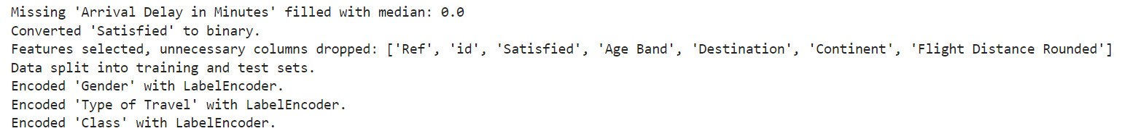
Figure 1: Data Preparation Outcome
Data Cleaning: The "Satisfied" variable is converted from an object to a binary format, and any missing values are resolved. This facilitates understanding of the model's use and analysis. This phase, together with removing superfluous columns, made the information more manageable and allowed it to concentrate on factors that have a direct impact on passenger satisfaction.
Class, gender, and type of trip are a few of the categorical factors that have been encoded into the label. In order for models to work together, this transformation will turn categories into numerical values. Since it is assumed that such groupings comprise nominal data, it is challenging to fit them in the correct sequence.
Load: As soon as the dataset is cleaned and transformed, it is split into training and test sets. To determine how well the model performs with unseen data, this split is required. Learning will so continue to be effective and beneficial for everyone.
At every level of the ETL process, two goals have been considered: that ensure staying good quality small data and preparing them to perform ever more and more complicated analytical techniques. Through the application of descriptive data analysis as well as prediction models, make it possible to expand the knowledge of passenger experience by all-embracing methodology.

EDA Findings
In the process of data exploration or EDA, it is really meaningful that the data be known and understood before any prediction model is chained. The analytics should provide descriptive statistics, visualisations and models that are ready to be applied to the data in order to aid in arranging the data, finding out hidden patterns under them and conduct proper analysis without any interruptions.
The EDA (Exploratory Data Analysis) way to invite flight patron patterns and insights is convenient in helping customer happiness. The purpose of the beginning part of the study is to show the form, distribution, structure, and primary trends of the features in the dataset using descriptive statistics. The similar fact that the participants' ages varied widely around the mean of 39.9 years (an indicator of a comprising group) was one of indications of variousness of participants. Many alternative flight durations were presented to allow for the types of flights either desired by passengers doing short or long travels.
In addition to this, other visualizations of data, such as boxplots and histograms, provide more comprehensible perceptions. The passenger histogram showed skewed age pattern with the left tail relatively short and the right tail long. It was clearly seen that the number of members who were in the younger age range reduced as the age went up. From the graphical representation of numbers, it seems that there were more satisfied passengers. This means that, as a general rule, airline's customers appear to be happy with what it has to offer.
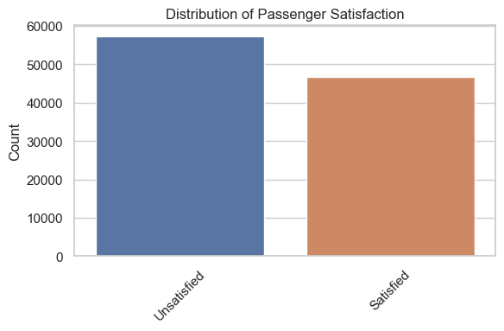
Figure 2: Bar Plot for Passenger Satisfaction
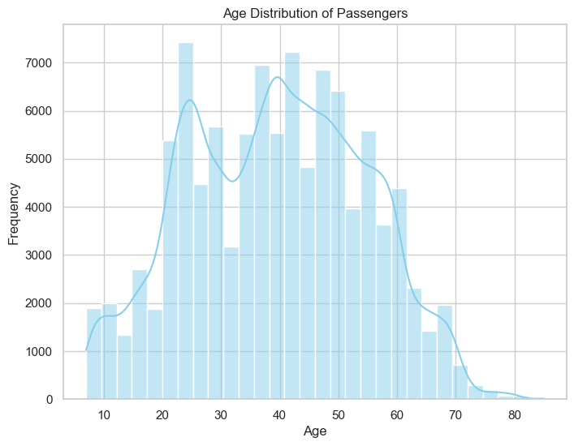
Figure 3: Histogram for Distribution of Age Variable
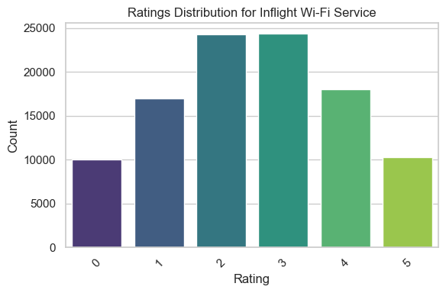
Figure 4: Inflight Wi-Fi Service Rating by Passengers
The boxplots for on time arrival and on time departure both indicated that there were outliers, which showed that many passengers did not have the same experience. Demographic trends within service classes could be better understood by looking at the gender and class satisfaction visuals that showed satisfaction disparity between men and woman as well as service classes.
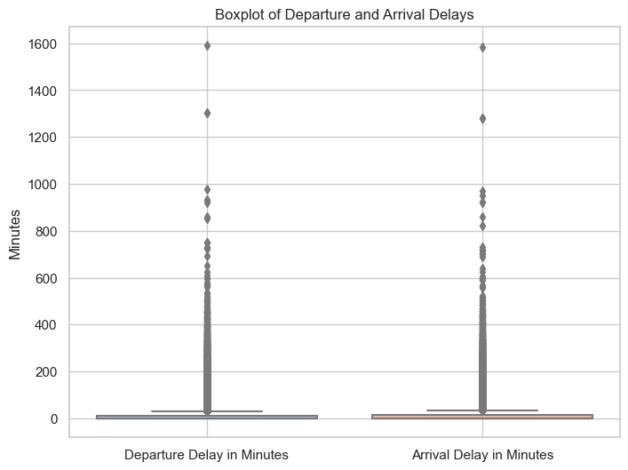
Figure 5: Departure and Arrival Delays
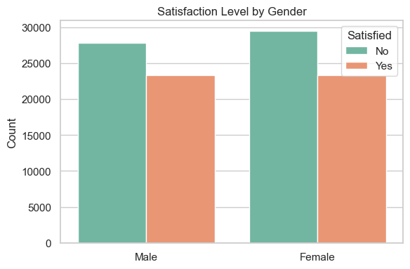
Figure 6: Distribution of Satisfaction by Gender
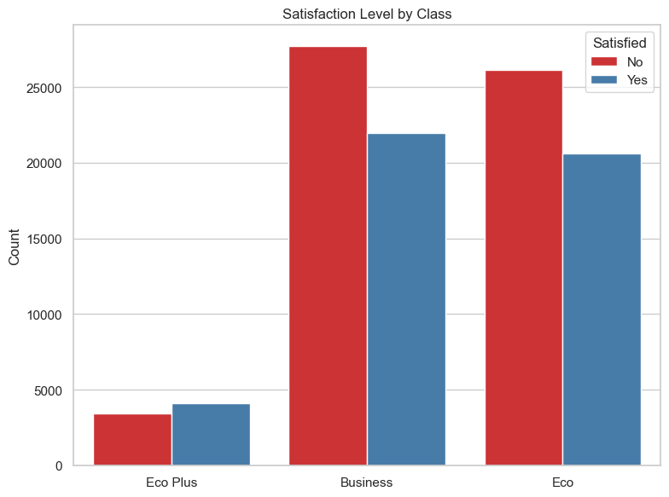
Figure 7: Class based Distribution of Satisfaction Counts
It is easy to identify the elements that have a significant impact on passenger satisfaction using the correlation heatmap and the EDA procedure. Passenger happiness and amenities like seat comfort, in-flight entertainment, and hygiene have strong positive relationships. This demonstrates how crucial these items are to the journey overall.
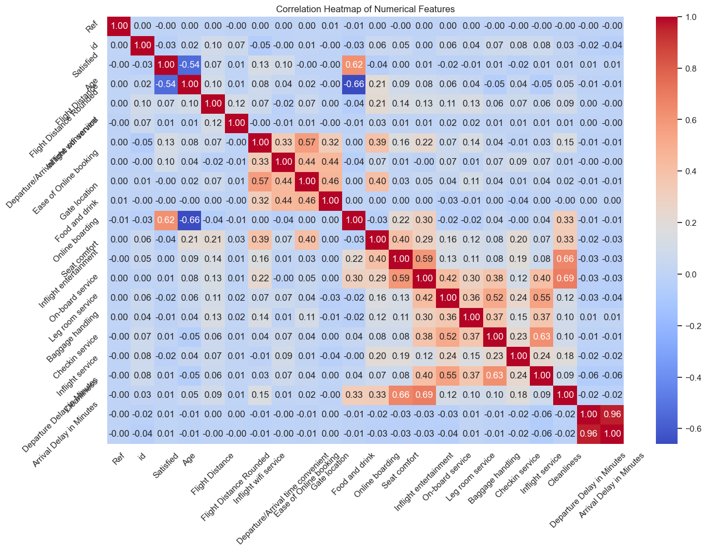
Figure 8: Correlation Heatmap of Attributes
The analytical model was selected with great assistance from the concepts acquired through EDA. Models capable of handling intricate, non-linear relationships had to be used due to the discovered correlations and the presence of both numerical and categorical components. Decision trees and random forests proved to be wise decisions because they can handle a wide variety of data types and identify intricate patterns in it. These two elements are necessary in order to forecast passenger satisfaction levels with any degree of accuracy.

Selected Analytical Models: Decision Tree and Random Forest
Within this binary classification study, one of the most important responsibilities is to forecast the passengers' level of pleasure. In this work, the decision tree and random forest models are selected due to their efficacy and ability to handle large datasets with various properties, including mathematical ones.
Decision Tree Model: Because the passenger satisfaction level is correlated with the feature columns in the dataset, a classification approach called the decision tree model is selected. This feature is among that of the DT system that make it superior. Simple and ease of interpretation is another feature that made the DT models admiration among the other models (Hayadi et al., 2021). Thus, the DPM the appropriate alternative to predict passenger satisfaction. However, the problem of overfitting is valid with extensive dimensionality or unknown datasets.
Random Forest Model: Resolution of decision trees problems was achieved during the research by using the Random Forest link. For this problem, the algorithm will generate a Tariff of Decision Trees, each of which will include an expectation value. Using this way of doing it every tree avoids oversampling as a process of averaging the found data among the trees is carried out. Moreover, (Hong et al., 2023) report that a forecast generated through deep learning has much greater accuracy and precision than that from traditional models. It may be a supporting stage where hard classification tasks can be listed and linear correlation is also considered. The main handicap of Random Forest's models is their complexity that may be making it more difficult to be understood by people and be consuming time longer than single decision tree.
This study presents data that these models do not only look but also simulate results in a wide range of aspects like customers’ happiness and loyalty. Since the Random Forest model is stronger than the Classification and Regression Tree model, it can be implemented more often. Nevertheless, the decision tree can help us to know essential pieces of the event which are essential. On the whole, way that they are utilized, they are the most efficient, correct, and simplest way of evaluating a level of passenger satisfaction.

Evaluation of Implemented Models
Examine performance measures and real-world consequences of predictive models, such as Random Forests and Decision Trees, to determine how well they function. Accuracy and the area under the receiver operating characteristic curve (AUC-ROC) are important factors in evaluation.
Accuracy Metrics: A basic model performance metric is the accuracy, or the percentage of accurate findings across all cases studied. At 99% and 99%, respectively, Random Forest and Decision Tree were only somewhat more accurate than each other. Even though these figures are quite high, choices should not be made solely on the basis of accuracy, especially if there is an imbalance in the data.
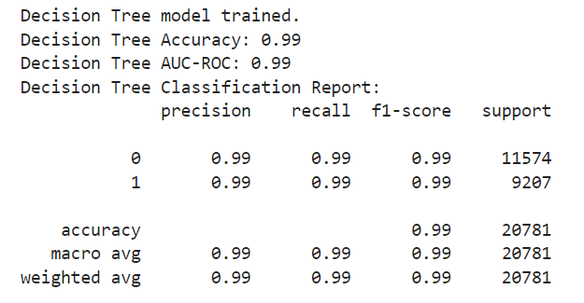
Figure 9: Classification Report of Decision Tree Model
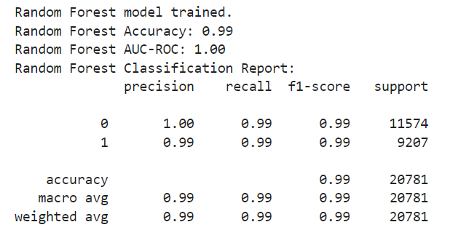
Figure 10: Classification Report of Random Forest
AUC-ROC: The AUC-ROC curve illustrates the performance of a classification task at various threshold settings. The ROC is a probability curve, and the AUC indicates how distinct they are. When the model's AUC value is near to 1, it performs better at differentiating across passenger satisfaction levels (Hong et al., 2020). While the Decision Tree model had an AUC of 0.99, the Random Forest model had an even more outstanding AUC of 1.00, indicating that it performed extremely well.
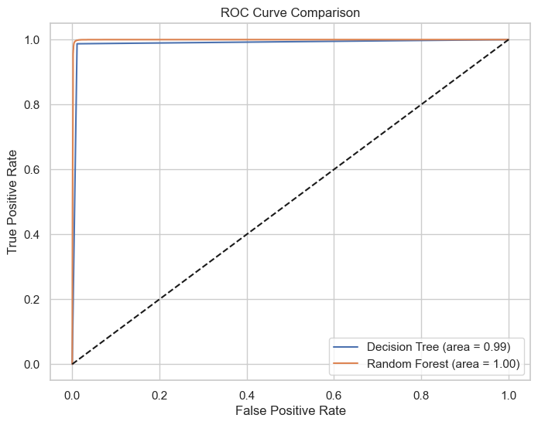
Figure 11: ROC Curve for Both the Models
Loss Function: For binary classification, a log loss function is employed. The model is more accurate if the log loss, which calculates the penalty for incorrect classifications, is smaller.
Graphical Findings of the Implemented Models:
- The relationship between the rate of genuine positives and the rate of false positives is displayed by the ROC Curve. Curves near the upper left corner in both versions indicate a high-performance level. Even yet, the Random Forest model comes very near to receiving a perfect score, indicating that it performs better at differentiating between persons who are content and those who are not.
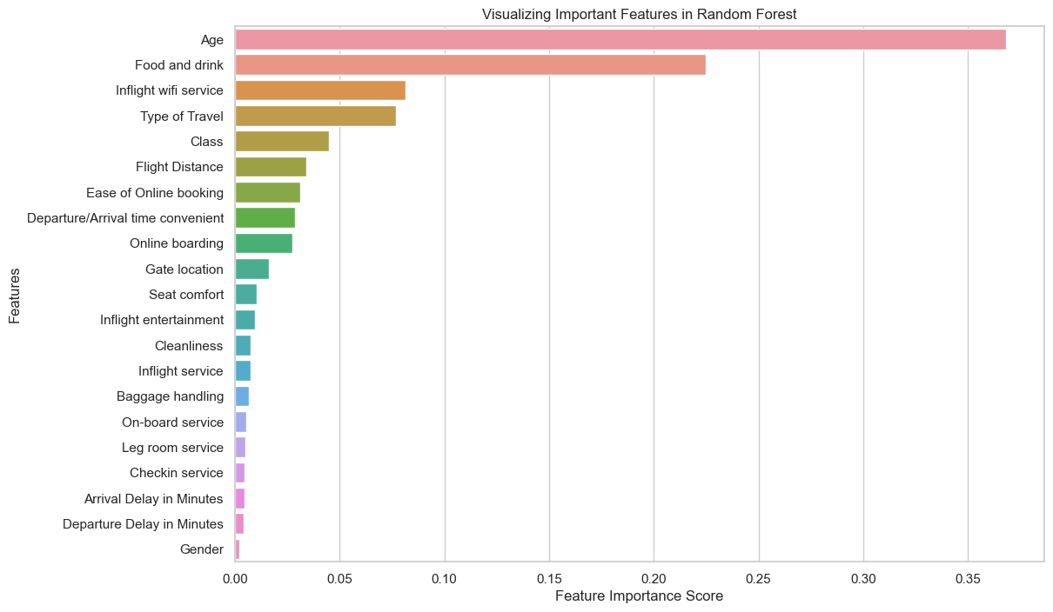
Figure 12: Feature Importance Score for Variables
- The Random Forest model's feature importance graph illustrates which characteristics have the most impact on passengers' levels of satisfaction. Certain elements, such as "Type of Travel," "Online boarding," and "Inflight wifi service," are particularly noteworthy and provide helpful information to enhance the overall client experience.
The Confusion Matrix is the visual representation of the correct and wrong predictions for each model. On the contrary, the Random Forest classifier misclassified fewer instances indicating that it models the classification task more stably and reliably than the Decision Tree classifier.
The comparison table displays the outcomes. Because it has a lower percentage of incorrect predictions and a greater accuracy and AUC-ROC score, the Random Forest is superior. According to this study, predicting passenger happiness more accurately with the Random Forest model can aid airlines in providing better services in the future.
As it has a higher AUC-ROC score and it is more accurate than the other two models, the RF (Random Forest) model provides more precise result than a one can get with any of the other models. The fact that it understands the changes in complicated sets of data as the connections between features, means that the number of inaccurate forecasts is reduced, what underlines its effectiveness in aviation.

Recommendations
This suggests that RF model might be able to forecast the level of passenger satisfaction. The performance of the model warrant support for this article hence its extreme accuracy and AUC-ROC metrics which are excellent for binary classification. RF model is definitely one of the best ones to use if you want to determine the traits that have an influence on passengers’ satisfaction since it has the capacity to handle complex data and the nonlinearity while, at the same time, keeping the errors to the minimum.
The ranking of the important variables illustrates the importance of the service sectors, such as inboard boarding and in-flight amenities. This approach can assist in making critical strategic decisions by insights drawn from the findings. Using a Random Forest approach, airlines may find out what their customers enjoy and make changes to their experience accordingly. Consumers would become more devoted to them, giving them a competitive edge in this day and age.

Next Steps
The seasonality, economic transitions that possibly remove the air travel, and the environment that the passenger is in just after entering the plane could all affect the pleasantness of flights. Also, through more advanced researching, this could probably change. This information enables the machine model to have better forecasts and improve its efficiency with regards to people's moods.
The identification of more pertinent data could also be much easier due to this network utilizing deep learning techniques or even the employment of complex models. Cluster analysis of the collected and mixed data, e.g. customer feedback and reviews will be also done in future work. This means that can result in targeting as individual as possible, which can result in advanced concepts and ideas, helping to improve client’s experience.
The results from this prediction should also be used for a bigger approach of customer relationship management (CRM). Predictive analytics would need to be merged into customer-centred approaches to business and communication instead of being a separate approach in order to achieve the desirable result. An adequately accurate model must require both regular reviewing and upgrading in order to remain current. Through this way, the interventions could be made to some extent to cater for the market requirements and the customers' needs.

References

Biswas, N., Sarkar, A. and Mondal, K.C., 2020. Efficient incremental loading in ETL processing for real-time data integration. Innovations in Systems and Software Engineering, 16(1), pp.53-61.
Hayadi, B.H., Kim, J.M., Hulliyah, K. and Sukmana, H.T., 2021. Predicting Airline Passenger Satisfaction with Classification Algorithms. International Journal of Informatics and Information Systems, 4(1), pp.82-94.
Hong, A.C.Y., KHAW, K.W., Chew, X. and Yeong, W.C., 2023. Prediction of US airline passenger satisfaction using machine learning algorithms. Data Analytics and Applied Mathematics (DAAM), pp.7-22.
Hong, S.H., Kim, B. and Jung, Y.G., 2020. Correlation analysis of airline customer satisfaction using random forest with deep neural network and support vector machine model. International Journal of Internet, Broadcasting and Communication, 12(4), pp.26-32.
Indra, E., Suwanto, J., Sitompul, D.R.H., Sinurat, S.H., Situmorang, A., Ruben, R. and Ziegel, D.J., 2022. Comparison of classification algorithm in classifying airline passenger satisfaction. Jurnal Sistem Informasi dan Ilmu Komputer Prima (JUSIKOM PRIMA), 6(1), pp.92-98.
Park, S.H., Kim, M.Y., Kim, Y.J. and Park, Y.H., 2022. A deep learning approach to analyze airline customer propensities: the case of South Korea. Applied Sciences, 12(4), p.1916.
Raj, A. and D’Souza, R., 2020. Implementation of ETL process using Pig and Hadoop. Int J Recent Technol Eng (IJRTE).

Appendix
https://colab.research.google.com/drive/1_-wTTJ2tv00c7GcB2c-1eCswj7xa0zm2?usp=sharing
Data Preparation
In [1]:
import pandas as pd
import numpy as np
from sklearn.model_selection import train_test_split
from sklearn.preprocessing import LabelEncoder

class DatasetLoader:
def __init__(self, file_path):
self.file_path = file_path

def load_data(self):
data = pd.read_csv(self.file_path, encoding='ISO-8859-1')
return data

def display_info(self, data):
print("Basic Dataset Information:")
print(data.info())

file_path = 'SKYWARDS_DATA_CW2-1-.csv'
loader = DatasetLoader(file_path)
data = loader.load_data()
loader.display_info(data)
print(f"\nInitial total rows: {len(data)}")
print(f"Number of duplicate rows: {data.duplicated().sum()}")

# Removing duplicates
data.drop_duplicates(inplace=True)

print(f"Rows after duplicates removed: {len(data)}")
print("Duplicates removed.")
Initial total rows: 103904
Number of duplicate rows: 0
Rows after duplicates removed: 103904
Duplicates removed.
In [4]:
print("\nMissing Values per Column:")
missing_counts = data.isnull().sum()
print(missing_counts)

# Additional analysis
total_cells = np.product(data.shape)
total_missing = missing_counts.sum()
print(f"\nTotal missing values: {total_missing}")
print(f"Percentage of data missing: {total_missing / total_cells * 100:.2f}%")
import pandas as pd
import numpy as np
from sklearn.model_selection import train_test_split
from sklearn.preprocessing import LabelEncoder

# Handling missing values
if 'Arrival Delay in Minutes' in data.columns:
median_arrival_delay = data['Arrival Delay in Minutes'].median() # Compute the median
data['Arrival Delay in Minutes'].fillna(median_arrival_delay, inplace=True) # Fill missing values
print(f"Missing 'Arrival Delay in Minutes' filled with median: {median_arrival_delay}")

# Data transformation
if 'Satisfied' in data.columns:
data['Satisfied'] = data['Satisfied'].map({'Y': 1, 'N': 0})
print("Converted 'Satisfied' to binary.")

# Feature selection and preprocessing
columns_to_drop = ['Ref', 'id', 'Satisfied', 'Age Band', 'Destination', 'Continent', 'Flight Distance Rounded']
X = data.drop(columns_to_drop, axis=1)
y = data['Satisfied']
print(f"Features selected, unnecessary columns dropped: {columns_to_drop}")

# Splitting the data into training and test sets
# Use 80% of the data for training and 20% for testing to evaluate the model
X_train, X_test, y_train, y_test = train_test_split(X, y, test_size=0.2, random_state=42)
print("Data split into training and test sets.")

# Applying label encoding
# Converting categorical columns to numerical values using LabelEncoder
# This is necessary as many machine learning algorithms require input to be numeric
columns_to_encode = ['Gender', 'Type of Travel', 'Class']
label_encoder = LabelEncoder()

for column in columns_to_encode:
X_train[column] = label_encoder.fit_transform(X_train[column])
X_test[column] = label_encoder.transform(X_test[column])
print(f"Encoded '{column}' with LabelEncoder.")
Missing 'Arrival Delay in Minutes' filled with median: 0.0
Converted 'Satisfied' to binary.
Features selected, unnecessary columns dropped: ['Ref', 'id', 'Satisfied', 'Age Band', 'Destination', 'Continent', 'Flight Distance Rounded']
Data split into training and test sets.
Encoded 'Gender' with LabelEncoder.
Encoded 'Type of Travel' with LabelEncoder.
Encoded 'Class' with LabelEncoder.
Exploratory Data Analysis
In [6]:
import pandas as pd
import matplotlib.pyplot as plt
import seaborn as sns
from sklearn.impute import SimpleImputer

# Descriptive Statistics
# Transposing the result to better view the statistics for each column
print("Descriptive Statistics of the Data:")
statistics = data.describe().T
print(statistics)
# Set a style for all the plots
sns.set(style="whitegrid")

# Distribution of Passenger Satisfaction
# Using a more detailed and interactive plot style
plt.figure(figsize=(6, 4))
satisfaction_plot = sns.countplot(x='Satisfied', data=data)
plt.title('Distribution of Passenger Satisfaction')
plt.xticks([0, 1], ['Unsatisfied', 'Satisfied'])
plt.xlabel('')
plt.ylabel('Count')
satisfaction_plot.set_xticklabels(satisfaction_plot.get_xticklabels(), rotation=45)
plt.tight_layout()
plt.show()

In [8]:
# Age Distribution of Passengers
plt.figure(figsize=(8, 6))
age_distribution_plot = sns.histplot(data['Age'], bins=30, kde=True, color='skyblue')
plt.title('Age Distribution of Passengers')
plt.xlabel('Age')
plt.ylabel('Frequency')
plt.grid(True)
plt.show()

In [9]:
# Ratings Distribution for Inflight Wi-Fi Service
plt.figure(figsize=(6, 4))
wifi_rating_plot = sns.countplot(x='Inflight wifi service', data=data, palette='viridis')
plt.title('Ratings Distribution for Inflight Wi-Fi Service')
plt.xlabel('Rating')
plt.ylabel('Count')
wifi_rating_plot.set_xticklabels(wifi_rating_plot.get_xticklabels(), rotation=45)
plt.tight_layout()
plt.show()

In [10]:
# Boxplot for Departure and Arrival Delays
plt.figure(figsize=(8, 6))
delay_boxplot = sns.boxplot(data=data[['Departure Delay in Minutes', 'Arrival Delay in Minutes']], palette='coolwarm')
plt.title('Boxplot of Departure and Arrival Delays')
plt.ylabel('Minutes')
plt.grid(True)
plt.show()

In [11]:
# Satisfaction Level by Gender
plt.figure(figsize=(6, 4))
gender_satisfaction_plot = sns.countplot(x='Gender', hue='Satisfied', data=data, palette='Set2')
plt.title('Satisfaction Level by Gender')
plt.xlabel('')
plt.ylabel('Count')
plt.legend(title='Satisfied', labels=['No', 'Yes'])
plt.tight_layout()
plt.show()

In [12]:
# Satisfaction Level by Class
plt.figure(figsize=(8, 6))
class_satisfaction_plot = sns.countplot(x='Class', hue='Satisfied', data=data, palette='Set1')
plt.title('Satisfaction Level by Class')
plt.xlabel('')
plt.ylabel('Count')
plt.legend(title='Satisfied', labels=['No', 'Yes'])
plt.tight_layout()
plt.show()

In [14]:
# Correlation Heatmap of Numerical Features
plt.figure(figsize=(15, 10))
numerical_data = data.select_dtypes(include=['int64', 'float64'])
corr_matrix = numerical_data.corr()
heatmap = sns.heatmap(corr_matrix, annot=True, cmap='coolwarm', fmt=".2f")
plt.title('Correlation Heatmap of Numerical Features')
heatmap.set_xticklabels(heatmap.get_xticklabels(), rotation=45)
heatmap.set_yticklabels(heatmap.get_yticklabels(), rotation=45)
plt.show()

In [15]:
# Handling missing values in the test set using a SimpleImputer
imputer = SimpleImputer(strategy="mean")
X_test_imputed = imputer.fit_transform(X_test)
print("Missing values in the test set have been imputed with the mean.")
Missing values in the test set have been imputed with the mean.
Model Training
In [16]:
import pandas as pd
import numpy as np
import matplotlib.pyplot as plt
import seaborn as sns
from sklearn.tree import DecisionTreeClassifier
from sklearn.ensemble import RandomForestClassifier
from sklearn.metrics import accuracy_score, classification_report, confusion_matrix
from sklearn.metrics import roc_auc_score, roc_curve

# Initialize the models
decision_tree = DecisionTreeClassifier(random_state=42)
random_forest = RandomForestClassifier(random_state=42)

# Train the Decision Tree model
decision_tree.fit(X_train, y_train)
print("Decision Tree model trained.")

# Predict on the test set
dt_predictions = decision_tree.predict(X_test)
dt_probabilities = decision_tree.predict_proba(X_test)[:, 1] # Probabilities for ROC-AUC

# Evaluate the Decision Tree model
dt_accuracy = accuracy_score(y_test, dt_predictions)
dt_auc_roc = roc_auc_score(y_test, dt_probabilities)
print(f"Decision Tree Accuracy: {dt_accuracy:.2f}")
print(f"Decision Tree AUC-ROC: {dt_auc_roc:.2f}")
print("Decision Tree Classification Report:")
print(classification_report(y_test, dt_predictions))
Decision Tree model trained.
Decision Tree Accuracy: 0.99
Decision Tree AUC-ROC: 0.99
Decision Tree Classification Report:
precision recall f1-score support

0 0.99 0.99 0.99 11574
1 0.99 0.99 0.99 9207

accuracy 0.99 20781
macro avg 0.99 0.99 0.99 20781
weighted avg 0.99 0.99 0.99 20781

In [17]:
# Train the Random Forest model
random_forest.fit(X_train, y_train)
print("Random Forest model trained.")

# Predict on the test set
rf_predictions = random_forest.predict(X_test)
rf_probabilities = random_forest.predict_proba(X_test)[:, 1] # Probabilities for ROC-AUC

# Evaluate the Random Forest model
rf_accuracy = accuracy_score(y_test, rf_predictions)
rf_auc_roc = roc_auc_score(y_test, rf_probabilities)
print(f"Random Forest Accuracy: {rf_accuracy:.2f}")
print(f"Random Forest AUC-ROC: {rf_auc_roc:.2f}")
print("Random Forest Classification Report:")
print(classification_report(y_test, rf_predictions))

# Plotting ROC Curve for both models
plt.figure(figsize=(8, 6))
fpr_dt, tpr_dt, _ = roc_curve(y_test, dt_probabilities)
fpr_rf, tpr_rf, _ = roc_curve(y_test, rf_probabilities)
plt.plot(fpr_dt, tpr_dt, label=f'Decision Tree (area = {dt_auc_roc:.2f})')
plt.plot(fpr_rf, tpr_rf, label=f'Random Forest (area = {rf_auc_roc:.2f})')
plt.plot([0, 1], [0, 1], 'k--') # Diagonal dashed line (no skill classifier)
plt.xlabel('False Positive Rate')
plt.ylabel('True Positive Rate')
plt.title('ROC Curve Comparison')
plt.legend(loc="lower right")
plt.show()
Random Forest model trained.
Random Forest Accuracy: 0.99
Random Forest AUC-ROC: 1.00
Random Forest Classification Report:
precision recall f1-score support

0 1.00 0.99 0.99 11574
1 0.99 0.99 0.99 9207

accuracy 0.99 20781
macro avg 0.99 0.99 0.99 20781
weighted avg 0.99 0.99 0.99 20781


In [18]:
# Feature Importance for Random Forest
feature_importance_rf = pd.Series(random_forest.feature_importances_, index=X_train.columns).sort_values(ascending=False)
plt.figure(figsize=(12, 8))
sns.barplot(x=feature_importance_rf, y=feature_importance_rf.index)
plt.xlabel('Feature Importance Score')
plt.ylabel('Features')
plt.title('Visualizing Important Features in Random Forest')
plt.show()

In [19]:
# Calculate the confusion matrix for both models
dt_cm = confusion_matrix(y_test, dt_predictions)
rf_cm = confusion_matrix(y_test, rf_predictions)

# Comparison of model performance
performance_comparison = pd.DataFrame({
"Model": ["Decision Tree", "Random Forest"],
"Accuracy": [dt_accuracy, rf_accuracy],
"AUC-ROC": [dt_auc_roc, rf_auc_roc],
"Correct Predictions": [np.sum(np.diagonal(dt_cm)), np.sum(np.diagonal(rf_cm))],
"Incorrect Predictions": [np.sum(dt_cm) - np.sum(np.diagonal(dt_cm)), np.sum(rf_cm) - np.sum(np.diagonal(rf_cm))]
})

print("Comparison of Decision Tree and Random Forest Performance:")
print(performance_comparison)
Comparison of Decision Tree and Random Forest Performance:
Model Accuracy AUC-ROC Correct Predictions
0 Decision Tree 0.988162 0.988062 20535 \
1 Random Forest 0.993937 0.998930 20655

Incorrect Predictions
0 246
1 126

