Contents
Introduction 3
Approach 3
Recommendations and Conclusion 11
Conclusion 13
References 15
Appendix 16

Introduction
Businesses today, like Zappy Financial Services (ZFS), have to deal with customers' rising demands while still running their businesses well. A local small business loan company called ZFS got a lot more loan requests after having a digital campaign not long ago. There has been a lot of progress with technology, but most of the loan application process is still done by hand. This meant they had to get a computer system that was geared towards analysing data.
It talks about the problems it wants to fix, how it will probably affect ZFS, the bad things that could happen if nothing is done, and the key people who are needed to make it work. This paper makes the point that we need a data-driven programming answer right away. The suggested way of programming can fix present issues by handling key steps in the loan approval process. This will make operations run more smoothly, cut down on the time needed to make choices, and lower the risks of operations and control.
Software for data analysis, tools for machine learning, and the flexible programming language Python are all used in the chosen method. The study goes into great detail about how the tools were picked. As part of data preparation, you clean the data very well, create features, and make a trained machine learning model that can predict whether a loan will be approved.
Because this method knows how important it is to both code tools to speed up development and careful testing to make sure the code is stable and correct, it creates a strong control environment.

Approach
Data analysis is an important part of building a computer system for Zappy Financial Services (ZFS). The process must be well-thought-out and thorough. The goal of this method is to solve the company's current problems and make choices based on what the data shows. It has several important parts, such as
1. Figure out what's wrong: The plan's first step is to find out what ZFS's current business issues are. A lack of trained workers, longer approval times, and the chance of operating and control problems are some of these problems. The process for taking loans is slow and done by hand. It's the goal to make the loan application process faster, safer, and fully automatic (Çetin, and YILDIZ, 2022).
2. To Get Data: This computer method is based on data. This plan first gets information about loans from two files named "PDA - Zappy Loan Data.xlsx" and "Loans_Dataset_Table.xlsx." What kind of people and how much money they have, as well as the results of loan decisions, are all important pieces of information that can be found in these files.
3. Getting the data clean and ready: To make sure the data is good quality and reliable, it needs to be cleaned and ready well. This needs to fix the copies and numbers that are missing. There were some rows that didn't have any data in them, so those were taken out to make sure the study is based on complete and correct data. Any copies of the data have also been taken out to keep it clean.
4. Putting numbers into groups that are useful: Some of the numbers in the files that have been mapped to useful groups are those that show gender, marital status, and level of schooling. This change helps people understand the data better and makes sure it helps the business reach its goals. It's possible to write "Male" and "Female" with the numbers "1" and "2" (Battineni, et al., 2020).
5. Data Integration: Putting the data from the two sources together into a single report that makes sense is the next step. You can use the "combined_data" file to see all of your past loan records and make choices or do research. Data-driven jobs that come after are built on top of the merged data.
6. Exploratory Data Analysis: This part of the plan is very important. So, you have to look at the data's patterns, trends, and links. Many kinds of visualisations have been used to help people understand things better. Here are some examples: the rate of loan approval by gender, the rate of loan approval by application income, and the relationship between number factors. EDA makes it easy to understand old data, see possible trends, and figure out what makes a loan offer go through or not go through.
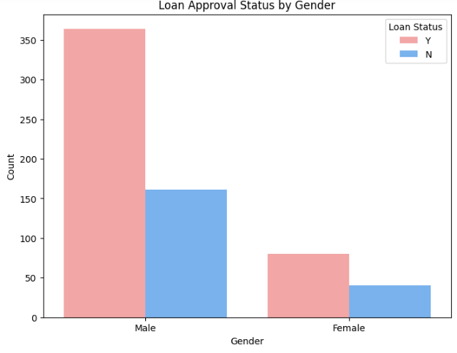
Figure 1: Loan Status distribution by Gender
The bar graph that shows the Loan Status by Gender helps you see how gender affects the chances of getting a loan. The graph makes it clear that loan results for both men and women can be broken down into "N" (loans were turned down) and "Y" (loans were accepted).
More loans have been given to men than to women, as shown by the 364 cases marked with a "Y" in the figure. On the other hand, about 80 loans have been accepted for women. Just so you know, a lot of loan requests from men have also been turned down (161 cases are marked as "N").
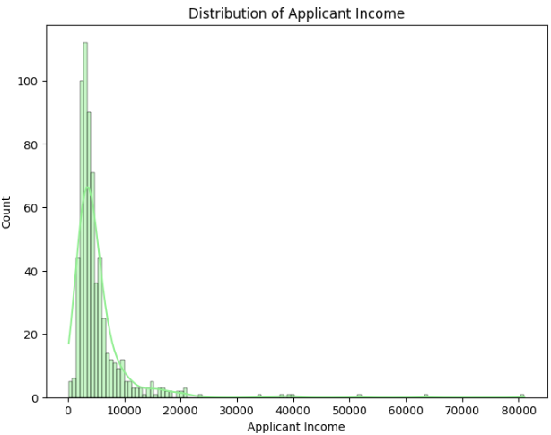
Figure 2: Distribution of Applicant's Income
A line shows the applicant's income and tells you about the range of incomes among loan applicants. The x-axis shows the range of applicants' incomes, and the y-axis displays the number of applicants in each income group.
Based on the graph, it's clear that most of the applicants have small incomes. The group with the biggest incomes is in the middle to lower income range. The spread is skewed to the right because not many people make a lot of money (Stančin, and Jović, 2019).
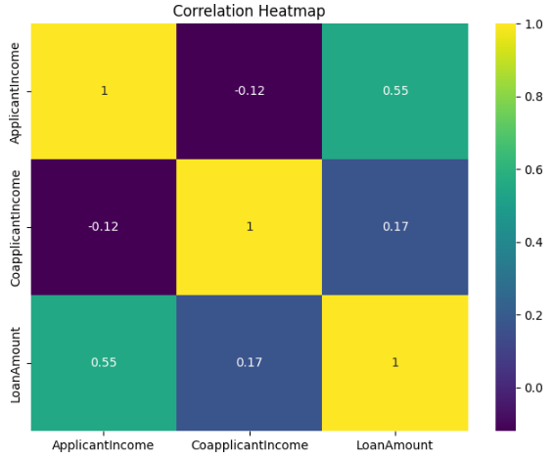
Figure 3: correlation heatmap
It shows how the number factors in the information are connected to each other. Each grid cell shows the association value between any two factors. Now we'll look at how "ApplicantIncome," "CoapplicantIncome," and "LoanAmount" are related.
- "LoanAmount" and "ApplicantIncome" are linked in a good way—0.434. At least in this case, the amount of the loan asked for goes up as the applicant's income does. This makes sense, since when people make more money, they can ask for bigger payments.
- "CoapplicantIncome" and "LoanAmount" are also related in a good way, but not as much. They are linked with a number of 0.312. It looks like the loan amount goes up when the co-applicant's income does (Lis and Otto, 2020).
- "ApplicantIncome" and "CoapplicantIncome" have a negative relationship (-0.180), which means that when one person's income goes up, the coapplicant's income generally goes down too.
In a picture called a heatmap, these connections are shown by a colour range that goes from cool (correlations that are negative) to warm (correlations that are positive). These links can help Zappy Financial Services decide what loans to give out and what things to sell. They are easy to find and look into.
7. Descriptive Analysis:
The method is based on exploratory data analysis. To look at the data's patterns, trends, and links is what it means. A lot of different kinds of visualisations have been used to help people understand things better. These include the distribution of loan approval status, loan approval status by gender, application income distribution, and the relationship between numerical factors. If someone wants to get a loan, EDA can help them understand data from the past and guess how it might change in the future (Waskom, 2021).
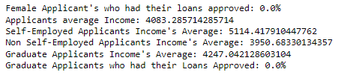
Figure 4: Descriptive Analysis

Recommendations and Conclusion
Our current loan data study at Zappy Financial Services has taught us a lot about what makes a loan offer go through or not go through. We can guess how to look at new loan applications based on these results. They also set the stage for a data-driven plan to improve the loan clearance process. The way forward is shown by the following ideas:
- Building a model for making predictions: Setting up a tool that can look at new loan requests and guess how likely it is that they will be accepted is the next step that makes sense. This can speed up the decision-making process and make it much less likely that people will be biassed.
- Getting data and cleaning it up: Getting data and cleaning it up is the first thing that needs to be done to make a prediction model. The detailed study starts with the loan data from the past. You can add more data to the set by getting credit scores, work records, and other financial signs that are useful. According to Toxopeus, Achterberg, and Polzin (2021), mistakes must be carefully dealt with before the data can be used. Missing values must also be filled in, and classified data must be turned into number format.
- Chosen Features and Engineering: Picking the features that tell you the most is one of the most important parts of building a model. You can use methods for feature selection to figure out what makes loans more likely to be approved. It might also be necessary to use feature engineering to add new factors or change old ones so that the model works better.
- Choice of Algorithm: There are different machine learning methods that can be used to make the forecast model. Choice trees, random forests, logistic regression, and gradient boosting methods like XGBoost are a few of these. The type of data and how easy it is to understand the model should determine which tools to use.
- Model evaluation: a number of review factors will be used to see how well the forecast model works. The F1 score, memory, accuracy, and precision are a few of these. Cross-validation methods can keep the model stable and lower the chance of it being too good at what it does.
- Automation and Integration: The model should be used in the loan application process after it is made. A system that works on its own can quickly look over applications. Plus, it can keep track of all reviews and give human insurers options to choose from.
- Checking and updating it often: Since prediction models are always changing, they need to be checked on and updated all the time. You need to give your customers information all the time and keep an eye on things to keep up with their changing needs and tastes. Zappy Financial Services should make a way to keep the model up to date and make sure it stays correct over time.
- Ethics worries: it's important to think about social issues when making a prediction model. It is important to follow fair loan rules so that the plan doesn't hurt any weak or underrepresented group. Part of the process should be regular exams and checks to make sure everything is fair (Yu, et al., 2021).
- Be able to understand and open about what’s going on: Complex machine learning models are very accurate, but they are often called "black boxes." It's important to know what's going on and be honest about it. It's important to leave some room for perception and freedom in the model so that you can figure out why certain choices were made. For example, SHAP (SHapley Additive Explanations) value methods can help us better understand what the model says will happen.
- Being aware of risks: Making a prediction model doesn't get rid of all the risk, but it does help you handle it better. If the model's expectations are wrong, there may be legal issues or other problems that were not expected. A risk management plan should be made so that these issues can be dealt with.

Conclusion
This study looked at a lot of information about Zappy Financial Services' loans. It talked about some important parts of getting data ready and doing basic data analysis. It also made a plan for future work that will include making a prediction model. The most important parts of the study are summed up below:
In the beginning of the study, it was talking about how important it is for current financial services to really look at data. It also talked about the study's goals and gave a quick list of things that had to be done.
The "Loan Data Automation" part took two files from different places, cleaned them up, and then put them together. The pandas package in Python was used to read and set up the data properly. It was saved for later study after the category numbers were put into the right groups. Different visualisations of the dataset have helped us understand its features. These include an association graph, a histogram of application income, and a scatter plot between applicant and coapplicant income.
In the "Descriptive Statistics" part, exploratory data analysis was used to answer important business questions. It also checked the uniform dataset to make sure it was correct and dealt with duplicates, missing values, and outliers. In these questions, you were asked about the average applicant's income, the difference in income between applicants who were self-employed and those who were not, the loan approval rate for grads, and the loan approval rate for women.
A number of visualisations were also explained in the study. Most of the loans that were shown on the bar chart were accepted; only a few were turned down. This helps Zappy reach its goal of making it easy for everyone to use banking services. It can be seen from the loan status by gender bar chart that more men than women asked for loans, and many of them were paid back.
The applicant's income histogram had some outliers with much higher rates than the rest of the data. The distribution was also skewed to the right overall. The salary of the application and coapplicant was shown on a scatter plot with a downward trend. This means that the coapplicant's income goes down as the applicant's income goes up. This could mean that applicants and coapplicants depend on each other for money.
Based on the association graph, there was a link between the applicant's salary and the loan amount that was positive. This means that people who apply for loans are more likely to want bigger ones if they make more money.
The "Recommendations and Future Work" part laid out a way to make a forecast model based on these data. It was emphasised how important it is to get good data, do the right preparation and feature engineering, pick the right machine learning methods, and test the models in the right ways. Banks were told to be open and be supervised all the time to make sure they were acting honestly and responsibly.
The "Future Work" section of the study talked about things like creating a specialised data science team, making an easy-to-use interface for loan officers, and checking the model often to make sure it is fair and correct. This could change how Zappy Financial Services loans money in the future and set new standards for fairness, efficiency, and inclusiveness.
By making choices based on data, Zappy Financial Services could improve the way it accepts loans, get rid of bias, and improve the customer experience in this study. It's possible that Zappy Financial Services will set the standard for how easy and fair it is for its clients to get loans by focusing on data quality, ethics, and model interpretability.

References
Çetin, V. and YILDIZ, O., 2022. A comprehensive review on data preprocessing techniques in data analysis. Pamukkale Üniversitesi Mühendislik Bilimleri Dergisi, 28(2), pp.299-312.
Battineni, G., Sagaro, G.G., Chinatalapudi, N. and Amenta, F., 2020. Applications of machine learning predictive models in the chronic disease diagnosis. Journal of personalized medicine, 10(2), p.21.
Stančin, I. and Jović, A., 2019, May. An overview and comparison of free Python libraries for data mining and big data analysis. In 2019 42nd International convention on information and communication technology, electronics and microelectronics (MIPRO) (pp. 977-982). IEEE.
Waskom, M.L., 2021. Seaborn: statistical data visualization. Journal of Open Source Software, 6(60), p.3021.
Toxopeus, H., Achterberg, E. and Polzin, F., 2021. How can firms access bank finance for circular business model innovation?. Business Strategy and the Environment, 30(6), pp.2773-2795.
Yu, W., Wong, C.Y., Chavez, R. and Jacobs, M.A., 2021. Integrating big data analytics into supply chain finance: The roles of information processing and data-driven culture. International Journal of Production Economics, 236, p.108135.

Appendix
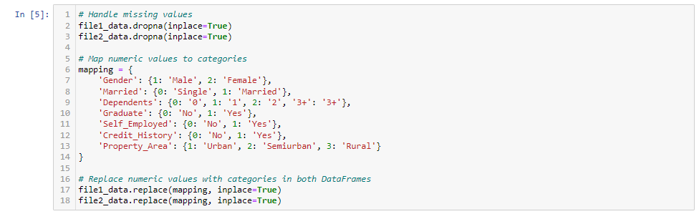
Figure 5: Cell 5
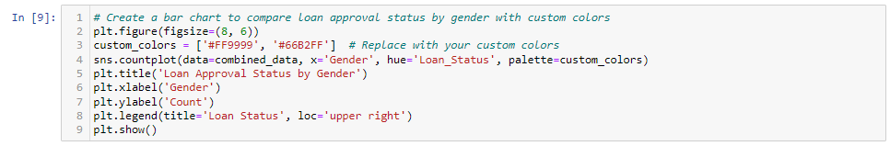
Figure 6: Cell 9
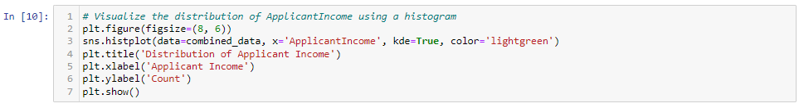
Figure 7: Cell 10
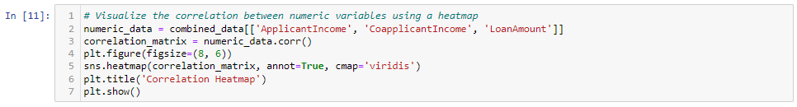
Figure 8: Cell 11
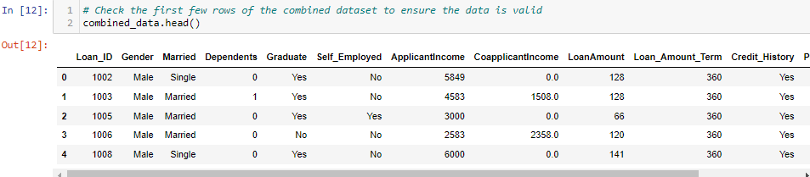
Figure 9: Cell 12

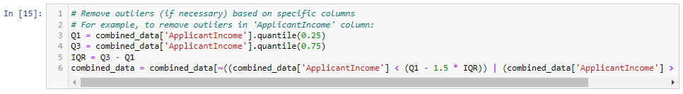
Figure 10: Cell 15
Figure 11: Cell 16
Figure 12: Cell 18
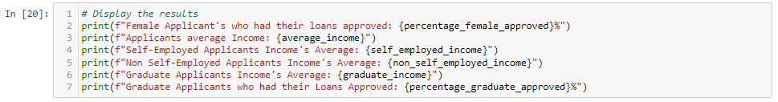
Figure 13: Cell 20

