**Project Summary**

An app to split the expenses among the people within a group, so that the amount pending for each user can be tracked and shown to all the members. Each expense has an history on what actions are done within that

**Core Features**

* **Functionality**
  + Faster Signup for creating account.
  + Option to choose the country code for the mobile number
  + Fast password reset by using code in email
  + Differentiate groups based on categories
  + Expenses with a valuable information including history and the split details
  + Modal dialogs for adding multiple selection of data
  + Balances Information owing to amount pending for each member in the group
  + Email notifications to all the members in the group when an expense is created/updated/deleted
  + Real time notifications when the user is online
  + Navigations added for useful information
* **UX**
  + Good looking black and white UI.
  + Responsive design.
  + Simple and minimalistic experience.
  + Loading indicators for better UX.
  + Font awesome icons to provide better attraction to the user

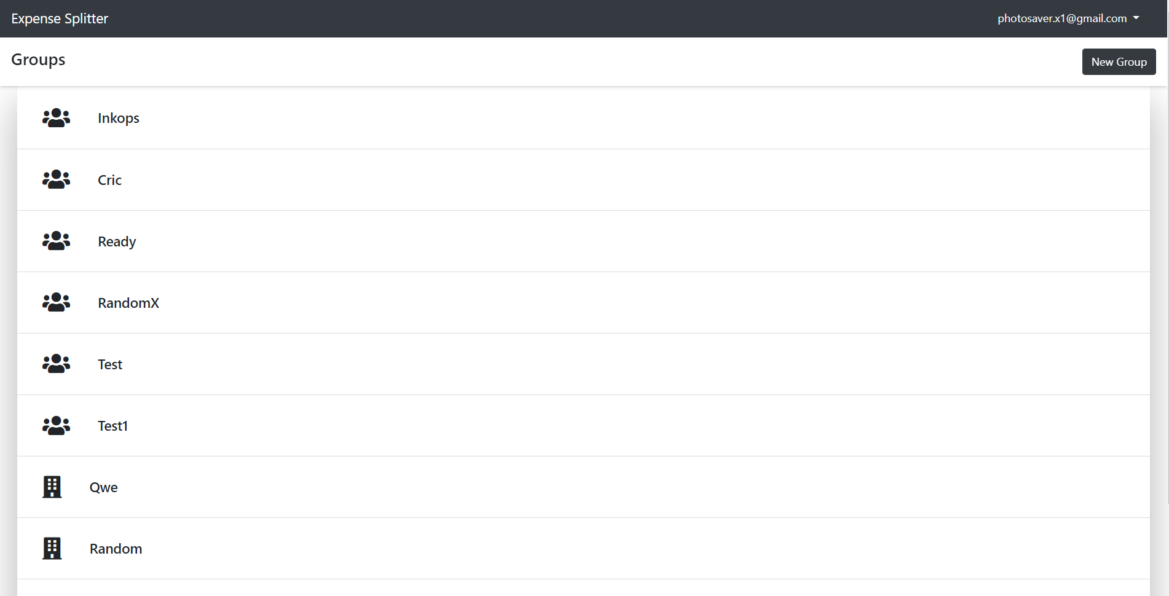

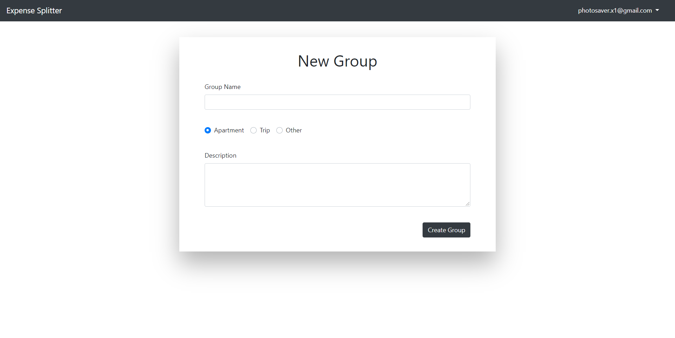

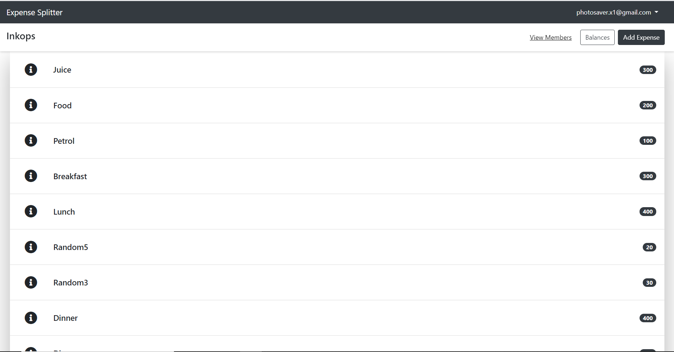

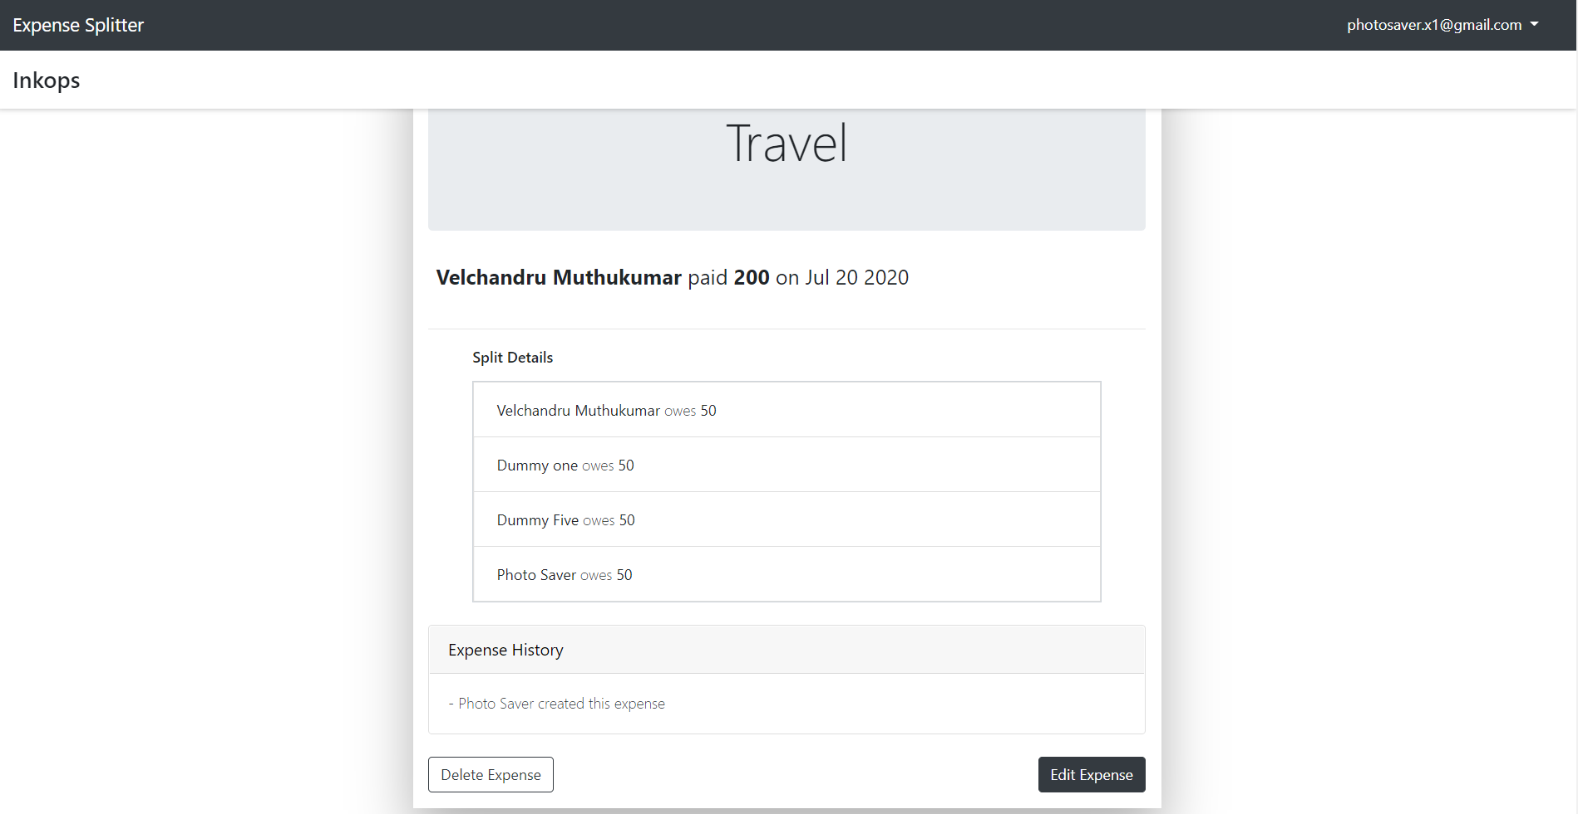

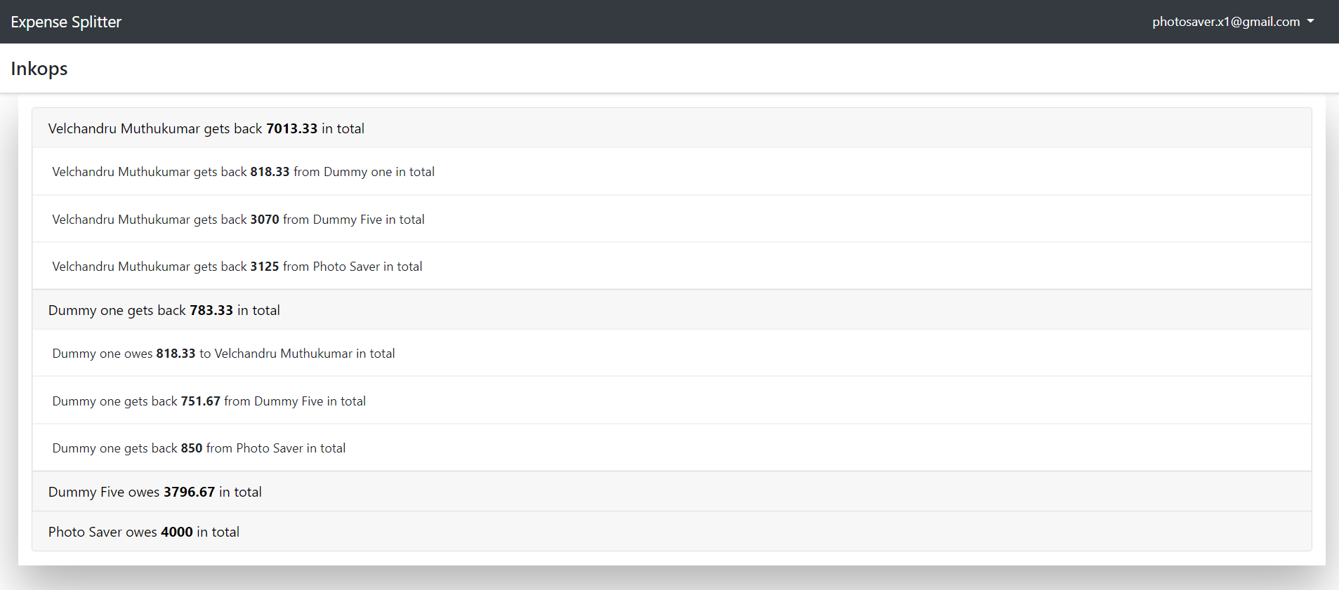

**GitHub**

<https://github.com/chan-mean/mean-expense-splitter>