**PART-2**

**CREATE TABLES**

CREATE TABLE GymLocation(

    locationid NUMERIC(3) PRIMARY KEY,

    locationname VARCHAR(30),

    address VARCHAR(30),

    tel VARCHAR(30),

    email VARCHAR(30),

    visitedTime NUMERIC(3)

)

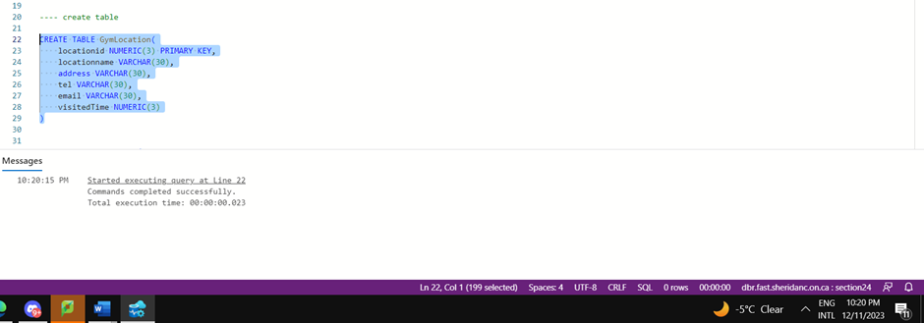

CREATE TABLE Amenity (

    amenityid NUMERIC(3) PRIMARY KEY,

    amenity VARCHAR(30),

    locationid numeric(3) CONSTRAINT gymlocation_locationid_pk FOREIGN KEY REFERENCES GymLocation(locationid)

)

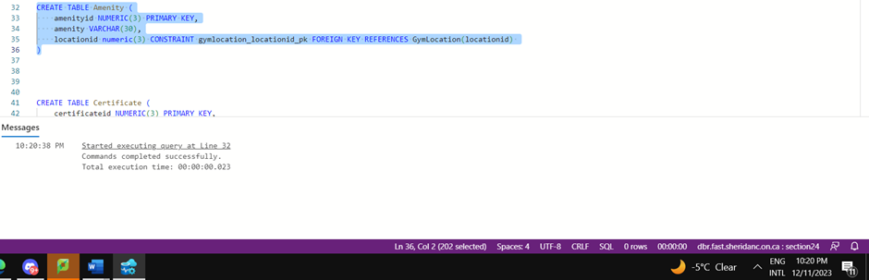

CREATE TABLE Certificate (

    certificateid NUMERIC(3) PRIMARY KEY,

    coachid NUMERIC(3) CONSTRAINT coach_coachid_pk FOREIGN KEY REFERENCES Coach(coachid),

    certificatename VARCHAR(30)

)

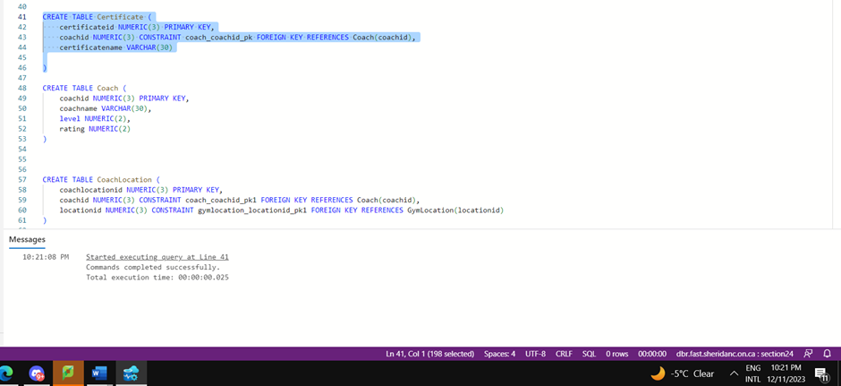

CREATE TABLE Coach (

    coachid NUMERIC(3) PRIMARY KEY,

    coachname VARCHAR(30),

    level NUMERIC(2),

    rating NUMERIC(2)

)

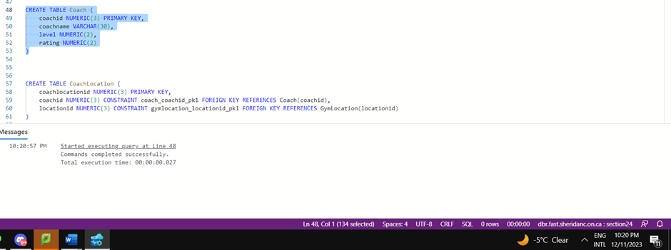

CREATE TABLE CoachLocation (

    coachlocationid NUMERIC(3) PRIMARY KEY,

    coachid NUMERIC(3) CONSTRAINT coach_coachid_pk1 FOREIGN KEY REFERENCES Coach(coachid),

    locationid NUMERIC(3) CONSTRAINT gymlocation_locationid_pk1 FOREIGN KEY REFERENCES GymLocation(locationid)

)

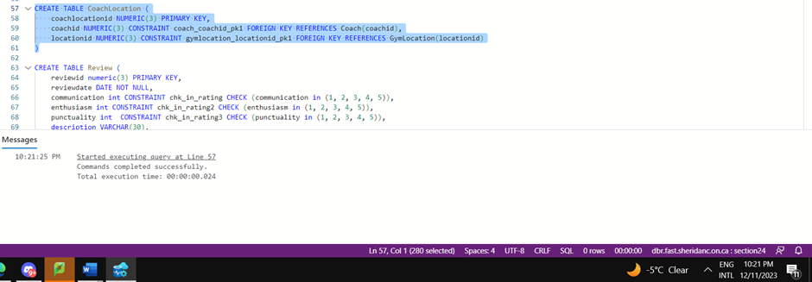

CREATE TABLE Review (

    reviewid numeric(3) PRIMARY KEY,

    reviewdate DATE NOT NULL,

    communication int CONSTRAINT chk_in_rating CHECK (communication in (1, 2, 3, 4, 5)),

    enthusiasm int CONSTRAINT chk_in_rating2 CHECK (enthusiasm in (1, 2, 3, 4, 5)),

    punctuality int  CONSTRAINT chk_in_rating3 CHECK (punctuality in (1, 2, 3, 4, 5)),

    description VARCHAR(30),

    coachid numeric(3)  CONSTRAINT coach_coachid_pk2 FOREIGN KEY REFERENCES Coach(coachid)

)

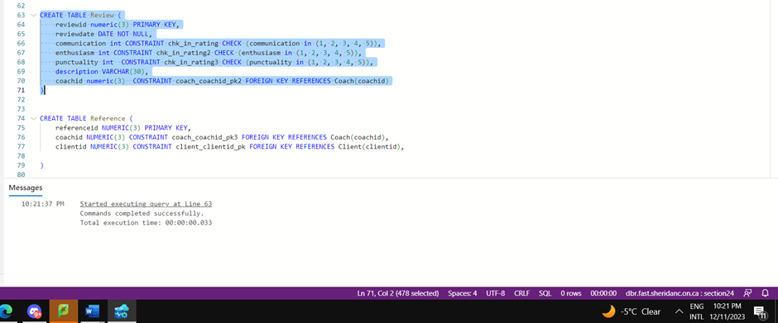

CREATE TABLE Reference (

    referenceid NUMERIC(3) PRIMARY KEY,

    coachid NUMERIC(3) CONSTRAINT coach_coachid_pk3 FOREIGN KEY REFERENCES Coach(coachid),

    clientid NUMERIC(3) CONSTRAINT client_clientid_pk FOREIGN KEY REFERENCES Client(clientid),

)

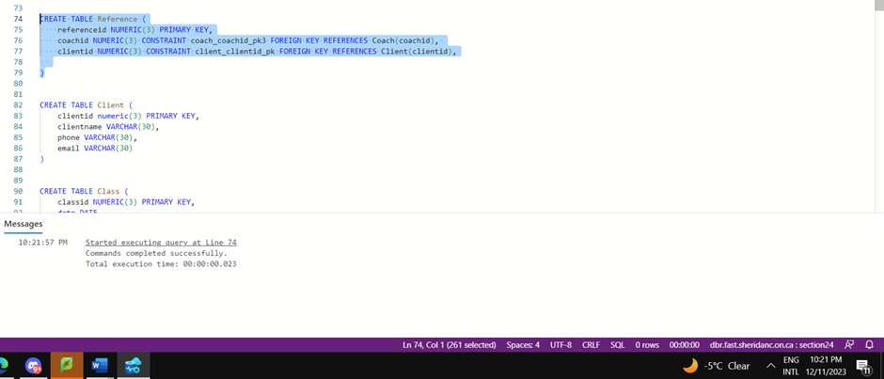

CREATE TABLE Client (

    clientid numeric(3) PRIMARY KEY,

    clientname VARCHAR(30),

    phone VARCHAR(30),

    email VARCHAR(30)

)

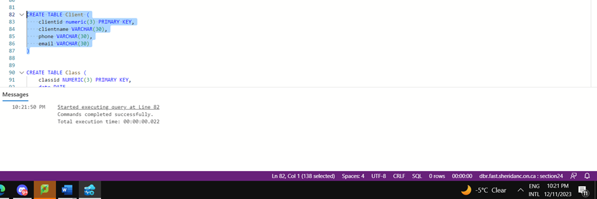

CREATE TABLE Class (

    classid NUMERIC(3) PRIMARY KEY,

    date DATE,

    time TIME,

    classname VARCHAR(30),

    price DECIMAL(5, 2) CONSTRAINT chk_in_price1 CHECK (price >= 0.0),

    room VARCHAR(30),

    locationid NUMERIC(3) CONSTRAINT locationid_pl FOREIGN KEY REFERENCES GymLocation(locationid)

)

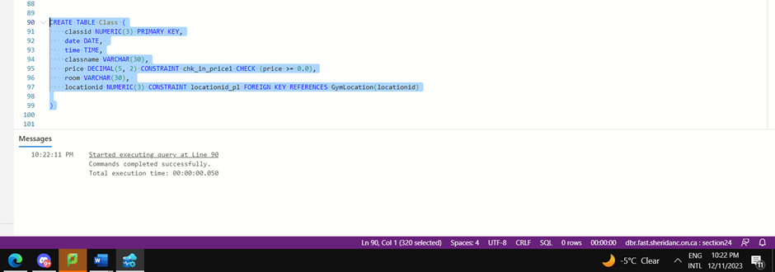

**INSERT ROWS**

INSERT INTO GymLocation

VALUES(100,'Midtown','Brampton','123-456-789','sin14844@sheridancollege.ca',15),

       (101,'Cabbagetown','Brampton1','123-456-789','sin14844@sheridancollege.ca',8),

       (102,'Eastview','Brampton2','123-456-789','sin14844@sheridancollege.ca',3)

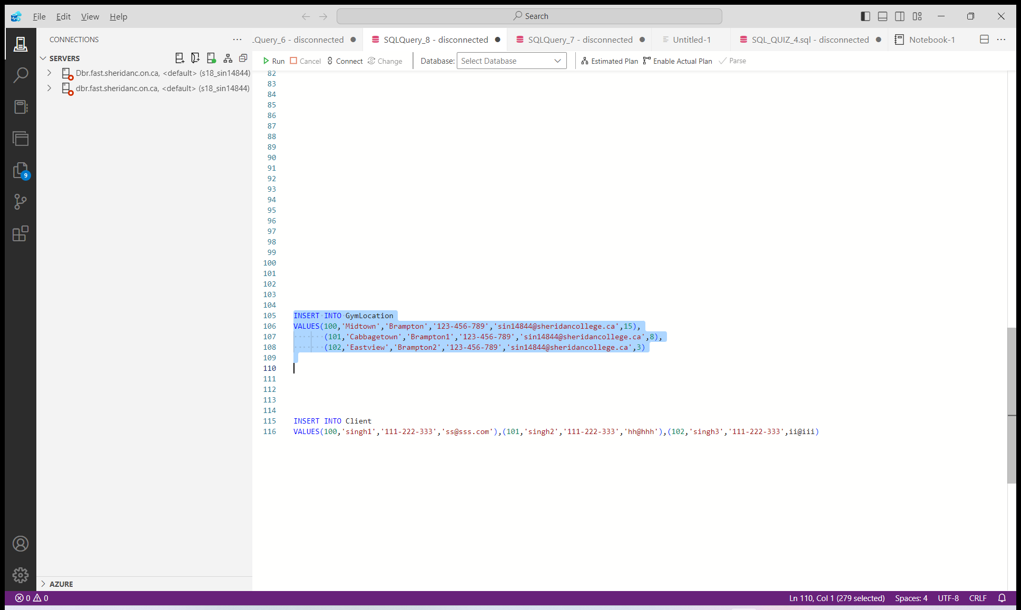

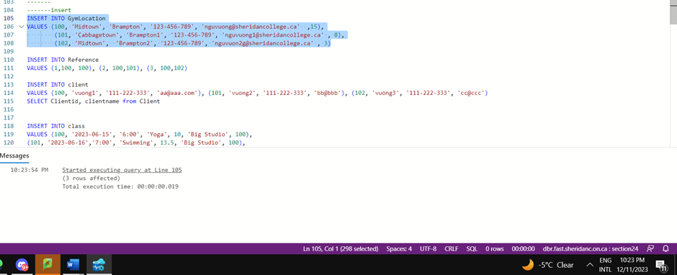

INSERT INTO Reference

VALUES (1,100, 100), (2, 100,101), (3, 100,102)

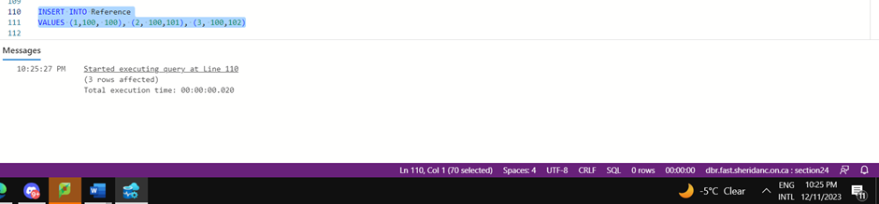

INSERT INTO Client

VALUES(100,'singh1','111-222-333','ss@sss.com'),(101,'singh2','111-222-333','hh@hhh'),(102,'singh3','111-222-333',ii@iii)

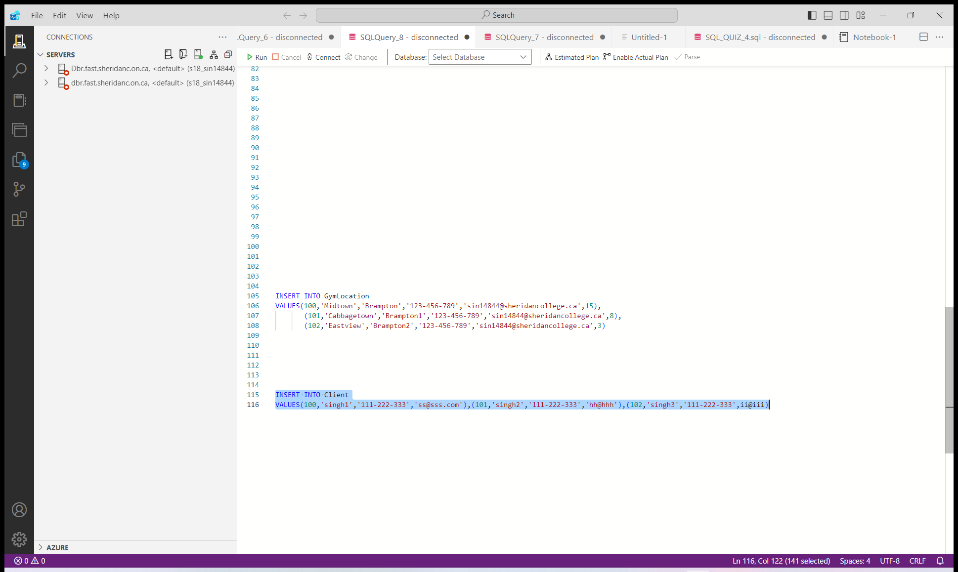

INSERT INTO class

VALUES (100, '2024-03-26', '6:00', 'Yoga', 8, 'Small Studio', 100),

(101, '2024-03-27','7:00', 'Body Pump', 10, 'Big Studio', 100),

(102, '2024-03-28','8:00', 'Hiit', 5, 'Studio 1', 100)

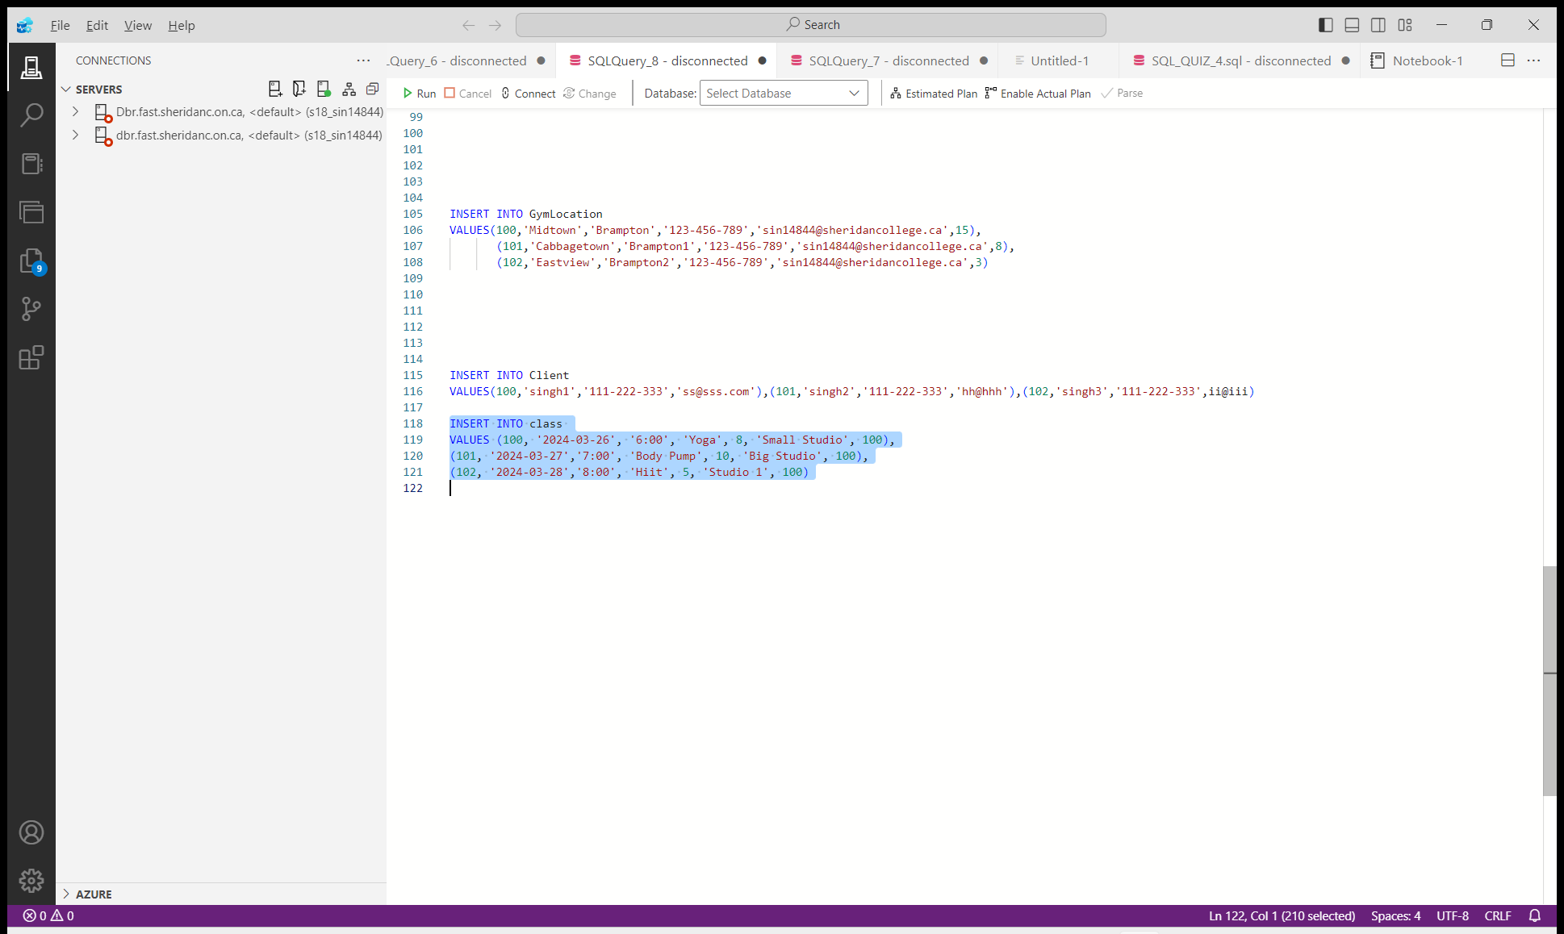

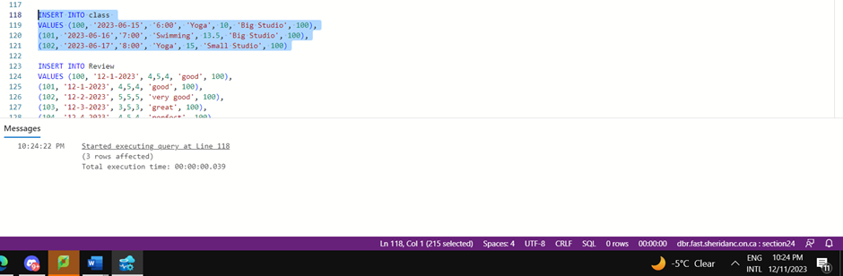

INSERT INTO Review

VALUES (100, '12-1-2024', 4,5,4, 'good', 100),

(101, '12-1-2024', 4,5,4, 'good', 100),

(102, '12-2-2024', 5,5,5, 'very good', 100),

(103, '12-3-2024', 3,5,3, 'great', 100),

(104, '12-4-2024', 4,5,4, 'perfect', 100)

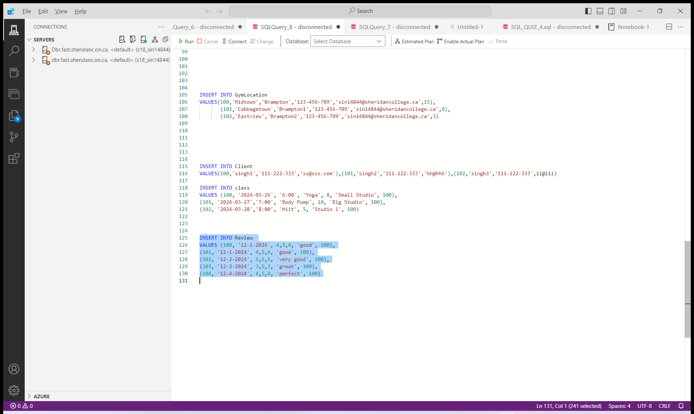

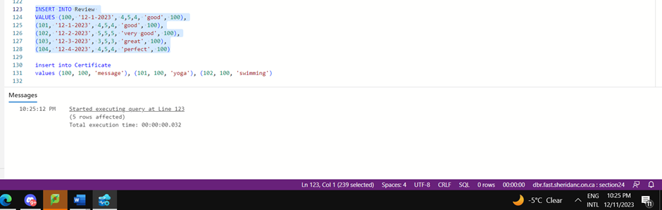

insert into Certificate

values (100, 100, 'message'), (101, 100, 'yoga'), (102, 100, 'swimming')

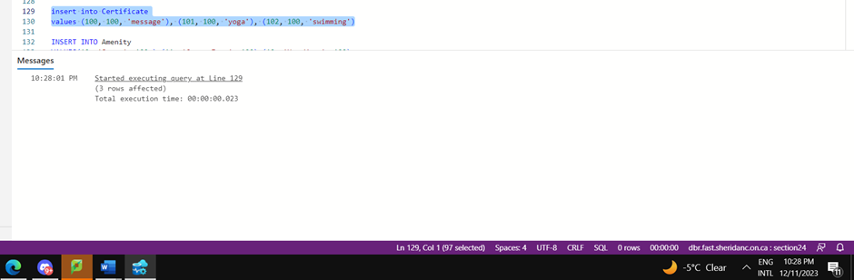

INSERT INTO Amenity

VALUES(10, 'Sauna', 100 ),(11, 'Green Zone', 100),(12, 'Hot Yoga', 100)

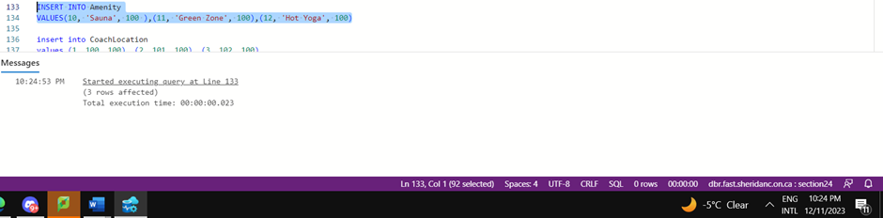

insert into CoachLocation

values (1, 100, 100), (2, 101, 100), (3, 102, 100)

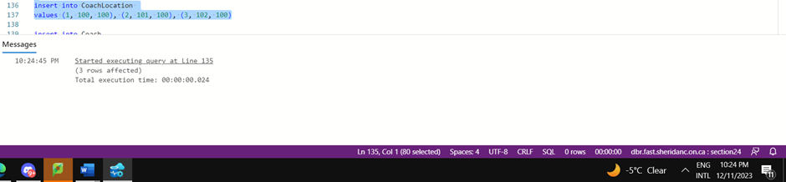

insert into Coach

VALUES (100, 'Sally', 3, 5), (101, 'Sayed', 2, 3), (102, 'Layla', 3, 5)

