**PART- 3 PROJECT**

**Convert entities to MongoDB collection**

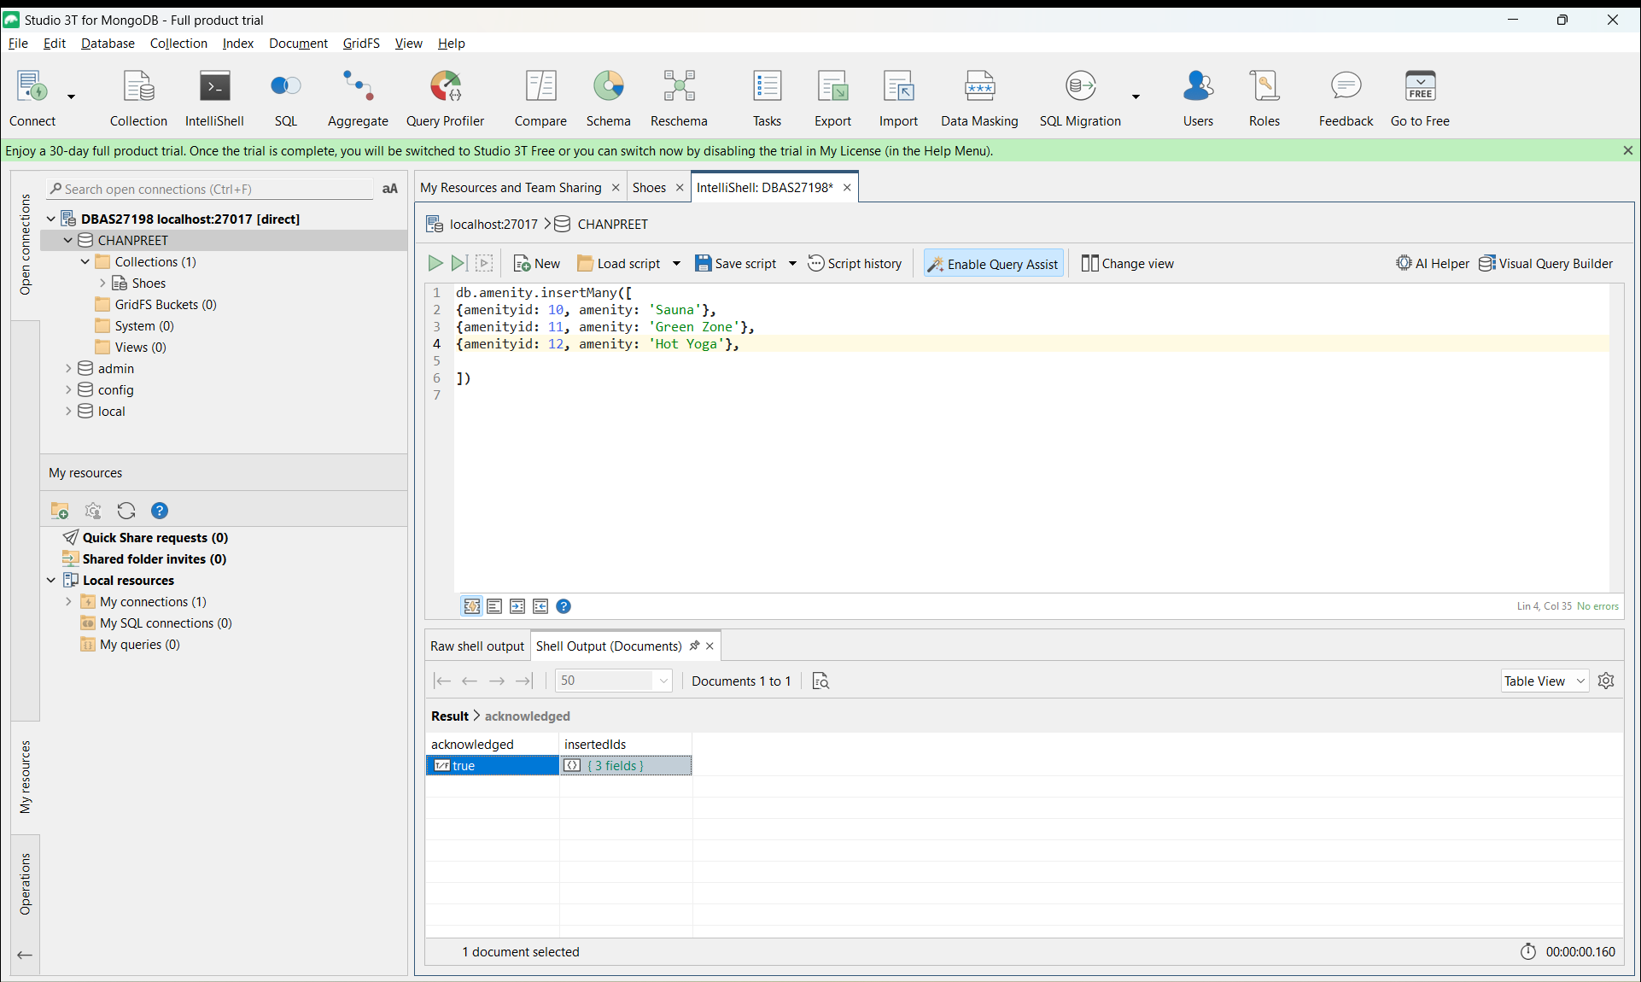

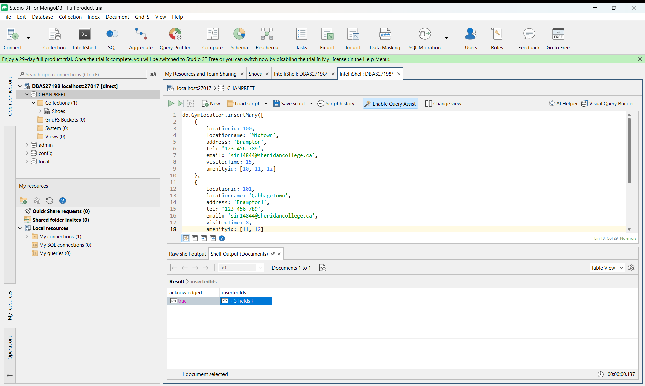

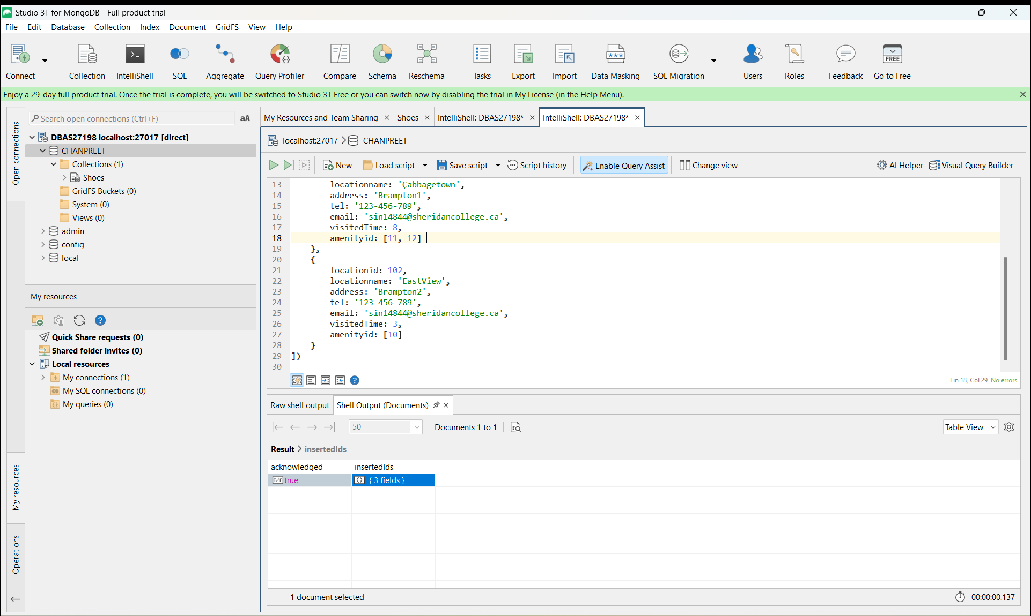

**WIREFRAME 1**

SELECT locationname as Locations, visitedTime as Timevisitedthismonth from GymLocation

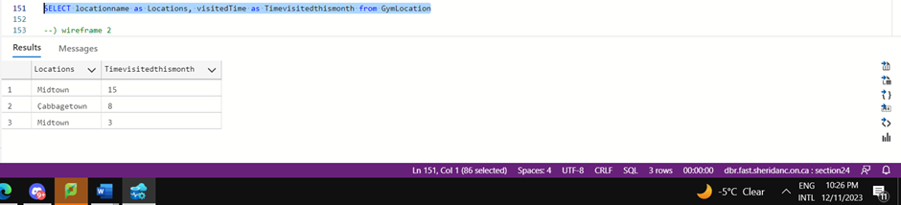



**WIREFRAME 2**

SELECT

    GymLocation.address,

    GymLocation.tel,

    GymLocation.email,

    Amenity.amenity as Amenities,

    Coach.coachname as Coaches

FROM

    GymLocation

JOIN

    Amenity ON GymLocation.locationid = Amenity.locationid

JOIN

    CoachLocation ON CoachLocation.locationid = GymLocation.locationid

JOIN

    Coach ON Coach.coachid =   CoachLocation.coachid

WHERE

    GymLocation.locationname = 'Midtown';

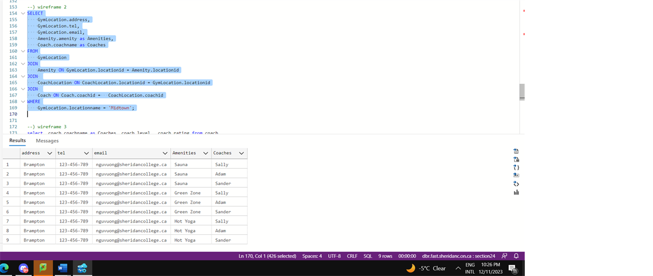



**WIREFRAME 3**

select  coach.coachname as Coaches, coach.level,  coach.rating from coach

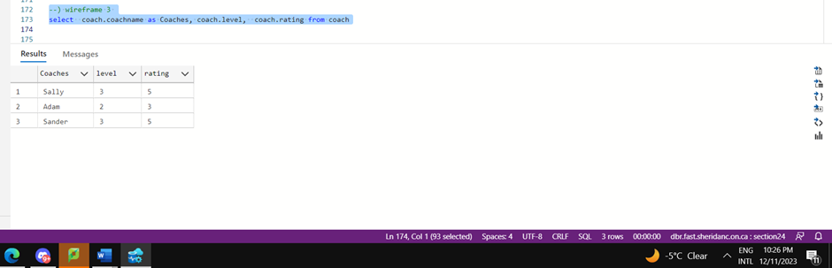

**WIREFRAME 4**

--) wireframe 4

SELECT Coach.coachname,

    Coach.[level],

    Coach.rating,

    GymLocation.locationname as Locations_I_work_from,

    Certificate.certificatename as Certificates,

    Client.clientname,

    Client.email,

    Client.phone

FROM GymLocation,

     CoachLocation,

     Coach,

     Certificate,

     Reference,

     Client

WHERE Certificate.coachid = (select Coach.coachid where coachname = 'Sally')

AND Reference.coachid = (select Coach.coachid where coachname = 'Sally')

AND GymLocation.locationid = any (select CoachLocation.locationid where CoachLocation.coachid =  (select Coach.coachid where coachname = 'Sally'))

AND Client.clientid = any (select Reference.clientid  where Reference.coachid = (select Coach.coachid where coachname = 'Sally'))



