Example of htlatex

## Example of htlatex

Thomas J. Leeper

August 10, 2018

This is a manuscript. Section 0.1 has a table. Section 0.2 has a figure. Section 0.3 has an equation. For demonstration purposes, here’s a reference (Groves et al., 2006).

#### 0.1 A Table

This section has a table. It’s Table 1.

Table 1: An example table

|  |  |
| --- | --- |
| Header 1 | Header 2 |
| Row 1 | Value 1 |
| Row 2 | Value 2 |
|  |  |

#### 0.2 A Figure

This section has a figure. It’s Figure 1.

Figure 1: An example figure

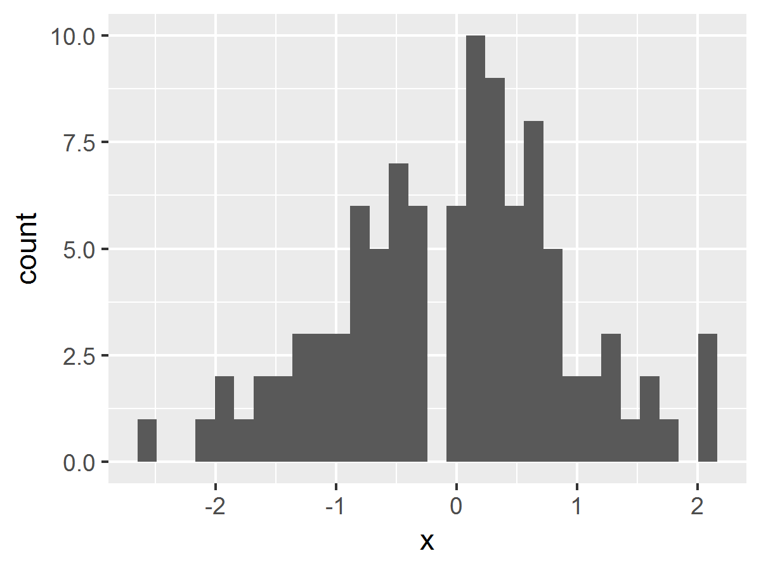

#### 0.3 An equation

This section has an in-line equation: x2 = 22 = 4 and an quation environment:

|  |  |
| --- | --- |
| a2 = b2 + c2 | (1) |

That’s it.

### References

   Groves, Robert M., Mick P. Couper, Stanley Presser, Eleanor Singer, Roger Tourangeau, Giorgina Piani Acosta, and Lindsay Nelson. 2006. “Experiments in Producing Nonresponse Bias.” Public Opinion Quarterly 70(5): 720–736.