Example of htlatex

Thomas J. Leeper

This is a manuscript. Section [sec:table] has a table. Section [sec:figure] has a figure. Section [sec:eq] has an equation. For demonstration purposes, here’s a reference (Groves et al. 2006).[1]

## A Table

This section has a table. It’s Table [tab:table1].

An example table

|  |  |
| --- | --- |
| Header 1 | Header 2 |
| Row 1 | Value 1 |
| Row 2 | Value 2 |

## A Figure

This section has a figure. It’s Figure [fig:fig1].

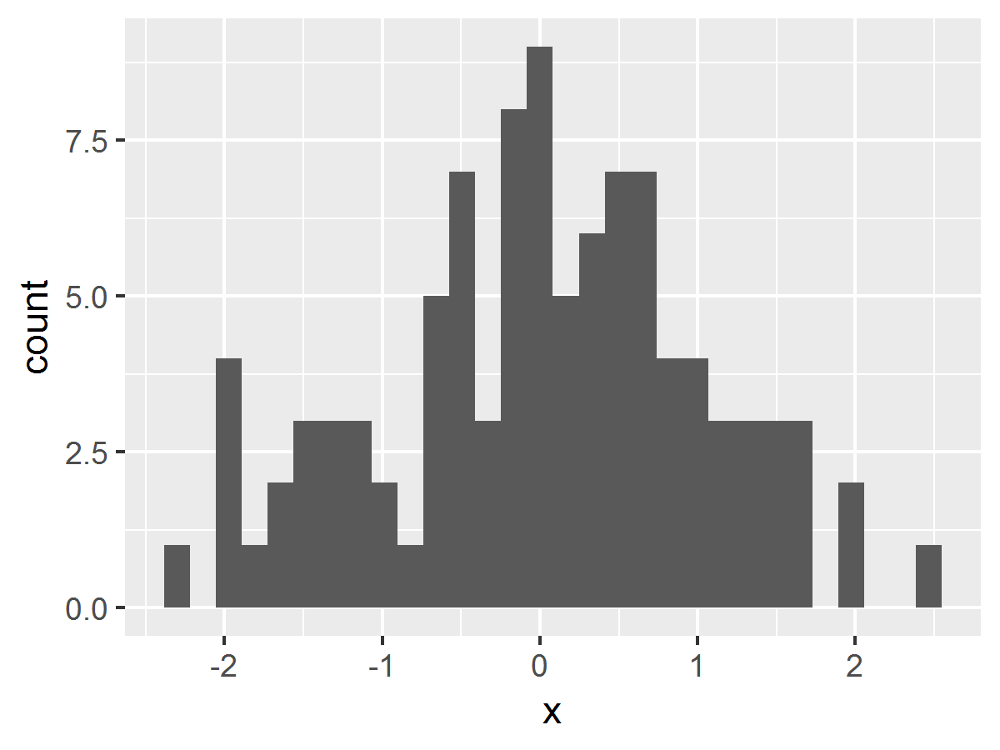

An example figure

## An equation

This section has an in-line equation: and an equation environment:

That’s it.

Groves, Robert M. et al. 2006. “Experiments in Producing Nonresponse Bias.” *Public Opinion Quarterly* 70(5): 720–36.

1. This is a footnote.