Example of htlatex

Thomas J. Leeper

This is a manuscript. Section [sec:table] has a table. Section [sec:figure] has a figure. Section [sec:eq] has an equation. For demonstration purposes, here’s a reference .

## A Table

This section has a table. It’s Table [tab:table1].

An example table

|  |  |
| --- | --- |
| Header 1 | Header 2 |
| Row 1 | Value 1 |
| Row 2 | Value 2 |

## A Figure

This section has a figure. It’s Figure [fig:fig1].

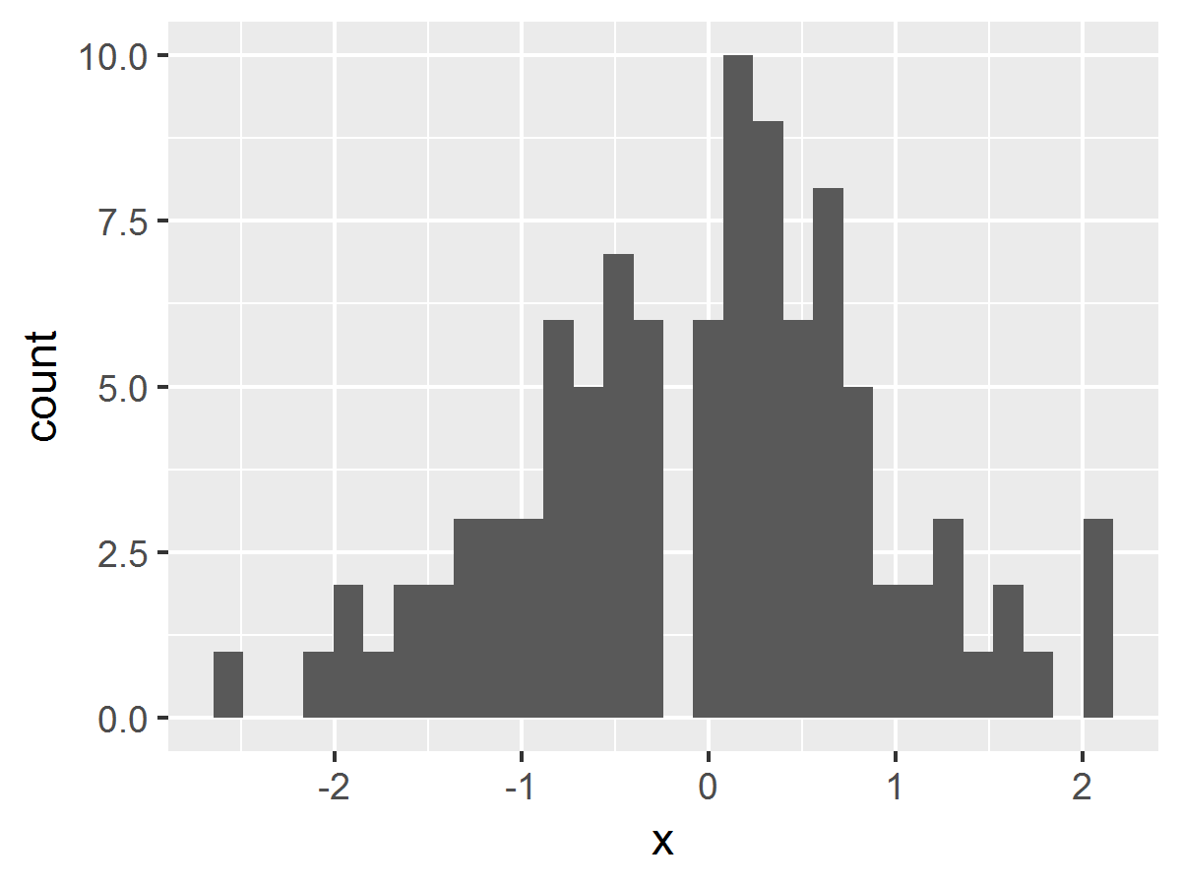

An example figure

## An equation

This section has an in-line equation: $x^{2}=2^{2}=4$ and an quation environment:

$$a^{2}=b^{2}+c^{2}$$

That’s it.