1. Grade Checker
Take a score as input and print the grade based on the following:
90+ : "A"
80-89 : "B"
70-79 : "C"
60-69 : "D"
Below 60 : "F"
here we used a basic if else statement to carry out marks and all.
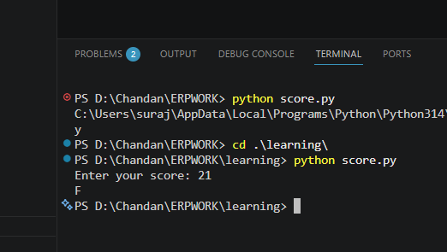
score = int(input("Enter your score: "))

if score >= 90:
print("A")
elif score >= 80:
print("B")
elif score >= 70:
print("C")
elif score >= 60:
print("D")
else:
print("F")

What’s happening here:
- input() → takes user input as text.
- int() → converts that text into a number.
- if-elif-else → checks conditions one by one.
- print() → shows the grade.
This is the basic Python flow: input → process → output.
No functions, no extras — just the essentials.

2 Student Grades
Create a dictionary where the keys are student names and the values are their grades. Allow the user to:
Add a new student and grade.
Update an existing student’s grade.
Print all student grades.

Used dictionary and basic operations. Using if else:
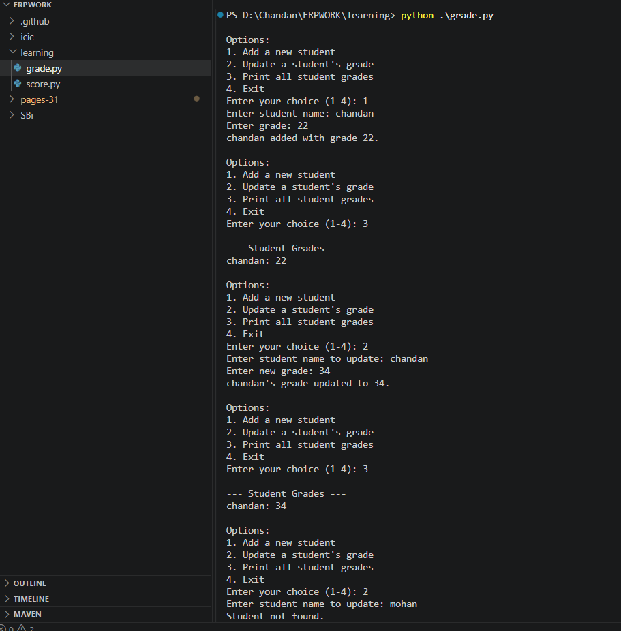
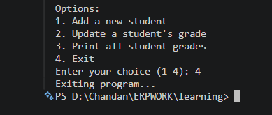
# Dictionary to store student grades
students = {}

while True:
print("\nOptions:")
print("1. Add a new student")
print("2. Update a student's grade")
print("3. Print all student grades")
print("4. Exit")

choice = input("Enter your choice (1-4): ")

if choice == "1":
name = input("Enter student name: ")
grade = input("Enter grade: ")
students[name] = grade
print(f"{name} added with grade {grade}.")

elif choice == "2":
name = input("Enter student name to update: ")
if name in students:
grade = input("Enter new grade: ")
students[name] = grade
print(f"{name}'s grade updated to {grade}.")
else:
print("Student not found.")

elif choice == "3":
if students:
print("\n--- Student Grades ---")
for name, grade in students.items():
print(f"{name}: {grade}")
else:
print("No students found.")

elif choice == "4":
print("Exiting program...")
break

else:
print("Invalid choice. Please try again.")

How this works:
- Dictionary (students) → stores names as keys and grades as values.
- Add → inserts a new key-value pair.
- Update → checks with if name in students before changing the grade.
- Print → loops through the dictionary with .items().
- Loop + if-else → keeps the program running until the user chooses to exit.
This is a simple interactive program that lets you manage student grades step by step.

3.Write to a File
Write a program to create a text file and write some content to it.

Using file functions like write and open.
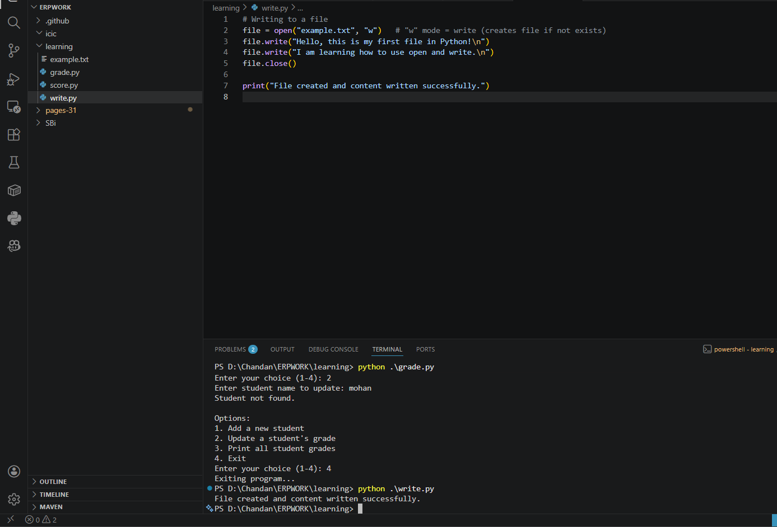

xplanation:
- open("example.txt", "w") → opens (or creates) a file named example.txt in write mode.
- write() → adds text into the file.
- \n → creates a new line.
- close() → closes the file to save changes.
"w" mode → overwrites the file if it already exists.
- If you want to add content without overwriting, use "a" (append mode).

4. Read from a File
We used open in read mode and file.read to read and print to display.
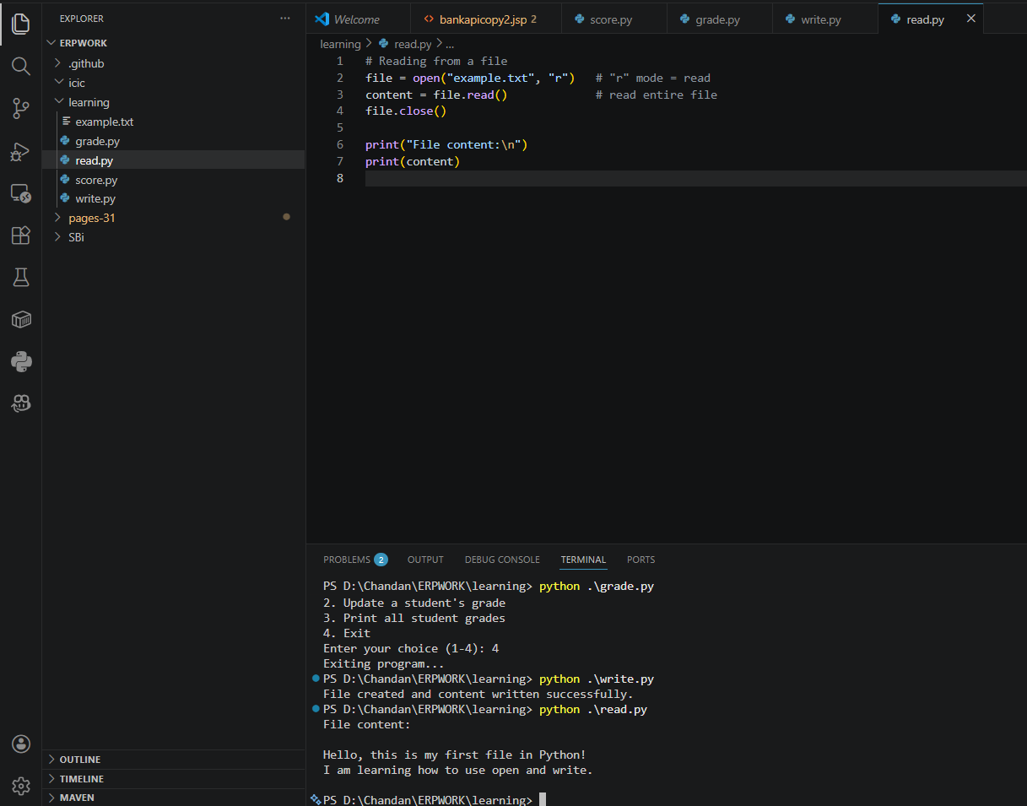

Explanation:
- open("example.txt", "r") → opens the file in read mode.
- read() → reads the entire content of the file as a string.
- close() → closes the file after reading (good practice).
- print(content) → displays the file’s content on the screen.

Submission Guidelines -: Attach Screenshots or command along with explanation and submit in doc(google doc or microsoft doc) format or share github link

