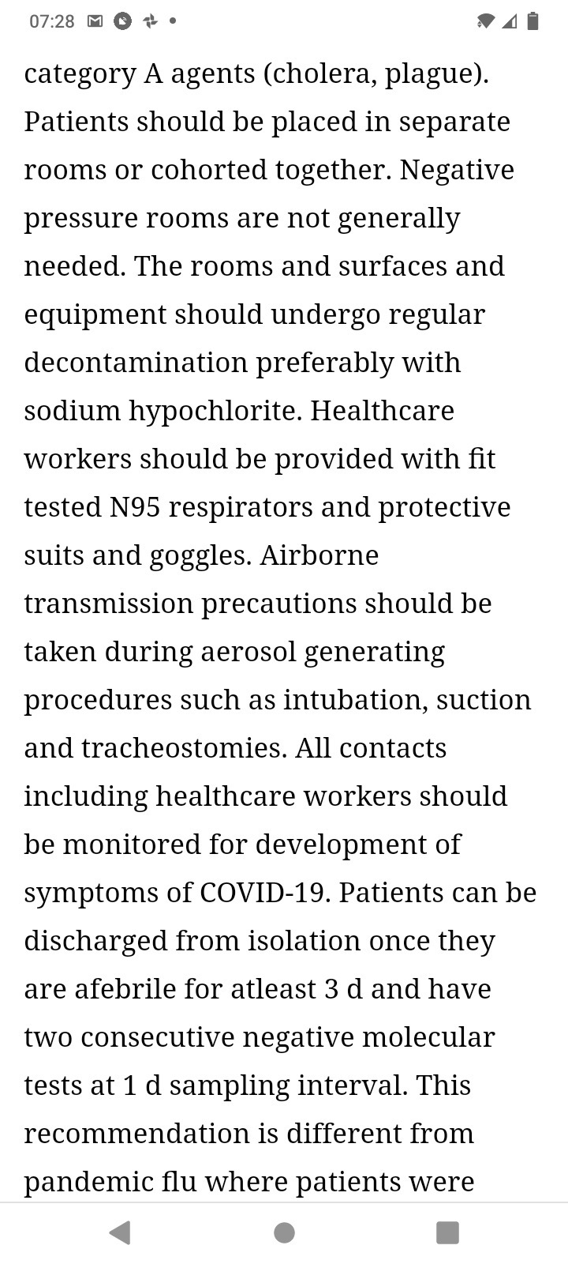

07:28 Ore 9748  
category A agents (cholera, plague).  
Patients should be placed in separate  
rooms or cohorted together. Negative  
pressure rooms are not generally  
needed. The rooms and surfaces and  
equipment should undergo regular  
decontamination preferably with  
sodium hypochlorite. Healthcare  
workers should be provided with fit  
tested N95 respirators and protective  
suits and goggles. Airborne  
transmission precautions should be  
taken during aerosol generating  
procedures such as intubation, suction  
and tracheostomies. All contacts  
including healthcare workers should  
be monitored for development of  
symptoms of COVID-19. Patients can be  
discharged from isolation once they  
are afebrile for atleast 3 d and have  
two consecutive negative molecular  
tests at 1 d sampling interval. This  
recommendation is different from  
  
pandemic flu where patients were

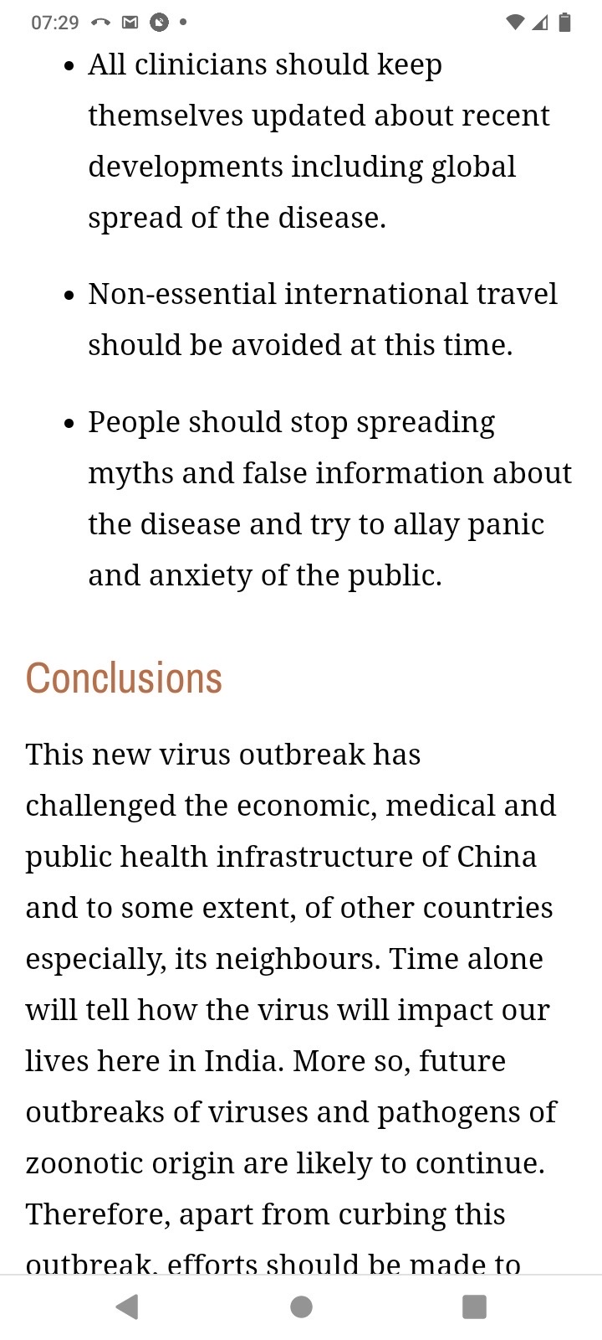

07:29 ~ Oe 948  
e All clinicians should keep  
themselves updated about recent  
developments including global  
  
spread of the disease.  
  
e Non-essential international travel  
  
should be avoided at this time.  
  
¢ People should stop spreading  
myths and false information about  
the disease and try to allay panic  
  
and anxiety of the public.  
  
Conclusions  
  
This new virus outbreak has  
challenged the economic, medical and  
public health infrastructure of China  
and to some extent, of other countries  
especially, its neighbours. Time alone  
will tell how the virus will impact our  
lives here in India. More so, future  
outbreaks of viruses and pathogens of  
zoonotic origin are likely to continue.  
Therefore, apart from curbing this  
  
outbreak. efforts should be made to

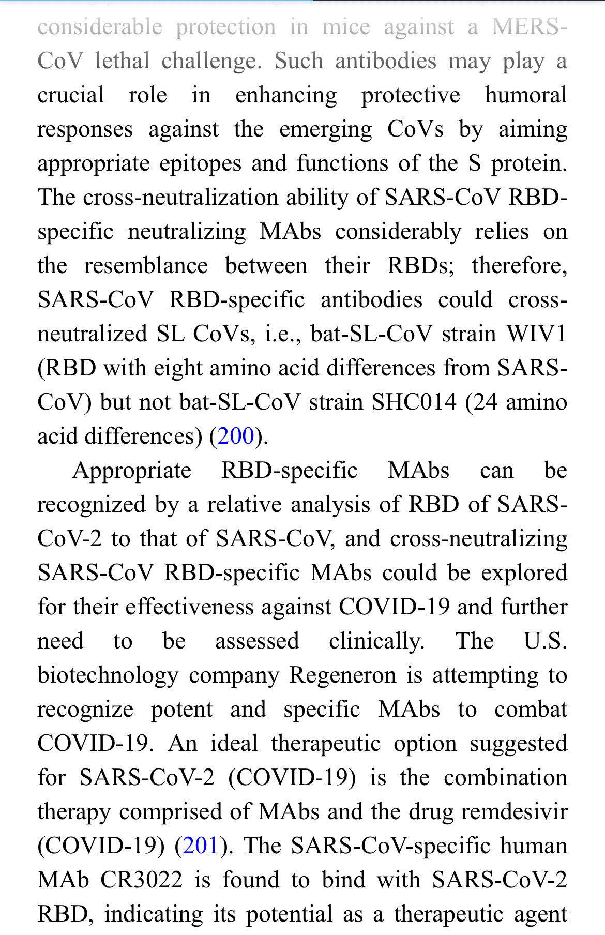

CoV lethal challenge. Such antibodies may play a  
crucial role in enhancing protective humoral  
responses against the emerging CoVs by aiming  
appropriate epitopes and functions of the S protein.  
The cross-neutralization ability of SARS-CoV RBD-  
specific neutralizing MAbs considerably relies on  
the resemblance between their RBDs; therefore,  
SARS-CoV RBD-specific antibodies could cross-  
neutralized SL CoVs, 1.e., bat-SL-CoV strain WIV1  
(RBD with eight amino acid differences from SARS-  
CoV) but not bat-SL-CoV strain SHC014 (24 amino  
acid differences) (200).  
  
Appropriate RBD-specific MAbs can be  
recognized by a relative analysis of RBD of SARS-  
CoV-2 to that of SARS-CoV, and cross-neutralizing  
SARS-CoV RBD-specific MAbs could be explored  
for their effectiveness against COVID-19 and further  
need to be assessed clinically. The USS.  
biotechnology company Regeneron is attempting to  
recognize potent and specific MAbs to combat  
COVID-19. An ideal therapeutic option suggested  
for SARS-CoV-2 (COVID-19) is the combination  
therapy comprised of MAbs and the drug remdesivir  
(COVID-19) (201). The SARS-CoV-specific human  
MAb CR3022 is found to bind with SARS-CoV-2  
RBD, indicating its potential as a therapeutic agent