IT3051 - FUNDAMENTALS OF DATA MINING
Final Report
An Intelligent Airline Flight Delay Risk Classification and
Prioritization System Using Machine Learning

BSc. (Hons) Information Technology Specializing in Data Science
Year 3 Semester 2, 2026
Student Name | Registration Number
EKANAYAKA E.J.M.C.U | IT23809024
Karunarathna M G L S | IT23769366
Kaumadi H G T | IT23862326
M N S EKANAYAKA | IT23793576

Table of Contents
1. Introduction and Problem Definition 5
Business Context 5
Objective, Target and Scope 5
Scope and Success Criteria 6
2. Assigned Scenario and User/Stakeholder Requirements 7
Scenario and Decisions Supported 7
Functional Requirements 7
Non-Functional Requirements 8
Inputs and Outputs 8
3. Dataset Identification, Source, Citation, and Validation 10
Source and Suitability 10
Structure and Analytical Grain 11
Dataset Proposal and Validation 11
Ethical, Privacy and Licensing Considerations 11
4. Data Understanding and EDA 13
Structure, Missing Values and Duplicates 13
Categorical Columns: Carriers and Airports 13
Distributions and Outliers 14
Target Distribution and Class Imbalance 14
Relationships with the Delay Rate 15
Correlation and Data Leakage Check 16
From Observation to Decision 18
5. Data Cleaning and Preprocessing 19
Cleaning and Target Creation 19
Preventing Data Leakage 19
Train-Test Split 19
Encoding, Outlier Treatment and Scaling 20
Saving the Preprocessing Pipeline for the Backend 20
Leakage Controls and Known Methodological Limits 21
6. Feature Engineering and Feature Selection 22
Final Feature Set 22
Engineered Features 22
Feature Importance 22
Feature Selection Experiment 23
7. Algorithms Implemented and Their Rationale 24
Logistic Regression 24
Decision Tree 24
Random Forest 25
K-Nearest Neighbours (KNN) 25
Reference Baseline 25
8. Model Evaluation and Comparison 26
Evaluation Metrics 26
Baseline Results 26
Why Some Models Perform Better Than Others 28
9. Hyperparameter Tuning and Optimization 29
Search Strategy 29
Decision Tree Tuning in Detail 29
Baseline versus Tuned Models 30
Interpretation of the Tuning Results 31
10. Final Model Selection and Justification 33
Test-Set Results 33
Justification 34
11. System Architecture and Implementation 35
System Architecture 35
Project Structure 37
Technology Stack 38
Implementation 38
12. Backend and Frontend Development 40
Backend Development 40
Frontend Development 44
End-to-End Prediction Flow 51
13. System Testing and Results 53
Testing Approach 53
Functional and Input-Validation Results 53
Preprocessing Consistency Check 54
Prediction Checks with Real Records 54
Warning and Error-Handling Checks 56
Performance and Reliability 57
Overall System Testing Result 57
14. Limitations and Possible Future Improvements 58
Limitations 58
Possible Future Improvements 58
15. Individual/Group Contributions, Where Required 60
References 60

1. Introduction and Problem Definition

Business Context
Flight delays are one of the most visible and costly problems in commercial aviation. When a large share of an airline's arrivals at an airport are late, the effects spread through the whole network: aircraft and crews miss their next rotations, passengers miss connections, gates and ground staff are overloaded, and the airline pays for rebooking, compensation and overtime while losing customer trust. Most of these costs can be reduced if planners know in advance which routes and months are likely to be problematic, because schedule buffers, spare crew, backup aircraft and extra ground staff have to be arranged weeks before the day of operation, not on the day itself.
Airlines and airports already publish large amounts of historical on-time performance data, but this information is usually presented as long tables of counts that are difficult for planners and managers to turn into decisions. This project converts ten years of U.S. Bureau of Transportation Statistics (BTS) delay records into a simple decision-support tool. A planner selects an airline, an arrival airport, a month, a year and the number of scheduled arrivals, and the system answers a single, practical question: how high is the delay risk for this airline at this airport in this month, and what should we do about it?
The project follows the complete data-mining workflow required by the module: problem understanding, dataset selection and validation, exploratory data analysis (EDA), preprocessing and feature engineering, the development and comparison of four machine learning algorithms, hyperparameter optimisation, final model selection, and the implementation of an end-to-end prediction system with a Flask backend and an HTML/CSS/JavaScript frontend.
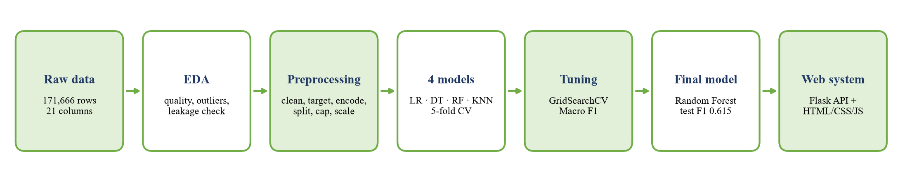
Figure 1: End-to-end workflow of the project, from the raw BTS records to the deployed web system.

Objective, Target and Scope
The objective is to classify each carrier-airport-month into one of three delay-risk levels. One record in the dataset describes one airline at one U.S. airport in one month, so the prediction is made at the same level. The target variable, delay_risk_category, is derived from the delay rate:
delay_rate = arr_del15 / arr_flights

Low Risk if delay_rate < 0.15
Moderate Risk if 0.15 <= delay_rate <= 0.25
High Risk if delay_rate > 0.25

where arr_del15 is the number of arrivals delayed by 15 minutes or more and arr_flights is the number of scheduled arrivals. The task is therefore a supervised multiclass classification problem with three ordered classes. A rate is used instead of the raw number of delayed flights because the raw count mainly reflects the size of the airport: a large hub always has more delayed flights than a small airport, even when it performs well. The rate makes a busy hub and a small regional airport directly comparable.
Table 1: Definition of the target classes and the action linked to each class
Risk level | Delay rate | Meaning | Recommended action
Low Risk | < 15% | Fewer than about 1 in 7 arrivals are 15+ minutes late | Routine monitoring; normal schedule and staffing
Moderate Risk | 15% - 25% | Around the national average of 18.3% | Closer monitoring; review turnaround buffers, spare crew and gates
High Risk | > 25% | More than 1 in 4 arrivals are 15+ minutes late | Priority review; add buffers, plan backup aircraft and crew, investigate causes

The thresholds were chosen around the overall delay rate of the cleaned dataset (18.3% of all arrivals). A rate below 15% is clearly better than average, a rate between 15% and 25% is close to normal, and a rate above 25% is clearly worse than average. These cut-offs give three classes that are meaningful to planners and still large enough to learn from (41% / 37% / 22%).

Scope and Success Criteria
The system predicts the delay risk of a whole month of arrivals for an airline at an airport. It does not predict whether one individual flight will be late, how many minutes a delay will last, or the cause of a delay. The project is considered successful when:
- at least four suitable algorithms are trained, compared fairly and tuned, and the final choice is justified with evidence;
- every model clearly beats a naive baseline that always predicts the most common class (Macro F1 0.194);
- the final model performs on the untouched test set as well as it did in cross-validation, showing that it generalises;
- the web system applies exactly the same preprocessing as model development and gives clear, non-technical results; this is proven with automated tests.

2. Assigned Scenario and User/Stakeholder Requirements

Scenario and Decisions Supported
The scenario is an airline operations planning team preparing the schedule and resources for the coming months. Before a month starts, a planner wants to know which routes need extra attention. The planner opens the Flight Delay Risk Checker in a web browser, enters the airline, the arrival airport, the month, the year and the planned number of arrivals, and receives a risk level, a confidence value, the probability of each risk level and a recommended action. High-risk combinations can then be prioritised for schedule-buffer reviews and resource planning, while low-risk combinations only need routine monitoring. The tool supports human decisions; it does not change schedules automatically.
Table 2: Stakeholders, their requirements and the decisions supported
Stakeholder | Requirement | Decision supported
Airline operations planners | Identify carrier-airport-months with a high chance of delays | Prioritise routes for schedule-buffer and turnaround reviews
Network and schedule planners | Compare risk across months and seasons | Adjust timetables and slack in peak months (e.g. summer, December)
Airport operations managers | Know when an airport is likely to be under delay pressure | Plan gates, ground staff and stand allocation
Crew and fleet managers | Advance warning of high-risk months | Keep spare crew and backup aircraft available
Customer service teams | Know where disruption is more likely | Prepare proactive passenger communication and rebooking capacity
Senior management | Simple, explainable risk levels | Allocate budget and attention to the most problematic routes

Functional Requirements
Table 3: Functional requirements
ID | Requirement | How it is met
FR1 | Accept the five inputs: airline, airport, month, year, scheduled arrivals | Web form with dropdowns, searchable airport field and number fields
FR2 | Validate inputs in the browser and on the server | JavaScript checks before sending; predictor.validate() returns an error per field (HTTP 400)
FR3 | Apply the same preprocessing as model development | preprocessor.joblib saved in Stage 4 is loaded by the backend; proven by a test on 34,245 records
FR4 | Predict with the final model | Random Forest (final_model.joblib) predict_proba()
FR5 | Return a clear and meaningful result | Risk level, confidence %, probabilities, plain-language meaning and recommended action
FR6 | Handle unusual inputs safely | Warnings for future years, unknown airports and routes with no history
FR7 | Help users enter realistic values | Typical monthly arrivals for the chosen route with a "Use this value" button

Non-Functional Requirements
Table 4: Non-functional requirements and measured evidence
Requirement | Target | Measured result
Usability | Usable by non-technical staff without training | Plain labels, help text, colour-coded results, no technical terms on the page
Performance | Answer within a few seconds | Median 52.5 ms per prediction over 30 repeated requests (max 69 ms)
Reliability | Same input gives the same output | 30 repeated requests returned identical results
Correctness | Same preprocessing as training | Backend features identical to test_processed.csv for all 34,245 test rows
Maintainability | Model and preprocessing versioned together | models/ folder + requirements.txt pinned to scikit-learn 1.9.0
Accessibility | Works on desktop and phone, light and dark mode | Responsive layout, no horizontal scrolling at 390 px, prefers-color-scheme support
Privacy | No personal data | Inputs and data are aggregated airline statistics only

Inputs and Outputs
Table 5: System inputs and outputs
Type | Item | Description
Input | Airline (carrier) | One of 21 airlines, e.g. Delta Air Lines Inc. (DL)
Input | Arrival airport | 3-letter IATA code, e.g. ATL; searchable by code or city
Input | Month and year | Month 1-12; year 2013-2033 (data covers 2013-2023)
Input | Scheduled arrivals | Planned number of arrivals of the airline at the airport in that month (1-50,000)
Output | Risk level | Low / Moderate / High Risk, colour-coded green / amber / red
Output | Confidence and probabilities | Probability of each of the three levels; the highest is shown as the confidence
Output | Meaning and action | What the level means in plain words and the recommended action
Output | Warnings | Shown when the prediction is less reliable (future year, unknown airport, no history)

3. Dataset Identification, Source, Citation, and Validation

Source and Suitability
The dataset is Flight Delay Data ("Flight Delay Data for U.S. Airports by Carrier, August 2013 - August 2023"), published on Kaggle by Sri Harsha Eedala. It is available at https://www.kaggle.com/datasets/sriharshaeedala/airline-delay. The data originally comes from the U.S. Bureau of Transportation Statistics (BTS) Airline On-Time Statistics and Delay Causes, which every major U.S. carrier is required to report. The Kaggle page lists the licence as U.S. Government Works (public domain), so it can be used freely for academic work.
Citation: Eedala, S. H. (2023). Flight Delay Data [Data set]. Kaggle. https://www.kaggle.com/datasets/sriharshaeedala/airline-delay. Original source: U.S. Department of Transportation, Bureau of Transportation Statistics, Airline On-Time Statistics and Delay Causes.
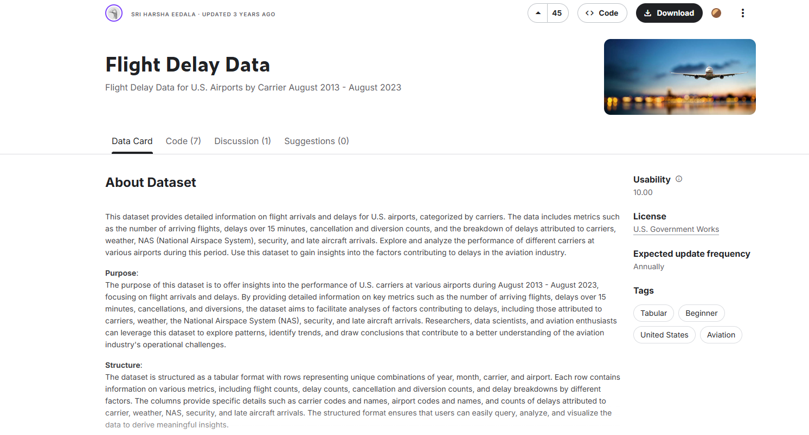
Figure 2: Kaggle page of the dataset showing the title, author, licence (U.S. Government Works) and description.
The dataset is suitable for the scenario because it contains exactly the information a planner has before a month starts (airline, airport, month, year and planned arrivals) together with the outcome needed to build the target (arrivals delayed 15+ minutes). It is large (171,666 records), comes from an official government source, covers ten years including the COVID-19 period, and contains enough complexity for meaningful EDA, preprocessing, modelling and optimisation: skewed distributions, a high-cardinality airport column, missing values and, importantly, several columns that would leak the answer if used carelessly.

Structure and Analytical Grain
Each row is one carrier-airport-month. There are 21 columns: 4 text columns, 2 integer columns and 15 numeric count/minute columns.
Table 6: Columns of the dataset and how each one is used
Column(s) | Type | Description | Role in this project
year, month | Integer | Period of the record (Aug 2013 - Aug 2023) | Model inputs (month also used to create season)
carrier, carrier_name | Text | Airline code and full name (21 airlines) | carrier = input; name used only for display
airport, airport_name | Text | Airport IATA code and full name (395 airports) | airport = input; name used only for display
arr_flights | Numeric | Number of scheduled arrivals | Model input; denominator of the target
arr_del15 | Numeric | Arrivals delayed by 15 minutes or more | Used only to build the target
carrier_ct, weather_ct, nas_ct, security_ct, late_aircraft_ct | Numeric | Delayed arrivals split by cause | Excluded - leak the target
arr_cancelled, arr_diverted | Numeric | Cancelled and diverted arrivals | Excluded - outcome of the same month
arr_delay + five *_delay columns | Numeric | Total delay minutes, overall and by cause | Excluded - outcome of the same month

Dataset Proposal and Validation
Following Stage 2 of the assignment, the group prepared a dataset proposal titled "An Intelligent Airline Flight Delay Risk Classification and Prioritization System Using Machine Learning" in the domain of Aviation and Transportation Analytics. The proposal described the dataset name and source, the URL and citation, the real-world context, the number of records and features, the target variable, the machine learning task (multiclass classification), the reasons the dataset suits the problem, the known data-quality limitations and the licensing considerations. The dataset was validated by the instructor before EDA, preprocessing, model training or system development started.

Ethical, Privacy and Licensing Considerations
- Privacy: the data is aggregated monthly statistics per airline and airport. It contains no passenger, crew or personal information.
- Licence: U.S. Government Works (public domain); the original source (BTS) and the Kaggle publisher are cited.
- Fair use of results: a High Risk prediction describes historical patterns; it should trigger a review, not penalise an airline or airport automatically.
- Limitations: the data is U.S.-only and ends in August 2023, so results may not transfer directly to other countries or to future operating conditions.

4. Data Understanding and EDA
EDA was carried out in Stage_3_EDA.ipynb before any modelling. Every observation below led to a concrete preprocessing or modelling decision, summarised at the end of this section.

Structure, Missing Values and Duplicates
Table 7: Summary of data-quality checks
Check | Result | Implication
Shape | 171,666 rows x 21 columns | Large enough for reliable training and a 20% test set
Period | August 2013 - August 2023 (11 calendar years) | Covers normal years and the COVID-19 drop in 2020
Data types | 15 float, 2 integer, 4 text | Text columns need encoding
Missing values | 443 rows (0.26%); 240 rows miss all 14 count columns, 203 more miss only arr_del15 | Too few to impute meaningfully - rows are removed
Fully duplicated rows | 0 | No de-duplication needed
Duplicate year-month-carrier-airport keys | 0 | Each carrier-airport-month appears once
Distinct carriers / airports | 21 / 395 | One-hot for carrier; frequency encoding for airport

Categorical Columns: Carriers and Airports
The carrier column has only 21 categories and is reasonably balanced, which makes one-hot encoding suitable. The airport column has 395 categories with a long tail of small airports; one-hot encoding it would add hundreds of sparse columns, so a lower-cardinality encoding (frequency encoding) is used instead.
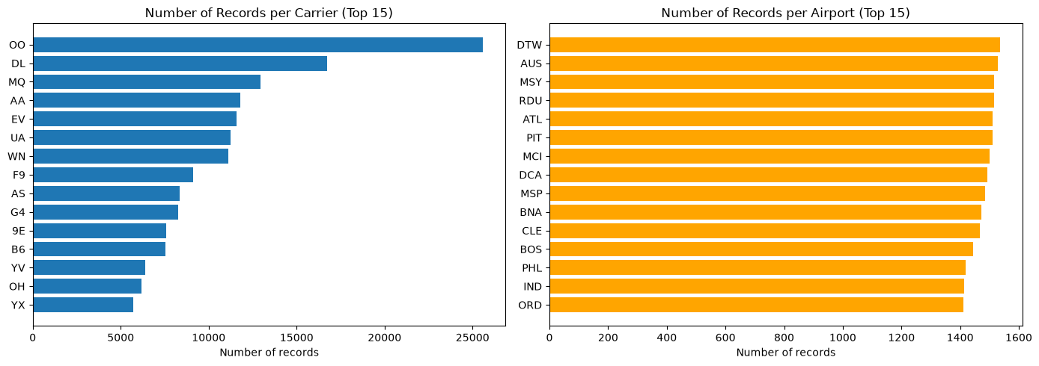
Figure 3: Number of records per carrier and per airport (top 15 of each).

Distributions and Outliers
Both arr_flights and arr_del15 are strongly right-skewed. The median carrier-airport-month has 101 scheduled arrivals, but the mean is 362.9 and the maximum is 21,977. The extreme values are not errors: they are real hub airports such as Atlanta (ATL) and Chicago O'Hare (ORD). The IQR rule (upper bound 550) would flag 12.6% of all records as outliers, which is far too many to delete or flatten.
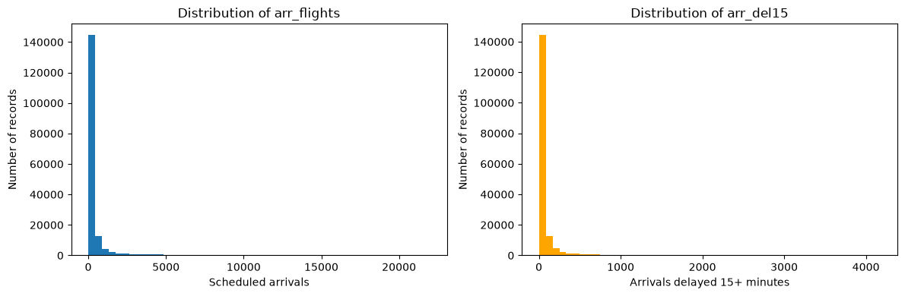
Figure 4: Histograms of arr_flights and arr_del15 - both are strongly right-skewed.
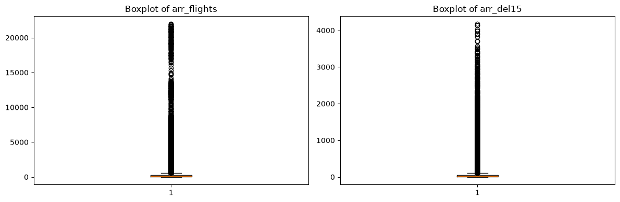
Figure 5: Boxplots of arr_flights and arr_del15 - the outliers are large hub airports.
Decision: keep the hub airports, use the delay rate as the target instead of the count, and cap (winsorise) arr_flights at the 99th percentile of the training data instead of deleting outliers.

Target Distribution and Class Imbalance
After cleaning, the target classes are Low Risk 70,452 (41.15%), Moderate Risk 62,906 (36.74%) and High Risk 37,865 (22.11%). The imbalance is moderate (about 1.9 : 1 between the largest and smallest class) but important: High Risk, the class that matters most to planners, is the smallest. A model could reach 41% accuracy by always predicting Low Risk while being useless.
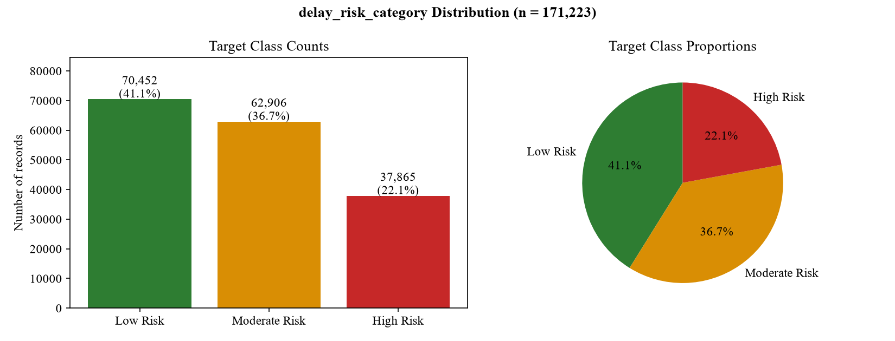
Figure 6: Target class counts and proportions (171,223 cleaned records).
Decision: use Macro F1 (which weights the three classes equally) as the main metric, report High Risk recall separately, and use a stratified train-test split and stratified cross-validation so every fold keeps the 41/37/22 ratio.

Relationships with the Delay Rate
To understand which inputs carry useful information, the delay rate was analysed against time and airline. The first chart below shows a clear seasonal pattern: delays peak in June (22.7%), July (22.0%) and December (21.2%), when traffic and summer thunderstorms or winter weather are highest, and are lowest in September (14.2%). The yearly view shows the sharp drop in 2020 (9.2%), when COVID-19 removed most traffic, and the highest rate in 2023 (22.5%) as traffic recovered.
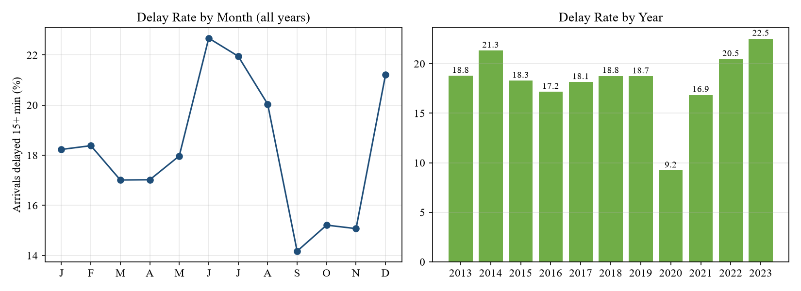
Figure 7: Delay rate by month (all years) and by year.
The airline also matters: the overall delay rate ranges from 12.3% for Hawaiian Airlines to 25.1% for Frontier Airlines (see the chart below). This confirms that the carrier must be a model input.
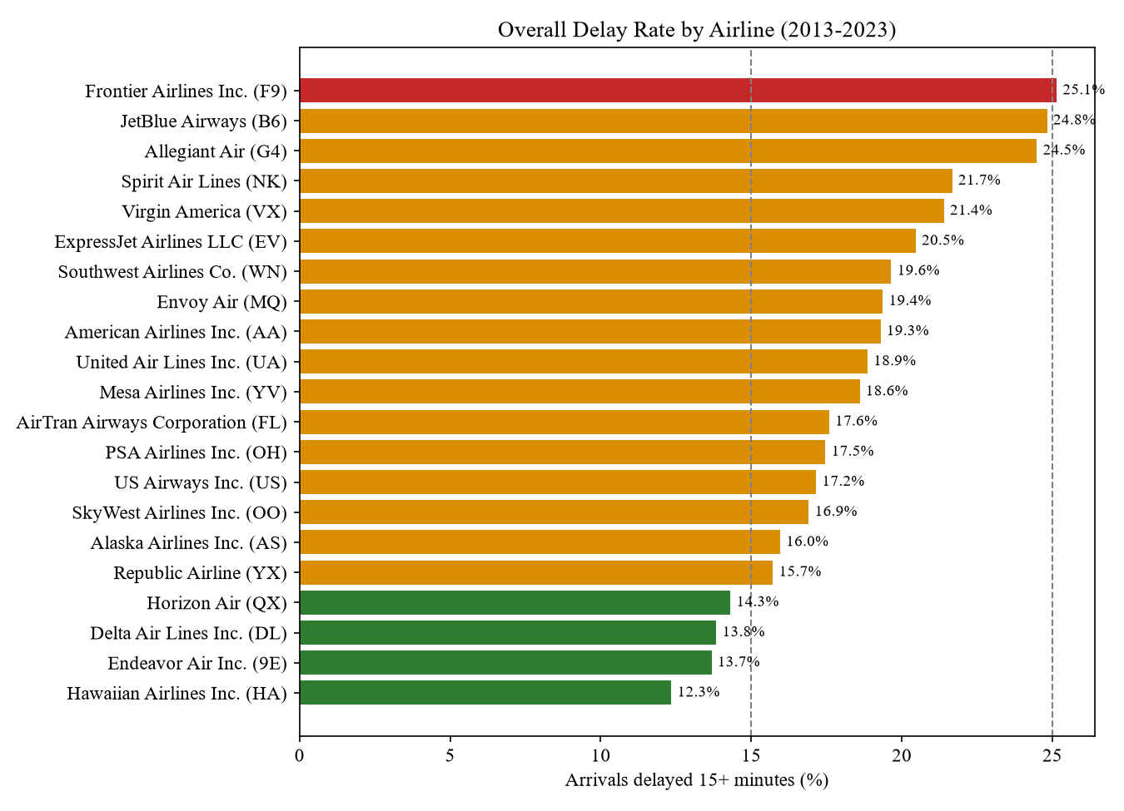
Figure 8: Overall delay rate by airline, 2013-2023 (dashed lines mark the 15% and 25% class thresholds).
Seasons change the mix of risk levels strongly. In Fall, 55.4% of records are Low Risk and only 11.3% are High Risk, while in Summer 33.3% are High Risk and only 28.8% are Low Risk (see the chart below). This motivated the engineered season feature.
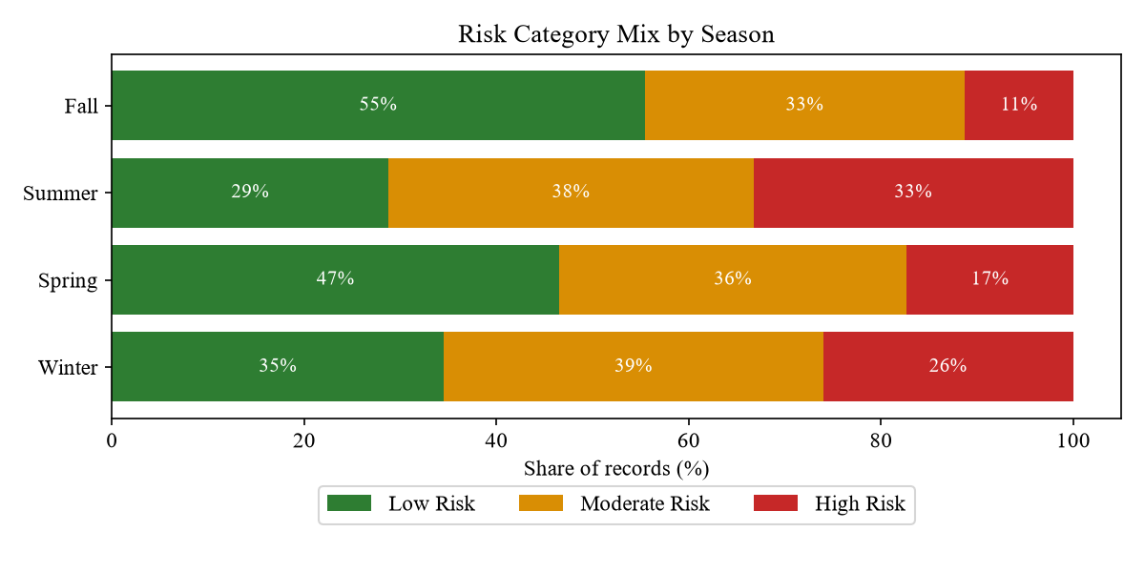
Figure 9: Share of Low, Moderate and High Risk records in each season.

Correlation and Data Leakage Check
The correlation matrix below shows that almost all count columns are very strongly correlated with each other, because they all grow with airport size (for example, arr_flights and arr_del15 have r = 0.918). More importantly, the five delay-cause counts are simply arr_del15 split by cause. The leakage-check scatter plot confirms this: their sum lies on the y = x line against arr_del15, with only rounding differences.
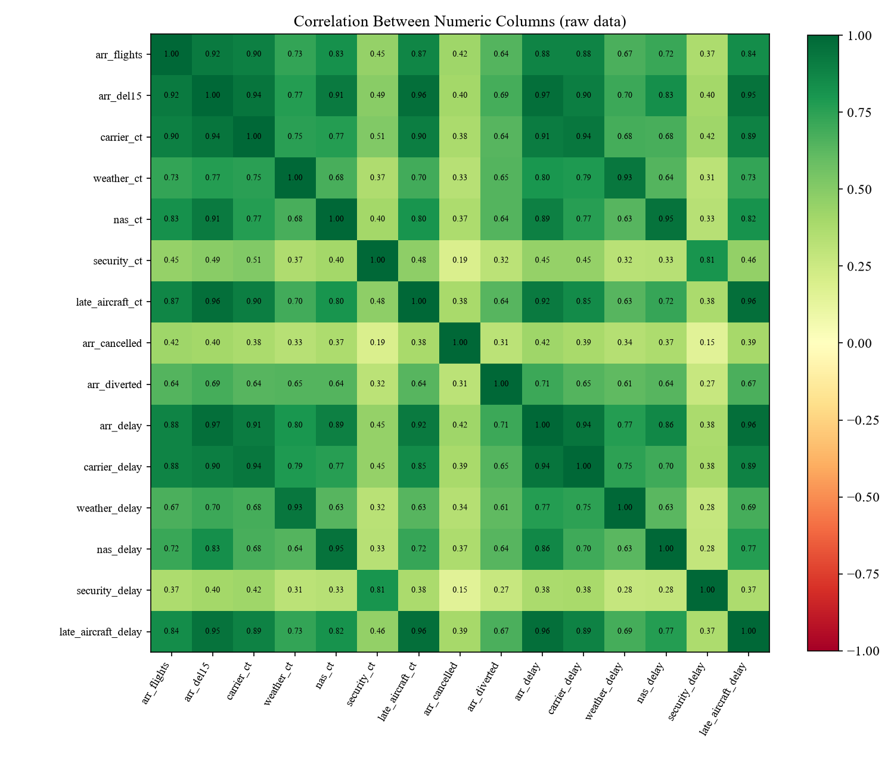
Figure 10: Correlation between the numeric columns of the raw data.
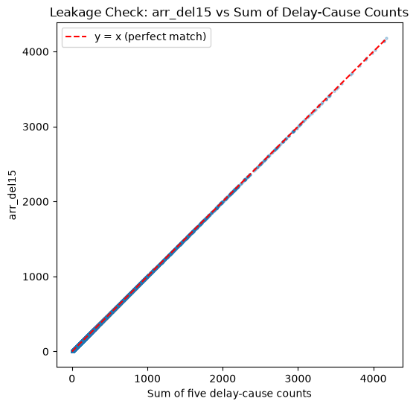
Figure 11: Leakage check: the sum of the five delay-cause counts equals arr_del15.
Decision: the cause counts, all delay-minute columns, cancellations and diversions describe the outcome of the same month. A planner cannot know them in advance and they directly reveal the target, so they are all excluded from the model inputs. Only year, month, carrier, airport and arr_flights - information available before the month starts - are used.

From Observation to Decision
Table 8: How the EDA findings shaped preprocessing and modelling
EDA observation | Decision taken
443 rows (0.26%) with missing values | Remove these rows (Stage 4)
Counts depend on airport size; strongly skewed | Use the delay rate to build the target
Hub airports are real extreme values | Cap arr_flights at the training 99th percentile instead of deleting
21 carriers / 395 airports | One-hot encode carrier; frequency-encode airport
Strong monthly and seasonal pattern | Engineer a season feature from month
Classes 41% / 37% / 22% | Macro F1, stratified split and stratified 5-fold CV
Cause counts add up to arr_del15 | Exclude all same-month outcome columns to prevent leakage
Different numeric scales | StandardScaler for the distance-based and linear models

5. Data Cleaning and Preprocessing
All preprocessing is implemented in Stage_4_Preprocessing.ipynb. The guiding rule is that every value that is learned from the data (frequencies, cap, scaler) is learned from the training set only and then applied unchanged to the test set and to new user inputs.

Cleaning and Target Creation
- Missing values: the 443 incomplete rows (0.26%) are dropped, leaving 171,223 records and no missing values.
- Invalid records: rows with zero scheduled arrivals are removed, because the delay rate would be a division by zero (none remained after the previous step, but the guard keeps the pipeline safe).
- Target: delay_rate = arr_del15 / arr_flights is converted into Low / Moderate / High Risk using the 15% and 25% thresholds.
- Feature engineering: a season (Winter, Spring, Summer, Fall) is derived from the month and one-hot encoded into four columns.

Preventing Data Leakage
Table 9: Columns removed to prevent leakage and redundancy
Group | Columns removed | Reason
Delay-cause counts | carrier_ct, weather_ct, nas_ct, security_ct, late_aircraft_ct | They add up to arr_del15 (the target source)
Delay minutes | arr_delay, carrier_delay, weather_delay, nas_delay, security_delay, late_aircraft_delay | Outcome of the same month
Other outcomes | arr_cancelled, arr_diverted | Outcome of the same month
Target sources | arr_del15, delay_rate | The target was built from them
Name columns | carrier_name, airport_name | Repeat the code columns

Train-Test Split
The data is split before any learned transformation, using an 80/20 stratified split with random_state = 42, so the three classes keep the same proportions in both sets and no test information can influence the training statistics.
Table 10: Train and test sets after the stratified split
Set | Records | Low Risk | Moderate Risk | High Risk
Training | 136,978 | 41.1% | 36.7% | 22.1%
Test | 34,245 | 41.1% | 36.7% | 22.1%

Encoding, Outlier Treatment and Scaling
Table 11: Encoding, capping and scaling steps
Step | Method | Learned from | Details
Carrier | One-hot encoding | - | 21 binary columns carrier_9E ... carrier_YX
Airport | Frequency encoding | Training set | Airport code replaced by its share of training records; airports not seen in training get 0
arr_flights outliers | Capping (winsorising) | Training set | 99th percentile = 4,927.46; 1,370 training and 327 test records capped
Numeric scaling | StandardScaler | Training set | year, month, arr_flights, airport_freq -> mean 0, std 1
Target | Ordered label mapping | - | Low = 0, Moderate = 1, High = 2 (keeps the natural order, unlike LabelEncoder)

The IQR rule was rejected for capping because its upper bound (550 arrivals) would flatten 12.6% of the records, including every major hub. The 99th-percentile cap only limits the most extreme 1% while keeping the information that an airport is very busy.

Saving the Preprocessing Pipeline for the Backend
A web system must repeat exactly the same steps on every new input. Section 11 of the Stage 4 notebook therefore saves all values learned from the training data into models/preprocessor.joblib: the season rule, the carrier list, the airport frequency map (391 airports), the arr_flights cap, the fitted StandardScaler, the column order and the label mapping. It also stores airline and airport names and the typical monthly arrivals of 2,625 carrier-airport pairs for the user interface (these are not model inputs).
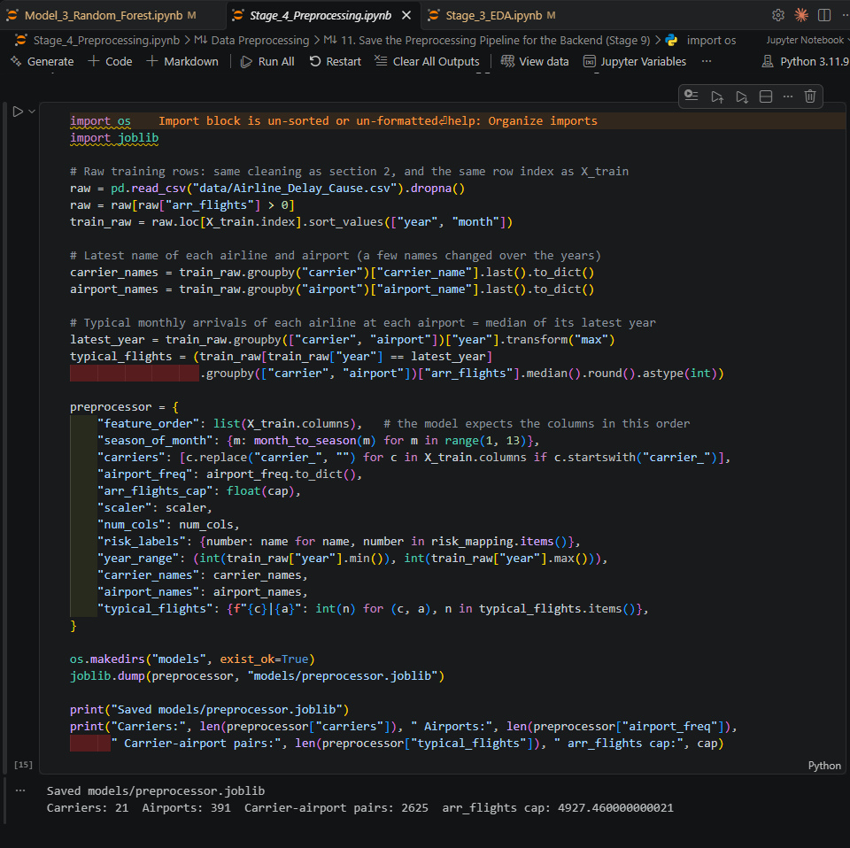
Figure 12: Stage 4, section 11: saving the preprocessing pipeline for the backend.

Leakage Controls and Known Methodological Limits
Leakage of the outcome is prevented by excluding every same-month outcome column and by fitting all learned transformations on the training set only. Two smaller methodological limits remain and are acknowledged: (1) the split is random rather than chronological, while year is an input, so the test set contains months from the same years as training; (2) the airport frequencies and the scaler are fitted once on the full training set before cross-validation, so each validation fold has seen these simple statistics. Their effect is very small, because the test-set score (0.615) matches the cross-validation score (0.612).

6. Feature Engineering and Feature Selection

Final Feature Set
The final model uses 29 features, all available to a planner before the month starts. They are stored in the order expected by the model in models/final_features.json.
Table 12: The 29 model features
Group | Features | Count | Rationale
Time | year, month (scaled) | 2 | Captures long-term trends (e.g. COVID-19 in 2020) and monthly patterns
Season (engineered) | season_Winter, season_Spring, season_Summer, season_Fall | 4 | Groups months with similar weather and traffic; strong effect on the risk mix
Airline | carrier_9E ... carrier_YX (one-hot) | 21 | Delay rates differ from 12.3% to 25.1% between airlines
Airport | airport_freq (frequency-encoded, scaled) | 1 | Measures how large/busy an airport is without 395 sparse columns
Volume | arr_flights (capped, scaled) | 1 | Busier routes face more congestion and knock-on delays

Engineered Features
- Season - derived from month (Dec-Feb Winter, Mar-May Spring, Jun-Aug Summer, Sep-Nov Fall). EDA showed that the share of High Risk records ranges from 11.3% in Fall to 33.3% in Summer.
- airport_freq - each airport's share of training records. It is a compact proxy for airport size and activity, and naturally handles new airports (frequency 0).
- delay_rate and delay_risk_category - the engineered target that makes airports of different sizes comparable.

Feature Importance
The tuned Random Forest provides an importance score for each feature (see the figure below). The most important single features are arr_flights (0.289), airport_freq (0.283), year (0.200) and month (0.063). Each one-hot carrier column has a small importance on its own, but together the 21 carrier columns account for 0.126 of the total importance, and the four season columns for 0.039.
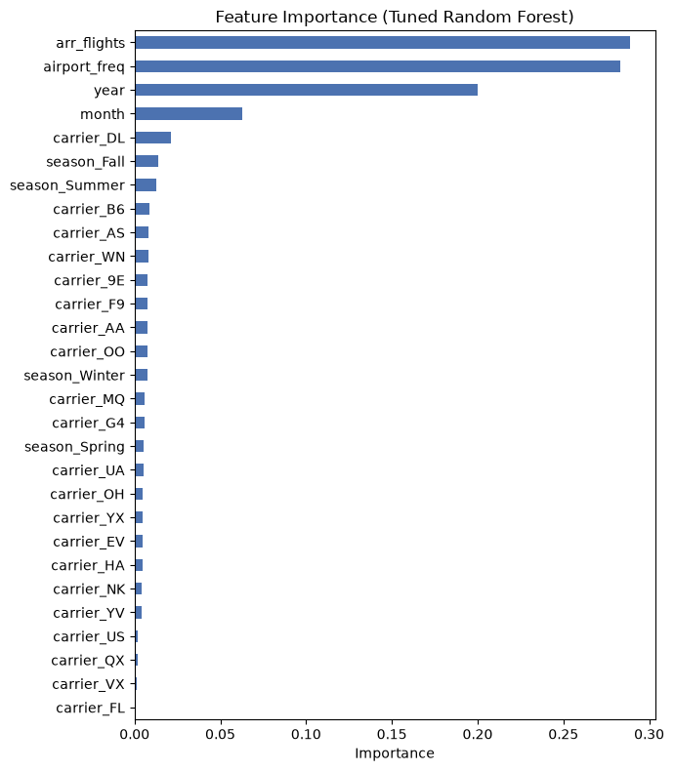
Figure 13: Feature importance of the tuned Random Forest.

Feature Selection Experiment
Stage 7 asks whether feature selection improves performance. The experiment removed every feature with an importance below 0.01 and re-ran the same 5-fold cross-validation with the tuned Random Forest.
Table 13: Result of the feature selection experiment
Feature set | Number of features | 5-fold CV Macro F1
All features | 29 | 0.612
Only features with importance >= 0.01 | 7 | 0.514

Removing the weak features made the model clearly worse (-0.098 Macro F1), so all 29 features are kept. 20 of the 22 removed features were one-hot carrier columns: one carrier column alone is weak because it describes only one airline, but together they tell the model which airline operates the route, which EDA showed to be important. Lesson learned: the importance of a one-hot encoded variable must be judged for the whole original column, not for each dummy column separately.

7. Algorithms Implemented and Their Rationale
Four algorithms from different families were implemented, one notebook each (Model_1 to Model_4). To make the comparison fair, all four use exactly the same rules:
- the same training data (data/train_processed.csv); the test set is not used in model development;
- the same validation: Stratified 5-Fold Cross-Validation with shuffle and random_state = 42;
- the same main metric (Macro F1) and the same additional metrics (accuracy, macro precision, macro recall, High Risk recall, training F1 and cross-validation time).
Table 14: The four algorithms and the reasons for choosing them
Algorithm | How it works | Why it was chosen | Main weakness
Logistic Regression | Multinomial linear model that gives a probability for each class | Simple, fast and explainable baseline that the other models must beat | Only linear boundaries; cannot learn feature combinations
Decision Tree | Learns if-then rules by splitting the data on feature thresholds | Non-linear, learns combinations (airline + airport + season), easy to explain | Overfits without limits; unstable
Random Forest | Many decision trees on random samples and features that vote | Non-linear and much more stable than one tree; gives probabilities and feature importance | Larger model file; less transparent than one tree
K-Nearest Neighbours | Predicts from the K most similar past records | Simple non-linear method that uses similarity of routes and months | Slow predictions; treats all features as equally important

Logistic Regression
Logistic Regression is the simplest model and serves as the reference point. It uses the scaled numeric features from Stage 4 and fits one weight per feature for each class. Because it adds up the effect of each feature separately, it cannot represent rules such as "this airline at this airport in summer", which is exactly how delay risk behaves. It was therefore expected to underfit.

Decision Tree
A Decision Tree asks a series of yes/no questions about the features. It can learn non-linear rules and feature combinations, and the rules are easy to explain to non-technical stakeholders. Without limits, however, it keeps splitting until it memorises the training data, so max_depth and min_samples_leaf were tuned.

Random Forest
A Random Forest trains many trees, each on a bootstrap sample of the records and a random subset of the features, and lets them vote. Averaging many different trees reduces the variance of a single tree while keeping its ability to learn combinations. It also outputs a probability for each class (used as the confidence in the web system) and feature importances.

K-Nearest Neighbours (KNN)
KNN stores the training records and classifies a new record by the majority class of its K most similar records, measured with Euclidean distance on the scaled features. It is a natural fit for the idea that similar airlines, airports and months behave similarly, but every prediction must compare the new record with all 136,978 training records.

Reference Baseline
A DummyClassifier that always predicts the most frequent class (Low Risk) gives a Macro F1 of 0.194. Every real model must clearly beat this value to show that it has learned something useful.

8. Model Evaluation and Comparison

Evaluation Metrics
Table 15: Evaluation metrics and their purpose
Metric | Why it is used
Macro F1 (main metric) | Average F1 of the three classes with equal weight, so the smaller High Risk class is not ignored
Accuracy | Share of correct predictions; easy to explain but can hide poor High Risk performance
Macro precision / recall | How many predicted levels are correct / how many real levels are found, averaged over classes
High Risk recall | Share of real High Risk records the model finds - the most important error for planners
Training F1 vs validation F1 | A large gap shows overfitting; two low values show underfitting
F1 standard deviation | Stability of the model across the five folds

Baseline Results
Table 16: Baseline results (default settings, 5-fold cross-validation on the training set)
Model | Accuracy | Precision | Recall | Macro F1 | F1 std | Train F1 | High Risk recall | CV time (s)
Logistic Regression | 0.499 | 0.489 | 0.464 | 0.466 | 0.003 | 0.467 | 0.289 | 8
Decision Tree | 0.562 | 0.551 | 0.551 | 0.551 | 0.004 | 0.999 | 0.503 | 8
Random Forest | 0.616 | 0.608 | 0.599 | 0.603 | 0.003 | 0.999 | 0.522 | 39
KNN | 0.597 | 0.594 | 0.574 | 0.580 | 0.003 | 0.708 | 0.470 | 745
Dummy (most frequent) | - | - | - | 0.194 | - | - | 0.000 | -

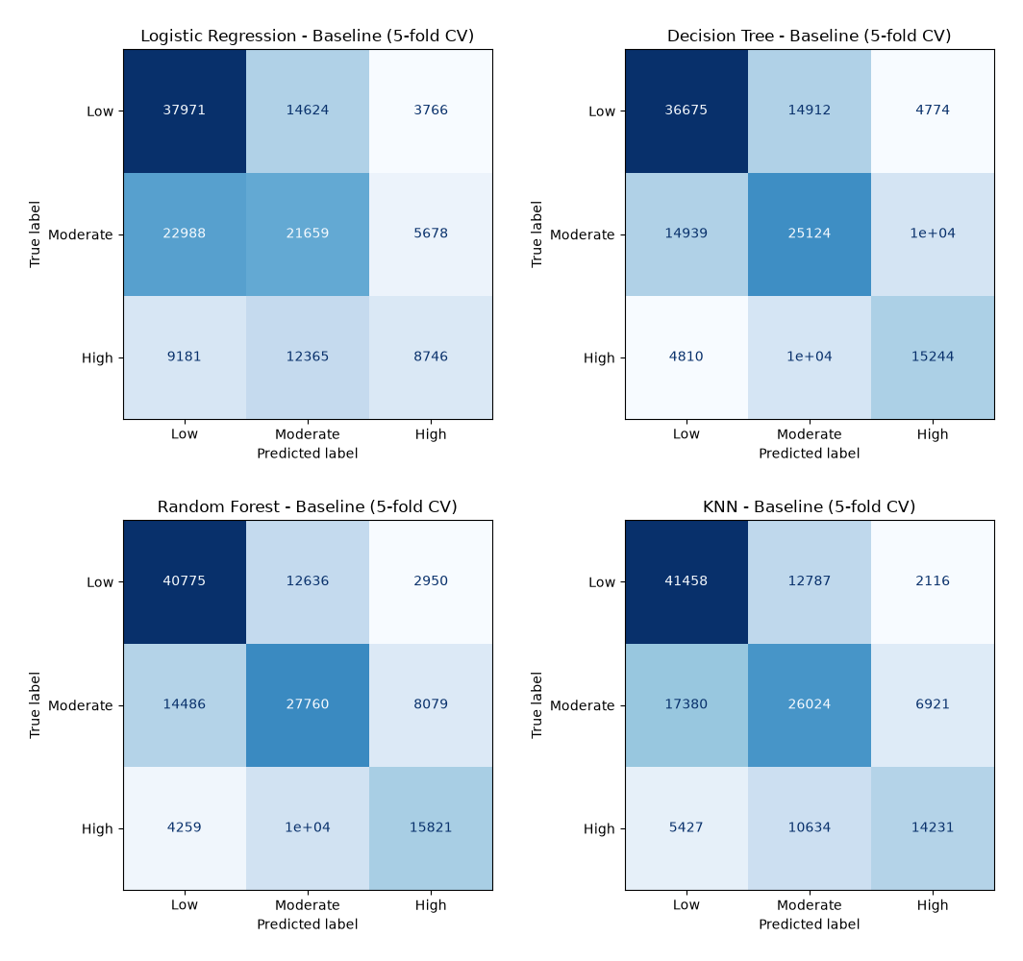
Figure 14: Baseline confusion matrices (5-fold CV): Logistic Regression, Decision Tree, Random Forest and KNN.
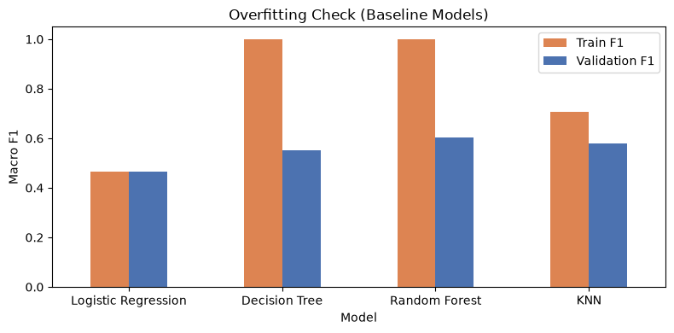
Figure 15: Overfitting check: training F1 versus validation F1 of the baseline models.

Why Some Models Perform Better Than Others
- Logistic Regression is the weakest (0.466). Its training and validation F1 are almost equal (0.467 vs 0.466), so it is underfitting: a straight-line model cannot represent combinations such as airline x airport x season. It finds only 29% of the real High Risk cases.
- The default Decision Tree overfits badly. It scores 0.999 on the training data but only 0.551 on validation data, because without limits it memorises individual records.
- Random Forest is the best (0.603). It learns combinations like a tree, but averaging many trees cancels individual mistakes, so although its training score is also high, its validation score is the highest of all models, and it finds the most High Risk records (52%).
- KNN is second (0.580). Similar routes and months do have similar risk, but KNN weights every feature equally and is by far the slowest (745 s for 5-fold CV).
- Most errors are between neighbouring classes (Low <-> Moderate, Moderate <-> High), which is expected for an ordered target. Low and High are confused much less often.
- All four models clearly beat the Dummy baseline (0.194), so they all learn real patterns.

9. Hyperparameter Tuning and Optimization

Search Strategy
All four models were tuned with GridSearchCV, using the same Stratified 5-Fold folds and Macro F1 as the scoring metric. Grid search tries every combination in a focused grid. It was chosen because only two important hyperparameters per model were tuned, so trying all combinations is still affordable and gives a complete, reproducible record of every experiment. Random search would be preferable with many hyperparameters. When a best value was found at the edge of a grid, the grid was extended and the search re-run.
Table 17: Hyperparameter grids and best settings
Model | Hyperparameters and values tried | Combinations | Best setting | Best CV Macro F1
Logistic Regression | C: 0.01, 0.1, 1, 10  class_weight: None, balanced | 8 | C = 10, class_weight = None | 0.466
Decision Tree | max_depth: 10, 15, 20, 25, 30, None  min_samples_leaf: 10, 20, 50 | 18 | max_depth = 25, min_samples_leaf = 20 | 0.586
Random Forest | n_estimators: 100, 200  max_depth: 15, 25, None | 6 | n_estimators = 200, max_depth = 25 | 0.612
KNN | n_neighbors: 5, 15, 25  weights: uniform, distance | 6 | n_neighbors = 25, weights = distance | 0.595

Decision Tree Tuning in Detail
The Decision Tree benefited most from tuning. The first grid found its best max_depth at the edge of the range, so the grid was extended to depths 25, 30 and no limit. The best setting is now inside the grid, and depths 25, 30 and None all score about 0.585-0.586 (std 0.0016), showing that the score has levelled off. Requiring at least 20 records per leaf beat both 10 and 50.
Table 18: Decision Tree before and after tuning
Metric | Baseline (no limits) | Tuned (depth 25, leaf 20)
Macro F1 | 0.551 | 0.586
Accuracy | 0.562 | 0.603
Precision (macro) | 0.551 | 0.595
Recall (macro) | 0.551 | 0.581
Training F1 | 0.999 | 0.658
High Risk recall | 0.503 | 0.475
CV time (s) | 7.7 | 2.4

The training F1 fell from 0.999 to 0.658, so the gap between training and validation became much smaller - the overfitting was largely fixed. There is one trade-off: the smoother tree predicts High Risk less often, so High Risk recall dropped slightly from 0.503 to 0.475.
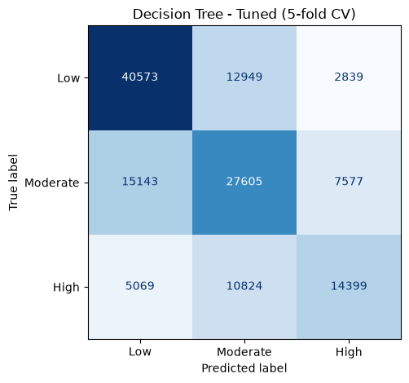
Figure 16: Confusion matrix of the tuned Decision Tree (5-fold CV).

Baseline versus Tuned Models
Table 19: Baseline versus tuned Macro F1 (5-fold cross-validation)
Model | Baseline Macro F1 | Tuned Macro F1 | Improvement | Rank
Random Forest | 0.603 | 0.612 | +0.010 | 1
KNN | 0.580 | 0.595 | +0.015 | 2
Decision Tree | 0.551 | 0.586 | +0.035 | 3
Logistic Regression | 0.466 | 0.466 | +0.000 | 4

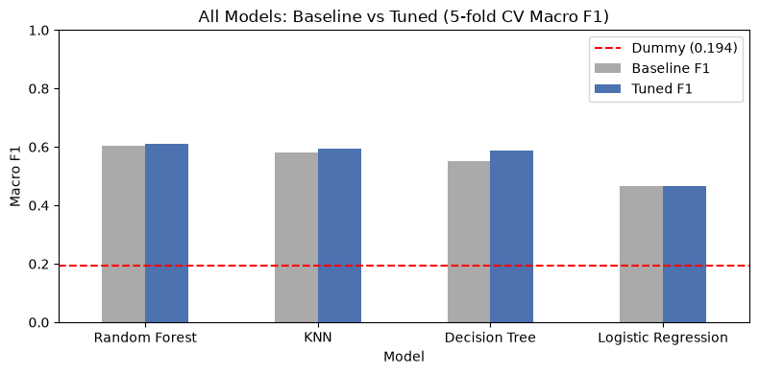
Figure 17: All models: baseline versus tuned Macro F1, with the Dummy baseline (red dashed line).
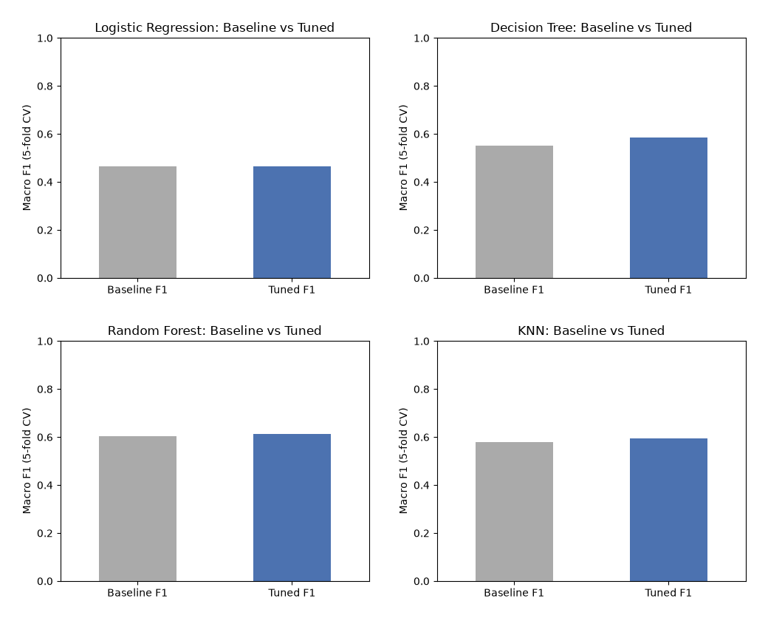
Figure 18: Baseline versus tuned Macro F1 for each model separately.

Interpretation of the Tuning Results
- Decision Tree (+0.035) gained the most, because limiting depth and leaf size directly fixed its overfitting.
- KNN (+0.015): 25 neighbours give a more reliable vote than 5, and distance weighting still lets the closest records count most.
- Random Forest (+0.010): more trees make the vote more stable, and a depth limit of 25 stops individual trees from growing too deep; no limit (0.604) and depth 15 (0.603) were both worse.
- Logistic Regression (+0.000): changing the regularisation strength cannot turn a linear boundary into a curved one; class_weight = balanced lowered Macro F1 to about 0.450 for every C.

10. Final Model Selection and Justification
The final model is the Random Forest with n_estimators = 200 and max_depth = 25, using all 29 features. It was rebuilt with these settings, trained on the full training set and evaluated once on the locked test set, which none of the models had seen during development.

Test-Set Results
Table 20: Classification report of the final model on the test set
Class | Precision | Recall | F1-score | Support
Low Risk | 0.69 | 0.74 | 0.71 | 14,091
Moderate Risk | 0.56 | 0.57 | 0.56 | 12,581
High Risk | 0.62 | 0.52 | 0.57 | 7,573
Macro average | 0.62 | 0.61 | 0.62 | 34,245
Accuracy |  |  | 0.63 | 34,245

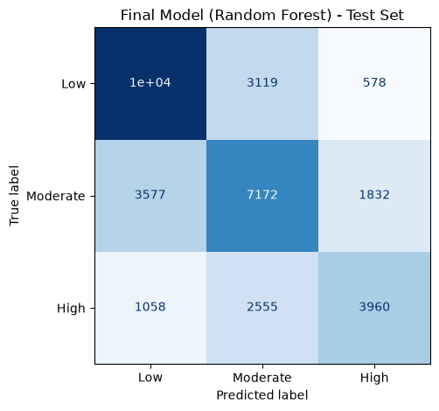
Figure 19: Confusion matrix of the final Random Forest on the test set.
The test Macro F1 is 0.615 and the accuracy 0.629, almost identical to the cross-validation Macro F1 of 0.612. The model therefore generalises to unseen data and is not overfitting the training set. Only 4.1% of real Low Risk records are predicted as High Risk. Of the misclassified High Risk records, most (2,555) are predicted as the neighbouring Moderate level rather than Low (1,058).

Justification
Table 21: Comparison of the tuned models against the selection criteria
Criterion | Logistic Regression | Decision Tree | Random Forest | KNN
Tuned CV Macro F1 | 0.466 | 0.586 | 0.612 | 0.595
Baseline High Risk recall | 0.289 | 0.503 | 0.522 | 0.470
Generalisation (test vs CV) | - | - | 0.615 vs 0.612 | -
Probability for confidence | Yes | Coarse | Yes (200-tree vote) | Yes
Prediction speed for one input | Fast | Fast | Fast (~50 ms) | Slow (compares 137k records)
Explainability | Coefficients | Rules | Feature importance | Neighbours

- Highest Macro F1, both before and after tuning (0.612 in cross-validation, 0.615 on the test set).
- Generalises well: the test score matches the cross-validation score.
- Finds High Risk routes best: when it predicts High Risk it is right about 6 times out of 10 (precision 0.62), and it rarely confuses Low with High.
- Gives a confidence value: predict_proba allows the system to show, for example, "High Risk - 74% confidence", as planned in the proposal.
- Suitable for a live system: unlike KNN, a prediction does not require comparing the input with every training record.
Limitation: Moderate Risk is the hardest class (F1 0.56) because it lies between the other two levels, and the available inputs do not include weather or air-traffic information. The model is also large (about 175 MB) because 200 deep trees are stored, so it is excluded from Git and recreated by running Final_Model_Comparison.ipynb.

11. System Architecture and Implementation

System Architecture
The prediction system follows a layered client-server architecture that separates offline model development from online prediction (see the figure below). The user works only with the frontend in a web browser. The frontend sends the inputs as JSON to the Flask backend, which validates them, applies the saved Stage 4 preprocessing and asks the saved Random Forest for the class probabilities. The result returns as JSON and is displayed as a colour-coded risk card.
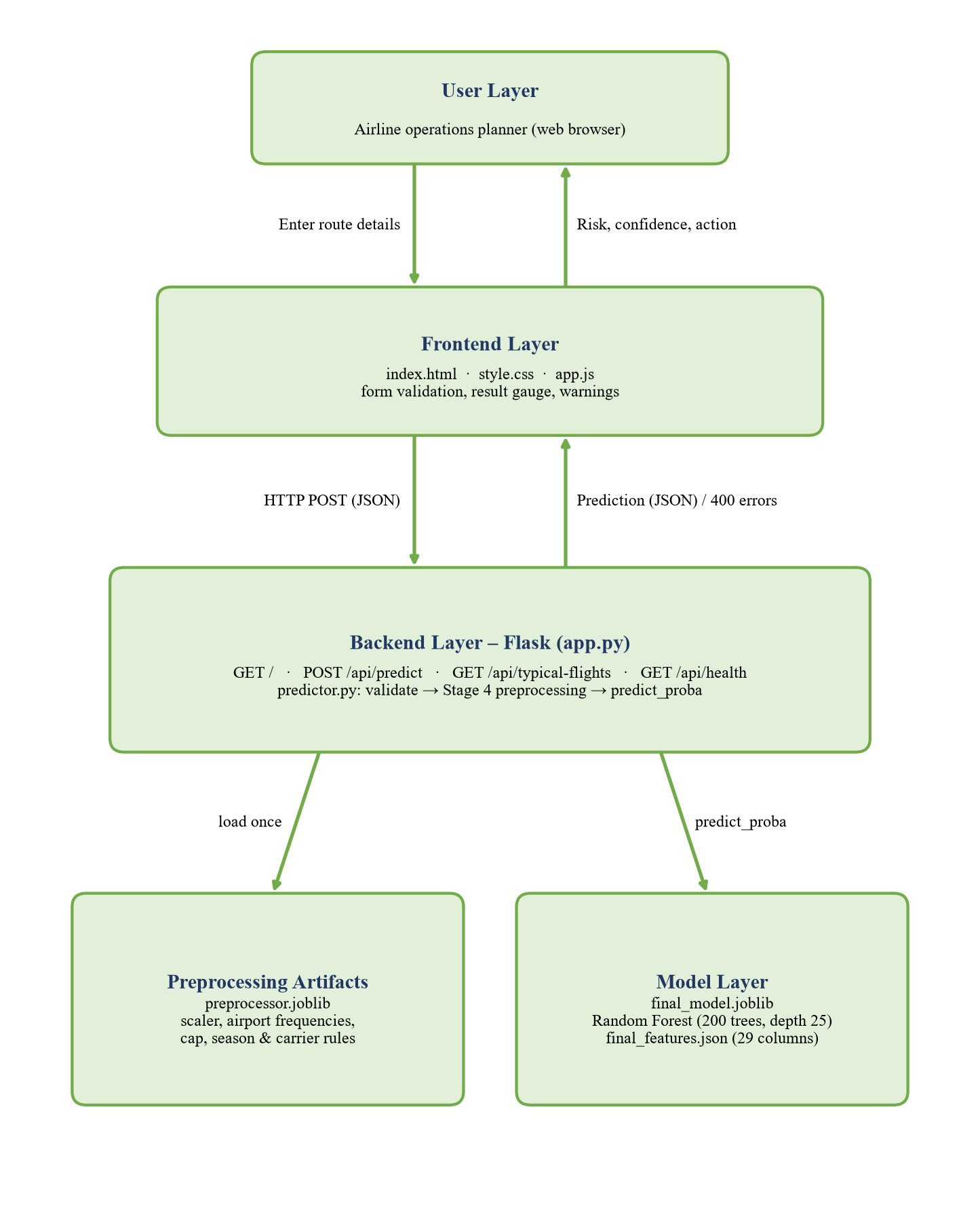
Figure 20: System architecture of the Flight Delay Risk Checker.
Table 22: Responsibilities of each layer
Layer | Components | Responsibility
User | Web browser (desktop or phone) | Enters route details and reads the result
Frontend | templates/index.html, static/style.css, static/app.js | Form, client-side validation, API calls, result display, warnings
Backend | webapp/app.py (Flask routes) | HTTP endpoints, JSON responses, error handling, logging
Prediction logic | webapp/predictor.py | Loads artifacts once, validates input, repeats Stage 4 preprocessing, predicts
Artifacts | models/final_model.joblib, final_features.json, preprocessor.joblib | Trained model, column order and learned preprocessing values
Development | Stage 3-4 and Model 1-4 notebooks, Final_Model_Comparison.ipynb | Offline EDA, preprocessing, training, tuning and model export

Project Structure
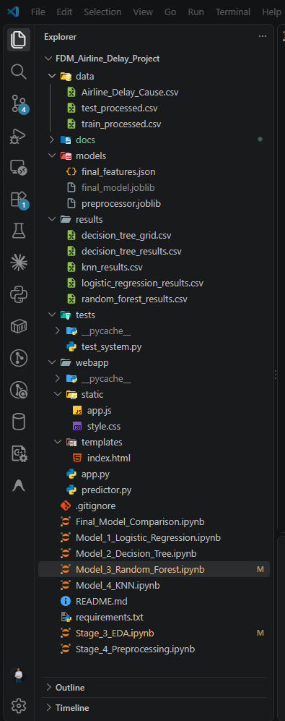
Figure 21: Project folder structure in Visual Studio Code.
Table 23: Main folders and files of the project
Folder / file | Contents
data/ | Raw Airline_Delay_Cause.csv and the processed train/test sets
Stage_3_EDA.ipynb, Stage_4_Preprocessing.ipynb | EDA and preprocessing (Stage 4 also saves preprocessor.joblib)
Model_1 ... Model_4 notebooks | Development and tuning of each algorithm; results saved to results/
Final_Model_Comparison.ipynb | Comparison, feature selection experiment, test-set evaluation, model export
models/ | final_model.joblib, final_features.json, preprocessor.joblib
webapp/ | app.py, predictor.py, templates/index.html, static/style.css, static/app.js
tests/test_system.py | 20 automated system tests
README.md, requirements.txt | Run instructions, API reference and pinned library versions

Technology Stack
Table 24: Technology stack
Purpose | Technology | Version
Language | Python | 3.11.9
Machine learning | scikit-learn | 1.9.0
Data handling | pandas / NumPy | 3.0.5 / 2.4.6
Model persistence | joblib | 1.6.0
Charts | matplotlib | 3.11.2
Backend web framework | Flask | 3.1.3
Frontend | HTML5, CSS3, vanilla JavaScript | -
Development and testing | Jupyter, VS Code, unittest, Git/GitHub | -

Implementation
Model development produces three artifacts that together form the deployable model: the trained Random Forest (final_model.joblib), the exact list and order of the 29 input columns (final_features.json) and the learned preprocessing values (preprocessor.joblib). The backend loads them once when the server starts (about 13 seconds, mainly for the 175 MB forest) and keeps them in memory, so each prediction takes only about 50 ms. At start-up the backend also checks that the feature list of the model and of the preprocessing are identical, and stops with a clear message if a file is missing or out of date.
scikit-learn models must be loaded with the same library version that saved them. The versions are therefore pinned in requirements.txt, and the project is run with Python 3.11 and scikit-learn 1.9.0, the environment that trained the model. The system is started with a single command:
pip install -r requirements.txt
python webapp/app.py
# then open http://127.0.0.1:5000 in a browser

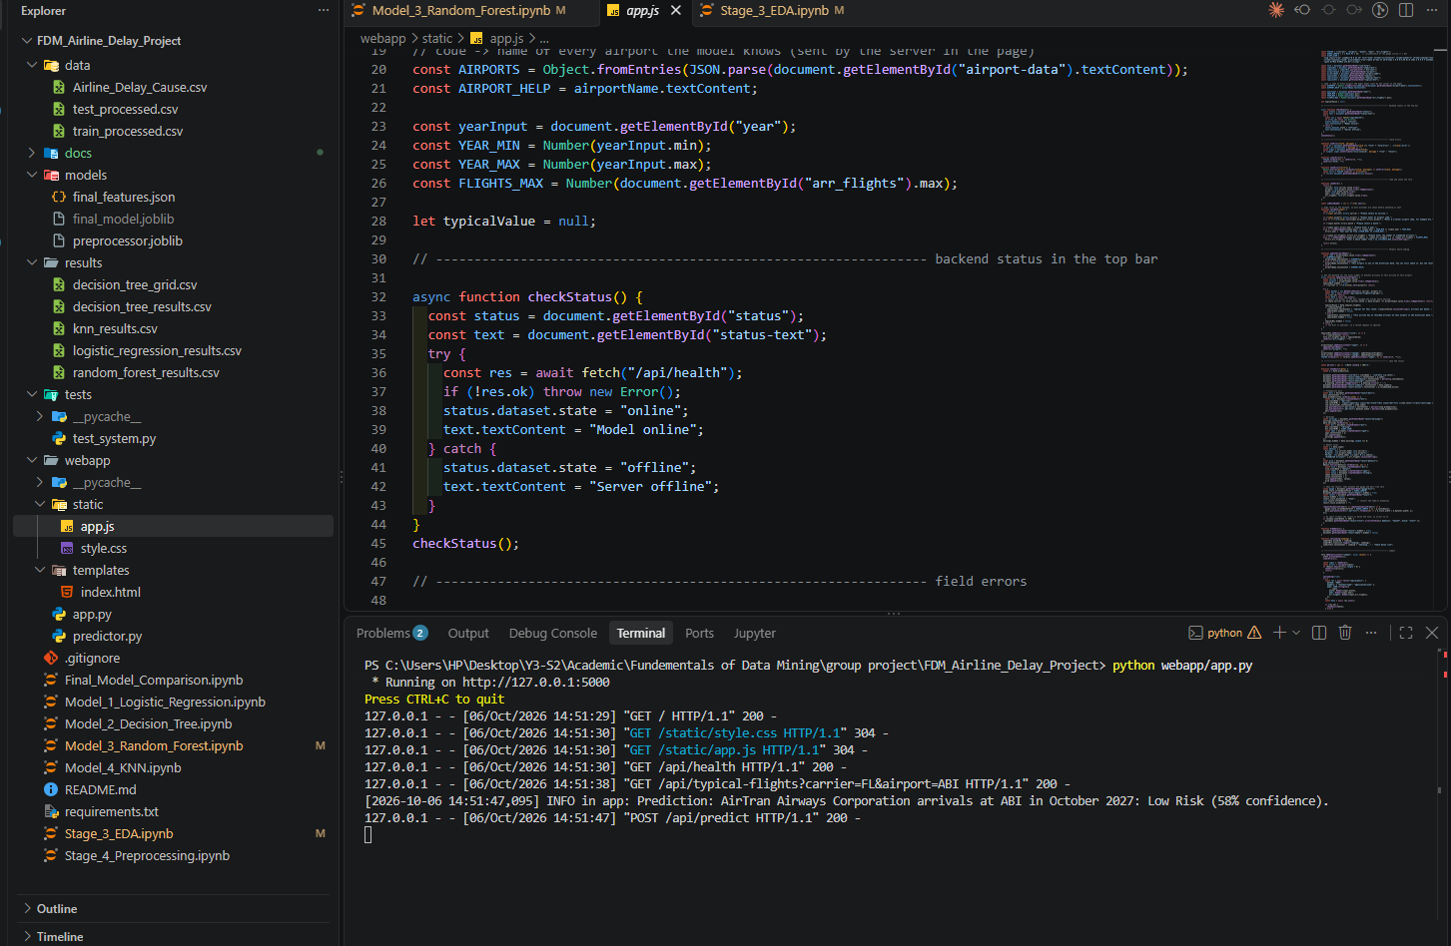
Figure 22: The Flask server running in VS Code, with requests from the browser in the terminal log.

12. Backend and Frontend Development

Backend Development
The backend (Stage 9) is a Flask application in webapp/app.py, with all prediction logic in a separate module, webapp/predictor.py. This separation keeps the web layer thin and allows the prediction logic to be tested directly.
Table 25: API endpoints of the backend
Method | Route | Purpose | Response
GET | / | Serves the web page with the airline and airport lists | HTML
POST | /api/predict | Validates the input and returns the prediction | 200 JSON result / 400 JSON field errors
GET | /api/typical-flights | Typical monthly arrivals for an airline at an airport | JSON number or null
GET | /api/health | Checks that the model is loaded | JSON status, model type, 29 features

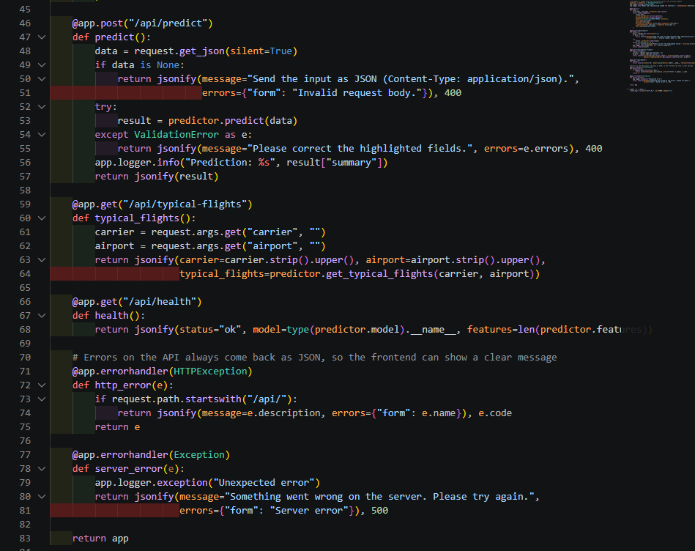
Figure 23: Flask routes in app.py, including the prediction endpoint and JSON error handling.

Input Validation
Every request is validated on the server even though the browser also validates it, because the API can be called directly. predictor.validate() checks every field and returns one clear message per invalid field with HTTP status 400, instead of a generic error.
Table 26: Server-side validation rules
Field | Rule | Error message (example)
All fields | Required, not empty | This field is required.
carrier | One of the 21 known airlines (case and spaces ignored) | Unknown airline. Please choose one of the airlines in the list.
airport | Exactly three letters (IATA format) | Enter a 3-letter airport code, for example ATL.
month | Whole number 1-12 (rejects 2.5, "July", true) | Month must be a whole number from 1 to 12.
year | Whole number 2013-2033 | Year must be a whole number from 2013 to 2033.
arr_flights | Whole number 1-50,000 | Scheduled arrivals must be a whole number from 1 to 50,000.
Request body | Must be a JSON object | Send the input as JSON (Content-Type: application/json).

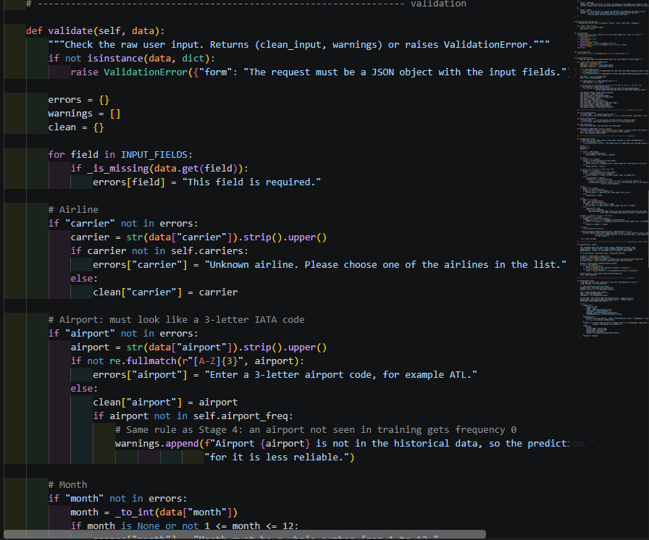
Figure 24: The validate() function in predictor.py.
Valid but unusual inputs are accepted with a warning instead of an error, so the planner still gets an answer but knows it is less reliable: a year after 2023 (the model assumes patterns similar to recent years), an airport not seen in training (frequency 0, the same rule as Stage 4) and an airline with no recorded arrivals at that airport.

Applying the Same Preprocessing
predictor.transform() rebuilds the 29 model columns from the five inputs using the values saved in Stage 4: season one-hot, carrier one-hot, airport frequency (0 if unseen), the arr_flights cap of 4,927.46, the fitted StandardScaler and the saved column order. It works on a DataFrame, so the same function handles one web request or all 34,245 test records in the consistency test (Section 13).
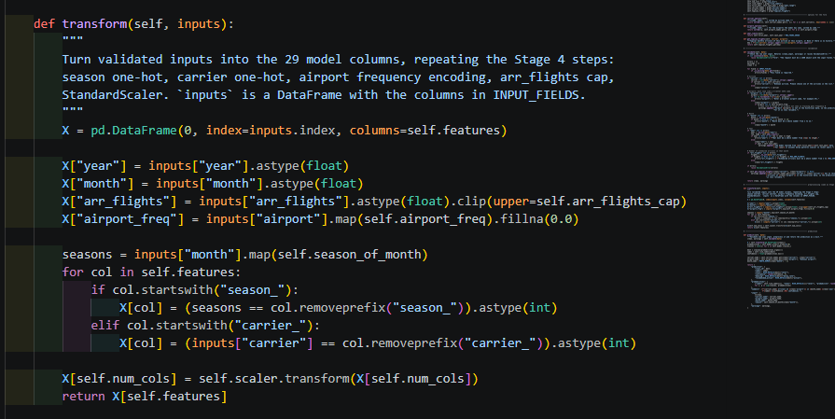
Figure 25: The transform() function that repeats the Stage 4 preprocessing.

Prediction Response
The model's predict_proba() gives the probability of each class. The response contains the predicted level, the confidence (highest probability), all three probabilities, the meaning of the level, the recommended action, a one-line summary, the cleaned inputs with readable names and season, and any warnings.
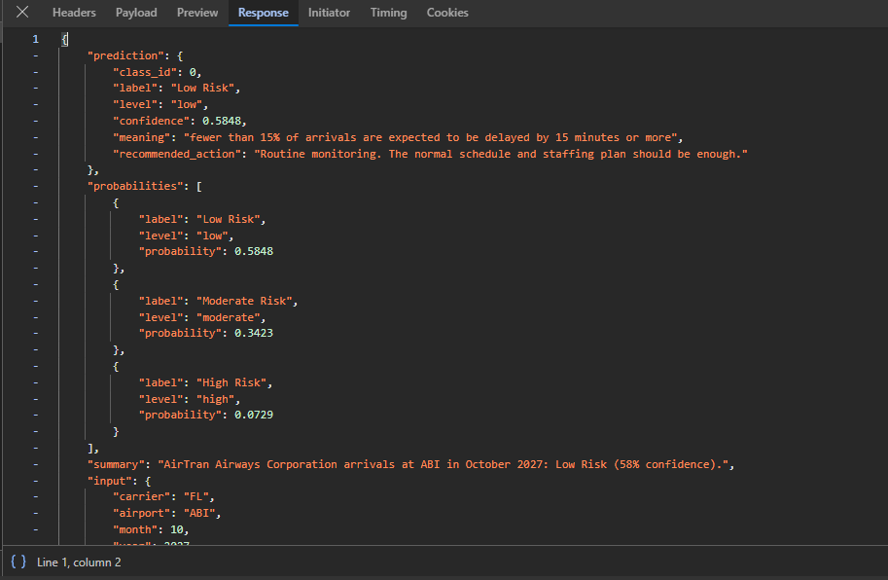
Figure 26: JSON response of POST /api/predict in the browser developer tools.
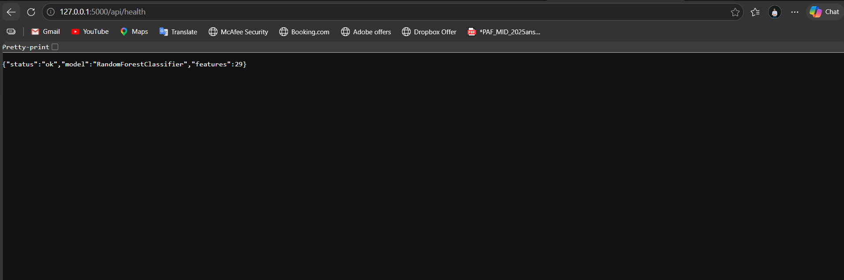
Figure 27: GET /api/health confirms that the Random Forest with 29 features is loaded.
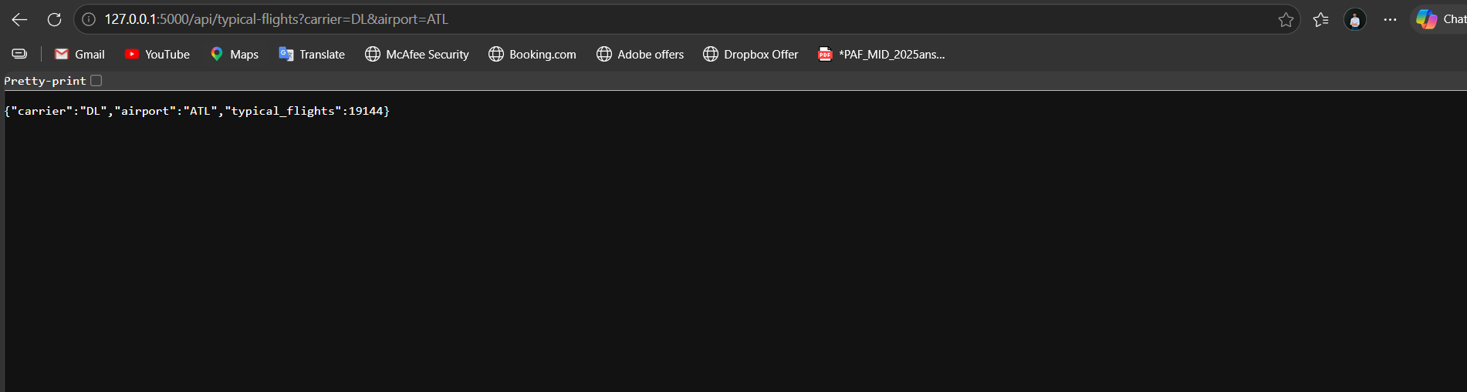
Figure 28: GET /api/typical-flights returns the typical monthly arrivals for Delta (DL) at Atlanta (ATL).
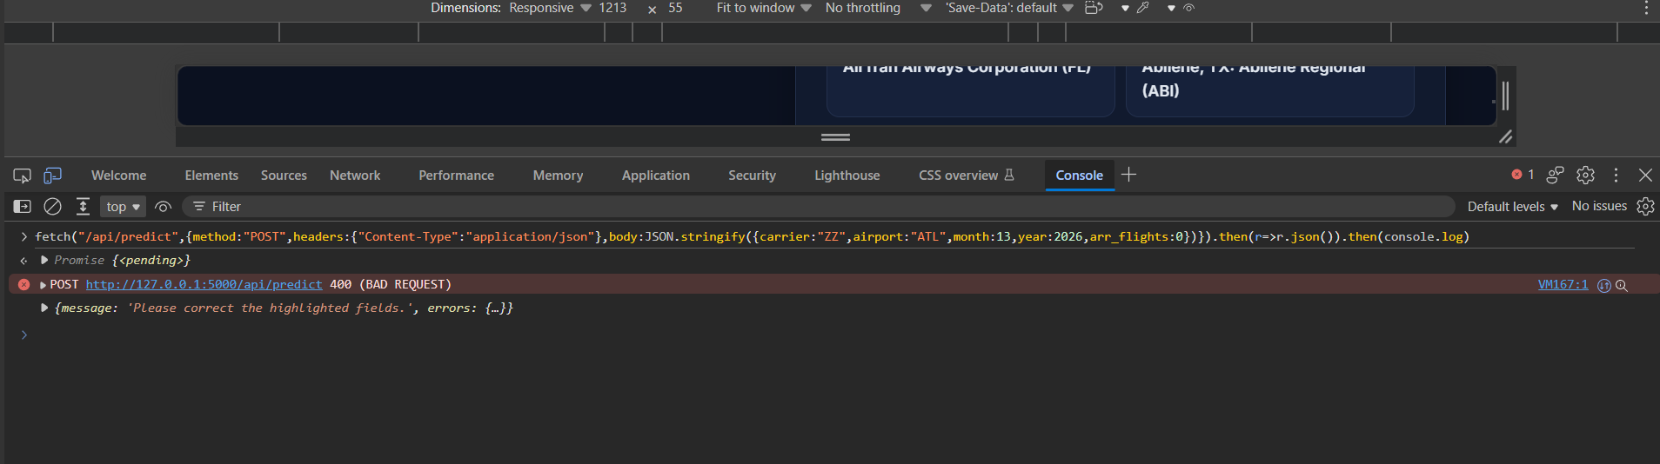
Figure 29: An invalid request (unknown airline, month 13, zero arrivals) is rejected with HTTP 400 and field-level errors.
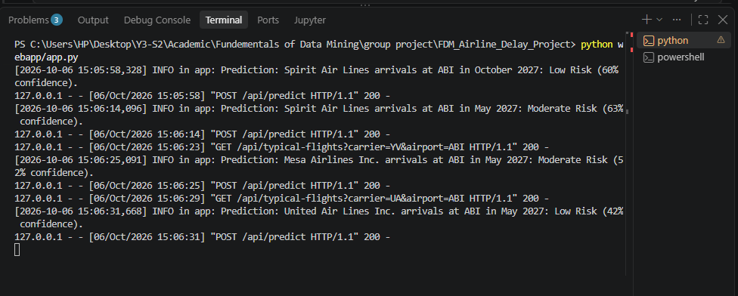
Figure 30: Each prediction is logged on the server with a readable summary.

Frontend Development
The frontend (Stage 10) is written in HTML, CSS and vanilla JavaScript without external frameworks, so it loads quickly and works offline on the demonstration laptop. It was designed for non-technical airline staff: every field has a clear label and help text, technical terms are avoided, and results are colour-coded.
Table 27: Main frontend features
Feature | Description
Live status badge | Calls /api/health and shows "Model online" or "Server offline"
Input form | Airline dropdown, searchable airport field (code or city), month dropdown, year and arrivals fields, each with an icon
Airport name hint | Shows the full airport name as soon as a valid code is typed
Typical arrivals helper | Shows the typical monthly arrivals for the chosen route and fills it with one click
Client-side validation | Same rules as the backend; errors shown in red under each field before anything is sent
Result card | Confidence gauge, risk level in green/amber/red, plain-language meaning and recommended action
Probability bars | Animated bars for Low, Moderate and High Risk
Warnings and details | Yellow warning boxes and a summary of the checked route
Error handling | Server field errors shown under the fields; a clear message if the server cannot be reached
Responsive and themed | Works on desktop and phone; automatic light and dark mode

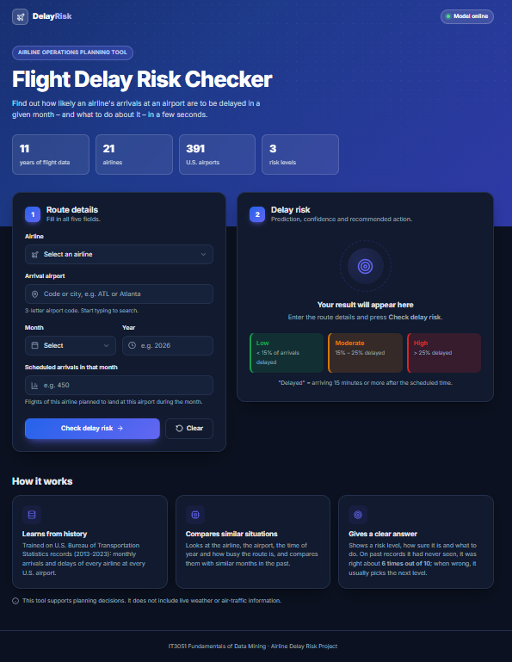
Figure 31: Home page of the Flight Delay Risk Checker.
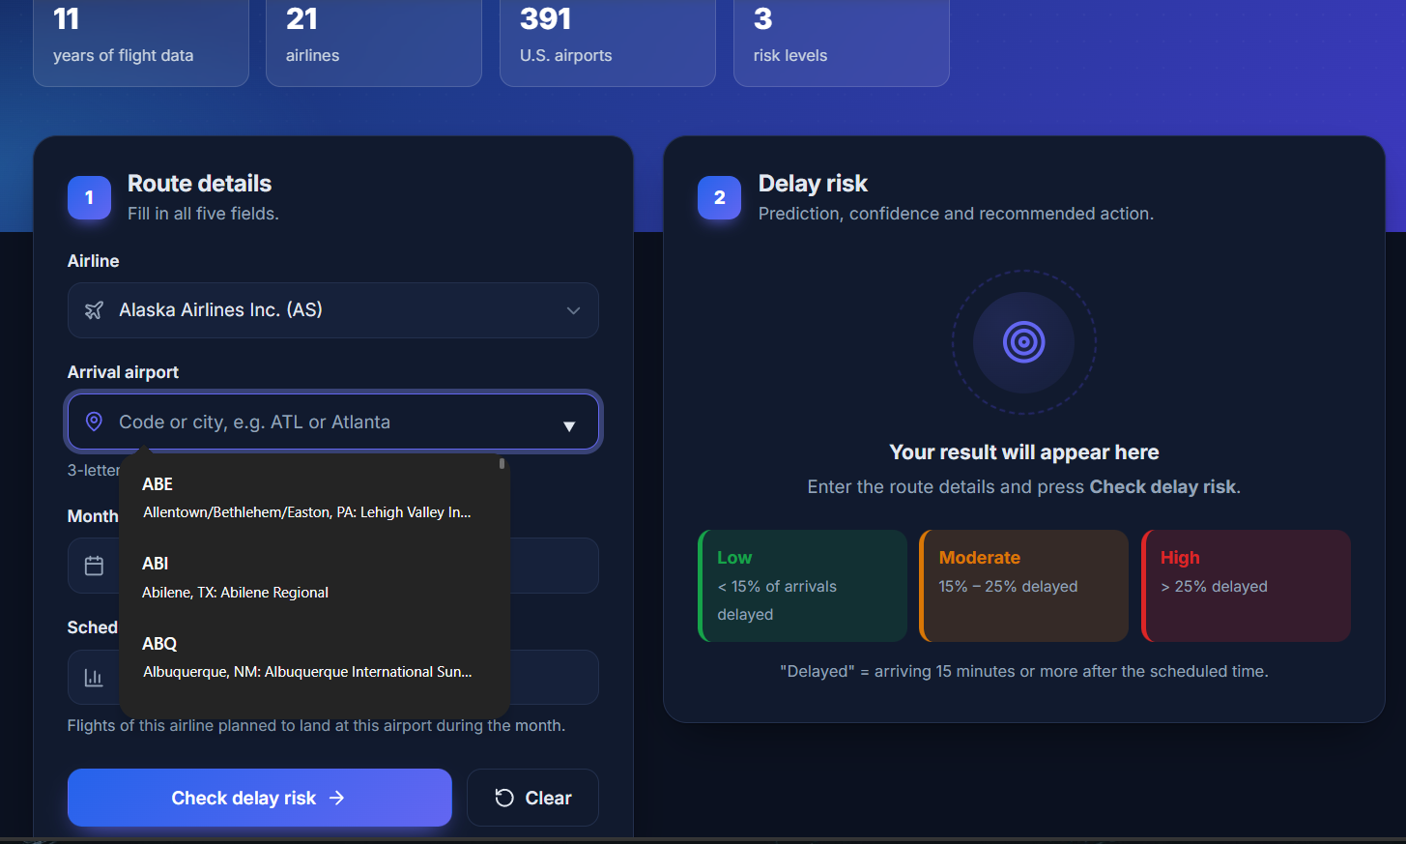
Figure 32: Searchable airport field: typing filters the airports by code or city.
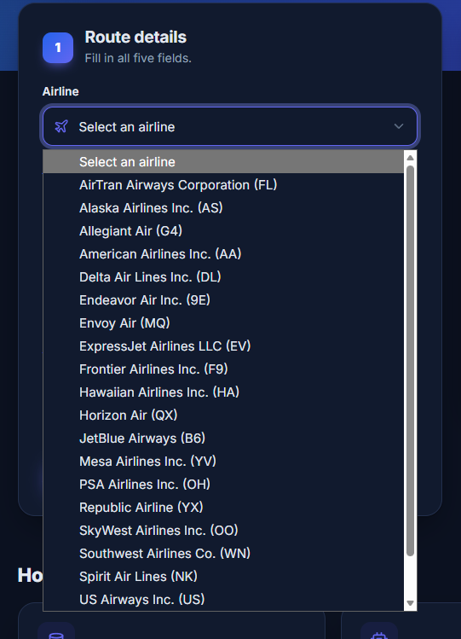
Figure 33: Airline dropdown listing all 21 airlines by full name and code.
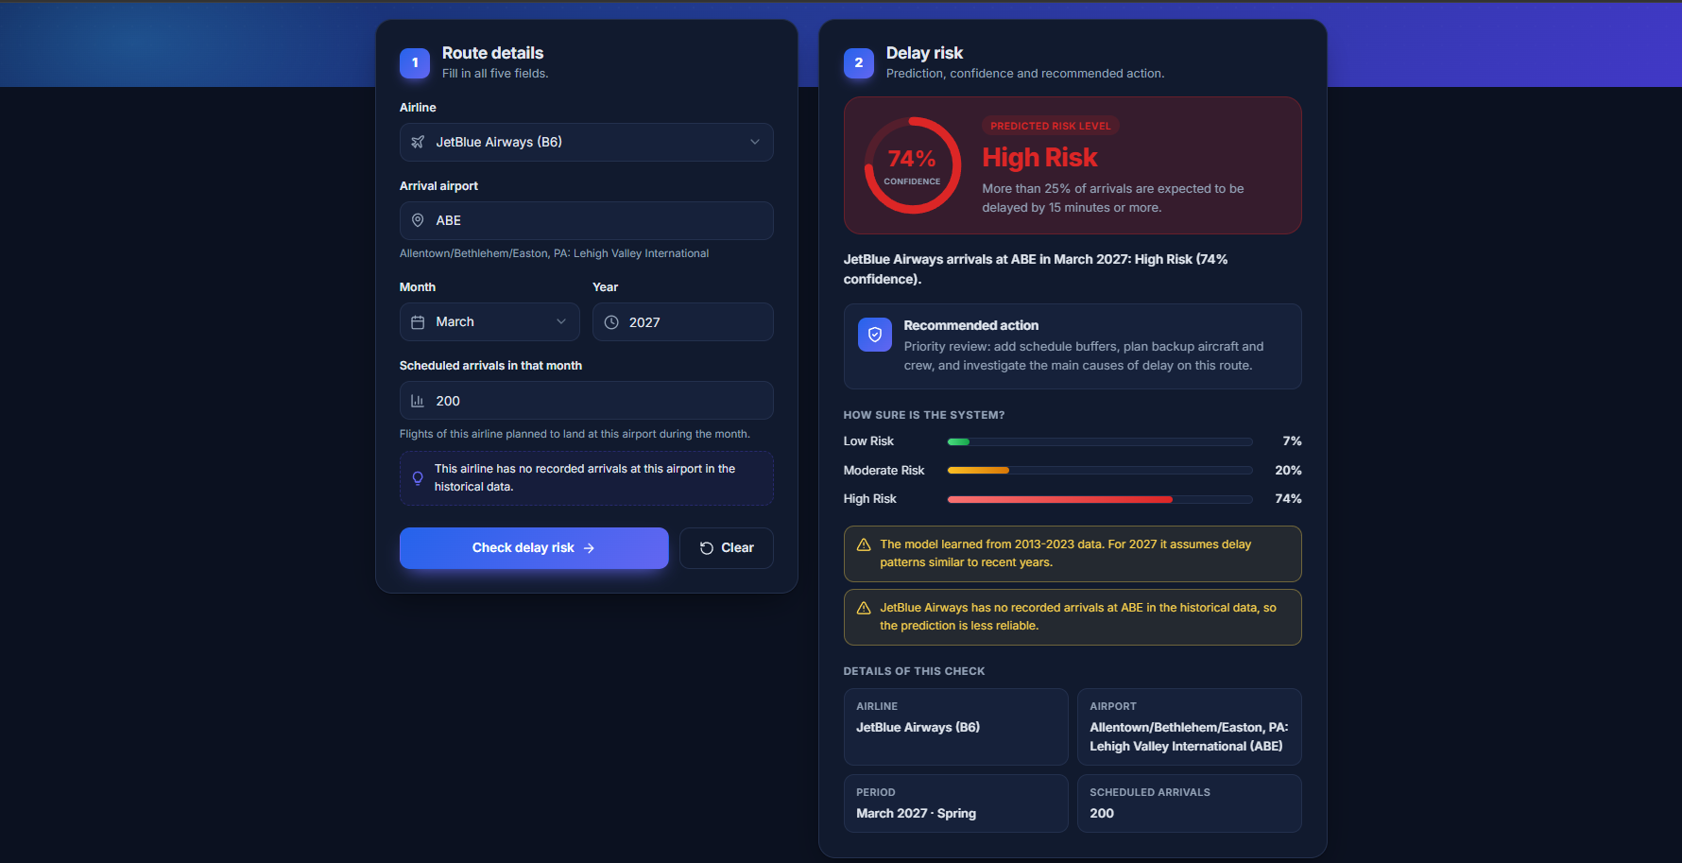
Figure 34: High Risk result with confidence gauge, recommended action, probabilities and warnings.

Figure 35: Moderate Risk result.
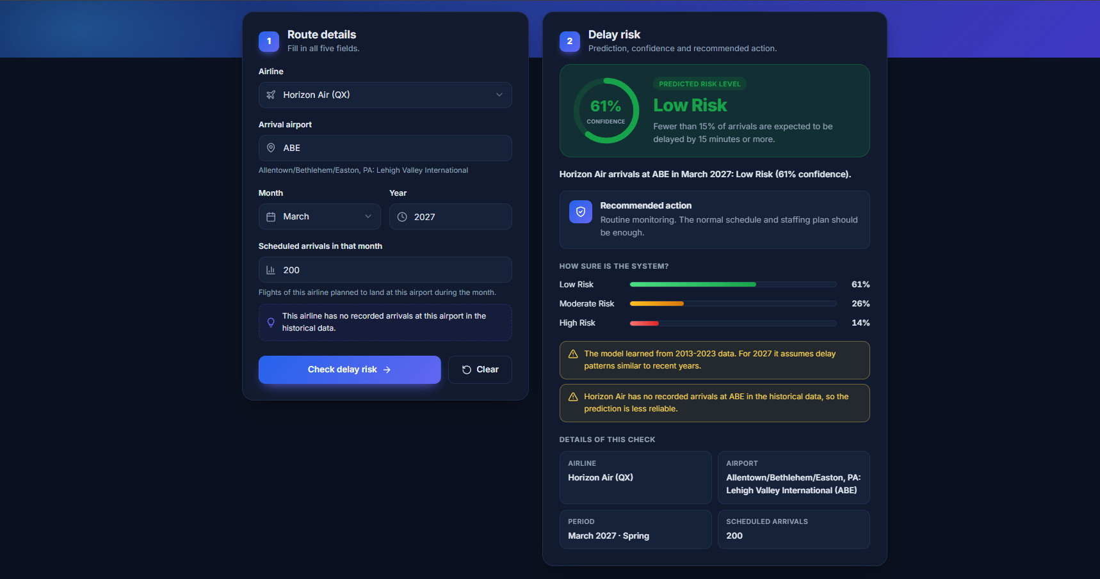
Figure 36: Low Risk result.

Figure 37: Light-mode result for Delta Air Lines at Atlanta (ATL) in July 2023 with the typical-arrivals helper.
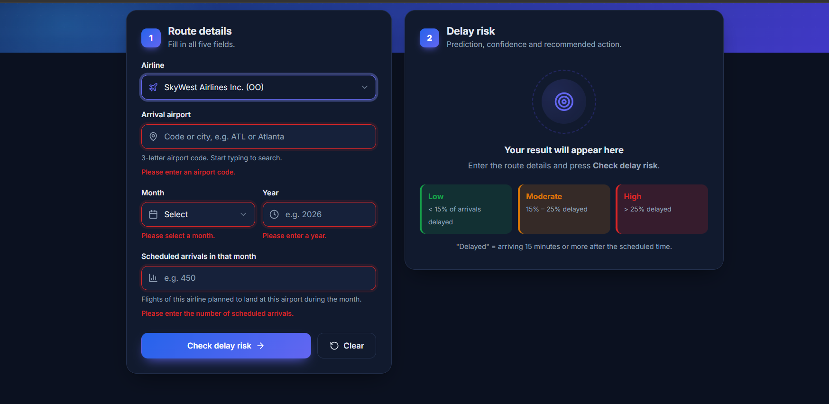
Figure 38: Client-side validation: each missing field is highlighted with its own message.
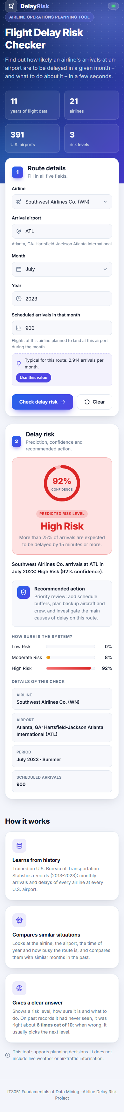
Figure 39: Responsive layout on a 390-pixel phone screen.

End-to-End Prediction Flow
- The planner selects the airline, airport, month and year and enters (or fills with one click) the scheduled arrivals.
- app.js validates the fields. If something is wrong, the errors are shown under the fields and nothing is sent.
- app.js sends the inputs as JSON to POST /api/predict and shows a loading spinner.
- Flask passes the request to predictor.validate(); invalid input returns HTTP 400 with one message per field.
- predictor.transform() rebuilds the 29 columns with the saved Stage 4 preprocessing.
- The Random Forest returns the probability of each risk level.
- The backend returns the level, confidence, probabilities, meaning, action and warnings as JSON and logs the prediction.
- app.js displays the colour-coded result card, animates the gauge and bars, and lists any warnings.

13. System Testing and Results

Testing Approach
The system was tested on 6 October 2026 at three levels: (1) 20 automated system tests in tests/test_system.py using Python's unittest and the Flask test client; (2) an end-to-end consistency check proving that the backend repeats the Stage 4 preprocessing exactly; and (3) manual browser testing with real records from the test set, invalid inputs, light/dark mode and a phone-sized screen. The automated tests are run with:
python -m unittest discover -s tests -v

Functional and Input-Validation Results
Table 28: Automated system test cases and results
# | Test | Input | Expected result | Result
1 | Page loads | GET / | Form with all airlines and airports | Pass
2 | Valid prediction | DL, ATL, July 2023, 2500 | 200; probabilities sum to 1; confidence = highest probability | Pass
3 | Input cleaning | " dl ", "atl ", numbers as text | Same result as test 2 | Pass
4 | All months and airlines | Months 1-12, all 21 airlines | All predicted (200) | Pass
5 | Very large flight count | 6,000 and 40,000 | Same result (capped as in Stage 4) | Pass
6 | Future year | 2026 | Prediction + warning | Pass
7 | Unknown airport | QQQ | Prediction + warning (frequency 0) | Pass
8 | Route with no history | Hawaiian Airlines at ABE | Prediction + warning | Pass
9 | Missing fields | Empty body / one field missing | 400 with an error for each field | Pass
10 | Invalid month | 0, 13, -1, 2.5, "July", true | 400, month error | Pass
11 | Invalid year | 2012, 2034, "abc", 2020.5 | 400, year error | Pass
12 | Invalid flight count | 0, -5, 1.5, "many", 50001 | 400, arr_flights error | Pass
13 | Invalid airline | ZZ | 400, carrier error | Pass
14 | Invalid airport format | AT, ATLA, 12A, A-L | 400, airport error | Pass
15 | Body is not a JSON object | Plain text, JSON list | 400 | Pass
16 | Unknown API route | /api/does-not-exist | 404 as JSON | Pass
17 | Typical flights helper | DL+ATL / DL+QQQ | Number / null | Pass
18 | Same preprocessing as Stage 4 | All 34,245 raw test rows | Features identical to test_processed.csv | Pass
19 | Same results as notebook | All 34,245 test rows | Accuracy 0.6286, Macro F1 0.6153 | Pass
20 | Health check | GET /api/health | 200, 29 features | Pass

All 20 tests passed in 6.5 seconds (see the figure below). Unlike a simple check of one sample request, tests 18 and 19 verify the whole serving pipeline against the model-development pipeline.
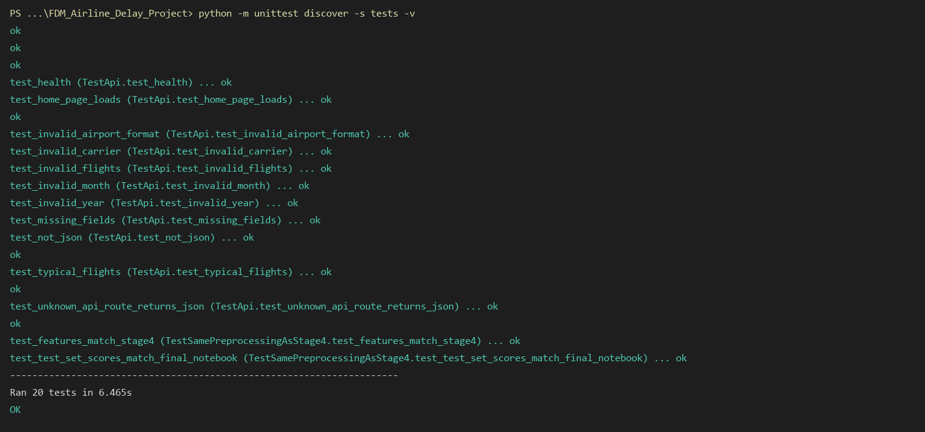
Figure 40: Output of the automated test suite: 20 tests, all passed.

Preprocessing Consistency Check
The assignment requires the system to use the final model with the correct preprocessing pipeline. To prove this, the test suite repeats the Stage 4 cleaning and split to recover the raw versions of all 34,245 test records, passes them through the backend's transform() and compares the result with data/test_processed.csv created in Stage 4. All 29 columns of every row are identical (difference below 1e-9). Passing these backend features to the final model reproduces the notebook's test results exactly: accuracy 0.6286 and Macro F1 0.6153.

Prediction Checks with Real Records
Ten real records from the test set - data the model never saw during training - were entered through the web interface. The table compares the system's answer with what actually happened in that month.
Table 29: System predictions for real test-set records compared with the actual outcome
Airline | Airport | Month / year | Arrivals | System prediction | Actual delay rate | Correct?
JetBlue (B6) | DFW | Apr 2021 | 32 | Low (72%) | 9.4% - Low | Yes
Republic (YX) | ORD | May 2021 | 3,557 | Low (85%) | 7.3% - Low | Yes
SkyWest (OO) | SEA | Jun 2023 | 2,070 | Low (74%) | 10.1% - Low | Yes
American (AA) | MIA | May 2023 | 4,466 | Moderate (69%) | 18.0% - Moderate | Yes
Hawaiian (HA) | HNL | Jun 2023 | 2,729 | Moderate (83%) | 19.7% - Moderate | Yes
Delta (DL) | LAS | Jan 2023 | 1,341 | Moderate (67%) | 23.0% - Moderate | Yes
Alaska (AS) | ORD | Dec 2022 | 207 | High (76%) | 37.2% - High | Yes
Hawaiian (HA) | SFO | Nov 2022 | 60 | High (77%) | 36.7% - High | Yes
Spirit (NK) | DFW | Aug 2023 | 810 | High (84%) | 33.5% - High | Yes
Hawaiian (HA) | LAS | Mar 2023 | 110 | High (65%) | 24.5% - Moderate | No

Nine of the ten predictions were correct. The incorrect one had an actual delay rate of 24.5%, just below the 25% High Risk threshold, and the model chose the neighbouring level - the typical error pattern seen in the confusion matrix.

Warning and Error-Handling Checks

Figure 41: A future year and a route with no history produce a prediction with two warnings.
Stopping the server and pressing Check delay risk shows the message "Could not reach the prediction service. Make sure the server is running and try again." instead of failing silently, and the status badge shows the server state when the page loads.

Performance and Reliability
Table 30: Performance and reliability results
Measure | Result
Model and preprocessing load time (once, at start-up) | About 13 seconds
Prediction time (30 repeated requests) | Median 52.5 ms, maximum 69 ms
Repeatability | 30 identical requests returned identical responses (High Risk, 64.29%)
Browser console errors | None
Layout at 390 px (phone) | No horizontal scrolling; all content readable

Overall System Testing Result
All automated and manual tests passed. The system loads the final model and the saved preprocessing pipeline, validates every input in both the browser and the server, applies exactly the same preprocessing as model development, returns clear predictions with confidence values and recommended actions, and handles missing, invalid and unusual inputs with clear messages. It is ready for the final demonstration as a decision-support tool. As with any prediction model, its output should support human review rather than replace it.

14. Limitations and Possible Future Improvements
The project shows that historical delay data can be turned into a useful risk-screening tool, but the following limitations must be considered when interpreting its results.

Limitations
- Moderate accuracy. The final model is correct for about 63% of unseen records (Macro F1 0.615). Moderate Risk is the hardest class (F1 0.56) because it lies between the other two, and errors usually fall into a neighbouring level.
- Limited inputs. The model knows only the airline, airport, month, year and planned arrivals. Weather, air-traffic control restrictions, aircraft type and staffing - major causes of delay - are not available as inputs.
- Historical, U.S.-only data. The data ends in August 2023 and covers U.S. airports only. For later years the model assumes patterns similar to recent years, and results may not transfer to other countries.
- Monthly aggregate level. Predictions describe a whole month of an airline at an airport, not an individual flight or day.
- User-estimated arrivals. The planner must enter the expected number of arrivals; the typical value from the data helps, but schedule changes affect accuracy.
- Random rather than time-based split. Because year is an input and the split is random, the test set includes months from the same years as training. A time-based test (train on 2013-2021, test on 2022-2023) would better estimate future performance.
- Preprocessing fitted before cross-validation. The scaler and airport frequencies were fitted on the full training set before cross-validation; the effect is small (test 0.615 vs CV 0.612) but a fully nested pipeline would be stricter.
- Prototype deployment. The system runs on Flask's development server on one machine, without user accounts, prediction history or monitoring, and the 175 MB model must be recreated on each new machine.

Possible Future Improvements
- Add external data: monthly weather summaries, air-traffic statistics and airline schedule data to explain more of the variation, especially in the Moderate class.
- Try gradient boosting: XGBoost or LightGBM often outperform Random Forests on tabular data and produce smaller models.
- Time-based validation: evaluate on the most recent years and retrain regularly as new BTS data is released.
- Ordinal methods and cost-sensitive thresholds: exploit the Low < Moderate < High order and tune decisions by the cost of missing a High Risk route.
- Explain each prediction: show the main factors behind an individual result (for example with SHAP values).
- Batch and dashboard mode: upload a whole schedule and rank all routes by risk, with charts for managers.
- Production deployment: a WSGI server (Waitress or Gunicorn), containerisation, user authentication, prediction logging and model-performance monitoring.
- Smaller model: limit tree size or use model compression so the artifact can be stored in Git and loaded faster.

15. Individual/Group Contributions, Where Required
The work was divided equally so that every member contributed to each main stage of the project: problem and data understanding, EDA, preprocessing, one of the four algorithms with its tuning, the prediction system and the report.
Table 31: Contribution of each group member
Registration Number | Contribution
IT23809024  EKANAYAKA E.J.M.C.U | ✓ Problem definition, stakeholder analysis and dataset proposal  ✓ EDA: data structure, missing values and duplicate checks  ✓ Decision Tree model development, tuning and grid extension  ✓ Backend development (Stage 9): Flask API, input validation, saving and reusing the preprocessing pipeline  ✓ Final Report: Introduction and problem definition, Assigned scenario and stakeholder requirements, Dataset identification, Backend development
IT23769366  Karunarathna M G L S | ✓ EDA: categorical columns (carriers and airports) and class imbalance  ✓ Preprocessing: cleaning, target creation and season feature engineering  ✓ Logistic Regression model development and tuning  ✓ Frontend development (Stage 10): user interface, client-side validation and result display  ✓ Final Report: Data understanding and EDA, Data cleaning and preprocessing, Frontend development
IT23862326  Kaumadi H G T | ✓ EDA: distributions, outliers and seasonal/airline relationships  ✓ Preprocessing: train-test split, encoding, outlier capping and scaling  ✓ Random Forest model development and tuning  ✓ Final model comparison, feature selection experiment and export of the final model  ✓ Final Report: Feature engineering and selection, Hyperparameter tuning, Final model selection and justification
IT23793576  M N S EKANAYAKA | ✓ EDA: correlation analysis and data leakage check  ✓ Common evaluation framework (stratified 5-fold CV and metrics) and Dummy baseline  ✓ KNN model development and tuning  ✓ System integration and testing: automated test suite, consistency check, real-record checks, README  ✓ Final Report: Algorithms and rationale, Model evaluation and comparison, System architecture, System testing, Limitations

All members reviewed each other's notebooks, took part in the model comparison and final model decision, tested the complete system and prepared for the progress evaluations and the final presentation.

References
- Eedala, S. H. (2023). Flight Delay Data [Data set]. Kaggle. https://www.kaggle.com/datasets/sriharshaeedala/airline-delay
- U.S. Department of Transportation, Bureau of Transportation Statistics. Airline On-Time Statistics and Delay Causes. https://www.transtats.bts.gov/
- Pedregosa, F. et al. (2011). Scikit-learn: Machine Learning in Python. Journal of Machine Learning Research, 12, 2825-2830.
- Breiman, L. (2001). Random Forests. Machine Learning, 45(1), 5-32.
- Pallets Projects. Flask Documentation (3.1). https://flask.palletsprojects.com/

