Airline Flight Delay Risk Classification
Model Development, Optimization and Final Model Selection
Study Guide for Progress Evaluation 2 (Stages 6, 7 and 8)
IT3051 - Fundamentals of Data Mining
Group internal document - for viva preparation

Contents
1. One-Page Summary 3
2. Project Background 4
3. Assignment Requirements and Where We Covered Them 4
4. Project Files and Run Order 6
5. Common Method (Everyone Must Know This) 7
6. Model 1 - Logistic Regression 9
7. Model 2 - Decision Tree 11
8. Model 3 - Random Forest (Final Model) 13
9. Model 4 - K-Nearest Neighbors (KNN) 15
10. Model Comparison 17
11. Feature Selection Experiment and Final Model 18
12. Common Viva Questions (Everyone) 21
13. Numbers to Remember 23
14. Preparation Checklist 23

(If the contents list is empty, right-click it in Word and choose Update Field.)

1. One-Page Summary
Problem: predict the delay risk of a carrier-airport-month as Low, Moderate or High (multiclass classification).
Models: Logistic Regression, Decision Tree, Random Forest, KNN (+ Dummy baseline for reference).
Validation: Stratified 5-Fold Cross-Validation on the training set. Test set used only once at the end.
Main metric: Macro F1 (the classes are imbalanced).
Tuning: GridSearchCV for all four models.
Final model: Random Forest (200 trees, max_depth 25).
Final test result: Macro F1 = 0.615, Accuracy = 0.629.

Model | Baseline F1 | Tuned F1 | Improvement | High Risk Recall | Rank
Random Forest | 0.603 | 0.612 | +0.010 | 0.522 | 1 (final)
KNN | 0.580 | 0.595 | +0.015 | 0.470 | 2
Decision Tree | 0.551 | 0.585 | +0.034 | 0.503 | 3
Logistic Regression | 0.466 | 0.466 | +0.000 | 0.289 | 4
Dummy (reference) | 0.194 | - | - | 0.000 | -

F1 values are 5-fold cross-validation Macro F1 on the training set. Baseline and tuned metrics are reported where the corresponding notebook has completed the full evaluation. Test-set metrics are reported only for the final model.

2. Project Background

2.1 The problem
The dataset (Bureau of Transportation Statistics, via Kaggle) gives monthly arrival statistics for each airline at each U.S. airport from 2013 to 2023. One record = one carrier at one airport in one month.
We predict delay_risk_category, built from the delay rate (arr_del15 / arr_flights):
Class | Label | Delay rate | Meaning
Low Risk | 0 | below 15% | Routine monitoring
Moderate Risk | 1 | 15% to 25% | Closer monitoring, review schedule buffers
High Risk | 2 | above 25% | Priority review and root-cause investigation

2.2 Data used for modelling (from Stage 4)
Item | Value
Training records | 136,978 (80%)
Test records | 34,245 (20%, stratified split)
Input features | 29
Class balance (train) | Low 41% / Moderate 37% / High 22%

The 29 features: year, month, arr_flights (capped at the 99th percentile and scaled), 4 season columns (one-hot), 21 carrier columns (one-hot) and airport_freq (frequency encoding of the airport).
Leakage prevention: delay-cause counts, delay minutes, cancellations and diversions were removed in Stage 4 because they describe the outcome of the same month. Scaling, capping and frequency encoding were learned from the training data only.

3. Assignment Requirements and Where We Covered Them
Stage | Requirement | Where / how we did it
6 | At least FOUR algorithms | Logistic Regression, Decision Tree, Random Forest, KNN (Model_1 to Model_4 notebooks)
6 | Algorithms suit the problem | "Why" section in every model notebook (Sections 6-9 of this guide)
6 | Appropriate validation strategy | Stratified 5-Fold Cross-Validation, same folds for all models
6 | Suitable performance metrics | Accuracy, Precision, Recall, Macro F1, High Risk Recall, confusion matrix
6 | Compare models systematically | Final_Model_Comparison notebook: tables and charts
6 | Record experiments and observations | results/*.csv files, Decision Tree grid log, comparison tables, and observation sections.
6 | Why models perform better or worse | Observation section in each model notebook
7 | Hyperparameter tuning | GridSearchCV in every model notebook
7 | Optimization / search strategy | Grid search with 5-fold CV, scoring = Macro F1
7 | Feature selection / engineering | Feature-importance selection experiment in Final_Model_Comparison: 29 features scored 0.612 vs 7 selected features scored 0.514. Further grouped/with-vs-without feature engineering is still recommended.
7 | Compare tuned vs baseline | Baseline vs tuned Macro F1 is compared. Full tuned Train F1, High Risk Recall and tuned confusion matrices are not yet available for all four models.
7 | Select and justify final model | Random Forest selected using the highest tuned Macro F1 (0.612), close test Macro F1 (0.615), and stable CV performance. Final justification should focus on measured evidence.
8 | Individual viva | This guide: Q&A in Sections 6-9 and 12

4. Project Files and Run Order
File | What it does
Stage_3_EDA.ipynb | Exploratory data analysis
Stage_4_Preprocessing.ipynb | Cleaning, target creation, encoding, scaling, train/test split
Model_1_Logistic_Regression.ipynb | Baseline + tuning for Logistic Regression
Model_2_Decision_Tree.ipynb | Baseline + tuning for Decision Tree
Model_3_Random_Forest.ipynb | Baseline + tuning for Random Forest
Model_4_KNN.ipynb | Baseline + tuning for KNN
Final_Model_Comparison.ipynb | Compares all models, feature selection, final test, saves the model
results/*_results.csv | Scores saved by each model notebook (one file per model)
models/final_model.joblib | The trained final Random Forest (about 175 MB, not on GitHub)
models/final_features.json | The 29 feature names in the order the model expects

Run order
- Model_1 to Model_4 (any order). Each one saves its own results file.
- Final_Model_Comparison last, because it reads the four results files.

Every model notebook follows the same rules so the comparison is fair: same training data, same 5 folds (random_state = 42), same main metric (Macro F1). The test set is not used in the model notebooks.

5. Common Method (Everyone Must Know This)

5.1 Validation strategy: Stratified 5-Fold Cross-Validation
- The training data is split into 5 equal parts (folds).
- The model is trained on 4 parts and tested on the 5th. This is repeated 5 times, so every part is used for testing once.
- The final score is the average of the 5 runs (we also report the standard deviation).
- Stratified means every fold keeps the same Low / Moderate / High ratio as the full data. This matters because the classes are imbalanced.
- Why not one simple split? One split can be lucky or unlucky. Five runs give a more reliable score.

5.2 Evaluation metrics
Metric | Meaning
Accuracy | Percentage of all predictions that are correct
Precision (macro) | When the model predicts a class, how often it is right (average of 3 classes)
Recall (macro) | Of the real cases of a class, how many the model finds (average of 3 classes)
Macro F1 (main metric) | Balance of precision and recall, each class weighted equally
High Risk Recall | Share of real High Risk records the model finds
Confusion matrix | Table showing which classes are mixed up with which

Why Macro F1 and not accuracy? The classes are imbalanced (41% / 37% / 22%). A model can get a decent accuracy by mostly predicting Low Risk. Macro F1 gives the smaller High Risk class the same weight as the others, and High Risk is the class operations teams care about most.

5.3 Dummy baseline
A Dummy model that always predicts the most common class (Low Risk) scores Macro F1 = 0.194 (accuracy 0.41). All four real models are far above it, so they learned real patterns.

5.4 Hyperparameter tuning: GridSearchCV
- We give a focused list of important hyperparameter values for each model. Where a best value was initially found at the edge of the search range, the grid was extended and re-run.
- GridSearchCV tries every combination with the same 5-fold CV and keeps the one with the best Macro F1.
- Why grid search? Only a few settings are tuned, so trying all combinations is still fast (a few minutes). Random search is better when there are many settings.
- After the search, the best model is re-trained on the whole training set.

5.5 Overfitting and underfitting
Term | Sign | Our example
Overfitting | Training score much higher than validation score | Decision Tree: 0.999 train vs 0.551 validation
Underfitting | Both scores low and similar | Logistic Regression: 0.467 train vs 0.466 validation
Good fit | High validation score, close to test score | Random Forest: 0.612 CV vs 0.615 test

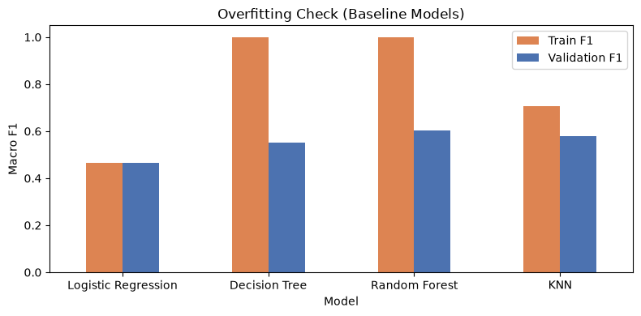
Training F1 vs validation F1 for the baseline models

6. Model 1 - Logistic Regression

How it works (simple explanation)
- It calculates a score for each class (Low, Moderate, High) by giving each feature a weight and adding them up.
- The scores are turned into probabilities with the softmax function, and the class with the highest probability is predicted.
- Because it only adds weighted features, the boundary between the classes is a straight line (linear).

Why we chose it for this problem
- It is the simplest and fastest model, so it is our baseline that the other models must beat.
- It is easy to interpret: each feature has one weight.
- It needs scaled numeric features, which Stage 4 already did with StandardScaler.

Baseline results (default settings, 5-fold CV)
Accuracy | Precision | Recall | Macro F1 | F1 std | Train F1 | High Risk Recall
0.499 | 0.489 | 0.464 | 0.466 | 0.003 | 0.467 | 0.289

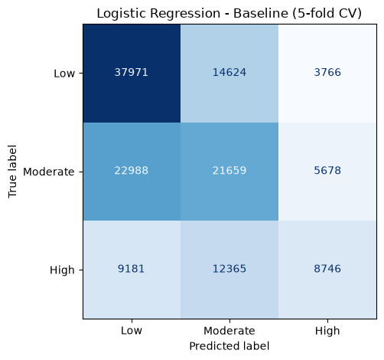
Logistic Regression baseline confusion matrix (5-fold CV on the training set)

Hyperparameter tuning (GridSearchCV)
Setting | Values tried | What it controls
C | 0.01, 0.1, 1, 10 | Regularization strength. Smaller C = simpler model; larger C fits the training data more closely
class_weight | None, balanced | "balanced" gives more weight to the smaller High Risk class

8 combinations were tried (4 x 2). Best: C = 10, class_weight = None. With class_weight = "balanced" the Macro F1 was lower (0.450) for every value of C.
 | Macro F1
Baseline | 0.466
Tuned | 0.466
Improvement | +0.000

Observations: why it performs like this
- The weakest of the four models. It finds only 29% of the real High Risk cases.
- Train F1 (0.467) and validation F1 (0.466) are equal. This is underfitting: the model is too simple, not overfitting.
- Delay risk depends on combinations of features (a certain carrier at a certain airport in a certain season). A linear model adds the effect of each feature separately and cannot learn such combinations.
- Tuning did not help. C only changes how strongly the model is regularized; it cannot turn a straight-line boundary into a curved one.

Viva questions for the Logistic Regression owner
Q: Why is Logistic Regression the weakest model?
A: It is a linear model. The relationship between carrier, airport, season and delay risk is non-linear, so a straight-line boundary cannot separate the classes well.
Q: Is it overfitting or underfitting? How do you know?
A: Underfitting. The training F1 (0.467) is almost the same as the validation F1 (0.466). An overfitting model would have a much higher training score.
Q: What does C do?
A: C controls regularization. Small C keeps the weights small (simpler model); large C lets the model fit the training data more closely. C = 10 was best, but the difference between C values was tiny.
Q: Why did tuning not improve it?
A: The problem is the model type, not the settings. No value of C can make a linear model learn non-linear patterns.
Q: Why keep it if it is the weakest?
A: It is our baseline. It shows how much the non-linear models improve over a simple model.

7. Model 2 - Decision Tree

How it works (simple explanation)
- It asks a series of yes/no questions about the features, for example "Is arr_flights > 500?" then "Is month in winter?".
- Each question splits the data into smaller groups. It chooses the question that makes the groups as "pure" (one class) as possible.
- When it reaches the end of a branch (a leaf), it predicts the most common class in that leaf.

Why we chose it for this problem
- It can learn non-linear rules and combinations of features, which Logistic Regression cannot.
- The rules are easy to explain to non-technical stakeholders.
- It does not need scaled features.

Baseline results (default settings, 5-fold CV)
Accuracy | Precision | Recall | Macro F1 | F1 std | Train F1 | High Risk Recall
0.562 | 0.551 | 0.551 | 0.551 | 0.004 | 0.999 | 0.503

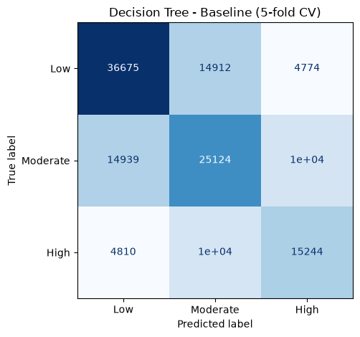
Decision Tree baseline confusion matrix (5-fold CV on the training set)

Hyperparameter tuning (GridSearchCV)
Setting | Values tried | What it controls
max_depth | 10, 15, 20, 25, 30, None | How many levels of questions the tree can ask. Limits overfitting
min_samples_leaf | 1, 20, 50 | Minimum records in a leaf. Stops rules based on only a few records

12 combinations were tried (4 x 3). Best: max_depth = 20, min_samples_leaf = 20. A very shallow tree (max_depth = 5) was much worse (0.426) because it is too simple.
 | Macro F1
Baseline | 0.551
Tuned | 0.585
Improvement | +0.034 (biggest of all models)

Observations: why it performs like this
- The baseline tree overfits badly: 0.999 on training data but only 0.551 on validation data. With no depth limit it memorises the training records.
- Tuning gave the biggest improvement of all four models (+0.034). Limiting the depth and requiring at least 20 records per leaf forces it to learn general rules.
- It beats Logistic Regression because it can learn feature combinations. The extended search also reduced the risk of selecting a value only because it was at the old grid boundary.
- It is behind Random Forest because a single tree is unstable: a small change in the data can change the whole tree.

Viva questions for the Decision Tree owner
Q: How do you know the baseline tree is overfitting?
A: Its training F1 is 0.999 but its validation F1 is only 0.551. It has memorised the training data instead of learning general rules.
Q: What do max_depth and min_samples_leaf do?
A: max_depth limits how many questions the tree can ask. min_samples_leaf means every final leaf must contain at least that many records. Both stop the tree from creating rules for very small groups.
Q: Why was max_depth = 5 so bad?
A: A tree with only 5 levels is too simple to capture the patterns (underfitting). max_depth = 20 is a balance between too simple and too complex.
Q: Why did your model improve the most from tuning?
A: Because the default tree overfits the most. Adding limits fixes this directly.
Q: Why is it worse than Random Forest?
A: One tree has high variance. Random Forest averages many trees, so the individual mistakes cancel out.

8. Model 3 - Random Forest (Final Model)

How it works (simple explanation)
- It builds many decision trees (100-200). Each tree is trained on a random sample of the records and looks at a random subset of features at each split.
- To predict, every tree votes, and the class with the most votes wins (this is called bagging / ensemble learning).
- Because each tree is slightly different, their mistakes are different too, and the vote cancels many of them out.

Why we chose it for this problem
- Like a Decision Tree, it learns non-linear rules and feature combinations.
- Averaging many trees reduces overfitting and makes it more stable than one tree.
- It gives a probability for each class, so the system can show a confidence value (planned in our proposal).
- It shows feature importance, which helps explain the model.

Baseline results (default settings, 5-fold CV)
Accuracy | Precision | Recall | Macro F1 | F1 std | Train F1 | High Risk Recall
0.616 | 0.608 | 0.599 | 0.603 | 0.003 | 0.999 | 0.522

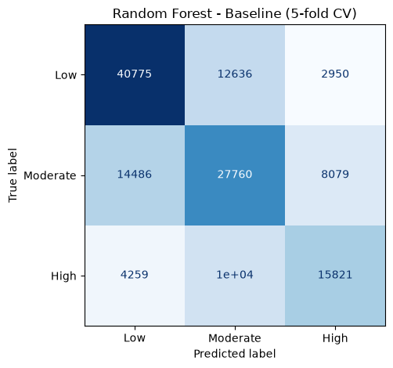
Random Forest baseline confusion matrix (5-fold CV on the training set)

Hyperparameter tuning (GridSearchCV)
Setting | Values tried | What it controls
n_estimators | 100, 200 | Number of trees. More trees = more stable vote, but slower
max_depth | 15, 25, None | Depth of each tree. Limits overfitting

6 combinations were tried (2 x 3). Best: n_estimators = 200, max_depth = 25. No depth limit (None) scored 0.604 and max_depth = 15 scored 0.603, so 25 is the balance.
 | Macro F1
Baseline | 0.603
Tuned | 0.612
Improvement | +0.010

Observations: why it performs like this
- Best model of the four, before and after tuning, and it finds the most High Risk cases (52%).
- Its training F1 is very high (0.999) because each tree grows deep, but its validation score is still the best. The averaging keeps overfitting under control.
- Tuning improved it slightly (+0.010). More trees make the vote more stable, and a depth limit of 25 stops the trees from growing too deep.
- Most mistakes are between neighbouring classes (Low/Moderate and Moderate/High). Low and High are rarely confused.

Viva questions for the Random Forest owner
Q: How is Random Forest different from a Decision Tree?
A: It trains many trees on random samples of the data and features, then takes a majority vote. This reduces variance, so it is more accurate and more stable than one tree.
Q: The training F1 is 0.999. Isn't that overfitting?
A: Each tree does fit the training data closely, but the validation and test scores (0.612 and 0.615) are still the best of all models and very close to each other. The ensemble generalises well.
Q: Why max_depth = 25 and not None?
A: With no limit the trees memorise noise (F1 0.604). With 15 they are too simple (0.603). 25 gave the best score (0.612).
Q: Why 200 trees and not more?
A: 200 was slightly better than 100 (0.612 vs 0.611). More trees give only very small gains but make the model slower and larger.
Q: Which features are most important?
A: arr_flights (traffic volume), airport_freq (airport size), year and month. Carrier columns are individually small but together they matter (see the feature selection experiment).

9. Model 4 - K-Nearest Neighbors (KNN)

How it works (simple explanation)
- To predict a record, it finds the K most similar records in the training data (the "nearest neighbours").
- Similarity is measured with distance between the feature values (Euclidean distance).
- The neighbours vote, and the most common class is predicted. With weights = "distance", closer neighbours get a bigger vote.

Why we chose it for this problem
- Similar carrier-airport-month records (same carrier, similar airport size, same season) usually have similar delay risk.
- It is a simple non-linear model with no training phase.
- It needs scaled features because it uses distance. Stage 4 already scaled them with StandardScaler.

Baseline results (default settings, 5-fold CV)
Accuracy | Precision | Recall | Macro F1 | F1 std | Train F1 | High Risk Recall
0.597 | 0.594 | 0.574 | 0.580 | 0.003 | 0.708 | 0.470

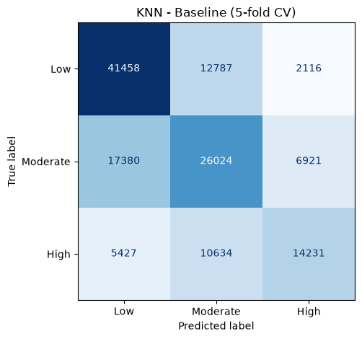
KNN baseline confusion matrix (5-fold CV on the training set)

Hyperparameter tuning (GridSearchCV)
Setting | Values tried | What it controls
n_neighbors | 5, 15, 25 | How many similar records vote. More = smoother, less affected by noise
weights | uniform, distance | "distance" gives closer neighbours a bigger vote

6 combinations were tried (3 x 2). Best: n_neighbors = 25, weights = distance. The default K = 5 was the weakest setting.
 | Macro F1
Baseline | 0.580
Tuned | 0.595
Improvement | +0.015

Observations: why it performs like this
- Second-best model. Looking at similar past records works well for this problem.
- Tuning improved it (+0.015). With only 5 neighbours a few unusual records can change the prediction. 25 neighbours give a more reliable vote.
- It is behind Random Forest because it treats every feature as equally important when measuring distance, while Random Forest learns which features matter.
- It is the slowest model (about 90 seconds for 5-fold CV, compared with about 40 for Random Forest), because every prediction compares the record with all training records.

Viva questions for the KNN owner
Q: Why must the features be scaled for KNN?
A: KNN uses distance. Without scaling, a feature with large numbers (like arr_flights) would dominate the distance and the small features would be ignored.
Q: What does K mean and why was 25 best?
A: K is the number of neighbours that vote. Small K is sensitive to noise; large K is smoother. 25 gave the best Macro F1 among 5, 15 and 25.
Q: What does weights = distance do?
A: Closer neighbours get a bigger vote than far ones, so the most similar records have the most influence.
Q: Why is KNN not the final model even though it is second?
A: Its score is lower than Random Forest, and it is slow: it must compare every new record with about 137,000 training records, which is not good for a live system.
Q: Does KNN have a training phase?
A: No. It just stores the training data. All the work happens at prediction time, which is why prediction is slow.

10. Model Comparison
Model | Accuracy | Precision | Recall | Macro F1 | Train F1 | Tuned F1 | Best settings
Random Forest | 0.616 | 0.608 | 0.599 | 0.603 | 0.999 | 0.612 | 200 trees, depth 25
KNN | 0.597 | 0.594 | 0.574 | 0.580 | 0.708 | 0.595 | K=25, distance
Decision Tree | 0.562 | 0.551 | 0.551 | 0.551 | 0.999 | 0.585 | depth 20, leaf 20
Logistic Regression | 0.499 | 0.489 | 0.464 | 0.466 | 0.467 | 0.466 | C=10
Dummy | 0.412 | 0.137 | 0.333 | 0.194 | 0.194 | - | -

Accuracy, Precision, Recall, Macro F1 and Train F1 are baseline (default settings) 5-fold CV results.
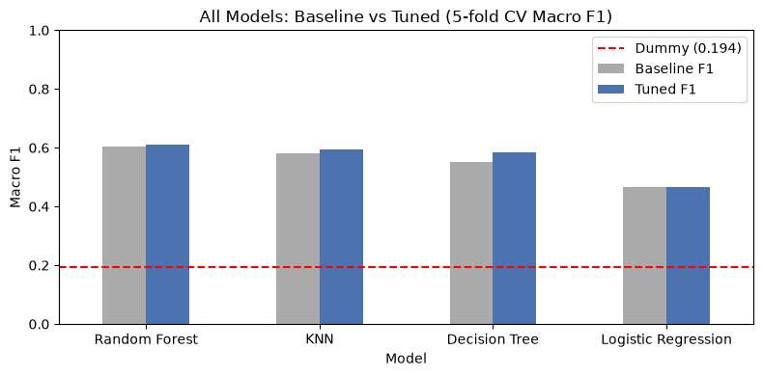
Baseline vs tuned Macro F1. The red line is the Dummy baseline.

Key findings
- All four models beat the Dummy baseline, so they learn real patterns.
- Tree-based and neighbour-based models beat Logistic Regression because delay risk is non-linear.
- Random Forest is the best before and after tuning; averaging many trees gives the most accurate and stable results.
- Decision Tree gained the most from tuning because limiting depth fixed its overfitting.
- Logistic Regression did not gain from tuning because its problem is the model type (linear), not its settings.
- All models mostly confuse neighbouring classes. Moderate Risk is the hardest because it sits between the other two.

11. Feature Selection Experiment and Final Model

11.1 Feature selection experiment
Question: does removing weak features improve the model?
- Measure feature importance with the tuned Random Forest.
- Remove every feature with importance below 0.01 (22 features).
- Run 5-fold CV again with only the 7 remaining features.
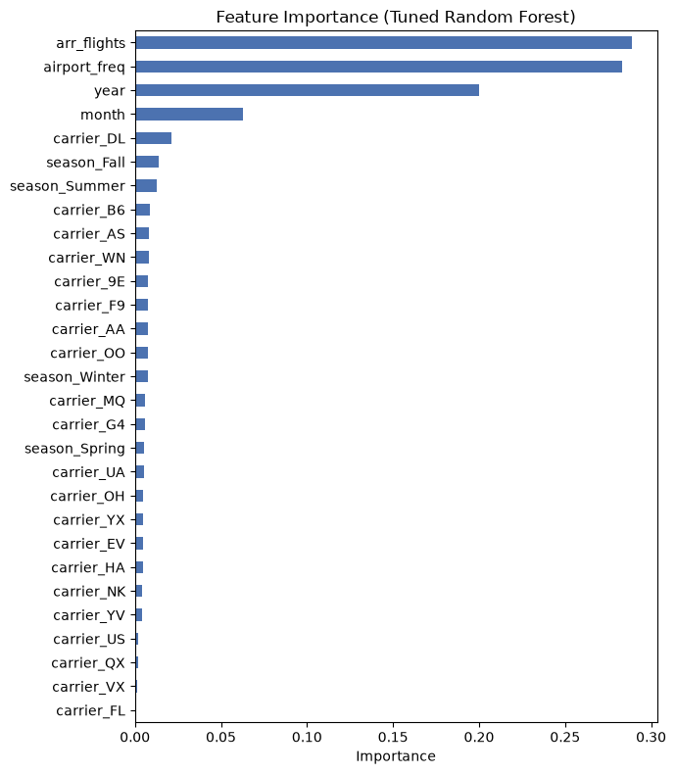
Feature importance of the tuned Random Forest
Feature set | Features | 5-fold CV Macro F1
All features | 29 | 0.612
Importance >= 0.01 only | 7 | 0.514

Result: removing features made the model worse (-0.10), so all 29 features are kept.
20 of the 22 removed features were one-hot carrier columns. Each column alone has low importance because it covers only one airline, but together they tell the model which airline it is, and the airline strongly affects delays.
Lesson: importance should be judged for the original column (carrier), not for each one-hot column separately.

11.2 Final test-set evaluation
The final Random Forest was trained on all training data and tested once on the 34,245 test records that no model had seen before.
Class | Precision | Recall | F1-score | Records
Low Risk | 0.69 | 0.74 | 0.71 | 14,091
Moderate Risk | 0.56 | 0.57 | 0.56 | 12,581
High Risk | 0.62 | 0.52 | 0.57 | 7,573
Macro average | 0.62 | 0.61 | 0.62 (0.615) | 34,245
Accuracy |  |  | 0.63 (0.629) | 34,245

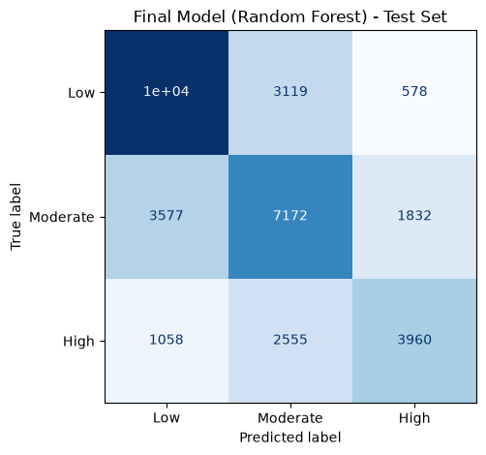
Confusion matrix of the final model on the test set
Reading the confusion matrix: 10,394 Low, 7,172 Moderate and 3,960 High records were predicted correctly. Only 578 Low records were called High and 1,058 High records were called Low; most mistakes are between neighbouring classes.

11.3 Why Random Forest is the final model
- Highest Macro F1 of all models, before and after tuning (0.612 CV).
- Generalises well: test Macro F1 (0.615) is almost the same as the CV score (0.612), so it is not overfitting.
- Finds High Risk well: High Risk precision 0.62 and recall 0.52, the best High Risk recall of the four models.
- Gives confidence values: predict_proba gives a probability per class, e.g. "High Risk - 78% confidence", as promised in our proposal.
- Fast predictions: KNN (second best) must compare each new record with about 137,000 records, which is too slow for a live system.

11.4 Limitations
- Moderate Risk is the hardest class (F1 0.56) because it lies between Low and High.
- The dataset has no weather, air-traffic control or schedule details, which limits the scores.
- The model is about 175 MB, so it is not stored on GitHub; it is recreated by running the notebooks.

12. Common Viva Questions (Everyone)
Q: Is this classification or regression?
A: Multiclass classification: three classes (Low, Moderate, High Risk).
Q: Why did you choose these four algorithms?
A: They were planned in our proposal and cover different model types: a linear baseline (Logistic Regression), a rule-based model (Decision Tree), an ensemble (Random Forest) and a distance-based model (KNN). This lets us compare simple vs complex and linear vs non-linear models.
Q: What validation strategy did you use and why?
A: Stratified 5-Fold Cross-Validation on the training set. Five runs give a more reliable score than one split, and stratification keeps the class ratio the same in every fold because the classes are imbalanced.
Q: When did you use the test set?
A: Only once, at the very end, to evaluate the final Random Forest. Using it earlier would make the final score unfair.
Q: Why Macro F1 instead of accuracy?
A: The classes are imbalanced. Macro F1 gives each class equal weight, so the smaller but most important High Risk class is not ignored.
Q: Why did you use a Dummy classifier?
A: As a minimum reference. It always predicts Low Risk and scores 0.194. All our models are far above it, which proves they learned something.
Q: What search strategy did you use for tuning?
A: GridSearchCV with 5-fold CV and Macro F1 as the score. Each model has only 2 settings with a few values, so trying every combination is fast and thorough.
Q: Which model improved the most after tuning and why?
A: Decision Tree (+0.034), because the default tree overfits and limiting max_depth and min_samples_leaf fixed that.
Q: Did feature selection help?
A: No. Removing 22 low-importance features dropped Macro F1 from 0.612 to 0.514, because the removed carrier columns together carry the airline information. So we kept all 29 features.
Q: Which features are most important?
A: arr_flights, airport_freq, year and month.
Q: Why is Random Forest your final model?
A: Random Forest has the highest tuned Macro F1 (0.612), its test Macro F1 (0.615) is close to CV, it has the highest recorded baseline High Risk recall (0.522), it can learn non-linear feature combinations, and the feature-selection experiment supports retaining all 29 features.
Q: What are the main mistakes of the model?
A: Confusing neighbouring classes, mostly Moderate with Low or High. Low and High are rarely confused.
Q: How could the model be improved?
A: Add features such as a carrier-airport's average delay rate in previous months (planned in the proposal), weather data, or try boosting models like XGBoost.
Q: How will the model be used in the system?
A: The saved model (final_model.joblib) will be loaded by the backend in Stage 9. The user enters carrier, airport, month and flight volume, and the system shows the risk category, confidence and a recommended action.
Q: What was your own contribution?
A: Explain the model you developed and tuned: why it fits the problem, the settings you tuned, your results and why it performed better or worse than the others.

Stage 8 – Progress Evaluation 2: Be ready to explain algorithm selection, Macro F1, Stratified 5-Fold CV, GridSearchCV, optimization decisions, feature-selection results, final-model selection, and your own technical contribution line by line.
Stage 7 – Remaining improvement before viva: extend the Random Forest n_estimators search beyond 200 and the KNN n_neighbors search beyond 25 because their current best values are at the search boundary. Also complete full tuned Train F1, High Risk Recall and tuned confusion-matrix evaluation for all models, and add at least one explicit with/without feature-engineering or grouped-feature experiment.
Stage 7 – Model Optimization: MOSTLY COMPLETE. GridSearchCV is used for all four models and the baseline-vs-tuned Macro F1 comparison is recorded. Decision Tree tuning was strengthened by extending max_depth to 25 and 30; the new best setting is max_depth=25, min_samples_leaf=20 (Macro F1=0.586).
Stage 6 – Model Development: COMPLETE in structure. Four suitable algorithms are implemented, Stratified 5-Fold CV with random_state=42 is used, the same folds are used for model comparison, the test set is kept for final evaluation, and multiple metrics are recorded.
12A. Stage 6-8 Requirement Status

13. Numbers to Remember
Item | Value
Training / test records | 136,978 / 34,245
Number of features | 29
Class balance | Low 41% / Moderate 37% / High 22%
Cross-validation | Stratified 5-fold, random_state = 42
Dummy Macro F1 | 0.194
Best baseline model | Random Forest, 0.603
Best tuned model | Random Forest, 0.612
Biggest tuning gain | Decision Tree, +0.034
Feature selection result | 29 features 0.612 vs 7 features 0.514 (kept all 29)
Final model settings | Random Forest, n_estimators = 200, max_depth = 25
Final test Macro F1 / Accuracy | 0.615 / 0.629
Final High Risk precision / recall | 0.62 / 0.52

14. Preparation Checklist
- Run your own model notebook on your computer and read every cell.
- Explain your model in simple words, with an example.
- Know what each tuned setting does and which value was best.
- Know your baseline, tuned and improvement numbers.
- Explain why your model is better or worse than the others.
- Read the Final_Model_Comparison notebook: everyone may be asked about the final model.
- Practise the common questions in Section 12 with another group member.
- Bring the notebooks open on your laptop to the evaluation.

