

**PSP [20ES104] COURSE PROJECT REPORT**

**On**

**“MOVIE TICKETS BOOKING”**

DevelopedBy:

H.T.NO STUDENTNAME

2203A51355 Kadidela Chanakya

Under the Guidance of

Mr. Riyaz Mohammed

Assistant Professor

Submitted to

Department Computer Science and Artificial Intelligence SR University

Ananthasagar(V), Hasanparthy(M), Hanamkonda(Dist.) – 506371

[www.sru.edu.in](http://www.sru.edu.in/)

**June 2023**

**Department of Computer Science and Artificial Intelligence**

**CERTIFICATE**

This is to certify that the PSP course project report entitled **“ Movie Ticket Booking ”** is a record of bonafide work carried out by the student(s) Kadidela Chanakya (2203A51355) of Computer Science and Artificial Intelligence department during the academic year 2022-23.

**Supervisor**

(Riyaz Mohammed)

**INDEX**

**Sl.No Title PageNo.**

1. Problemstatement 1
2. Module-wisedescription 2
3. Knowledge required to develop the project 3
4. Source code (.c file code followed by .hfile code) 4
5. Results 10

# PROBLEM STATEMENT:

The project Movie Ticket Booking Systemis based on the concept of booking movie tickets. This simple project contains limited features, but the essential one.

The functionality are as below mentioned:

1. Reading the customer details:

* Movie Name
* User Name
* Phone Number

1. Sorting the customer chosen case as:

* Book tickets
* Cancel tickets
* Change the ticket price
* Exit system

1. Theanother feature of this project is about cancelling the tickets which can be done by entering the booking id.
2. Printing the output ticket systematically.

# MODULES:

In this application all variables and structure are declared globally so that these variables and structure members can be accessed throughout the program at any function call. We can choose any function by using function calls which are declared in switch-case. In order to repeat the loop control statement (for, while) is used with condition. The memory allocation will be done in this programdynamically. The application asks the person to enter certain details such as user name, movie name, phone number.

In this application four modules are used.

1. Read/Input

In this module the application asks the person to enter the customer details such as user name, movie name, phone number etc. printf function is used to print the details entered by the user.

1. Sorting

In this module sorting of data is done according to the chosen wise.In this module there is a sub menu which asks to select the sorting wise by using switch case. The sorting sub menu will be like press 1 to sort by edit ticket price press2 to sort and view booked tickets press 3 to book tickets press 4 to sort by cancel the ticket press 5 to sort by exit the system.

In this module we used another control statement (while) so that the application asks whether to continue sorting.

1. Searching

In this module searching of data is done according to the chosen wise.

In this module there is a sub menu which asks to select the sorting wise by using switch case. The sorting sub menu will be like press 1 to search by edit ticket price press

2 to search by view the booked tickets press 3 to search by and book the tickets press 4 to search by cancel the tickets press 5 to search by exit the system.

1. Print

In this module all the stored details entered by the customer will be displayed in a systematic manner on to the screen. In this module printf function is used.

**KNOWLEDGE REQUIRED TO DEVELOP THIS APPLICATION**

* + Control Statements (if, if-else,switch)
  + Loop Statements (while/do while,for)
  + Arrays(1D/2D-arrays)
  + Strings (Strings and Table of strings) and its functions (strcpy, strcmp)
  + Functions (Any type of user definedfunctions)
  + Structure (structures and nested structures)
  + Pointers (pointer to strings and pointers tostructures)
  + Dynamic Memory Allocation (malloc/ calloc/realloc)

**SOURCE CODE [.C FILE]:**

#include<stdio.h>

#include<stdlib.h>

#include<string.h>

int changeprize(int);

void booking(int *,int,int );

int choice1(void);

void cancel(int *);

void ticket1(int choice,char name[10],int id1,int price);

void ticket2(int choice,char name[10],int id1,int price);

void ticket3(int choice,char name[10],int id1,int price);

int cmovie(void);

int movie(void);

void details(void);

struct moviedetails

{

char name[25];

char phone[15];

int seat;

int id;

};

struct moviedetailsperson[300];

int count=0;

int id1=100;

int main()

{

int **seat,choice,price=250,selection,i;

seat=(int **)calloc(101,sizeof(int *));

for (i=0;i<3;i++)

*(seat+i)=(int *)calloc(101,sizeof(int ));

int x;

while(x!=5)

{

choice=choice1();

switch(choice)

{

case 1:

price=changeprize(price);

break;

case 2:

details();

break;

case 3:

selection=movie();

booking(seat[selection-1],price,selection);

count++;

break;

case 4:

selection=cmovie();

cancel(seat[selection-1]);

break;

case 5:

x=5;

break;

default:

printf("Choice not available\n");

break;

}

}

}

int changeprize(int prize)

{

char pass[10],pak[10]="pass";

printf("Enter the admin password: ");

scanf("%s",&pass);

if (strcmp(pass,pak)==0)

{

printf("Please enter new price:");

scanf("%d",&prize);

printf("New ticket prize is %d\n",prize);

}

else

printf("The entered password is wrong!");

return prize;

}

void booking(int *array,intprice,int selection)

{

FILE *f1;

int i,j;

printf("\n SCREEN\n\n\n");

for (i=1;i<=100;i++)

{

if (array[i]==0)

printf("%d\t",i);

else

printf("\t",i);

if(i%10==0)

printf("\n\n");

}

f1=fopen("C:/1234/file1.txt","w");

printf("Please enter your name:");

while(fscanf(stdin,"%s",&person[count].name)!=EOF)

fprintf(f1,"%s",person[count].name);

printf("Which seat number you want?:");

while(fscanf(stdin,"%d",&j)!=EOF)

fprintf(f1,"%d",j);

fclose(f1);

if(j>100||j<1)

{

printf("The seat you have selected is unavailable in this theater\n");

printf("Please re-enter seat number: ");

scanf("%d",&j);

}

if(array[j]==1)

{

printf("Sorry, this ticket is already booked! Please choose another seat.\n");

scanf("%d",&j);

}

else

array[j]=1;

person[count].seat=j;

if(selection==1)

ticket1(j,person[count].name,id1,price);

else if(selection==2)

ticket2(j,person[count].name,id1,price);

else

ticket3(j,person[count].name,id1,price);

id1++;

}

int choice1(void)

{

int choice;

printf(" Simple Movie Ticket Booking System\n");

printf("======================================================\n");

printf("|| 1- To edit ticket price: ||\n");

printf("|| 2- To view booked tickets: ||\n");

printf("|| 3- To book ticket: ||\n");

printf("|| 4- To cancel ticket: ||\n");

printf("|| 5- Exit system: ||\n");

printf("||====================================================||\n");

printf("Enter your choice:");

scanf("%d",&choice);

return choice;

}

void cancel(int *array)

{

int Cseat,i,temp=0;

printf("Please enter ID number of ticket: ");

scanf("%d",&Cseat);

for(i=0;i<300;i++)

{

if(Cseat==person[i].id)

{

temp=2;

printf("%s your seat is %d cancelled\n",person[i].name,person[i].seat);

array[person[i].seat]=0;

i=300;

}

}

if(temp!=2)

printf("Ticket ID number is incorrect please enter right one to cancel ticket: \n");

}

void ticket1(int choice,char name[10],int id1,int price)

{

FILE *f1;

printf("\n\n");

printf("\n-------------------THEATER BOOKING TICKET-------------------\n");

printf("\t====================================================\n");

printf("\tBooking ID : %d \t\t\tMovie Name : Dasara\n",id1);

f1=fopen("C:/1234/file1.txt","r");

while(fscanf(f1,"%s%d",name,choice)!=EOF)

fprintf(stdout,"\tCustomer : %s\n",name);

printf("\t\t\t Date : Thu,03-06-2023\n");

printf("\t Time : 06:00pm\n");

printf("\tTelugu,2D Screen : 01\n");

fprintf(stdout,"\tAsian Sridevi Multiplex, Seat No : GOLD,%d \n",choice);

fclose(f1);

printf("\tHanumakonda Price : %d \n\n",price);

person[count].id=id1;

printf("\t==========================================================\n");

return;

}

void details(void)

{

int i;

char pass[10],pak[10]="pass";

printf("Enter the admin password to see details: ");

scanf("%s",&pass);

if(strcmp(pass,pak)==0)

{

for(i=0;i<count;i++)

{

printf("seat no: %d is booked by %s booking id is %d\n",person[i].seat,person[i].name,person[i].id);

}

}

else

printf("Entered password is wrong \n");

}

int movie(void)

{

int i;

printf("\t\t\twhich movie you want to see?\n");

printf("\t\t\t----------------------------\n\n");

printf("\t\t\tpress 1 for Dasara\n\n");

printf("\t\t\tpress 2 for Balagam\n\n");

printf("\t\t\tpress 3 for Virupaksha\n");

scanf("%d",&i);

return i;

}

void ticket2(int choice,char name[10],int id1,int price)

{

FILE *f1;

printf("\n\n");

printf("\t-------------------THEATER BOOKING TICKET-------------------\n");

printf("\t=========================================================\n");

printf("\tBooking ID : %d \t\t\tMovie Name : Balagam\n",id1);

f1=fopen("C:/1234/file1.txt","r");

while(fscanf(f1,"%s%d",name,choice)!=EOF)

fprintf(stdout,"\tCustomer : %s\n",name);

printf("\t\t\t Date : Thu,04-05-2023\n");

printf("\t Time : 06:00pm\n");

printf("\tTelugu,2D Screen : 02\n");

fprintf(stdout,"\tAsian Sridevi Multiplex, Seat No : GOLD,%d \n",choice);

fclose(f1);

printf("\tHanumakonda Price : %d \n\n",price);

person[count].id=id1;

printf("\t==========================================================\n");

return;

}

int cmovie(void)

{

int i;

printf("\t\t\twhich movie ticket you want to cancel\n");

printf("\t\t\t-------------------------------------\n");

printf("\t\t\tpress 1 DASARA\n\n");

printf("\t\t\tpress 2 BALAGAM\n\n");

printf("\t\t\tpress 3 VIRUPAKSHA\n");

scanf("%d",&i);

return i;

}

void ticket3(int choice,char name[10],int id1,int price)

{

FILE *f1;

printf("\n\n");

printf("\t-------------------THEATER BOOKING TICKET-------------------\n");

printf("\t============================================================\n");

printf("\tBooking ID : %d \t\t\tMovie Name : Virupaksha \n",id1);

f1=fopen("C:/1234/file1.txt","r");

while(fscanf(f1,"%s%d",name,choice)!=EOF)

fprintf(stdout,"\tCustomer : %s\n",name);

printf("\t\t\t Date : Thu,04-05-2023\n");

printf("\t Time : 06:00pm\n");

printf("\tTelugu,2D Screen : 03\n");

fprintf(stdout,"\tAsian Sridevi Multiplex, Seat No : GOLD,%d \n",choice);

fclose(f1);

printf("\tHanumakonda Price : %d \n\n",price);

person[count].id=id1;

printf("\t=======================================================\n");

return;

}

**RESULTS:**

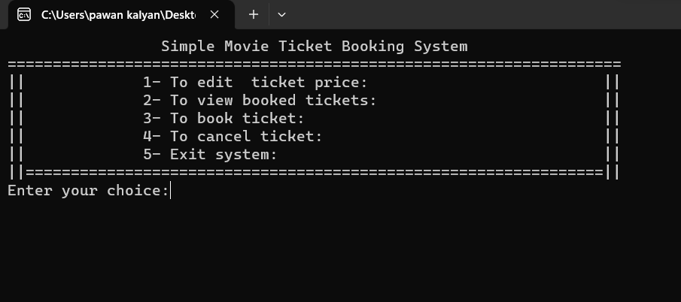

After entering the choice as 3:

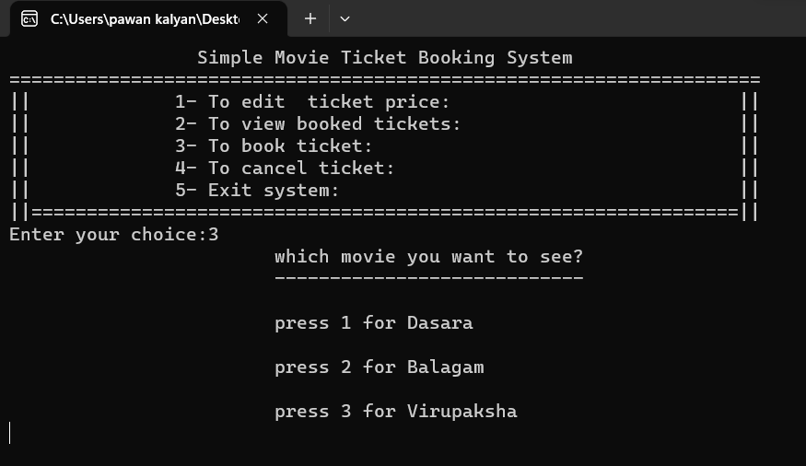

The output ticket is printed as:

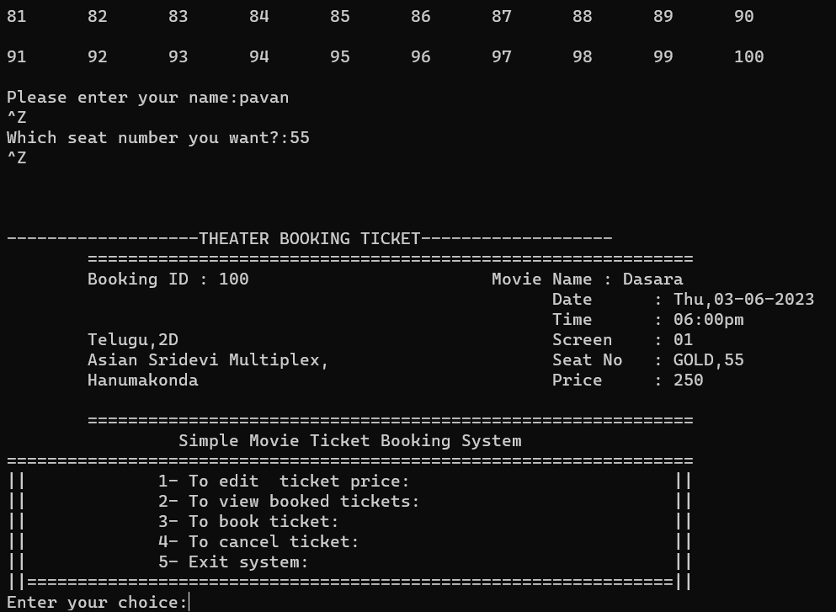

After entering the choice as 1:

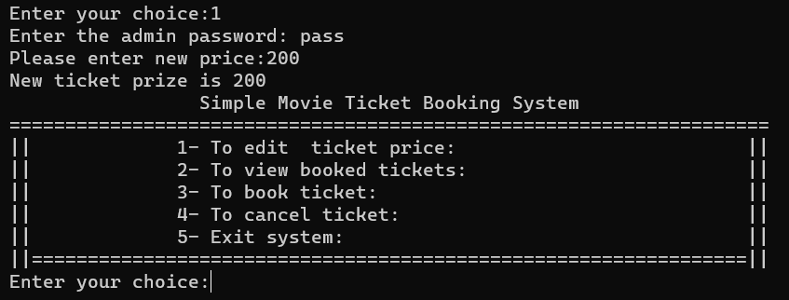

After entering the choice as 2:

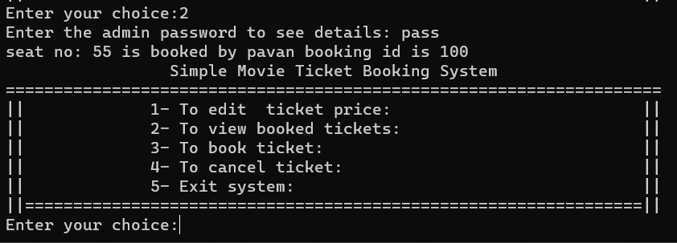

After entering the choice as 4:

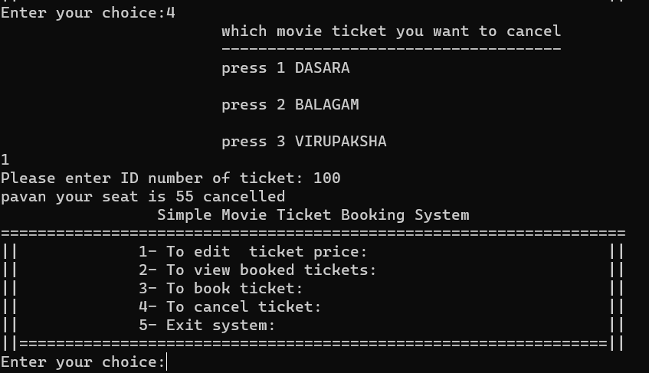

After entering the choice as 5 it exits :

