1
Title template
This chapter covers
- Normal text (bulleted)
- Normal text (bulleted)
- Normal text (bulleted)
Introductory text for the chapter (Normal text)

1.1 Head 1

1.1.1 Head 2

HEAD 3 (heading 3)

Listing 1.1 (heading 4) .
code <property name="src" location="src"/> #A (normal 7pt roboto mono)
(normal 7pt roboto mono)
#A Code annotations (normal 7pt Arial)
Normal text
Normal text
Normal text
code <property name="src" location="src"/> #A (normal 7pt roboto mono)
(normal 7pt roboto mono)
#A Code annotations (normal 7pt Arial)
Normal text
Normal text
code <property name="src" location="src"/> #A (normal 7pt roboto mono)

Table 1.X (heading 5)
table head title (normal 7pt red)
table text (normal 7pt)
Normal text

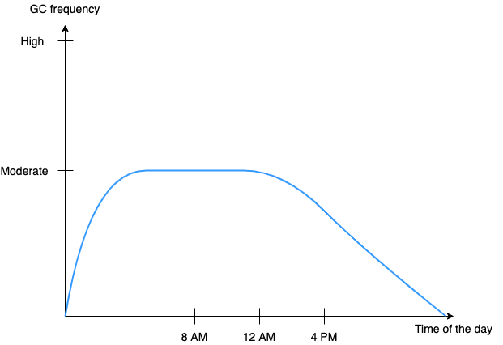

Figure 1.X Captions (heading 6) images should be .pngs.

Sidebar head (heading 3) .
Sidebar (normal)
Callouts callout text callout text callout text callout text callout text callout text callout text callout text callout text callout text callout text callout text callout text
Paragraph text text /.code in text/ text 𝑯
This is equation
text /Bold/ text /.Italics/ text text /. Bold Italics/ text text text text /._{Subscript}/ text text text / .^{Superscript}/ text text /.Underline/ /.Underline Bold/ /.Underline Italic/
Formula a ∗ b + a ∗ c = a ∗ (b + c)
$Equation Xy$ (Insert>Eqaution)
Equation X.Y
$Q = X * Wq$
$\frac{(a+b)}{c}$
𝑄 = 𝑋 * 𝑊𝑞
Equation 2.1
Normal text

AI Prompt Begin [blank line] (heading 3) (background color light gray 1)
Prompt text goes here.
Code lines in prompts can be a maximum of 72 characters (including spaces).
AI Prompt End [blank line]
NOTE Use normal code styles for code and normal text styles for text.

AI Response Begin [Add name of AI tool and version] (heading 3) (background color light gray 1)
Response text goes here.
Code lines in responses can be a maximum of 72 characters (including spaces).
AI Response End [blank line]
NOTE When typeset, each prompt will begin with a small icon with your initials. Responses will begin with the icon associated with the AI tool used.

CALLOUT Callout text.

Summary
- Bullets

Footnote (normal)

