|  |  |
| --- | --- |
| **Project: New Haven Urgent Care Team# 28** | |
|  | **Test Date: 12/12/19** |
| **Test Case ID#: 1** | **Name(s) of Tester(s): Dan Belair** |
| **Test Description (What are you testing? – you must be specific):**  Yes, all patients need to have a guardian. It’s a foreign key constraint. Even adults cannot be created without a guardian. |  |
|  |  |

**NOTE: The following information must be provided to be given credit for any test.**

**Test Data (Provide the file name of the script used to insert data, provide a screen capture to reflect data, or provide script here):**

INSERT INTO C4707F19U28.Patient VALUES (22, 'ed', 'M', 'Jones', 12/19/1983, "6122555131", 'Dad', '6123245235', '821', 'Oak St', 'Minneapolis', 'MN', '55414'); //this did not work “foreign key constraint fails”

insert into C4707F19U28.Guardian values('dode', 'tommy',22);

INSERT INTO C4707F19U28.Patient VALUES (22, 'ed', 'M', 'Jones', 12/19/1983, "6122555131", 'Dad', '6123245235', '821', 'Oak St', 'Minneapolis', 'MN', '55414');

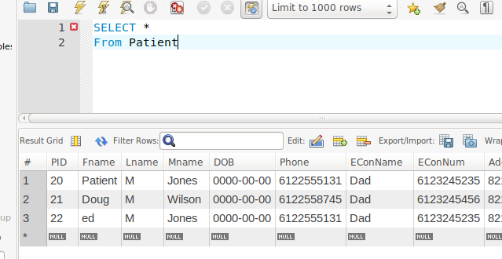

**SQL Query(s) used for testing:**

select *

from Patient

#ed was added

|  |  |
| --- | --- |
| **Project: New Haven Urgent Care Team#28** | |
|  | **Test Date: 12/12/19** |
| **Test Case ID#: 2** | **Name(s) of Tester(s): Dan Belair** |
| **Test Description (What are you testing? – you must be specific):**  No As stated in test case 1  All patients need to have a guardian. It’s a foreign key constraint. Even adults cannot be created without a guardian |  |
|  |  |

**NOTE: The following information must be provided to be given credit for any test.**

**Test Data (Provide the file name of the script used to insert data, provide a screen capture to reflect data, or provide script here):**

INSERT INTO C4707F19U28.Patient VALUES (22, 'ed', 'M', 'Jones', 12/19/1983, "6122555131", 'Dad', '6123245235', '821', 'Oak St', 'Minneapolis', 'MN', '55414'); //this did not work “foreign key constraint fails”

insert into C4707F19U28.Guardian values('dode', 'tommy',22);

INSERT INTO C4707F19U28.Patient VALUES (22, 'ed', 'M', 'Jones', 12/19/1983, "6122555131", 'Dad', '6123245235', '821', 'Oak St', 'Minneapolis', 'MN', '55414');

**SQL Query(s) used for testing:**

select *

from Patient

|  |  |
| --- | --- |
| **Project: New Haven Urgent Care Team#28** | |
|  | **Test Date:** |
| **Test Case ID#: 3** | **Name(s) of Tester(s): Dan Belair** |
| **Test Description (What are you testing? – you must be specific):** New payment method created without insurance referencing it via foreign key.  Query of payment method will display insurance as empty |  |
|  |  |

**NOTE: The following information must be provided to be given credit for any test.**

**Test Data (Provide the file name of the script used to insert data, provide a screen capture to reflect data, or provide script here):**

**SQL Query(s) used for testing:**

INSERT INTO C4707F19U28.PaymentMethod VALUES (101, 4, 20);

Select *

from PaymentMethod

|  |  |
| --- | --- |
| **Project: New Haven Urgent Care Team#28** | |
|  | **Test Date: 12/12/19** |
| **Test Case ID#: 4** | **Name(s) of Tester(s): Dan Belair** |
| **Test Description (What are you testing? – you must be specific):** Patients has one insurance saved in Payment methods  Add another insurance. |  |
|  |  |

**NOTE: The following information must be provided to be given credit for any test.**

**Test Data (Provide the file name of the script used to insert data, provide a screen capture to reflect data, or provide script here):**

INSERT INTO C4707F19U28.Insurance VALUES (70, 100, 11/10/2018, 11/10/2019);

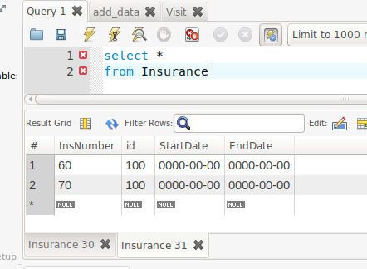

**SQL Query(s) used for testing:**

**#add second insurance**

select *

from Insurance

#note that our date format was entered incorrectly

|  |  |
| --- | --- |
| **Project: New Haven Urgent Care Team#28** | |
|  | **Test Date: 12/12/19** |
| **Test Case ID#: 5** | **Name(s) of Tester(s): Brandon Chan** |
| **Test Description (What are you testing? – you must be specific):**  SEE TEST 6 DOCX. |  |
|  |  |

**NOTE: The following information must be provided to be given credit for any test.**

**Test Data (Provide the file name of the script used to insert data, provide a screen capture to reflect data, or provide script here):**

**SQL Query(s) used for testing:**

TEST5.SQL

|  |  |
| --- | --- |
| **Project: New Haven Urgent Care Team#28** | |
|  | **Test Date: 12/12/19** |
| **Test Case ID#: 6** | **Name(s) of Tester(s): Brandon Chan** |
| **Test Description (What are you testing? – you must be specific):**  **SEE TEST6.DOCX** |  |
|  |  |

**NOTE: The following information must be provided to be given credit for any test.**

**Test Data (Provide the file name of the script used to insert data, provide a screen capture to reflect data, or provide script here):**

**SEE TEST6.DOCX**

[**test6scripts.sql**](https://github.umn.edu/umn-csci-4707-f19/repo-Team28/blob/master/project/Task3/Tests/test6scripts.sql)

|  |  |
| --- | --- |
| **Project: New Haven Urgent Care Team#28** | |
|  | **Test Date: 12/12/19** |
| **Test Case ID#: 7** | **Name(s) of Tester(s): Brandon Chan** |
| **Test Description (What are you testing? – you must be specific):**  **SEE TEST 7 DOCX** |  |
|  |  |

**NOTE: The following information must be provided to be given credit for any test.**

**Test Data (Provide the file name of the script used to insert data, provide a screen capture to reflect data, or provide script here):**

**SQL Query(s) used for testing:**

[**test7scripts.sql**](https://github.umn.edu/umn-csci-4707-f19/repo-Team28/blob/master/project/Task3/Tests/test7scripts.sql)

|  |  |
| --- | --- |
| **Project: New Haven Urgent Care Team#28** | |
|  | **Test Date: 12/12/19** |
| **Test Case ID#: 8** | **Name(s) of Tester(s): Brandon Chan** |
| **Test Description (What are you testing? – you must be specific):**  **SEE TEST 8 DOCX** |  |
|  |  |

**NOTE: The following information must be provided to be given credit for any test.**

**Test Data (Provide the file name of the script used to insert data, provide a screen capture to reflect data, or provide script here):**

**SQL Query(s) used for testing:**

[**test8scripts.sql**](https://github.umn.edu/umn-csci-4707-f19/repo-Team28/blob/master/project/Task3/Tests/test8scripts.sql)

|  |  |
| --- | --- |
| **Project: New Haven Urgent Care Team#28** | |
|  | **Test Date: 12/12/19** |
| **Test Case ID#: 9** | **Name(s) of Tester(s): Brandon Chan** |
| **Test Description (What are you testing? – you must be specific):**  **SEE TEST 9 DOCS** |  |
|  |  |

**NOTE: The following information must be provided to be given credit for any test.**

**Test Data (Provide the file name of the script used to insert data, provide a screen capture to reflect data, or provide script here):**

**SQL Query(s) used for testing:**

|  |  |
| --- | --- |
| **Project: New Haven Urgent Care Team#28** | |
|  | **Test Date: 12/12/19** |
| **Test Case ID#: 10** | **Name(s) of Tester(s): Brandon Chan** |
| **Test Description (What are you testing? – you must be specific):**  SEE TEST 10 DOCX |  |
|  |  |

**NOTE: The following information must be provided to be given credit for any test.**

**Test Data (Provide the file name of the script used to insert data, provide a screen capture to reflect data, or provide script here):**

**SQL Query(s) used for testing:**

[**test10scripts.sql**](https://github.umn.edu/umn-csci-4707-f19/repo-Team28/blob/master/project/Task3/Tests/test10scripts.sql)

|  |  |
| --- | --- |
| **Project: New Haven Urgent Care Team#28** | |
|  | **Test Date: 12/12/19** |
| **Test Case ID#: 11** | **Name(s) of Tester(s): Dan Belair** |
| **Test Description (What are you testing? – you must be specific):**  Testing to see if patient can have multiple visits |  |
|  |  |

**NOTE: The following information must be provided to be given credit for any test.**

**Test Data (Provide the file name of the script used to insert data, provide a screen capture to reflect data, or provide script here):**

**#Create second visit for our patient**

INSERT INTO C4707F19U28.Visit VALUES ('10AM', '1PM', 107, 20, 123);

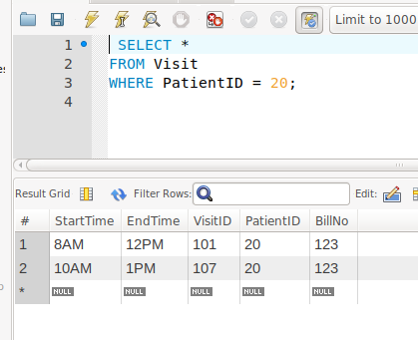

**SQL Query(s) used for testing:**

SELECT *

FROM Visit

WHERE PatientID = 20;

|  |  |
| --- | --- |
| **Project: New Haven Urgent Care Team#28** | |
|  | **Test Date: 12/12/19** |
| **Test Case ID#: 12** | **Name(s) of Tester(s): Dan Belair** |
| **Test Description (What are you testing? – you must be specific):** |  |
|  |  |

**NOTE: The following information must be provided to be given credit for any test.**

**Test Data (Provide the file name of the script used to insert data, provide a screen capture to reflect data, or provide script here):**

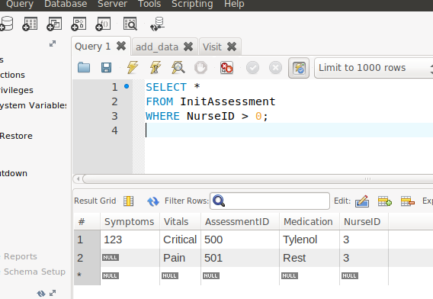

**SQL Query(s) used for testing:**

SELECT *

FROM InitAssessment

WHERE NurseID > 0;

|  |  |
| --- | --- |
| **Project: New Haven Urgent Care Team#28** | |
|  | **Test Date: 12/12/19** |
| **Test Case ID#: 13** | **Name(s) of Tester(s): Dan Belair** |
| **Test Description (What are you testing? – you must be specific):** |  |
|  |  |

**NOTE: The following information must be provided to be given credit for any test.**

**Test Data (Provide the file name of the script used to insert data, provide a screen capture to reflect data, or provide script here):**

INSERT INTO C4707F19U28.Guardian VALUES ('pops', 'Guy', 21);

INSERT INTO C4707F19U28.Patient VALUES (21, 'Doug', 'M', 'Wilson', 12/19/1985, "6122558745", 'Dad', '6123245456', '821', '8th St', 'Minneapolis', 'MN', '55408');

INSERT INTO C4707F19U28.Visit VALUES ('9AM', '12PM', 102, 21, null);

INSERT INTO C4707F19U28.InitAssessment VALUES (null, 'Pain', 501, 'Rest', 3);

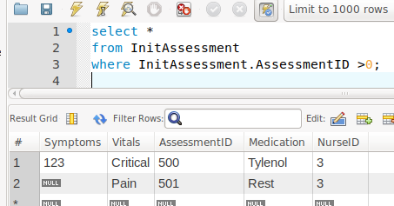

**SQL Query(s) used for testing:**

select *

from InitAssessment

where InitAssessment.AssessmentID >0;

|  |  |
| --- | --- |
| **Project: New Haven Urgent Care Team#28** | |
|  | **Test Date: 12/12/19** |
| **Test Case ID#: 14** | **Name(s) of Tester(s): Dan Belair** |
| **Test Description (What are you testing? – you must be specific):** Test to see if you can add a multiple nurses to initial assessments. |  |
|  |  |

**NOTE: The following information must be provided to be given credit for any test.**

**Test Data (Provide the file name of the script used to insert data, provide a screen capture to reflect data, or provide script here):**

#create employee

INSERT INTO C4707F19U28.Employee VALUES (7, 123456791, 'Thomas', 'Poe', 'tam', 'Salary', 49559, 3);

#create nurse

INSERT INTO C4707F19U28.Nurse VALUES (7);

#add nurse to assessment

#This won’t work. initial assessment is unique and holds one nurseID.

**#ERROR Code:1062 Duplicate Entry**

**SQL Query(s) used for testing:**

**N/A**

|  |  |
| --- | --- |
| **Project: New Haven Urgent Care Team#28** | |
|  | **Test Date: 12/12/19** |
| **Test Case ID#: 15** | **Name(s) of Tester(s):** |
| **Test Description (What are you testing? – you must be specific):** |  |
|  |  |

**NOTE: The following information must be provided to be given credit for any test.**

**Test Data (Provide the file name of the script used to insert data, provide a screen capture to reflect data, or provide script here):**

**SQL Query(s) used for testing:**

|  |  |
| --- | --- |
| **Project: New Haven Urgent Care Team#28** | |
|  | **Test Date: 12/12/19** |
| **Test Case ID#: 16** | **Name(s) of Tester(s): Dan Belair** |
| **Test Description (What are you testing? – you must be specific):** First select all employees, then select employees of salary OR hourly. Compare the two. Both results will need to appear the same. |  |
|  |  |

**NOTE: The following information must be provided to be given credit for any test.**

**Test Data (Provide the file name of the script used to insert data, provide a screen capture to reflect data, or provide script here):**

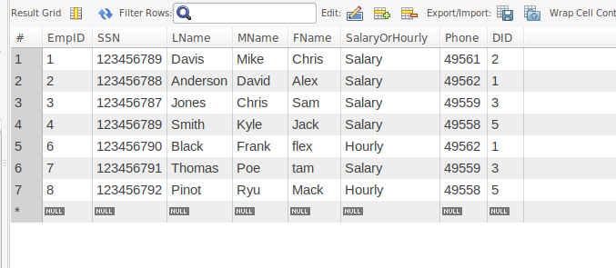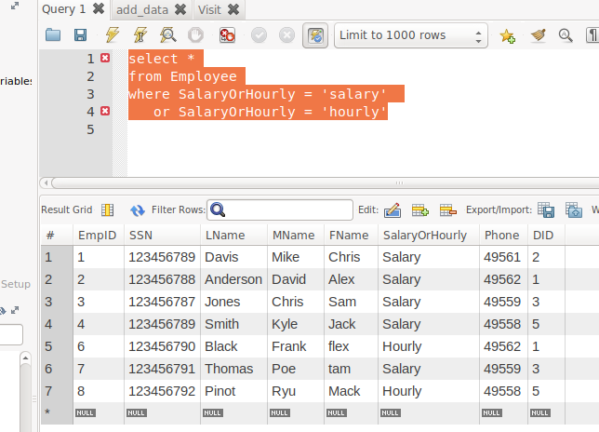

**SQL Query(s) used for testing:**

select *

from Employee

select *

from Employee

where SalaryOrHourly = 'salary'

or SalaryOrHourly = 'hourly'

|  |  |
| --- | --- |
| **Project: New Haven Urgent Care Team#28** | |
|  | **Test Date: 12/12/19** |
| **Test Case ID#: 17** | **Name(s) of Tester(s):** |
| **Test Description (What are you testing? – you must be specific):** |  |
|  |  |

**NOTE: The following information must be provided to be given credit for any test.**

**Test Data (Provide the file name of the script used to insert data, provide a screen capture to reflect data, or provide script here):**

**SQL Query(s) used for testing:**

|  |  |
| --- | --- |
| **Project: New Haven Urgent Care Team#28** | |
|  | **Test Date: 12/12/19** |
| **Test Case ID#: 17** | **Name(s) of Tester(s):** |
| **Test Description (What are you testing? – you must be specific):** |  |
|  |  |

**NOTE: The following information must be provided to be given credit for any test.**

**Test Data (Provide the file name of the script used to insert data, provide a screen capture to reflect data, or provide script here):**

**SQL Query(s) used for testing:**

|  |  |
| --- | --- |
| **Project: New Haven Urgent Care Team#28** | |
|  | **Test Date: 12/12/19** |
| **Test Case ID#: 18** | **Name(s) of Tester(s):** |
| **Test Description (What are you testing? – you must be specific):** |  |
|  |  |

**NOTE: The following information must be provided to be given credit for any test.**

**Test Data (Provide the file name of the script used to insert data, provide a screen capture to reflect data, or provide script here):**

**SQL Query(s) used for testing:**

|  |  |
| --- | --- |
| **Project: New Haven Urgent Care Team#28** | |
|  | **Test Date: 12/12/19** |
| **Test Case ID#: 19** | **Name(s) of Tester(s):** |
| **Test Description (What are you testing? – you must be specific):** |  |
|  |  |

**NOTE: The following information must be provided to be given credit for any test.**

**Test Data (Provide the file name of the script used to insert data, provide a screen capture to reflect data, or provide script here):**

**SQL Query(s) used for testing:**

|  |  |
| --- | --- |
| **Project: New Haven Urgent Care Team#28** | |
|  | **Test Date: 12/12/19** |
| **Test Case ID#: 20** | **Name(s) of Tester(s):** |
| **Test Description (What are you testing? – you must be specific):** |  |
|  |  |

**NOTE: The following information must be provided to be given credit for any test.**

**Test Data (Provide the file name of the script used to insert data, provide a screen capture to reflect data, or provide script here):**

**SQL Query(s) used for testing:**