**Lab 7&8 – Configuring Routing Protocols**

**Final Grade 10%**

**Build the network with the following specifications using packet tracer as shown in diagram below:**

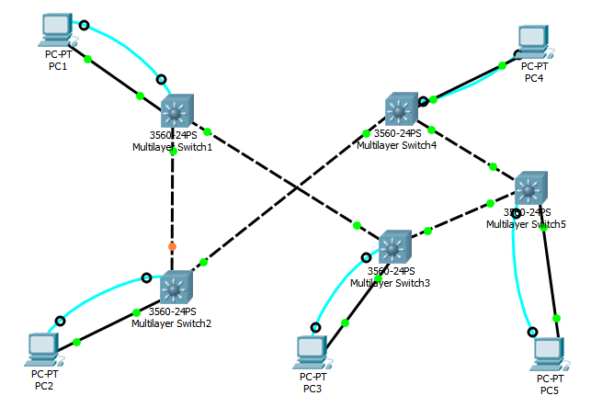

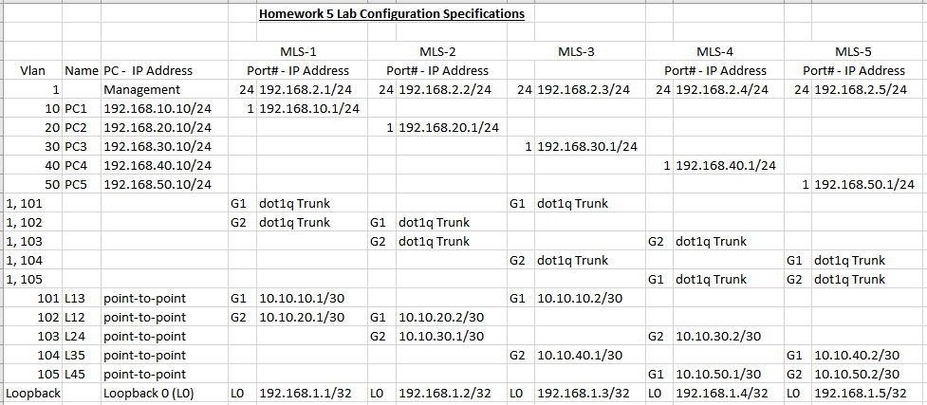

**We will use the network you created for Homework 5 to learn all routing protocols in this Lab 7-8 by making 6 additional copies of your .pkt file as follows:**

1. **HW5-original**
2. **HW5-static**
3. **HW5-Degault Route**
4. **HW5-rip**
5. **HW5-ospf**
6. **HW5-ospf2 (with two independent networks)**

**Next make 2 additional copies of HW5-ospf2 as follows:**

1. **HW5-ospf2-default route**
2. **HW5-ospf2-bgp**

**Next we will reconfigure the network as follows:**

1. **Network 1 – MLS-1 & MLS-2 with OSPF 100**
2. **Network 2 – MLS-3, MLS-4 & MLS-5 with OSPF 200**
3. **Network 1 MLS-1 G1 port connects to – Network 2 MLS3 G1 port**
4. **Optional: Network 1 MLS-2 G2 port connects to – Network 2 MLS4 G2 port**

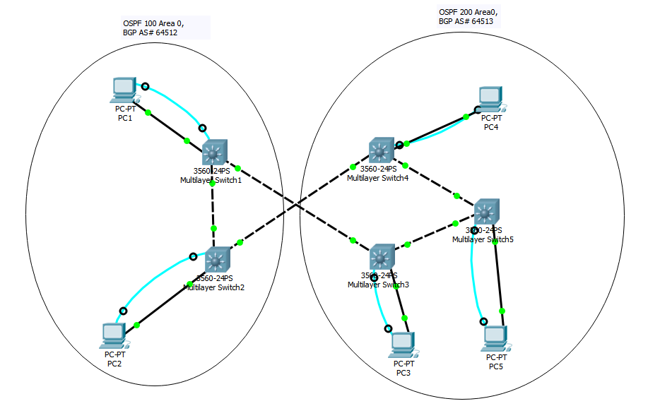

**This creates two independent networks. Next we will verify that hosts in network 1 cannot communicate with hosts in network 2. We will assume that these are two independent networks that need to be connected together. We will accomplish this as follows:**

1. **Default Route (Static)**
2. **BGP Routing with AS# 64512 & 64513 respectively as shown.**

**We will use each of these files to create and learn the following:**

1. **Static Routing**
2. **RIP Routing**
3. **OSPF Routing**
4. **Default Routing**
5. **BGP Routing**

**Configuration Item Examples and Functionality:**

1. **HW5-original functionality:**
   1. **Ping form PCn to MLSn should work fine.**
   2. **Ping from MLSn to all MLS should work on vlan 1**
   3. **Telnet from PCn to MLSn loopback should work fine.**
   4. **Check out the routing table to understand functionality.**
2. **HW5-static Configuration:**

! For hostname MLS-1

!

ip route 192.168.20.0 255.255.255.0 10.10.20.2

ip route 192.168.30.0 255.255.255.0 10.10.10.2

ip route 192.168.40.0 255.255.255.0 10.10.20.2

ip route 192.168.50.0 255.255.255.0 10.10.10.2

!

! Repeat for hostname MLS2, MLS3, MLS4, MLS5 with correct destination IP Address.

**HW5-static Functionality:**

* 1. **Ping form PCn to PC# should work fine.**
  2. **Ping from MLS# to all MLS should work on vlan 1**
  3. **Telnet from PCn to MLSn loopback should work fine.**
  4. **Check out the routing table to understand functionality.**

1. **HW5-Default Route Configuration:**

! For hostname MLS-1

!

ip route 0.0.0.0 0.0.0.0 10.10.10.2

!

! Repeat for hostname MLS3, MLS5, MLS4, MLS2 with correct destination IP Address.

**HW5-Default Route Functionality:**

1. **All Pings should work fine after routing table is fully populated.**
2. **Check out the routing table to understand functionality.**

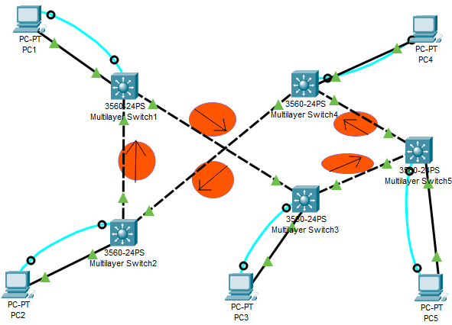

1. **HW5-rip Configuration:**

! For hostname MLS-1

!

router rip

version 2

network 10.0.0.0

network 192.168.1.0

network 192.168.10.0

!

! Repeat for hostname MLS2, MLS3, MLS4, MLS5 with correct networks.

**HW5-RIP Functionality:**

* + 1. **All Pings should work fine.**

1. **HW5-ospf Configuration:**

OSPF uses Reverse Netmask (replace 1 bits with 0 & 0 with 1) …

So 255.255.255.252 becomes 0.0.0.3

255.255.255.255 becomes 0.0.0.0

255.255.255.0 becomes 0.0.0.255

! For hostname MLS-1

!

router ospf 200

network 10.10.10.0 0.0.0.3 area 0

network 10.10.20.0 0.0.0.3 area 0

network 192.168.1.1 0.0.0.0 area 0

network 192.168.10.0 0.0.0.255 area 0

!

! Repeat for hostname MLS2, MLS3, MLS4, MLS5 with correct networks and reverse netmask.

HW5-OSPF Functionality:

* 1. All Pings should work fine.

1. **HW5-ospf2 Configuration: (with two independent networks)**
2. Network 1 – MLS-1 & MLS-2 with OSPF 100
3. Network 2 – MLS-3, MLS-4 & MLS-5 with OSPF 200
4. Network 1 MLS-1 G1 port connects to – Network 2 MLS3 G1 port
5. Optional: Network 1 MLS-2 G2 port connects to – Network 2 MLS4 G2 port

! For hostname MLS-1

!

router ospf 100

~~network 10.10.10.0 0.0.0.3 area 0 (Primary Link)~~

network 10.10.20.0 0.0.0.3 area 0

network 192.168.1.1 0.0.0.0 area 0

network 192.168.10.0 0.0.0.255 area 0

!

! Repeat for hostname MLS2, MLS3, MLS4, MLS5 with correct ospf#(100or200),networks and reverse netmask.

This creates two independent networks. Next we will verify that hosts in network 1 cannot communicate with hosts in network 2. We will assume that these are two independent networks that need to be connected together. We will accomplish this as follows:

1. Default Route (Static)
2. BGP Routing with AS# 64512 & 64513 respectively as shown.

HW5-ospf2 Functionality:

* 1. All Pings should work fine for Network 1
  2. All Pings should work fine for Network 2
  3. Pings should not work between Network 1 & 2.

Next make 2 additional copies of HW5-ospf2 as follows:

1. HW5-ospf2-default route Configuration:

hostname MLS-1

!

ip route 0.0.0.0 0.0.0.0 10.10.10.2 100

!

router ospf 100

default-information originate

hostname MLS-3

!

ip route 0.0.0.0 0.0.0.0 10.10.10.1 100

!

router ospf 200

default-information originate

HW5-ospf2-default route Functionality:

* 1. **All Pings should work fine.**
  2. **Redundancy can be added as follows:**

**Network 1 MLS-2 G2 port connects to – Network 2 MLS4 G2 port**

**c. For both default & BGP options**

1. HW5-ospf2-bgp Configuration:

hostname MLS-1

!

router bgp 64512

neighbor 10.10.10.2 remote-as 64513

redistribute ospf 100

**!**

hostname MLS-3

!

router bgp 64513

neighbor 10.10.10.1 remote-as 64512

redistribute ospf 200

!

Explain this in class

On MLS1 include:

!

router ospf 100

redistribute bgp 64512 subnets

!

On MLS3 include:

!

router ospf 200

redistribute bgp 64513 subnets

!

HW5-ospf2-bgp Funcationality:

1. **All Pings should work fine.**
2. **Redundancy can be added as follows:**

**Network 1 MLS-2 G2 port connects to – Network 2 MLS4 G2 port**

**c. For both default & BGP options**

**Please submit the following for grading:**

1. **configuration items for each of the five routers MLS1-5 and all routing protocols Static, Default, RIP, OSPF, OSPF-2, Default and OSPF-2 BGP (not the entire configuration file), similar to the worksheet in the class. Also include show vlan from all MLS1-5**

**Config Items - Static**

MLS-1

ip route 192.168.20.0 255.255.255.0 10.10.20.2

ip route 192.168.30.0 255.255.255.0 10.10.10.2

ip route 192.168.40.0 255.255.255.0 10.10.20.2

ip route 192.168.50.0 255.255.255.0 10.10.10.2

MLS-2

ip route 192.168.40.0 255.255.255.0 10.10.30.2

ip route 192.168.50.0 255.255.255.0 10.10.30.2

ip route 192.168.30.0 255.255.255.0 10.10.30.2

ip route 192.168.10.0 255.255.255.0 10.10.20.1

MLS-3

ip route 192.168.20.0 255.255.255.0 10.10.10.1

ip route 192.168.40.0 255.255.255.0 10.10.40.2

ip route 192.168.10.0 255.255.255.0 10.10.10.1

ip route 192.168.50.0 255.255.255.0 10.10.40.2

MLS-4

ip route 192.168.50.0 255.255.255.0 10.10.50.2

ip route 192.168.10.0 255.255.255.0 10.10.30.1

ip route 192.168.20.0 255.255.255.0 10.10.30.1

ip route 192.168.30.0 255.255.255.0 10.10.50.2

MLS-5

ip route 192.168.10.0 255.255.255.0 10.10.40.1

ip route 192.168.20.0 255.255.255.0 10.10.50.1

ip route 192.168.30.0 255.255.255.0 10.10.40.1

ip route 192.168.40.0 255.255.255.0 10.10.50.1

**Config Items – Default Routing**

MLS-1

ip route 0.0.0.0 0.0.0.0 10.10.10.2

MLS-2

ip route 0.0.0.0 0.0.0.0 10.10.20.1

MLS-3

ip route 0.0.0.0 0.0.0.0 10.10.40.2

MLS-4

ip route 0.0.0.0 0.0.0.0 10.10.30.1

MLS-5

ip route 0.0.0.0 0.0.0.0 10.10.50.1

**Config Items – RIP**

MLS-1

router rip

version 2

network 10.0.0.0

network 192.168.1.0

network 192.168.10.0

MLS-2

router rip

version 2

network 10.0.0.0

network 192.168.1.0

network 192.168.20.0

MLS-3

router rip

version 2

network 10.0.0.0

network 192.168.1.0

network 192.168.30.0

MLS-4

router rip

version 2

network 10.0.0.0

network 192.168.1.0

network 192.168.40.0

MLS-5

router rip

version 2

network 10.0.0.0

network 192.168.1.0

network 192.168.50.0

**Config Items – OSPF**

MLS-1

router ospf 200

log-adjacency-changes

network 10.10.10.0 0.0.0.3 area 0

network 10.10.20.0 0.0.0.3 area 0

network 192.168.1.1 0.0.0.0 area 0

network 192.168.10.0 0.0.0.255 area 0

MLS-2

router ospf 200

log-adjacency-changes

network 10.10.20.0 0.0.0.3 area 0

network 10.10.30.0 0.0.0.3 area 0

network 192.168.20.0 0.0.0.255 area 0

network 192.168.1.2 0.0.0.0 area 0

MLS-3

router ospf 200

log-adjacency-changes

network 10.10.10.0 0.0.0.3 area 0

network 10.10.40.0 0.0.0.3 area 0

network 192.168.30.0 0.0.0.255 area 0

network 192.168.1.3 0.0.0.0 area 0

MLS-4

router ospf 200

log-adjacency-changes

network 10.10.30.0 0.0.0.3 area 0

network 10.10.50.0 0.0.0.3 area 0

network 192.168.40.0 0.0.0.255 area 0

network 192.168.1.4 0.0.0.0 area 0

MLS-5

router ospf 200

log-adjacency-changes

network 10.10.40.0 0.0.0.3 area 0

network 10.10.50.0 0.0.0.3 area 0

network 192.168.50.0 0.0.0.255 area 0

network 192.168.1.5 0.0.0.0 area 0

**Config Items – OSPF2**

MLS-1

router ospf 100

log-adjacency-changes

network 10.10.20.0 0.0.0.3 area 0

network 192.168.10.0 0.0.0.255 area 0

network 192.168.1.1 0.0.0.0 area 0

MLS-2

router ospf 100

log-adjacency-changes

network 10.10.20.0 0.0.0.3 area 0

network 192.168.1.2 0.0.0.0 area 0

network 192.168.20.0 0.0.0.255 area 0

MLS-3

router ospf 200

log-adjacency-changes

network 10.10.40.0 0.0.0.3 area 0

network 192.168.1.3 0.0.0.0 area 0

network 192.168.30.0 0.0.0.255 area 0

MLS-4

router ospf 200

log-adjacency-changes

network 10.10.50.0 0.0.0.3 area 0

network 192.168.1.4 0.0.0.0 area 0

network 192.168.40.0 0.0.0.255 area 0

MLS-5

router ospf 200

log-adjacency-changes

network 10.10.50.0 0.0.0.3 area 0

network 10.10.40.0 0.0.0.3 area 0

network 192.168.1.5 0.0.0.0 area 0

network 192.168.50.0 0.0.0.255 area 0

**Config Items – OSPF2 Default Route**

MLS-1

router ospf 100

log-adjacency-changes

network 10.10.20.0 0.0.0.3 area 0

network 192.168.10.0 0.0.0.255 area 0

network 192.168.1.1 0.0.0.0 area 0

default-information originate

!

ip route 0.0.0.0 0.0.0.0 10.10.10.2 100

MLS-2

router ospf 100

log-adjacency-changes

network 192.168.20.0 0.0.0.255 area 0

network 192.168.1.2 0.0.0.0 area 0

network 10.10.20.0 0.0.0.3 area 0

MLS-3

router ospf 200

log-adjacency-changes

network 10.10.40.0 0.0.0.3 area 0

network 192.168.30.0 0.0.0.255 area 0

network 192.168.1.3 0.0.0.0 area 0

default-information originate

!

ip route 0.0.0.0 0.0.0.0 10.10.10.1 100

MLS-4

router ospf 200

log-adjacency-changes

network 10.10.50.0 0.0.0.3 area 0

network 192.168.40.0 0.0.0.255 area 0

network 192.168.1.4 0.0.0.0 area 0

MLS-5

router ospf 200

log-adjacency-changes

network 10.10.50.0 0.0.0.3 area 0

network 192.168.50.0 0.0.0.255 area 0

network 192.168.1.5 0.0.0.0 area 0

network 10.10.40.0 0.0.0.3 area 0

**Config Items – OSPF2 BGP**

MLS-1

router ospf 100

log-adjacency-changes

redistribute bgp 64512 subnets

network 10.10.20.0 0.0.0.3 area 0

network 192.168.10.0 0.0.0.255 area 0

network 192.168.1.1 0.0.0.0 area 0

!

router bgp 64512

bgp log-neighbor-changes

no synchronization

neighbor 10.10.10.2 remote-as 64513

redistribute ospf 100

!

MLS-2

router ospf 100

log-adjacency-changes

network 192.168.20.0 0.0.0.255 area 0

network 192.168.1.2 0.0.0.0 area 0

network 10.10.20.0 0.0.0.3 area 0

MLS-3

router ospf 200

log-adjacency-changes

redistribute bgp 64513 subnets

network 10.10.40.0 0.0.0.3 area 0

network 192.168.30.0 0.0.0.255 area 0

network 192.168.1.3 0.0.0.0 area 0

!

router bgp 64513

bgp log-neighbor-changes

no synchronization

neighbor 10.10.10.1 remote-as 64512

redistribute ospf 200

MLS-4

router ospf 200

log-adjacency-changes

network 10.10.50.0 0.0.0.3 area 0

network 192.168.40.0 0.0.0.255 area 0

network 192.168.1.4 0.0.0.0 area 0

MLS-5

router ospf 200

log-adjacency-changes

network 10.10.50.0 0.0.0.3 area 0

network 192.168.50.0 0.0.0.255 area 0

network 192.168.1.5 0.0.0.0 area 0

network 10.10.40.0 0.0.0.3 area 0

**Show VLAN**

MLS-1

MLS-2

MLS-3

MLS-4

MLS-5

1. **show ip route for MLS1 for Static, RIP and OSPF Routing**

**Static**

Gateway of last resort is not set

10.0.0.0/30 is subnetted, 2 subnets

C 10.10.10.0 is directly connected, Vlan101

C 10.10.20.0 is directly connected, Vlan102

192.168.1.0/32 is subnetted, 1 subnets

C 192.168.1.1 is directly connected, Loopback0

C 192.168.2.0/24 is directly connected, Vlan1

C 192.168.10.0/24 is directly connected, Vlan10

S 192.168.20.0/24 [1/0] via 10.10.20.2

S 192.168.30.0/24 [1/0] via 10.10.10.2

S 192.168.40.0/24 [1/0] via 10.10.20.2

S 192.168.50.0/24 [1/0] via 10.10.10.2

**RIP**

Gateway of last resort is not set

10.0.0.0/30 is subnetted, 5 subnets

C 10.10.10.0 is directly connected, Vlan101

C 10.10.20.0 is directly connected, Vlan102

R 10.10.30.0 [120/1] via 10.10.20.2, 00:00:28, Vlan102

R 10.10.40.0 [120/1] via 10.10.10.2, 00:00:29, Vlan101

R 10.10.50.0 [120/2] via 10.10.20.2, 00:00:28, Vlan102

[120/2] via 10.10.10.2, 00:00:29, Vlan101

192.168.1.0/24 is variably subnetted, 2 subnets, 2 masks

R 192.168.1.0/24 [120/2] via 10.10.10.2, 00:00:03, Vlan101

C 192.168.1.1/32 is directly connected, Loopback0

C 192.168.2.0/24 is directly connected, Vlan1

C 192.168.10.0/24 is directly connected, Vlan10

R 192.168.20.0/24 [120/1] via 10.10.20.2, 00:00:28, Vlan102

R 192.168.30.0/24 [120/1] via 10.10.10.2, 00:00:29, Vlan101

R 192.168.40.0/24 [120/2] via 10.10.20.2, 00:00:28, Vlan102

R 192.168.50.0/24 [120/2] via 10.10.10.2, 00:00:29, Vlan101

**OSPF**

Gateway of last resort is not set

10.0.0.0/30 is subnetted, 5 subnets

C 10.10.10.0 is directly connected, Vlan101

C 10.10.20.0 is directly connected, Vlan102

O 10.10.30.0 [110/2] via 10.10.20.2, 00:00:34, Vlan102

O 10.10.40.0 [110/2] via 10.10.10.2, 00:00:24, Vlan101

O 10.10.50.0 [110/3] via 10.10.10.2, 00:00:24, Vlan101

[110/3] via 10.10.20.2, 00:00:24, Vlan102

192.168.1.0/32 is subnetted, 5 subnets

C 192.168.1.1 is directly connected, Loopback0

O 192.168.1.2 [110/2] via 10.10.20.2, 00:00:34, Vlan102

O 192.168.1.3 [110/2] via 10.10.10.2, 00:00:34, Vlan101

O 192.168.1.4 [110/3] via 10.10.20.2, 00:00:34, Vlan102

O 192.168.1.5 [110/3] via 10.10.10.2, 00:00:24, Vlan101

C 192.168.2.0/24 is directly connected, Vlan1

C 192.168.10.0/24 is directly connected, Vlan10

O 192.168.20.0/24 [110/2] via 10.10.20.2, 00:00:34, Vlan102

O 192.168.30.0/24 [110/2] via 10.10.10.2, 00:00:34, Vlan101

O 192.168.40.0/24 [110/3] via 10.10.20.2, 00:00:34, Vlan102

O 192.168.50.0/24 [110/3] via 10.10.10.2, 00:00:24, Vlan101

1. **show ip route for MLS1 & MLS3 for OSPF-2 Default**

MLS-1

Gateway of last resort is 10.10.10.2 to network 0.0.0.0

10.0.0.0/30 is subnetted, 2 subnets

C 10.10.10.0 is directly connected, Vlan101

C 10.10.20.0 is directly connected, Vlan102

192.168.1.0/32 is subnetted, 2 subnets

C 192.168.1.1 is directly connected, Loopback0

O 192.168.1.2 [110/2] via 10.10.20.2, 00:02:56, Vlan102

C 192.168.2.0/24 is directly connected, Vlan1

C 192.168.10.0/24 is directly connected, Vlan10

O 192.168.20.0/24 [110/2] via 10.10.20.2, 00:02:56, Vlan102

S* 0.0.0.0/0 [100/0] via 10.10.10.2

MLS-3

Gateway of last resort is 10.10.10.1 to network 0.0.0.0

10.0.0.0/30 is subnetted, 3 subnets

C 10.10.10.0 is directly connected, Vlan101

C 10.10.40.0 is directly connected, Vlan104

O 10.10.50.0 [110/2] via 10.10.40.2, 00:03:49, Vlan104

192.168.1.0/32 is subnetted, 3 subnets

C 192.168.1.3 is directly connected, Loopback0

O 192.168.1.4 [110/3] via 10.10.40.2, 00:03:39, Vlan104

O 192.168.1.5 [110/2] via 10.10.40.2, 00:03:49, Vlan104

C 192.168.2.0/24 is directly connected, Vlan1

C 192.168.30.0/24 is directly connected, Vlan30

O 192.168.40.0/24 [110/3] via 10.10.40.2, 00:03:39, Vlan104

O 192.168.50.0/24 [110/2] via 10.10.40.2, 00:03:49, Vlan104

S* 0.0.0.0/0 [100/0] via 10.10.10.1

1. **show ip route for MLS1, MLS2 & MLS3 for OSPF-2 BGP**

**MLS-1**

Gateway of last resort is not set

10.0.0.0/30 is subnetted, 4 subnets

C 10.10.10.0 is directly connected, Vlan101

C 10.10.20.0 is directly connected, Vlan102

B 10.10.40.0 [20/1] via 10.10.10.2, 00:00:00

B 10.10.50.0 [20/2] via 10.10.10.2, 00:00:00

192.168.1.0/32 is subnetted, 5 subnets

C 192.168.1.1 is directly connected, Loopback0

O 192.168.1.2 [110/2] via 10.10.20.2, 00:00:18, Vlan102

B 192.168.1.3 [20/20] via 10.10.10.2, 00:00:00

B 192.168.1.4 [20/3] via 10.10.10.2, 00:00:00

B 192.168.1.5 [20/2] via 10.10.10.2, 00:00:00

C 192.168.2.0/24 is directly connected, Vlan1

C 192.168.10.0/24 is directly connected, Vlan10

O 192.168.20.0/24 [110/2] via 10.10.20.2, 00:00:18, Vlan102

B 192.168.30.0/24 [20/1] via 10.10.10.2, 00:00:00

B 192.168.40.0/24 [20/3] via 10.10.10.2, 00:00:00

B 192.168.50.0/24 [20/2] via 10.10.10.2, 00:00:00

**MLS-2**

Gateway of last resort is not set

10.0.0.0/30 is subnetted, 4 subnets

C 10.10.20.0 is directly connected, Vlan102

C 10.10.30.0 is directly connected, Vlan103

O E2 10.10.40.0 [110/20] via 10.10.20.1, 00:01:23, Vlan102

O E2 10.10.50.0 [110/20] via 10.10.20.1, 00:01:23, Vlan102

192.168.1.0/32 is subnetted, 5 subnets

O 192.168.1.1 [110/2] via 10.10.20.1, 00:01:38, Vlan102

C 192.168.1.2 is directly connected, Loopback0

O E2 192.168.1.3 [110/20] via 10.10.20.1, 00:01:23, Vlan102

O E2 192.168.1.4 [110/20] via 10.10.20.1, 00:01:23, Vlan102

O E2 192.168.1.5 [110/20] via 10.10.20.1, 00:01:23, Vlan102

C 192.168.2.0/24 is directly connected, Vlan1

O 192.168.10.0/24 [110/2] via 10.10.20.1, 00:01:38, Vlan102

C 192.168.20.0/24 is directly connected, Vlan20

O E2 192.168.30.0/24 [110/20] via 10.10.20.1, 00:01:23, Vlan102

O E2 192.168.40.0/24 [110/20] via 10.10.20.1, 00:01:23, Vlan102

O E2 192.168.50.0/24 [110/20] via 10.10.20.1, 00:01:23, Vlan102

**MLS-3**

Gateway of last resort is not set

10.0.0.0/30 is subnetted, 4 subnets

C 10.10.10.0 is directly connected, Vlan101

B 10.10.20.0 [20/20] via 10.10.10.1, 00:00:00

C 10.10.40.0 is directly connected, Vlan104

O 10.10.50.0 [110/2] via 10.10.40.2, 00:03:15, Vlan104

192.168.1.0/32 is subnetted, 5 subnets

B 192.168.1.1 [20/20] via 10.10.10.1, 00:00:00

B 192.168.1.2 [20/2] via 10.10.10.1, 00:00:00

C 192.168.1.3 is directly connected, Loopback0

O 192.168.1.4 [110/3] via 10.10.40.2, 00:03:15, Vlan104

O 192.168.1.5 [110/2] via 10.10.40.2, 00:03:15, Vlan104

C 192.168.2.0/24 is directly connected, Vlan1

B 192.168.10.0/24 [20/20] via 10.10.10.1, 00:00:00

B 192.168.20.0/24 [20/2] via 10.10.10.1, 00:00:00

C 192.168.30.0/24 is directly connected, Vlan30

O 192.168.40.0/24 [110/3] via 10.10.40.2, 00:03:15, Vlan104

O 192.168.50.0/24 [110/2] via 10.10.40.2, 00:03:15, Vlan104

1. **Tabulate Ping results as shown below and submit it for grading.**

|  |  |  |  |  |
| --- | --- | --- | --- | --- |
| **Test from MLS-1** | **Original** | **Static** | **RIP** | **OSPF** |
|  |  |  |  |  |
| 192.168.2.1 | **Pass** | **Pass** | **Pass** | **Pass** |
| 192.168.2.2 | **Pass** | **Pass** | **Pass** | **Pass** |
| 192.168.2.3 | **Pass** | **Pass** | **Pass** | **Pass** |
| 192.168.2.4 | **Pass** | **Pass** | **Pass** | **Pass** |
| 192.168.2.5 | **Pass** | **Pass** | **Pass** | **Pass** |
| 192.168.1.1 | **Pass** | **Pass** | **Pass** | **Pass** |
| 192.168.1.2 | **Fail** | **Fail** | **Pass** | **Pass** |
| 192.168.1.3 | **Fail** | **Fail** | **Pass** | **Pass** |
| 192.168.1.4 | **Fail** | **Fail** | **Pass** | **Pass** |
| 192.168.1.5 | **Fail** | **Fail** | **Pass** | **Pass** |
| 192.168.10.10 | **Pass** | **Pass** | **Pass** | **Pass** |
| 192.168.20.10 | **Fail** | **Pass** | **Pass** | **Pass** |
| 192.168.30.10 | **Fail** | **Pass** | **Pass** | **Pass** |
| 192.168.40.10 | **Fail** | **Fail** | **Pass** | **Pass** |
| 192.168.50.10 | **Fail** | **Fail** | **Pass** | **Pass** |

|  |  |  |  |  |  |  |
| --- | --- | --- | --- | --- | --- | --- |
| **Test** | **OSPF2 from MLS-2** | **OSPF2**  **from**  **MLS-5** | **OSPF2**  **Default from MLS-2** | **OSPF2**  **Default**  **from MLS-5** | **OSPF2**  **BGP**  **From MLS-2** | **OSPF2**  **BGP**  **from MLS-5** |
|  |  |  |  |  |  |  |
| 192.168.1.1 | **Pass** | **Fail** | **Pass** | **Pass** | **Pass** | **Pass** |
| 192.168.1.2 | **Pass** | **Fail** | **Pass** | **Pass** | **Pass** | **Pass** |
| 192.168.1.3 | **Fail** | **Pass** | **Pass** | **Pass** | **Pass** | **Pass** |
| 192.168.1.4 | **Fail** | **Pass** | **Pass** | **Pass** | **Pass** | **Pass** |
| 192.168.1.5 | **Fail** | **Pass** | **Pass** | **Pass** | **Pass** | **Pass** |
| 192.168.10.10 | **Pass** | **Fail** | **Pass** | **Pass** | **Pass** | **Pass** |
| 192.168.20.10 | **Pass** | **Fail** | **Pass** | **Pass** | **Pass** | **Pass** |
| 192.168.30.10 | **Fail** | **Pass** | **Pass** | **Pass** | **Pass** | **Pass** |
| 192.168.40.10 | **Fail** | **Pass** | **Pass** | **Pass** | **Pass** | **Pass** |
| 192.168.50.10 | **Fail** | **Pass** | **Pass** | **Pass** | **Pass** | **Pass** |

**Please note that the grading for Homeworks and Labs require that you configure correct vlans on the switch and trunk based on the design. Configuring access vlans or configuring all vlans on trunk is a very bad idea. I have seen many networks destroyed by this bad practice. I want to make sure that you do not learn to do that. You will not get full credit for work if you use this bad practice for homeworks and Labs.**