
VI- Semester BCA Internship Report on

“FULL STACK DEVELOPMENT”
Submitted by

CHANCHAL MALVIYA

U03AI23S0025

Under the Guidance of
Mrs. Jewell Debnath
Assistant professor
Department of Computer Applications – BCA

Acharya Bangalore B-School

Andrahalli Main Road, Off Magadi Road,

Bengaluru - 560091, Karnataka, India

CERTIFICATE

This is to certify that the “Internship report” submitted by Chanchal Malviya (Regd. No. U03AI23S0025) during 2023 – 2026 academic year, in partial fulfilment of the requirements for the award of the degree of BACHELOR OF COMPUTER APPLICATIONS, at Sandhut India Private Limited, Bangalore.

Mrs. Jewell Debnath Mr.Praveen Kumar V
Assistant professor, BCA Head of the Department ,BCA
Department Internship Coordinator

CERTIFICATE
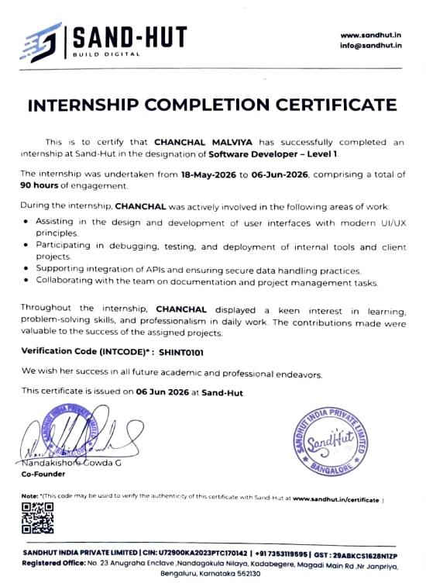

ACKNOWLEDGEMENT

Firstly, I would like to thank Mr.Nandakishore Gowda the Founder of Sandhut India Private Limited for giving me the opportunity to do an internship within the organization.

I also would like to thank the people that worked along with me at Sandhut India Private Limited with their patience and openness as they created an enjoyable working environment.

It is indeed with a great sense of pleasure and immense sense of gratitude that I acknowledge the help of these individuals.

I would like to thank my Principal Dr.Rajesh C for the facilities provided to accomplish this internship.

I would like to thank my Head of the Department Mr.Praveen Kumar V for his constructive criticism throughout my internship.

I would like to thank Mrs.Jewel Debnath, college and Department of BCA internship coordinator for their support and advices to get and complete internship in above said organization.

I am extremely great full to my department staff members and friends who helped me in successful completion of this internship.

Chanchal Malviya,
U03AI23S0025

Paste Log Sheet
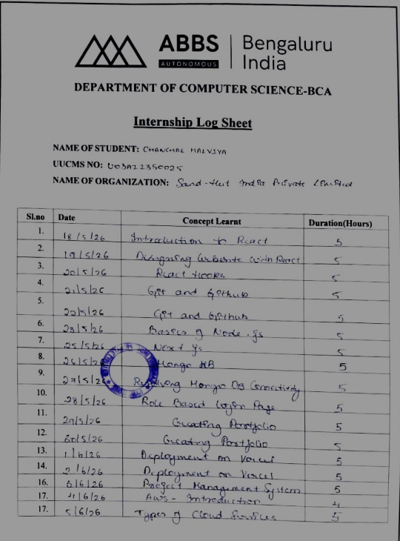

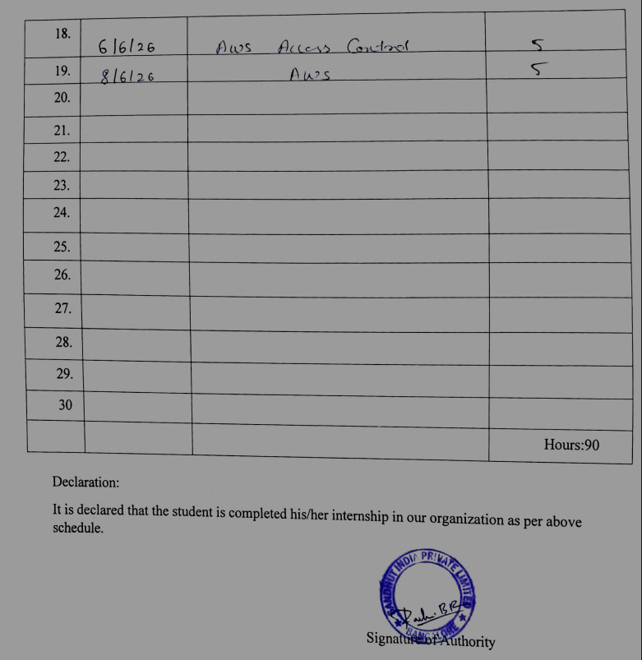

INDEX

Sl.No | CHAPTERS / CONTENTS | PAGE  NO.
1. | CHAPTER 1: INTRODUCTION | 10-14
1.1 | Introduction | 10
1.2 | Objectives | 10
1.3 | Goals | 11
1.4 | Motivation | 12
2. | CHAPTER 2: ORGANIZATION PROFILE | 15
2.1 | Company Information | 15
2.3 | Head Office Details | 15
3. | CHAPTER 3: ROLES AND RESPONSIBILITIES  OF THE INTERNSHIP | 16-23
3.1 | Introduction | 16
3.2 | Training Attended | 16
3.3 | Delegated Responsibilities | 18
3.4 | Environment of Work | 20
4. | CHAPTER 4: INTERNSHIP OUTCOMES | 24-31
4.1 | Problems and Solutions | 24
4.2 | Outcomes of Learning | 26
4.3 | Challenges Faced | 28
5. | CHAPTER 5: FUTURE SCOPES | 32-35
5.1 | Future Scopes | 32
 | Conclusion | 35

ABSTRACT
The report highlights the overall efforts that went into the internship program involving full-stack development in connection with web architecture, using modern techniques based on the MERN stack (MongoDB, Express.js, React, Node.js). The main output that was delivered through this process involved the design, development, and deployment of a project management system portal. Front-end development involved the creation of dynamic applications, built using frameworks such as React (React Hooks), and further accelerated using the Next.js approach. The back-end approach heavily involved the use of Node.js to handle the business logic and develop efficient server routing architectures. MongoDB database was used for persistence of information involving dynamic and non-relational document indexing. Production workflow was an integral part of the internship life cycle with Sand-Hut India Private Limited,
involving the development of secure and role-based authentication mechanisms, dynamic portfolio creation, and continuous delivery of processes onto Vercel using cloud services, as well as the introduction to server architecture with AWS.

Chapter 1: INTRODUCTION

1.Introduction
In today's digital era, full-stack development has become one of the most valuable skill sets in the software industry. A full-stack developer works across every layer of a web application the front-end interface that users interact with, the back-end logic that processes requests, and the database that stores information.
During my internship at Sandhut India Private Limited, I got the opportunity to work on real-world full-stack development projects using modern JavaScript technologies. The internship began with React.js, covering component-based UI design and React Hooks for managing state. This was followed by training in Git and GitHub for version control.
I then moved on to back-end development with Node.js and Next.js, and learned MongoDB for database management, including resolving real connectivity issues. Using these skills, I worked on practical projects — a Role-Based Login Page, a personal portfolio website deployed on Vercel, and a Project Management System.
Towards the end of the internship, I was introduced to cloud computing through AWS, learning about different types of cloud services and AWS Access Control (IAM).
The main goal of this internship was to bridge the gap between theoretical knowledge and practical application. By working on live projects, I gained hands-on experience with the complete development process — from coding and debugging to deployment.
This report documents the concepts I learned, the responsibilities I handled, the challenges I faced, and the outcomes of my internship at Sandhut India Private Limited.

1.1.Objectives

- The primary objective of this internship was
- To obtain practical experience in front-end and back-end web application development (full stack) using the React.js, Next.js, Node.js, and MongoDB frameworks and to gain experience implementing source code version control using Git/GitHub within a professional development setting.
- To develop real-world applications including a professional portfolio, a role-based login system and a software/hardware project management system.
- To develop knowledge and ability to implement cloud-based deployment techniques using Vercell and develop a fundamental understanding of Amazon Web Services (AWS) cloud services.
- To enhance my problem-solving skills around real world problems such as MongoDB connectivity and role based access control issues.
- To utilize standard professional software development practices including code modularity, responsive design and secure authentication.
- To develop a comprehensive understanding of front-end and back-end application interface development by using React/Next.js interfaces with Node.js APIs and MongoDB.
- To gain an understanding of some basic cloud security concepts using AWS Identity and Access Management (IAM), including principles of least privilege.
- To develop a good ability to manage my time to complete work and prioritize tasks as I learn new technology and complete project work.
- To experience working in a team-based, professional software development environment and experience the process of creating software.

1.2 Goals

The main goal of this internship was to gain practical experience in modern web development technologies and understand how real-world web applications are designed, developed, and deployed. It provided me with an opportunity to apply the theoretical knowledge gained during my academic studies to practical projects and industry-level practices.
The specific goals of this internship were as follows:

1. To Build a Strong Foundation in MERN Stack Development
One of the major goals of this internship was to understand the MERN Stack, which consists of React.js, Node.js, and MongoDB. Through practical learning, I gained knowledge of how frontend, backend, and database technologies work together to develop efficient and dynamic web applications.
2. To Enhance Frontend Development Skills
The internship aimed to improve my ability to design interactive, responsive, and user-friendly websites using React.js. I learned concepts such as components, React Hooks, and creating modern user interfaces that provide a better user experience.
3. To Learn Professional Code Management Practices
A significant goal was to understand the importance of version control using Git and GitHub. This helped me learn how developers manage source code, track modifications, and collaborate effectively while working on software projects.
4. To Understand Database Operations and Application Connectivity
The internship provided practical exposure to MongoDB, including managing data and connecting databases with web applications. This helped me understand how information is stored, retrieved, and handled efficiently in real-world applications.
5. To Understand Authentication and User Access Management
Another important goal was to learn how secure authentication systems are developed. I gained knowledge about login systems and role-based access control, where users receive access to features based on their roles and permissions.
6. To Gain Knowledge of Application Deployment
The internship provided hands-on experience in deploying web applications using platforms like Vercel. This helped me understand the complete process of taking a project from the development stage to a live production environment.
7. To Explore Cloud Computing Technologies
A key goal of the internship was to gain an introduction to cloud computing and Amazon Web Services (AWS). I learned about cloud service models, AWS access management, and the role of cloud platforms in modern software development.
8. To Develop Problem-Solving and Professional Skills
The internship helped me strengthen my debugging, analytical thinking, and problem-solving abilities. It also improved my professional skills, including communication, teamwork, time management, and adapting to a workplace environment.

1.3 Motivation

The motivation behind choosing this internship was my interest in understanding how modern websites and applications are developed and used in real-world situations. While my academic studies provided me with theoretical knowledge of computer applications, I wanted to gain practical experience by working with current industry technologies and tools.

This internship at Sandhut Media Private Limited gave me an excellent opportunity to explore MERN Stack development, including React.js, Node.js, MongoDB, and other essential technologies used in the software industry. I was motivated to improve my programming skills, understand the complete development process, and gain exposure to how professional web applications are designed, built, and deployed.

I also wanted to develop technical skills such as creating responsive user interfaces, managing databases, using Git and GitHub for version control, deploying applications using Vercel, and gaining basic knowledge of cloud technologies like AWS. Learning these technologies through practical tasks helped me improve my confidence and problem-solving abilities.
Another important motivation was to experience a professional work environment, interact with mentors, and understand the importance of teamwork, communication, discipline, and time management in a software development career.
Overall, this internship was a valuable learning experience that helped me connect my academic knowledge with practical implementation. It strengthened my interest in full-stack development and motivated me to continuously improve my skills for future opportunities in the IT industry.

CHAPTER 2
ENTERPRISE OF THE INTERNSHIP

2.1 Company information
​
COMPANY PROFILE SAND-HUT INDIA PRIVATE LIMITED 

2.1.1 Overview of the Organization Sand-Hut is a forward-thinking technology company committed to driving innovation by integrating advanced hardware and software solutions. With a mission to transform how businesses operate, Sand-Hut focuses on delivering cutting-edge, sustainable, and highperformance technological products and services that address real-world challenges across industries.
At the heart of Sand-Hut is a multidisciplinary team of experts, including hardware engineers, software developers, UX/UI designers, and project managers, who work collaboratively to deliver holistic and scalable solutions. The organization fosters a culture of creativity, precision, and continuous improvement, ensuring that each product not only meets but exceeds industry standards.
Rooted in a strong commitment to excellence and sustainability, Sand-Hut continues to push the boundaries of possibility, empowering businesses with the tools they need to innovate, grow, and succeed in an increasingly digital world.

2.2 Domain Description

Sand-Hut Workspace is a digital platform designed to facilitate efficient collaboration, project management, and communication among individuals and teams, particularly in remote or hybrid work environments. The platform provides an integrated suite of tools that support task tracking, file sharing, real-time messaging, and workflow organization, enabling users to manage projects and collaborate seamlessly from any location.
The core domain of Sand-Hut Workspace lies in workplace productivity and collaboration technology, with a focus on creating a centralized environment for managing workspaces, users, and shared resources. It serves diverse industries such as software development, marketing, education, and enterprise operations by streamlining team coordination and enhancing productivity through digital means.

2.2.1 Smart Schoolify

Sand-Hut’s latest innovation in the realm of educational technology, developed with the vision of transforming school and college management through digital automation and artificial intelligence. This next-generation platform is designed to streamline administrative and academic operations, eliminate paper-based processes, and promote a more efficient, ecofriendly approach to educational management.

Built with a strong focus on usability, sustainability, and data-driven functionality, Smart Schoolify offers institutions a comprehensive suite of tools for student information management, attendance tracking, academic scheduling, communication, and performance monitoring. By harnessing the power of AI, the platform enhances decision-making and optimizes day-to-day operations, allowing educators and administrators to focus more on quality teaching and student engagement.

At Sand-Hut, we are committed to innovation and excellence. With Smart Schoolify, we aim to empower educational institutions to embrace digital transformation, ensuring they remain agile, sustainable, and future-ready.

ROLES AND RESPONSIBILITIES OF ORGANIZATION
- Providing a Professional Learning Environment
• Offered a structured workspace conducive to learning and productivity.
• Ensured access to necessary tools, software, and resources required for project execution.

- Mentorship and Supervision
• Assigned a dedicated supervisor/mentor to guide and evaluate the intern’s progress.
• Conducted regular meetings to discuss project goals, tasks, and feedback.

3. Training and Skill Development
• Delivered hands-on training sessions on industry-relevant tools, technologies, and practices.
• Encouraged participation in team discussions, project planning, and problemsolving activities.

4.Task Assignment and Project Involvement
• Involved the intern in real-time projects and company operations.
• Assigned meaningful tasks that contributed to both learning outcomes and company objectives.

5.Performance Monitoring and Feedback
  - Monitored intern performance and provided constructive feedback for improvement.
  - Offered opportunities for self-assessment and reflection.
6. Professional Conduct and Ethics
  - Set expectations for professional behavior, time management, and teamwork.
  - Fostered a culture of respect, accountability, and continuous improvement.
7. Certification and Acknowledgment
  - Provided a certificate of completion and formal acknowledgment of the intern's contributions upon successful completion of the program.

  - Organizational Profile
Name: Sand-HutWorkspace
Founded: 2023
Type: Private Industry: Technology/Software and Hardware Solutions
Headquarters: Kadabagere,Bengaluru
Core Focus: Innovation-driven hardware and software integration for digital transformation.

Overview:
Sand-Hut Workspace is a dynamic and innovation-led technology company that specializes in building integrated hardware and software solutions to empower businesses across various sectors. With a strong emphasis on sustainability, efficiency, and user-centric design, Sand-Hut aims to bridge the gap between traditional workflows and future-ready digital systems.
The company thrives on collaboration, bringing together a diverse team of hardware engineers, software developers, UX/UI designers, and project managers. Each team member plays a vital role in shaping products that are both high-performing and adaptable to evolving market demands.
Sand-Hut’s portfolio includes transformative solutions such as Smart Schoolify, a digital education management platform designed to modernize and digitize academic operations through artificial intelligence.
Mission:
To deliver sustainable, cutting-edge technological solutions that drive efficiency and innovation in business processes.

Vision: To be a leading force in digital transformation by seamlessly integrating hardware and software to solve real-world challenges.

Products & Clients Products: Sand-Hut Workspace develops a range of innovative technology solutions that combine hardware and software to meet the evolving needs of modern businesses and institutions. Key products include:
1. SmartSchoolify A comprehensive, AI-powered educational management platform designed to digitize and streamline academic and administrative operations in schools and colleges. It eliminates paper-based processes and enhances institutional efficiency, communication, and sustainability.
2. IoT-Enabled Custom-designed smart hardware solutions integrated with software applications to support automation, data collection, and control in sectors like manufacturing, logistics, or energy.
3. Enterprise Scalable platforms to help businesses manage internal workflows, task assignments, and team communication efficiently across departments.
4. Software Tailored software development services to meet unique client requirements across different industries, focusing on performance, security, and scalability. Clients: Sand-Hutserves a diverse client base, ranging from educational institutionsto enterprise organizations. Some representative client segments include:
• Educational Schools, colleges, and universities adopting Smart Schoolify to modernize operations and improve data-driven decision-making.
• Startups Businesses seeking customized technology solutions for workflow automation, data analytics, or smart device integration.i

.

CHAPTER 3
ROLES AND RESPONSIBILITY OF THE INTERNSHIP

3.1 Introduction:
The internship at Sandhut Media Private Limited provided me with valuable practical exposure to modern web development technologies and professional software development practices. During this internship, I gained knowledge of MERN Stack technologies, cloud computing concepts, and application deployment through both theoretical learning and hands-on implementation.
The training covered frontend development using React.js, backend concepts using Node.js, database management using MongoDB, version control using Git and GitHub, and deployment using Vercel. I also learned React Hooks, component-based development, and how different parts of a web application work together to create efficient and user-friendly applications.
Through practical projects such as role-based login systems, portfolio websites, and project management applications, I improved my understanding of authentication, user interface design, and the overall software development lifecycle.
Additionally, the internship introduced me to cloud computing and Amazon Web Services (AWS), including basic cloud services and access management concepts. Overall, this internship enhanced my technical skills, problem-solving abilities, time management, and understanding of real-world software development environments.

3.2 Training Attended
During my internship at Sandhut Media Private Limited, I attended various training sessions that focused on modern web development technologies, software development practices, and cloud computing concepts. These sessions provided a strong foundation in both theoretical knowledge and practical implementation.
1. Training on React.js and Frontend Development
The initial phase of the training focused on React.js, a popular JavaScript library used for building interactive user interfaces. I learned the concepts of components, JSX syntax, properties, state management, and event handling. The training emphasized the importance of creating reusable components and developing responsive user interfaces.
Practical exercises were conducted to understand how React applications are structured and how different components interact with each other. I gained hands-on experience in designing webpages using React and creating a smooth user experience.
2. Training on React Hooks
After understanding the basics of React, I learned about React Hooks, which allow developers to use state and lifecycle features in functional components. The training covered important hooks such as useState and useEffect.
Through practical implementation, I understood how hooks simplify component development and improve code readability. This knowledge helped me create more dynamic and interactive web applications.
3. Training on Git and GitHub
The internship included training on Git and GitHub, which are essential tools for version control and collaborative software development. I learned how to create repositories, clone projects, commit changes, push updates, and maintain different versions of source code.
The training helped me understand industry practices for managing projects efficiently and maintaining proper documentation of code changes.
4. Training on Node.js and Backend Concepts
I was introduced to Node.js and its role in developing backend services for web applications. The training covered the basic architecture of Node.js, handling server requests, and understanding how backend systems communicate with frontend applications and databases.
This training helped me understand the complete flow of a web application from user interaction to data processing.
5. Training on Next.js
During the internship, I received training on Next.js, a React-based framework used for developing fast and optimized web applications. The training introduced me to the advantages of Next.js, including improved performance, better project organization, and support for advanced web development concepts.
I learned how Next.js simplifies the process of building scalable applications through its organized folder structure, routing system, and optimization features. The training also provided practical knowledge on creating pages, managing components, and understanding the differences between traditional React applications and Next.js applications.
This training enhanced my understanding of modern frontend technologies and how professional web applications are developed with improved speed and efficiency.

6. Training on MongoDB and Database Connectivity
A major part of the internship involved learning MongoDB, a NoSQL database widely used in modern web applications. The training covered database concepts such as collections, documents, data storage, and retrieval.
I learned how MongoDB is connected with web applications to store and manage user data dynamically. Practical sessions involved understanding database connectivity, handling data operations, and troubleshooting common connection issues.
This training provided me with knowledge of how backend applications interact with databases and the importance of efficient data management in real-world software projects.

7. Training on Authentication and Role-Based Login System
The internship provided practical exposure to developing secure authentication systems and role-based access mechanisms. I learned the importance of identifying users and providing access based on their responsibilities within an application.
The training covered concepts such as user login systems, managing user roles, and restricting access to certain functionalities depending on user permissions. Through practical implementation, I gained an understanding of how security and user management are integrated into modern web applications.

8. Training on Portfolio Website Development
As part of the internship, I worked on creating a personal portfolio website using modern web development technologies. This training helped me understand website structure, user interface design, and responsive layouts.
I learned how to organize information effectively, design attractive web pages, and create a professional online presence. The portfolio project improved my frontend development skills and enhanced my understanding of user experience and web design principles.

9. Training on Application Deployment Using Vercel
The internship also included training on deploying web applications using Vercel, a cloud platform used for hosting modern web projects. I learned the complete process of moving an application from the development environment to a live online platform.
The training covered connecting projects with deployment platforms, managing updates, and understanding how applications are made accessible to users. This provided practical knowledge of the final stage of the software development lifecycle.

10. Training on Project Management System Development
During the internship, I gained experience in understanding the structure and functionality of a Project Management System. The training focused on how digital platforms can be used to manage projects, assign tasks, monitor progress, and improve collaboration among users.
I learned the importance of proper planning, organized workflows, and efficient communication in software development. This training helped me understand how technology can simplify project tracking and management processes in professional environments.

3.3 Delegated Responsibilities:

During my internship at Sandhut Media Private Limited, I was assigned various learning tasks and practical responsibilities related to web development, database management, application deployment, and cloud computing. These responsibilities allowed me to apply my theoretical knowledge to real-world scenarios and gain valuable industry experience
.
1. Developing Frontend Interfaces Using React.js
One of my primary responsibilities was learning and developing interactive user interfaces using React.js. I worked on understanding component-based development, designing webpage layouts, and creating responsive interfaces that provide a smooth user experience.
This responsibility improved my skills in organizing frontend code, developing reusable components, and creating visually appealing web applications.

2. Implementing React Hooks and Managing Application State
I was responsible for understanding and implementing React Hooks in different applications. I worked with hooks to manage component data, handle user interactions, and improve the overall functionality of web pages.
This experience helped me understand modern React development practices and how efficient state management contributes to creating dynamic applications.

3. Managing Source Code Using Git and GitHub
Another important responsibility during the internship was maintaining and managing project source code using Git and GitHub. I practiced creating repositories, tracking modifications, committing changes, and maintaining different versions of applications.
This responsibility introduced me to professional software development workflows and the importance of version control while working on projects.

4. Understanding Backend Development and Database Integration
I was involved in learning backend concepts using Node.js and connecting applications with MongoDB databases. My responsibilities included understanding how data flows between frontend interfaces, server-side applications, and databases.
I gained practical knowledge about managing data, resolving database connectivity issues, and creating applications that handle user information effectively.

5. Developing Secure Login and User Access Features
I was responsible for understanding the implementation of authentication systems and role-based access control. This involved learning how different users can be provided access to specific features based on their roles and responsibilities.
Through this task, I gained knowledge about application security and user management techniques used in modern software systems.

3.4 Environment of Work:

The internship at Sandhut Media Private Limited provided a professional and supportive working environment that encouraged continuous learning and practical skill development. The environment allowed me to understand how software projects are developed in the industry while working with modern tools, technologies, and development methodologies.
1. Learning-Oriented Environment
The organization provided an environment focused on learning and skill improvement. Regular training sessions, practical assignments, and project-based activities helped me understand both the theoretical and practical aspects of web development.
The mentors and trainers provided proper guidance whenever difficulties were faced, encouraging independent learning and helping me improve my technical knowledge.

2. Use of Modern Development Tools and Technologies
During the internship, I worked with various modern tools and technologies used in the software industry. The development process involved using React.js for frontend development, Node.js for backend concepts, MongoDB for database management, and Git and GitHub for version control.
Additional tools such as Visual Studio Code for coding, Vercel for application deployment, and AWS for understanding cloud technologies were also introduced during the internship. Working with these tools gave me practical exposure to industry-standard software development practices.

3. Teamwork and Collaboration
The work environment encouraged collaboration, communication, and knowledge sharing. Although many tasks were performed individually for learning purposes, discussions with mentors and other team members helped in solving problems and gaining new perspectives.
The importance of teamwork, effective communication, and sharing ideas was emphasized throughout the internship. This helped me understand how successful software projects require coordination between different individuals and teams.

4. Project-Based Learning Approach
The internship followed a practical approach where learning was combined with real-world tasks and mini-projects. Instead of focusing only on theoretical concepts, I was given opportunities to apply my knowledge by creating React applications, portfolio websites, authentication systems, and understanding complete project workflows.
This hands-on approach significantly improved my confidence and helped me understand the complete lifecycle of software development, including planning, development, testing, and deployment.

5. Problem Solving and Continuous Improvement
The work environment encouraged problem-solving and self-learning. While working on projects, I encountered various technical challenges related to coding, database connectivity, and application development.
With the help of documentation, online resources, and guidance from mentors, I learned how to analyze problems, identify solutions, and improve my coding practices. This experience strengthened my debugging skills and enhanced my confidence in handling technical challenges.

CHAPTER 4
INTERNSHIP OUTCOMES
4.1 Problems and their Solutions

During my internship at Sandhut Media Private Limited, I worked on various technologies related to modern web development and cloud computing. While learning and implementing these technologies, I faced several technical challenges that helped me improve my problem-solving skills and gain a deeper understanding of software development practices.
The process of identifying errors, analyzing their causes, searching for appropriate solutions, and implementing improvements was an important part of my learning experience. Every challenge provided an opportunity to understand the practical aspects of web development and improve my technical abilities.

1. Understanding React.js Concepts
Problem:
Initially, understanding the component-based architecture of React.js was challenging. Managing different components, passing data between them, and organizing the application structure required a different approach compared to traditional web development.
Solution:
Through regular practice, building small projects, and studying React concepts such as components, props, state, and event handling, I developed a better understanding of how React applications are structured. Practical implementation helped me gain confidence in creating reusable and well-organized components.

2. Managing State Using React Hooks
Problem:
While developing interactive applications, managing changing data and handling component behavior using React Hooks was difficult in the beginning. Understanding how and when to use hooks like useState and useEffect required additional practice.
Solution:
By implementing various examples and experimenting with different scenarios, I learned how React Hooks simplify state management and make applications more dynamic. This improved my ability to create responsive user interfaces with cleaner code.

3. Working with Git and GitHub
Problem:
Initially, understanding Git commands, repository management, and tracking code changes was challenging. Managing commits, pushing updates, and handling different versions of a project required careful attention.
Solution:
Continuous practice with Git commands and working with repositories helped me understand version control workflows. I learned how to maintain project history, manage updates efficiently, and use GitHub for storing and sharing code.

4. Understanding Backend Concepts Using Node.js
Problem:
Learning backend development concepts, such as server-side processing, handling requests, and understanding the communication between frontend and backend systems, was a new experience.
Solution:
Through practical exercises and guidance from mentors, I learned how Node.js handles requests and supports application functionality. This helped me understand the complete flow of data between users, applications, and databases.

5. Connecting Applications with MongoDB
Problem:
Establishing a successful connection between applications and the MongoDB database and understanding how data is stored and retrieved presented initial challenges. Errors related to database connections and data handling required troubleshooting.
Solution:
By learning MongoDB fundamentals, understanding connection methods, and debugging issues, I gained practical experience in database integration. This helped me understand how databases support dynamic web applications.

6. Implementing Role-Based Login Systems
Problem:
Developing authentication systems and controlling access for different types of users was a challenging task. Understanding user roles, permissions, and secure access management required careful planning.
Solution:
Through practical implementation and guidance, I learned how authentication works and how different users can be assigned specific permissions. This improved my understanding of security and user management in web applications.

7. Creating Responsive User Interfaces
Problem:
Designing websites that look attractive and function properly on different screen sizes was initially difficult. Maintaining proper layout, alignment, and user experience required attention to detail.
Solution:
By improving my frontend development skills and following responsive design practices, I learned how to create user-friendly interfaces that provide a better experience across different devices.

4.2 Outcomes of Learning

4.2.1 Introduction
The internship at Sandhut Media Private Limited provided a valuable learning experience that helped me develop both technical and professional skills. The training and practical activities enhanced my understanding of modern software development practices and provided exposure to industry-standard technologies.

1. Improved Knowledge of MERN Stack Development
One of the major outcomes of the internship was gaining a strong foundation in MERN Stack development. I understood the role of React.js in creating user interfaces, Node.js in handling backend operations, and MongoDB in managing and storing application data.
Through practical exercises, I learned how these technologies work together to develop complete web applications.

2. Enhanced Frontend Development Skills
The internship improved my ability to design responsive and interactive websites. I gained practical experience in creating reusable components, managing application states, using React Hooks, and improving user experience.
This knowledge helped me understand modern frontend development practices followed in the software industry.

3. Understanding Version Control Practices
Learning Git and GitHub was an important achievement during the internship. I understood the importance of maintaining source code history, managing different versions of projects, and collaborating with developers effectively.
This experience prepared me to follow professional software development workflows.

4. Improved Understanding of Backend and Database Concepts
The internship helped me understand how backend services communicate with databases and manage application data. I gained practical knowledge of Node.js concepts, MongoDB operations, and database connectivity.
This improved my understanding of the complete flow of full-stack applications.

5. Development of Problem-Solving Skills
Throughout the internship, solving technical issues improved my analytical thinking and debugging abilities. I learned how to identify errors, analyze their causes, search for solutions, and implement improvements.
This experience increased my confidence in handling technical challenges independently.

4.3 Challenges
4.3.1 Introduction
During the internship, I encountered several challenges while learning new technologies and implementing practical tasks. As most of the technologies were new to me, understanding their concepts and applying them effectively required continuous practice, patience, and self-learning.
However, these challenges became opportunities for growth and helped me improve my technical skills, analytical thinking, and problem-solving ability.

1. Adapting to New Technologies
One of the major challenges faced during the internship was adapting to various new technologies such as React.js, Node.js, MongoDB, Next.js, and AWS. Initially, understanding their concepts and workflows was difficult due to the vast amount of information and unfamiliar development approaches.
Through regular practice, online resources, documentation, and guidance from mentors, I gradually developed confidence in using these technologies.

2. Understanding Full-Stack Application Flow
Understanding how the frontend, backend, and database communicate with each other was another challenge. Initially, connecting all parts of a web application and understanding the flow of data required significant effort.
By working on practical applications and experimenting with different features, I gained a better understanding of the architecture of full-stack applications.

3. Debugging and Resolving Errors
While developing applications, I frequently encountered syntax errors, logical mistakes, dependency issues, and database connection problems. Identifying the exact cause of these issues was often time-consuming.
By carefully reading error messages, researching solutions, and testing different approaches, I improved my debugging skills and developed patience while solving technical problems.

4. Managing Time and Multiple Learning Tasks
The internship involved learning multiple technologies within a limited period, which required proper time management and consistent effort. Balancing theoretical concepts, practical exercises, and project tasks was challenging.
By creating a learning schedule, prioritizing tasks, and maintaining regular practice, I was able to complete my assignments effectively.

5. Implementing Real-World Features
Developing practical features such as role-based login systems, responsive interfaces, database connectivity, and project management functionalities required careful planning and understanding of multiple concepts.
Through repeated practice and guidance from mentors, I successfully understood these features and gained confidence in implementing real-world solutions.

6. Understanding Deployment and Cloud Concepts
Learning application deployment using Vercel and understanding cloud computing concepts such as AWS services and access control was initially challenging because these areas involved new workflows beyond programming.
By exploring documentation, following practical examples, and understanding the concepts step by step, I gained basic knowledge of deployment and cloud technologies.

7. Continuous Learning and Self-Improvement
The rapidly changing nature of technology required me to continuously learn and adapt to new concepts. Keeping up with modern development practices and improving my skills was a continuous challenge throughout the internship.
This experience taught me the importance of self-learning, curiosity, and staying updated with emerging technologies.

Overall Challenges and Growth
Although the internship presented several challenges, each difficulty contributed to my personal and professional development. Overcoming these challenges improved my confidence, technical expertise, problem-solving ability, and readiness to work in a professional software development environment.
The experience at Sandhut Media Private Limited helped me understand that challenges are an essential part of the learning process and provided me with valuable skills that will support my future career in the field of software development.

CHAPTER 5: FUTURE SCOPE
5.1 Conclusion
The internship at Sandhut Media Private Limited was a highly valuable and enriching learning experience that provided me with practical exposure to modern web development technologies and professional software development practices. It allowed me to bridge the gap between the theoretical knowledge gained during my academic studies and its practical implementation in real-world applications.
Throughout the internship, I gained knowledge of MERN Stack technologies, including React.js for frontend development, Node.js for backend concepts, and MongoDB for database management. I also developed an understanding of React Hooks, component-based development, and the process of creating responsive and user-friendly web applications.
The internship provided practical experience in using Git and GitHub for version control, implementing authentication systems, developing role-based login features, creating portfolio websites, and understanding project management applications. I also learned the process of deploying applications using Vercel and gained introductory knowledge of cloud computing concepts and Amazon Web Services (AWS).
Apart from technical knowledge, the internship helped me improve my problem-solving abilities, debugging skills, communication, time management, and adaptability to a professional work environment. The challenges faced during the internship encouraged continuous learning and improved my confidence in handling real-world software development tasks.
Overall, this internship served as an important step in my journey toward becoming a software developer. The knowledge and experience gained during this period will be beneficial for my future academic projects and career opportunities in the IT industry.

5.2 Future Scopes
The internship at Sandhut Media Private Limited has provided a strong foundation in modern web development and cloud technologies. The knowledge and skills acquired during this period can be further enhanced by exploring advanced concepts and emerging technologies. The future scope of this internship includes the following:
1. Advanced MERN Stack Development
In the future, I aim to strengthen my knowledge of MERN Stack technologies by exploring advanced concepts such as scalable application architecture, efficient state management, API optimization, and advanced database operations. This will help in developing more complex and industry-level web applications.
2. Mastering Frontend Technologies
Further improvement in frontend development can be achieved by learning advanced React concepts, performance optimization techniques, modern UI/UX principles, and additional frameworks and libraries. This will enable the development of highly interactive and user-friendly web applications.
3. Backend Development and API Design
There is significant scope to gain deeper knowledge in backend technologies, including RESTful API development, authentication mechanisms, security practices, server optimization, and efficient data handling techniques.
4. Database Management and Optimization
Future learning can focus on advanced database concepts such as database design, indexing, optimization, data security, and handling large-scale data efficiently using MongoDB and other database management systems.
5. Cloud Computing and AWS Services
The introduction to cloud computing during the internship opens opportunities to explore advanced AWS services such as cloud infrastructure management, storage solutions, deployment strategies, monitoring, and security practices.
6. DevOps and Deployment Practices
Further knowledge can be gained in DevOps methodologies, including continuous integration and continuous deployment (CI/CD), containerization using Docker, server management, and automated deployment workflows.
7. Cybersecurity and Application Security
Future development can include learning more about web application security, secure authentication methods, data protection techniques, vulnerability testing, and implementing security best practices in software applications.
8. Full-Scale Software Project Development
The skills gained during the internship can be applied to develop complete enterprise-level applications involving requirement analysis, system design, development, testing, deployment, and maintenance.
9. Emerging Technologies and Artificial Intelligence
There is future scope to explore emerging technologies such as Artificial Intelligence, Machine Learning, and AI-powered web applications that can provide intelligent and automated solutions to real-world problems.
10. Professional Growth and Career Opportunities
The experience gained during the internship provides a strong base for pursuing a career as a Full Stack Developer, Frontend Developer, Backend Developer, Cloud Engineer, or Software Developer. Continuous learning and practical experience will help in adapting to the constantly evolving IT industry.

5.3 REFERENCE

- 1. React.js Official Documentation – https://react.dev/
- 2. Node.js Official Documentation – https://nodejs.org/
- 3. MongoDB Official Documentation – https://www.mongodb.com/docs/
- 4. Git Official Documentation – https://git-scm.com/doc
- 5. GitHub Documentation – https://docs.github.com/
- 6. Next.js Official Documentation – https://nextjs.org/docs
- 7. Vercel Documentation – https://vercel.com/docs
- 8. Amazon Web Services (AWS) Documentation – https://docs.aws.amazon.com/
- 9. JavaScript MDN Web Documentation – https://developer.mozilla.org/
- 10. Online tutorials, technical articles, and learning resources related to MERN Stack development and cloud computing.

