**Pointers and References**

1. POINTERS
2. Type of variables in CPP.
3. Pointers are not integers.
4. These variables store addresses of other variables.
5. "point to" the variable whose address they store.
6. Pointer allows you to refer to the same memory space from multiple locations.
7. DEREFERNCE OPERATOR
8. Is that they can be used to access the variable they point to directly.
9. By preceding the pointer name with the dereference operator (*)
10. REFERENCE AND DEREFERNCE OPERATOR
11. & is the address-of operator, and can be read simply as "address of"
12. * is the dereference operator and can be read as "value pointed to by
13. Thus, they have sort of opposite meanings: An address obtained with & can be dereferenced with *.
14. REFERENCES
15. another name for an already existing variable.
16. DIFFERENCENCE BETWEEN REFERENCE AND POINTER

<https://www.geeksforgeeks.org/pointers-vs-references-cpp/>

1. PASS BY REFERENCE AND PASS BY POINTER

<https://www.geeksforgeeks.org/passing-by-pointer-vs-passing-by-reference-in-c/>

1. POINTER USES

 i) It is used to access array elements  
           ii) It is used for dynamic memory allocation.

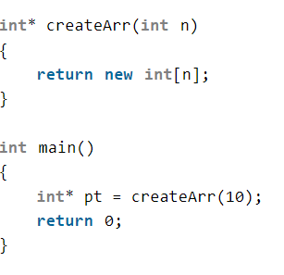  
           iii) It is used in Call by reference  
           iv) It is used in data structures like trees, graphs, linked list

1. WHEN TO USE REFERENCE

<https://www.geeksforgeeks.org/when-do-we-pass-arguments-by-reference-or-pointer/>

1. TYPES OF POINTERS(Coding ninjas notes)

<https://www.codingninjas.com/codestudio/library/introduction-to-pointers>

1. POINTERS AND ARRAY

