《操作系统》课程实验报告（二）
班级 | 201(7班) |  | 实验日期 |  | 2018.4.12
姓名 | 易诗雨 |  | 学号 |  | 2016141231175
实验名称 | 作业调度系统
实验环境 | Deepin
实  验  目  的  及  要  求 | 1.理解操作系统中调度的概念和调度算法。  2.学习Linux下进程控制以及进程之间通信的知识。  3.理解在操作系统中作业是如何被调度的，如何协调和控制各作业对CPU的使用。
算  法  及  实  验  步  骤 | 1.一个头文件job.h，五个源文件scheduler.c、enq.c、deq.c、stat.c、signal.c  2.job.h文件中为命名管道FIFO设置正确的路径.找到宏定义语句 #define FIFO “/home/chanchan/chanchan/fifo”修改引号内的路径为任意已存在的路径，fifo是准备创建管道的文件名，可任意命名。3.用gcc分别编译连接作业调度程序scheduler.c 、三个命令程序enq.c、deq.c、stat.c和作业signal.c。  4.在一个终端中运行作业调度程序scheduler.c作为服务端。  5.重新打开一个终端，用enq提交编译后的作业signal.c，并用stat查看状态、deq退出作业.enq和deq此处要用完全路径。  6.在scheduler.c文件中添加作业的打印信息，即修改函数do_stat,要求再输出作业的当前优先级、默认优先级两项内容，找到语句printf(“JID\tPID\tOWNER\tRUNTIME\tWAITTIME\tCREATTIME\t\tSTATE\n”);在其中添加DEFPRI、CURPRI两项，并在接下来的两个printf输出语句根据前面的添加对应修改，注意printf语句的输出格式，输出参数名和类型参照jobinfo结构体.（可以参照修改后的scheduler.c）。  7. 重新编译连接scheduler.c并重复步骤4和5
调  试  过  程  及  实  验  结  果 | 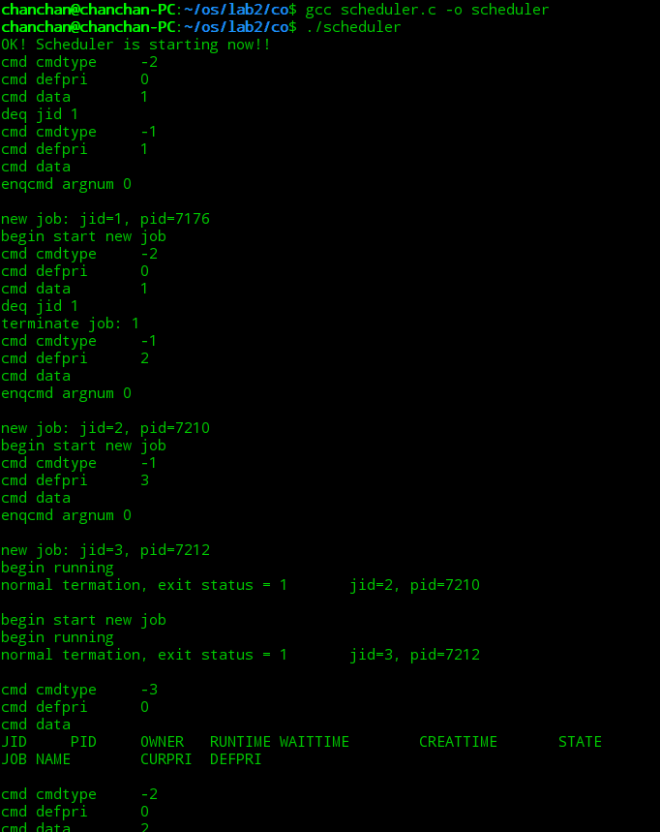  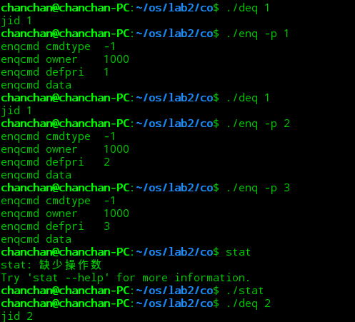
总  结 | 通过这次实验，我学到了简单的作业调度原理和实现过程，在平时生活中看似简单的操作系统，实际上后台还有复杂的运行计算  通过这次实验——作业的调度，我知道了作业调度的过程中的状态分为就绪（READY），运行（RUNNING）,完成（DONE），作业调度的实现由 “enq.c: 建立数据结构；deq.c:查找该作业；Stat.c：遍历就绪队列”这几个步骤实现。同时每一个步骤的实现都需要运用到多种函数。  在运行过程中，由于路径问题导致程序变成死循环，通过重新检索文件路径的方式解决，在更改路径后由于并没有再次编译scheduler和deq和enq和stat文件导致运行错误，经多次尝试才发现。
附  录 | Stat.c  int main (int argc,char *argv[])  {  struct jobcmd statcmd;  int fd;  if (argc !=1) {  usage();  return 1;  }  statcmd.type = STAT;  statcmd.defpri = 0;  statcmd.owner = getuid();  statcmd.argnum = 0;  strcpy(statcmd.data, "\0");  if ((fd = open(FIFO,O_WRONLY)) < 0 )  error_sys("stat open fifo failed");  if (write(fd,&statcmd,DATALEN) < 0)  error_sys("stat write failed");  close (fd);  return 0;  }  signal.c  void ChildHandler (int sig, siginfo_t* sip, void* notused)  {  int status;  printf("The process generating the signal is PID: %d\n",sip->si_pid);  fflush(stdout);  status=0;  if(sip->si_pid==waitpid(sip->si_pid, &status, WNOHANG))  {  if(WIFEXITED(status)||WTERMSIG(status))  printf("The child is gone!!!!!\n");  else  printf("Uninteresting\n");  }  else  {  printf("Uninteresting\n");  }  };  Schedual.c  void schedule()  {  struct jobcmd cmd;  int count = 0;  bzero(&cmd, DATALEN);  if ((count = read(fifo, &cmd, DATALEN)) < 0)  error_sys("read fifo failed");  #ifdef DEBUG  if (count) {  printf("cmd cmdtype\t%d\n"  "cmd defpri\t%d\n"  "cmd data\t%s\n",  cmd.type, cmd.defpri, cmd.data);  }  #endif  switch (cmd.type) {  case ENQ:  do_enq(cmd);  break;  case DEQ:  do_deq(cmd);  break;  case STAT:  do_stat(cmd);  break;  default:  break;  }  updateall();  struct waitqueue *next = jobselect();  jobswitch(next);  }  struct waitqueue* prevnode(struct waitqueue* currnode)  {  struct waitqueue *p, *prev=NULL;  for (p=head; p!=NULL; prev=p, p=p->next)  {  if (p==currnode) break;  }  return prev;  }  void updateall()  {  struct waitqueue *p;  if (current)  current->job->run_time += 1;  for (p = head; p != NULL; p = p->next) {  p->job->wait_time += 100;  if (p->job->wait_time >= 1000 && p->job->curpri < 3)  p->job->curpri++;  }  }  struct waitqueue* jobselect()  {  struct waitqueue *p, *select, *selectprev;  int highest = -1;  select = NULL;  selectprev = NULL;  if (head)  {  for (p=head; p!=NULL; p=p->next)  {  if (p->job->curpri > highest)  {  select = p;  highest = select->job->curpri;  }  }  if (select == head)  {  head = select->next;  }  else  {  selectprev = prevnode(select);  if (selectprev)  selectprev->next = select->next;  }  if (select) select->next = NULL;  }  return select;  }  void jobswitch(struct waitqueue *next)  {  struct waitqueue *p;  int i;  if (current && current->job->state == DONE) {  for (i = 0; (current->job->cmdarg)[i] != NULL; i++) {  free((current->job->cmdarg)[i]);  (current->job->cmdarg)[i] = NULL;  }  free(current->job->cmdarg);  free(current->job);  free(current);  current = NULL;  }  if (next == NULL && current == NULL)  return;  else if (next != NULL && current == NULL) {  printf("begin start new job\n");  current = next;  current->job->state = RUNNING;  kill(current->job->pid, SIGCONT);  return;  } else if (next != NULL && current != NULL) {  kill(current->job->pid, SIGSTOP);  current->job->curpri = current->job->defpri;  current->job->wait_time = 0;  current->job->state = READY;  if (head) {  for (p = head; p->next != NULL; p = p->next);  p->next = current;  } else {  head = current;  }  current = next;  current->job->state = RUNNING;  kill(current->job->pid, SIGCONT);  return;  } else {  return;  }  }  void sig_handler(int sig, siginfo_t *info, void *notused)  {  int status;  int ret;  switch (sig) {  case SIGVTALRM:  schedule();  return;  case SIGCHLD:  ret = waitpid(-1, &status, WNOHANG);  if (ret == 0 || ret == -1)  return;  if (WIFEXITED(status)) {  #ifdef DEBUG  #endif  current->job->state = DONE;  printf("normal termation, exit status = %d\tjid = %d, pid = %d\n\n",  WEXITSTATUS(status), current->job->jid, current->job->pid);  } else if (WIFSIGNALED(status)) {  printf("abnormal termation, signal number = %d\tjid = %d, pid = %d\n\n",  WTERMSIG(status), current->job->jid, current->job->pid);  } else if (WIFSTOPPED(status)) {  printf("child stopped, signal number = %d\tjid = %d, pid = %d\n\n",  WSTOPSIG(status), current->job->jid, current->job->pid);  }  return;  default:  return;  }  }  void do_enq(struct jobcmd enqcmd)  {  struct jobinfo *newjob = NULL;  struct waitqueue *newnode, *p;  int i=0, pid;  char *offset, *argvec, *q;  char **arglist;  sigset_t zeromask;  sigemptyset(&zeromask);  newjob = (struct jobinfo *)malloc(sizeof(struct jobinfo));  newjob->jid = allocjid();  newjob->defpri = enqcmd.defpri;  newjob->curpri = enqcmd.defpri;  newjob->ownerid = enqcmd.owner;  newjob->state = READY;  newjob->create_time = time(NULL);  newjob->wait_time = 0;  newjob->run_time = 0;  arglist = (char**)malloc(sizeof(char*)*(enqcmd.argnum+1));  newjob->cmdarg = arglist;  offset = enqcmd.data;  argvec = enqcmd.data;  while (i < enqcmd.argnum) {  if (*offset == ':') {  *offset++ = '\0';  q = (char*)malloc(offset - argvec);  strcpy(q,argvec);  arglist[i++] = q;  argvec = offset;  } else  offset++;  }  arglist[i] = NULL;  #ifdef DEBUG  printf("enqcmd argnum %d\n",enqcmd.argnum);  for (i = 0; i < enqcmd.argnum; i++)  printf("parse enqcmd:%s\n",arglist[i]);  #endif  newnode = (struct waitqueue*)malloc(sizeof(struct waitqueue));  newnode->next = NULL;  newnode->job = newjob;  if (head) {  for (p = head; p->next != NULL; p = p->next);  p->next = newnode;  } else  head = newnode;  if ((pid = fork()) < 0)  error_sys("enq fork failed");  if (pid == 0) {  newjob->pid = getpid();  raise(SIGSTOP);  dup2(globalfd,1);  if (execv(arglist[0],arglist) < 0)  printf("exec failed\n");  exit(1);  } else {  newjob->pid = pid;  printf("\nnew job: jid=%d, pid=%d\n", newjob->jid, newjob->pid);  }  }  void do_deq(struct jobcmd deqcmd)  {  int deqid,i;  struct waitqueue *p,*prev,*select,*selectprev;  deqid = atoi(deqcmd.data);  if (current && current->job->jid == deqid) {  printf("terminate job: %d\n", current->job->jid);  kill(SIGTERM, current->job->pid);  for (i = 0; (current->job->cmdarg)[i] != NULL; i++) {  free((current->job->cmdarg)[i]);  (current->job->cmdarg)[i] = NULL;  }  free(current->job->cmdarg);  free(current->job);  free(current);  current = NULL;  } else {  select = NULL;  selectprev = NULL;  if (head) {  for (p = head; p != NULL; p = p->next) {  if (p->job->jid == deqid) {  select = p;  break;  }  }  if (select == head) {  head = select->next;  }  else {  selectprev = prevnode(select);  if (selectprev)  selectprev->next = select->next;  }  }  if (select) {  for (i = 0; (select->job->cmdarg)[i] != NULL; i++) {  free((select->job->cmdarg)[i]);  (select->job->cmdarg)[i] = NULL;  }  printf("\njob of jid=%d was killed!\n", select->job->jid);  free(select->job->cmdarg);  free(select->job);  free(select);  select = NULL;  }  }  }  void do_stat()  {  struct waitqueue *p;  char timebuf[BUFLEN];  printf( "JID\tPID\tOWNER\tRUNTIME\tWAITTIME\tCREATTIME\tSTATE\n");  if (current) {  strcpy(timebuf,ctime(&(current->job->create_time)));  timebuf[strlen(timebuf) - 1] = '\0';  printf("%d\t%d\t%d\t%d\t%d\t%s\t%s\n",  current->job->jid,  current->job->pid,  current->job->ownerid,  current->job->run_time,  current->job->wait_time,  timebuf,  "RUNNING" );  }  for (p = head; p != NULL; p = p->next) {  strcpy (timebuf,ctime(&(p->job->create_time)));  timebuf[strlen(timebuf) - 1] = '\0';  printf("%d\t%d\t%d\t%d\t%d\t%s\t%s\n",  p->job->jid,  p->job->pid,  p->job->ownerid,  p->job->run_time,  p->job->wait_time,  timebuf,  "READY" );  }  printf("\n");  }  Job.h  struct jobcmd {  enum cmdtype type;  int argnum;  int owner;  int defpri;  char data[BUFLEN];  };  struct jobinfo {  int jid;  int pid;  int defpri;  int curpri;  int ownerid;  ulong wait_time;  time_t create_time;  int run_time;  enum jobstate state;  };  struct waitqueue {  struct waitqueue *next;  struct jobinfo *job;  };  Enq.c  int main(int argc,char *argv[])  {  int p = 0;  int fd;  char c, *offset;  struct jobcmd enqcmd;  if (argc == 1) {  usage();  return 1;  }  while (--argc > 0 && (*++argv)[0] == '-') {  while ((c = *++argv[0]))  switch (c) {  case 'p':  p = atoi(*(++argv));  argc--;  break;  default:  printf("Illegal option %c\n",c);  return 1;  }  }  if (p < 0 || p > 3) {  printf("invalid priority: must between 0 and 3\n");  return 1;  }  enqcmd.type = ENQ;  enqcmd.defpri = p;  enqcmd.owner = getuid();  enqcmd.argnum = argc;  offset = enqcmd.data;  while (argc-- > 0) {  strcpy(offset,*argv);  strcat(offset,":");  offset = offset + strlen(*argv) + 1;  argv++;  }  #ifdef DEBUG  printf("enqcmd cmdtype\t%d\n"  "enqcmd owner\t%d\n"  "enqcmd defpri\t%d\n"  "enqcmd data\t%s\n",  enqcmd.type, enqcmd.owner, enqcmd.defpri, enqcmd.data);  #endif  if ((fd = open(FIFO,O_WRONLY)) < 0)  error_sys("enq open fifo failed");  if (write(fd,&enqcmd,DATALEN)< 0)  error_sys("enq write failed");  close(fd);  return 0;  }  Deq.c  int main(int argc,char *argv[])  {  struct jobcmd deqcmd;  int fd;  if (argc != 2) {  usage();  return 1;  }  deqcmd.type = DEQ;  deqcmd.defpri = 0;  deqcmd.owner = getuid();  deqcmd.argnum = 1;  strcpy(deqcmd.data,*++argv);  printf("jid %s\n",deqcmd.data);  if ((fd = open(FIFO,O_WRONLY)) < 0)  error_sys("deq open fifo failed");  if (write(fd,&deqcmd,DATALEN)< 0)  error_sys("deq write failed");  close(fd);  return 0;  }
实验地点 |  |  |  | 指导教师

