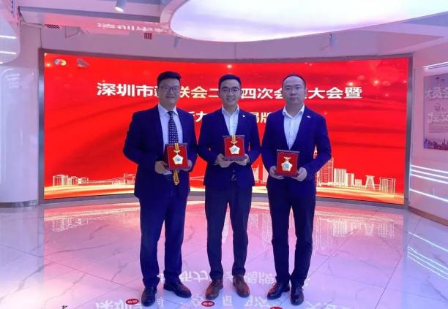

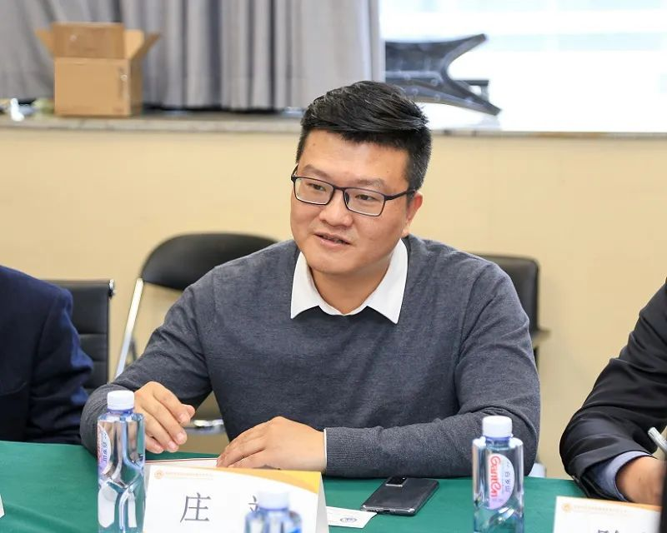

Company founder & chief developer: Benjamin Zhuang
Education
- Bachelor’s in Mechatronics & Precision Machinery from Nanjing University of Aeronautics and Astronautics.
- Master’s in Biomedical Engineering (specializing in microfluidics) from UNSW, Australia.
Career
- Began in aviation manufacturing and micro/nano disc etching before joining Mindray Medical, contributing to China’s first 5-part hematology analyzer.
- Led microfluidics R&D at a Chinese Academy of Sciences (CAS)-affiliated chip company.
Entrepreneurship
- Founded Create&Care (创怀医疗) in 2016, focusing on microfluidic chip industrialization, and established Pendox Instruments Ltd. as the overseas commercialization arm.
- Launched the "Bemaner"—a portable AI-powered semen analyzer (iF & Red Dot 2018), serving 100K+ users in China. Clinical validation: NUL study (PMC7714652).
- Expanded microfluidics to primary care, home diagnostics, and veterinary(e.g., blood tests, semen analysis).
Achievements
- National "10,000 Talents Plan" Expert and Shenzhen High-Level Talent.
- Awards: China Youth Innovation Gold Award, China Medical Device Innovation Award.
- Holds 30+ global patents in microfluidic biochips; recognized as the "Inventor of Cell-Level Microfluidic Chips".

Benjamin Zhuang: Company founder & chief developer:
Education
- B.Eng. in Mechatronics, Nanjing Univ. of Aeronautics & Astronautics
- M.Eng. in Biomedical Engineering (Microfluidics), UNSW, Australia
Career
- Early work in aviation manufacturing and micro/nano etching
- Joined Mindray, helped develop China’s first 5-part hematology analyzer
- Led microfluidics R&D at a CAS-affiliated chip company
Entrepreneurship
- Founded Create&Care (2016), focused on microfluidic chip industrialization
- Launched Bemaner, a portable AI semen analyzer (iF & Red Dot 2018); 100K+ users; validated by NUL (PMC7714652)
- Expanded tech to primary care, home diagnostics, and veterinary use
- Established Pendox Instruments for global commercialization
Achievements
- National “10,000 Talents Plan” expert; Shenzhen High-Level Talent
- Awards: China Youth Innovation Gold Award, Medical Device Innovation Award
- 30+ global patents; dubbed “Inventor of Cell-Level Microfluidic Chips”

