To distinguish the significant different expressed genes in bladder cancer samples

1. Prepare the documents: copy“symbol.txt” which got from the last section”merge” and “mRNAsi12.diffGene.R”(fixed)

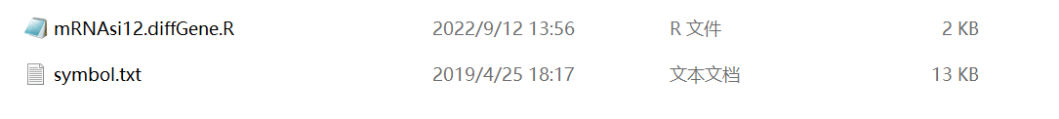

1. Open “mRNAsi12.diffGene.R” in R software and changed the stored path(like in red block) below, then run the code:

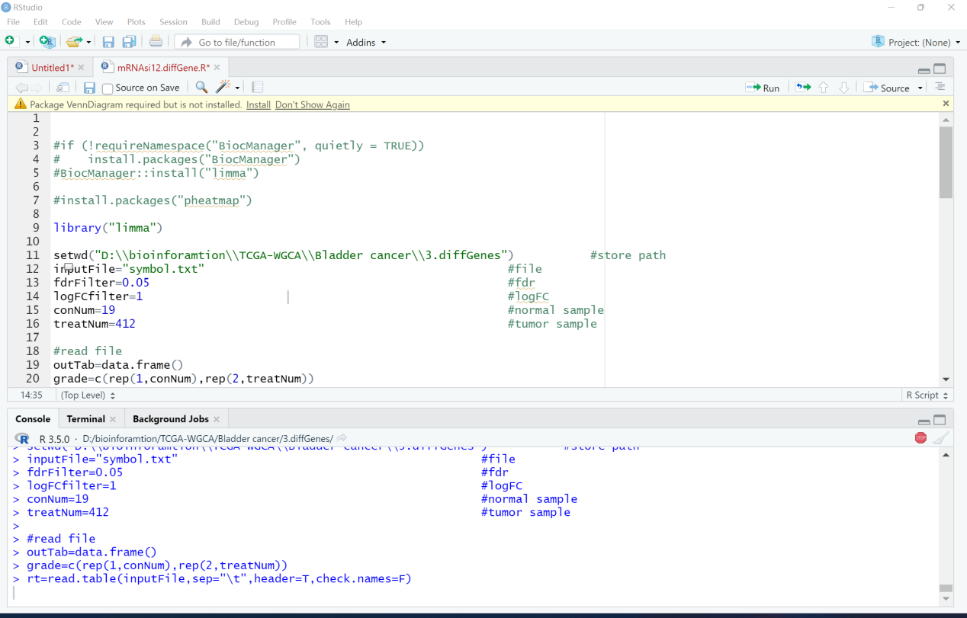

1. Finally, got the results’ files like below:

