1. prepare the documents”keyGeneExp.txt”from last section; “mRNAsi15.boxplot.R” （fixed）like below:

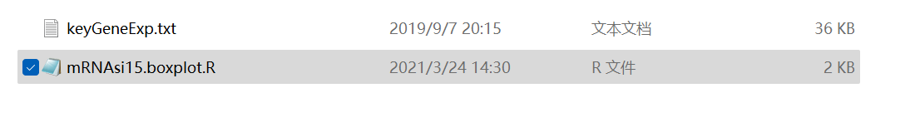

1. Open the “mRNAsi15.boxplot.R” in R software（remember to changed the stored path）and run the code

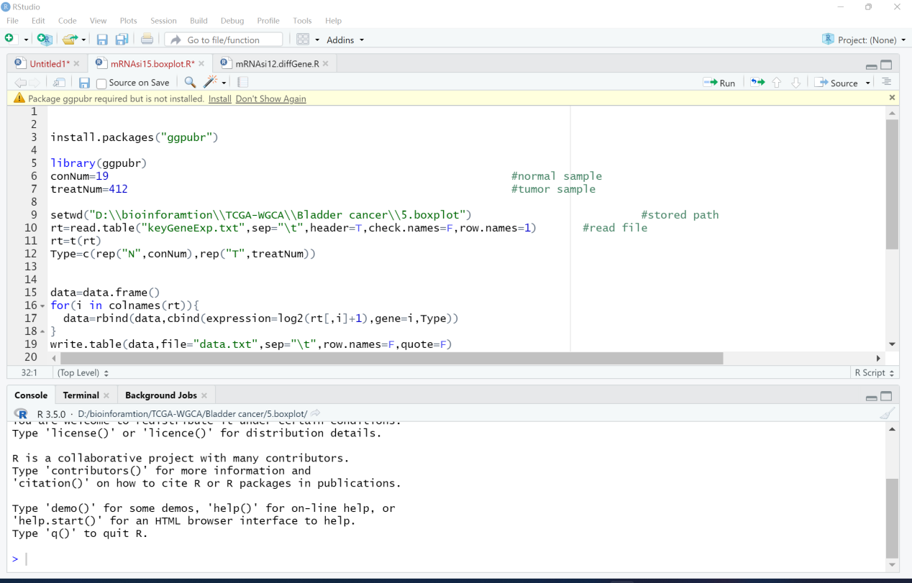

1. Final result like below and the plot stored in the “boxplot.pdf”

