- prepare the file: “diffGeneExp.txt” from last section; “gene.txt”(potential selected gene to be showed in the plot) and “mRNAsi14.keyGeneExp.pl”(fixed)
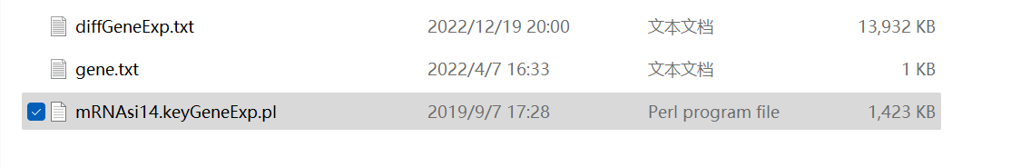
- Open the CMD in the computer
2.1 define the stored disk such as “d: “ like below
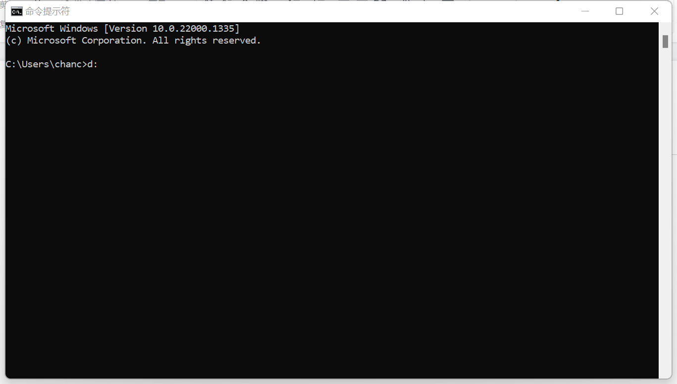
2.2 define the specific stored path like below:
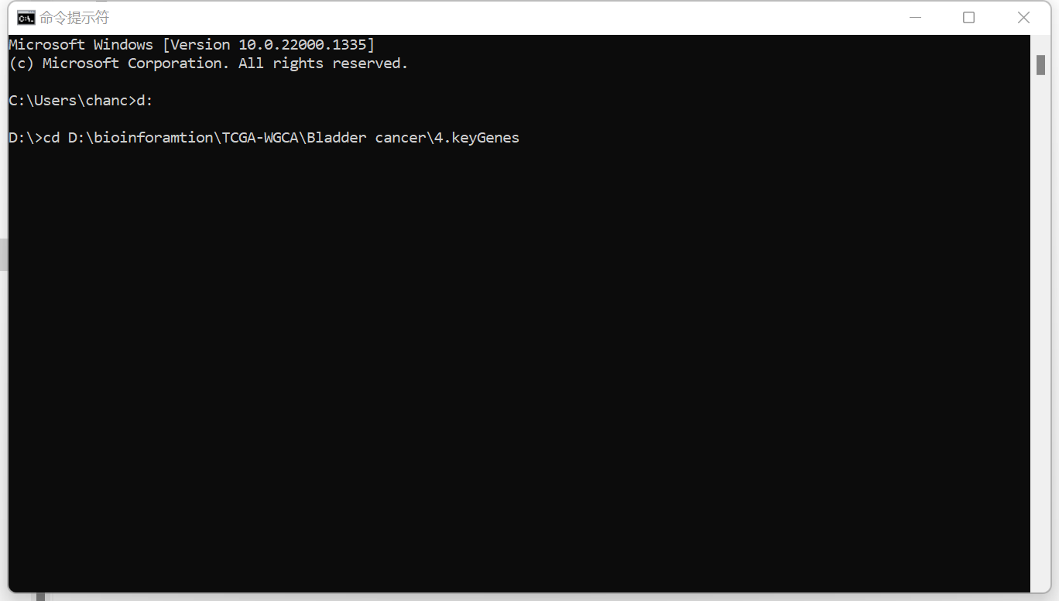

2.3 input “perl mRNAsi14.keyGeneExp.pl”
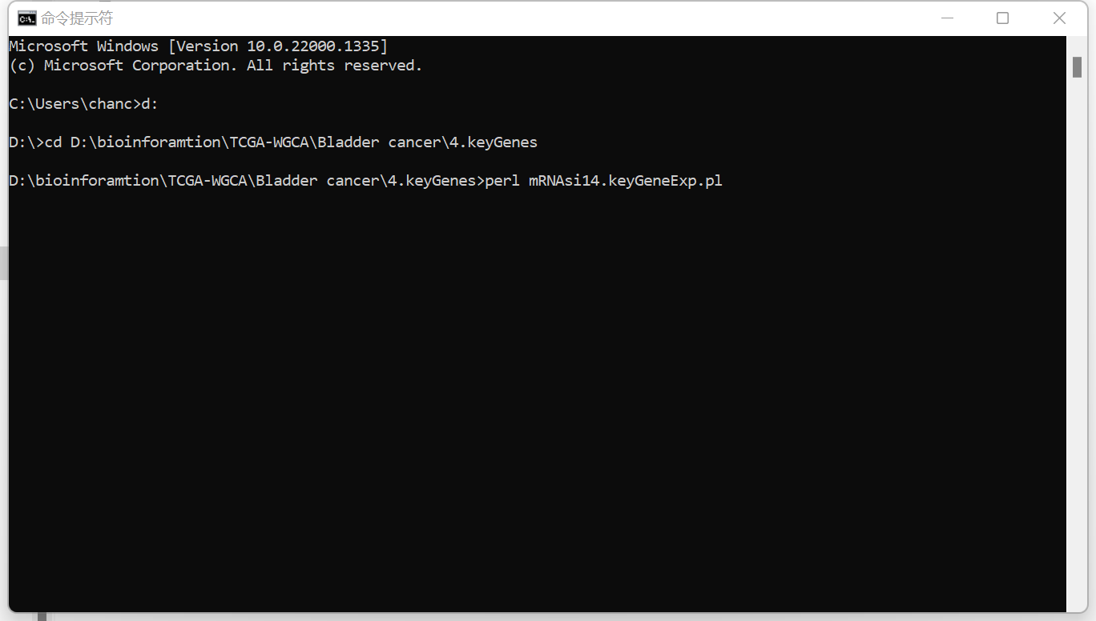

2.4 The genes cannot be searched successfully showed in list as below：
（sometimes gene name have several gene synonyms, such as CD105 vs END, if cannot find gene expression please try other synonyms）
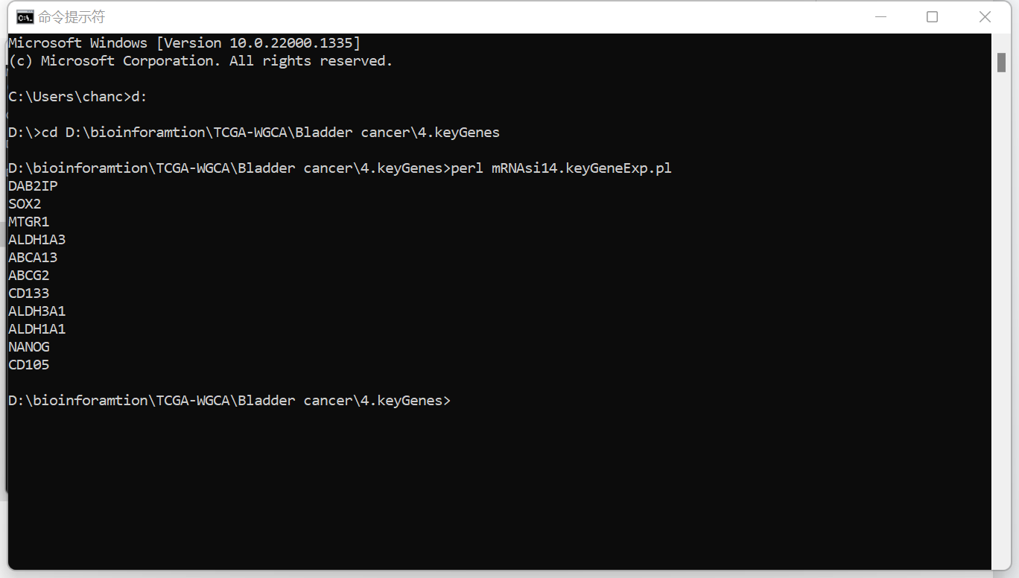
And the selected genes’ expression from TCGA stored in the file named: “keyGeneExp.txt”