Class Lead Guide
For: class leads who take attendance and upload class videos and music.
Website: https://umdsc-dance-class.umdancesportc.workers.dev
Works on: phone or computer. Two steps are easier on a computer; they are marked 💻.

1. Before your first class (ask the admin)
You need four things from the club admin:
1. A class lead account: a username and a password for the website.
2. Your Gmail added to the website's Google sign-in list. Without this, Google refuses your sign-in when you upload.
3. A Google Drive folder for your style's videos. Create a folder in your own Google Drive (for example "Locking Class Videos"), then share it with `umdancesportc@gmail.com` as Editor.
4. The folder link inserted on the website. Send the folder link to the admin, who inserts it for your dance style.
Your videos are stored in your Drive folder and use your Google storage.

2. Log in
1. Open the website and add `/admin/login` to the end of the address:
https://umdsc-dance-class.umdancesportc.workers.dev/admin/login
2. Enter your username and password, then tap LOGIN.
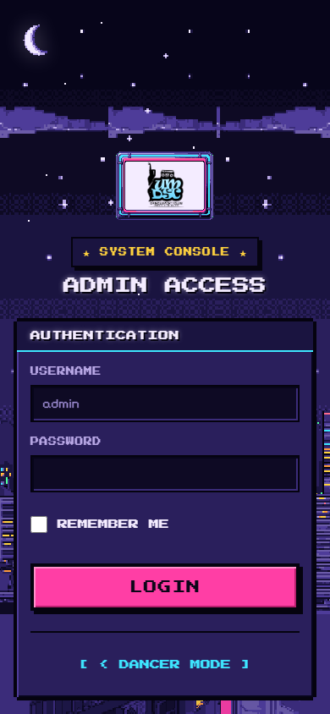
Admin login screen
On a phone, the menu is at the bottom: Calendar · Attendance · Media · Dancers · More. If the menu covers something, tap HIDE NAV; tap SHOW NAV to bring it back.
Some menu pages (for example Settings) are for admins only. If you open one, the website shows an error. That is normal.

3. Take attendance
1. Tap Attendance.
2. Check the EVENT at the top (for example OCT MONTHLY CLASS). Change it if needed.
3. Tap your STYLE (for example Hip Hop).
4. Tap the class you are teaching (for example #3 22 Oct).
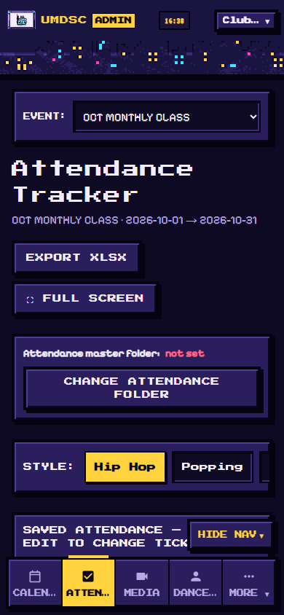
Attendance page
5. Tap EDIT.
6. For each dancer who came, tap ABSENT. It turns green and shows ✓ PRESENT. Tap again to undo.
- SCORE shows how many dancers are present.
- Use Search dancer or matric… to find someone quickly.
- Long names cut off on a phone? Tap ▼ SHOW FULL NAMES. The website remembers this on your phone.
7. Tap SUBMIT to save. Ticks are not saved until you tap SUBMIT.
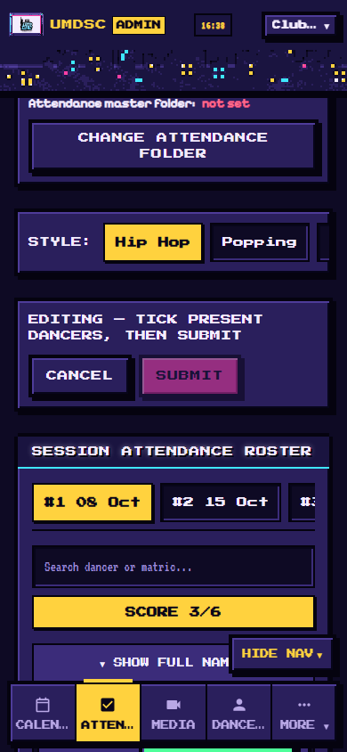
Ticking dancers
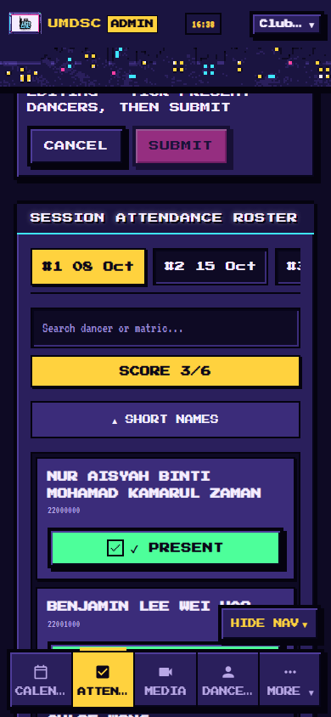
Full names shown
Good to know:
- If you try to close the page before tapping SUBMIT, the website warns you.
- If the internet drops while saving, the website keeps retrying in the background. Keep the page open until it finishes.
- Another class lead can tick at the same time. Their ticks appear on your screen within about 20 seconds.
- EXPORT XLSX downloads the attendance as an Excel file. The sheet link opens the attendance in Google Sheets.

4. One-time setup: authorize your video folder 💻
Do this once, before your first upload. It is easiest on a computer.
1. Log in, then open Media.
2. Find CLASS LEAD VIDEO DRIVE FOLDERS and tap ▼ EXPAND.
3. Look at Google account:.
- Shows your Gmail? Good.
- Shows another account, or not signed in? Tap SWITCH ACCOUNT (or SIGN IN) and choose your Gmail.
4. On your style's row, tap AUTHORIZE.
5. Google opens a window showing one folder: your folder. Tap it, then tap Select.
6. Your row now shows ✓ AUTHORIZED and Uploads as your Gmail.
AUTHORIZE button missing? Your account may not have permission to edit dance styles. Ask the admin to do this step with you, signed in with your Gmail.

5. Upload a class video
1. Open Media.
2. Choose the EVENT at the top and your STYLE.
3. Tap the class card (for example CLASS #3), then tap + ADD RECAP FOR CLASS #3, or tap UPLOAD VIDEO.
4. Check Google account: shows your Gmail. If not, tap SWITCH ACCOUNT.
5. Check TARGET CLASS SESSION is the right class.
6. Tap Choose Files and pick the video. You can pick several.
7. Choose the speed:
- ⚡ FAST: UPLOAD ORIGINAL: starts at once and keeps the original quality. Uses more storage. The website picks this for videos of 150 MB or less.
- 📦 SMALLER: COMPRESS FIRST: your phone shrinks the video to 720p first. Slower to start, but saves storage and mobile data. The website picks this for videos over 150 MB.
8. Tap START UPLOAD.
9. Keep the screen on and the page open until it finishes. A phone pauses uploads when the screen locks.
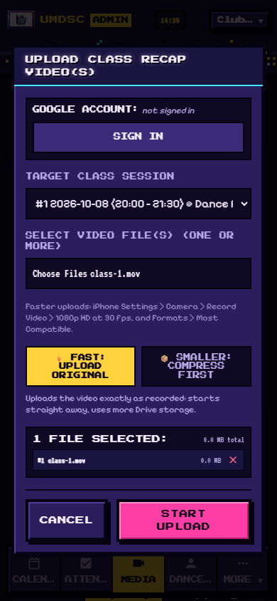
Upload window
Tip for faster uploads (iPhone): Settings › Camera › Record Video › 1080p HD at 30 fps, and Settings › Camera › Formats › Most Compatible.
If the upload is blocked, the message tells you why:
Message | What to do
Class lead video folder link not inserted | Ask the admin to insert your folder link.
…has no upload account yet | Do section 4 (authorize).
…uploads with X, but you're signed in as Y | Tap SWITCH ACCOUNT and choose X.
This class lead folder isn't authorized yet | Do section 4 on a computer.

Delete a video
Tap DELETE (or DEL) on the video, then confirm. The video disappears from the website and its file moves to the Google Drive trash, where you can restore it for 30 days.

6. Add class music
On the Media page, with your class chosen:
- + MUSIC LINK: paste a YouTube, Spotify, SoundCloud or Google Drive MP3 link, give it a Track Title, choose the class in Link to Session, then save.
- UPLOAD MP3: upload an MP3 file from your device.

Practice sections
Under a music track, tap MANAGE SECTIONS to add named parts, for example Chorus part A, from 0:15 to 0:45. Dancers see them in the Studio and can loop them while practising.

7. Quick checklist for each class
☐ Attendance: EDIT → tick → SUBMIT
☐ Video: Media → class → upload (screen on)
☐ Music and sections, if new
Questions? Contact the club admin.

