Admin Guide
For: club committee members who run the website.
Website: https://umdsc-dance-class.umdancesportc.workers.dev/admin/login
Use a laptop or PC. All admin pages also work on a phone, but setting things up is easier on a big screen.
Admins can do everything class leads can do; see the Class Lead Guide for attendance and uploads. This guide covers setting up and managing the club's data.

1. Log in and find your way
Log in at /admin/login with your username and password, then tap LOGIN.
The left menu has Calendar, Attendance, Media, Dancers, and under More: Dance Styles, Instructors, Roles & Permissions, Admin Accounts, System Settings, Events.
The EVENT: picker at the top chooses which event (month) every page shows.
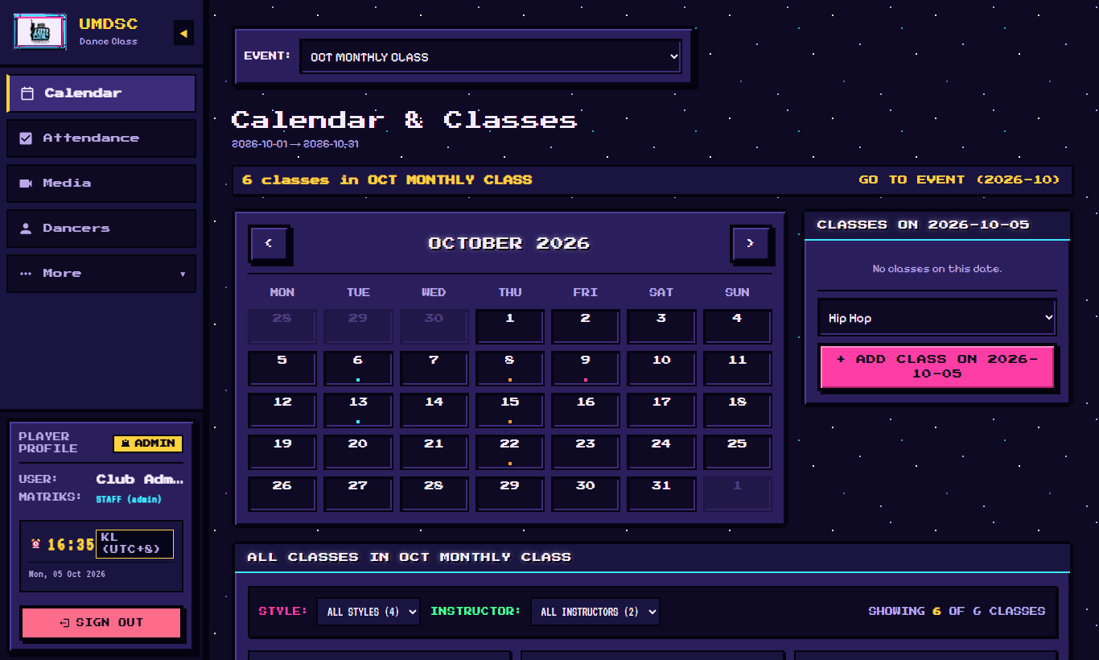
Calendar

2. Events: one per monthly class, trial class or workshop
Each event has its own Google Form for registration. Dancers who fill in the form are imported automatically.
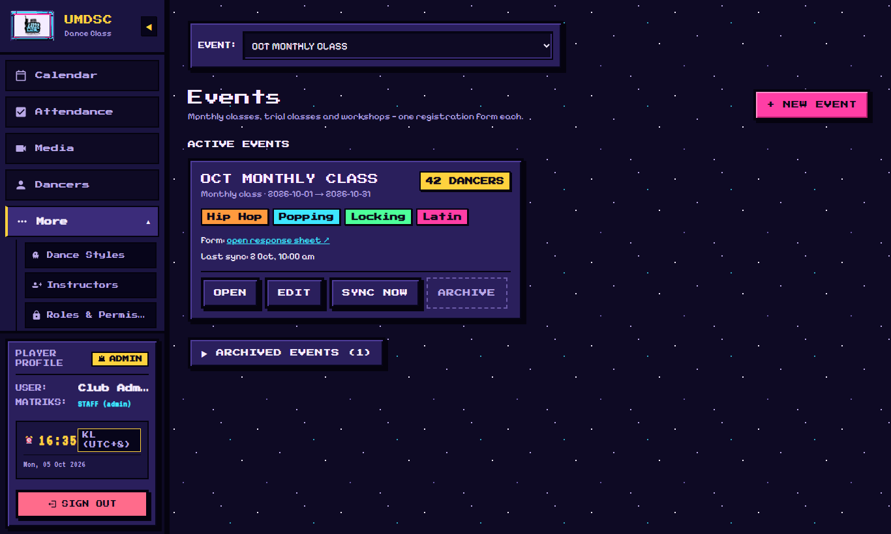
Events

Create a new event
Before you start:
- Create the event's Google Form, and link it to a response sheet.
- Share the response sheet with `umdancesportc@gmail.com` as Editor. The website refuses links it cannot edit.
- Make sure the form has a question where dancers choose their class(es).
Then click Events › + NEW EVENT and go through the 5 steps:
1. FORM LINK: paste the Google Form response sheet link, then choose the Class choice column, i.e. the form question where dancers pick their classes.
2. DETAILS: Event name (for example NOV MONTHLY CLASS), Event type, Start day and End day.
3. STYLES: tick the dance styles taught in this event. If some class answers in the form don't match a style, the wizard lists them under CLASS ANSWERS THAT MATCH NO STYLE. Fix them by adding an alias to the style (see section 3).
4. SCHEDULE: for each style, use AUTO-FILL (day, start time, end time, number of classes) to create all the classes at once, then adjust single dates if needed.
5. REVIEW: check everything, then create the event.
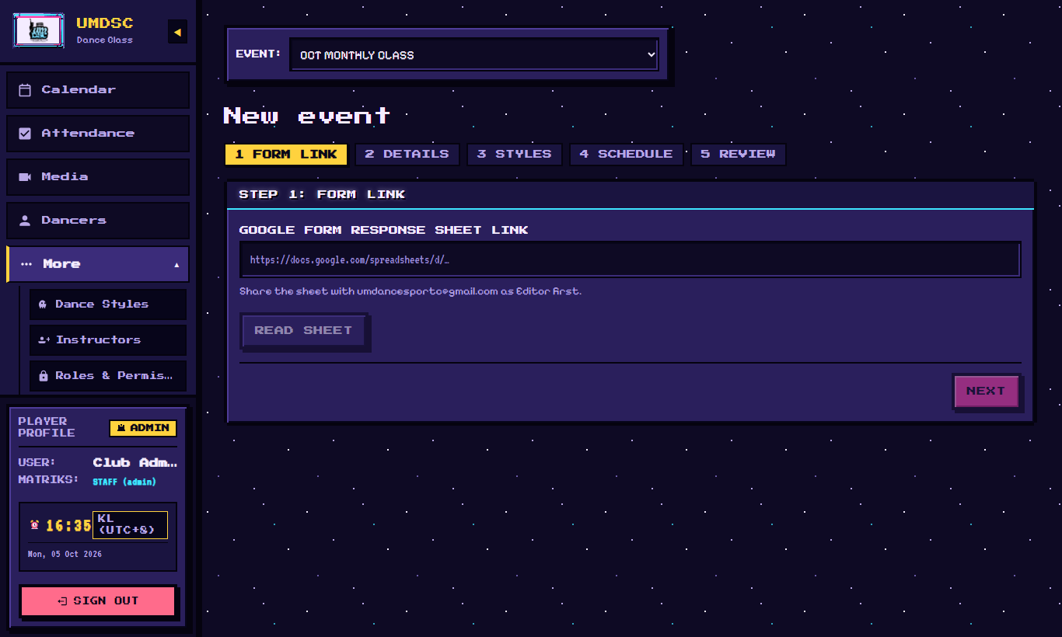
New event wizard

Look after events
- SYNC NOW: imports new form registrations immediately. This also runs automatically.
- EDIT: change the details, styles or schedule.
- ARCHIVE: when a month is over, archive it. Archived events stop syncing and move under ARCHIVED EVENTS.

3. Dance styles
More › Dance Styles. Each style (Hip Hop, Popping, Locking, Latin…) has:
Field | Meaning
Style Name | Shown everywhere
Aliases (comma-separated) | Other ways dancers write it in the form, for example hiphop, hip-hop. Used to match form answers to the style.
Color Swatch | The style's colour on calendars
Default Day / Start Time / End Time / Default Instructor / Default Venue | Used when creating classes
Attendance Folder Link / Video Folder Link | Optional Drive folders for this style

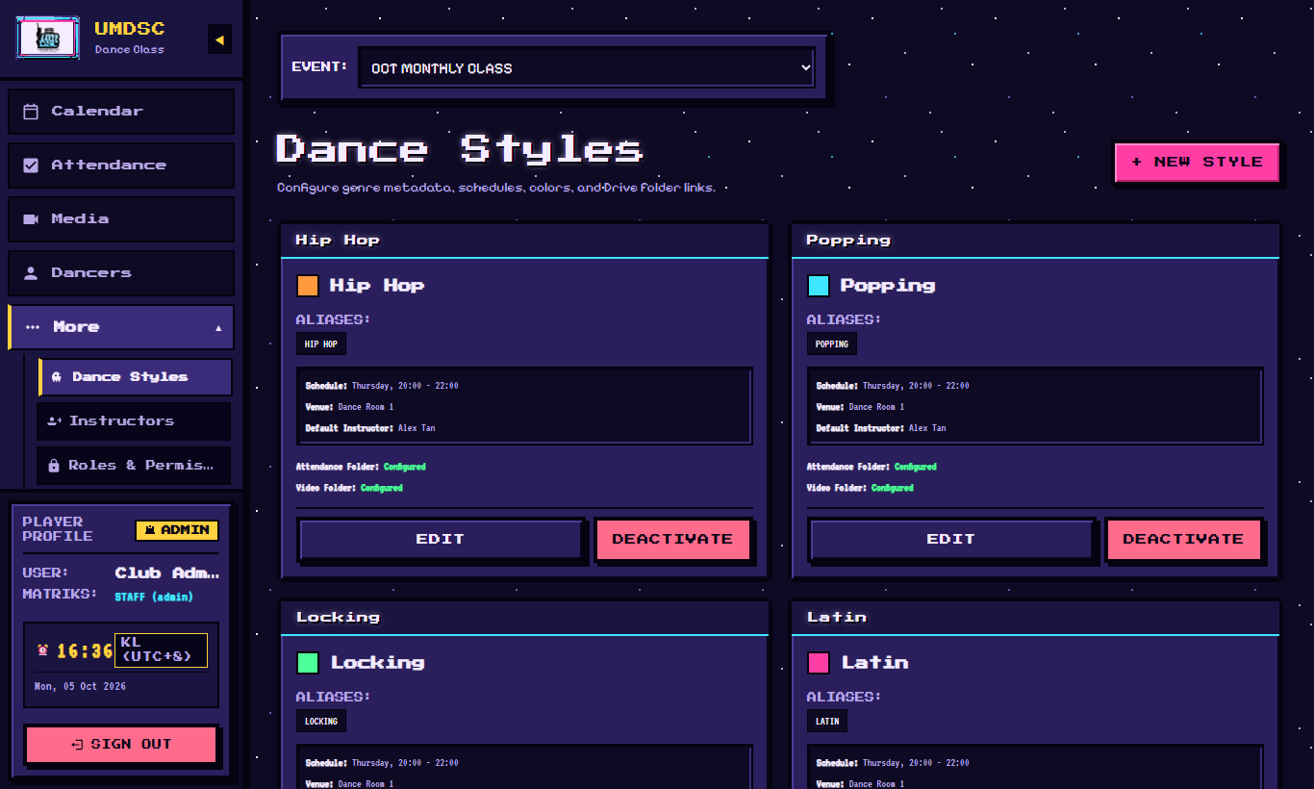
Dance styles
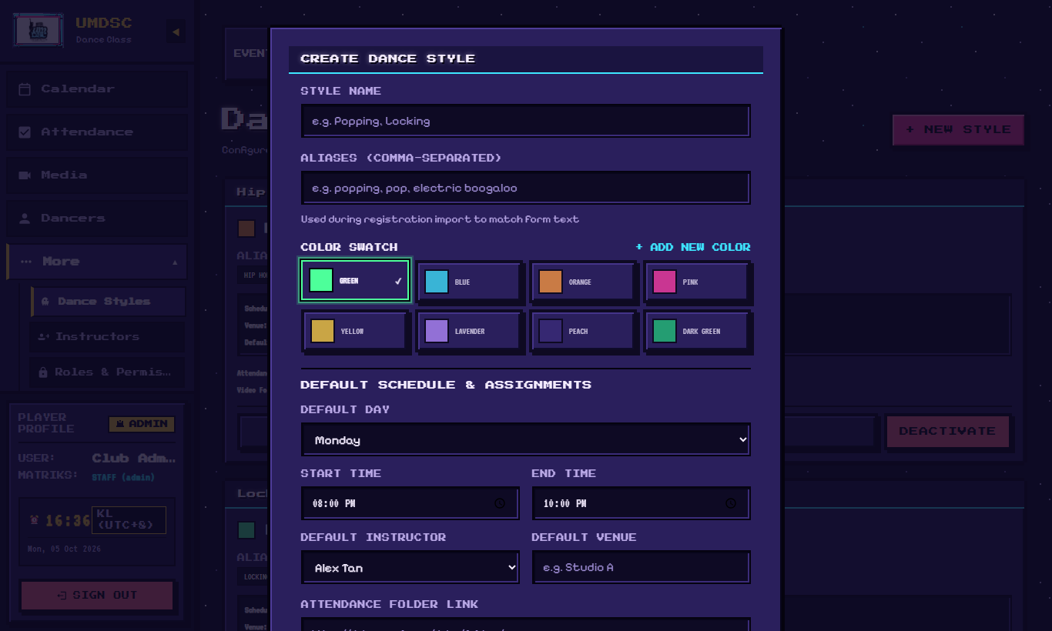
Style form

4. Instructors
More › Instructors › + NEW INSTRUCTOR. Enter Full Name, Contact (Phone / WhatsApp) and Instructor Signature Color. Add a photo with + UPLOAD PICTURE (recommended size 1080 × 1350, portrait), or + LINK URL for a photo already online. Several photos can be kept; the ACTIVE one is shown to dancers.
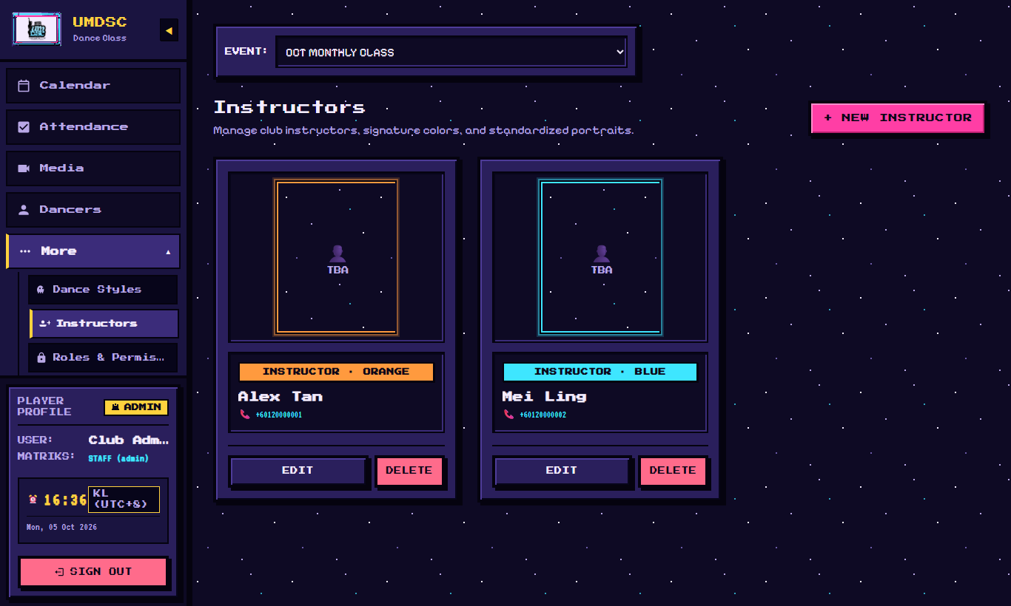
Instructors
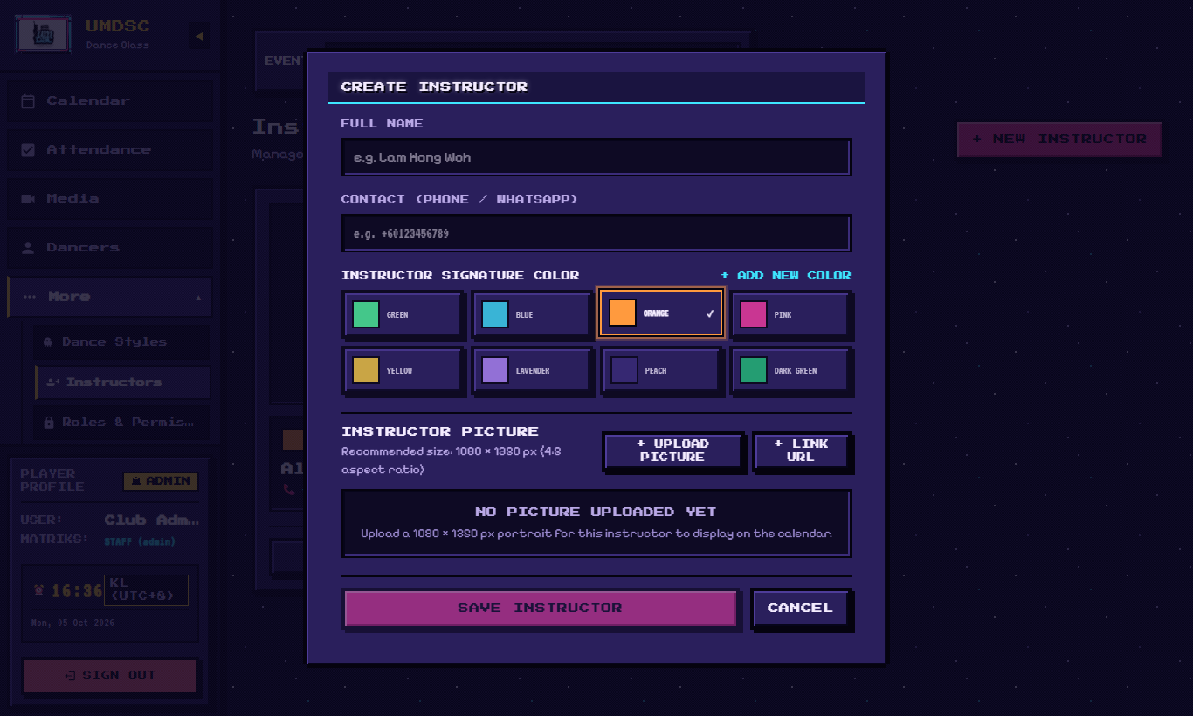
Instructor form

5. Classes (calendar)
Calendar shows all classes of the chosen event. Filter by dance style or instructor.
- Click a class to edit its date, venue, instructor (or a replacement), and a note. Its status can be set to scheduled, replacement or cancelled.
- Add an extra class by choosing the event and style for the new class.

6. Dancers
Dancers lists everyone registered for the chosen event: matric number, full name, contact, email, gender, and their classes. Use Search name, matric, phone… to find someone.
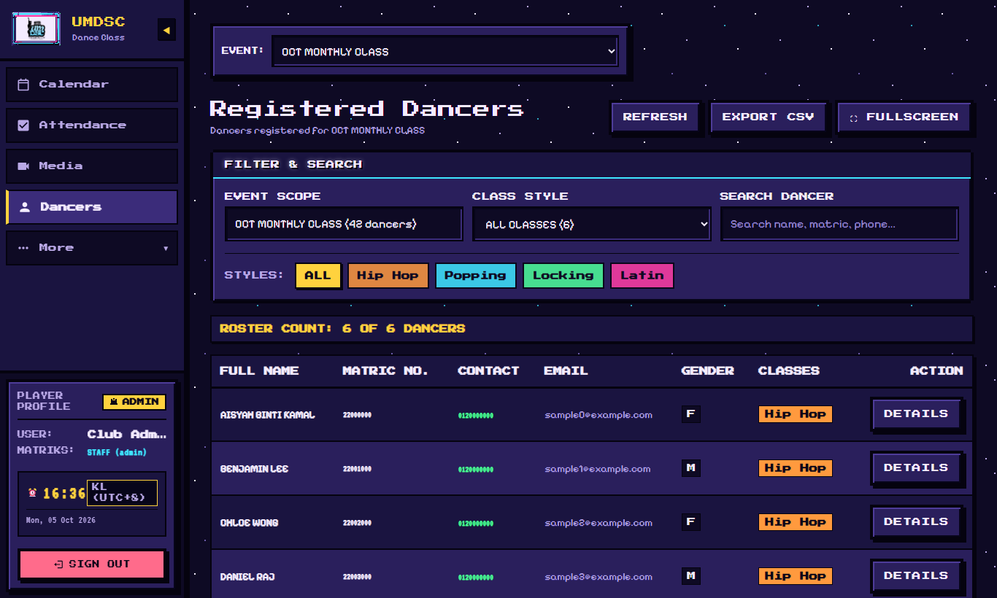
Dancers
Dancer details come from the Google Form. To fix a name, correct it in the form response sheet, then SYNC NOW.

7. Media: class lead video folders
Media › CLASS LEAD VIDEO DRIVE FOLDERS. Each dance style uploads its videos into its class lead's own Google Drive folder.
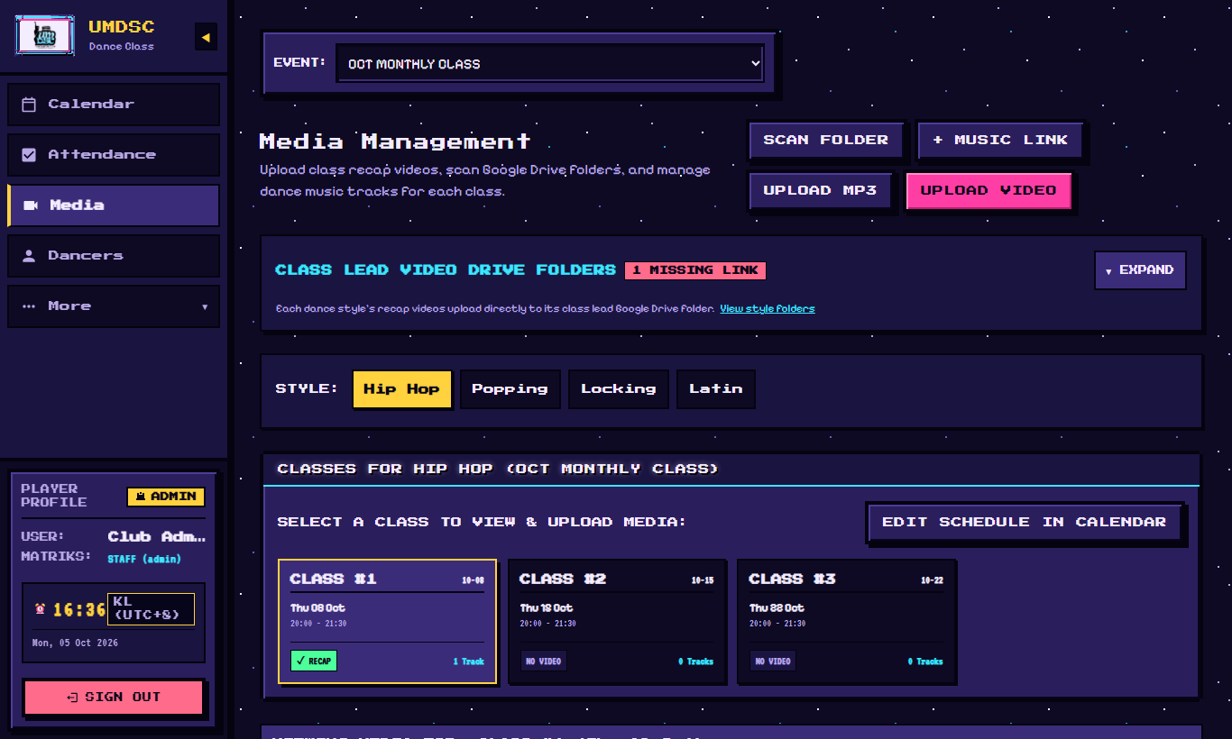
Media
For each style:
- + INSERT LINK / CHANGE LINK: paste the class lead's folder link. The folder must be shared with `umdancesportc@gmail.com` as Editor.
- REMOVE LINK: disconnect the folder. Uploads are blocked for that style until a new link is inserted. Videos already in Drive are not touched.
- AUTHORIZE: links the folder to a Google account. Uploads for that style then must use that account, and use its storage. Before tapping AUTHORIZE, use SWITCH ACCOUNT to choose the class lead's Gmail. The row then shows Uploads as that Gmail.
The same page is used for uploading videos and music; see the Class Lead Guide.

8. Roles & permissions
More › Roles & Permissions. A role is a set of permissions. Two are built in: Admin (everything) and Dancer (calendar, own attendance, videos, music).
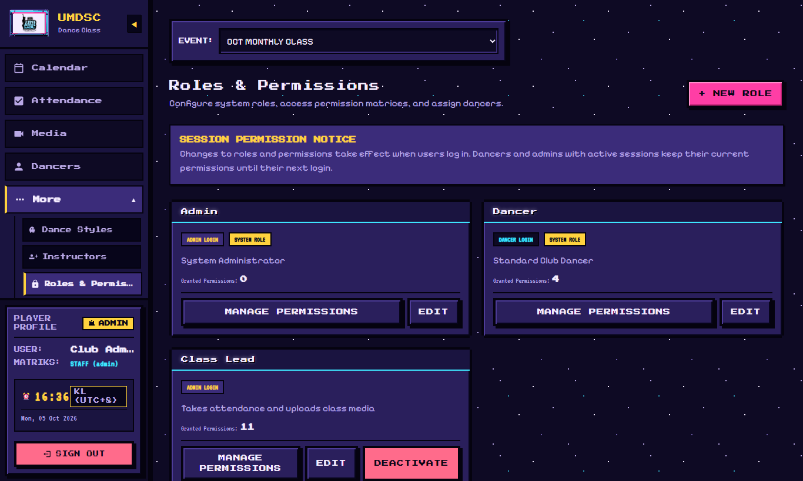
Roles

The Class Lead role (create it once)
1. + NEW ROLE: Role Name Class Lead, Login Type `Admin`, then SAVE ROLE.
It must be Admin login type. Dancer-type accounts cannot open the Attendance or Media pages.
2. MANAGE PERMISSIONS and tick:
calendar.view, attendance.view.all, attendance.edit, export.download, members.view, videos.view, videos.upload, videos.edit, music.view, music.edit, sections.edit, and `styles.edit`. The last one lets class leads AUTHORIZE their own folder; it also lets them edit dance styles.
3. Click SAVE PERMISSIONS.
Never give settings.edit, admins.manage or roles.manage to class leads.
When you change a role's permissions, everyone with that role is asked to log in again.

9. Admin accounts
More › Admin Accounts › + NEW ADMIN. Create an account for each admin and each class lead: Username, Display Name, Initial Password, Assigned Role. Send the username and password privately, for example in a direct message, never in a group.
- Forgotten password: RESET PASSWORD on their account, enter a New Password, then UPDATE PASSWORD.
- Someone leaves: DEACTIVATE their account.
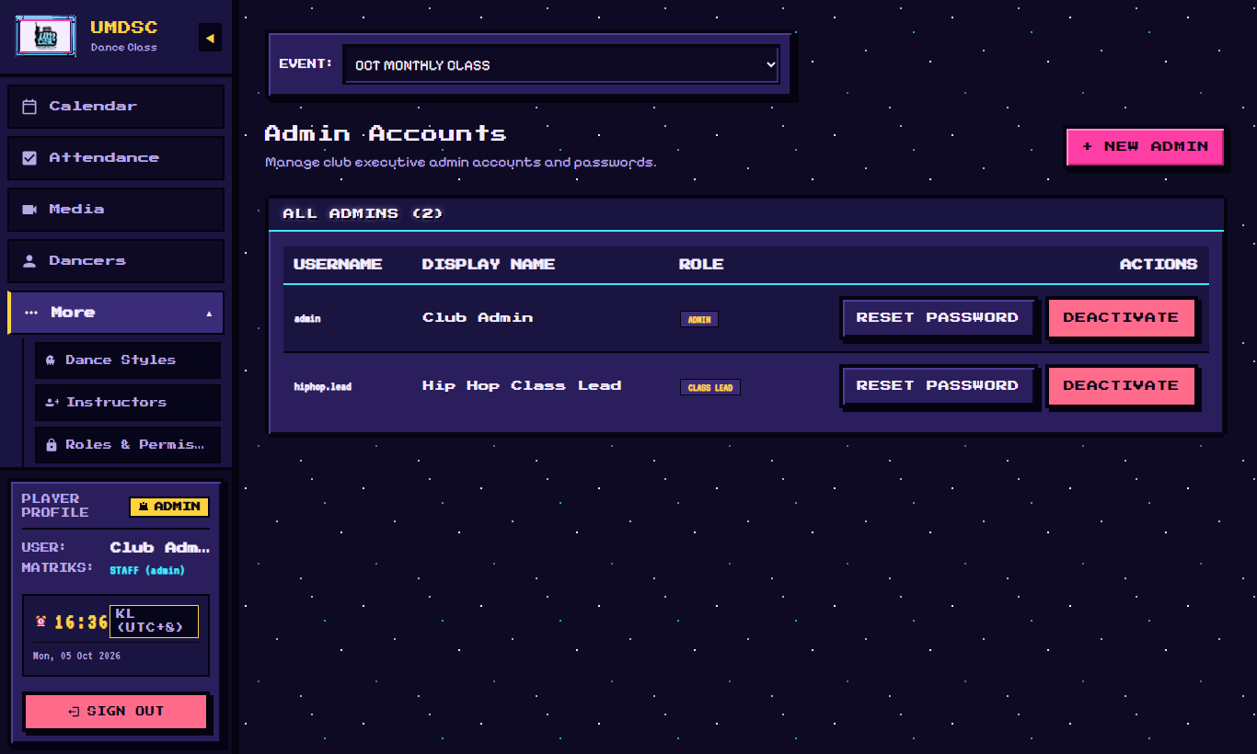
Admin accounts
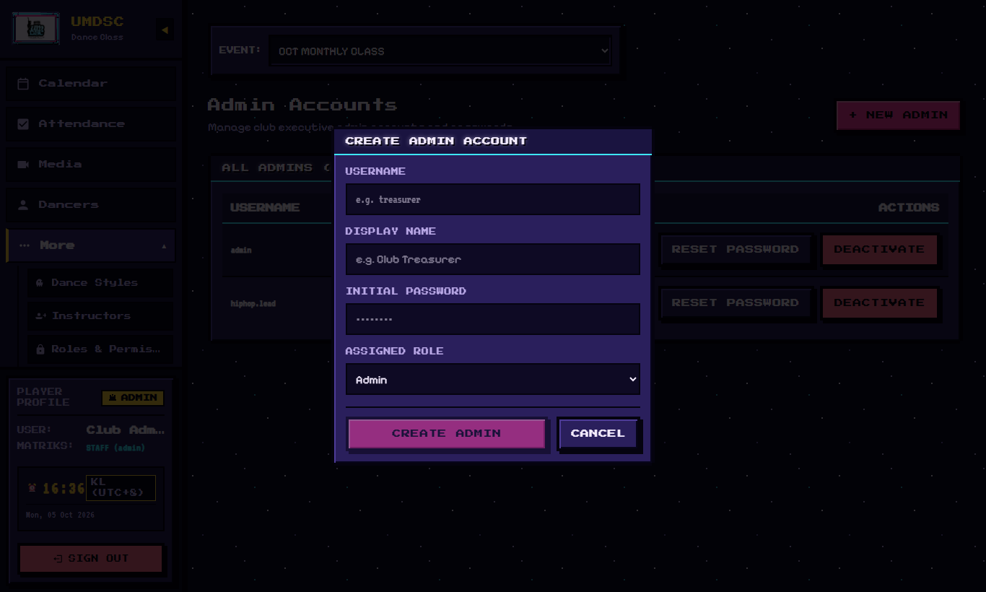
New admin account
The full step-by-step for a new class lead (account, Google sign-in list, folder) is in the Admin Handover Guide, section 4.

10. System settings
More › System Settings.
Setting | Meaning
Database Folder | The Google Drive folder that holds the website's database (a Google Sheet). Do not delete it.
Default Attendance Folder | Where attendance sheets are created. Also shown on the Attendance page.
Link Update History | Who changed which folder link, and when.
Data Retention (3 years) | Old data is cleared after 3 years.
Reset Test Data | ⚠️ Only for before the real launch: it deletes test data. You must type a confirmation.

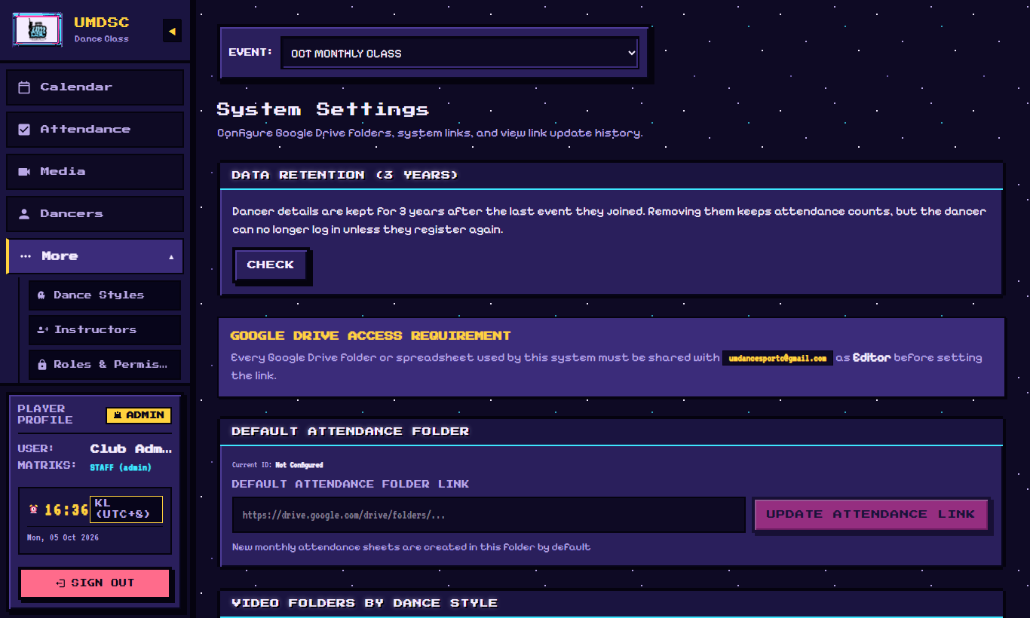
Settings

